NR-721 wk3

Student Lesson Plan

Overview
- Program Competencies
- Course Outcomes
- Weekly Objectives
- Main Concepts
- Applies organizational and system leadership skills to affect systemic changes in corporate culture and to promote continuous improvement in clinical outcomes. (PO 6)
- Appraises current information systems and technologies to improve health care. (POs 6, 7)
- Analyzes health care policies to advocate for equitable health care and social justice to all populations and those at risk due to social determinants of health. (POs 2, 9)
- Creates a supportive organizational culture for flourishing collaborative teams to facilitate clinical disease prevention and promote population health at all system levels. (PO 8)
- Leads others in professional identity, advanced clinical judgment, systems thinking, resilience, and accountability in selecting, implementing, and evaluating clinical care. (POs 1, 4)

Schedule
Section | Read/Review/Complete | Course Outcomes | Due
Prepare | Assigned Readings | COs 1, 2, 3 | Wednesday
Explore | Lesson | COs 1, 2, 3 | Wednesday
Translate to Practice | Discussion: Initial Post | COs 1, 2, 3 | Wednesday
Translate to Practice | Discussion: Follow-Up Posts | COs 1, 2, 3 | Sunday
Reflect | Reflection | COs 1, 2, 3 | No submission

Foundations for Learning
American Association of Colleges of Nursing. (2006). The essentials of doctoral education for advanced nursing practice.Links to an external site. https://www.aacnnursing.org/DNP/DNP-Essentials (Note: These Essentials outline the foundational competencies of advanced nursing practice for the DNP.)
American Organization for Nursing Leadership. (2015). AONL nurse leader competencies.Links to an external site. https://www.aonl.org/resources/nurse-leader-competencies
Broome, M. E., & Marshall, E. S. (2021). Transformational leadership in nursing: From expert clinician to influential leader (3rd ed.). Springer Publishing Company.
- Read Chapter 8
  - Section: Mentoring the Next Generation of Leaders to Create a Sustainable Culture of Excellence

Student Learning Resources
Click on the following tabs to view the resources for this week.
- Required Textbooks
- Required Articles
- Additional Resources
Daft, R. L. (2017). The leadership experience (7th ed.). Cengage Learning.
- Read Chapter 13
Huber, D. L. (2018). Leadership & nursing care management (6th ed.). Elsevier.
- Read Chapters 21, 22

Learning Success Strategies
- Review the assigned readings to ensure you understand the key terms and can relate them to the role of the DNP-prepared nurse leader.
- As you review weekly content, consider how each concept and discussion can be translated into practice in your unique setting.
- Be ready to share your own thoughts through the interactive discussion. It is important to share your own thoughts so that we hear your voice. Also, support your positions with evidence from the literature. Growing in your ability to share your ideas is encouraged, and the use of first-person is accepted for the discussion board.
- Review the discussion guidelines and rubric to optimize your performance.
- You have access to a variety of resources to support your success. Click the DNP Resources tab on the home page to access program and project resources.
- Your course faculty is here to support your learning journey. Reach out for guidance with study strategies, time management, and course-related questions. Review rubric feedback and individual comments to optimize performance.
- Let’s Check-In: Tips for Success: PowerPoints and recordings are posted each Sunday for the following week. Live Let’s Check-Ins are conducted in selected weeks throughout the course, so check your announcements for details.

Interacting with Feedback
Each week your course faculty will provide feedback in the rubric on any assignment you have submitted. Take a moment to review the following video on how to view rubric feedback in Canvas. (After clicking the link, scroll down or click on the title in the Summary area to jump directly to the video.)
- Link (video): Looking at FeedbackLinks to an external site. (2:26)
Review the following video on how to accept/reject track changes when viewing course faculty feedback on your assignment:
- Link (video): Word: Track Changes and Comments (4:19)

Lesson
Staffing, Scheduling, and Mentoring: The Role of the Nurse Leader

Recruitment and Retention: Stopping the Revolving Door
Healthcare organizations today are faced with significant operational challenges. The substantial transformation of healthcare delivery has resulted in organizations searching for innovative ways to ensure the sustainability of financial and human resources. With the retirement of baby boomers, the nursing profession faces a significant loss of nursing expertise. Retention of existing nursing staff is, therefore, critical to the financial and operational sustainability of healthcare systems.
While healthcare organizations may not experience difficulty recruiting new graduates, the task of retaining novice nurses can present a significant challenge for nurse leaders. A newly licensed nurse presents for work with an equal measure of excitement and anxiety. They must now perform as a healthcare team member without the guidance and safety net they experienced under their academic faculty.
The learning curve can be steep, with no room for errors in judgment. This can lead to significant stress and apprehension for the novice nurse, resulting in feelings of despair and dissatisfaction.
Review the following graphic.
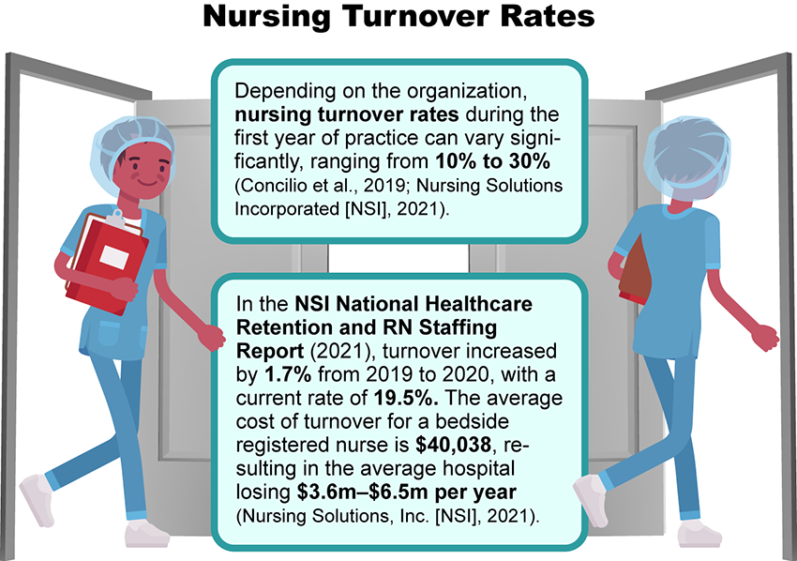

Nursing Turnover Image Description
A key factor impacting retention is nurse satisfaction, which is directly impacted by the culture of the healthcare organization. To maintain satisfaction, the nurse must have a sense of belonging and feel engaged with the organization's culture.
The importance of the cultural environment of the clinical site cannot be overemphasized.
Click on the plus signs in the following interactive to learn more about the importance of environment for the preceptee.

Cultural Environment Interactive Transcript

Staffing and Scheduling: Meeting the Needs of Complex Healthcare Systems
Sufficient employment of nursing and ancillary staff is an endless challenge for nursing leaders. The availability of employable nurses is a multifactor issue influenced by nursing education, changing demographics, work environment, workload, and compensation. A cause-and-effect relationship within nursing education impacts the number of available nurses to fill existing job vacancies.
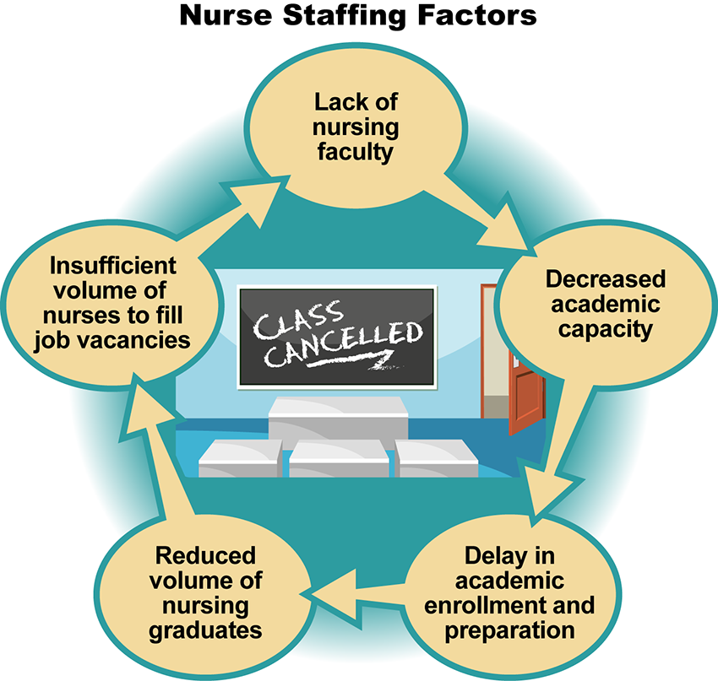

Staffing Factors Image Description
The expanding number of nurses leaving the profession through attrition or retirement contributes to the problem of insufficient nursing graduates to fill existing openings. The 2020 National Nursing Workforce Survey, compiled by the National Council of State Boards of Nursing (NCSBN), showed that the median age of registered nurses was 52. Nurses over 65 account for approximately 19% of the RN workforce. The survey also indicated that one-fifth of all nurses reported plans to retire from nursing over the next five years (Smiley et al., 2021), which will result in a significant loss of knowledge and expertise. Inadequate staffing can jeopardize nurse and patient safety and result in dissatisfaction. When staffing levels are insufficient to safely care for the needs of patients, frustration, call-ins, and burnout can occur.
The survey further revealed that from 2018-2020, employment setting, age, diversity, and education had all evolved. Challenges will continue to be associated with matching workplace diversity to the community population. As a DNP-prepared nurse leader, you will play a pivotal role in recruiting and mentoring nurses of diverse backgrounds to care for the represented populations within your community and state.
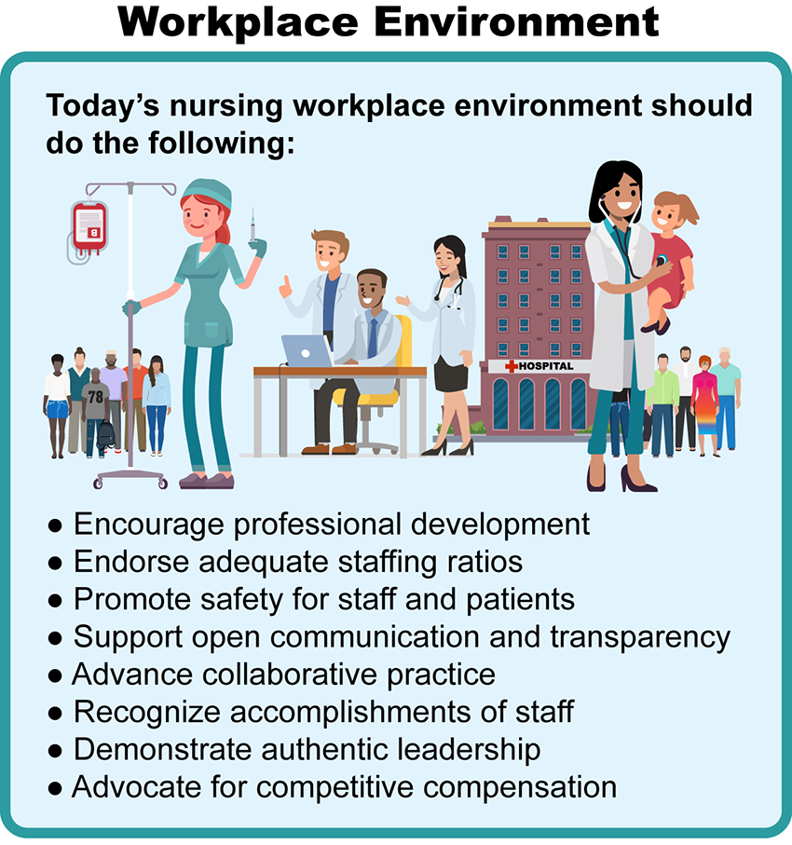

Workplace Environment Image Description
Compensation in nursing salaries is influenced by the academic preparation and certifications held by the nurse. Geographic variations in compensation can also impact intent to stay and may fluctuate based on supply and demand. Hospitals in urban settings typically have higher vacancy rates than rural facilities, and multihospital systems report higher vacancy rates than integrated healthcare delivery systems (Huber, 2018).
Meeting the human capital needs of complex healthcare systems requires awareness of the many factors impacting staffing, both internal and external to the facility. For a DNP-prepared nurse leader, collaborating with human resources to recruit and retain valuable talent will be key to maintaining a stable and high-performing workforce.
When turnover occurs, it can be disruptive to both staff and patients. Turnover is costly to an organization, with the average rate of turnover around 15% (Huber, 2018). Analyzing the root cause of turnover is an important step in reducing future attrition. By identifying barriers to retention, strategies can be put in place to help mitigate future turnover. One way to reduce turnover is by developing preceptor and mentoring programs. Through preceptor and mentoring programs, new graduates, as well as established employees, will have the support and resources needed to provide quality healthcare services and become an integral part of the healthcare team.

Characteristics of an Effective Mentor
Novice nurses must feel welcomed and supported as they navigate the healthcare system and become confident in their role. Their intrinsic motivation must be based on the value their influence brings to the organization and the patients they serve. While important, benefits, work hours, or pay will not sustain satisfaction if the organization's culture is not healthy or consistent with their personal and professional values. Transition to practice can be significantly enhanced through an effective mentoring relationship.
Watch the following video that describes the characteristics of a good mentor.
Characteristics of an Effective Mentor (0:50)

Mentor-Mentee Match Questions
The following is a list of questions to contemplate when matching a mentor to a mentee:
- Are the values of the mentor consistent with those of the mentee?
- Does the mentor role model behavior consistent with the organization’s values?
- Is the mentor approachable?
- Does the mentor give constructive feedback to support other nurses?
- Does the mentor practice active listening?
- Is the mentor willing to share their experiences and knowledge?
- Is the mentor reliable?
- Does the mentor foster an inclusive environment?
- Is the mentor trustworthy?
- Does the mentor support teamwork and networking?
- Is the mentor a good communicator?
- Does the mentor demonstrate respect for others?
- Is the mentor passionate about their work?
- Does the mentor have the skills to teach others?
- Does the mentor have the time to invest in working with the mentee?
- Does the mentor demonstrate compassion for others?
- Is the mentor calm during times of stress?
- Is the mentor encouraging?
- Do the expectations of the mentor align with those of the mentee?
While this list is not all-inclusive, it does provide a launching point when identifying a potential mentor-mentee partnership.

Mentor-Mentee Relationships
Establishing a mentor-mentee relationship should be a reciprocal collaboration in which each individual is an active participant, working towards defined goals and accomplishments. A mentoring relationship can be fulfilling for both the mentor and the mentee, personally and professionally. Mentors can provide exposure to different aspects of the nurse leader role and give encouragement to raise the self-confidence of the less-experienced nurse leader.
Click through the following slides to explore some of the most significant benefits of the mentor-mentee relationship.

Benefits of Mentor-Mentee Relationship Interactive Transcript

Differentiating Between the Roles of Mentor and Preceptor
Although the terms mentor and preceptor are frequently used interchangeably, it is important to note the differences between the two roles.
Click on the following tabs to learn more about each role.
- Mentor
- Preceptor
The term mentor refers to an individual with knowledge, skills, or expertise who supports a less experienced nurse for an extended period. In some cases, the mentorship may last for many years or even the duration of their professional career. The mentor provides guidance for career growth, development, and job advancement.

Barriers to Mentoring
Even with the best-laid preparation, there can be barriers to an effective mentoring relationship.

Barriers to Mentoring
Barriers to precepting can include the following:
- Poorly matched mentor and mentee
- Time constraints
- Productivity benchmarks and demands
- High patient volume
- Unavailability of mentor or mentee
- Insufficient coaching skills of the mentor
- Poor communication between mentor and mentee
- Emotional exhaustion of mentor or mentee
- Lack of tangible incentives for serving as a mentor
The first step in avoiding barriers is identifying their potential and developing a plan to overcome the obstacle. Assessing the learning needs of the mentee can help guide the mentorship in a way that best accomplishes the desired goals. Clarity in the style of interaction used and an explanation of how feedback will be provided can help set the tone for the relationship. Giving and receiving feedback needs to be structured so both parties can benefit from the interaction.
Serving as a mentor can be very rewarding. The experience allows the mentor to demonstrate their leadership expertise in a way that benefits patients, the community, and the nursing profession.

References
Concilio, L., Lockhart, J., Oermann, M., Kronk, R., & Schreiber, J. (2019). Newly licensed nurse resiliency and intervention to promote resiliency in the first year of hire: An integrative review. The Journal of Continuing Education in Nursing, 50(4), 153-161. https://doi.org/10.3928/00220124-20190319-05
Davey, Z., Jackson, D., & Henshall, C. (2020). The value of nurse mentoring relationships: Lessons learnt from a work-based resilience enhancement programme for nurses working in the forensic setting. International Journal of Mental Health Nursing, 29(5) 992-1001. https://doi.111/inm.12739
Huber, D. L. (2018). Leadership & nursing care management (6th ed.). Elsevier.
Nursing Solutions, Inc. (2021). 2021 NSI national health care retention & RN staffing report. https://www.nsinursingsolutions.com/Documents/Library/NSI_National_Health_Care_Retention_Report.pdf
Smiley, R., Ruttinger, C., Oliveira, C., Reneau, K., Silvestre, J., & Alexander, M. (2021). The 2020 national nursing workforce survey. Journal of Nursing Regulation, 12(1), S1-S96. https://doi.org/1016S2155-8256(21)00027-2.

The DNP-Prepared Nurse as a Mentor

Discussion

Purpose
The purpose of this discussion is to evaluate the leadership skills and competencies needed to be an effective mentor or preceptor to promote interprofessional collaboration.

Instructions
Reflect on your readings this week. Picture a nurse you know who may be a valuable mentor for you to support your development and growth as a DNP-prepared nurse leader and address the following:
- Evaluate leadership characteristics the nurse possesses that you would want to emulate if you were asked to be a mentor or preceptor for a new nurse leader.
- Examine your role and responsibility as a future DNP-prepared nurse in mentoring or precepting the next generation of nurses.
Please click on the following link to review the DNP Discussion Guidelines on the Student Resource Center program page:
- Link (webpage): DNP Discussion GuidelinesLinks to an external site.

Program Competencies
This discussion enables the student to meet the following program competencies:
- Applies organizational and system leadership skills to affect systemic changes in corporate culture and to promote continuous improvement in clinical outcomes. (PO 6)
- Appraises current information systems and technologies to improve health care. (POs 6, 7)
- Analyzes health care policies to advocate for equitable health care and social justice to all populations and those at risk due to social determinants of health. (POs 2, 9)
- Creates a supportive organizational culture for flourishing collaborative teams to facilitate clinical disease prevention and promote population health at all system levels. (PO 8)
- Leads others in professional identity, advanced clinical judgment, systems thinking, resilience, and accountability in selecting, implementing, and evaluating clinical care. (POs 1, 4)

Course Outcomes
This discussion enables the student to meet the following course outcomes:
- Evaluate the attributes of effective communication practices that build collaborative relationships and balance the concerns of individuals with organizational goals. (PCs 5, 6; POs 2, 8)
- Create collaborative relationships with interprofessional and interprofessional groups to champion organizational strategies and goals. (PCs 2, 4, 5, 6; POs 2, 6, 8)
- Analyze the role of the nurse leader in financial management, human resource management, strategic management, and information management at the micro, meso, and macrosystem levels. (PCs 2, 4, 5, 6, 8; POs 2, 4, 6, 8, 9)

Due Dates
- Initial Post: By 11:59 p.m. MT on Wednesday
- Follow-Up Posts: By 11:59 p.m. MT on Sunday
Search entries or author
Filter replies by unreadUnread Collapse replies Expand replies
Subscribe
ReplyReply to Week 3: Discussion | The DNP-Prepared Nurse as a Mentor

Collapse SubdiscussionPhillis Dewitt

Phillis Dewitt
Feb 13, 2024Local: Feb 13 at 9:26am
Course: Feb 13 at 7:26am
Manage Discussion Entry
Hi everyone,
Welcome to Week 3! The purpose of this week’s discussion is to evaluate the leadership skills and competencies needed to be an effective mentor or preceptor to promote interprofessional collaboration.

This discussion enables you to meet the following course and program outcomes:

1. Evaluate the attributes of effective communication practices that build collaborative relationships and balance the concerns of individuals with organizational goals. (POs 2, 8)
2. Create collaborative relationships with interprofessional and intraprofessional groups to champion organizational strategies and goals. (POs 2, 6, 8)
3. Analyze the role of the nurse leader in financial management, human resource management, strategic management, and information management at the micro, meso, and macrosystem levels. (POs 2, 4, 6, 8, 9)

Please review the discussion grading guidelines and support your post with scholarly references.

I am looking forward to our discussion!

