Re: Week 11 Discussion: EBP Models, Theoretical Concepts and SPP
by Tiffany White - Tuesday, 12 March 2024, 5:17 PM
According to nursing theorist Patricia Benner's Novice to Expert, the novice is unable to priorititize because of their inability to use discessionary judgement, and therefore are unable to use context to determine which tasks or information is most relevant. In this way, the nursing student is unable to determine which information is "most important" when all information is new, in theory, and concept, and without context to apply the information. The new nursing student is a novice at being a nursing student, unable to determine the best ways to study or learn the foreign language of the healthcare industry and nursing field, in my opinion. My project is focused on the use of short form videos (SFVs) to better meet students where they are more comfortable, in technology and micro learning (Chicca & Shellenbarger, 2018) perhaps where they are even considered an expert (at technology and consuming information through technology-based-sources). These students prefer learning through technology, including video content, and specifically via mobile devices, as it is easy and convenient (Szymkowiak et al., 2021). In this way, the faculty are perhaps the novice at technology but the expert at nursing, while the student is the novice at nursing (and being a nursing student), though possibly an expert at consuming information via technology.
The EBP model I am using is the Iowa Model. I like the step-by-step approach, the decision points, and the focus on evaluation (Tucker et al., 2021). This process flow chart is helpful in easily identifying the next step in the project plan. This format works well with the “Plan-Do-Study-Act” or PDSA project plan, as described in Figure 13.8 on page 324 of The Doctor of Nursing Practice Project (Moran et al., 2024).
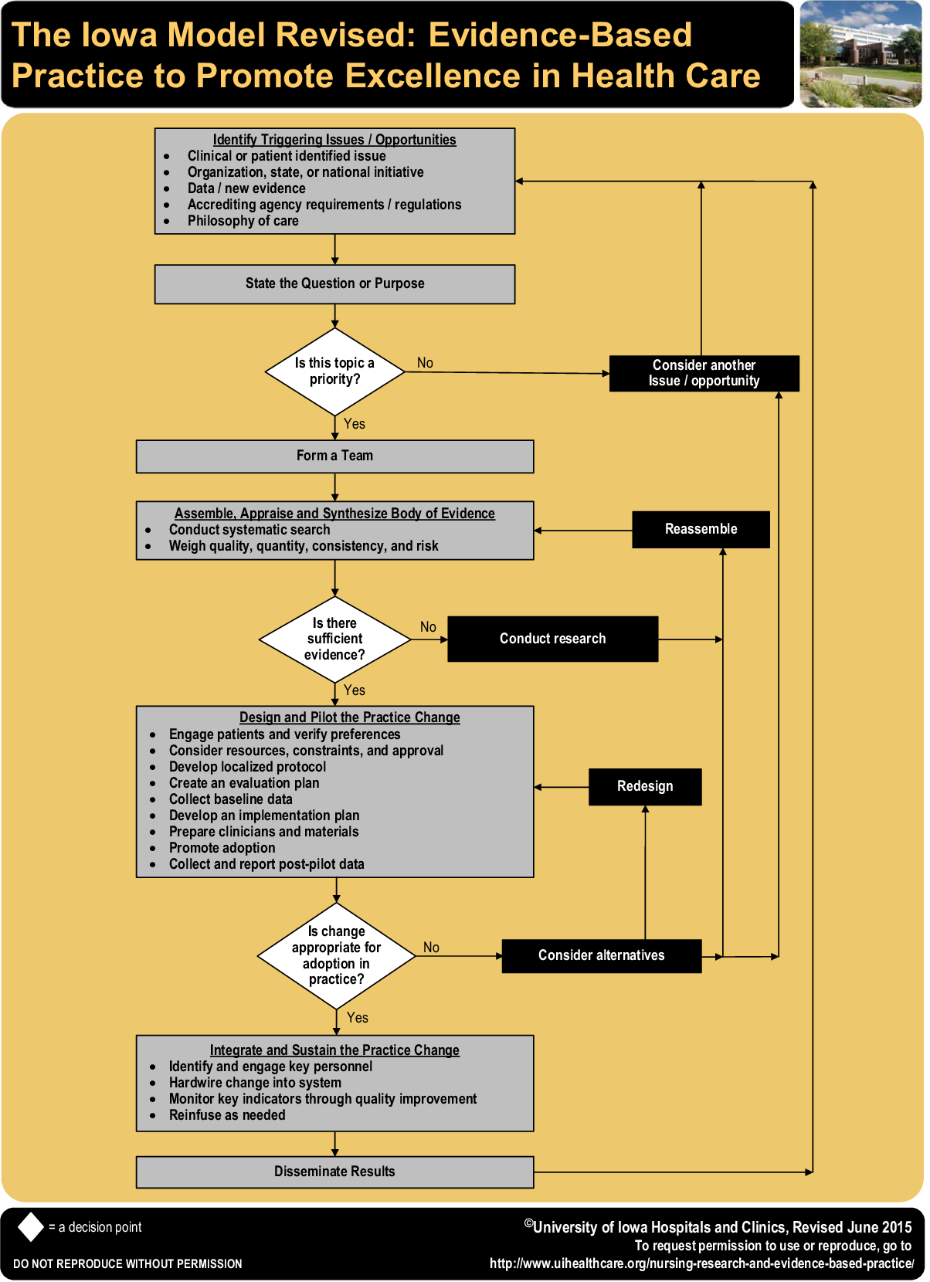
(Buckwalter et al., 2017)

References
Benner, P. (1982). From novice to expert. American Journal of Nursing, 82(3), 402-407.
Buckwalter, K., Cullen, L., Hanrahan, K., Kleiber, C., McCarthy, A. M., Rakel, B., Steelman, V., Tripp‐Reimer, T., & Tucker, S. (2017). Iowa model of evidence‐based practice: Revisions and validation. Worldviews on Evidence-Based Nursing, 14(3), 175–182. https://doi.org/10.1111/wvn.12223
Chicca, J., & Shellenbarger, T. (2018). Connecting with generation Z: Approaches in nursing education. Teaching and Learning in Nursing, 13(3), 180–184. https://doi.org/10.1016/j.teln.2018.03.008
Moran, K. J., Burson, R., & Conrad, D. (2020). The doctor of nursing practice project: A framework for success (3rd ed.). Jones & Bartlett Learning.
Szymkowiak, A., Melović, B., Dabić, M., Jeganathan, K., & Kundi, G. S. (2021). Information Technology and gen Z: The role of
teachers, the internet, and technology in the education of young people. Technology in Society, 65, 101565. https://doi.org/10.1016/j.techsoc.2021.101565
Tucker, S., McNett, M., Mazurek Melnyk, B., Hanrahan, K., Hunter, S. C., Kim, B., Cullen, L., & Kitson, A. (2021). Implementation science: Application of evidence-based practice models to improve healthcare quality. Worldviews on Evidence-Based Nursing, 18(2), 76.
463 words

PermalinkShow parentReply

Re: Week 11 Discussion: EBP Models, Theoretical Concepts and SPP
by Chinonye Okeke - Wednesday, 13 March 2024, 8:58 AM
Nursing professionals can utilize the Iowa Model of Evidence-Based Practice to Promote Quality Care as a guide for applying research findings to enhance patient care (Hanrahan et al., 2017). It offers guidance on how to apply scholarly, methodical procedures that result in secure, high-quality care (Hanrahan et al., 2017). Health care providers can use the Iowa model to identify problems, seek solutions, and implement the necessary changes.
Leininger's framework, Iowa's model, and the literature regarding nutrition and exercise influence on blood pressure in persons of color all fit together because they offer guidance for practical application. In urban primary care settings, they can be applied and used as a standard of practice.
The Iowa model will help with the practice question since it promotes using the most recent research findings to guarantee improved patient outcomes, behaviors, and interactions to provide the best care possible (Cullen et al., 2022). There is a wealth of information regarding how nutrition and exercise affect blood pressure, but people of color still experience the negative impacts of hypertension. The model offers a framework for putting this evidence into action and implementing the necessary adjustments to lower the high rate of hypertension among persons of color.
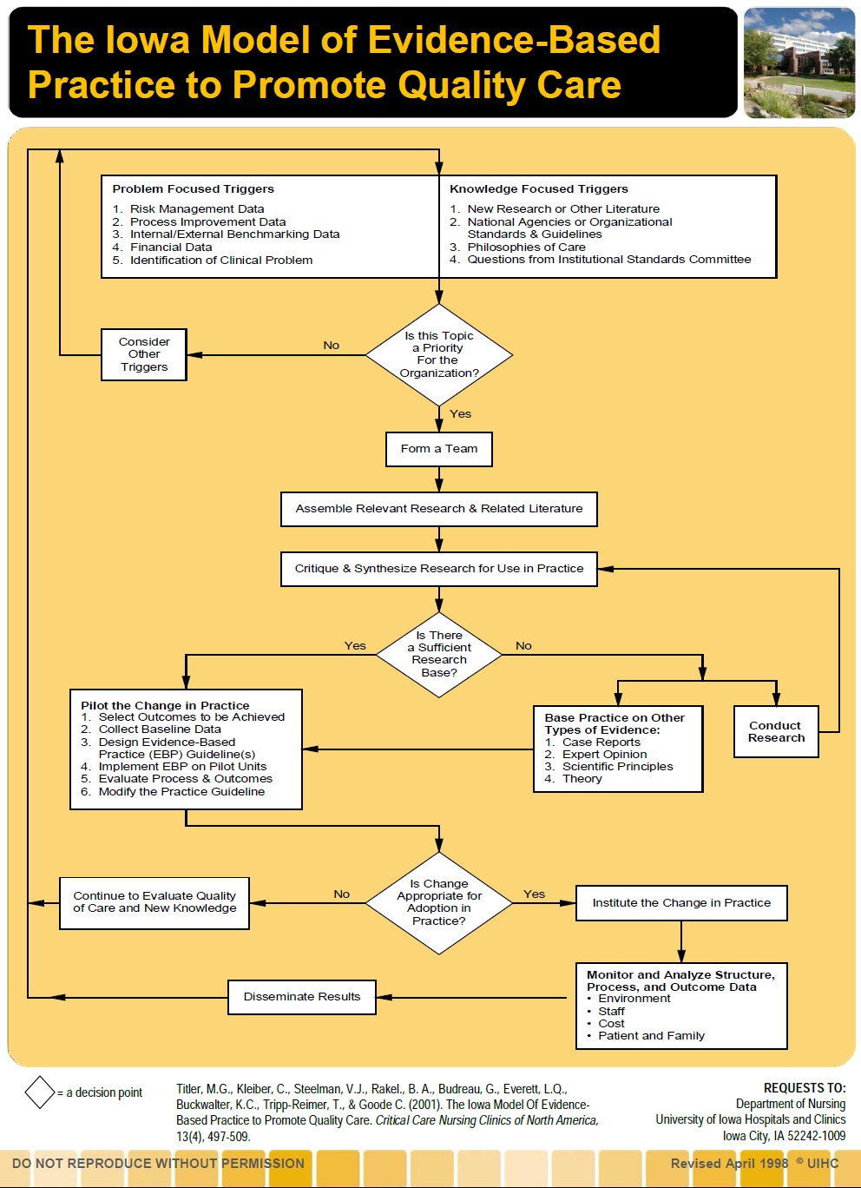 Titler, M. G., Kleiber, C., Steelman, V. J., Rakel, B. A., Budreau, G., Everett, L. Q., Buckwalter, K. C., Tripp-Reimer, T., & Goode, C. J. (2001). The Iowa model of evidence-based practice to promote Quality Care. Critical Care Nursing Clinics of North America, 13(4), 497–509. https://doi.org/10.1016/s0899-5885(18)30017-0
References
Cullen, L., Hanrahan, K., Edmonds, S. W., Reisinger, H. S., & Wagner, M. (2022). Iowa Implementation for Sustainability Framework. Implementation Science : IS, 17(1), 1. https://doi.org/10.1186/s13012-021-01157-5
Hanrahan, K., Cullen, L., & Rempel, K. (2017b). The Iowa Model: A catalyst for evidence-based practice ... Sigma. https://sigma.nursingrepository.org/bitstream/handle/10755/18029/Hanrahan_97851_PST313.pdf?isAllowed=y&sequence=1
Titler, M. G., Kleiber, C., Steelman, V. J., Rakel, B. A., Budreau, G., Everett, L. Q., Buckwalter, K. C., Tripp-Reimer, T., & Goode, C. J. (2001). The Iowa model of evidence-based practice to promote Quality Care. Critical Care Nursing Clinics of North America, 13(4), 497–509. https://doi.org/10.1016/s0899-5885(18)30017-0
340 words
PermalinkShow parentReply

Re: Week 11 Discussion: EBP Models, Theoretical Concepts and SPP
by Denice Morgan - Wednesday, 13 March 2024, 4:39 PM
The evidence-based practice model being used in this SPP will be the ADDIE Model of Instructional Design. ADDIE consists of five sections and stands for analysis, design, development, implementation, and evaluation. This model is used for instructional design and training and has a flexible guide to develop tools for performance enhancement. The first phase of this EBP model is the analysis phase. During this phase, data will be gathered, a needs assessment will be done to identify the gap, the behavioral outcome will be decided, the project will be delivered, and a timeline will be discussed (Bouchrika, 2024). The second phase is the design phase, and in this phase, the main focus is on creating a blueprint, the structure, content, learner process, and the activities that will be used (Bouchrika, 2024). The third phase is the development phase. This phase is where the SPP will address how the materials for instruction will be used to engage the learners and support their learning outcomes (Bouchrika, 2024). The fourth phase, the implementation phase, is when the SPP will be put into practice, a pilot program within a semester, to evaluate the functioning of the project (Bouchrika, 2024). The fifth and last phase is the evaluation phase, and here is where the SPP looks at the success, limitations, and outcomes of the project (Bouchrika, 2024). Two surveys will be sent out at the end of the implementation, one specific to the students and one specific to the clinical instructors, to gain insight into the effectiveness of the SPP.
SPP practice question is: In post-clinical debrief / post-conference, what are the effects of structured faculty-led debriefing versus informal debriefing on participation, and can it improve students' critical thinking skills and provide meaningful learning opportunities?
Tanner’s Clinical Judgment Model (CJM) is being used to guide the SPP and will be used as the main tool in post-conference/debriefing. Bandura’s Social Cognitive Theory (SCT) is the guiding theoretical framework for the SPP.
References
Bouchrika, I. (2024). The ADDIE model explained Evolution, steps, and application in 2024. Research.com. https://research.com/education/the-addie-model#what

