Examining the Impact of Cultural Competence Education Program on the Effectiveness of Cognitive Health Delivery Process

A Scholarly Project

Presented to

The Faculty of Regis College

In Partial Fulfillment
of the Requirements of the
Doctor of Nursing Practice Degree

by

Bruce Nsubuga, BSN, RN

3/24/2024

This scholarly practice project of _____________, entitled ______________________directed and approved by the faculty chair, has been accepted by the Nursing Faculty of Regis College in fulfillment of the requirements for the Doctor of Nursing Practice.

__________________________________________
Dean, Richard and Sheila Young School of Nursing

__________________________________________
Chair, Doctoral Scholarly Project Team, (credentials)

__________________________________________
Team Member, (credentials)

__________________________________________
Team Member, (credentials)

___________________________________________
Team Member, (credentials)

Add an additional signature line for each additional team member

Table of Contents
Abstract…………………………………………………………………………………. ………. i
Acknowledgements……………………………………………………………………………… ii
Table of Contents…………………………………………………………………………………iii
Chapter I: Introduction…………………………………………………………………………6
Introduction……………………………………………………………………………….6
Background……………………………………………………………………….............7
Significance………………………………………………………………………............10
Problem Statement……………………………………………………………………….13
Clinical/Practice Question(s) ……………………………………………………………14
Purpose of the Project……………………………………………………………………14
Theoretical or Conceptual Framework………………………………………………….15
Evidence-based Practice (EBP) Model………………………………………………….18
Conclusion……………………………………………………………………………….22
Chapter II: Review of Literature
Introduction
Comprehensive Literature Review
Supporting Literature
Conclusion
Chapter III: Methodology
Introduction
Project Design
Project Methods/Plan and Procedures
Evidence-Based Clinical/Practice Question
Recruitment Plan
Sample Size
Sampling
Inclusion Criteria
Exclusion Criteria
Informed Consent
Ethical Considerations
Evaluation
Variables
Tools/Instruments
Data
Timetable
Conclusion
Chapter IV: Results
Introduction
Conclusion
Chapter V: Discussion and Conclusion
Introduction
Interpretation of Results
Implications for Nursing Practice
Limitations
Dissemination of Findings
Conclusion
References
Appendices
Tables
Table of the Levels of Evidence
Figures

Examining the Impact of Cultural Competence Education Program on the Effectiveness of Cognitive Health Delivery Process
Chapter I: Introduction
Introduction
In the United States, a substantial demographic shift is characterized by increasing diversity. However, the composition of healthcare providers does not exemplify this diversity adequately (Marcelin et al., 2019). The nation's diverse cultures pose numerous problems to the healthcare systems due to the lack of culturally competent and congruent care, adversely affecting patients' quality of life. Conversely, this can give rise to an array of healthcare disparities in accessibility, provider cultural incompetence, and the delivery of suboptimal care. The paucity of cultural competence education programs and training in mental health settings can harm the effectiveness of cognitive health delivery processes. Healthcare providers who do not provide culturally competent care and have never undergone cultural competence training may inadvertently overlook cultural nuances or misunderstand their patients' opinions and concerns, resulting in redundant misdiagnoses, inadequate treatment modalities, and the lack of proper engagement between patients and the providers (Nair & Adetayo, 2019). The lack of cultural understanding contributes to unfavorable attitudes towards cross-cultural care. As a result, this deters healthcare professionals' preparedness to effectively address the needs of culturally diverse patients (Kaihlanen, Hietapakka & Heponiem, 2019).
Stubbe (2019) postulates that biases, microaggressions, and stereotypes exhibited by healthcare providers can impact patient-clinician interactions and clinical decision-making processes, potentially compromising the quality of care delivered to diverse patient populations. In particular, the delivery of cognitive healthcare services is an intricate process influenced by various factors, including nurses' cultural competence and communication between healthcare providers and patients (Stubbe, 2019). Cultural miscommunication can be caused by variations in cultural perspectives on health and illness, disparities in cultural values, differences in patients' preferences regarding doctor-patient relationships, instances of racism and perceptual biases, and linguistic obstacles.
Healthcare providers may lack cognizance of how their communication styles may adapt to individual patient attributes. In this case, their implicit bias may further contribute to the reluctance among patients from diverse cultural groups to seek cognitive healthcare services (Gopal et al., 2021). Notably, most healthcare providers find it challenging to work with multicultural populations. Thus, providing cultural competence training to clinicians is paramount to better meet the needs of a growing, diverse patient population (Desai et al., 2020). Culturally competent healthcare encompasses delivering comprehensive, effective, and culturally sensitive care. Acknowledging the presence of bias and its impacts on healthcare disparities can help mental health nurses deliver culturally competent cognitive care, mitigating healthcare inequities, building patient trust, augmenting the cognitive health delivery process, and eradicating healthcare gaps precipitated by cultural diversity (Lin & Hsu, 2020). Hence, there is a critical need to bolster cultural competency, particularly among mental health nurses whose effective communication is the cornerstone of cognitive health treatment. The scholarly practice project aims to implement a cultural competence education program to optimize the effectiveness of the cognitive health delivery processes and promote positive patient outcomes.
Background
Cultural competence is the linchpin of healthcare that aims to mitigate existing inequalities in delivering culturally sensitive and top-tier healthcare services. Primarily, culturally competent care seeks to provide unbiased access to healthcare among diverse patient groups, ascertaining that they all receive culturally sensitive and congruent care tailored to their specific health needs (Arruzza & Chau, 2021). However, the lack of culturally competent care can lead to avoidable medical errors and adverse events, negatively impacting cognitive health delivery processes and patient outcomes as well as satisfaction. In mental healthcare, the delivery of cognitive healthcare services is impacted by numerous elements, including the cultural competence of healthcare providers and increasing diversity (AHRQ, 2019).
Cultural competence entails the healthcare provider's capability to interact with patients from diverse cultural backgrounds while highlighting their cultural norms, practices, inclinations, and values. Culturally competent healthcare providers deliver bespoke, germane, and efficient services, demonstrating cultural sensitivity to the patient's cultural identities (Chu, Wippold & Becker, 2022). In healthcare, culturally incompetent providers deliver suboptimal patient care as they may misconstrue patient's behaviors as a lack of interest in receiving care. When healthcare providers overlook the peculiarities between themselves and their patients, they risk inadvertently providing subpar care. Therefore, enhancing the nurses' cross-cultural communication skills through cultural competence training is essential to ensure equitable care delivery. Cultural competence has become increasingly associated with health literacy, recognizing that espousing mutual understanding between patients and healthcare providers necessitates assimilating culturally coupled with linguistically proficient and health literate strategies (AHRQ, 2019).
Arruzza and Chau (2021) report that cultural competence training enhances healthcare provider's proficiency levels, resulting in treatment improvements, patient satisfaction, and information-sharing. Alternatively, cognitive health delivery processes entail providing healthcare services that promote and improve the mental well-being of patients, diagnosing and treating cognitive impairments, and bolstering individuals with mental health conditions. According to Chu, Wippold, and Becker (2022), significant healthcare disparities in cognitive health outcomes exist among distinct minority populations. It is worth mentioning that aspects such as socioeconomic status, access to healthcare, and health beliefs coupled with attitudes towards aging and cognitive decline contribute to healthcare disparities. Failure to address these cultural disparities between healthcare providers and patients can lead to significant issues such as miscommunication, distrust, dissatisfaction, and disempowerment, which are highly adverse consequences (Arruzza & Chau, 2021).
Existing Gaps
Additionally, despite the extensive plethora of evidence accentuating cultural competence in healthcare delivery, there exist gaps in evidence about the effect of cultural competence education programs on cognitive health outcomes. There is a dearth of evidence for integrating discussions on discrimination and prejudice into nursing curricula (Nair & Adetayo, 2019). The lack is troubling, as individuals from marginalized communities frequently face discrimination, leading to experiences of microaggression during cognitive health treatment and therapy. Subsequently, this contributes to miscommunication between patients and providers, weakened therapeutic relationships, and inadequate patient outcomes (Chu, Wippold & Becker, 2022). Notably, with the cumulative diversity and the composition of healthcare providers failing to exemplify this diversity, there is a need to examine the impact of cultural competence education programs on the efficacy of cognitive health delivery processes.
The Impact of Discrimination on Patient Experiences
Healthcare providers must acknowledge the influence of discrimination on patients' experiences and provide clinicians with practical strategies, such as cultural competency education programs and training, to address provider-bigoted behaviors. Integrating conversations about prejudice and discrimination into workforce training programs is in line with policy and practice guidelines aimed at eradicating systemic racism within mental healthcare systems (Chu, Wippold & Becker, 2022). The project aims to contribute to the growth of culturally sensitive and effective cognitive health delivery processes by addressing existing gaps in evidence. Additionally, it will examine the influence of a cultural competence education program on healthcare provider knowledge, attitudes, and behaviors related to cultural competence. Conversely, it will explore the effects of the education program on patient outcomes such as cognitive function, quality of life, and healthcare utilization.
Significance
The lack of cultural competence training and education programs among mental health nurses providing cognitive healthcare may result in patient safety disparities (AHRQ, 2019). These disparities could manifest as diagnostic errors, missed screenings, unforeseen adverse reactions to medication, harmful interactions between conventional medicines, and substandard cognitive health services. Thus, it is essential to implement cultural competence education programs in healthcare organizations to enhance mental health nurses' cultural awareness, knowledge, and skills to foster behavioral changes and optimal patient outcomes (AHRQ, 2019). Cultural competence training and education programs can boost providers' comprehension of their diverse patients' experiences and equip them with adept skills to surmount cultural distinctions, promoting a culture of trust.
Nursing Practice
In nursing practice, healthcare providers' competencies significantly influence the dynamics between patients seeking cognitive healthcare services and healthcare providers. Stubbe (2019) suggests that biases, microaggressions, and stereotypes displayed by healthcare providers can influence interactions between patients and clinicians and the decision-making processes in clinical settings, potentially compromising the quality of care provided to diverse patient populations. L
inguistic and cultural barriers frequently contribute to cultural miscommunication among healthcare providers and patients (Arruzza & Chau, 2021). As a result, patients may be unenthusiastic in seeking cognitive healthcare services, exacerbating high rates of poor patient outcomes, experiences, and dissatisfaction.
Therefore, providing clinicians with culturally competent training is vital since patients are more likely to engage in cognitive therapy and share information when healthcare professionals demonstrate sensitivity to their cultural backgrounds. Remarkably, prioritizing the development of cultural competence among the healthcare workforce is often an initial and prominent strategy, given the significant impact that healthcare professionals have on the quality of patient care and curtailing gaps in healthcare (Lin & Hsu, 2020). Providing cultural competence education to clinicians helps them understand and address patients' concerns as well as deliver culturally appropriate care. Patient attitudes and behaviors are deeply influenced by their cultural backgrounds, underscoring the need for healthcare professionals to provide culturally congruent care.
Besides, recognizing and accommodating a patient's religious or cultural perspectives is crucial in providing adequate care and enhancing cultural competency through a patient-centric approach (Nair & Adetayo, 2019). A cultural competence education program can aid mental health providers in changing their attitudes, augmenting their knowledge, and honing their skills. Consequently, this will empower them to address the mental health needs of underserved cultural communities effectively and eliminate healthcare disparities. Many healthcare providers are oblivious to the extent of health disparities nationwide (Arruzza & Chau, 2021). The lack of cognizance could be precipitated by the inadequacies in their undergraduate education regarding practical, cultural competency training. In particular, developing a comprehensive curriculum covering all aspects of cultural competency remains an acknowledged impediment. Thus, investigating the methods employed to expedite cultural competency education could potentially enhance providing culturally appropriate care (Arruzza & Chau, 2021).
Nursing Education

Implementing cultural competence training, particularly for nurse students, can prepare them to deliver culturally congruent and compassionate care, enhancing clinical care practices (Ličen & Prosen, 2023). The training enhances clinicians' cultural awareness and addresses healthcare gaps stemming from cultural diversity. Furthermore, cultural competency education programs can improve pertinent student outcomes, including knowledge acquisition, skill development, satisfaction, confidence, and personal attributes (Arruzza & Chau, 2021). Additionally, implementing the cultural competence education program in healthcare organizations can improve patient-clinician interactions, enhance communication, and improve health outcomes for diverse patient populations (Cerveny et al., 2022). It can also foster awareness of the health disparities impacting diverse patient populations and enable nurses to confront their implicit biases, enhancing their ability to provide culturally competent care.
Nursing Leadership
The cultural competence education program will also benefit patients from distinct cultural backgrounds by enhancing their satisfaction and experiences and fostering profound societal acceptance (Cerveny et al., 2022). Nurse leaders and managers are integral in espousing cultural competence within healthcare organizations. In this context, they can bolster the intervention, advocate for cultural competency training, and provide adequate resources, demonstrating their commitment to nurturing a more inclusive, equitable, and diversified work environment. The lack of healthcare providers' cultural competence presents an invaluable opportunity for nurse leaders to pursue ethnic diversity and cultural competency to successfully cater to an increasingly diverse patient population (Kaihlanen, Hietapakka & Heponiemi, 2019). The leaders ought to espouse evidence-based strategies that foster cultural competency, such as recruiting diverse healthcare providers, utilizing interpreter services, providing cultural competency training for healthcare team members, and disseminating information on cultural competency to the nursing workforce.
Nursing Research
Researchers should compare conventional lengthy training approaches with shorter training sessions and online platforms to recognize the most viable strategy for bolstering cultural competence among mental health providers and enhancing their cultural cognizance, skills, and knowledge. The lack of cultural competence among healthcare providers creates a significant opportunity for researchers to investigate the impediments and facilitators in employing cultural competence education programs and training (Kaihlanen, Hietapakka & Heponiemi, 2019). These findings can inform future interventions, promoting equitable and culturally competent care.
Problem Statement
The lack of cultural competence and training among healthcare providers in mental healthcare settings catering to patients with cognitive health conditions manifests through disparities in health outcomes and diminished satisfaction with care. This deficiency is compounded by clinician biases and a lack of culturally competent education, training, and services (Nair & Adetayo, 2019). Inadequate access to interpreter services further exacerbates the issue, making it challenging for patients from diverse cultural backgrounds to communicate their needs and concerns effectively. Additionally, the lack of representation in the healthcare workforce of individuals who share the same racial and linguistic backgrounds as the patients further contributes to the problem. As a result, patients may feel misunderstood or marginalized, leading to suboptimal care experiences and outcomes (Nair & Adetayo, 2019). Addressing the paucity of cultural competence training is essential to ensure equitable access to high-quality mental health care services for diverse patient populations, regardless of their cultural or linguistic backgrounds.
Clinical/Practice Question(s)
Developing a clinical/practice question is crucial to conducting a high-quality study. The clinical/practice question will employ the PICO(t) framework, which stands out as the most commonly utilized strategy. The PICOt framework will integrate five essential rudiments: P for population, I for intervention, C for comparison, O for outcome, and t for time.
In mental health settings (P), does the implementation of a cultural competence education program (I) compared to standard care (C) impact the effectiveness of cognitive health delivery processes (O) over eight weeks (T)?
Purpose of the Project
The project aims to examine the influence of a cultural competence education program on the effectiveness of cognitive health delivery processes. Specifically, it seeks to assess shifts in provider knowledge, impetus, attitudes, and behaviors akin to cultural competence and examine their influence on patient outcomes and healthcare disparities. Assessing the participants' knowledge, attitudes, and behaviors will enhance their understanding of culturally competent care and curtail disparities in the delivery of cognitive and mental healthcare services. Additionally, the project seeks to implement the program within a mental health unit to educate healthcare providers on cultural awareness and congruence to bolster their capabilities and address healthcare disparities. Research indicates that healthcare providers equipped with cultural competency exhibit augmented knowledge, behaviors, and attitudes, enhancing the efficiency of cognitive health delivery processes (Nair & Adetayo, 2019).
Culturally cognizant and competent providers address the health needs of patients regardless of their cultural backgrounds, improving access to timely illness diagnosis, treatment, and rapport in care (Stubbe, 2019). The rapport and positive patient-provider communication may boost the patients' engagement and adherence to treatment protocols. Thus, it will be essential to measure the objectives of this project through pre- and post-assessments prior to implementing the project. As the lead investigator, the student plans to introduce ongoing cultural competence training sessions in the mental health unit.
Theoretical or Conceptual Framework
The project will use Leininger's Culture Care Theory as the theoretical framework. The theory underscores the significance of culturally competent care, which encompasses tailoring decisions that align with individuals, institutions, or groups' cultural beliefs, values, and practices (McFarland & Wehbe-Alamah, 2019). The theory suggests that culturally competent care aims to attain worthwhile value and health outcomes for individuals with similar or diverse cultural identities. As such, it centers on comprehending and assimilating cultural factors into nursing care, accentuating cultural competence in healthcare settings. It is worth noting that the framework is consistent with the project's design of implementing a cultural competence education program (Maniago, 2020). The program will help inculcate and educate psychiatric-mental health nurses about cultural competence care to boost the efficiency of cognitive health delivery processes.
Most importantly, implementing the program will enhance participants' knowledge, attitude, skills, and behaviors, potentially improving their efficiency when providing cognitive health services to patients from disparate cultures (Chu, Wippold & Becker, 2022). Leininger's theory underscores the essence of culturally congruent care, which necessitates nurse-patient collaboration to classify, strategize, design, introduce, and appraise culturally competent and responsive care modalities. Using novel knowledge, nurses can employ culturally-based approaches to provide holistic and meaningful care tailored to the patient's preference (McFarland & Wehbe-Alamah, 2019). Leininger's model applies to the project as it focuses on the concept of culturally congruent nursing care and acknowledges the significance of culture in shaping the health beliefs, practices, and behaviors of individuals from diverse cultural backgrounds.
The theory is embedded in five tenets of cultural competence, including respecting diversity, conducting cultural self-assessments, understanding the dynamics of variances, institutionalizing cultural knowledge, and adapting to diversity (McFarland & Wehbe-Alamah, 2019). These principles will inform the development of the education program and guide nurses in effectively meeting the needs of diverse patient populations in mental healthcare settings. The first principle emphasizes valuing diversity, which involves accepting and respecting cultural differences to foster better understanding. Secondly, conducting cultural self-assessment and engaging in discussions and surveys is vital to expand knowledge of cultural diversity and prevent misconceptions (McFarland & Wehbe-Alamah, 2019). Thirdly, the theory emphasizes comprehending the dynamics of differences, factors influencing cross-cultural interaction, respecting patients, and communicating effectively (McFarland & Wehbe-Alamah, 2019). Another crucial tenet focuses on institutionalizing cultural knowledge through training and policies promoting culturally competent practices.
Furthermore, Leininger's theory involves acclimatizing to diversity, values, attitudes, behaviors, and practices that acknowledge cultural diversity (McFarland & Wehbe-Alamah, 2019). Therefore, integrating these principles and the concept of transcultural nursing into the project can aid healthcare providers in effectively meeting the needs of diverse groups, particularly in mental healthcare environments. Some of the theoretical concepts that will be measured in the pre-and post-questionnaires that are in accordance with the project are the nurses' knowledge, attitudes, skills, and behaviors.
Philosophical Assumptions
The fundamental philosophical assumptions of Leininger's culture care theory are consistent with the scholarly practice project's goal of promoting cultural competence in the healthcare sector. The theory suggests that cultural aspects significantly impact individuals' health practices, beliefs, and behaviors (McFarland & Wehbe-Alamah, 2019). The assumption highlights the necessity of acknowledging and valuing patients' cultural backgrounds in delivering equitable healthcare. The education program will also emphasize valuing patients' cultural backgrounds and preferences when providing cognitive health services. Leininger's theory assumes understanding and accepting cultural distinctions without prejudice. As such, this philosophical assumption will inform the project by training the participants on providing culturally sensitive, empathetic, and compassionate cognitive care.
Mental health settings often encounter obstacles such as stigma, discrimination, and prejudice, which can encumber patients' access to and compliance with essential healthcare services, including cognitive care (Stubbe, 2019). Thus, training the nurses on cultural disparities will allow them to recognize their biases, address them, and provide equitable cognitive healthcare. Implementing the project will enable the nurses to incorporate the transcultural nursing concept of cultural consideration into practice to meet the health necessities of patients from diverse cultural backgrounds (McFarland & Wehbe-Alamah, 2019). Implementing the project will enable mental health nurses to provide patient-centric care that values and dignifies clients' cultural identities and experiences.

Evidence-based Practice (EBP) Model
Johns Hopkins Nursing Evidence-Based Practice (JHNEBP) Model
The project will employ the Johns Hopkins Nursing Evidence-Based Practice (JHNEBP) Model. This model was selected because it systematically integrates contemporary research findings into clinical nursing practice using user-friendly tools (Dang et al., 2022). The systematic approach guarantees that evidence-based decisions are tailored consistently, contributing to augmented patient outcomes and efficient cognitive health delivery processes. More so, it comprises a pragmatic, three-phase process that identifies the practice question, compiles the best available evidence to address it, and translates evidence into clinical practice (Dang et al., 2022). These stages are commonly known as PET. The JHNEBP model contains convenient and practical tools, including evidence-based practice tools that simplify evidence-based practices in real-world clinical settings (Johns Hopkins Nursing, n.d.). JHNEBP model was selected because the user-friendly EBP tools will guide the student researcher through each project step. The tools
PET Steps
The Johns Hopkins Nursing EBP model comprises threefold steps known as PET that guide healthcare professionals through the EBP process (Johns Hopkins Nursing, n.d.). The PET process within the JHEBP model commences with the practice question phase, which includes seven steps. These levels include articulating the EBP problem, formulating the EBP question, substantiating the EBP project, assembling an interprofessional team, establishing project leadership, identifying stakeholders, and scheduling team meetings. The first stage underpins the subsequent phases, ensuring the project's objectives are concisely delineated and aligned with the EBP tenets (Dang et al., 2022). The second step is the evidence phase, which consists of five stages. These stages include acquiring, appraising, encapsulating, synthesizing evidence, and making practice change recommendations (Dang et al., 2022).
Notably, the second category underscores the significance of effectively appraising evidence and the applicability of research findings. The final phase is translation, where findings are synthesized to tailor recommendations for practice. The phase comprises eight levels, including identifying an appropriate practice setting, strategic planning, ensuring support through stakeholder support and engagement, implementing the plan, analyzing outcomes, communicating outcomes to stakeholders, devising the following steps, and disseminating findings (Dang et al., 2022). The last phase allows the researcher to engage in continuous evaluation to warrant the successful incorporation of EBP, maximizing the probability of sustainable practice change and expected outcomes.
Applying the JHNEBP Model as a Roadmap for Evidence Selection, Application, and Evaluation in the Project
The JHNEBP model confers a comprehensive blueprint for approaching alternatives to selecting, applying, and evaluating evidence for this project. When selecting evidence, the project will primarily incorporate the practice question stage to identify the crucial areas that necessitate evidence (Dang et al., 2022). For instance, the project will incorporate keywords from the practice question, such as the cultural competence education program, mental health nurses, or cognitive health delivery processes, to select the most suitable evidence. The model will help ensure that the selected evidence is current and high-quality. Additionally, to apply evidence, the project will assimilate the translation steps.
The stages will help synthesize findings and tailor an optimal action plan to implement the evidence-based project in the organization strategically. The project needs to infuse the evidence and translation steps when evaluating evidence. In this light, the evidence category will allow the researcher to appraise the quality and pertinence of evidence, ascertaining that the selected evidence aligns with the project's objectives of enhancing the efficacy of the cultural competence education program (Dang et al., 2022). Once the project is implemented, the translation phase will play a vital role in expediting incessant evaluation of the impact of the intervention.
The Link Between the Project and the JHNEBP Model
The components of the EBP model, including the practice question, evidence, and translation (PET) stages, correspond to the phases of the project's research process, which involve formulating the practice question, gathering relevant evidence, and applying the conceptual framework (Dang et al., 2022). For one, the initial step of ensuring the project's success is incorporating a clinical practice query, aligning with the model's initial phase. The evidence level will underpin the project's acquisition and assessment of germane evidence. Finally, the translation phase will facilitate the implementation of findings into clinical practice through continuous assessment for further improvement. Below are diagrammatic figures that elucidate the connection between the JHNEBP model and the project (See Figures 1. And 2.)

Johns Hopkins Nursing Evidence-Based Practice (JHNEBP) Model Diagrammatic Figures
JHNEBP Model
Figure 1.
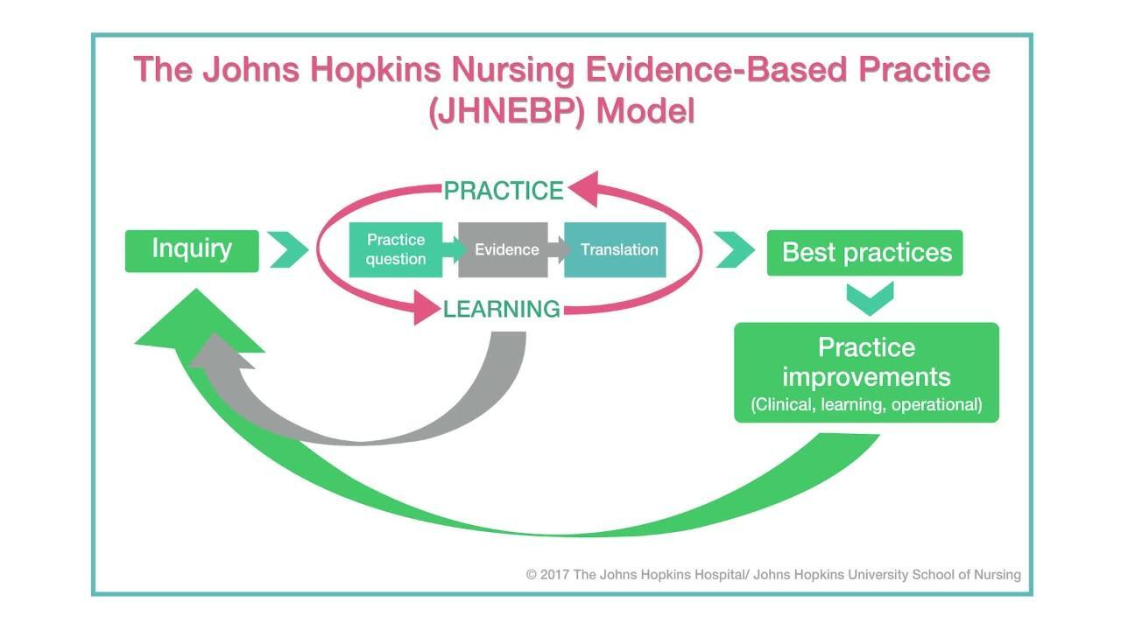
(Dang et al., 2022).

Application of the JHNEBP Model in the Project
Figure 2.

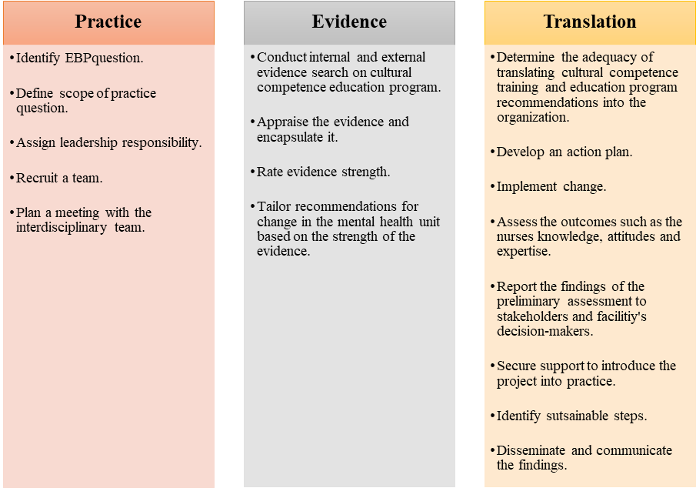
Clinical Practice Question.
EBP best practices

Conclusion
In summary, the lack of cultural competence education programs and training in mental health settings can negatively impact the efficacy of cognitive health delivery processes. The project reflects the significant gaps in evidence and factors that enhance poor cognitive health delivery services, such as healthcare disparities and stigma. It aims to boost patient outcomes, safety, cognitive health delivery processes and curtail healthcare inequalities. The outcomes will be achieved by assessing shifts in provider impetus, knowledge, behaviors, and attitudes correlated with cultural competence education programs. Leininger's theory of culture care will underpin the project to ensure its success. The project will employ the JHNEBP model because it provides evidence-based practice tools and a step-by-step approach known as the PET process. Notably, the iterative processes of the model will guide the project in ascertaining that it will be implemented successfully. The model aligns with the project's goal of enhancing the efficacy of cognitive health processes using EBP to achieve positive patient outcomes and satisfaction.

References
AHRQ. (2019, December 27). Cultural competence and patient safety. Agency for Healthcare Research and Quality (AHRQ). Patient Safety Network (PSNet). https://psnet.ahrq.gov/perspective/cultural-competence-and-patient-safety
Arruzza, E., & Chau, M. (2021). The effectiveness of cultural competence education in enhancing knowledge acquisition, performance, attitudes, and student satisfaction among undergraduate health science students: A scoping review. Journal of Educational Evaluation for Health Professions, 18. https://doi.org/10.3352/jeehp.2021.18.3
Chu, W., Wippold, G., & Becker, K. D. (2022). A systematic review of cultural competence trainings for mental health providers. Professional Psychology, Research and Practice, 53(4), 362. https://doi.org/10.1037/pro0000469
Dang, D., Dearholt, S., Bissett, K., Ascenzi, J., & Whalen, M. (2022). Johns Hopkins evidence-based practice for nurses and healthcare professionals: Model and guidelines. 4th ed. Sigma Theta Tau International
Desai, M. U., Paranamana, N., Restrepo-Toro, M., Davidson, L., & Stanhope, V. (2020). Implicit organizational bias: Mental health treatment culture and norms as barriers to engaging with diversity. The American Psychologist, 76(1), 78. https://doi.org/10.1037/amp0000621
Gopal, D. P., Chetty, U., Gajria, C., & Blackadder-Weinstein, J. (2021). Implicit bias in healthcare: Clinical practice, research, and decision making. Future Healthcare Journal, 8(1), 40–48. https://doi.org/10.7861/fhj.2020-0233
Johns Hopkins Nursing. (n.d.). Evidence-based practice. Johns Hopkins Medicine, based in Baltimore, Maryland. https://www.hopkinsmedicine.org/nursing/center-nursing-inquiry/nursing-inquiry/evidence-based-practice
Kaihlanen, A., Hietapakka, L., & Heponiemi, T. (2019). Increasing cultural awareness: Qualitative study of nurses' perceptions about cultural competence training. BMC Nursing, 18(1). https://doi.org/10.1186/s12912-019-0363-x
Ličen, S., & Prosen, M. (2023). The development of cultural competences in nursing students and their significance in shaping the future work environment: A pilot study. BMC Medical Education, 23(1), 819. https://doi.org/10.1186/s12909-023-04800-5
Lin, M., & Hsu, H. (2020). Effects of a cultural competence education program on clinical nurses: A randomized controlled trial. Nurse Education Today, p. 88, 104385. https://doi.org/10.1016/j.nedt.2020.104385
Marcelin, J. R., Siraj, D. S., Victor, R., Kotadia, S., & Maldonado, Y. A. (2019). The impact of unconscious bias in healthcare: How to recognize and mitigate it. The Journal of Infectious Diseases, 220(220 Suppl 2), S62–S73. https://doi.org/10.1093/infdis/jiz214
Nair, L., & Adetayo, O. A. (2019). Cultural competence and ethnic diversity in healthcare. Plastic and Reconstructive Surgery Global Open, 7(5). https://doi.org/10.1097/GOX.0000000000002219
Stubbe, D. E. (2019). Practicing cultural competence and cultural humility in the care of diverse patients. Focus: Journal of Life Long Learning in Psychiatry, 18(1), 49-51. https://doi.org/10.1176/appi.focus.20190041

