Week 5:

Student Lesson Plan

Week 5Student Lesson Plan

Overview
- Program Competencies
- Course Outcomes
- Weekly Objectives
- Main Concepts
- Applies organizational and system leadership skills to affect systemic changes in corporate culture and to promote continuous improvement in clinical outcomes. (PO 6)
- Appraises current information systems and technologies to improve health care. (POs 6, 7)
- Analyzes health care policies to advocate for equitable health care and social justice to all populations and those at risk due to social determinants of health. (POs 2, 9)
- Creates a supportive organizational culture for flourishing collaborative teams to facilitate clinical disease prevention and promote population health at all system levels. (PO 8)
- Leads others in professional identity, advanced clinical judgment, systems thinking, resilience, and accountability in selecting, implementing, and evaluating clinical care. (POs 1, 4)

Schedule
Section | Read/Review/Complete | Course Outcomes | Due
Prepare | Assigned Readings | COs 1, 2, 3 | Wednesday
Explore | Lesson | COs 1, 2, 3 | Wednesday
Translate to Practice | Discussion: Initial Post | COs 1, 2, 3 | Wednesday
Translate to Practice | Discussion: Follow-Up Posts | COs 1, 2, 3 | Sunday
Reflect | Reflection | COs 1, 2, 3 | No submission

Foundations for Learning
American Association of Colleges of Nursing. (2006). The essentials of doctoral education for advanced nursing practice.Links to an external site. https://www.aacnnursing.org/DNP/DNP-Essentials (Note: These Essentials outline the foundational competencies of advanced nursing practice for the DNP.)
American Organization for Nursing Leadership. (2015). AONL nurse leader competencies.Links to an external site. https://www.aonl.org/resources/nurse-leader-competencies

Student Learning Resources
Click on the following tabs to view the resources for this week.
- Required Textbooks
- Required Articles
- Additional Resources
Huber, D. L. (2018). Leadership & nursing care management (6th ed.). Elsevier.
- Read Chapter 20

Learning Success Strategies
- Review the assigned readings to ensure you understand the key terms and can relate them to the role of the DNP-prepared nurse leader.
- As you review weekly content, consider how each concept and discussion can be translated into practice in your unique setting.
- Be ready to share your own thoughts through the interactive discussion. It is important to share your own thoughts so that we hear your voice. Also, support your positions with evidence from the literature. Growing in your ability to share your ideas is encouraged, and the use of first-person is accepted for the discussion board.
- Review the discussion guidelines and rubric to optimize your performance.
- You have access to a variety of resources to support your success. Click the DNP Resources tab on the home page to access program and project resources.
- Your course faculty is here to support your learning journey. Reach out for guidance with study strategies, time management, and course-related questions. Review rubric feedback and individual comments to optimize performance.
- Let’s Check-In: Tips for Success: PowerPoints and recordings are posted each Sunday for the following week. Live Let’s Check-Ins are conducted in selected weeks throughout the course, so check your announcements for details.

Interacting with Feedback
Each week your course faculty will provide feedback in the rubric on any assignment you have submitted. Take a moment to review the following video on how to view rubric feedback in Canvas. (After clicking the link, scroll down or click on the title in the Summary area to jump directly to the video.)
- Link (video): Looking at FeedbackLinks to an external site. (2:26)
Review the following video on how to accept/reject track changes when viewing course faculty feedback on your assignment:
- Link (video): Word: Track Changes and Comments (4:19)
- Week 5: Lesson | Violence in the Workplace
Immersive Reader
March 2024

Week 5: Lesson | Violence in the Workplace

Week 5Lesson
Violence in the Workplace

The Nurse Leader’s Personal and Organizational Responsibility for Staff Safety
The National Institute for Occupational Safety and Health (OSHA, n.d.) defines workplace violence as physical or verbal acts or threats, including verbal abuse or any other disruptive behavior such as stalking or provocation, directed towards a person at their place of employment. Nurses, like employees in any other public or private place of employment, have a right to work in a safe environment free of health and safety hazards. When a potential risk is suspected or identified, the risk should be mitigated to ensure the safety of the employee. This is especially true when a threat of violence in any form is suspected.
Click through the following interactive to review four basic types of workplace violence.

Types of Workplace Violence Interactive Transcript
Violence against nurses is a growing epidemic within the global healthcare environment. View the following graphic for more information.
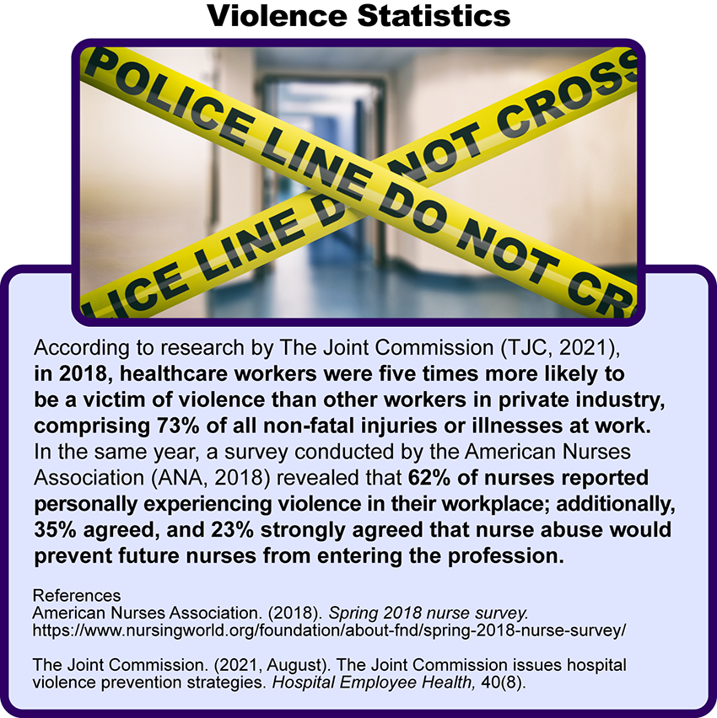

Violence Against Nurses Image Description
According to the American College of Emergency Physicians (2021), healthcare providers, especially those in the emergency department, are the recipients of up to 50% of all workplace violence. With nurses positioned on the front line of healthcare delivery 24/7, they are frequently the target of violence perpetrated by patients, families, and visitors. Although the reports of violence within the brick-and-mortar of healthcare institutions continue to rise, the actual rate of violence is believed to be much higher due to low reporting rates. Under-reporting of actions associated with violence in the workplace is a global problem within the nursing profession (Song, et al., 2021) with minimal legislation enacted globally to address the magnitude of the problem.
With an increased focus on patient satisfaction and the Hospital Consumer Assessment of Healthcare Providers and Systems (HCAHPS) scores impacting reimbursement for healthcare institutions, many nurses are reluctant, and at times fearful, of reporting acts of verbal abuse or aggression.
Click through the following slide show to view additional barriers to reporting.

Barriers to Reporting Interactive Transcript
As a DNP-prepared nurse leader, your role in addressing workplace violence will be multi-focal and should include violence prevention programs, in-services and training of staff, and policies and procedures for reporting acts of violence through collaboration with a multi-disciplinary team. Violence prevention programs may contain many facets but typically include the following:
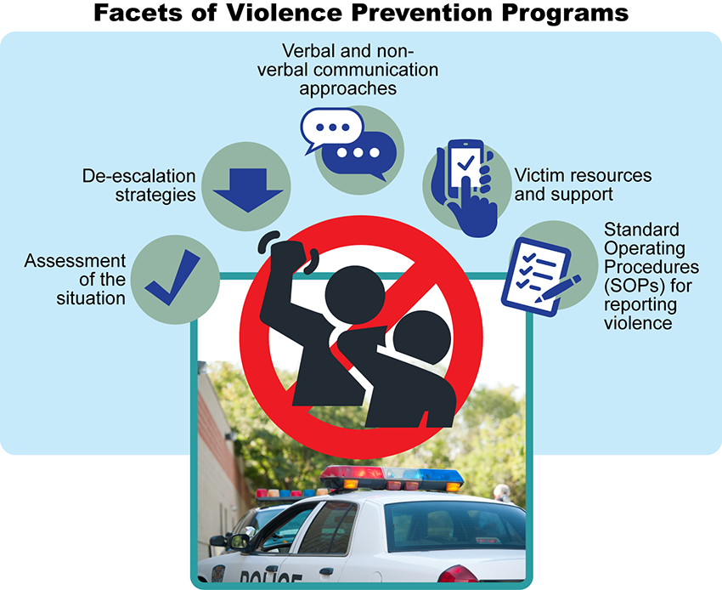

Violence Prevention Programs Image Description
Your contributions to a threat assessment team will be crucial to maintaining a safe work environment for your staff. Threat assessment teams were initially formed by the Secret Service to assess threats against the President of the United States. Threat assessment teams are multidisciplinary teams comprised of administration, safety, security, human resources, legal, risk management, and mental health professionals. A threat assessment team may serve two primary purposes:
- Assessing behavior or actions that may indicate an impending threat
- Providing training to staff on how to respond to aggressive or threatening behaviors to de-escalate a situation
Threat assessment teams can make recommendations on appropriate actions to take based on the situation and are a value-added component of a workplace prevention program.
One of the most important responsibilities of a nurse leader is to foster a culture that promotes a safe and healthy workplace in which all staff feel supported, empowered, and able to achieve their professional goals. When a team member is consumed with anxiety over their safety at work, the potential for errors in judgment can rise, giving way to medical errors and the risk for sentinel events.
Your ethical, moral, and legal responsibility will be to maintain a workplace free of behaviors that negatively impact employees or patients. You will be accountable for ensuring a clear and consistent message of intolerance to aggression and violence throughout the organization. In the absence of leadership commitment to a healthy work environment, the potential for verbal and physical violence can fester and infect the fabric of the organization until there is no semblance of respect for the welfare of others. This includes acts of bullying or incivility among or to employees, which can negatively impact the health of both patients and staff.
Click through the following interactive to review a case study.

Case Study Interactive Transcript

Violence in the Workplace: A Call to Action
Violence against nurses can arise from various sources, including patients, families, visitors, supervisors, and coworkers. When individuals are placed at risk due to the actions or behaviors of others, swift but strategic measures should be taken to mitigate all risks. As a DNP-prepared nurse leader, your team will look to you to advocate for the physical and emotional welfare of the targeted person. Hesitancy or slow responses by leadership to threats may be perceived as a sign of condoning the behavior and can result in decreased nurse satisfaction, attrition, feelings of hopelessness and isolation, fear of further acts of violence, decreased patient satisfaction, and poor patient care.
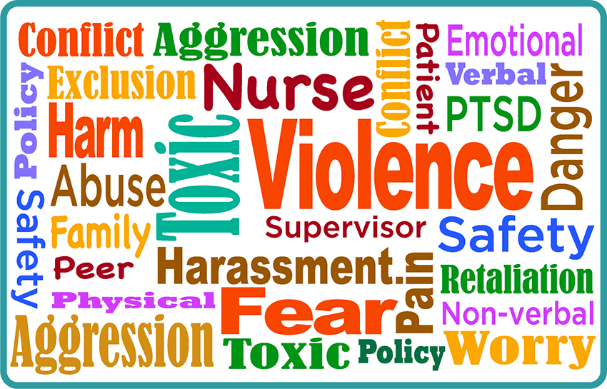
Interactions with patients and families are not the only source of threats of violence. Acts of verbal or physical violence can occur as a result of internal interactions between supervisors and staff or between coworkers. Acts of lateral or horizontal violence are certainly not new to the nursing profession but have been behaviors exhibited by nurses for decades. Although disruptive behaviors within the profession were once seen primarily from seasoned nurses against nursing students or novice nurses and referred to as “nurses eating their young,” the evolution of incivility within the nursing profession is no longer confined to this stereotype. The incidence of violence against nurses has become so abundant that in April of 2021, the United States House of Representatives passed federal legislation, H.R. 1195 Workplace Violence Prevention for Health Care and Social Service Workers Act, to protect healthcare and social service workers in hospitals and clinics. The legislation required the Department of Labor to take action to mandate (under the authority of OSHA) a safe work environment for those employed in the healthcare and social service sector.
Behaviors of aggression, hostility, humiliation, minimalization, exclusion, cynicism, and other similar conduct can significantly damage the health, self-confidence, and career trajectory of the targeted individual. Additionally, the resulting morale of the nursing unit where this behavior is perpetrated can plummet, along with the safety and quality of care of patients on the unit. Implementing a Zero Tolerance policy for workplace violence can establish a foundation for the expected behavior of and between nursing staff. While much work and research have been done related to nurse incivility, much work still needs to be done to eliminate bullying and horizontal violence in the workplace. What will you do to ensure a safe and healthy workplace, free of violence, bullying, and incivility?

References
American College of Emergency Physicians. (2021). Violence in the emergency department: Resources for a safer workplace. https://www.acep.org/administration/violence-in-the-emergency-department-resources-for-a-safer-workplace/
American Nurses Association. (2015). Incivility, bullying, and workplace violence (Position Statement). https://www.nursingworld.org/~49d6e3/globalassets/practiceandpolicy/nursing-excellence/incivility-bullying-and-workplace-violence--ana-position-statement.pdf
American Nurses Association. (2018). Spring 2018 nurse survey. https://www.nursingworld.org/foundation/about-fnd/spring-2018-nurse-survey/
Henkel, S. (2019). Threat assessment strategies to mitigate violence in healthcare. International Association for Healthcare Security and Safety Foundation. https://iahssf.org/assets/IAHSS-Foundation-Threat-Assessment-Strategies-to-Mitigate-Violence-in-Healthcare.pdf
The Joint Commission. (2021, August). The Joint Commission issues hospital violence prevention standards. Hospital Employee Health, 40(8). https://www.reliasmedia.com/articles/148309-the-joint-commission-issues-hospital-violence-prevention-standards
Occupational Health and Safety Administration. (n.d.). Health: Workplace violence. United States Department of Labor. Retrieved December 6, 2021 from https://www.osha.gov/healthcare/workplace-violence
Song, C., Wang, G., & Wu, H. (2021). Frequency and barriers of reporting workplace violence in nurses: An online survey in China. International Journal of Nursing Sciences, 8(1), 65-70. https://doi.org/10.1016/j.ijnss.2020.11.006

Workplace Violence

Discussion

Purpose
The purpose of this discussion is to explore the role of the DNP-prepared nurse in preventing workplace violence in the healthcare setting.

Instructions
Scenario: There have been increased reports of patient-perpetrated attacks in the Emergency Department. Staff morale has decreased, and there has been an increase in absenteeism as staff have been injured. As a DNP-prepared nurse and unit director, you have been asked to develop a workplace violence prevention program to address this issue.
Reflect on your readings this week and respond to the following:
- Who would be included in the development, implementation, and evaluation of the workplace violence prevention program?
- Detail the steps you would take to develop and implement a workplace violence prevention program.
Please click on the following link to review the DNP Discussion Guidelines on the Student Resource Center program page:
- Link (webpage): DNP Discussion GuidelinesLinks to an external site.

Program Competencies
This discussion enables the student to meet the following program competencies:
- Applies organizational and system leadership skills to affect systemic changes in corporate culture and to promote continuous improvement in clinical outcomes. (PO 6)
- Appraises current information systems and technologies to improve health care. (POs 6, 7)
- Analyzes health care policies to advocate for equitable health care and social justice to all populations and those at risk due to social determinants of health. (POs 2, 9)
- Creates a supportive organizational culture for flourishing collaborative teams to facilitate clinical disease prevention and promote population health at all system levels. (PO 8)
- Leads others in professional identity, advanced clinical judgment, systems thinking, resilience, and accountability in selecting, implementing, and evaluating clinical care. (POs 1, 4)

Course Outcomes
This discussion enables the student to meet the following course outcomes:
- Evaluate the attributes of effective communication practices that build collaborative relationships and balance the concerns of individuals with organizational goals. (PCs 5, 6; POs 2, 8)
- Create collaborative relationships with interprofessional and interprofessional groups to champion organizational strategies and goals. (PCs 2, 4, 5, 6; POs 2, 6, 8)
- Analyze the role of the nurse leader in financial management, human resource management, strategic management, and information management at the micro, meso, and macrosystem levels. (PCs 2, 4, 5, 6, 8; POs 2, 4, 6, 8, 9)

Due Dates
- Initial Post: By 11:59 p.m. MT on Wednesday
- Follow-Up Posts: By 11:59 p.m. MT on Sunday
Search entries or author
Filter replies by unreadUnread Collapse replies Expand replies
Subscribe
ReplyReply to Week 5: Discussion | Workplace Violence

Collapse SubdiscussionPhillis Dewitt

Phillis Dewitt
Feb 13, 2024Local: Feb 13 at 9:31am
Course: Feb 13 at 7:31am
Manage Discussion Entry
Hi everyone,
Welcome to the Week 5 discussion! The purpose of this discussion is to explore the role of the DNP-prepared nurse in preventing workplace violence in the healthcare setting.

This discussion enables you to meet the following course and program outcomes:
1. Evaluate the attributes of effective communication practices that build collaborative relationships and balance the concerns of individuals with organizational goals. (POs 2, 8)
2. Create collaborative relationships with interprofessional and intraprofessional groups to champion organizational strategies and goals. (POs 2, 6, 8)
3. Analyze the role of the nurse leader in financial management, human resource management, strategic management, and information management at the micro, meso, and macrosystem levels. (POs 2, 4, 6, 8, 9)
Please review the discussion grading guidelines and support your post with scholarly references.

