Week 5 730

Student Lesson Plan

Overview
- Program Competencies
- Course Outcomes
- Weekly Objectives
- Main Concepts
- Integrates scientific underpinnings into everyday clinical practice. (POs 3, 5)
- Applies organizational and system leadership skills to affect systemic changes in corporate culture and to promote continuous improvement in clinical outcomes. (PO 6)
- Uses analytic methods to translate critically appraised research and other evidence into clinical scholarship for innovative practice improvements. (POs 3, 5)
- Appraises current information systems and technologies to improve health care. (POs 6, 7)
- Analyzes health care policies to advocate for equitable health care and social justice to all populations and those at risk due to social determinants of health. (POs 2, 9)
- Creates a supportive organizational culture for flourishing collaborative teams to facilitate clinical disease prevention and promote population health at all system levels. (PO 8)
- Leads others in professional identity, advanced clinical judgment, systems thinking, resilience, and accountability in selecting, implementing, and evaluating clinical care. (POs 1, 4)

Schedule
Section | Read/Review/Complete | Course Outcomes | Due
Prepare | Assigned Readings | COs 1, 2 | Wednesday
Explore | Lesson | COs 1, 2 | Wednesday
Translate to Practice | Discussion: Initial Post | COs 1, 2 | Wednesday
Translate to Practice | Discussion: Follow-Up Posts | COs 1, 2 | Sunday
Translate to Practice | Assignment | COs 1, 2, 3 | Sunday
Reflect | Reflection | COs 1, 2 | No submission

Foundations for Learning
American Association of Colleges of Nursing. (2006). The essentials of doctoral education for advanced nursing practice.Links to an external site. https://www.aacnnursing.org/DNP/DNP-Essentials (Note: These Essentials outline the foundational competencies of advanced nursing practice for the DNP.)
Chamberlain University. (2021). Chamberlain University: Institutional review board.Links to an external site. https://www.chamberlain.edu/about/leadership/institutional-review-board

Student Learning Resources
Click on the following tabs to view the resources for this week.
- Required Textbooks
- Required Articles
- Additional Resources
Roush, K. (2019). A nurse’s step-by-step guide to writing a dissertation or scholarly project (2nd ed.). Sigma Theta Tau International.
- Read Chapter 3
  - Section: Ethical Considerations and Consent
  - Section: Writing a Consent Form

Learning Success Strategies
- Review the assigned readings to ensure you understand the key terms and can relate them to the role of the DNP-prepared nurse.
- As you review weekly content, consider how each concept and discussion can be translated into practice in your unique setting.
- Be ready to share your thoughts through the interactive discussion. It is important to share your own thoughts so that we hear your voice. Also, support your positions with evidence from the literature. Growing in your ability to share your ideas is encouraged, and the use of first-person is accepted for the discussion board.
- Review the discussion guidelines and rubric to optimize your performance.
- You have access to a variety of resources to support your success. Click on the DNP Resources tab on the home page to access program and project resources.
- Your course faculty is here to support your learning journey. Reach out for guidance with study strategies, time management, and course-related questions. Review rubric feedback and individual comments to optimize performance.
- Let's Check-In: Tips for Success are available several weeks throughout the course. Check announcements and please listen to the recording posted in the announcements if unable to attend.
- Your revised DNP Practicum Readiness Form is due at the end of this week. Be sure to integrate the feedback from course faculty into your revisions.
- The Human Subjects Research Course CITI training is due at the end of Week 6. You may begin working on this training at any time, as it takes approximately 6-12 hours to complete the required training. You may start and stop the training as your schedule permits.

Interacting with Feedback
Each week your course faculty will provide feedback in the rubric on any assignment you have submitted. Take a moment to review the following video on how to view rubric feedback in Canvas. (After clicking the link, scroll down or click on the title in the Summary area to jump directly to the video.)
- Link (video): Looking at FeedbackLinks to an external site. (2:26)
Review the following video on how to accept/reject track changes when viewing course faculty feedback on your assignment:
- Link (video): Word: Track Changes and Comments (4:19)

Lesson
The Ethical and Legal Aspects of Practice Change

The Protection of Human Rights
As a professional nurse, you are familiar with the legal and ethical requirements of protecting the privacy of patient information and the compliance guidelines as stated in the Health Insurance Portability and Accountability Act (HIPAA) of 1996. HIPAA was established to protect the confidentiality, integrity, and disclosure of personal health information, thereby protecting the privacy of patient health data.
Similarly, there exist regulations and responsibilities to protect the rights of individuals involved in human subjects research. The need for more formal guidelines to govern research evolved during the Nuremberg War Crime Trials following World War II. In 1979, The Belmont Report was written to provide ethical guidelines for individuals conducting research and to ensure the protection of human subjects involved in the research process. The Belmont Report is guided by three ethical principles:
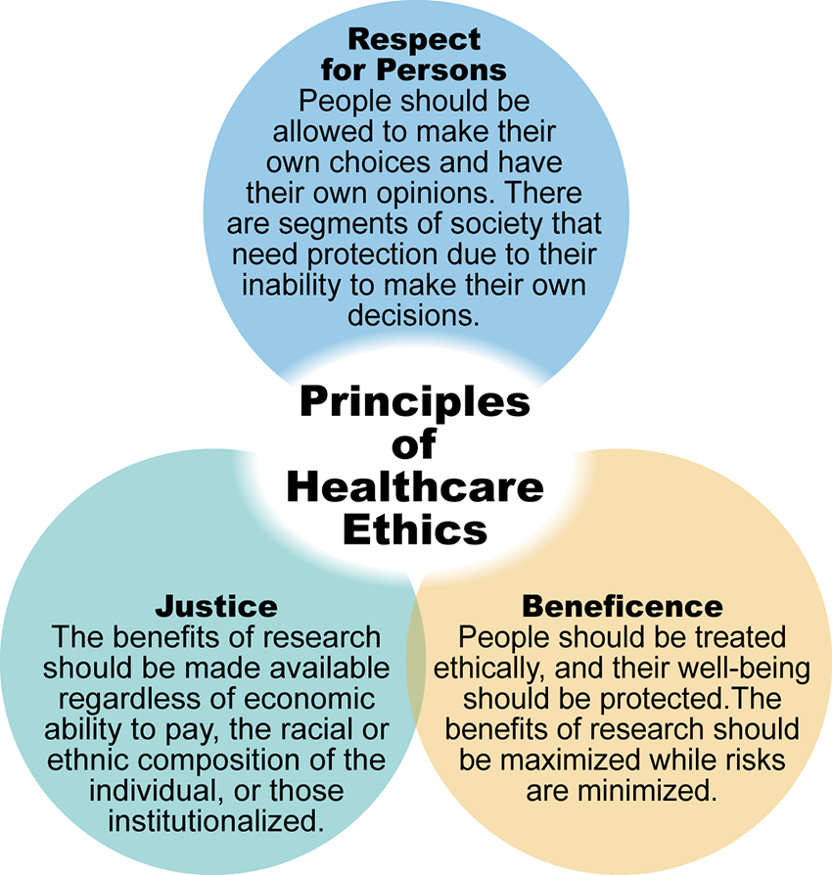

Ethical Principles Image Description
Although as a DNP student you will not be conducting primary human subjects research, you will be implementing an evidence-based DNP practice change project that will involve human participants. These participants may be patients, family members, nurses, providers, or other individuals. The same protection should be provided to participants of your DNP practice change project, as those who participate in primary research. Participants must have a full understanding of the scope of the DNP practice change project, benefits, risks, and consequences if the participant decides to leave the project before it is completed. One way to communicate this information is through a consent form. Depending on the focus of your intervention, an informed consent form may be required for your DNP practice change project.
As a requirement and to prepare you for implementing your DNP practice change project, you will complete training provided by the Collaborative Institute Training Initiative (CITI).

CITI Training Content Areas

Your CITI training will include the following content areas:
- History of human subjects protections
- Ethical codes and regulations governing the protection of human subjects
- Basic definitions of human subjects protection terminology, including human subjects, research, informed consent, assent, identifiable private information, vulnerable populations, and minimal risk
- Evaluation of risks to human subjects and how to minimize risks
- Procedures to obtain and ensure informed consent
- The role and responsibilities of institutional review boards (IRBs)
- Oversight of the conduct of human subjects research
The CITI training will provide you with a foundation for ethical and responsible practices as you prepare to develop, implement, and evaluate your DNP practice change project.
Click on the following hourglass and take a moment to reflect on the statement.

Time to Pause Interactive Transcript

The Role of the Institutional Review Board (IRB)

An institutional review board (IRB) is a committee created to protect human subjects participating in research and to ensure that all research studies are conducted in compliance with federal, institutional, and ethical standards and requirements. The Chamberlain University IRB is registered with the Office for Human Research Protections of the U.S. Department of Health and Human Services and is responsible for reviewing all applicable research studies conducted by members of the Chamberlain community, including administrators, faculty, and students.
Although you will not be conducting research, regardless of the focus of your DNP practice change project, you will be required to receive a pre-screening determination by the Chamberlain IRB that the DNP practice change project does not constitute human subjects research. A thorough review of the proposed DNP practice change project is completed to ensure the protection of human participants, protected health information, or health data during the implementation and evaluation of the DNP practice change project. DNP student practice change projects are not considered approved until a pre-screening determination has been made by the Chamberlain IRB. DNP practice change projects may go through several revisions before final approval is received.
In addition to the Chamberlain IRB, the identified practicum site may also require IRB approval before the approval and implementation of a DNP practice change project. Because each practicum site has specific internal requirements for the implementation of a quality improvement or translation science project, you will need to determine the approval process at your practicum site. You must have approval from both Chamberlain University College of Nursing and your practicum site before any components of your project can be implemented. If your practicum site does not require IRB approval, a letter of authorization to implement your DNP practice change project and to collect data will be needed.

Important

Stop and take a moment to reflect on the following information:
Remember, you may not implement any component of your DNP practice change project until you have IRB approval from both Chamberlain University College of Nursing and your practicum site. It is important to discuss the process with your practicum site early, so you are aware of the requirements.

The Ethical and Legal Aspects of Practice Change

Discussion

Purpose
The purpose of this assignment is to examine the ethical responsibilities of a DNP-prepared nurse when implementing practice change.

Instructions
Reflect on your readings this week and respond to the following:
- Identify the participants of your proposed DNP practice change project as stated in your PICOT question.
- Examine the benefits and risks for the participants of your DNP practice change project.
- Detail the measures you will take to protect their human rights.
Please click on the following link to review the DNP Discussion Guidelines on the Student Resource Center program page:
- Link (webpage): DNP Discussion GuidelinesLinks to an external site.

Program Competencies
This discussion enables the student to meet the following program outcomes:
- Integrates scientific underpinnings into everyday clinical practice. (POs 3, 5)
- Applies organizational and system leadership skills to affect systemic changes in corporate culture and to promote continuous improvement in clinical outcomes. (PO 6)
- Uses analytic methods to translate critically appraised research and other evidence into clinical scholarship for innovative practice improvements. (POs 3, 5)
- Appraises current information systems and technologies to improve health care. (POs 6, 7)
- Analyzes health care policies to advocate for equitable health care and social justice to all populations and those at risk due to social determinants of health. (POs 2, 9)
- Creates a supportive organizational culture for flourishing collaborative teams to facilitate clinical disease prevention and promote population health at all system levels. (PO 8)
- Leads others in professional identity, advanced clinical judgment, systems thinking, resilience, and accountability in selecting, implementing, and evaluating clinical care. (POs 1, 4)

Course Outcomes
This discussion enables the student to meet the following course outcomes:
- Prioritize and apply ethical considerations and theories relevant to translation science. (PCs 1, 3, 8; POs 3, 4, 5)
- Apply clinical scholarship methodologies for designing, developing, implementing, and evaluating quality improvements and the translation of evidence-based practice, to improve healthcare outcomes at the micro, meso, or macrosystem level. (PCs 1, 3, 5; POs 3, 5, 9)

Due Dates
- Initial Post: By 11:59 p.m. MT on Wednesday
- Follow-Up Posts: By 11:59 p.m. MT on Sunday
Search entries or author
Filter replies by unreadUnread Collapse replies Expand replies
Subscribe
ReplyReply to Week 5: Discussion | The Ethical and Legal Aspects of Practice Change

Feb 27, 2024Local: Feb 27 at 5:36pm
Course: Feb 27 at 3:36pm
Manage Discussion Entry
Hello class and welcome to the Week 5 discussion. This discussion enables the student to meet the following course outcomes:
  - Prioritize and apply ethical considerations and theories relevant to translation science. (POs 3, 4, 5)
  - Apply clinical scholarship methodologies for designing, developing, implementing, and evaluating quality improvements and the translation of evidence-based practice, to improve healthcare outcomes at the micro, meso, or macrosystem level. (POs 3, 5, 9)
Reflect on your readings this week and respond to the following:
  - Identify the participants of your proposed DNP practice change project as stated in your PICOT question.
  - Examine the benefits and risks for the participants of your DNP practice change project.
  - Detail the measures you will take to protect their human rights.

