Week 2Student Lesson Plan

Overview
- Program Competencies
- Course Outcomes
- Weekly Objectives
- Main Concepts
- Integrates scientific underpinnings into everyday clinical practice. (POs 3, 5)
- Uses analytic methods to translate critically appraised research and other evidence into clinical scholarship for innovative practice improvements. (POs 3, 5)
- Appraises current information systems and technologies to improve healthcare. (POs 6, 7)
- Analyzes healthcare policies to advocate for equitable healthcare and social justice to all populations and those at risk due to social determinants of health.
- Leads others in professional identity, advanced clinical judgment, systems thinking, resilience, and accountability in selecting, implementing, and evaluating clinical care.

Schedule
Section | Read/Review/Complete | Course Outcomes | Due
Prepare | Assigned Readings | COs 2, 3 | Wednesday
Explore | Lesson | COs 2, 3 | Wednesday
Translate to Practice | Discussion: Initial Post | CO 3 | Wednesday
Translate to Practice | Discussion: Follow-Up Posts | CO 3 | Sunday
Translate to Practice | Assignment | COs 2, 3 | Sunday
Reflect | Reflection | COs 2, 3 | No submission

Foundations for Learning
Bilik, O., Kankaya, E. A., & Deveci, Z. (2020). Effects of web-based concept mapping education on students’ concept mapping and critical thinking skills: A double blind, randomized, controlled study.Links to an external site. Nurse Education Today, 86, 104312–104312. https://doi.org/10.1016/j.nedt.2019.104312
Institute for Healthcare Improvement. (2021). Home page.Links to an external site. http://www.ihi.org/Pages/default.aspx

Student Learning Resources
Click on the following tabs to view the resources for this week.
- Required Textbooks
- Required Articles
- Additional Resources
Harris, J, Roussel, L., Dearman, C., & Thomas, P. (2020). Project planning and management: A guide for nurses and interprofessional teams (3rd ed.). Jones & Bartlett.
- Read Chapters 1, 5
Waxman, K. T., & Knighten, M. L. (2023). Financial and business management for the Doctor of Nursing Practice (3rd ed.). Springer Publishing Company.
- Read Chapter 13

Learning Success Strategies
- Review the assigned readings to ensure you understand the key terms and can relate them to the changing and evolving roles of the DNP-prepared nurse.
- As you review weekly content, consider how each concept and discussion can be translated into practice at your unique setting.
- Importantly, consider the Global Burden of Disease and National Practice Problems facing us every day in our healthcare settings. You will begin to consider your ability to bring forward practice changes as you search for research solutions.
- Be ready to share your thoughts through the interactive discussion. It is important to share your own thoughts so that we hear your voice. Also, support your positions with evidence from the literature. Growing in your ability to share your ideas is encouraged, and the use of first person is accepted for the discussion board.
- Review the discussion guidelines and rubric to optimize your performance.
- You have access to a variety of resources to support your success. Click on the DNP Resources tab on the home page to access program and project resources.
- Your course faculty is here to support your learning journey. Reach out for guidance with study strategies, time management, and course-related questions.
- The Organizational Needs Assessment assignment is due this week by Sunday at 11:59 pm MT.

Interacting with Feedback
Each week your course faculty will provide feedback in the rubric on any assignment you have submitted. Take a moment to review the following video on how to view rubric feedback in Canvas. (After clicking the link, scroll down or click on the title in the Summary area to jump directly to the video.)
- Link (video): Looking at FeedbackLinks to an external site. (2:26)
Review the following video on how to accept/reject track changes when viewing course faculty feedback on your assignment:
- Link (video): Word: Track Changes and Comments

Lesson 1
Project Management

Introduction to Project Management
Project management refers to the methodology used to achieve the goals of a project (Harris et al., 2020). There are several systems of project management and determining which is most appropriate is based on the type of project, the desired outcome, and the preferences of the organization. The project management system acts as a road map to direct the activities of the team in design, development, and implementation of a project.

Project Management Body of Knowledge Guide
The Project Management Institute (PMI®) is a professional organization that works to further the profession of project managers and standardize methodologies and is presented in the Project Management Body of Knowledge Guide (PMBOK® Guide, 2021). The PMBOK® Guide views a project as an overlapping set of tasks that seek to accomplish a goal using the resources available within established constraints. These tasks fall within five categories:
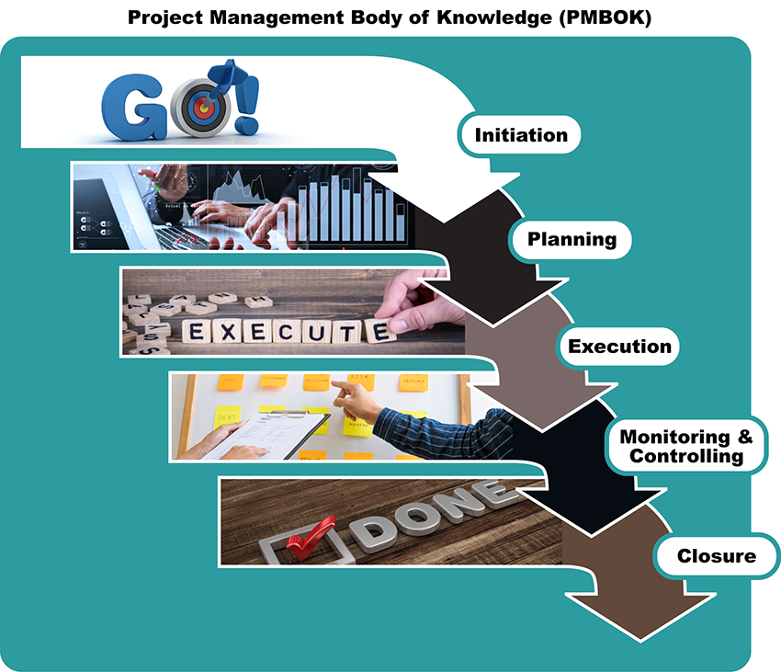

PMBOK Image Description
The PMBOK® Guide involves creating a matrix of the five categories of tasks.

Critical Chain Management
Critical chain management focuses on avoiding bottlenecks or project breakdowns caused by the failure of a component that keeps others from proceeding until that task is accomplished. One example of this is building the foundation before a house can be built. Critical Chain Management is often used to analyze and improve ongoing operations but may be useful in implementing a project, especially if the current project is similar to prior efforts and the team hopes to avoid repeating the same problems. Critical chain theory has, over time, incorporated several lean management theories of project management. These theories look to eliminate waste in all forms by not only avoiding bottlenecks, but also through the standardization of tasks, as well as assignment to the most appropriate entity and accountability for specialized task completion. One example of this is Six Sigma, which analyzes processes to look for opportunities for standardization of repetitive processes and eliminate the duplication of efforts (American Society for Quality, 2021). Lean Six Sigma has a series of defined sub-goals, all of which interrelate to move toward accomplishing the desired ultimate outcome.
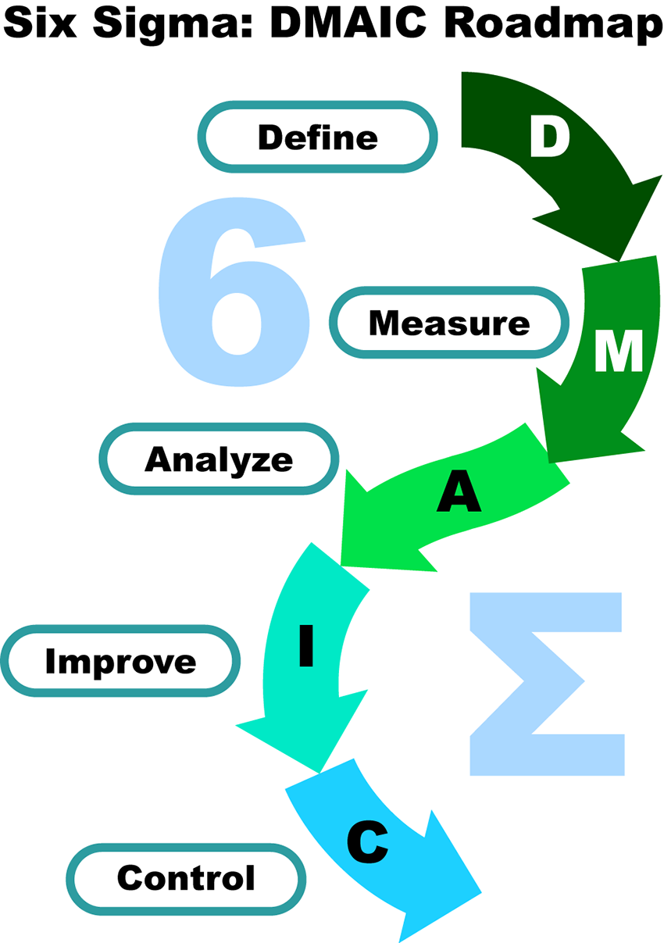

Lean Six Sigma DMAIC Image Description

Benefits Realization Management
Benefits realization management (Project Management Institute, 2019) focuses on the goal(s) rather than products or outputs and is usually tied to specific measures that determine if a project is on track and ultimately is successful. This theory is less concerned with how a goal is accomplished and is extremely useful when dealing with motivated professionals who work with a significant amount of autonomy. This type of management promotes creativity and innovation as it does not limit the various team members in their approach to the situation but instead simply defines the goal to be accomplished. The goals, rather than a specific product or identifiable item, are instead stated and evaluated in relation to the benefits obtained. Thus, instead of worrying about how an electronic medical record system is built and operates, evaluation may include whether the records were appropriately input and could be accessed as needed.
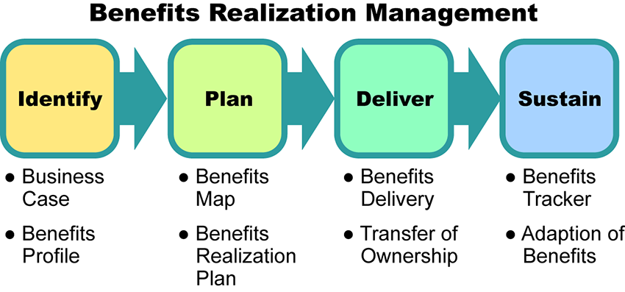

Benefits Realization Management Image Description
Most projects will include a blend of various project management methods. After the project plan is created, minor modifications may be added to meet the needs of the organization. The common element is that all project management systems are a framework designed to aid in the accomplishment of the team's objectives and need not be rigidly adhered to if some aspect is unduly burdensome or provides no benefit in relation to the effort expended.

Note
PMP, PMBOK, and PMI are registered marks of Project Management Institute, Inc.

Lesson 2
Project Initiation

Project Initiation and Scope
As you begin planning your DNP practice change project, consider each of the elements in the following graphic.
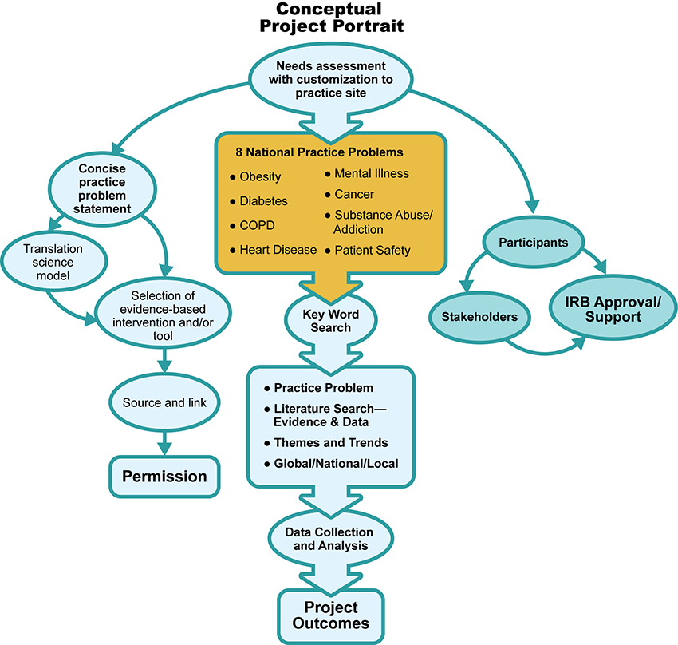

Concpetual Project Portrait Image Description
After conducting a thorough needs assessment to justify a project, the next step is the development of the project charter. The project charter should clarify the goals and scope of the project, reporting process, responsibilities, timeframe, resources, and measures of success (Smith & Johnson, 2019). The project charter is a living document that can be updated as the project progresses.
View the following video to discover how to begin a project.
Project Initiation and Scope (4:18)

Project Management Case Study
View the following case study to discover project initiation tips:

Case Study Interactive Transcript

Lesson 3
Evidence Synthesis Review

Synthesis of Research
As you incorporate published research findings into your writing, you aim to create a synthesis from the multiple studies you gather about a practice problem. Before learning how to write a synthesis, it is important to define this term. At its most basic level, a synthesis involves combining two or more summaries. Synthesis writing is more difficult than it might first appear because this combination must be done in a meaningful way.
A synthesis requires critical reading and thinking to compare different sources, highlighting similarities, differences, and connections. As a DNP-prepared nurse, when you synthesize successfully, you can present new ideas based on interpretations of published research evidence. Conceptually, it can be helpful to think about synthesis at both the local (or paragraph) level and the global (or paper) level. A synthesis is a discussion that presents facts related to a practice problem in an objective manner. A synthesis infers relationships among two or more research studies. A synthesis does not go much beyond what is obvious from a careful reading of the studies. Simply writing a summary of one study after another is not a synthesis. If you are using direct quotes, this is a warning sign you may have strayed from synthesis.
Before developing a synthesis, the best available evidence must be identified and presented to address a practice problem. The Johns Hopkins Individual Summary Tool is a fluid document where you will systematically add evidence and create an ongoing list of research articles. This is a table of articles identifying key points as well as research findings, sample sizes, limitations, and grade and quality of evidence. Using information from the Johns Hopkins Summary Table will help you identify key research concepts related to your practice problem.
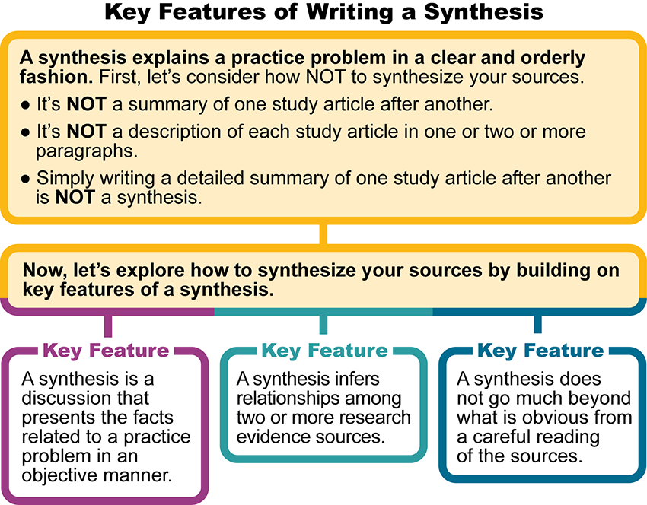

Key Features of Writing a Synthesis Image Description
Let's look at the summary, analysis, and synthesis process more closely. Click on the following tabs to learn about each step:

Summary, Analysis, & Synthesis Interactive Transcript

Summary, Analysis, & Synthesis Process
Summary
Analysis
Synthesis
Summary

The Johns Hopkins Individual Evidence Summary Tool assists you with documenting the main points of each research study. The transfer of findings from the Johns Hopkins Research Appraisal Tool to the Johns Hopkins Individual Evidence Summary Tool captures important details about individual studies. The eleven columns guide you to ensure that you record important details about individual research studies. This process is referred to as a summary.

References
American Society for Quality. (2021). Quality resources. https://asq.org/quality-resources/articles/search#q=six%20sigma
Dang, D., & Dearholt, S., Bissett, K., Ascenzi, J., Whalen, M. (2022). Johns Hopkins evidence-based practice for nursing and healthcare professionals (4th ed.). Sigma Theta Tau International.
Project Management Institute. (2019). Benefits realization management: A practice guide. Project Management Institute. https://www.pmi.org/pmbok-guide-standards/practice-guides/benefits-realization
Project Management Institute. (2021). The standard for project management and a guide to the project management body of knowledge (PMBOK® guide) (7th ed.). Project Management Institute.
Smith, C. M. & Johnson, C. S. (2019). Preparing nurse leaders in nursing professional development. Journal for Nurses in Professional Development, 35(3), 160-162. https://doi.org/10.1097/NND.0000000000000549

Project Scope

Discussion

Purpose
The purpose of this discussion is to explore the scope of the DNP project. Scope is the backbone of any project and must be accurately assessed by the project manager. When issues occur during a project, it is frequently related to the scope. A well-defined goal helps keep everyone on track.

Instructions
Reflect upon your readings and personal or professional experience and address the following:
- Describe how issues that occur during a project are frequently related to the scope.
- Examine how poorly defined project scope statements are often linked to project problems or even to failed projects.
- Propose strategies to manage scope creep.
Please click on the following link to review the DNP Discussion Guidelines on the Student Resource Center program page:
- Link (webpage): DNP Discussion GuidelinesLinks to an external site.

Program Competencies
This discussion enables the student to meet the following program competencies:
- Integrates scientific underpinnings into everyday clinical practice. (POs 3, 5)
- Uses analytic methods to translate critically appraised research and other evidence into clinical scholarship for innovative practice improvements. (POs 3, 5)
- Appraises current information systems and technologies to improve healthcare. (POs 6, 7)

Course Outcomes
This discussion enables the student to meet the following course outcomes:
- Develop strategies to lead project planning, implementation, management, and evaluation to promote high value healthcare. (PCs 1, 3, 4; POs 3, 5, 7)

Due Dates
- Initial Post: By 11:59 p.m. MT on Wednesday
- Follow-Up Posts: By 11:59 p.m. MT on Sunday
Search entries or author
Filter replies by unreadUnread Collapse replies Expand replies
Subscribe
ReplyReply to Week 2: Discussion | Project Scope

Apr 19, 2024Local: Apr 19 at 8:43am
Course: Apr 19 at 6:43am
Manage Discussion Entry
Class,
Welcome to our Week 2 Discussion! After taking time to read Chapter 1 in Harris et al. (2020) and spending time in our lessons, you are ready for the discussions.
This week we focus on project scope and the effects of scope creep on project outcomes. We will also discuss strategies to manage scope creep.
Our interactive discussion addresses the following course outcomes:
  - CO 2 Formulate a needs-based organizational assessment to inform strategic leadership decision-making. (POs 3, 5, 7)
  - CO 3 Develop strategies to lead project planning, implementation, management, and evaluation to promote high-value healthcare. (POs 3, 5, 7)
Remember that your initial post needs to be completed by Wednesday 11:59 pm MT

Organizational Needs Assessment

Assignment

Purpose
The identification of a significant practice problem and associated project need are the cornerstone of a practice change project. The purpose of this assignment is to conduct an organizational needs assessment. The formulation of a comprehensive organizational needs assessment supports the professional formation of the DNP-prepared nurse. To complete the assessment of the organizational need, you will need to interview a key decision-maker at the practicum site.

Instructions
To create flexibility, we are providing options on this assignment. For this assignment, each of the sections can be presented either as a narrative or as a concept map. Concept maps are an effective way to express complex ideas, especially for visual learners.
Please note that you are not required to complete any or all sections as a concept map. If you choose to use a concept map for a section, it should be created in Microsoft Word and placed in that section of your paper. The concept map must meet all the requirements of the assignment rubric for that section. The rubric and page length requirements of the paper are the same whether you complete the sections of this assignment as a narrative or as a concept map.

Concept Map Resources
If you need additional information on concept maps and how to create a concept map in Microsoft Word, review the following videos:
- Link (video): Microsoft Word: Creating a Flowchart, Concept Map, or Process MapLinks to an external site. (4:03)
Concept Map (2:48)

Additionally, review the conceptual maps section in the current APA manual.
Follow these guidelines when completing each component of this assignment. Contact your course faculty if you have questions.
- Use the most current version of the APA formatted Microsoft Word document for the DNP Program. The document is located in Student resources and saved as a Microsoft Word Document and will end in "docx."
- All Chamberlain University policies related to plagiarism must be observed.
- Review the rubric for the grading criteria.
The assignment includes the following components:
- Title Page
  - Title of the paper
  - Student name
  - Chamberlain University College of Nursing
  - Course number and course name
  - Session month and year
- Introduction
  - Start your introduction with a powerful purpose statement or two to stimulate interest.
  - Introduce the practice problem or need.
  - Provide a preview of what the paper will include with a strong thesis sentence.
- Identification of the Practice Problem or Need
  - Describe the practice problem or need.
  - Discuss how the practice problem or need was determined.
  - Briefly summarize the evidence in the literature which is focused on the practice problem and builds a compelling case for the practice problem. using in-text citations/ and references, to support the need for change.
  - A minimum of 3 current (within 5 years) research articles from peer-reviewed journals are required. The three research articles must support the significance and compelling nature of the practice problem. Non-research data can also be added to the 3 articles to support the compelling nature of the practice problem. (Examples of sources of non-research data are the CDC, state or county Health Department, Kaiser Family Foundation, AHRQ.)
  - Describe the source of the evidence or data at the practicum site to support the need for change at the practicum site. This may be the infection rate, obesity prevalence, or diabetic patients with A1C of 7 or higher, for example. This evidence might also be from a conversation with the organizational leader. State the source of the data that supports this need at the practicum site.
- Identification of Stakeholders (Stakeholders have some form of stake or interest in the project outcomes.)
  - Identify (state explicitly) key stakeholders who will support the change.
  - Identify (state explicitly) key stakeholders who may resist the change.
  - Identify (state explicitly) stakeholders who will have the most influence on positive or negative changes related to your identified problem.
- Gap Analysis Table
  - Complete the gap analysis table, which can be downloaded at the following link:
    - Link (Word doc): Gap Analysis TemplateLinks to an external site.
  - Include the table in your paper. Review the following instructions on how to copy a table in Word:
    - Link (webpage): Move or Copy a TableLinks to an external site.
  - Answer all of the questions completely and separately. Do not combine answers.
    - What is currently happening at the practicum site?
    - What should be happening at the practicum site based on current evidence?
    - What is your practice gap? (state what is currently happening and state what should be happening)
    - Why is there a practice gap?
    - What factors are contributing to the practice gap?
    - What evidence do you have to demonstrate there is a practice gap?
- Conclusion
  - Write one concise paragraph, providing a clear and logical summation of the paper.
  - Summarize the main points from the needs assessment section above. (New information should not be included in the conclusion)
- APA Standards and References
  - Use appropriate Level I headers.
  - Create the reference page with a minimum of three current (within 5 yrs) peer-reviewed journal articles.
  - References and citations are in current APA style.
  - Each reference has a matching citation.

Writing Requirements (APA format)
- 1-inch margins
- Double-spaced pages
- 12-point Times New Roman font or 11-point Arial
- Headings & subheadings
- In-text citations
- Title page
- References page
- Standard English usage and mechanics

Program Competencies
This discussion enables the student to meet the following program competencies:
- Integrates scientific underpinnings into everyday clinical practice. (POs 3, 5)
- Uses analytic methods to translate critically appraised research and other evidence into clinical scholarship for innovative practice improvements. (POs 3, 5)
- Appraises current information systems and technologies to improve healthcare. (POs 6, 7)
- Analyzes healthcare policies to advocate for equitable healthcare and social justice to all populations and those at risk due to social determinants of health.
- Leads others in professional identity, advanced clinical judgment, systems thinking, resilience, and accountability in selecting, implementing, and evaluating clinical care.

Course Outcomes
This assignment enables the student to meet the following course outcomes:
- Examine the role of the DNP-prepared nurse in leading financial planning and management across healthcare settings. (PCs 5, 8; POs 2, 4, 9)
- Formulate a needs-based organizational assessment to inform strategic leadership decision-making. (PCs 1, 3, 4; POs 3, 5, 7)
- Develop strategies to lead project planning, implementation, management, and evaluation to promote high value healthcare. (PCs 1, 3, 4; POs 3, 5, 7)

Due Date
- By 11:59 p.m. MT on Sunday
- Late Assignment Policy applies

Rubric
Week 2 Assignment Grading Rubric
Week 2 Assignment Grading Rubric
Criteria | Ratings | Pts
This criterion is linked to a Learning OutcomeIntroduction  Requirements:  1. Start your introduction with a powerful purpose statement to stimulate interest.  2. Introduce the practice problem or need.  3. Provide a preview of what the paper will include with a strong thesis sentence. |  | 20 pts
  20 pts  Includes all requirements and provides an in-depth introduction. | 18 pts  Includes all requirements and provides a sufficient introduction. | 16 pts  Includes 2 requirements and/or provides a partial introduction. | 0 pts  Provides an undeveloped introduction.
This criterion is linked to a Learning OutcomeIdentification of the Practice Problem or Need  Requirements:  1. Describe the practice problem or need.  2. Discuss how the practice problem or need was determined.  3. Briefly summarize the evidence in the literature which is focused on the practice problem and builds a compelling case for the practice problem.  4. A minimum of 3 current (within 5 years) research articles from peer-reviewed journals are required. The three research articles must support the significance and compelling nature of the practice problem. Non-research data can also be added to the 3 articles to support the compelling nature of the practice problem. (Examples of sources of non-research data are the CDC, state or county Health Department, Kaiser Family Foundation, AHRQ.)  5. Describe the source of the evidence or data at the practicum site to support the need for change at the practicum site. (This may be the infection rate, obesity prevalence, or diabetic patients with A1C of 7 or higher, for example. This evidence might also be from a conversation with the organizational leader. State the source of the data that supports this need at the practicum site.) |  | 25 pts
  25 pts  Includes all requirements and an provides an in-depth discussion about the practice problem or need. | 23 pts  Includes at least 4 requirements and/or provides a sufficient discussion about the practice problem or need. | 20 pts  Includes at least 3 requirements and/or provides a partial discussion about the practice problem or need. | 0 pts  Provides an undeveloped discussion about the practice problem or need.
This criterion is linked to a Learning OutcomeStakeholders  Requirements:  1. Identify (state explicitly) key stakeholders who will support the change.  2. Identify (state explicitly) key stakeholders who may resist the change.  3. Identify (state explicitly) stakeholders who will have the most influence on positive or negative changes related to your identified problem. |  | 20 pts
  20 pts  Includes all requirements and provides an in-depth evaluation of stakeholders. | 18 pts  Includes at least 2 requirements and/or provides a sufficient evaluation of stakeholders. | 16 pts  Includes at least 1 requirements and/or provides a partial evaluation of stakeholders. | 0 pts  Provides an undeveloped evaluation of stakeholders.
This criterion is linked to a Learning OutcomeGap Analysis  Requirements:  1. Embed the completed gap analysis table in your paper. Please answer all of the questions separately. Do not combine answers.  2. What is currently happening at the practicum site?  3. What should be happening at the practicum site based on current evidence?  4. What is your practice gap ? (State what is currently happening and what should be happening.)  5. Why is there a practice gap ?  6. What factors are contributing to the practice gap?  7. What evidence do you have to demonstrate there is a practice gap? |  | 25 pts
  25 pts  Includes all requirements of the gap analysis and provides an in-depth gap analysis table presentation. | 23 pts  Includes at least 6 requirements of the gap analysis and/or provides a sufficient gap analysis table presentation. | 20 pts  Includes at least 5 requirements of the gap analysis and/or provides a partial gap analysis table presentation. | 0 pts  Provides an undeveloped gap analysis table presentation.
This criterion is linked to a Learning OutcomeConclusion  Requirements:  1. Write one concise paragraph, providing a clear and logical summation of the paper.  2. Summarize the main points from the needs assessment section above. |  | 20 pts
  20 pts  Includes all requirements and provides an in-depth summary in the conclusion. | 18 pts  Includes all requirements and provides a sufficient summary in the conclusion. | 16 pts  Includes at least 1 requirement and provides a partial summary in the conclusion. | 0 pts  Provides an undeveloped summary of the main points in the needs assessment in the conclusion.
This criterion is linked to a Learning OutcomeAPA Style and Standards  Requirements:  1. Uses appropriate Level I headers.  2. Create the reference page with a minimum of three (3) current (within 5 yrs) peer-reviewed journal articles.  3. References and citations are in current APA style.  4. Each reference has a matching citation. |  | 10 pts
  10 pts  Includes all requirements of APA style and standards. | 9 pts  Includes 3 requirements of APA style and standards. | 8 pts  Includes 2 requirements of APA style and standards. | 0 pts  Includes 1 requirement of APA style and standards.
This criterion is linked to a Learning OutcomeClarity of Writing  Requirements:  1. Standard English grammar and sentence structure  2. No spelling or typographical errors  3. Organized presentation of ideas |  | 10 pts
  10 pts  Includes all requirements of clarity of writing. | 9 pts  Includes 2 requirements of clarity of writing. | 8 pts  Includes 1 requirement of clarity of writing. | 0 pts  Includes fewer than all requirements and/or demonstrates poor clarity of writing.
Total Points: 130
PreviousNext

This week, you discovered that it is important to utilize all the steps of the project management process when leading a change in practice. Using a comprehensive approach is required to implement successful change and foster outcome improvement while improving the cost components of care. You began the week by reviewing the steps of the project management process. You also gained insight into the importance of carefully considering the scope of the change project. Don’t make the same mistake that other healthcare leaders commonly make by forgetting this step. Deciding and agreeing upon the work to be done are among the most important aspects of any project. DNP-prepared nurses are making a significant impact on the quality and effectiveness of healthcare systems through their contributions in fostering outcome improvement. Your work is needed to help move the needle forward! So, let’s keep going!

