WK-3

Student Lesson Plan

Overview
- Program Competencies
- Course Outcomes
- Weekly Objectives
- Main Concepts
- Integrates scientific underpinnings into everyday clinical practice. (POs 3, 5)
- Uses analytic methods to translate critically appraised research and other evidence into clinical scholarship for innovative practice improvements. (POs 3, 5)
- Appraises current information systems and technologies to improve healthcare. (POs 6, 7)
- Analyzes healthcare policies to advocate for equitable healthcare and social justice to all populations and those at risk due to social determinants of health. (POs 2, 9)
- Leads others in professional identity, advanced clinical judgment, systems thinking, resilience, and accountability in selecting, implementing, and evaluating clinical care. (POs 1, 4)

Schedule
Section | Read/Review/Complete | Course Outcomes | Due
Prepare | Assigned Readings | COs 1, 3 | Wednesday
Explore | Lesson | COs 1, 3 | Wednesday
Translate to Practice | Discussion: Initial Post | COs 1, 3 | Wednesday
Translate to Practice | Discussion: Follow-Up Posts | COs 1, 3 | Sunday
Reflect | Reflection | COs 1, 3 | No submission

Foundations for Learning
Guanci, G., & Bjork, C. (2019). An introduction to project management.Links to an external site. Nursing Management, 50(10), 20-26. https://doi.org/10.1097/01.NUMA.0000580584.07510.9b

Student Learning Resources
Click on the following tabs to view the resources for this week.
- Required Textbooks
- Required Articles
- Additional Resources
Harris, J., Roussel, L., Dearman, C., & Thomas, P. (2020). Project planning and management: A guide for nurses and interprofessional teams (3rd ed.). Jones & Bartlett.
- Chapters 7, 8, 10

Learning Success Strategies
- Review the assigned readings to ensure you understand the key terms and can relate them to the changing and evolving roles of the DNP-prepared nurse.
- As you review weekly content, consider how each concept and discussion can be translated into practice at your unique setting.
- Importantly, consider the Global Burden of Disease and National Practice Problems facing us every day in our healthcare settings. You will begin to consider your ability to bring forward practice changes as you search for research solutions.
- Be ready to share your thoughts through the interactive discussion. It is important to share your own thoughts so that we hear your voice. Also, support your positions with evidence from the literature. Growing in your ability to share your ideas is encouraged, and the use of first person is accepted for the discussion board.
- Review the discussion guidelines and rubric to optimize your performance.
- You have access to a variety of resources to support your success. Click on the DNP Resources tab on the home page to access program and project resources.
- Your course faculty is here to support your learning journey. Reach out for guidance with study strategies, time management, and course-related questions.
- The Evidence Synthesis and Tables assignment is due next week by Sunday at 11:59 pm MT.

Interacting with Feedback
Each week your course faculty will provide feedback in the rubric on any assignment you have submitted. Take a moment to review the following video on how to view rubric feedback in Canvas. (After clicking the link, scroll down or click on the title in the Summary area to jump directly to the video.)
- Link (video): Looking at FeedbackLinks to an external site. (2:26)
Review the following video on how to accept/reject track changes when viewing course faculty feedback on your assignment:
- Link (video): Word: Track Changes and Comments (4:19)

Lesson 1
Project Planning

Project Manager and Stakeholders

Project Manager
At the initiation of a project, a project manager or team leader should be identified and charged with the responsibility of the initial tasks (Project Management Institute, 2021).
If the project initiates through a suggestion from a senior administrator from a regulatory agency, the senior sponsor and other relevant stakeholders should identify someone with appropriate skills for the Project Manager role. Once that person is selected, they should identify individuals who may have relevant skills or insight into the situation and determine whether they should be included on the project team.
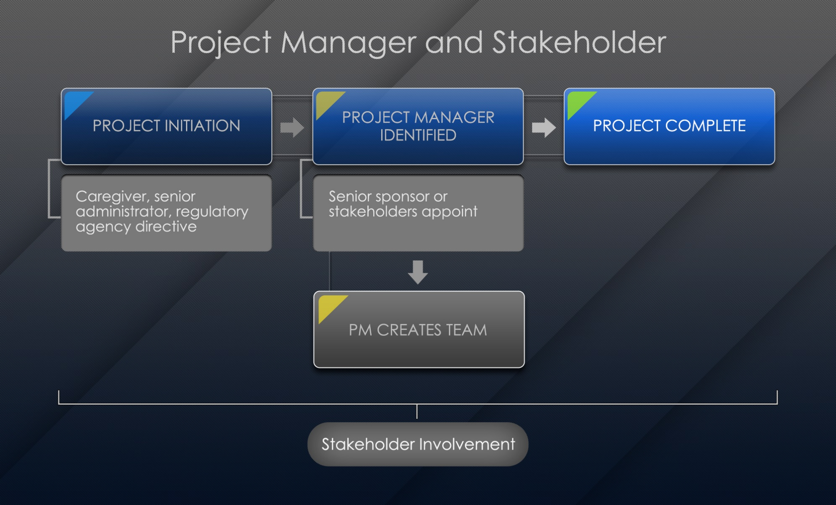

Project Manager and Stakeholder Image Description

Stakeholders
Healthcare requires a multidisciplinary approach for almost every aspect of management and operations. Stakeholders in a healthcare organization are varied and must be consulted whenever changes that potentially touch on their area of operations are contemplated.
While there may be primary stakeholders such as the physicians who use surgical suites and supplies, there are also other important stakeholders with equal concerns who should be addressed when evidence-based clinical protocols for surgical procedures are changed.
Click on the following images for examples.

Stakeholders Interactive Transcript
The scope of the project and desired outcomes are no longer solely the purview of the frontline caregivers but are instead topics of concern for a variety of stakeholders in the organization and the community.

Benefits of Stakeholders
Community stakeholders are beneficial in supporting all phases of the evidence-based practice change project, including sustaining the practice change.
Click through the following slides for examples.

Stakeholder Benefits Interactive Transcript
When undertaking a project, it is therefore important to identify stakeholders in the early stages of the design phase to involve all stakeholders in a comprehensive discussion about the various needs and desires of all potential customers to formulate a broad-based consensus regarding the anticipated project.
In modern healthcare, interdisciplinary teams of stakeholders have the advantage of providing different perspectives on a situation, including solutions that might otherwise have been overlooked. Thus, potential problems can be addressed at the earliest possible phase and often at the lowest possible cost, as team members may be aware of a solution that is already available and need only be implemented to resolve a situation.
Another benefit of gathering stakeholders early relates to the efficiency of the team and adds credibility and aids acceptance of the outcomes. The earlier the involvement of a broad base of stakeholders in a project, the more likely there will be grassroots support and ultimate acceptance of the change.

Feasibility and Cost
Feasibility and cost require an in-depth analysis once a project leader is in place and has selected the initial team (Project Management Institute, 2021). The team and any relevant stakeholders who are not included on the team should meet with the senior sponsors to confirm the project's scope and determine what resources are available for the various steps involved. These discussions ensure expectations from involved parties are both realistic and sufficient to meet the project's needs. The goals and anticipated outcomes of the project should be determined along with a timeline that allows activities to be monitored and progress measured. Additionally, outcome measures that will be used to determine the project's success must be agreed upon and memorialized once again to confirm the scope and objectives of the project.
Stakeholders who may have unique information relevant to the project must be present and ready to participate in these discussions. This should include end-users of the product and those who will be expected to support and maintain crucial systems that may be impacted by ongoing expenses that are not a part of the initial project budget.
Once the pertinent information is compiled, a cost-benefit analysis that examines the return on investment, anticipated future expenses, and other factors that may impact operations or organizational support for the project should be examined to permit an accurate cost-benefit analysis. This will allow senior administrators to determine whether adjustments are necessary to allocations of budget and resources, staffing, timelines, or even whether to proceed with the project after all other factors are considered.
Ultimately, reassurance should come from the senior sponsor indicating continued support for the project after full disclosure of all relevant information. Few projects are completed without some unexpected event, and the support of an appropriate senior sponsor is needed to ensure advocacy for additional resources or other accommodations when necessary. Lack of support by a senior sponsor can be a sign of weakness to others within the organization who may not be supportive of a project, and this may open the project to collateral attack by competing interests.

Project Team
Watch the following video on team characteristics and conflict management.
Project Team (2:15)

Planning and Tracking a Project
One of the primary tasks in the project planning phase is goal setting. The S.M.A.R.T. goal setting method is commonly used and allows project managers to make clearly defined and achievable goals.
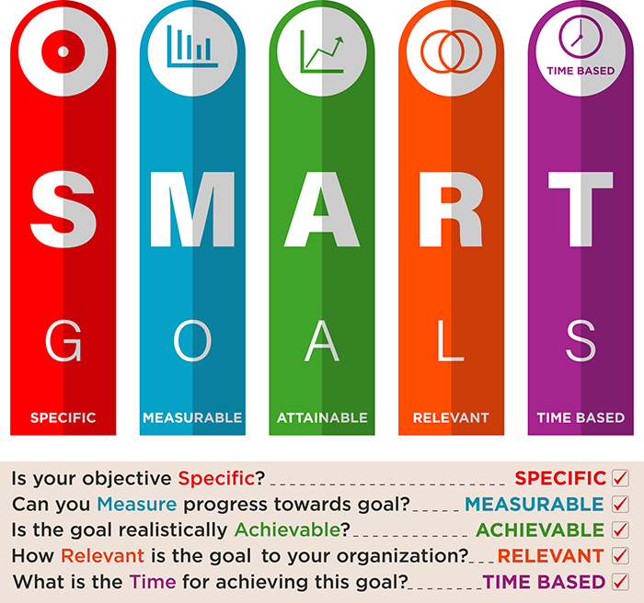

SMART Goals Image Description

Writing a S.M.A.R.T. Goal
Format: We want to improve (metric) from (initial state) to (target state) by (target date).
Example: Decrease the rate of CAUTIs for patients in the stepdown unit from 6.08 CAUTIs per 1,000 urinary catheter (UC) days to the national benchmark of 1.80 by December 31, 2021, by implementing the CAUTI Prevention Bundle.
A detailed project timeline is another important element of the planning phase. The Johns Hopkins Evidence-Based Practice Action Planning Tool is a tool that can be used to create a project action plan (Dang et.al 2022). A variety of specific techniques are available to aid the DNP-prepared nurse in planning and tracking a project. Examples of these approaches are the Gantt Chart, PERT, and the critical path method. Each of these methods provides an approach for displaying the specific steps to be taken and when each activity must be accomplished. Milestones mark essential points along the project timeline. They are crucial checkpoints that let the project manager know if the project is on the right track and not going off-course! There are computer software programs available that apply many of these approaches.
Click on the plus signs in the following interactive to learn more.

Planning and Tracking Model Interactive Transcript

Lesson 2
Culture

Organizational Culture
Every organization has a unique culture that may have evolved over years and it may be a recent event that necessitated a shift in philosophy and methodology. The culture of an organization will impact every aspect of a project, from how it can be initially suggested and presented to how it is researched and structured to how it is presented to the organization and ultimately implemented. This must be considered when one is tasked with researching and leading a project team to ensure that the methods and recommendations of the team operate within acceptable parameters for the organization's culture (Harris et al., 2020).
Many projects can result in cultural transformations throughout an organization. However, if the organization is not ready for a significant cultural shift and does not embrace the changes, a project may fail regardless of the support of senior management or any other group of stakeholders (Catiglione & Lavoie-Tremblay, 2021). There must be a convergence of conditions that make implementation of such a change viable. During the early stages of project contemplation, it may be necessary to evaluate the organizational culture to determine whether it will be receptive to a major change.
Change can only be accomplished with widespread grassroots support, which is provided primarily by those informal leaders who grasp the significance of the project. Determining the identity of these individuals is important, for only then can they be co-opted into the project as participants and supporters. These powerful stakeholders within the organization will also be the ones who help convince the reluctant employees to move with the tide of change and to abandon their prior or preferred mode of operation and adopt the modifications.
A major project in a healthcare facility is not something that can be addressed by simply forming a team, assessing the situation, and then creating a project with the assumption that things will proceed without the need for further attention. Instead, a communal concept of project development involving several participants with differing perspectives may result in the best outcomes.

Project Management Case Study
View the following case study to discover project planning tips:

Project Planning Case Study Interactive Transcript

Lesson 3
Project Implementation and Management

Implementation and Management
Watch the following video to explore the project management and implementation process.
Project Management and Implementation (4:00)

Communication
Effective communication is crucial to building support for a project and must begin with the initial conversations regarding the need to address a situation (Harris et al., 2020). Proponents must be able to explain the issue to be addressed, the steps necessary to undertake an initial evaluation of the situation, and the anticipated thresholds to allow decisions by senior administration. The organizational leaders will use this information to determine whether to proceed, the resources to be allocated, timelines, and anticipated outcomes used to determine project success. These factors must then be adopted by identified stakeholders who will participate in the analysis and response to the practice problem.
Communication is one of the project manager’s greatest roles. Project managers must ensure that communication is unequivocal, especially when a project involves an interdisciplinary workgroup. Although this would seem to be a relatively straightforward concept, it is often one that is overlooked and can result in delays, difficulties, or potentially the downfall of an entire project.
The individuals in charge of communications regarding a committee's activities should be proactive in providing information about relevant events to a spectrum of people and organizations that may be interested or impacted by the eventual outcomes. Be cautious, though, about simply posting minutes to a web page or e-mailing them to the entire organization wholesale and if the information contained will be noticed by others. Processes must be in place to ensure that the message is being sent from the team and that those for whom it is intended are receiving it. If this is not occurring, it may be necessary to adjust the communication process to improve outcomes and communication.

Lesson 4
Marketing

Marketing
Sponsorship and leadership are critical during the initial stages of every project because this is where the initial parameters of the project are determined. Goals must be specific enough so that everyone is working toward a common objective, but the goals should also have sufficient flexibility to allow for both creativity and unexpected contingencies during the life of the project. The ultimate outcome should add value to the organization and justify the use of resources needed.
At each level of development of a project, it is important to take a step back and make sure that there is still support from relevant stakeholders within the organization, especially from the most important audience at that phase of the effort. As potential users begin to recognize or question the value of the project, their willingness to support it may change. To increase enthusiasm for a project, it must be marketed not only to anticipated users but also to less obvious consumers who may recognize adaptive possibilities of which the team is unaware.
Just as importantly, an effective marketing effort will manage expectations regarding what a project will not do. If users have expectations that are vastly different than capabilities the potential for perceived failure increases. First, it is necessary to determine which outcomes are expected and then publicize those sufficiently to stakeholders to make certain that interested parties understand the rubric used to evaluate outcomes. If the project under consideration is expected to rise from the ashes of a failed system, it may also be necessary to continue to explain the need that the failed effort addressed while differentiating the new product from its predecessor.
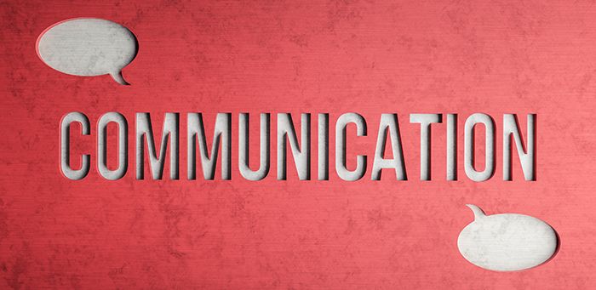Through the implementation and management phase of a project, the team should continue to assess the mood of the organization and address any resistance or opposition that may occur. Organizational mood changes happen in part by marketing the project among the select users and then throughout the organization. Communication is essential to facilitate project adoption, and it is up to the team, sponsors, and leaders to continually explain the project's purpose and what it cannot do. Honest transparency is essential for the team, sponsors, and leaders to address any complications or issues that arise, rumors or incorrect information, and to provide timelines and implementation details. Managing expectations is a crucial part of marketing that should not be overlooked or shortchanged.
One error many teams make is that of delaying or entirely omitting the marketing process. Marketing a project involves educating the target demographic and creating a readily recognizable brand. Though the use of trinkets such as t-shirts, pens, balloons, key rings, and the like may seem to be unnecessary budget items, remember that the purpose is to help build brand identification and familiarity among the target audience. If a project is very large and will be implemented across an organization over an extended period, these things keep the project in the consciousness of those who may not yet have had personal contact. Marketing is also helpful because as the project reaches those who are later in the rollout process, it isn't viewed as unusual or new—it is accepted as an established and desired tool that is finally being distributed to them. This can significantly promote acceptance of the product by addressing the fear of the unknown and encouraging adoption and implementation of the change

Project Management Case Study
View the following case study to discover project management tips.

Project Management Case Study Interactive Transcript

References
Catiglione, S. A., & Lavoie-Tremblay, M. (2021). An integrative review of organizational factors influencing successful large-scale changes in healthcare. The Journal of Nursing Administration, 51(3), 264–270. https://doi.org/10.1097/NNA.0000000000001011
Dang, D., & Dearholt, S., Bissett, K., Ascenzi, J., & Whalen, M. (2022). Johns Hopkins evidence-based practice for nursing and healthcare professionals (4th ed.). Sigma Theta Tau International.
Harris, J, Roussel, L., Dearman, C., & Thomas, P. (2020). Project planning and management: A guide for nurses and interprofessional teams (3rd ed.). Jones & Bartlett.
Project Management Institute. (2021). The standard for project management and a guide to the project management body of knowledge (PMBOK® guide) (7th ed.). Project Management Institute.

Project Manager Roles and Responsibilities

Discussion

Purpose
The purpose of this discussion is to explore the responsibilities of a project manager.

Instructions
Reflect upon your readings and professional experience and address the following:
- Detail your implementation plan for your DNP project. Include milestones for a timeframe of 8-12 weeks.
- Explicate how you will gauge the success of your project.
- What is your role in managing your project budget and resources in the planning and implementation phases?
Please click on the following link to review the DNP Discussion Guidelines on the Student Resource Center program page:
- Link (webpage): DNP Discussion GuidelinesLinks to an external site.

Program Competencies
This discussion enables the student to meet the following program competencies:
- Integrates scientific underpinnings into everyday clinical practice. (POs 3, 5)
- Uses analytic methods to translate critically appraised research and other evidence into clinical scholarship for innovative practice improvements. (POs 3, 5)
- Appraises current information systems and technologies to improve healthcare. (POs 6, 7)
- Analyzes healthcare policies to advocate for equitable healthcare and social justice to all populations and those at risk due to social determinants of health. (POs 2, 9)
- Leads others in professional identity, advanced clinical judgment, systems thinking, resilience, and accountability in selecting, implementing, and evaluating clinical care. (POs 1, 4)

Course Outcomes
This discussion enables the student to meet the following course outcomes:
- Examine the role of the DNP-prepared nurse in leading financial planning and management across healthcare settings. (PCs 5, 8; POs 2, 4, 9)
- Develop strategies to lead project planning, implementation, management, and evaluation to promote high-value healthcare. (PCs 1, 3, 4; POs 3, 5, 7)

Due Dates
- Initial Post: By 11:59 p.m. MT on Wednesday
- Follow-Up Posts: By 11:59 p.m. MT on Sunday
Search entries or author
Filter replies by unreadUnread Collapse replies Expand replies
Subscribe
ReplyReply to Week 3: Discussion | Project Manager Roles and Responsibilities

Collapse SubdiscussionMary Nimmo
Welcome to Week 3!
Class,
Welcome to our Week 3 Discussion. The purpose of this discussion is to explore project planning management as students explain the details of their project implementation plan, including project milestones. An important part of project management is ensuring the effective and efficient use of resources. This week students explain your role in managing the budget and resources during implementation. What are some strategies for tracking and managing resources and expenses?
Reflect upon your readings and personal or professional experience. Be sure to read the question carefully.
Our interactive discussion addresses the following course outcome:
  - CO 3 Develop strategies to lead project planning, implementation, management, and evaluation to promote high value healthcare. (POs 3, 5, 7)
We are all here for your success!! Don’t hesitate to let me know if you have any questions this week.

