Week 2 Assignment 1: Culture Paper
Annette Kivumbi
Regis College
NU-716-01-24PAS1 Culture & Health: Perspectives
Dr. Fruin Brandi
5/12/2024

Examining the African Culture
Africa accounts for 15% of the global population and a quarter of the worldwide disease burden (Olufadewa et al., 2021). More so, Africa accounts for less than 35% of global health practitioners and barely less than 1% of worldwide research output (Olufadewa et al., 2021). In addition, the Sub-Saharan region contributes an average of 0.45 of its scientific Gross Domestic Product (GDP), while Europe contribute 27%, while Asia contributes 31%, and North America contributes 37% in education (Olufadewa et al., 2021). The paper seeks to discuss and define African culture, elaborate on the transcultural theoretical model, and illustrate the model in African culture. The paper will further discuss cultural competence in advanced practice as a nurse practitioner (NP) or Doctor of Nursing Practice (DNP) prepared nurse and provide a conclusion and future implications for research.
African Culture in Research and Development
Africa is termed the barrel of gunpowder (Olufadewa et al., 2021), revealing it is an inimitable continent with numerous diverse societies, religions, cultures, traditions, and beliefs that vary from Western and European cultures or the developed world. Notably, African-based initiatives and organizations range from understanding these factors based on root causes of health and social factors challenging the continent. Evidence reveals Africa should advance and acknowledge spectacular failures that might hamper the leadership of African leadership (Olufadewa et al., 2021). The African Union Commission collaborates with the United Nations, working in tandem to promote equitable research on policies and ensure equitable policies along with better funding in research (Olufadewa et al., 2021). These collaborations aim to attain inter-African networking and fellowship opportunities to benefiting the people (Olufadewa et al., 2021).
In the healthcare sector, the continent has made efforts to gear programs to recruit and retain a diverse workforce and train cultural competency for healthcare providers. Cultural competence and congruence are predominant in the African culture such that healthcare organizations employ translators from diverse cultural backgrounds to guarantee that patients receive culturally appropriate care specific to their health needs. As such, this results in a positive patient-clinician connection, efficient communication, and optimal outcomes (Nair & Adetayo, 2019). In Africa, the delivery of culturally congruous care boosts provider awareness, bolsters research equity, inclusivity, and the espousal of international policies and guidelines, which foster advocacy and teamwork globally (Nair & Adetayo, 2019; Olufadewa et al., 2021). African culture has a mutual dogma known as ubuntu that unites people from disparate cultures. Ubuntu signifies interconnectedness and kindness to other people regardless of their cultural backgrounds (Chigangaidze et al., 2021). Although African culture is diverse and each community has different cultural practices and norms, specific themes such as interconnectedness, spirituality, and resilience are pervasive across Africa. These themes embody the African values of unity, compassion, empathy, hospitality, and love (Chigangaidze et al., 2021).
Transcultural Theoretical Model
With the global increment in cultural diversity among healthcare providers and patients, transcultural diversity and leadership must be understood. Campinha-Bacote's Model of Cultural Competence in healthcare delivery provides a purpose, goals, primary constructs, and a cultural competence process (Fitzgerald & Campinha-Bacote, 2019). The purpose and goal of the Campinha-Bacote Model of Cultural Competence involves assisting clinicians in fathoming the importance of culturally competent care (Fitzgerald & Campinha-Bacote, 2019). The theory aims to equip healthcare providers with erudite guidelines for tailoring culturally competent care (Fitzgerald & Campinha-Bacote, 2019). This theory equips nurses with the necessary expertise to provide efficient and top-notch care through the cultural competence process delineated in the subsequent graphics (Figures 1 and 2.).
The Process of Cultural Competence in the Delivery of Healthcare Services (Figure 1.)
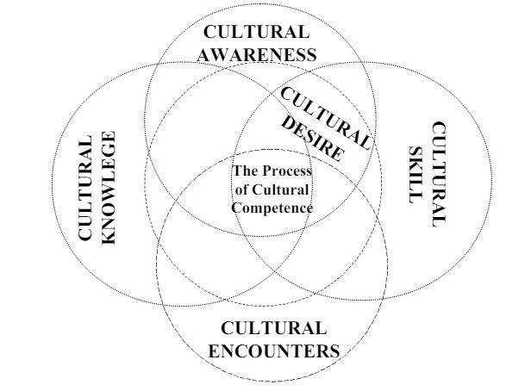
“The Process of Cultural Competence in the Delivery of Healthcare Services,” is copyrighted by Campinha-Bacote and reprinted with permission from Transcultural C.A.R.E. Associates (Campinha-Bacote, 2002, P.183).
The Process of Cultural Competence (Figure 2.)
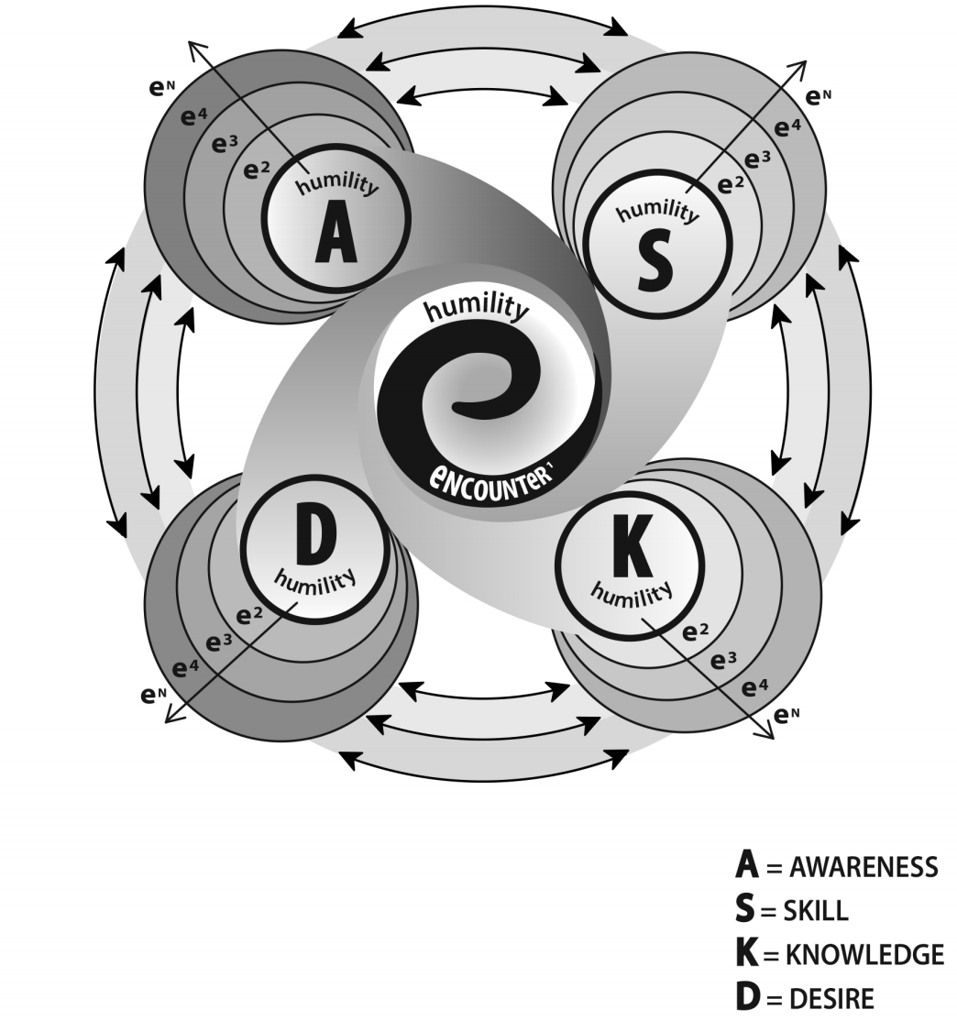
(Campinha-Bacote, 2018).
The tenets of the cultural competence process include cultural awareness, skill, knowledge, encounter, and desire (Albougami et al., 2016). These components are pivotal as they enable healthcare providers to deliver culturally competent care to their diverse patient populations efficiently. Primarily, cultural awareness inspires clinicians to consciously identify their cultural backgrounds to avoid prejudices towards other cultures (Fitzgerald & Campinha-Bacote, 2019). Cultural skill encompasses a healthcare provider's aptitude to conduct culturally appropriate assessments and collect essential patient data while respecting their values and preferences (Albougami et al., 2016). Cultural knowledge encompasses a nurse's candid learning of cultural and ethnic differences (Albougami et al., 2016). Conversely, cultural encounters are connections and engagements with patients from distinct cultural settings (Albougami et al., 2016). The last component is desire, which encompasses the impetus to be an erudite, skilled, proficient, and culturally aware healthcare provider open to transcultural interactions (Albougami et al., 2016). Essentially, these five constructs are grounded by cultural humility which is incessantly incorporated throughout each component (Fitzgerald & Campinha-Bacote, 2019).
In the African context, globalization, competitiveness, wars, and technological advancement have increased workplace diversity, leading to people from diverse cultural backgrounds delivering services that meet the needs of patients from varying cultures (Teixeira et al., 2023). As such, transactional nursing leadership is crucial in nursing management, education, policy, and research aimed to advance culturally congruent care, solve health disparities, and build inclusivity. Therefore, the Campinha-Bacote Model of Cultural Competence will guide research and translation of evidence-based nursing practice and the development of culturally competent care, future administrations, and leadership in policies related to cultural diversity and underserved populations in the African continent component (Fitzgerald & Campinha-Bacote, 2019).
Cultural Competence in Advanced Practice as a Nurse Practitioner or Doctor of Nursing Practice (DNP) Prepared Nurse
In advanced practice, cultural competence is a nurse's aptitude to appraise the cultural facets impacting a person's health and attitudes regarding a disability and illness (Liu et al., 2022). Most importantly, cultural competence enables Doctor of Nursing Practice (DNP)-prepared nurses to communicate effectively and build consensus with diverse patient populations, enhancing patient outcomes and experiences. As a psychiatric mental health nurse practitioner (PMHNP), there have been several encounters that necessitated the provision of culturally competent care.
For instance, a 75-year-old African American female presented to the facility for an annual checkup during one of the clinicals. The patient could barely converse in English. Since the organization has interpreters, it was vital to solicit their services to communicate effectively. The interpreter facilitated the processes, ensuring we maintained a rapport and provided culturally competent care. The five components of the Campinha-Bacote Model guided the process and ensured we provided the patient with bespoke care with interventions informed by her cultural background, values, and preferences (Fitzgerald & Campinha-Bacote, 2019).
Conclusion and Future Implications for Research
In conclusion, African culture is diverse and accounts for approximately 15% of the global population (Olufadewa et al., 2021). The African culture has numerous diverse societies, religions, cultures, traditions, and beliefs. Although the cultures are diverse, the African people are interconnected, valuing each other's support and respecting the diversity. Thus, DNP-prepared nurses should infuse the Campinha-Bacote Model, specifically the cultural competence process, into practice when providing care to this patient population. For future studies, researchers should advocate for the inclusion of the Campinha-Bacote Model into practice to motivate clinicians to deliver culturally competent healthcare to distinct patient populations.

References
Albougami, A. S., Pounds, K. G., & Alotaibi, J. S. (2016). Comparison of four cultural competence models in transcultural nursing: A discussion paper. International Archives of Nursing and Health Care, 2(4). https://doi.org/10.23937/2469-5823/1510053
Campinha-Bacote, J. (2002). The process of cultural competence in the delivery of healthcare services: A model of care. Journal of transcultural nursing, 13(3), 181-184. https://doi.org/10.1177/10459602013003003
Campinha-Bacote, J. (2018). Cultural competemility: A paradigm shift in the cultural competence versus cultural humility debate – Part I. OJIN: The Online Journal of Issues in Nursing, 24(1). https://doi.org/10.3912/ojin.vol24no01ppt20
Chigangaidze, R. K., Matanga, A. A., & Katsuro, T. R. (2021). Ubuntu philosophy as a humanistic-existential framework for the fight against the COVID-19 pandemic. Journal of Humanistic Psychology. https://doi.org/10.1177/00221678211044554
Fitzgerald, E., & Campinha-Bacote, J. C. (2019). An intersectionality approach to the process of cultural competemility – Part II. OJIN: The Online Journal of Issues in Nursing. https://ojin.nursingworld.org/table-of-contents/volume-24-2019/number-2-may-2019/articles-on-previously-published-topics/intersectionality-approach-to-cultural-competemility/
Liu, T., Chen, Y., Chang, M., & Lin, H. (2022). A preliminary study on the cultural competence of nurse practitioners and its affecting factors. Healthcare, 10(4). https://doi.org/10.3390/healthcare10040678
Nair, L., & Adetayo, O. A. (2019). Cultural competence and ethnic diversity in healthcare. Plastic and Reconstructive Surgery - Global Open, 7(5), e2219. https://doi.org/10.1097/gox.0000000000002219
Olufadewa, I. I., Adesina, M. A., & Ayorinde, T. (2020). From Africa to the world: Reimagining Africa's research capacity and culture in the global knowledge economy. Journal of Global Health, 10(1). https://doi.org/10.7189/jogh.10.010321
Teixeira, G., Cruchinho, P., Lucas, P., & Gaspar, F. (2023). Transcultural nursing leadership: A concept analysis. International Journal of Nursing Studies Advances, 5, 100161. https://doi.org/10.1016/j.ijnsa.2023.100161

