Week 11 Discussion 1: Impact of a Timeline with SPP Components
- Dashboard
- My courses
- NU-727-04-24PCFA
- Week 11: Timetable
- Week 11 Discussion 1: Impact of a Timeline with SPP Components
Open course index
Completion requirements
To do: Make forum posts: 1
Value: 100 points
Due: Initial post by Day 3; reply to at least two peers by Day 7.
Grading category: Discussions

Initial Post
The selected theory guides why the project is conducted; the Evidence-Based Practice Model instructs how to complete the SPP project. Now consider the intervention in your timeline to conduct your project. Selecting a theory to guide research or EBP projects has been a tradition in nursing Inquiry. In addition, the selection of the theory will influence the design of the intervention for your SPP.
Summarize how your theoretical framework, EBP model, and intervention all work together and why the connection is important in relation to your timeline for your SPP.

Week 11 Assignment 1: Project Completion Plan—Timeline/Gantt Chart
- Dashboard
- My courses
- NU-727-04-24PCFA
- Week 11: Timetable
- Week 11 Assignment 1: Project Completion Plan—Timeline/Gantt Chart
Open course index
Completion requirements
To do: Make a submission
Due: Sunday, 10 November 2024, 11:55 PM
Value: 100 points
Due: Day 7
Grading Category: Practice Scholarly Project Timeline

Instructions
Planning efforts should include the development of a project completion plan that provides estimates of when important tasks will be completed. A Gantt chart is a useful tool to develop your plan. Review the presentation and, using Microsoft Excel, develop a proposed Gantt chart for your Scholarly Practice Project. Review “Figure 8.2: Project Timeline” in the Polit and Beck (2021) textbook for ideas on the tasks you might want to include in the conceptual, design/planning, empirical, analytic, and dissemination phases of your project. Think about which upcoming terms, during which you will be enrolling in NU741–NU743, to more realistically reflect the specifics tasks of the SPP.
Watch Project Management in Under 5: What is a Gantt Chart? for this assignment.
- Project Management in Under 5: What is a Gantt Chart? Video Transcript
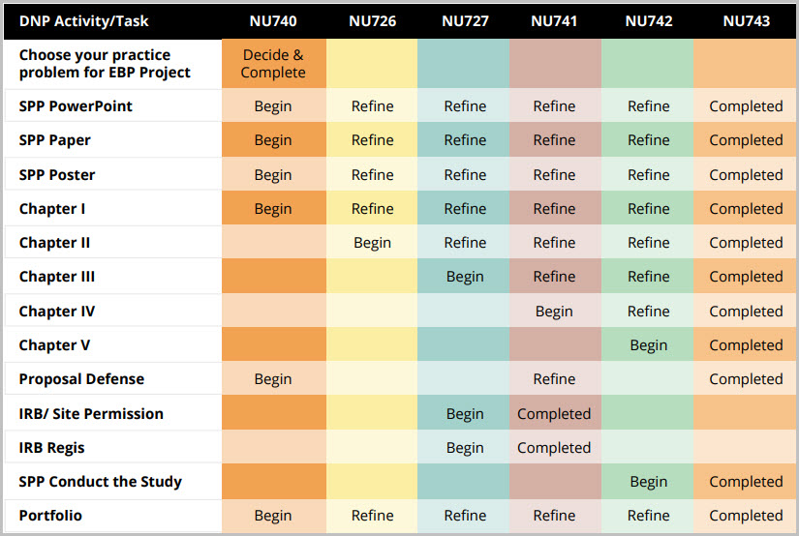
DNP Activity/Task Table (PDF)
Refer to the Grading Rubric for details on how this activity will be graded.



Advanced Research Methods for EBP II

Week 11: Learning Materials

Readings

Required
- Polit, D. F., & Beck, C. T. (2021). Nursing research: Generating and assessing evidence for nursing practice (11th ed.). Philadelphia, PA: Lippincott, Williams, & Wilkins. (WO 1, 2, 3)
  - Chapter 8: Planning a Nursing Study (WO 1, 2)
  - Box 8.2: “Project Timeline” p. 170 (WO 1, 2)

Week 11: Introduction and Objectives
- Dashboard
- My courses
- NU-727-04-24PCFA
- Week 11: Timetable
- Week 11: Introduction and Objectives
Open course index
Completion requirements
Done: View

Introduction
This week, we will work on the need for and importance of timetables. We also discuss the need for advanced planning of your proposal timeline and tasks and tips to complete everything in a timely manner.
For your Chapter III Scholarly Practice Project paper, apply the timetable to the appropriate section. Chapter III includes the timeline for each step of your project including recruitment, data collection, and analysis.

Learning Materials Introduction
This week, our focus is on constructing timetables. In the Polit and Beck text, “Box 8.2” (WO 1, WO 2, WO 3), you will learn about project timelines and the impact that a timeline has on constructing a SPP.

Learning Objectives
By the end of this week, you will be able to:
- Describe the timeline for the SPP.
- Analyze the need for a timetable for a successful DNP SPP construction.
- Apply the timeline in the SPP project.

