EBP Models and Conclusion
According to Dusin et al. (2023), choosing an appropriate evidence-based practice (EBP) model allows implementers to map the change process, determine the resources required, identify barriers and facilitators, and plan on solutions to mitigate the barriers. The proposed project will use the knowledge-to-action (KTA) model. The model allows systematic and iterative process of knowledge translation that relies on planned action in influencing change (Graham et al., 2006; Ramos-Morcillo et al., 2020). The model encompasses two components – the knowledge-creation cycle and action cycle – that provide a framework for change implementation (Graham et al., 2006). The knowledge-creation cycle involves knowledge inquiry (search for primary evidence), knowledge synthesis (appraisal of the evidence and consideration of second-generation knowledge from menta-analysis or meta-synthesis), and the generation of knowledge tools. The cycle enables the identification of appropriate supporting evidence and its presentation in a clear and understandable format to guide the change process and uptake of the knowledge. The action cycle involves seven phases focused on problem identification, contextualization of the knowledge, assessing barriers, tailoring the intervention implementation, monitoring knowledge use, evaluating outcomes, and sustaining knowledge use.
Figure 1 below illustrates the fit between the framework’s components and the SPP. The iterative process started with the identification of a practice problem involving the lack of a supportive nurse-led program to enhance adherence to psychotropic medications. Knowledge inquiry and synthesis focused on the problem and the role of MI in addressing it. Clinical practice guidelines were also reviewed and will enable the training of the nursing staff on MI. In addition, several barriers and facilitators that could influence the implementation have been identified. The proposed intervention will be tailored to reflect the Organizational Toolkit on Medication Adherence by the National Council of Mental Wellbeing (2021). Monitoring of knowledge use will involve formative assessment involving weekly staff meetings, observation and review of MI sessions, tailored feedback, and ongoing support to the nursing staff. The outcomes will be evaluated using Morisky Medication Adherence Scale (MMAS-8) and the Medication Understanding and Self-Efficacy (MUSE) questionnaire. Sustainability measures will involve ongoing review of MI use in daily clinical practices, staff retraining and professional development, and monthly meetings to share experiences and knowledge about MI use.
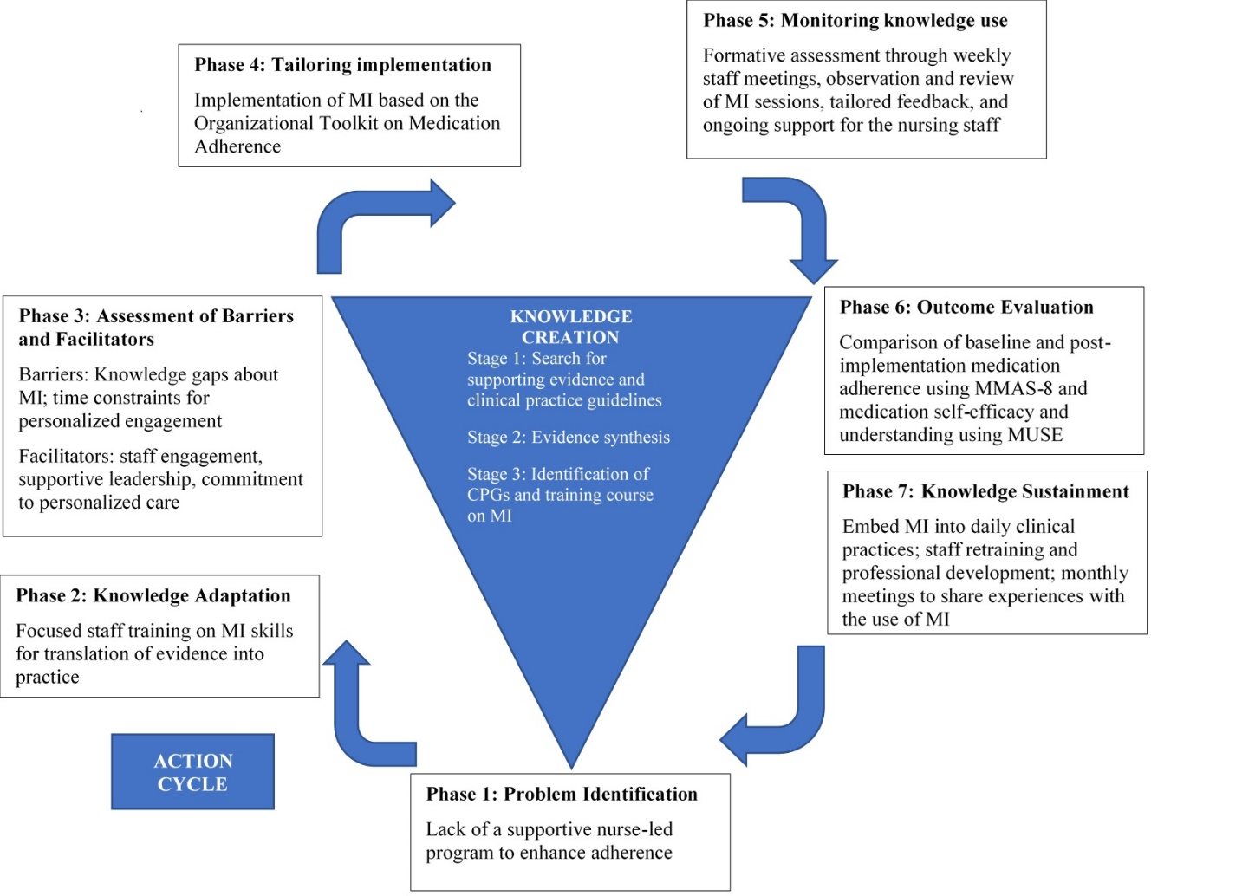
Figure 1. The Knowledge-to-Action Framework. Adapted from "Lost in knowledge translation: time for a map?." by Graham, I.D., Logan, J., Harrison, M.B., Strauss, S.E., Tetroe, J., Caswell, W., & Robinson, N., 2006, Journal of Continuing Education in the Health Professions, 26(1), 19.
Conclusion
Figure 2. The Knowledge-to-Action Framework. Adapted from "Lost in knowledge translation: time for a map?." by Graham, I.D., Logan, J., Harrison, M.B., Strauss, S.E., Tetroe, J., Caswell, W., & Robinson, N., 2006, Journal of Continuing Education in the Health Professions, 26(1), 13-24.
The chapter provided the background knowledge relating to the lack og a supportive nurse-led program to enhance medication adherence. As revealed, nonadherence to psychotropic medication poses a significant challenge for patients and the healthcare system. The lack of adherence support at the practicum site compounds patient-related factors that lead to nonadherence. The chapter identified a nurse-led MI-based program as a potential intervention to address the problem. Moreover, it discussed the significance of the program to nursing practice, research, education, and leadership. The identified problem enabled the development of a PICOT question to guide the project and the specific aims and objectives. Further, it explored the SCDT as the theoretical framework and the KTA framework as the underpinning EBP model, noting the fit of the project question into the model. It is expected that using the structured approach to implementing the program will lead to sustainable outcomes.
References
Dusin, J., Melanson, A., & Mische-Lawson, L. (2023). Evidence-based practice models and frameworks in the healthcare setting: A scoping review. BMJ Open, 13(5), e071188. https://doi.org/10.1136/bmjopen-2022-071188
Graham, I. D., Logan, J., Harrison, M. B., Straus, S. E., Tetroe, J., Caswell, W., & Robinson, N. (2006). Lost in knowledge translation: time for a map?. Journal of Continuing Education in the Health Professions, 26(1), 13-24. https://doi.org/10.1002/chp.47
National Council for Mental Wellbeing. (2021). Organizational toolkit on medication adherence. https://www.thenationalcouncil.org/wp-content/uploads/2021/12/Medication_Adherence_Toolkit_Final.pdf
Ramos‐Morcillo, A. J., Harillo‐Acevedo, D., & Ruzafa‐Martinez, M. (2020). Using the Knowledge‐to‐Action framework to understand experiences of breastfeeding guideline implementation: A qualitative study. Journal of Nursing Management, 28(7), 1670-1685. https://doi.org/10.1111/jonm.13123

