Week 4 NR-707
Student Lesson Plan
Overview
- Program Competencies
- Course Outcomes
- Weekly Objectives
- Main Concepts
- Integrates scientific underpinnings into everyday clinical practice. (POs 3, 5)
- Applies organizational and system leadership skills to affect systemic changes in corporate culture and to promote continuous improvement in clinical outcomes. (PO 6)
- Uses analytic methods to translate critically appraised research and other evidence into clinical scholarship for innovative practice improvements. (POs 3, 5)
- Appraises current information systems and technologies to improve health care. (POs 6, 7)
- Analyzes health care policies to advocate for equitable health care and social justice to all populations and those at risk due to social determinants of health. (POs 2, 9)
- Creates a supportive organizational culture for flourishing collaborative teams to facilitate clinical disease prevention and promote population health at all system levels. (PO 8)
- Leads others in professional identity, advanced clinical judgment, systems thinking, resilience, and accountability in selecting, implementing, and evaluating clinical care. (POs 1, 4)
Schedule
Section | Read/Review/Complete | Course Outcomes | Due
Prepare | Assigned Readings | COs 1, 2, 4 | Wednesday
Explore | Lesson | CO 2 | Wednesday
Translate to Practice | Discussion: Initial Post | COs 1, 2, 4 | Wednesday
Translate to Practice | Discussion: Follow-Up Posts | COs 1, 2, 4 | Sunday
Translate to Practice | Assignment | COs 1, 4 | Sunday
Reflect | Reflection | COs 1, 2, 4 | No submission
Foundations for Learning
Baumgardner, A. (2017, May 11). Collaborative artistic leadership: 3 tips on leveraging strengths to enhance the power of your team.Links to an external site. Astrid Baumgardner Coaching & Training. https://www.astridbaumgardner.com/blog-and-resources/blog/collaborative-artistic-leadership-3-tips-on-leveraging-strengths-to-enhance-the-power-of-your-team/
Di Stefano, G., Cataldo, E., & Laghetti, C. (2019). The client-oriented model of cultural competence in healthcare organizations.Links to an external site. International Journal of Healthcare Management, 12(3), 189-196. https://doi.org/10.1080/20479700.2017.1389476
Student Learning Resources
Click on the following tabs to view the resources for this week.
- Required Textbooks
- Required Articles
- Additional Resources
Bemker, M., Ralyea, C., & Schreiner, B. (2021). The successful completion of your DNP project: A practical guide with exemplars. DESTech Publications.
- Read Chapter 13
Learning Success Strategies
- Resources
  - Review the assigned readings to ensure you understand the key terms and relate them to the role of the DNP-prepared nurse.
  - Read the additional resources to understand the weekly topics. Supplemental resources are not mandatory but can provide additional knowledge and understanding of the course content.
  - Your course faculty is here to support your learning journey. Reach out for guidance with study strategies, time management, and course-related questions.
- Appointments & Forums
  - Attend Let’s Check-In Student Forum when offered. In the student forums, the course leader will offer an overview of the assignments in detail. This is an opportunity to ask questions and connect with your online course community each week.
  - If implementing your DNP practice change project at the practicum site, meet with your preceptor (and mentor if applicable) weekly to share your DNP practice change project updates. Remind your preceptor that the Mid-Term Evaluation Form will be due during Week 4 of the course.
- Discussions
  - There are two parts to the discussions every week. All students respond to Part 1 and Part 2. Part 1 is focused on our course content. Part 2 is focused on updates for your practice change project. Be sure your project-related updates in Part 2 of the discussions are specific and robust. Write in detail so that your discussion creates a full 360-degree view or picture of what is happening in your implementation. There is no word limit for the project update Part 2 discussion.
  - Be ready to share your thoughts and leadership experiences through the interactive discussion. It is essential to share your thoughts so that we hear your voice. Also, support your positions with evidence from the literature. Use of first-person is accepted for the discussion board.
- Practicum Hour Logs
  - Log your practicum hours weekly.
  - Remember to use the resources in the Project & Practicum section of the DNP Program Resources page for guidance on these entries.
  - Enter no more than 4 hours for each entry and ensure that the activities represent the block of time requested. Be sure to select the correct DNP Essential and activity that matches your activity in your notes.
  - You can also enter practicum hours for working on your Professional Poster assignment, which is due this week.
  - Check your practicum hours weekly to identify the number of hours you need to enter each week to reach your required practicum hours for our course. The best practice is to record your hours each week so that you will have the required number of practicum hours in Week 8 for the Practicum Log assignment.
- Project
  - As you review weekly content, consider how each concept and discussion can be translated into practice in your unique setting.
  - When you receive your grade and feedback on your Professional Poster from your course faculty, please revise your Professional Poster as your course faculty requested in their feedback. If you have questions about the feedback on your poster, please ask your course faculty.
- Chamberlain Care®
  - Please take some time for self-care this week. During your busy implementation, it is important to care for yourself to rejuvenate and reduce stress.
Interacting with Feedback
Each week your course faculty will provide feedback in the rubric on any assignment you have submitted. Take a moment to review the following video on how to view rubric feedback in Canvas. (After clicking the link, scroll down or click on the title in the Summary area to jump directly to the video.)
- Link (video): Looking at FeedbackLinks to an external site. (2:26)
Review the following video on how to accept/reject track changes when viewing course faculty feedback on your assignment:
- Link (video): Word: Track Changes and Comments (4:19)
Lesson
Role of the DNP-Prepared Nurse Leader
Leveraging Strengths as a Health Systems Leader
One of the strengths of leadership is the ability to leverage skills and talents in yourself and others. By developing your Strengths-to-Strategy plan, you can better assess where strengths can be applied to compensate for areas that require development. The same dynamic can be applied to those for whom the leader manages. Each team member brings strengths that complement the team's diversity and contribute to a substantial and successful structure.
Astrid Baumgardner (2017) is a successful career coach who offers three tips to leverage the strengths of the team to achieve the best outcomes:
- Know the strengths and weaknesses of your team members
- Discuss strengths with each team member when planning your practice change project
- Allocate roles based on the strengths of your teammates (para. 8)
Knowing your strengths and weaknesses as a leader and the leadership strengths of your team is the first step in creating a Strengths-to-Strategy plan. Begin this first step by identifying the following:
- Your leadership strengths
- Areas of opportunities for growth, improvement, and development in leadership (weaknesses)
- Strategies to turn these opportunities into strengths (i.e., build weaknesses into strengths)
- Strategies for leveraging the strengths of others (i.e., staffing your weaknesses)
A Strengths-to-Strategy plan uses others' strengths to contribute a full complement of skills to the healthcare team. Likewise, leveraging others' strengths through delegation can strengthen your leadership gaps.
Emotional intelligence (EI) is a necessary leadership competency. The seminal work on emotional intelligence (EI) by Goleman (1998) suggested that EI may be more important in the functional world than an individual's intellectual capabilities. Nurse leaders may feel uncomfortable with emotions and shut down conversations and displays of emotions with staff. Leaders who allow appropriate emotions are inspiring and encouraging and engage in strong relationship-building. Leaders must practice emotional intelligence to know when appropriate emotions are necessary. Positive, encouraging, and inspiring emotions construct an engaging work environment that the staff emulates in collaborative teamwork.
Goleman (1998) outlined the five components of EI:
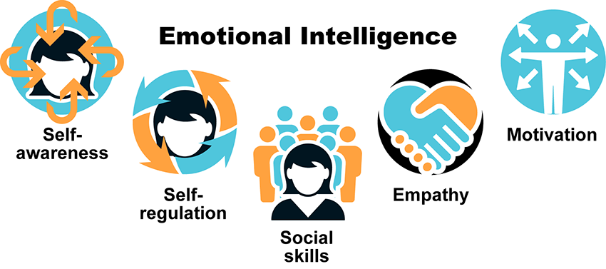
Emotional Intelligence Image Description
Emotional Intelligence is one leadership tool or competency used in individual and organizational performance and is fundamental to creating a transformational work environment.
Learn More
Further your exploration of EI by viewing the following video:
- Link (video): Spotlight on leadership: Emotional intelligenceLinks to an external site. (4:14)
Leading Rapid Change Across Complex Healthcare Environments
Nurse leaders are often required to make thoughtful and strategic decisions to lead the organizational workforce in the right direction. Today’s nurse leaders must make rapid and thoughtful decisions and, at times, take decisive action quickly to secure or utilize precious resources prudently and ensure safe patient care. This was most prominent during the pandemic when adapting to fluctuations in patient census, new infection control rules, new treatments, and staffing shortages.
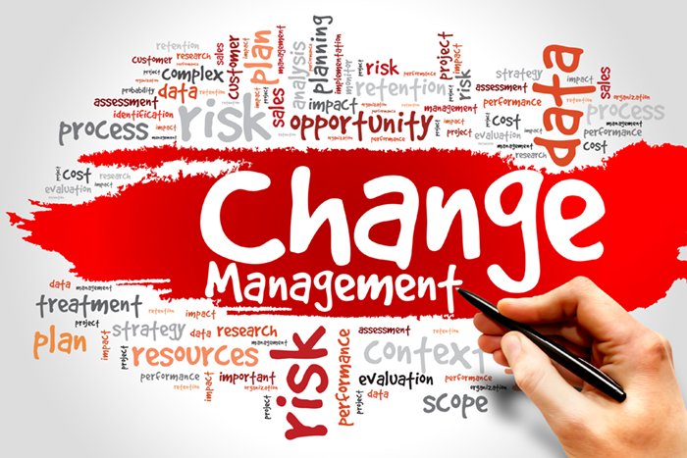During rapid change, the nurse leader must use intellectual and emotional intelligence to provide a clear direction, alleviate fears of the unknown, maintain high ethical standards, and maintain morale and motivation to meet the needs of patients and the organization (Daft, 2017). The need for clear direction and transparency was heightened during the pandemic. When rapid change is needed, the nurse leader must have a seat at the table for decisions impacting patients, staff, and operations. The standard procedures and policies can become antiquated during rapid change as the needs of complex healthcare environments are not always compatible with strategies that focus on authoritarian power and control (Boston-Fleischhauer, 2020). As the need for rapid change developed during the early months of COVID-19, nurse leaders across the country and globally brainstormed to quickly identify potential solutions and processes to adapt to the pandemic environment. Innovative ideas were brought forth and tested for their efficacy in addressing the problems at hand.
As a need for rapid change is identified, the nurse leader should collaborate with staff and other disciplines to identify and engage in a viable solution. Even small rapid changes that have a positive outcome can instill confidence in staff and cultivate an environment in which change is readily accepted and adopted.
Emotional Support Strategies
Change is not easy for many individuals; sometimes, the initial response to change may be emotion and resistance.
The DNP-prepared nurse leader needs to provide emotional support through strategies such as the following:
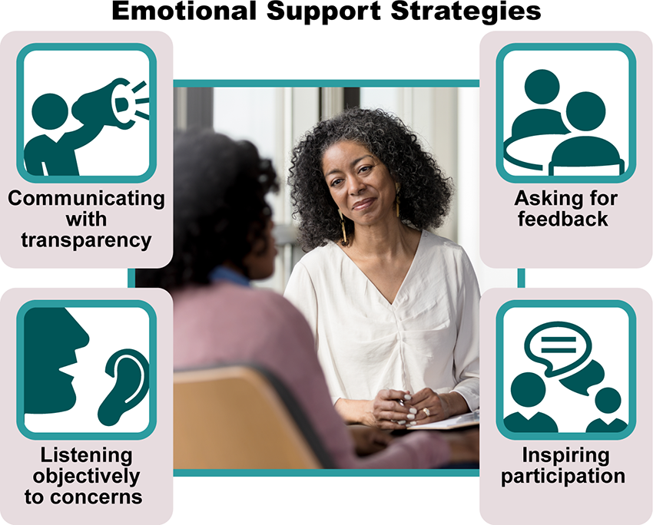
Emotional Support Strategies Image Description
Monitoring reactions from stakeholders is important with any change, especially when rapid change is needed. Using the strategies discussed, the nurse leader can reduce fear and resistance to change and establish a healthy work environment where change is viewed as a positive disruption.
Embracing and Cultivating Diversity and Cultural Awareness
Growing migration movements have resulted in greater ethnic diversity and increased religious and linguistic variations. As the United States has moved to a more diverse presence of cultures, attitudes regarding cultural differences have also evolved. Communities have become more multi-ethnic with a blend of multiple cultures. While there is still work to be done as a nation, there is more acceptance and appreciation of what diverse cultures bring to the workplace and communities.
Within healthcare, cultural competence is a necessity. To address health disparities, often related to race or ethnicity, healthcare organizations must respond to all patients' needs, regardless of ethnicity (Di Stefano et al., 2019). As a DNP-prepared nurse leader, you can be the champion of an inclusive environment and reduce the challenges associated with interpersonal communication and relationships between individuals of diverse cultures. Recruiting and hiring staff from varied cultural backgrounds provide a more global perspective of nursing and healthcare. Exchanging ideas and practices can increase cultural awareness and benefit culturally diverse patients’ understanding and compliance with treatment plans.
Open dialogue is essential in decreasing obstacles to a culturally inclusive environment. Through self-assessments and cultural competency training, biases can be acknowledged, and tools identified to diminish preconceived ideas or perceptions of other cultures or groups. As the nurse leader, your direction and guidance toward a more culturally accepting and welcoming environment will be crucial for all stakeholders within and outside your organization.
References
Baumgardner, A. (2017, May 11). Collaborative artistic leadership: 3 tips on leveraging strengths to enhance the power of your team. Astrid Baumgardner Coaching & Training. https://www.astridbaumgardner.com/blog-and-resources/blog/collaborative-artistic-leadership-3-tips-on-leveraging-strengths-to-enhance-the-power-of-your-team/
Boston-Fleischhauer, C. (2020). Chief nurse executive readiness for the here and now. Journal of Nursing Administration, 50(6), 307-309. https://doi.org/10.1097/NNA.0000000000000889
Di Stefano, G., Cataldo, E., & Laghetti, C. (2019). The client-oriented model of cultural competence in healthcare organizations. International Journal of Healthcare Management, 12(3), 189-196. https://doi.org/10.1080/20479700.2017.1389476
Goleman, D. (1998). Working with emotional intelligence. Bantam Books
You must post before seeing replies. Edit history will be available to instructors.
Close
Due Nov 25 1:59am
50 points possible
2 Replies, 2 Unread
2 Replies, 2 Unread
Reply to subscribeManage Discussion
Discussion Topic: Week 4: Discussion | The Role of the DNP-Prepared Nurse LeaderWeek 4: Discussion | The Role of the DNP-Prepared Nurse Leader
Week 4The Role of the DNP-Prepared Nurse Leader
Discussion
Purpose
The purpose of this discussion is to explore the role of the DNP-prepared nurse leader and the various activities within that role.
Instructions
Students respond to all of the Part 1 and Part 2 questions every week. Use the numbered questions as headers in your response.
Part 1: General Discussion
Reflect upon your readings and professional experience and address the following in 150 words or less:
- What is the impact of the DNP-prepared nurse leader on today's healthcare systems?
- How do you anticipate integrating this leadership role in your current or future career?
- In your opinion, what is needed for successful professional identity formation for DNP-prepared nurse graduates to achieve healthcare systems leadership positions?
Part 2: Implementation Update
For this week's implementation update, address the following:
- State your practice question in PICOT format.
- State the exact date the intervention began and the week number for your intervention implementation.
- Evaluate your implementation progress and any specific successes, barriers, or challenges you are experiencing with your practice change project implementation.
- Identify the current number of participants and the number who have withdrawn (if applicable).
- Examine your leadership style in your DNP practice change project implementation specifically. What is your leadership style in your practice change project? Explain your assessment of your leadership style and determine if it is congruent with the stakeholder team. Defend your reasons why it is or is not congruent. If not congruent, how might your leadership style need to change?
Please click on the following link to review the DNP Discussion Guidelines on the Student Resource Center program page:
- Link (webpage): DNP Discussion GuidelinesLinks to an external site.
Program Competencies
This discussion enables the student to meet the following program competencies:
- Integrates scientific underpinnings into everyday clinical practice. (POs 3, 5)
- Applies organizational and system leadership skills to affect systemic changes in corporate culture and to promote continuous improvement in clinical outcomes. (PO 6)
- Uses analytic methods to translate critically appraised research and other evidence into clinical scholarship for innovative practice improvements. (POs 3, 5)
- Appraises current information systems and technologies to improve health care. (POs 6, 7)
- Analyzes health care policies to advocate for equitable health care and social justice to all populations and those at risk due to social determinants of health. (POs 2, 9)
- Creates a supportive organizational culture for flourishing collaborative teams to facilitate clinical disease prevention and promote population health at all system levels. (PO 8)
- Leads others in professional identity, advanced clinical judgment, systems thinking, resilience, and accountability in selecting, implementing, and evaluating clinical care. (POs 1, 4)
Course Outcomes
This discussion enables the student to meet the following course outcomes:
- Demonstrate effective project management strategies. (PCs 1, 2, 3, 4, 5; POs 2, 3, 6)
- Explore possible career trajectories for the DNP-prepared nurse and the contributions to healthcare to be achieved through those career options. (PCs 1, 2, 3, 4, 5; POs 2, 3, 6)
- Use project management processes to implement the DNP project. (PCs 6, 8; POs 4, 8)
Due Dates
- Initial Post: By 11:59 p.m. MT on Wednesday
- Follow-Up Posts: By 11:59 p.m. MT on Sunday

