Culture Paper Draft I
Name
School Affiliation
Course
Instructor
Date Due

Culture Paper Draft II
Poverty in urban settings in the US remains relatively higher than in comparable developed countries and a persistent challenge of the twenty-first century. Although multiple efforts to reduce the problem have emerged, the rates remain disproportionately high in marginalized groups such as immigrants and racial/ethnic minorities. Conventionally, the population lives in inner-city neighborhoods that experience social and economic isolation, deprivation, and poor access to services (Beech et al., 2021). A culturally competent approach to care delivery is required in addressing the health challenges that the population faces. Adopting the approach would enable tailoring and individualizing care according to the group’s and individuals’ needs.
Poverty among urban dwellers influences the group’s economic status, which results in significant physical and mental health effects. The existing evidence illustrates that living in inner-city neighborhoods with a high prevalence of unemployment, violent crime, social exclusion, and housing instability exacerbates the effects on health outcomes (Beech et al., 2021; Egede et al., 2021). In addition, structural factors, including systemic racism, discrimination, and gaps in public policy perpetuate the cycle of intergenerational poverty. Consequently, this results in a disproportionate exposure to social determinants risk factors that increase the group’s vulnerability to poor health. The complex relationship between poverty and health requires a nursing workforce equipped with adequate cultural skills and knowledge to meet the health and social needs of this group.
In this regard, this paper examines the demographics of this group and the importance of cultural competence in addressing the adverse health outcomes. It further explored the application of transcultural nursing theories in understanding and addressing unique challenges in delivering care to the diverse urban population living in poverty based on the Campinha-Bacote Model. Moreover, it discusses the role of advanced practice registered nurses (APRNs) in ensuring cultural competence in care delivery with the aim of enhancing health equity and reducing health disparities.
Definition of the Group
Broadly, the urban poor population refers to city dwellers with limited economic security and social mobility who face notable challenges in negotiating society pertinent to education, employment, housing, and healthcare (Beech et al., 2021; Egede et al., 2021). Poverty is prevalent in inner-city neighborhoods that experience continued environmental, social, and economic deterioration from systematic resource removal and persistent segregation and isolation (Egede et al., 2021). According to Desmond (2023), people living in poverty across the country receive lower public aid compared to those from wealthy backgrounds, which reproduces the cycle of poverty. In addition, the urban poor population is exposed to higher levels of violent crime, unemployment, gun violence, mass incarceration, housing insecurity and evictions, and challenges in accessing healthcare services (Brady, 2023). Consequently, this leads to a disproportionate burden of mental health disorders because of the socioeconomic disadvantage.
Demographic and Socioeconomic Status
Urban poverty primarily affects the racial and ethnic minorities, people living in densely populated metropolitan areas, and undocumented immigrants. Compared to their suburban counterparts, individuals living in poverty within urban areas have experienced long-standing disparities that could be linked to systemic socioeconomic exclusion and inequality. According to Iceland (2021), urban poverty affects African Americans, Native Americans, and Hispanics disproportionately. Almost 30% of African Americans live in socioeconomically disadvantaged neighborhoods compared to 4.5% of non-Hispanic Whites (Christie-Mizell, 2022). The poverty rates among African Americans in urban areas is almost twice that of non-Hispanic Whites (Iceland, 2021). Similarly, Native Americans and Hispanics face disproportionate levels of socioeconomic deprivation that expose them to poverty.
Refugees and immigrants without legal status form another vulnerable urban population that faces high levels of poverty. While many immigrants who have resided in the US for at least 10 years live at or above the federal poverty level (Balakrishan & Jordan, 2019), many of the recent immigrants from Latin America live in poverty. For example, about 32% of undocumented immigrants in Texas live below the federal poverty level (Clarke et al., 2020). The subgroup experiences challenges such as limited access to health care services, unstable employment, barriers to educational advancement, and systemic discrimination that compound their problems (Brady, 2023). Limited English proficiency and the fear of deportation result in many undocumented immigrants working in low-wage jobs. Moreover, a significant proportion of them face homelessness or housing insecurity because they cannot afford adequate housing in urban areas (Desmond, 2023). Consequently, this results in many families of undocumented immigrants living in overcrowded and substandard housing, exacerbating their health inequalities.
As a whole, the urban poor face disproportionately high unemployment rates. According to Gemelas et al. (2022), structural racism has exacerbated the problem, with significant decline in the number, quality, and types of jobs available for the people of color living in urban areas. With the gradual collapse of the industrial sectors, many racial/ethnic minorities living in urban areas found themselves without stable employment. In turn, unemployment limits the group’s access to health insurance, contributing to the cycle of economic insecurity and poor health outcomes (Venkataramani et al., 2020). In addition, this population has inadequate access to educational opportunities, which perpetuates the cycle of poverty. Indeed, research shows that children growing in deprived neighborhoods have low high school completion rates and likelihood to pursue higher education (Gunning, 2022). According to Knifton and Inglis (2020), low educational attainment could hinder social mobility among the urban poor, leaving the subsequent generations in the continuous state of hardship. In addition, the group’s socioeconomic status characterizes significant inequalities in access to resources. For example, many urban poor populations lack access to clean water, healthy food options, and health-promoting environments (Beech et al., 2021). The combination of unemployment, low income, limited education, and housing insecurity exacerbate the group’s vulnerability to mental health problems.
Cultural Norms and Traditions
People living in poverty across the US characterize a diverse population with different cultural belief systems, traditions, and norms. Factors such as race, ethnicity, language, immigration status, and historical experiences of marginalization and oppression shape the group’s cultural diversity. The intra-group differences impact attitudes to healthcare, perceptions of health and illness, and health-seeking behaviors significantly. For example, African Americans, whether US-born or foreign-born, espouse both collectivist and individualistic cultural values. As such, the group emphasizes community bonding, family closeness, solidarity, and individualistic values such as autonomy (Smith et al., 2019). The extensive family networks, kinship ties, and religious faith, and spirituality helps in coping with racism, as supported by Johnson and Carter (2020). At the same time, historical experiences of systemic racism, discrimination, and mistreatment, for instance, from the Tuskegee syphilis study, are associated with high levels of mistrust and suspicion of healthcare providers (Thomas and Quinn, 2019). In both Black and Hispanic communities living in poverty, religion and spirituality often shapes individual group’s attitudes towards health, illness, and treatment (Kent et al., 2021). Compounded with financial strain, the mistrust could affect health-seeking behaviors adversely in this group.
Among Hispanics, cultural values such as familismo (commitment to family) and respeto (respect) influence health-related attitudes, beliefs, and decisions significantly. For example, the group considers family involvement in caregiving processes essential, which affects individuals’ perception and engagement with health care providers (Lopez et al., 2022). Similarly, many Hispanics consider respect essential in their interactions with healthcare providers (Floríndez et al., 2020). Consequently, demonstrating respect for the cultural beliefs and practices during care interactions tends to foster engagement with treatment. Another aspect of the population entails linguistic barriers that may affect the group’s navigation of the health care system. For example, many refugees and immigrants from non-English-speaking countries experience language gaps that result in miscommunication and misunderstanding, potentiating inadequate treatment or misdiagnosis (Pandey et al., 2021).
Health Disparities and Exposure to Social Determinant Risks
Urban poor population face a disproportionate exposure to social determinant risks that have entrenched the health disparities. Poverty increases the group’s risk for chronic conditions, including diabetes, hypertension, and cardiovascular disease, as well as poor mental health outcomes, for example, the severity of depression (Beech et al., 2021). Stressors such as housing insecurity, unemployment, social isolation, violent crime, food insecurity, and housing insecurity contribute significantly to the occurrence of mental health disorders and poor mental health outcomes in this group (Egede et al., 2021; Kirkbride et al., 2024). Many of the people living in poverty cannot access optimal mental health treatment because of financial constraints, stigma towards the group, and an inadequacy of culturally competent mental health workforce (Jimenez et al., 2022). Consequently, mental health disorders are often underdiagnosed, undertreated, or untreated, increasing the risk of worse mental health outcomes.
Transcultural Theoretical Model and Graphic
The emergence of transcultural nursing in the 1950s led to the development and evolution of multiple transcultural theoretical models aimed at shaping cultural competence among nurses. The Process of Cultural Competence in the Delivery of Healthcare Services (the Campinha-Bacote model) is among the transcultural models used in nursing practice. The model conceptualizes cultural competence as an ongoing process of improving one’s self-efficacy in delivering care to diverse populations in diverse environments (Albougami et al., 2016; Campinha-Bacote, 2002). It incorporates five interrelated concepts relevant to cultural competence: “cultural awareness, cultural skills, cultural knowledge, cultural encounters, and cultural desire” (Figure 1).
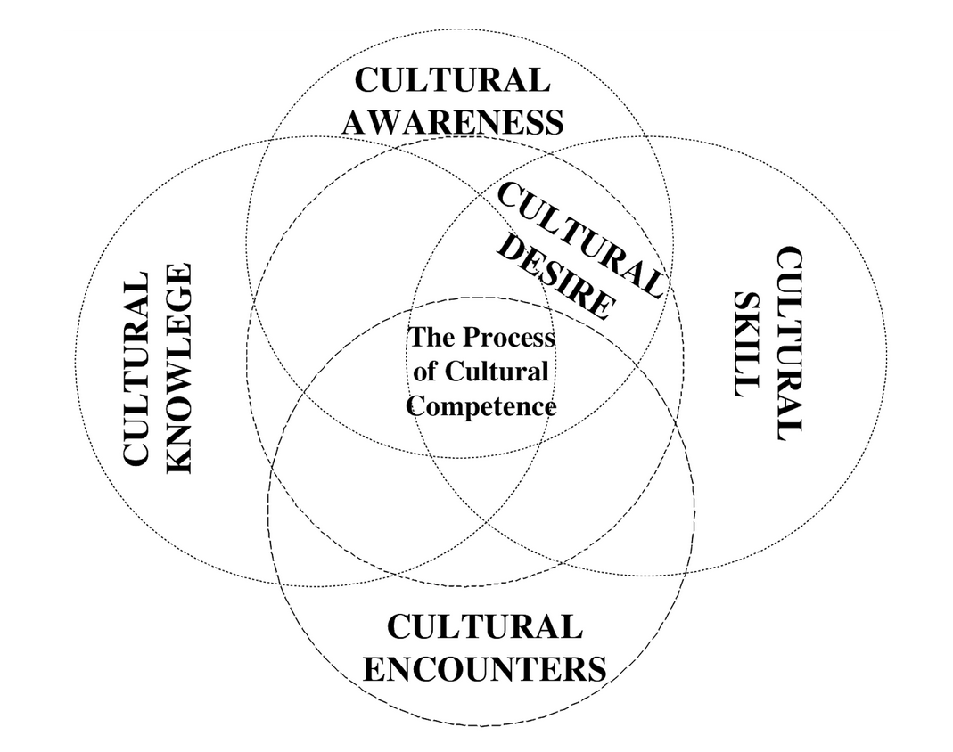
Figure 1: Process of Cultural Competence in the Delivery of Healthcare Services
According to the model, cultural awareness emanates from a conscious introspection of one’s cultural background to ensure an understanding of individual biases towards people from other cultures. Cultural knowledge involves maintaining open-mindedness, which fosters the acknowledgment of variations in cultural beliefs and ethnic traits that shape individuals’ attitudes to health and illness. Cultural skill involves adjusting care based on client information to meet their specific cultural beliefs, values, and practices. Cultural encounters entail the proactive efforts and encouragement of interactions with culturally diverse groups with the aim of identifying personal prejudices and understanding the other cultures’ beliefs, values, and practices. Finally, cultural desire refers to individual inclination to interact with culturally diverse groups to enhance self-efficacy in delivering culturally congruent care. While the five concepts have commensurate importance in ensuring cultural competence, Fitzgerald and Campinha-Bacote (2019) emphasized cultural encounters as the foundation for developing the other capabilities.
The model incorporates concepts from diverse theories, including psychosocial models of care, transcultural nursing theory, and cultural anthropology. Leininger’s Theory of Culture and Care Diversity and Universality informs the concepts based on its emphasis on adapting to patients’ cultural contexts (Leiniger, 2006). In extending the theory, Campinha-Bacote model offers a structured process for the development and enhancement of cultural competence based on its conceptualization as an ongoing process. In addition, the model draws significantly from Bandura’s social learning theory that posits that learning of norms, values, and behaviors involves observing and interacting with others within social contexts (Bandura, 1977). In this regard, interacting with diverse patient population (cultural encounters) fosters learning about others’ cultural values, beliefs, and practices. The need for ongoing improvement of cultural competence aligns the Campinha-Bacote model with the critical race theory. The theory acknowledges the entrenched nature of racism in social institutions. Pertaining to the health care system, this applies the need to engage in continuing efforts to address structural inequalities based on the recognition of the effect of systemic racism on health disparities (Todic et al., 2022).
The model aligns with the cultural context of the poor, especially in relation to addressing mental health problems. For instance, the model shows the need to acknowledge cultural dimensions of mental health, including individuals’ beliefs and attitudes towards psychiatric disorders, Western medicine. In turn, this could affect their health-seeking behaviors and adherence to treatment plans or medication. In many marginalized urban poor groups, religious, cultural, and socioeconomic factors lead to stigma and misunderstanding of mental health disorders (Ahad et al., 2023). Consequently, this model offers mental health professionals a way of navigating the complex interplay of factors through cultural encounters, awareness, skill, and knowledge. Consistent with the group’s collectivist values, I resonate with the importance of community-centered mental health care. Community mental health services involve a holistic approach to care that recognizes the importance of biological, psychological, psychological, and spiritual factors in addressing social determinants of mental health (van Genk et al., 2023). Based on the concept of cultural desire, this implies the need for lifelong learning and continued motivation to understand different cultural backgrounds.
In addition, my core values as a DNP student mirror the components of the model. In caring for diverse populations, I espouse values such as equity, patient-centered care, and ethical accountability. From the model’s perspective, this implies that addressing health disparities and ensuring health equity depends on a continuous journey of learning about other cultures and the influence of the cultural values on their health-related behaviors (Hernandez & Gibb, 2019). Cultural encounters cultivate positive relationships with diverse patients, fostering trust and patient-centered care. For example, the encounters could provide a comprehensive understanding of subjective beliefs and attitudes towards psychotropic medications, enabling tailored interventions to address the problem. Cultural awareness could contribute to efforts towards improving health equity for the urban poor. Through self-reflection, I could understand personal prejudices and assumptions that may contribute to inequitable care delivery. In turn, this provides a basis to commit to cultural competence as a professional responsibility for high-quality and equitable care.
Cultural Competence in Advanced Practice as a NP/DNP
Sociodemographic changes in the country have led to a culturally diverse population and cemented the importance of cultural competence in nursing. Among advanced practice registered nurses (APRNs), this implies taking leadership roles in creating a vision and implementing strategies that enhance transcultural synergy within practice settings (Teixera et al., 2023). In serving vulnerable populations, for instance, the diverse urban poor, NP/DNPs should gear towards achieving optimal cultural competence that goes beyond empathy and compassion. Consequently, this requires establishing a culturally safe care environment, acknowledging cultural differences, and establishing therapeutic relationships with patients. Delivering culturally congruent care would imply viewing mental health problems from patients’ perspectives and understanding their cultural values and beliefs in supporting them to develop treatment goals.
In my practice, the care for an adolescent who recently immigrated from a conflict-affected part of Nigeria and currently living in a socioeconomically and disenfranchised neighborhood would serve as a specific scenario. As with many urban poor, the patient could be facing a range of problems, including face food insecurity, housing instability, and negative experiences with the system, besides mental health symptoms that may require immediate attention. Biased cultural beliefs about mental health problems and historical experiences of disenfranchisement and colonization could create mental health professionals and Western medicine, reducing the patient’s willingness to seek help or open up. Based on the Campinha-Bacote (2002) model, care for this patient would reflect several expectations for me as a DNP. Broadly, the expectations would focus on creating a culturally safe and trust-based environment that values and respects the clients’ cultural beliefs and values. Interacting with additional members of the group (cultural encounters) would serve as a foundation for culturally congruent care. As supported by Leyva-Moral et al. (2023), cultural encounters help in understanding and appreciating others’ cultural beliefs, practices, and the underpinning historical issues. Every encounter with a member of the group would provide a deep understanding of the unique group needs that inform tailoring of interventions. Consequently, this would improve my cultural knowledge, which is essential to respecting the patient’s cultural beliefs and practices during care delivery.
Moreover, navigating the situations would require understanding personal biases and prejudices (cultural awareness) and committing to lifelong learning about other cultures (cultural motivation). According to Stubbe (2020), optimal cultural competence requires lifelong self-critique and self-evaluation of the personal biases that could hinder optimally congruent care. The components would help in addressing possible power imbalances with patients, demonstrating openness during communication, and portraying cultural sensitivity. For example, cultural awareness would inform approaches to establishing trust-based relationships and providing care through a non-judgmental way. Moreover, cultural desire would ensure commitment to lifelong learning, with the aim to understand the broader social determinants of health that may influence mental health problems. For instance, it could help in understanding the disparate effects of poverty on mental health, the levels of resilience, and the availability of coping resources. Finally, this would translate to modifying my practice by aligning care with individual patients’ socioeconomic and cultural contexts. For example, this could involve active approaches to addressing stigma, using understandable and accessible language, and acknowledging the effects of financial constraints when developing the treatment plan.
Adapting the approach used to the patient scenario would require understanding the covert and overt factors that could influence the patient’s experiences and tailoring care to meet specific needs. While structured mental health assessment could benefit, it would be essential to adapt it to the patient’s culture and language. In supporting the perspective, Kaiser et al. (2020) observed that the cross-cultural translation of assessment tools could impede optimal care because of the non-equivalence of languages or the consideration of some items as stigmatizing. In this regard, I would adapt the assessment by contextualizing it to the cultural context and maintaining sensitivity. Indeed, flexibility is required in applying structured clinical assessments to account for patients’ formulation of mental health disorders and embed language relevant to patients’ local idioms of psychological distress (Kyrillos et al., 2023). In addition, adapting my approach would involve a focus on the broader social determinants of mental health. Factors such as housing, the availability of social support, English language proficiency, employment, and discrimination could significantly affect help-seeking behaviors, adherence to treatment, and mental health outcomes of immigrants (Rashki Kemmak et al., 2021). In adapting my approach, I would emphasize collaboration with social workers, community-based organizations, and other relevant stakeholders to address the patients’ needs holistically. In addition, I would factor in the patient’s realities when creating his treatment plan. For example, this could involve prescribing affordable and accessible drugs and psychotherapies that align with his financial situation. Finally, I would engage in ongoing self-reflection and continuous professional development to enhance my cultural competence. The approaches would ensure alignment of care with individual needs and respect for their cultural beliefs, practices, and values.
Conclusion
The population living in poverty in the U.S. urban centers comprises of a culturally and linguistically diverse group, including undocumented immigrants and racial/ethnic minorities. Lack of employment, exposure to violent crime, and housing insecurity are prevalent in this group. In addition, the group is vulnerable to systemic racism, discrimination, and social marginalization that exacerbate the effects of poverty on mental health. Delivering optimal, timely, and quality care to the population requires DNP-prepared nurses to understand the unique cultural, health, and socioeconomic challenges affecting each group. Demonstrating cultural competence could foster the implementation of strategies that address the multifaceted disparities, leading to improved mental health outcomes.
As revealed, the Campinha-Bacote model offers APNs an indispensable framework for the enhancement of cultural competence among APNs. Based on the five components of the model, APNs can deliver culturally congruent care based on a comprehensive understanding and appreciation of unique cultural values and beliefs. The historical experiences of most people living in poverty within urban areas implies the need for trust-based relationships. By interacting with members from this populations, a DNP-prepared nurse would be better positioned to tailor care according to needs. In addition, addressing the diverse disparities requires self-reflection to prevent personal biases and prejudices from affecting the care process.
APNs have a professional obligation to reduce healthcare disparities and promote health equity. The increasing population diversity requires APNs to continually enhance their cultural competence to foster culturally safe environments responsive to unique patient needs. Applying cultural competence in care delivery would help in acknowledging the broader social determinants that affect the population. In addition, this implies the need for a broader perspective in addressing healthcare disparities for marginalized groups, including engaging in leadership and advocacy. Such efforts could improve the patient-centeredness of care and result in equitable and accessible care.
Overall, the paper illustrates the importance of embracing cultural competence as an ongoing process rather than a static goal. In efforts to improve care for a diverse population, APNs should commit to self-reflection, continuous learning, and encounters with different patient populations. In this way, nurses gain a comprehensive understanding of their biases and prejudices that could affect their efficacy in care delivery, as well as the complex needs of the populations served. The adaptation of practice to align with individual patient needs and preferences contribute significantly to equitable and culturally congruent care for the urban poor population.

References


