National Practice Problem Identification
Resources
The following websites provide information and data on the complex health disparities from the global to local perspective. The websites allow you to look at the global, national, regional, state, and local levels, showing the incidence and prevalence of disease. Explore the websites to identify an area of interest to you.
This link will take you to a site where there are many areas where you can review the Global Burden of Disease and prevalence. Take a moment to review this important information data!
- Link (website): Global Burden of Disease (GBD) (IHME)Links to an external site.
View main findings by country:
- Link (website): Country Profiles (IHME)Links to an external site.
View main findings in the United States:
- Link (website): United States of America Findings (IHME)Links to an external site.
Welcome to your first week of NR707. This will be an enriching course. This will be an exciting time as you implement your DNP practice change project! You have the potential to make a significant impact on healthcare outcomes through your project. In Week 1, the focus is on the role of the DNP-prepared nurse as the project manager and leader of the practice change project. Please take time to view and read the resources that will support your success. Remember that it is important to carve out time for project implementation. Your course faculty is here to guide you every step of the way, and it is critical to plan time for self-care as you juggle the many important school milestones with your career, family, and personal needs. All the best for success in Week 1!
Student Lesson Plan
Overview
- Program Competencies
- Course Outcomes
- Weekly Objectives
- Main Concepts
- Integrates scientific underpinnings into everyday clinical practice. (POs 3, 5)
- Applies organizational and system leadership skills to affect systemic changes in corporate culture and to promote continuous improvement in clinical outcomes. (PO 6)
- Uses analytic methods to translate critically appraised research and other evidence into clinical scholarship for innovative practice improvements. (POs 3, 5)
- Appraises current information systems and technologies to improve health care. (POs 6, 7)
- Analyzes health care policies to advocate for equitable health care and social justice to all populations and those at risk due to social determinants of health. (POs 2, 9)
- Creates a supportive organizational culture for flourishing collaborative teams to facilitate clinical disease prevention and promote population health at all system levels. (PO 8)
- Leads others in professional identity, advanced clinical judgment, systems thinking, resilience, and accountability in selecting, implementing, and evaluating clinical care. (POs 1, 4)
Schedule
Section | Read/Review/Complete | Course Outcomes | Due
Prepare | Assigned Readings | COs 1, 2, 4 | Wednesday
Explore | Lesson | COs 1, 2, 4 | Wednesday
Translate to Practice | Discussion: Introduction Posts | n/a | Wednesday
Translate to Practice | Discussion: Initial Post | COs 1, 2, 4 | Wednesday
Translate to Practice | Discussion: Follow-Up Posts | COs 1, 2, 4 | Sunday
Translate to Practice | Assignment 1 | COs 1, 4 | Sunday
Translate to Practice | Assignment 2 | COs 1, 4 | Sunday
Reflect | Reflection | COs 1, 2, 4 | No submission
Foundations for Learning
Alatawi, M., Aljuhani, E., Alsufiany, F., Aleid, K., Rawah, R., Aljanabi, S., & Banakhar, M. (2020). Barriers of implementing evidence-based practice in nursing profession: A literature review.Links to an external site. American Journal of Nursing Science, 9(1), 35-42.
Student Learning Resources
Click on the following tabs to view the resources for this week.
- Required Textbooks
- Required Articles
- Additional Resources
Bemker, M., Ralyea, C., & Schreiner, B. (2021). The successful completion of your DNP project: A practical guide with exemplars. DESTech Publications.
- Read Chapter 1
  - Section: DNP Role Emphasis on Direct Advanced Clinical Healthcare
  - Section: DNP Practice Settings
  - Section: The Future for the DNP
Learning Success Strategies
- Reflection on Learning: As you familiarize yourself with the course layout, you will see the system of information prepared for your learning. Please look at each section; moving systematically will assist you as you learn throughout the course.
  - The Prepare section will have the objectives and key terms and direct you to the readings to broaden your knowledge.
  - Moving next to the Explore section, there will be information about the topics and additional readings, links, and references to continue to build your knowledge.
  - Next, the Translate section is where you apply your new knowledge by answering the discussion questions for the week and completing the assignments.
  - Finally, we close off the week with a Reflect section to recap what you learned and give you pause to consider the value of the new knowledge you are gaining.
- Resources
  - Review the assigned readings to ensure you understand the key terms and relate them to the role of the DNP-prepared nurse.
  - Read the additional resources to understand the weekly topics. Supplemental resources are not mandatory but can provide additional knowledge and understanding of the course content.
  - Your course faculty is here to support your learning journey. Reach out for guidance with study strategies, time management, and course-related questions.
- Appointments & Forums
  - Attend the Let’s Check-In Student Forum when offered. In the weekly student forums, the course leader will offer an overview of the weekly concepts and discussions and discuss the assignments in detail. This is an opportunity to ask questions and connect with your online course community each week.
  - When implementing your DNP practice change project at the practicum site, meet with your preceptor (and mentor if applicable) weekly to share your DNP practice change project updates.
- Discussions
  - There are two parts to the discussions every week. All students respond to Part 1 and Part 2. Part 1 is focused on our course content. Part 2 is focused on updates for your practice change project. Be sure your project-related updates in Part 2 of the discussions are specific and robust. Write in detail so that your discussion creates a full 360-degree view or picture of what is happening in your implementation. There is no word limit for the project update Part 2 discussion.
  - Be ready to share your thoughts and leadership experiences through the interactive discussion. It is essential to share your thoughts so that we hear your voice. Also, support your positions with evidence from the literature. The use of first-person is accepted for the discussion board.
- Practicum Hour Logs
  - Log your practicum hours weekly.
  - Remember to use the resources in the Project & Practicum section of the DNP Program Resources page for guidance on these entries.
  - Enter no more than 4 hours for each entry and ensure that the activities represent the block of time requested. Be sure to select the correct DNP Essential and activity that matches your activity in your notes.
  - Check your practicum hours weekly to identify the number of hours you need to enter each week to reach your required practicum hours for our course. A best practice is to record your hours each week.
- Project
  - Complete the two non-graded assignments this week:
    - Student Attestation
    - IRB Approval Letters
  - As you review weekly content, consider how each concept and discussion can be translated into practice in your unique setting.
Interacting with Feedback
Each week your course faculty will provide feedback in the rubric on any assignment you have submitted. Take a moment to review the following video on how to view rubric feedback in Canvas. (After clicking the link, scroll down or click on the title in the Summary area to jump directly to the video.)
- Link (video): Looking at FeedbackLinks to an external site. (2:26)
Review the following video on how to accept/reject track changes when viewing course faculty feedback on your assignment:
- Link (video): Word: Track Changes and Comments (4:19)
- Lesson 2
- Project Management and Implementation
- Management and Implementation
- Watch the following video to explore the project management and implementation process:
- Project Management and Implementation (4:00)

Lesson 3
Stakeholder Communication

Foundational Communication Strategies
Throughout the didactic courses in the DNP degree program, you learned about stakeholder communication and engagement in the planning phase of your practice change project. It was essential to involve the stakeholders as soon as possible to receive their support during the design and implementation phases. It is now crucial to increase stakeholder communications throughout the implementation phase of the practice change project. Once again, the research holds the keys to the most common communication errors that lead to project failure and the recommendations for successful communication (Rajhans, 2018).
Communication errors that lead to practice change project failure:
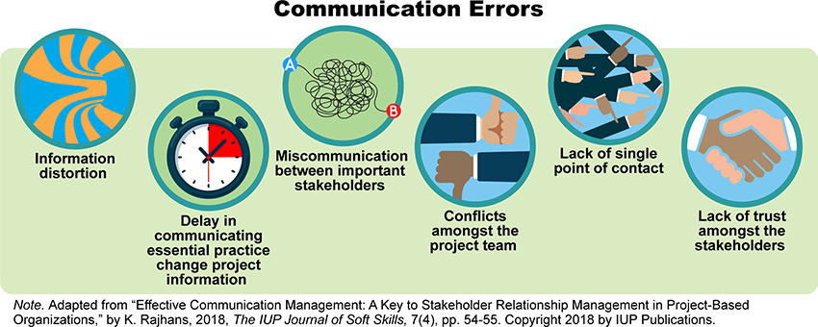

Communication Errors Image Description
Strategies for communication supporting practice change project success:
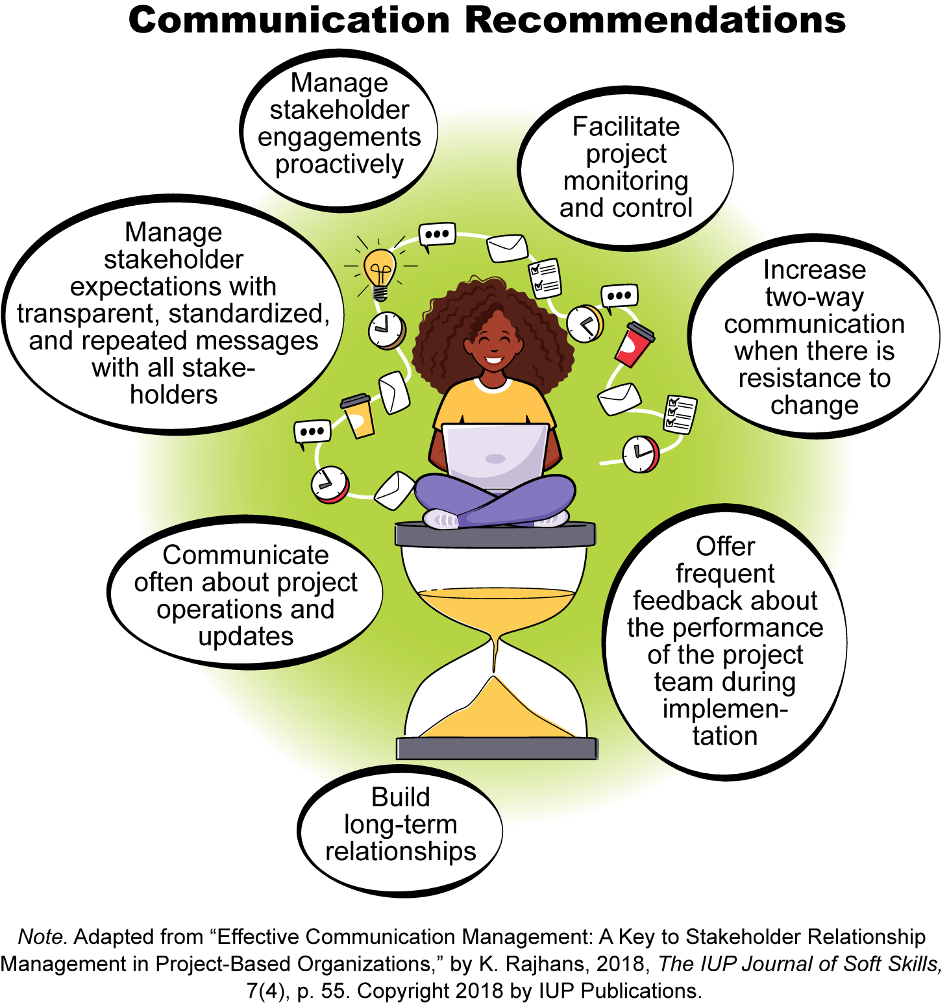

Communication Recommendations Image Description
References
Rajhans, K. (2018). Effective communication management: A key to stakeholder relationship management in project-based organizations. The IUP Journal of Soft Skills, 7(4), 47-66.
Week 1: Discussion | The Role of the DNP-Prepared Nurse as Project Manager
Week 1The Role of the DNP-Prepared Nurse as Project Manager
Discussion
Purpose
This discussion aims to explore the role of the DNP-prepared nurse as the project manager. A particular emphasis will be on project scope management and communication with stakeholders. During a project, problems are frequently related to the project scope and inadequate communication with stakeholders. Planning and implementing strategies to avoid scope creep and to provide ample stakeholder communication will support the project’s success.
Instructions
Students respond to all of the Part 1 and Part 2 questions every week. Use the numbered questions as headers in your response.
Part 1: General Discussion
Reflect upon your readings and professional experience and address the following in 150 words or less:
- Scope creep can cause project failure, especially when the complexity of the healthcare environment changes and the increased needs of the patients, stakeholders, or organizations are pressing. Propose your strategies to ensure the project scope remains intact for the implementation duration.
- Stakeholder communication is essential for a successful DNP practice change project. Explain your strategies for effective communication with stakeholders, including frequency and the method of communication. (For this discussion question, you may refer to our required article this week, Rajhans [2018], or other scholarly articles.)
Part 2: Implementation Update
For this week's implementation update, address the following:
- State your practice question in PICOT format.
- State the exact date the intervention began (or will begin) and the week number for your intervention implementation.
- Identify the current number of participants.
- Post the weekly details of your implementation plan so we can follow your implementation throughout this class. Include the exact dates for your project milestones (e.g., education, data collection cycles, enrollment, intervention implementation beginning, formative evaluation frequency, length of intervention implementation, transition to sustaining the practice change with stakeholders, and data analysis.)
- Provide a detailed update on your implementation progress. Include specific examples of successes, challenges, and barriers, and note any concerns.
For question #4, you may use the example below for guidance as needed.
- Week #: (date) Education and pre-implementation data collection, and stakeholder communication
- Week #: (date) Intervention implementation and formative evaluation frequency, and stakeholder communication (Frequency and type of communication may vary depending on stakeholder group.)
- Week #: (date) Data collection and stakeholder communication
- Week #: (date) Data analysis and stakeholder communication
Please click on the following link to review the DNP Discussion Guidelines on the Student Resource Center program page:
- Link (webpage): DNP Discussion GuidelinesLinks to an external site.
Program Competencies
This discussion enables the student to meet the following program competencies:
- Integrates scientific underpinnings into everyday clinical practice. (POs 3, 5)
- Applies organizational and system leadership skills to affect systemic changes in corporate culture and to promote continuous improvement in clinical outcomes. (PO 6)
- Uses analytic methods to translate critically appraised research and other evidence into clinical scholarship for innovative practice improvements. (POs 3, 5)
- Appraises current information systems and technologies to improve health care. (POs 6, 7)
- Analyzes health care policies to advocate for equitable health care and social justice to all populations and those at risk due to social determinants of health. (POs 2, 9)
- Creates a supportive organizational culture for flourishing collaborative teams to facilitate clinical disease prevention and promote population health at all system levels. (PO 8)
- Leads others in professional identity, advanced clinical judgment, systems thinking, resilience, and accountability in selecting, implementing, and evaluating clinical care. (POs 1, 4)
Course Outcomes
This discussion enables the student to meet the following course outcomes:
- Demonstrate effective project management strategies. (PCs 1, 2, 3, 4, 5; POs 2, 3, 6)
- Explore possible career trajectories for the DNP-prepared nurse and the contributions to healthcare to be achieved through those career options. (PCs 1, 2, 3, 4, 5; POs 2, 3, 6)
- Use project management processes to implement the DNP project. (PCs 6, 8; POs 4, 8)
Due Dates
- Initial Post: By 11:59 p.m. MT on Wednesday
- Follow-Up Posts: By 11:59 p.m. MT on Sunday

