Culture Paper Draft I
Name
School Affiliation
Course
Instructor
Date Due

Culture Paper Draft I
Poverty remains relatively higher in the United States compared to other developed countries. Among working-aged adults, poverty levels are above the cross-national median, especially in inner-city dwellings within Metropolitan Statistical Areas (Beech et al., 2021). Poverty is rampant among marginalized groups such as racial/ethnic minorities and immigrants who live in inner-city neighborhoods. The pernicious cycle is associated with inter-generational transmission of poverty, social stratification, persistent socioeconomic marginalization, structural racism, the interaction between culture and behavior, and gaps in public policy (Beech et al., 2021; Egede et al., 2021). Poverty can be an antecedent and also an outcome of mental health problems. The significant diversity of the urban poor population requires a comprehensive understanding of individual cultural factors that influence mental health outcomes. Proactive efforts are required in building a culturally competent nursing workforce capable of delivering culturally congruent care to individual subgroups.
Definition of the Group
Broadly, the urban poor population refers to city dwellers with limited economic security and social mobility who face notable challenges in negotiating society pertinent to education, employment, housing, and healthcare (Beech et al., 2021; Egede et al., 2021). Poverty is prevalent in inner-city neighborhoods that experience continued environmental, social, and economic deterioration from systematic resource removal and persistent segregation and isolation (Egede et al., 2021). According to Desmond (2023), people living in poverty across the country receive lower public aid compared to those from wealthy backgrounds, which reproduces the cycle of poverty. In addition, the urban poor population is exposed to higher levels of violent crime, unemployment, gun violence, mass incarceration, housing insecurity and evictions, and challenges in accessing healthcare services (Brady, 2023). Consequently, this leads to a disproportionate burden of mental health disorders because of the socioeconomic disadvantage.
The urban poor population characterizes significant diversity in terms of race, ethnicity, culture, and language. However, statistics show that minority groups such Asians, Hispanics, Blacks, and American Indians, non-native born Americans, and undocumented immigrants living in urban areas experience higher levels of poverty compared to non-Hispanic whites and native-born Americans (Iceland, 2019; Iceland, 2021). The disproportionate exposure to social determinant risks such as unemployment, socioeconomic disadvantage, lack of education, and discrimination have widened health disparities for the group, resulting in poor health-related outcomes (Knifton & Inglis, 2020). The diversity of cultural norms, traditions, and religious practices that influence interactions with healthcare providers in this group accentuates the importance of cultural competence to meet the needs for specific sub-groups.
Transcultural Theoretical Model and Graphic
The emergence of transcultural nursing in the 1950s led to the development and evolution of multiple transcultural theoretical models aimed at shaping cultural competence among nurses. The Process of Cultural Competence in the Delivery of Healthcare Services (the Campinha-Bacote model) is among the transcultural models used in nursing practice. The model conceptualizes cultural competence as an ongoing process of improving one’s self-efficacy in delivering care to diverse populations in diverse environments (Albougami et al., 2016; Campinha-Bacote, 2002). It incorporates five interrelated concepts relevant to cultural competence: “cultural awareness, cultural skills, cultural knowledge, cultural encounters, and cultural desire” (Figure 1).
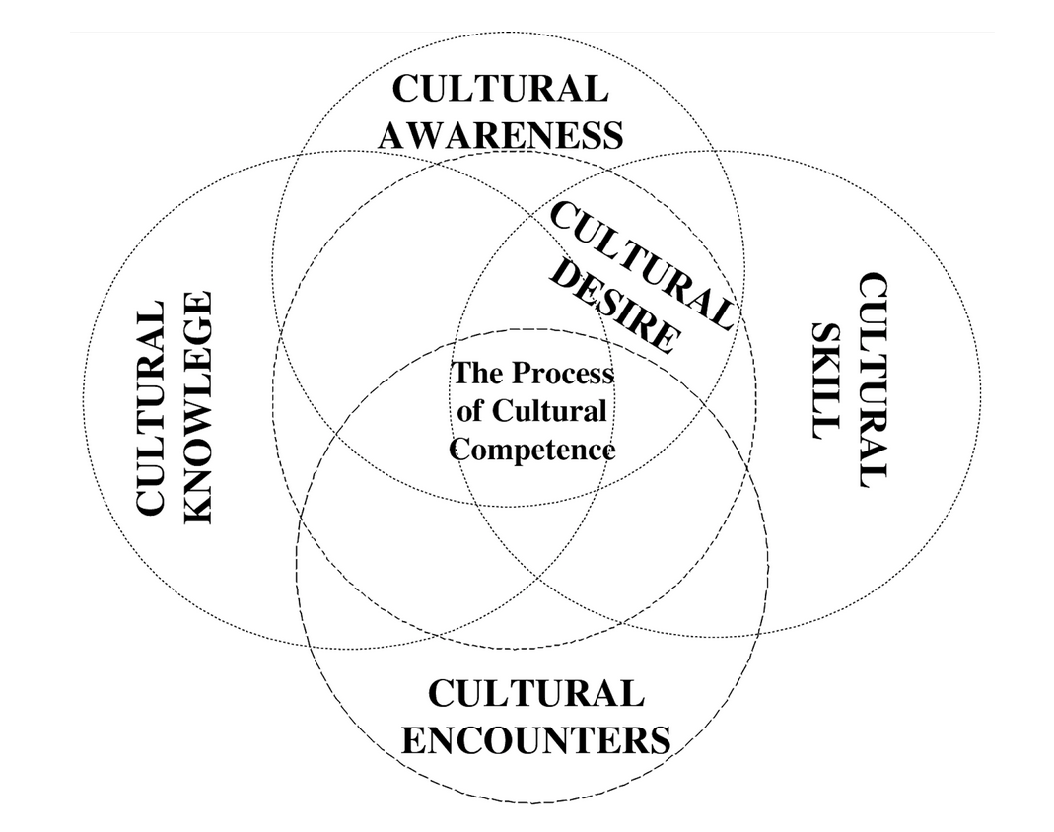
Figure 1: Process of Cultural Competence in the Delivery of Healthcare Services
According to the model, cultural awareness emanates from a conscious introspection of one’s cultural background to ensure an understanding of individual biases towards people from other cultures. Cultural knowledge involves maintaining open-mindedness, which fosters the acknowledgment of variations in cultural beliefs and ethnic traits that shape individuals’ attitudes to health and illness. Cultural skill involves adjusting care based on client information to meet their specific cultural beliefs, values, and practices. Cultural encounters entail the proactive efforts and encouragement of interactions with culturally diverse groups with the aim of identifying personal prejudices and understanding the other cultures’ beliefs, values, and practices. Finally, cultural desire refers to individual inclination to interact with culturally diverse groups to enhance self-efficacy in delivering culturally congruent care. While the five concepts have commensurate importance in ensuring cultural competence, Fitzgerald and Campinha-Bacote (2019) emphasized cultural encounters as the foundation for developing the other capabilities.
Cultural Competence in Advanced Practice as a NP/DNP
Sociodemographic changes in the country have led to a culturally diverse population and cemented the importance of cultural competence in nursing. Among advanced practice registered nurses (APRNs), this implies taking leadership roles in creating a vision and implementing strategies that enhance transcultural synergy within practice settings (Teixera et al., 2023). Based on their clinical expertise and knowledge in cultural competence, APRNs/DNPs could influence transformative changes that ensure culturally congruent care. For example, Berry et al. (2024) noted that APRNs could tap their advanced knowledge in using health literacy communication tools for culturally relevant health education among poor minority groups. As mentors of the future nursing workforce, APRNs/DNPs should also apply their advanced knowledge and mentorship skills in encouraging newly qualified nurses to engage in self-reflection on individual cultural biases towards other cultures and interactions with culturally diverse populations. In turn, this could enhance organization-wide cultural knowledge and cultural skill, leading to the delivery of culturally congruent care. Besides, this could involve implementing mentorship or training programs focused on cultural competence in nursing care. As supported by Červený et al. (2022), building organization-wide cultural competence would help in adapting care to the local cultural environment. Indeed, Kaihlanen et al. (2019) found that implementing a cultural competence program fostered open discussions around approaches to aligning care with the local cultures based on a comprehensive understanding of the varying cultural values and beliefs. Overall, APRNs/DNPs have a crucial responsibility in the delivery of culturally congruent care through mentorship, training, and leadership focused on cultural competence.
In summary, the increasing cultural diversity in the country’s population highlights the importance of ongoing efforts to enhance cultural competence in the nursing workforce. The competence is essential in meeting unique needs of specific populations such as the urban dwellers living in poverty. As revealed, this population faces a disproportionate burden of disease because of exposure to social determinant risks such as high unemployment rates, lack of education, discrimination, and inadequate access to healthcare services. However, meeting the needs of this population requires a comprehensive understanding of individual sub-group cultural beliefs, values, and traditions. To this end, the Campinha-Bacote (2002) model could be used in shaping cultural competence among nurses serving this population. By encouraging cultural encounters, nurses working in this environment could understand individual subcultures and their influence on health-related beliefs and practices. APRNs should take a frontline role in ensuring cultural competence, for instance, by leading the development of strategic visions that emphasize transcultural synergy, mentoring other nurses, and implementing training programs. Future research should explore specific factors that should be addressed in enhancing cultural competence in care delivery for the highly diverse urban poor population.

References
Albougami, A. S., Pounds, K. G., and Alotaibi, J. S. (2016). Comparison of four cultural competence models in transcultural nursing: A discussion paper. International Archives of Nursing and Health Care, 2(4), 2–5.
Beech, B. M., Ford, C., Thorpe, R. J., Jr, Bruce, M. A., & Norris, K. C. (2021). Poverty, racism, and the public health crisis in America. Frontiers in Public Health, 9, 699049. https://doi.org/10.3389/fpubh.2021.699049
Berry, J. A., Cranford, J., & Powell, R. (2024). The stress of advancement: A nurse practitioner's exploration in providing culturally competent obesity prevention counseling in Black Women. Health Promotion Practice, 15248399231221767. Advance online publication. https://doi.org/10.1177/15248399231221767
Brady D. (2023). Poverty, not the poor. Science Advances, 9(34), eadg1469. https://doi.org/10.1126/sciadv.adg1469
Campinha-Bacote J. (2002). The Process of Cultural Competence in the Delivery of Healthcare Services: a model of care. Journal of Transcultural Nursing: Official Journal of the Transcultural Nursing Society, 13(3), 181–201. https://doi.org/10.1177/10459602013003003
Červený, M., Kratochvílová, I., Hellerová, V., & Tóthová, V. (2022). Methods of increasing cultural competence in nurses working in clinical practice: A scoping review of literature 2011-2021. Frontiers in Psychology, 13, 936181. https://doi.org/10.3389/fpsyg.2022.936181
Desmond, M. (2023). Poverty, by America. Crown.
Egede, L. E., Walker, R. J., Campbell, J. A., Dawson, A. Z., & Davidson, T. (2021). A new paradigm for addressing health disparities in inner-city environments: Adopting a disaster zone approach. Journal of Racial and Ethnic Health Disparities, 8(3), 690–697. https://doi.org/10.1007/s40615-020-00828-1
Fitzgerald, E., & Campinha-Bacote, J. (2019). An intersectionality approach to the process of cultural competemility–Part II. Online Journal of Issues in Nursing, 24(2). https://doi.org/10.3912/OJIN.Vol24No02PPT202
Iceland J. (2019). Racial and ethnic inequality in poverty and affluence, 1959-2015. Population Research and Policy Review, 38(5), 615–654. https://doi.org/10.1007/s11113-019-09512-7
Iceland J. (2021). Hardship among immigrants and the native-born in the United States. Demography, 58(2), 655–684. https://doi.org/10.1215/00703370-8958347
Kaihlanen, A. M., Hietapakka, L., & Heponiemi, T. (2019). Increasing cultural awareness: qualitative study of nurses' perceptions about cultural competence training. BMC Nursing, 18, 38. https://doi.org/10.1186/s12912-019-0363-x
Knifton, L., & Inglis, G. (2020). Poverty and mental health: policy, practice and research implications. BJPsych Bulletin, 44(5), 193–196. https://doi.org/10.1192/bjb.2020.78
Teixeira, G., Cruchinho, P., Lucas, P., & Gaspar, F. (2023). Transcultural nursing leadership: A concept analysis. International Journal of Nursing Studies Advances, 5, 100161. https://doi.org/10.1016/j.ijnsa.2023.100161

