The Implementation of a Cultural Competence Educational Intervention
in a Psychiatric Mental Health Setting

A Scholarly Project

Presented to

The Faculty of Regis College

In Partial Fulfillment
of the Requirements of the
Doctor of Nursing Practice Degree

by

Bruce Nsubuga, MSN, RN

March 21, 2025

Abstract
[Refer to APA Publication Manual, 2020, p. 38]
Problem Statement:
Purpose:
Methods:
Inclusion Criteria:
Analysis:
Implications for Practice:
Keywords: (list three to five key search words for this project)
[Refer to APA Publication Manual, 2020, p. 38]

Signature Page

This scholarly practice project of _____________, entitled _____________________directed and approved by the faculty chair, has been accepted by the Nursing Faculty of Regis College in fulfillment of the requirements for the Doctor of Nursing Practice.

__________________________________________
Dean, Richard and Sheila Young School of Nursing

__________________________________________
Chair, Doctoral Scholarly Project Team, (credentials)

__________________________________________
Team Member, (credentials)

__________________________________________
Team Member, (credentials)

___________________________________________
Team Member, (credentials)

Add an additional signature line for each additional team member.

[This page is a temporary placeholder which will be replaced with the signature page signed by all project team members.]

Acknowledgments
[This page acknowledges those who helped complete the project: colleagues, faculty, project participants, and personal assistance. Refer to APA Publication Manual, 2020, p. 36-37.]

Table of Contents
[Insert a Table of Contents. https://support.microsoft.com/en-us/office/insert-a-table-of-contents-882e8564-0edb-435e-84b5-1d8552ccf0c0]

List of Tables [Start on a new page]
Table 1. The table title belongs here

List of Figures [Start on a new page]
Figure 1. The figure title belongs here

Implementation of a Cultural Competence Educational Program in Psychiatric Mental Health Settings

Chapter I
Introduction
In the United States, research highlights a considerable demographic shift driven by snowballing cultural diversity, largely due to the rise in international migration (Sahamkhadam et al., 2023). The transformation presents both opportunities and challenges, particularly in healthcare. The cumulative diversity provides a need for a proficient nursing workforce which can provide culturally competent care to their clients. Rice and Harris (2021) postulate that cultural competence serves as an underpinning that empowers patients to feel contented with their clinician and continuously seek out critical care. While the patient population has become more diverse, the healthcare workforce has not kept pace with this growing heterogeneity, which can contribute to disparities in health outcomes (Marcelin et al., 2019). The psychiatric mental health care is still one of the most underutilized services within the continuum of care despite its purported catholicity. Therefore, addressing these challenges is critical to ensuring the delivery of culturally competent and sensitive care, essential for meeting the needs of an increasingly diverse society (Stubbe, 2020). The delivery of culturally competent care is requisite to expedite access to culturally equitable care for the diverse patient cohorts (Fante-Coleman & Jackson-Best, 2020).
Evidence indicate that cultural competency has become a critical prerequisite for mental health nurses catering to culturally divergent patient groups. As such, it is vitally important to train psychiatric mental health registered nurses to ascertain they provide culturally competent care (Raval et al., 2024). Cultural competence training enhances healthcare delivery processes and mitigate abysmal patient outcomes (Sahamkhadam et al., 2023). Patients seeking mental healthcare frequently occur at manifold stages of society such as systemic, provider-connected, and individual-linked barriers. Specifically, provider-akin barriers entail racism and discrimination from clinicians, the ineptitude to deliver culturally competent care and the paucity of organizational backing (Fante-Coleman & Jackson-Best, 2020). Nonetheless, a culturally competent psychiatric nursing workforce serve as enablers of cultural competence.
Training a nursing personnel in cultural competence boosts their capacity to delivering cultural effective and sensitive care. The training can result in optimal outcomes such as aligned treatment care plans and enhanced patient engagement (Sahamkhadam et al., 2023; Nair & Adetayo, 2019; Stubbe, 2020). Research also suggests that a lack of cultural competence can contribute to unconscious biases, stereotypes, and microaggressions among healthcare providers, which may further alienate patients and discourage them from seeking necessary care (Cruz et al., 2019; Stubbe, 2020). The scholarly practice project (SPP) will explore the effect of a cultural competence education program in psychiatric mental health setting. The principal investigator (PI) will implement the intervention in a homecare agency that provides comprehensive and holistic medical and mental health services. The cultural competence education program will foster greater cultural understanding among healthcare providers and aim to augment care delivery as well as patient experiences.
Background
Nurses' cultural competence and the cumulative diversity of patient populations directly influences cognitive mental health services (AHRQ, 2019). As such, training nurses on cultural competence can improve their clinical practice efficiency and lessen healthcare disparities in culturally diverse populations (Eken et al., 2021). Psychiatric nurses, who regularly interact with patients to improve their health, consider themselves moderately culturally competent (Sahamkhadam et al.,2023). Chu et al. (2022) discovered that engaging and working in tandem with clients from different cultural settings can boost healthcare providers' cultural competence. However, prior to collaborating with patients, nurses should identify their individual biases, norms, and prejudices to become well-suited to provide bespoke and efficient healthcare services that esteem and prioritize patients' cultural identities (Sahamkhadam et al., 2023).
Culturally edified psychiatric personnel are effectively equipped to provide cultural rapport and competent care to their clients, expediting access to care (Fante-Coleman & Jackson-Best, 2020). However, research studies state that a paucity of cultural understanding can have dire repercussions for the providers during client interactions. For instance, they may radiate an unyielding demeanor and cease to recognize their client’s anguish on account of poor therapeutic alliance (Fante-Coleman & Jackson-Best, 2020). As such, the providers may inadvertently dismiss patients by not including them during treatment decisions and tailoring informed care plans. These challenges may precipitate inadequate patient outcomes and instigate numerous health inequities (Alkhamees & Alasqah, 2023). Patients from marginalized and minority groups often experience barriers to care like stigma and biases, which negatively affect their quality of life and determination to seek appropriate psychiatric care (Cruz et al., 2019; Gopal et al., 2021). Stubbe (2020) opined that most nurses experience delivery complexities when caring for clients from varied cultural affiliations.
The challenges may perpetuate a lack of culturally competent care, and workflow ineffectiveness. As such, nurses should use these experiences as a driving force to engage in cultural competence training and lifelong learning to address the ever-evolving health requirements of divergent healthcare clientele (Desai et al., 2020). Essentially the aptitude to deliver culturally competent care can be attributed to the impeccability of providers in offering culturally holistic, congruent, and sensitive care, making it easier for them to accomplish ideal healthcare delivery processes and patient outcomes (Desai et al., 2020). Cultural competence accredits nurses with satisfactory expertise in providing equitable care which complements the inimitable health necessities of patients from disparate cultural backgrounds (Arruzza & Chau, 2021). Even so, an inadequacy in cultural competence among mental health nurses can prompt redundant medical blunders which can increase incompetence’s (Chu et al., 2022).
Some clinicians are often adamant in recognizing their biases and may make assumptions that patients are apathetic in receiving necessary care, giving rise to a gamut of health inequalities like discrimination, microaggressions, and unawareness (Handtke et al., 2019). When nurses project their prejudices and bias towards patients from diverse cultural backgrounds, they become culturally insensitive and fail to address the patients’ diversity. As such, they may stereotype their clients, especially those seeking mental health care and make hurtful statements which may lead to microaggressions (Cruz et al., 2019). These consequences may lead to misunderstanding patients’ cultural representations of their experiences, contributing to distrust of the psychiatric healthcare system (Fante-Coleman & Jackson-Best, 2020). It is critically important to note that the outcomes may dishearten clients, making it difficult for them to seek the care they so deserve. Unfortunately, the lack of proper treatment mechanisms can deteriorate their quality of life and upsurge the risk of mortality and morbidity rates (Cruz et al., 2019).
According to Handtke et al. (2019), a variety of nurses’ report that they grapple with the lack of cultural understanding, particularly in scenarios in which clients do not constantly adhere to the stipulated treatment recommendations. The process enhances nurse’s negative assumptions and may presume the patients do not value their well-being. The misunderstanding may alienate patients from engaging in mental health services and impede access to quality care (Fante-Coleman & Jackson-Best, 2020). Similarly, when clients with pain issues request for pain medication, nurses might put labels on the clients by referring them to as drug-seekers rather than individuals grappling with mental health ailments (Cruz et al., 2019). These assumptions and typecasts can aggravate healthcare disparities, such as discrimination, language impediments, and lack of cultural awareness (Handtke et al., 2019).
Mental healthcare providers also face difficulties akin to organizational barriers such as praxis which makes it difficult to bridge the gap between acknowledging the necessity for equitable care and implementation within the paradigm of care (Fante-Coleman & Jackson-Best, 2020). Therefore, clinicians ought to introduce cultural competence training at their workplaces to better fathom their patients' cultural behaviors and tailor treatment plans that are reliant on their values (Fante-Coleman & Jackson-Best, 2020). Introducing a cultural competence education program will boost cultural competence among providers. As a result, patients may feel comfortable expressing their health concerns and adhering to the administered treatment plans. As United States continues to diversify, providers may register an increment in healthcare inequalities, making it paramount for Doctor of Nursing Practice (DNP) scholars and other practitioners to implement cultural competence training within the continuum of care (Sahamkhadam et al., 2023).
The strategic approach ensures that providers are well-equipped to provide culturally competent care. Cultural proficiency plays a critical role in helping nurses recognize their biases and respect the diversity of their patients (Lin & Hsu, 2020). More so, cultural competence improves nurse’s cultural awareness, enabling them to provide more sensitive care and lessen existing healthcare disparities (Rukadikar et al., 2022). As vital affiliates of the healthcare system, nurses are responsible for building trust with patients, streamlining psychiatric care processes, and addressing challenges arising from cultural differences (Lin & Hsu, 2020). On the other hand, healthcare administrators and leaders are central in promoting cultural competence by educating nurses to espouse essential elements such as cultural understanding, knowledge, motivation, experiences, and skills (Kaihlanen et al., 2019).
Cultural competence is closely linked to cultural awareness because it develops effective communication between nurses and patients from diverse backgrounds. It also helps nurses design effective care strategies (Handtke et al., 2019). According to Arruzza and Chau (2021), training healthcare providers in cultural competence elevates their skills, leading to better treatment outcomes, higher patient satisfaction, and efficient information sharing. While cultural competence is an unending procedure that inspires clinicians to familiarize their care practices with the needs of diverse patients more effectively, there are still barriers to fully integrating cultural competence education into healthcare (Liu et al., 2021).
Impact of Discrimination on Patient Experiences
It is critical for healthcare organizations to edify their workforce, on effective strategies such as cultural competence training and materials to help providers better understand the diverse cultural backgrounds of their patients (Nair & Adetayo, 2019). The lack of culturally competent care can precipitate poor health outcomes, both mentally and physically (Cruz et al., 2019). A major approach to mitigating this gap is promoting cultural competence discourse to understand the impact of prejudice and discrimination on patients. The training through discussions can help nurses understand the eminence of cultural competence education (Chu et al., 2022). On the other hand, healthcare leaders can strengthen more culturally sensitive care by amalgamating training initiatives with organizational guiding principles designed to eradicate racism and discrimination (Chu et al., 2022). The project will assess the impact and significance of cultural competence training on healthcare providers' knowledge, attitudes, and behavior, as well as its effect on patient outcomes. As such, the assessment will help raise awareness on the current gaps and provide effective ways of addressing them.
Significance
Cultural competence is a significant topic which healthcare providers are mandated to incorporate in their practice (Rukadikar et al., 2022). Cultural competence allows providers deliver respectful and empathic care that holds in high regard the diverse beliefs, values, and behaviors of patients with dissimilar characteristics. It is important for nurses to espouse culturally informed and health-literate approaches to enhance competence (AHRQ, 2019). For instance, when they fail to adopt cultural competence strategies, they are susceptible to jeopardizing their clients’ safety and instigating adverse disparities, such as diagnostic errors, missed screenings, adverse medication reactions, and substandard cognitive health services (AHRQ, 2019). There are merits associated with cultural competence training such as augmented nurses’ awareness, understanding, knowledge, and skills, positive behavioral vicissitudes and better patient outcomes (Sahamkhadam et al., 2023). Thus, training nurses in cultural competence can assist nurses, overcome cultural differences, and build a stronger culture of trust and transparency (AHRQ, 2019). Cultural competence is essential across nursing, research, clinical practice, education, and leadership.
Nursing Practice
Culturally competent nurses demonstrate increased knowledge, behaviors, and attitudes that improve the efficiency of mental healthcare delivery (Nair & Adetayo, 2019; Chae et al., 2020). Additionally, nurses who are culturally aware are better equipped to meet their patients' health needs, resulting in timely diagnoses, effective treatments, and stronger relationships throughout the care process (Stubbe, 2020. In nursing practice, positive communication and affinity between patients and providers enhance patients’ engagement and adherence to treatment plans (Stubbe, 2020). However, biases, stereotypes, and microaggressions can undermine cultural competence, potentially harming the quality of care within healthcare sector (Stubbe, 2020). Additionally, language and cultural barriers can lead to miscommunication, making patients less likely to follow treatment recommendations and resulting in poorer outcomes (Arruzza & Chau, 2021).
Nurses should prioritize educational programs associated with cultural proficiency so as to provide adequate patient-centric care (Lin & Hsu, 2020). Regardless of their own cultural background, nurses who are culturally competent can offer care that aligns with patients' values, attitudes, and behaviors, highlighting the importance of ongoing cultural competence education. Healthcare disparities can be addressed when organizations, administrators, and nurse leaders collaborate to promote cultural competence through training and continuous learning. These initiatives help the workforce better understand patients' cultural affiliations, which encourages patients to be more engaged and open about their care (Lin & Hsu, 2020). Cultural competence among providers gives rise to positive patient outcomes such as treatment adherence, satisfaction, and engagement improve. Healthcare gaps can be tackled by ensuring the entire team of clinicians are well-educated on the tenets of cultural competence (Sahamkhadam et al., 2023).
Nursing Education
Nursing tutors should assimilate cultural competence training into the nursing curriculum to better prepare nurses to deliver optimal care that aligns with their clients cultural preferences and needs (Ličen & Prosen, 2023). Therefore, inculcating nurses on cultural competence can boost their cultural knowledge and enable them to address care gaps that arise from cultural differences. Teaching nurses to provide unbiased care creates a more skilled, diverse, and confident nursing workforce capable of addressing the distinct needs of their patients (Arruzza & Chau, 2021). This approach ultimately enhances healthcare delivery and patient outcomes. Nursing institutions face challenges in creating comprehensive curricula that cover all aspects of cultural competency. Therefore, nursing educators must reassess the methods used to teach cultural competence and ensure that future nurses are equipped to provide culturally appropriate care (Arruzza & Chau, 2021).
Nursing Leadership
Culturally competent leadership helps enhance staff engagement and motivation, encourages innovation, and promotes the adaptation of diverse cultural practices, all of which improve patient care (Cerveny et al., 2022). By focusing on patient-centered care, culturally competent leaders create a healthcare environment that values individualized understanding and high-quality care (Gulati & Weir, 2022). Nurse leaders should emphasize the development of skills, knowledge, and attitudes necessary for providing culturally competent care. These efforts can improve patient-provider relationships and empower nurses to design care plans that are culturally appropriate (Arruzza & Chau, 2021). Nurse leaders and managers play a crucial role in advocating for cultural competence within their institutions. They create strategies to implement culturally sensitive practices and inspire culturally competent behavior throughout the workforce (Manlangit et al., 2022).
Nursing Research
Cultural competence is also essential in nursing research, as it helps researchers develop effective training approaches and communicate the importance of culturally competent care (Kaihlanen et al., 2019). Research on cultural competence provides insights into cultural awareness, skills, and knowledge, helping address differences in cultural expression and improving care delivery (Sahamkhadam et al., 2023). Studies consistently show that cultural competence enhances healthcare providers’ ability to navigate multicultural encounters and promote inclusive care (Cerveny et al., 2022).
Problem Statement
A lack of cultural competence among nurses can hinder their ability to deliver effective care to patients with diverse cultural backgrounds, beliefs, behaviors, and values (Nair & Adetayo, 2019). This gap in cultural understanding can lead to challenges such as miscommunication, mistrust, and patient dissatisfaction, ultimately compromising the quality of care (Arruzza & Chau, 2021). Microaggressions and biases toward marginalized populations can further exacerbate these issues, contributing to provider insensitivity and misunderstandings that negatively impact patient outcomes (Cruz et al., 2019). Culturally competent leadership recognizes the importance of comprehending patients' cultural backgrounds and experiences, facilitating the delivery of culturally competent care (Gulati & Weir, 2022). It is essential to address the lack of cultural competence to promote inclusivity and equity and ensure that all patients, regardless of cultural or linguistic differences, receive high-quality mental healthcare.
At the project site, the PI conducted a needs assessment prior to initiating the project which will be implemented in a psychiatric homecare agency that serves patients with a range of mental health conditions. The needs assessment survey revealed that the cultural competence of mental health nurses fell below expected standards. Nurses reported difficulties in caring for culturally diverse patients, particularly those with limited English proficiency, due to a lack of access to interpreters. These challenges contributed to systemic barriers such as, missed appointments, poor medication management, and disruptions in the delivery of mental health care. The principal investigator shared these findings with the unit's charge nurse and hospital administration, identifying gaps in practice and proposing the targeted intervention. This scholarly practice project will implement a cultural competence education program in the mental health unit to evaluate its impact on improving the efficiency and quality of mental healthcare delivery.
Clinical/Practice Question(s)
The project will employ the PICO(T) framework, which is an extensively acknowledged and operative strategy in clinical research. PICO(T) stands for Population (P), Intervention (I), Comparison (C), Outcome (O), and Time (T). The following is the clinical query for this project:
Does the implementation of a culturally competent educational intervention improve the levels of confidence in the use of cultural competence for psychiatric mental health registered nurses?
Purpose of the Project
The overarching determination of the project is to investigate the impact of a cultural competence education program on the effectiveness of cognitive mental health care delivery. Specifically, the project will evaluate how provider knowledge, motivation, attitudes, and behaviors change as a result of cultural competence training. It will also explore the program's effect on patient outcomes and healthcare disparities.
Project Objectives/Aims
The following objectives are outlined for the project:
1. To create an educational intervention based on current evidence about cultural competence, empathy, and humility.
2. To improve levels of cultural competence.
3. To increase levels of confidence.
4. To work with the stakeholders to achieve sustainability for this project at the external site.
5. To disseminate the findings through conference presentation and publication.
Theoretical or Conceptual Framework
Leininger’s culture care theory is a cornerstone of this Doctor of Nursing Practice (DNP) project, which aims to implement a cultural competence educational intervention (See Figure 1; See Appendix A & B) program. This framework is germane to the project because it supports the objective of providing culturally competent care. Leininger’s framework helps healthcare providers make evidence-based decisions that honor the diverse cultural beliefs, values, and practices of patients, particularly those who may not share common cultural backgrounds (McFarland & Wehbe-Alamah, 2019). Leininger’s theory interlaces cultural elements into nursing care, creating room for enhancing cultural competence within healthcare environments (McFarland & Wehbe-Alamah, 2019).
Leininger’s framework is based on five key principles: respecting diversity, conducting cultural self-evaluations, understanding the dynamics of cultural changes, integrating cultural knowledge, and adapting to diversity (McFarland & Wehbe-Alamah, 2019). As such, the tenets can be used in the project to stress the relevance of a cultural competence education. For example, respecting diversity suggests embodying cultural differences. Conversely, self-evaluations allow nurses to ruminate on their cognizance of cultural diversity and confront any biases they may hold. Additionally, grasping cross-cultural dynamics and promoting open communication are essential for enhancing patient care (McFarland & Wehbe-Alamah, 2019). Thus, the PI will draw inferences from these insights and assimilate them in the project as optimal resources (Sahamkhadam et al., 2023).
Figure 1
Leininger's Sunrise Model
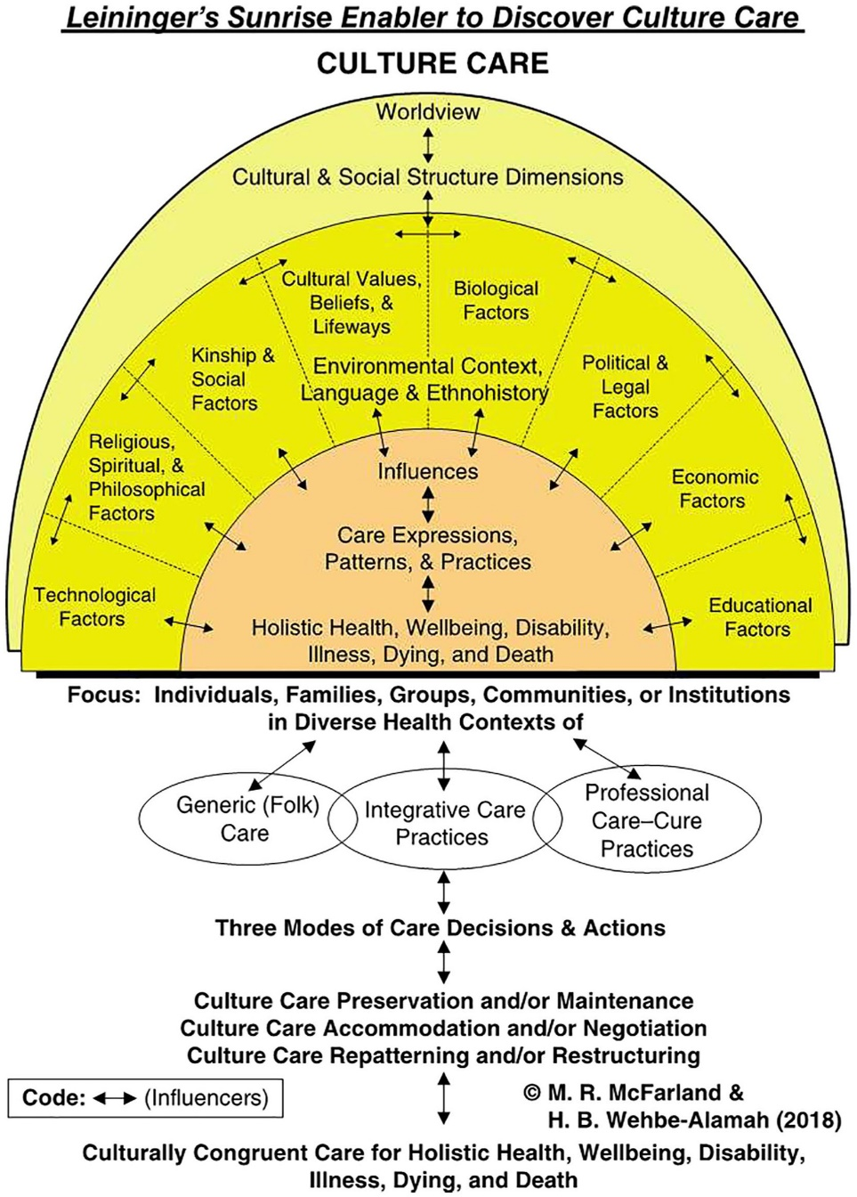
(McFarland & Wehbe-Alamah, 2018b, p. 47).
Philosophical Assumptions
The investigators who coined the Leininger’s culture care theory ensured that the framework can be used to frame other projects investigating the efficacy of cultural competence training and inculcations in nursing research. The theory articulates that cultural elements significantly affect people’s health practices, beliefs, and behaviors (McFarland & Wehbe-Alamah, 2019). Leininger’s culture care theory assumes that culture, social structure, and worldviews are meticulously affiliated with well-being, care, and health (McFarland & Wehbe-Alamah, 2019). As such, care is paramount for growth, health, and survival. Care entails emotional, cultural, and spiritual dimensions, allowing individuals to recover from illnesses (McFarland & Wehbe-Alamah, 2019). The theory also assumes that care is impacted by cultural values, practices, and beliefs. Thus, nurses should comprehend these cultural distinctions to deliver culturally meaningful and effective care.
The third assumption is that culture is entrenched in every facet of human life and shapes how people perceive, respond, and experience health, care, and diseases. McFarland and Wehbe-Alamah (2019) further elucidate that although cultural care is grounded on universality, it is practiced and perceived differently across cultures. Thus, healthcare providers ought to acknowledge the catholicity and divergent factors of care to thwart ethnocentrism and deliver culturally sensitive care (McFarland & Wehbe-Alamah, 2019). Additional philosophical assumptions include integrating culturally congruent care within the care paradigm, recognizing individual worldviews and social structures, and acquiring cultural knowledge.
Leininger’s culture care theory assumes three modes of nursing care actions and decisions. These modes including cultural care preservation, accommodation, and repatterning, assist in achieving culturally congruent care (McFarland & Wehbe-Alamah, 2019). Culture care preservation empowers professional actions or decisions that aid cultures to retain valuable care beliefs and principles or face mortality, illness, or frailty. Conversely, culture care accommodation enables creative provider care actions or decisions that assist cultures to become accustomed to or negotiate with others for culturally congruent and competent care or address mortality and morbidity issues (McFarland & Wehbe-Alamah, 2019). Cultural care repatterning entails modifying harmful cultural practices whilst respecting the patient’s values. Another assumption is the significance of analyzing care within a cultural context to fathom patients’ cultural meanings and practices of adequate care. Lastly, Leininger’s theory assumes a holistic strategy to care by taking into consideration the physical, social, emotional, and spiritual components of health (McFarland & Wehbe-Alamah, 2019).
Johns Hopkins Nursing Evidence-Based Practice (JHNEBP) Model
The Johns Hopkins Nursing Evidence-Based Practice (JHNEBP) Model is a well-established framework that will guide the project plan for implementation (See Figure 2; See Appendix C and D). This model integrates the latest research findings into clinical nursing practices using practical tools (Dang et al., 2022). It follows a systematic approach that empowers nurses to make evidence-based decisions, which enhance patient outcomes and improve the efficiency of cognitive mental health services. The JHNEBP model utilizes user-friendly tools, such as evidence-based practice instruments, which streamline the use of research evidence in clinical settings (Johns Hopkins Nursing, n.d.). The model will support the project’s implementation in the mental health unit by guiding the principal investigator through each step to ensure successful adoption. The JHNEBP model operates in three phases: defining the practice question, finding the best available evidence, and translating that evidence into practice (Dang et al., 2022). These steps form the PET process, which entails the practice question, evidence, and translation stages.
PET Steps
The PET process of the JHNEBP model is essential for guiding healthcare providers through evidence-based practice (EBP) (Johns Hopkins Nursing, n.d.). The first phase begins with identifying the practice question, which involves outlining the issue, formulating the question, and assembling a project team (Dang et al., 2022). This initial step will help the student achieve the project’s goals by clearly defining the objectives and aligning them with EBP principles.
The second phase focuses on evidence, which involves gathering, reviewing, and synthesizing evidence and making practice change recommendations (Dang et al., 2022). Lastly, translation equips researchers with the skills to synthesize evidence and create clinical recommendations. This phase includes planning, securing stakeholder support, implementing the plan, evaluating outcomes, and communicating results (Dang et al., 2022).
Figure 2
JHNEBP Model
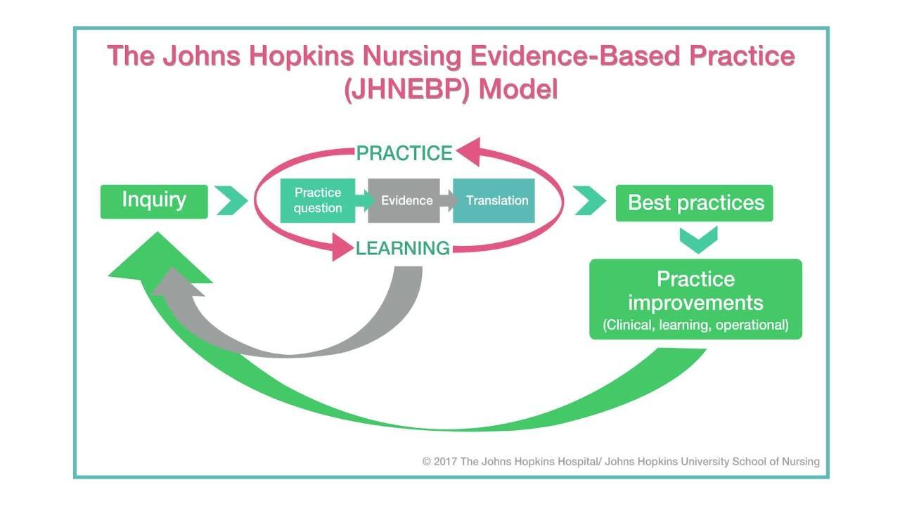
(Dang et al., 2022).
Conclusion
In summary, the absence of a cultural competence education program in a mental health unit can significantly hinder the effectiveness of mental health services, impact patient outcomes, and limit the cultural knowledge, skills, and awareness of healthcare providers. The project aims to provide a discourse on significant gaps in evidence along with rudiments that contribute to culturally incompetent psychiatric delivery services. Its primary goal is to improve patient outcomes and safety, streamline cognitive mental health delivery processes, and reduce healthcare inequalities. These objectives will be achieved by assessing changes in provider motivation, cultural knowledge, behaviors, and attitudes resulting from cultural competence education programs. Leininger's culture care theory will serve as the guiding framework for the project. The JHNEBP model will provide essential evidence-based practice tools and the PET process to ensure the project's success.

Chapter II: Review of Literature
Introduction
The second chapter adds on what is known about the scholarly project topic of cultural incompetence among mental health nurses. The chapter will encapsulate the study's literature, including the search strategy and the most pertinent themes. Yu et al. (2023) suggested that the paucity in cultural competence in mental health services negatively affects patient outcomes and the general healthcare delivery process. However, educating providers on cultural competence can elevate their competence levels, such as cultural knowledge, expertise, and attitudes. These positive implications enable nurses to fathom their patients' cultural differences and experiences, improving patient outcomes, engagement, and health equity (Raval et al., 2024).
Literature Review Overview
A literature evaluation is crucial to nursing research, enabling investigators to judiciously appraise and amalgamate findings from manifold studies' evidence (Snyder, 2019).
Search Strategy
The PI selected academic databases such as PubMed, Google Scholar, Cumulative Index of Nursing and Allied Health Literature (CINAHL), and PsycINFO to find relevant literature. These databases selected had advanced search features, such as Medical Subject Headings (MeSH), article type, publication year, language, and text format. The PI applied Boolean operators to refine searches and focus on the most current and relevant evidence. The keywords were "cultural competence," "education program or training," "nurses," and "health delivery processes."
The literature search was initiated in the summer of 2024, whereby the student included articles published between August 1, 2019, and 2024. Inclusion criteria required full-text articles in English related to the clinical question, while exclusion criteria removed articles older than five years, abstract-only publications, and those unrelated to the clinical question. The student also manually searched key references to ensure all relevant studies were included. The clinical question, framed using the PICO(t) model, is: Does the implementation of a culturally competent educational intervention improve the levels of confidence in the use of cultural competence for psychiatric mental health registered nurses?
Comprehensive Literature Review
The principal investigator used the selected databases, keywords, and Boolean operators to perform a comprehensive literature search following the Preferred Reporting Items for Systematic Reviews and Meta-Analyses (PRISMA) guidelines. The initial search produced 352 articles, which were screened for duplicates and irrelevant content that did not align with the clinical question. After removing 152 irrelevant articles, 200 articles remained. The inclusion and exclusion criteria were applied, eliminating 158 more articles for reasons such as being older than five years, only available as abstracts, not peer-reviewed, or unrelated to the clinical question. The remaining 48 full-text studies were further evaluated against more detailed inclusion and exclusion criteria. Ten studies were excluded for lacking peer review, and 26 did not focus on cultural competence education interventions. Ultimately, 12 studies were included in the final literature review as they met all the necessary criteria. These studies highlighted key themes aligned with the project's clinical research question.
Improved Nurses' Cultural Awareness
Numerous studies have underscored the importance of cultural competence educational interventions. Kaihlanen et al. (2019) performed a qualitative study investigating nurses' perspectives on cultural competence training and awareness. The study revealed the importance of inculcating nurses on cultural competence to boost their cultural awareness and effective communication (Kaihlanen et al., 2019). Although the sample size was localized, the insights can be generalized to specific populaces such as psychiatric nursing and inform the researcher of educational methods that can elevate nursing practice and promote cultural awareness. Cultural awareness equips clinicians with the aptitude to self-reflect, identify their prejudices, and stop labeling patients from different backgrounds (Kaihlanen et al., 2019).
This study offers valuable insights into nurses’ cultural awareness, which can be integrated into the project and train psychiatric nurses about the relevance of cultural competence and addressing health disparities. Manlangit et al. (2022) imposed the necessity of scrutinizing how cultural awareness, sensitivity, and behaviors affect nurse leaders. The sleuths used the Cultural Competence Assessment instrument and the Decision-Making Quality Scale questionnaire and disseminated it to 122 participants who were affiliated with a Saudi Arabian institution. The findings showcased that cultural awareness and sensitivity are inextricably entangled with nurses' cultural competence and their capacity to make informed cultural-founded decisions (Manlangit et al., 2022).
Additionally, cultural competence training proliferates cultural awareness of nurse leaders and their team, making it easier for them to make informed, evidence-based decisions that can achieve ideal patient and health outcomes (Manlangit et al., 2022). Mukhalalati et al. (2022) appraised how cultural competence training is pertinent to nurses' cultural awareness. The qualitative element of the study implied that healthcare educators have a positive attitude towards cultural competence training. In the meantime, the quantitative results proved a noteworthy increment in cultural awareness, suggestive that cultural competence training also equips nurses with the necessary skills to deliver impartial care (Mukhalalati et al., 2022). Most importantly, these findings bolster the project's aim of improving cultural awareness. As such, the student will leverage these insights to inform psychiatric nurses about the benefits of cultural competence training in enhancing cultural awareness.
The Influence of Cultural Competence Education
The second theme identified in the search strategy was the effect of cultural competence education and training on healthcare providers. Research indicates a positive link between cultural awareness, skills, knowledge, attitudes, and behaviors. Several studies prove the validity of educational initiatives in boosting nurses' cultural competencies to achieve the best health results. Slobodin et al. (2020) tailored a culturally informed educational intervention to improve healthcare students' cultural competence. The qualitative segment of the study involved semi-structured interviews with ten participants. The researchers used interpretative phenomenological analysis to evaluate the data (Slobodin et al., 2020).
In the quantitative phase, participants were divided into intervention and non-intervention groups. The study began in September 2018 and lasted two years, addressing gaps in cultural competence curricula and training. Slobodin et al. (2020) reported that incorporating cultural competence education programs can develop providers' understanding of cultural diversity, lessen cultural dissonance, and cultivate efficient communication and outcomes between patients and providers. The findings support the project's goal of enhancing healthcare providers' cultural competence to impact psychiatric settings positively.
Lin and Hsu (2020) conducted a randomized control study in which they randomly assigned respondents to experimental (n=47) and control (n=50) groups. The results showed that the experimental group's cultural competence scores of 0.51 were higher than the control groups', both at follow-up and post-intervention (Lin & Hsu, 2020). The study demonstrated that cultural competence training can significantly improve nurses' cultural aptitude and overall competence.
These findings support the project's implementing a cultural competence education program to enhance workflow efficiencies in the mental health unit.
Raval et al. (2024) conducted mixed-methods research to evaluate the effect of training in cultural competence for mental healthcare providers. The researchers postulate that providing culturally competent care to people from diverse backgrounds is necessary due to the universality of mental health care (Raval et al., 2024). Raval et al. (2024) assessed the impact of cultural competence training by investigating graduate students, practitioners, and faculty perspectives in India and the United States of America. The investigators used various data collection approaches such as focus groups (n=25). In this case, the researchers included fifteen focus groups in India with 69 participants and ten focus groups in America, each with 38 participants. They also used a survey with a sample population of 800; 450 participants were from India, while the rest were from the United States (Raval et al., 2024).
The inclusion criteria involved higher education, psychology degrees, and doctoral degrees—most participants identified as cisgender women (Raval et al., 2024). An online survey link was sent via email to all participants in America individually, whilst in India, the email links were sent through the psychology department chairs. Both the qualitative and quantitative findings indicate that training in cultural competence is crucial in addressing disparities, promoting equitable care, and augmenting patient outcomes (Raval et al., 2024). The article bolsters the objectives of the SPP of training in cultural competence to ensure that the psychiatric registered nurses are well-prepared to engage in culturally competent care.
Cultural Competence on Nurses’ Cultural Knowledge and Skills
Argyriadis et al. (2022) conducted a mixed-methods study to explore healthcare professionals’ knowledge and skill levels associated with their cultural competence. The researchers used the Cultural Competence Self-Assessment Checklist from the Central Vancouver Island Multicultural Society for the quantitative data and 62 semi-structured interviews to collect qualitative data (Argyriadis et al., 2022). They found that nurses are often sensitive to cultural competence practices. The training and educational materials can offer providers cultural competence expertise when working with patients from diverse backgrounds (Argyriadis et al., 2022). These findings can be used to tailor a detailed cultural competence educational program, expanding providers' expertise on cultural competence.
Arruzza and Chau (2021) conducted a scoping review study to appraise the usefulness of educational learning materials in boosting nursing students’ knowledge, skills, attitudes, and routines when they conducted a scoping review. The researchers incorporated an experimental study design to review ten experimental research studies. Based on the research verdicts, nurses inculcated with cultural competence reported higher scores concomitant with adequate cultural knowledge and heightened skills (Arruzza & Chau, 2021). Furthermore, cultural knowledge and skills gained through training enhance nurses' understanding of cultural concepts during healthcare delivery (Arruzza & Chau, 2021). The findings from the study article correspond with the project’s purpose of ensuring nurses, specifically those working in a mental health unit, are culturally competent to successfully deliver cognitive mental health care.
Supporting Literature
Importance of Cultural Competence
The Agency for Healthcare Research and Quality (AHRQ, 2019) reported that cultural competence is a crucial aspect of healthcare that enables health systems to deliver patient-centered care by integrating patients' values, beliefs, and practices. Culturally competent care makes patients feel safe and respected, as they are treated by a workforce that values their cultural journey without judgment (AHRQ, 2019).
The Centers for Disease Control and Prevention (CDC) elucidated that cultural competence combines attitudes, policies, and behaviors that enable healthcare providers to work effectively in cross-cultural situations (NPIN.CDC.gov., n.d..). These merits arouse top-notch quality care and impeccable delivery processes (NPIN.CDC.gov., n.d.). As such, by adopting the concepts of the studies and integrating the recommended principles of cultural competence in educational materials, the project can augment cognitive mental health delivery processes and patient outcomes (AHRQ, 2019; NPIN.CDC.gov., n.d.).
Conclusion
In conclusion, the chapter includes a literature review and synthesized important themes that relate to the clinical question used in the project. Some studies suggested that educating healthcare providers in cultural competence expedites effective communication and optimizes health delivery processes. The second theme greatly demonstrated the impact of cultural competence education, showing its direct effect on nurses' cultural proficiency, which leads to better health outcomes. The literature review also discussed improving nurses' cultural skills and knowledge. Based on the review of the literature, ongoing cultural competence training is pivotal for practitioners and can boost better engagement, ensure patient-centric care, and curtail health inequalities.

Chapter III: Methodology
Introduction
Cultural competence is an indispensable skill in healthcare, but many nurses still lack the training necessary to fulfill the cultural requirements of their clients. The paucity of proper training has precipitated an increment in cultural incompetence. As such, this gap in practice can instigate poor patient outcomes, dissatisfaction with care, and misunderstandings in psychiatric settings (Arruzza & Chau, 2021). At the project’s site, many of the psychiatric nurses report grappling with challenges in delivering culturally appropriate care, which affects their ability to support clients from disparate cultural milieus effectively. Furthermore, the lack of cultural competence has been shown to impact the quality and consistency of mental health care. Intrinsically, the issue of cultural incompetence can be tackled by incorporating an evidence-based cultural competence education program to help clinicians provide equitable and culturally tailored care, especially for patients from diverse backgrounds (Arruzza & Chau, 2021).
The educational intervention based on Leininger’s theory will focus on enhancing key elements of cultural competency such as cultural awareness, knowledge, and skill development. The rudiments of cultural competency aim to foster positive behavioral change among nurses and improve patient outcomes (Sahamkhadam et al., 2023). The cultural proficiency training will help psychiatric nurses understand cultural nuances, utilize effective communication techniques, and incorporate culturally sensitive practices into their care routines. Leininger's culture care theory and the Johns Hopkins Nursing Evidence-Based Practice (JHNEBP) model will guide the steps of the project, providing an evidence-based foundation. The third chapter will encapsulate the methodology used for the scholarly project (SPP). As such, it will detail the project’s design, guiding EBP model, methods, participant recruitment, ethical considerations, plans and procedures, tools, data analysis, timetable, limitations, and transferability. The goal is to describe the project’s design, implementation, and evaluation of the program to measure its impact on enhancing cultural competence among psychiatric nurses in a Northeastern U.S. home care facility.
Project Design
The principal investigator will employ a quality improvement design, thereby assimilating current evidence-based practices to implement and measure the cultural competence educational program within a psychiatric unit. In addition, the project will be customized to address gaps in culturally competent care by augmenting nurses’ cultural awareness, expertise, and knowledge. The Johns Hopkins Nursing Evidence-Based Practice (JHNEBP) model will serve as the project’s basis. The model will enable the principal investigator to leverage the PET approach, which comprises the practice question, evidence, and translation procedure, which is advantageous for structured EBP initiatives (Dang et al., 2022).
The primary goals are to improve cultural competence among psychiatric nurses and patient care delivery processes by providing culturally sensitive care. The project will also foster a more all-encompassing clinical milieu that acknowledges, and respects patients' varied cultural upbringings. The probable results include improved cultural competence levels, including knowledge, skills, and attitudes, as evaluated by the Vancouver Cultural Competence Checklist.
The JHNEBP model will provide the principal investigator with a blueprint to bolster the identification, collation, translation, and application of evidence akin to cultural competence (Dang et al., 2022). The following model's PET process has three stages that expedite the evidence-based practice (EBP) approach.
PET Procedure
The first level of the PET process involves categorizing a practice question, which includes delineating the EBP issue, articulating the question, and affirming the project’s goals. This stage will help the principal investigator form an interdisciplinary team, designate project roles, involve stakeholders, and prepare for cohort meetings (Dang et al., 2022).
The second segment consists of the evidence level used to obtain, review, recap, and synthesize evidence and recommend practice modifications (Dang et al., 2022). The principal investigator thoroughly appraised studies probing cultural competence interventions in psychiatric settings. Some of the keywords used related to the practice question, and using credible databases like PubMed and CINAHL to locate suitable evidence. The JHNEBP model buttressed the appraisal of quality literature, allowing the principal investigator to utilize first-class studies directly relevant to the practice question (Dang et al., 2022). As such, the process expedited a well-founded synthesis of evidence to assess the effectiveness of a cultural competence program and identify existing gaps in literature.
At the translation level, the principal investigator will bring evidence into practice by developing and implementing an actionable plan in the psychiatric unit. This phase will involve working with key stakeholders, including the project mentor and psychiatric nursing staff, to gain support and foster engagement in the initiative. The implementation plan will involve tailoring the educational program to fit the practice environment, with pre-and post-intervention assessments conducted using the Central Vancouver Island Multicultural Society’s Cultural Competence Self-Assessment Checklist.
Application of the JHNEBP Model in the Project
Figure 3
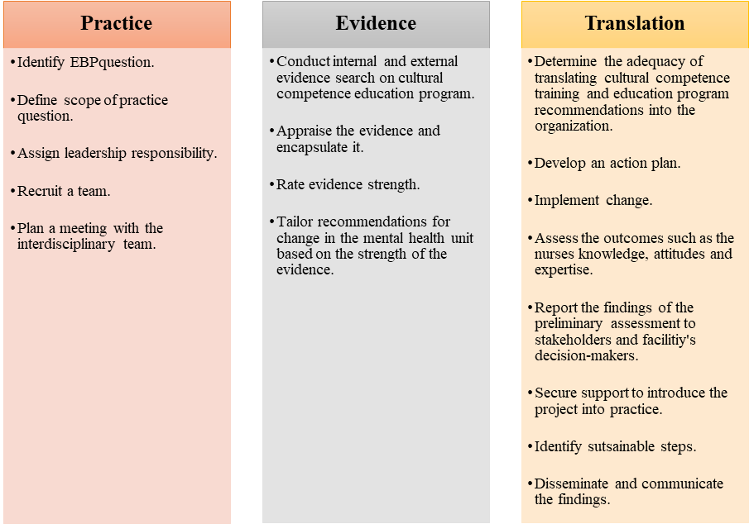
Plans and Procedures
The following are the steps the PI will take:
- Create the educational intervention based on Leininger PowerPoint. Record and narrate the presentation in Zoom. The PI will include YouTube clips from experts, evidence, and supporting literature.
- Obtain external site permission.
- Obtain permission to use the instrument of the Vancouver cultural competence self-assessment checklist and confidence scale.
- Create open-ended questions for the nurses about their feelings.
- Tailor a comprehensive demographic Survey.
- Become familiar with Qualtrics to collect data.
- Become familiar with Intellectus Statistics and secure a Statistician consult.
Evidence-Based Clinical/Practice Question
Does the implementation of a culturally competent educational intervention improve the levels of confidence in the use of cultural competence for psychiatric mental health registered nurses?
Setting
The principal investigator will launch the project at a psychiatric home care agency, which is located in the Northeast, once external site approval is obtained (See Appendix E). It is worth noting that the home care agency serves individuals with mental health issues in the community, offering services such as in-home therapy, daily living activities, and medication management. The facility has a capacity of 370 beds and more than 50 registered nurses and delivers rounded and wide-ranging treatment with ease and care to clients facing psychiatric challenges.
Sample
A sample serves as a representative segment of a larger population, allowing researchers to make inferences that can potentially be applied to similar populations (Andrade, 2020). The following are the rudimentary elements akin to a sample. The PI will draw the participants from the intended population of psychiatric mental health registered nurses.
Recruitment Plan
The project’s principal investigator will obtain approval from the facility’s administrator under the guidance of the quality appraisal committee, which undertakes improvement efforts. In particular, the quality improvement committee’s primary goals include classifying areas necessitating improvement, enabling constructive vicissitudes, guaranteeing compliance with established regulations, inculcating the workforce and practitioners, and accentuating key enhancement prospects (Polit & Beck, 2021). The committee will be briefed on the project purpose and significance, the rationale for selecting the location, details of the research, and the commitment to upholding ethical standards. The principal investigator will collaborate with psychiatric nurse leaders and a project mentor to identify eligible participants based on established inclusion criteria (Purna Singh et al., 2023). Once the external site letter is provided to give permission to conduct the project and the Regis IRB Board approves the project, eligible participants will receive an invitation to participate on Regis College letterhead to recruit participants (See Appendix F). The informed consent and details about the project’s goals, processes, expectations, and the voluntary nature of participation will be provided in Qualtrics software. A link to the Qualtrics site will be provided in the invitation to participate and consent must be signed prior to advancing in the site. If consent is not signed, the participant will not be able to proceed. As the consent is signed, the participant will be assigned a random numerical code by Qualtrics, thus protecting confidentiality and anonymity.
Sample Size
The principal investigator performed a G*power analysis to determine the adequate sample size. Based on the results, the PI will incorporate a sample size of 34 participants (See figure 3).
Figure 4
G*Power Analysis
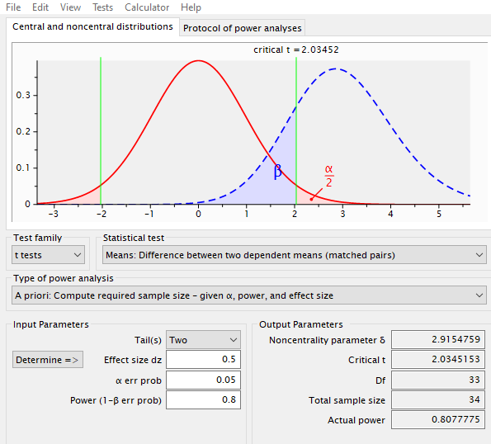
Sampling
A convenience sampling method will be used, allowing for easy participant access. This sampling approach is cost-effective, time-efficient, and practical for involving colleagues already working at the project’s location (Purna Singh et al., 2023). The PI will seek permission from the homecare agency administrator and nurse manager to implement the project. Subsequently, after receiving approval, the PI will send invitation links via Qualtrics to potential participants who are readily available and willing to join in the project. Those interested will be sent an informed consent document with detailed information about the project. The inclusion and exclusion criteria will be considered during sampling.
Inclusion Criteria
The following are the inclusion criteria:
- Psychiatric mental health registered nurses working at the project site.
- Individuals must have a minimum of two years of nursing experience. DO WE NEED THIS??
- Direct care for clientele in the psychiatric unit.
- A bachelor’s degree in nursing. DO WE NEED THIS??
Exclusion Criteria
The PI will use the following criterion to exclude individuals from participating in the project.
- Psychiatric mental health registered nurses not working at the project site.
- Individuals must have a minimum of two years of nursing experience. DO WE NEED THIS??
- Do not provide direct care for clientele in the psychiatric unit.
- Do not have a bachelor’s degree in nursing. DO WE NEED THIS??

Ethical Considerations
Ethical considerations are fundamental to the success of any scholarly project, particularly one involving human participants. This project will focus on a cultural competence educational intervention for psychiatric mental health registered nurses, aiming to improve mental health service delivery for diverse patient populations and levels of cultural competence. The principal investigator will adhere to ethical tenets, ensuring that participants are protected, respected, and fully informed about their involvement in the study. The primary ethical considerations in this project include informed consent, beneficence, respect for secrecy and confidentiality, and respect for privacy. The PI will ensure that the participants are not harmed, are adequately informed about the project, and understand the risks and benefits of participating in the study. The following are the ethical considerations the PI will uphold throughout the project.
Informed Consent
The principal investigator will provide each participant with an informed consent document that demarcates and elucidates all relevant information about the project of cultural competence (See Appendix G). The reading level for the informed consent is calculated to assure that it is at 8.0 or less (See Appendix H). In addition, the informed consent will also be concise on the respondents' right to participate voluntarily or opt out (Polit & Beck, 2021). The document will detail the project's goals and objectives, explain the data collection procedures, and describe how participants will be involved. It will also include a clause ensuring the discretion and obscurity of the respondents. Crucially, the participants will be advised of their choice to withdraw from the project at any time without facing any consequences. The principal investigator will seek approval from the Institutional Review Board (IRB) at Regis College and the hospital’s quality improvement committee to guarantee that the project is conducted morally, and that respondents’ privileges and safety are safeguarded.
Beneficence
The principle of beneficence requires the project investigator not to expose participants to harm and instead maximize benefits while minimizing risks. Therefore, the principal investigator will ascertain that every effort will be made to prevent participant harm (Polit & Beck, 2021). The cultural competence education program is designed to enhance skills and improve patient outcomes, providing potential benefits for participants' professional development, levels of cultural competence, and patient care quality. Risks are anticipated to be minimal as this study involves an educational intervention. Nonetheless, any potential discomfort or unintended negative consequences of the intervention will be monitored and addressed promptly to ensure participants’ well-being.
Anonymity and Confidentiality
The project investigator will respect the participants' anonymity and confidentiality to uphold trust and integrity throughout the research process. Per se, the respondents’ data will be de-identified by assigning codes to participants rather than using personal identifiers. Consequently, only their aggregate data will be reported, ensuring no individual can be identified from the findings. Furthermore, access to any identifying information will be restricted to the research investigator, and data will be stored securely in encrypted files to prevent unauthorized access (Polit & Beck, 2021). These measures will help protect participants’ identities and maintain the confidentiality of their information.
Respect for Privacy
Respecting respondents’ privacy is critical, especially when dealing with sensitive topics such as cultural competence and mental health care. Hence, the participants will be informed about the data collected and how the information will be used. They will have control over the extent of their participation in completing the cultural competence self-assessment questionnaire and the volition to refuse to complete any queries they feel uncomfortable with. As a result, this strategy will play a focal role in respecting their right to privacy (Polit & Beck, 2021).
Measurement of Variables
1. Demographic Survey (See Appendix I):
The PI will collect demographic data using a demographic data sheet. This tool will capture participant characteristics such as age, gender, and years of experience. Descriptive statistics, including means, medians, frequencies, and percentages, will summarize the data, ensuring the sample is well-described and contextualized.

2. Cultural Competence Self-Assessment Checklist (See Appendix J & K):
The principal investigator will collect pretest and posttest data from the Cultural Competence Self-Assessment Checklist. The tool has been validated for use among healthcare professionals. Its reliability was established using Cronbach’s alpha with average values of 0.78 across the three sections, indicative of great internal homogeneity (Argyriadis et al., 2022). A confirmatory factor analysis (CFA) also validates the tool’s structure, confirming its robustness and reliability for assessing cultural competence. These metrics bolster the use of the checklist in the project, ensuring that it provides consistent and accurate data to measure changes in cultural competence (Argyriadis et al., 2022).
Additionally, the cultural competence checklist is grounded on a Likert scale format, in which participants rate their responses to items that assess cultural awareness, knowledge, and skills. In this light, the checklist includes multiple items that address specific aspects of cultural competence across the three domains. The founders of the questionnaire ascertained that the Likert scale items are structured so that the participants can indicate the magnitude to which they agree or disagree with statements (Argyriadis et al., 2022). The checklist enables capturing the degree of cultural competence among respondents.
It is essential to note that the cultural competence cohort focuses on understanding cultural distinctions, self-awareness, and stereotypes. In this light, more outstanding scores indicate a more developed awareness of cultural differences. On the other hand, the cultural knowledge scale dictates elements that assess understanding of cultural histories, discrimination, and cultural boundaries. As such, a high score reflects enhanced knowledge and vice versa. The cultural expertise section includes questions on diversity acceptance, support for individuals from various backgrounds, and communication skills (Argyriadis et al., 2022).
3. Confidence Scale (See Appendix L & M):
The confidence scale (C-scale) will help measure participants' confidence levels in providing culturally competent care (Grundy, 1993). This instrument is suitable since it strives to evaluate the efficacy of educational interventions such as the cultural competence educational intervention. The C-scale is a structured Likert-scale questionnaire in which participants rate their confidence level about specific statements akin to cultural competence across several domains. These domains include cultural awareness, expertise, encounters, and knowledge (Grundy, 1993). The C-scale is a corroborated tool with strong validity and dependability, demonstrating strong psychometric properties. Grundy (1993) elucidates that the C-scale’s internal consistency is bolstered by a superior Cronbach’s alpha value and construct validity, which validate the tool’s accuracy. The PI will administer the tool to the participants before and after the intervention to measure their confidence levels. The analysis will help determine the efficacy of the educational intervention
4. Open-ended Questions:
The PI will provide the participants with open-ended questionnaires to gather their perspectives on cultural competence training (See Appendix N). The questionnaires will help the PI understand the participants’ challenges, insights, and areas for improvement. The PI will use thematic analysis to recognize emerging patterns and themes related to cultural competence in psychiatric care settings.
Educational Intervention
The principal investigator will measure the independent variable, which is a cultural competency educational program, using the cultural competence checklist with five-item Likert scale questions. The queries vary from “strongly disagree to strongly agree” to quantify the participant's levels of cultural competency. The cultural competence educational intervention program will be designed to boost psychiatric Registered Nurses’ levels of cultural competency, including knowledge, awareness, and expertise (See Appendix O). The educational intervention will include a PowerPoint presentation on cultural competence, disparities, and cultural sensitivity. Additionally, the PI will incorporate case studies demonstrating pragmatic scenarios about cultural diversity and a poster to reinforce critical cultural competence concepts.
add power ptt to appendices
Data Collection and Analysis
All data will be collected using Qualtrics software. Once the participant is given access to the informed consent, they will agree to participate, they will be deidentified, and given a random numerical value. Only the Primary Investigator (PI) and the Project Chair will have access to this data in a password-protected computer. The data will be stored for three years and then destroyed. The data will be downloaded from Qualtrics once cleaned and then securely uploaded to Intellectus Statistics, an online software program for analysis. The PI and Project Chair have each been trained and certified in human subjects protection (See Appendix P).
Timetable
The project is intended to take fourteen weeks starting in May 2025. For a detailed timeline, see Table 1.
Table 1
Activity | Timeline | Details
Proposal Hearing | Week 1 | Present project to committee, gather feedback.
IRB Approval | Weeks 2–6 | Submit IRB application to secure approval from the Institution’s IRB and await approval.
Participant Recruitment and Distribution of Informed Consent Forms | Weeks 7–8 | Recruit eligible participants based on the inclusion and exclusion criteria and obtain informed consent. Then, disseminate informed consent to participants via Qualtrics.
Pre-Intervention Survey | Week 9 | Administer the Cultural Competence Self-Assessment Checklist pre-intervention survey to establish baseline data on participants’ current cultural competence status.
Educational Intervention | Weeks 10–12 | Conduct cultural competence training sessions via Zoom and distribute educational materials.
Post-Intervention Survey | Week 13 | Re-administer the Cultural Competence Self-Assessment Checklist.
Data Analysis | Week 14 | Use Intellectus Statistics and conduct paired t-tests to evaluate changes in cultural competence levels.
Compile and Disseminate Findings | Week 14 | Present findings to stakeholders and academic reviewers. Share outcomes with stakeholders.

Conclusion
In conclusion, the chapter discussed key components such as the project’s site, actions, design, informed consent, inclusion and exclusion measures, IRB approval, tools, and data analysis. The project will comprise a sample size of forty human subjects who will complete pre- and post-intervention queries. Besides, the principal investigator will ascertain that they adhere to the ethical standards required for conducting research with human subjects and foster a trustworthy environment that encourages honest and open participation. The Cultural Competence Self-Assessment Checklist is an effective and unswerving tool for assessing changes in cultural competence among nurses. The instrument will provide comprehensive data to gauge the influence of the intervention on nurses' cultural awareness, knowledge, and skills, ultimately supporting the project's aim of boosting cognitive health delivery procedures. Although the project is marred by a small sample, which may restrict the generalizability of the results, the sample may provide precise and sophisticated measurements. Most importantly, the findings will allow for transferability to other clinical contexts, ensuring that readers understand the significance of a culturally competent nursing workforce. Ultimately, the timeline provides an ideal structure in which the project advances efficiently, meeting all critical deadlines within the stipulated timeframe.

References
AHRQ. (2019, December 27). Cultural competence and patient safety. Agency for Healthcare Research and Quality (AHRQ). Patient Safety Network (PSNet). https://psnet.ahrq.gov/perspective/cultural-competence-and-patient-safety
Alkhamees, M., & Alasqah, I. (2023). Patient-physician communication in intercultural settings: An integrative review. Heliyon, 9(12). https://doi.org/10.1016/j.heliyon.2023.e22667
Argyriadis, A., Patelarou, E., Paoullis, P., Patelarou, A., Dimitrakopoulos, I., Zisi, V., Northway, R., Gourni, M., Asimakopoulou, E., Katsarou, D., & Argyriadi, A. (2022). Self-assessment of health professionals’ cultural competence: knowledge, skills, and mental health concepts for optimal health care. International Journal of Environmental Research and Public Health, 19(18). https://doi.org/10.3390/ijerph191811282
Arruzza, E., & Chau, M. (2021). The effectiveness of cultural competence education in enhancing knowledge acquisition, performance, attitudes, and student satisfaction among undergraduate health science students: A scoping review. Journal of Educational Evaluation for Health Professions, 18. https://doi.org/10.3352/jeehp.2021.18.3
Chae, D., Kim, J., Kim, S., Lee, J., & Park, S. (2020). Effectiveness of cultural competence educational interventions on health professionals and patient outcomes: A systematic review. Japan Journal of Nursing Science, 17(3), e12326. https://doi.org/10.1111/jjns.12326
Chu, W., Wippold, G., & Becker, K. D. (2022). A systematic review of cultural competence trainings for mental health providers. Professional Psychology, Research and Practice, 53(4), 362. https://doi.org/10.1037/pro0000469
Cruz, D., Rodriguez, Y., & Mastropaolo, C. (2019). Perceived microaggressions in health care: A measurement study. PLOS ONE, 14(2), e0211620. https://doi.org/10.1371/journal.pone.0211620
Dang, D., Dearholt, S., Bissett, K., Ascenzi, J., & Whalen, M. (2022). Johns Hopkins evidence-based practice for nurses and healthcare professionals: Model and guidelines. 4th ed. Sigma Theta Tau International
Desai, M. U., Paranamana, N., Restrepo-Toro, M., Davidson, L., & Stanhope, V. (2020). Implicit organizational bias: Mental health treatment culture and norms as barriers to engaging with diversity. The American Psychologist, 76(1), 78. https://doi.org/10.1037/amp0000621
Eken H. N., Dee E. C., Powers A. R. III, Jordan A. (2021). Racial and ethnic differences in perception of provider cultural competence among patients with depression and anxiety symptoms: A retrospective, population-based, cross-sectional analysis. The Lancet Psychiatry, 8(11), 957–968. https://doi.org/10.1016/S2215-0366(21)00285-6
Fante-Coleman, T., & Jackson-Best, F. (2020). Barriers and facilitators to accessing mental healthcare in Canada for Black youth: A scoping review. Adolescent Research Review, 5(2), 115-136. https://doi.org/10.1007/s40894-020-00133-2
Gopal, D. P., Chetty, U., Gajria, C., & Blackadder-Weinstein, J. (2021). Implicit bias in healthcare: Clinical practice, research, and decision making. Future Healthcare Journal, 8(1), 40–48. https://doi.org/10.7861/fhj.2020-0233
Handtke, O., Schilgen, B., & Mösko, M. (2019). Culturally competent healthcare – A scoping review of strategies implemented in healthcare organizations and a model of culturally competent healthcare provision. PLoS ONE, 14(7). https://doi.org/10.1371/journal.pone.0219971
Hietapakka, L., & Heponiemi, T. (2019). Increasing cultural awareness: Qualitative study of nurses' perceptions about cultural competence training. BMC Nursing, 18(1). https://doi.org/10.1186/s12912-019-0363-x
Johns Hopkins Nursing. (n.d.). Evidence-based practice. Johns Hopkins Medicine, based in Baltimore, Maryland. https://www.hopkinsmedicine.org/nursing/center-nursing-inquiry/nursing-inquiry/evidence-based-practice
Kaihlanen, A., Hietapakka, L., & Heponiemi, T. (2019). Increasing cultural awareness: Qualitative study of nurses' perceptions about cultural competence training. BMC Nursing, 18(1). https://doi.org/10.1186/s12912-019-0363-x
Ličen, S., & Prosen, M. (2023). The development of cultural competences in nursing students and their significance in shaping the future work environment: A pilot study. BMC Medical Education, 23(1), 819. https://doi.org/10.1186/s12909-023-04800-5
Lin, M., & Hsu, H. (2020). Effects of a cultural competence education program on clinical nurses: A randomized controlled trial. Nurse Education Today, p. 88, 104385. https://doi.org/10.1016/j.nedt.2020.104385
Liu J., Gill E., Li S. (2021). Revisiting cultural competence. The Clinical Teacher, 18(2), 191–197. https://doi.org/10.1111/tct.13269
Manlangit, A. T., Jabonete, F. G. V., & Ridulme, Q. R. (2022). Cultural competence and decision-making of nurse leaders in a university hospital in Saudi Arabia: A descriptive correlational study. Journal of Nursing Management, 30(5), 1215–1224. https://doi.org/10.1111/jonm.13631
Marcelin, J. R., Siraj, D. S., Victor, R., Kotadia, S., & Maldonado, Y. A. (2019). The impact of unconscious bias in healthcare: How to recognize and mitigate it. The Journal of Infectious Diseases, 220(220 Suppl 2), S62–S73. https://doi.org/10.1093/infdis/jiz214
McFarland M. R., Wehbe-Alamah H. B. (2018b). Leininger’s Sunrise Enabler to Discover Culture Care. In McFarland M. R., Wehbe-Alamah H. B. (Eds.), Leininger’s Transcultural Nursing Concepts, Theories, Research, & Practice (4th edition; p. 47). New York, NY: McGraw-Hill Education.
Mukhalalati, B., Ahmed, A., Elshami, S., & Awaisu, A. (2022). Cultural competence among healthcare professional educators: A mixed-methods study. Sustainability, 15(18), 13793. https://doi.org/10.3390/su151813793
Nair, L., & Adetayo, O. A. (2019). Cultural competence and ethnic diversity in healthcare. Plastic and Reconstructive Surgery Global Open, 7(5). https://doi.org/10.1097/GOX.0000000000002219
NPIN.CDC.gov. (n.d.). Cultural competence in health and human services. National Prevention Information Network (NPIN)| Centers for Disease Control and Prevention (CDC). https://npin.cdc.gov/pages/cultural-competence-health-and-human-services
Raval, V. V., Gopal, B., Aggarwal, P., Mohan, M. P., Padmakumari, P., Thomas, E., Luebbe, A. M., & Hay, M. C. (2024). Training in cultural competence for mental health care: A mixed-methods study of students, faculty, and practitioners from India and USA. Culture, Medicine and Psychiatry, 48(4), 699–730. https://doi.org/10.1007/s11013-024-09867-3
Rosumeck, S., Wagner, M., Wallraf, S., & Euler, U. (2020). A validation study revealed differences in design and performance of search filters for qualitative research in PsycINFO and CINAHL. Journal of Clinical Epidemiology, 128, 101-108. https://doi.org/10.1016/j.jclinepi.2020.09.031
Rukadikar, C., Mali, S., Bajpai, R., Rukadikar, A., & Singh, A. K. (2022). A review on cultural competency in medical education. Journal of Family Medicine and Primary Care, 11(8), 4319. https://doi.org/10.4103/jfmpc.jfmpc_2503_21
Sahamkhadam, N., Andersson, A. K., Golsäter, M., Harder, M., Granlund, M., & Wahlström, E. (2023). Testing the assumptions in the process of cultural competence in the delivery of healthcare services using empirical data, focusing on cultural awareness. Journal of Transcultural Nursing, 34(3), 187-194. https://doi.org/10.1177/10436596231152212
Sarvarizadeh, M., Miri, S., Darban, F., & Farokhzadian, J. (2024). Innovative cultural care training: the impact of flipped classroom methods on critical cultural competencies in psychiatric nursing: A quasi-experimental study. BMC Nursing, 23(1), 340. https://doi.org/10.1186/s12912-024-02001-z
Slobodin, O., Clempert, N., Kula, Y., & Cohen, O. (2020). Educating health professionals for cultural competence in emergency situations: A study protocol for a randomized controlled trial. Journal of Advanced Nursing, 76(1), 380–386. https://doi.org/10.1111/jan.14245
Stubbe, D. E. (2020). Practicing cultural competence and cultural humility in the care of diverse patients. Focus: Journal of Life Long Learning in Psychiatry, 18(1), 49-51. https://doi.org/10.1176/appi.focus.20190041

Table 1
Timetable
Activity | Timeline | Details
Proposal Hearing | Week 1 | Present project to committee, gather feedback.
IRB Approval | Weeks 2–6 | Submit IRB application to secure approval from the Institution’s IRB and await approval.
Participant Recruitment and Distribution of Informed Consent Forms | Weeks 7–8 | Recruit eligible participants based on the inclusion and exclusion criteria, obtain informed consent. Disseminate informed consent to participants via Qualtrics
Pre-Intervention Survey | Week 9 | Administer the Cultural Competence Self-Assessment Checklist pre-intervention survey to establish baseline data on participants’ current cultural competence status.
Educational Intervention | Weeks 10–12 | Conduct cultural competence training sessions via Zoom and distribute educational materials.
Post-Intervention Survey | Week 13 | Re-administer the Cultural Competence Self-Assessment Checklist.
Data Analysis | Week 14 | Use Intellectus Statistics, conduct paired t-tests to evaluate changes in cultural competence levels.
Compile and Disseminate Findings | Week 14 | Present findings to stakeholders and academic reviewers. Share outcomes with stakeholders.

Appendices

Appendix A-Theoretical Framework Graphic
Figure 1
Leininger's Sunrise Model

Appendix B-Permission for Use

please add-take a screen shot if it says open access

Appendix C-Evidence-Based Practice Model Graphic
Figure 2
JHNEBP Model

Appendix C-Permission for the use of the JHNEBP Model graphic

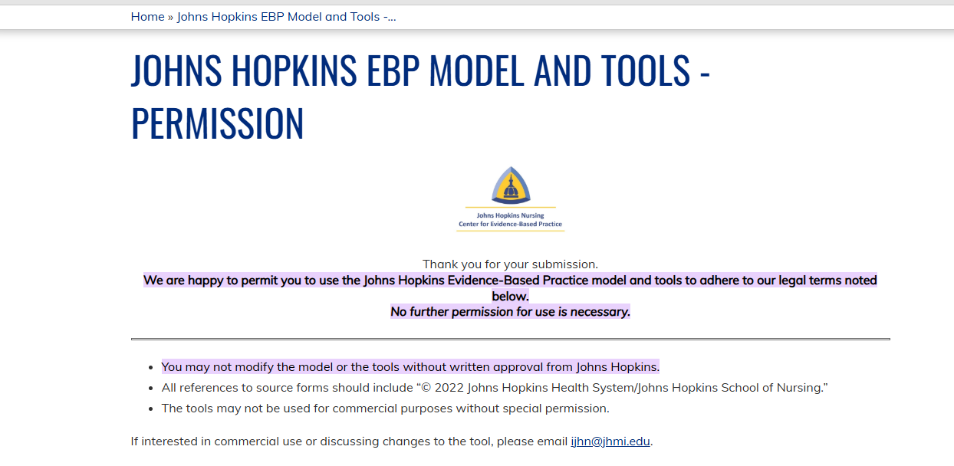

Appendix E-External Site Permission

add letter here or email with the person's email in view

Appendix F-Invitation to Participate
please add using the template that was provided

Appendix G-Informed Consent
Informed Consent for a DNP Project entitled Cultural Competence Educational Program in Psychiatric Care settings
Primary Investigator (PI)Researcher: Bruce Nsubuga, BSN, RN
Introduction
Please read this informed consent form slowly. The PI requests that you join a DNP project to teach nurses about cultural competency. The principal investigator carefully selected you to participate in this project because you are a nurse who has worked directly with individuals in the psychiatric inpatient or emergency department (ED), have a nursing experience of more than two years, specialize in psychiatric mental health nursing, work in the psychiatric department of the home care agency, and you are a registered nurse. You do not qualify to join if you are not a registered nurse, work in units other than the ED or inpatient psych unit, and are not directly involved with patients suffering from psychiatric conditions. Please ask any questions before joining the project.
Purpose of the Project
The project will investigate whether introducing a cultural competence education program at the home care agency will increase mental health nurse's cultural awareness, skills, and attitudes.
If you decide to join this project, the PI you to attend an educational training.
Timeline-Add C-Scale and Consent and Demographics
Activity | Duration | Details
Pre-Test (Baseline Assessment) | Week 1(1 week) | Participants complete the Vancouver Cultural Competence Self-Assessment Checklist online. Anonymous responses ensure privacy and confidentiality.
Educational Intervention (PowerPoint Sessions & Resources) | Weeks 2-4 (2 weeks) | Four 30-minute PowerPoint presentations on cultural competence, health disparities, cultural competence constructs, and Leininger’s model. Sessions occur twice per week during lunch hours. Additional educational links and resources provided.
Post-Test (Cultural Competence Reassessment) | Weeks 4-5 (1 week) | Participants complete the same assessment as the pre-test to measure changes in cultural competence. URL link sent via email for secure, de-identified responses.
Survey on Program Experience & Perceptions | Week 5 (1 week) | Participants complete a three-question survey reflecting on their experiences and perceptions of the program.
Benefits of Being in this Project
You will contribute to the body of knowledge about nurses and cultural competence.
Risks and Discomforts of Participating in this Project
You may feel fatigue and will need to devote time to the project to complete it. Breaks are encouraged to avoid fatigue. There are no risks other than what you experience in your daily life.
Payments
You will not receive payment for participating in the project.
Cost
There is no cost to participate.
Choosing to Participate and Quit the Project
If you decide to withdraw from the project, your decision to cancel will not affect your association with Regis or your employer. It is your choice to leave without giving any reasons. You will not be penalized for leaving the project.
Getting Dismissed from the Project
The PI may discharge you from the project for not fulfilling the following reasons:
- The lack of adherence to the study guidelines.
- The PI decides to end the project.
- You are swamped with work and cannot make time.
Privacy
The PI investigator will maintain the participants' privacy and anonymity of each participant throughout the project. The digital records will be password protected in a secure online survey website. Only the PI and Project Chair project lead will have access to the project deidentified data. No names will be used. All data will be destroyed after three years while stored in a password protected file. Participants will refrain from using any identifying data.
Contacts and Questions
The PI conducting this project is Bruce Nsubuga, BSN, RN. You can reach him via your Regis email [phone number and email address] for clarification and queries. For any queries or concerns regarding your rights, reach out to Dr. Colleen, who is the chair of the Regis Institutional Review Board:
Dr. Colleen C. Malachowski, PhD
781-768-7373
colleen.malachowski@regiscollege.edu
Signature(s)/Date
Participant Printed Name: ___________________________________
Participant Signature: ___________________________________ Date: __________

Appendix H-Flesch-Kincaid Grade Level for the Informed Consent

please add

Appendix I-Demographic Survey
please add

Appendix J-Instrument #1
Vancouver Cultural Competence Self-Assessment Checklist
This self-assessment tool is designed to explore individual cultural competence. This tool allows us to obtain your input on the training series entitled “Culturally Relevant Programs for Probation” which will enable us to tailor this training series to fit your needs. This training supports the Enhanced Outcome-Based Supervision (EBOS) model by helping to enrich interactions with diverse populations. The checklist looks at your general skills, knowledge, and awareness pertaining to culture in the world around you—not necessarily specific to your role in supervision. It is important for us to understand your history and experiences pertaining to people with different cultural backgrounds so please answer these questions honestly—all responses are anonymous.

Please note the term ‘culture’ includes race, ethnicity and ancestry, but also the culture (e.g. beliefs, common experiences and ways of being in the world) shared by people with characteristics in common. It’s important to consider that many of the interpersonal skills you’ve developed during your lifetime through your interactions with people from differing cultural backgrounds are transferable and can be applied across various settings.

Directions: Read each entry and place a check mark in the appropriate column that best represents your opinion.

Awareness | Statement | Never | Sometimes  Occasionally | Fairly Often  Pretty Well | Always  Very well
Value Diversity | I view difference as positive and a reason to celebrate.
Know myself | I have a clear sense of my own ethnic, cultural and racial identity.
Share my culture | I am aware that in order to learn more about others I need to understand and be prepared to share my own culture.
Be aware of areas of discomfort | I am aware of my discomfort when I encounter differences in race, color, religion, sexual orientation, language, and ethnicity.
Check my assumptions | I am aware of the assumptions that I hold about people of cultures different from my own.
Challenge my stereotypes | I am aware of my stereotypes as they arise and have developed personal strategies for reducing the harm they cause.
Reflect on how my culture informs my judgement | I am aware of how my cultural perspective influences my judgement about what are ‘appropriate’, ‘normal’, or ‘admirable’ behaviors, values, and communication styles.
Awareness | Statement | Never | Sometimes  Occasionally | Fairly Often  Pretty Well | Always  Very well
Accept ambiguity | I accept that in cross cultural situations there can be uncertainty and that can cause uneasiness.
 | I take the time needed to get more information in cross cultural situations.
Be curious | I take any opportunity to put myself in places where I can learn about difference and create relationships.
Aware of racial privilege | I am aware that having “racial privilege” means one’s race does not create barriers to goal attainment or justice.
 | Those who are perceived as having racial privilege may also be perceived as having certain advantages and benefits when compared to those who are perceived as not having racial privilege.
 |  | 1 pt x | 2 pt x | 3 pt x | 4 pt x

Knowledge | Statement | Never | Sometimes  Occasionally | Fairly Often  Pretty Well | Always  Very well
Gain from my mistakes | I will make mistakes and will learn from them.
Assess the limits of my knowledge | I recognize that my knowledge of certain cultural groups is limited and will commit to creating opportunities to learn more.
Ask questions | I will really listen to the answers before asking another question.
Acknowledge the importance of difference | If I am working with a person of a different culture, ethnicity, etc. I understand that I may be perceived as a person with different degrees of power or privilege, and that I may not be seen as ‘unbiased’ or as an ally.
Know the historical experiences of non-European Americans | I am knowledgeable about historical incidents in America’s past that demonstrate racism and exclusion towards Americans of non-European heritage (e.g. the Japanese internment, slavery, Jim Crow, Islamophobia…).
Understand the influence culture can have | I recognize that cultures change over time and can vary from person to person, as does attachment to culture.
Knowledge | Statement | Never | Sometimes  Occasionally | Fairly Often  Pretty Well | Always  Very well
Commit to life-long learning | I recognize that achieving cultural competence involves a commitment to learning over a life-time.
Understand the impact of racism, sexism, homophobia . . . | I recognize that stereotypical attitudes and discriminatory actions can dehumanize and even encourage violence against individuals because of their membership in groups which are different from myself.
Know my own family history | I know my family’s story of immigration and assimilation into America.
Know my limitations | I continue to develop my capacity for assessing areas where there are gaps in my knowledge of other cultures.
 |  | 1 pt x | 2 pt x | 3 pt x | 4 pt x

Skills | Statement | Never | Sometimes  Occasionally | Fairly Often  Pretty Well | Always  Very well
Adapt to different situations | I am developing ways to interact respectfully and effectively with individuals and groups.
Challenge discriminatory and/or racist behavior | I can effectively intervene when I observe others behaving in a racist and/or discriminatory manner.
Communicate across cultures | I am able to adapt my communication style to effectively interact with people who speak in ways that are different from my own.
Seek out situations to expand my skills | I seek out people who challenge me to maintain and increase the cross-cultural skills I have.
Become engaged | I am actively involved in initiatives, big or small, that promote understanding among members of diverse groups.
Act respectfully in cross-cultural situations | I act in ways that demonstrate respect for the culture and beliefs of others.
Practice cultural protocols | I am learning about and put into practice the specific policies and procedures related to culture which are necessary for my work.
Skills | Statement | Never | Sometimes  Occasionally | Fairly Often  Pretty Well | Always  Very well
Act as an ally | My colleagues who are of a different ethnicity than I am consider me to be an ally and know that I will support them in culturally appropriate ways.
Be flexible | I work hard to understand the perspectives of others and consult with my diverse colleagues about culturally respectful and appropriate courses of action.
Be adaptive | I know and use a variety of relationship building skills to create connections with people who are different from me.
 |  | 1 pt x | 2 pt x | 3 pt x | 4 pt x

Appendix K-Permission for the use of the Cultural Competence Checklist
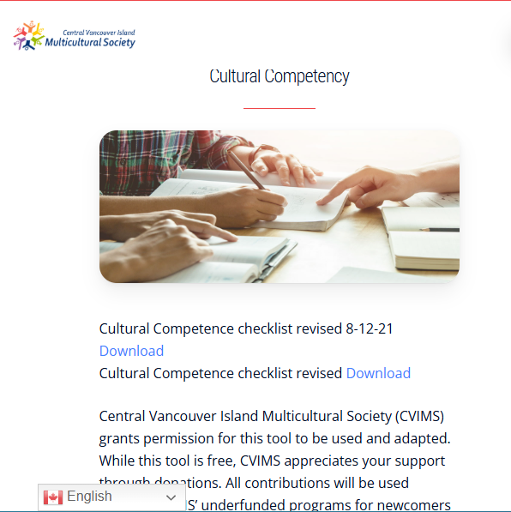

Appendix L-Instrument #2 (C-Scale)
Directions: Circle the number which best describes how you perceive your current ability to perform strategies to become competent in the use of cultural competence education program.
(NOTE: Make sure that the circle encloses just ONE number.)

1. I am certain that my performance is correct:

1 |  | 2 |  | 3 |  | 4 |  | 5
not at all certain |  | certain for only a few steps |  | fairly certain for a good number of steps |  | certain for almost all steps |  | absolutely certain for all steps
2. I feel that I perform the task without hesitation:

1 |  | 2 |  | 3 |  | 4 |  | 5
I have much hesitation |  | a fair amount of hesitation |  | a good part of it without hesitation |  | almost completely without hesitation |  | absolutely no hesitation
3. My performance would convince an observer that I'm competent at this task:

1 |  | 2 |  | 3 |  | 4 |  | 5
not at all |  | agree, a little |  | for much of it |  | for almost all of it |  | for absolutely all of it
4. I feel sure of myself as I perform the task:

1 |  | 2 |  | 3 |  | 4 |  | 5
not at all |  | very little |  | for much of it |  | for almost all of it |  | for absolutely all of it
5. I feel satisfied with my performance:

1 |  | 2 |  | 3 |  | 4 |  | 5
not at all |  | very little |  | for much of it |  | for almost all of it |  | absolutely satisfied with all of it

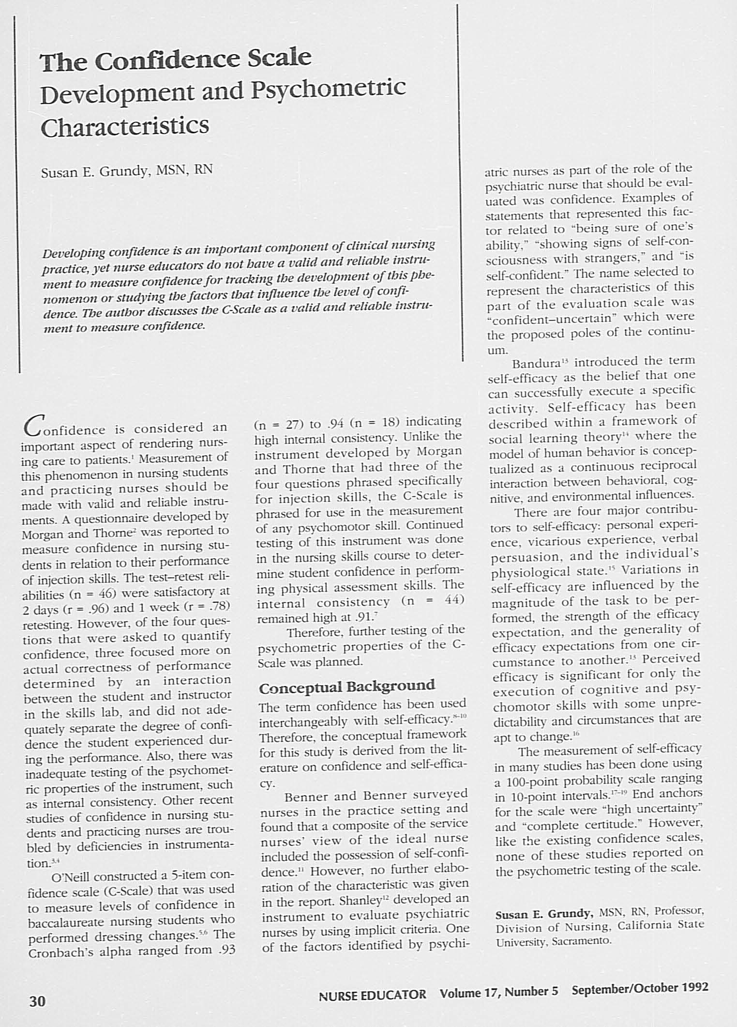

Appendix M-Permission for Use
need to email Dr Grundy at
grundys@csus.edu

Appendix N-Open-Ended Questions

please add

Appendix O-Educational Intervention

add all ppt slides

Appendix P-CITI Training Certificates
Add yours

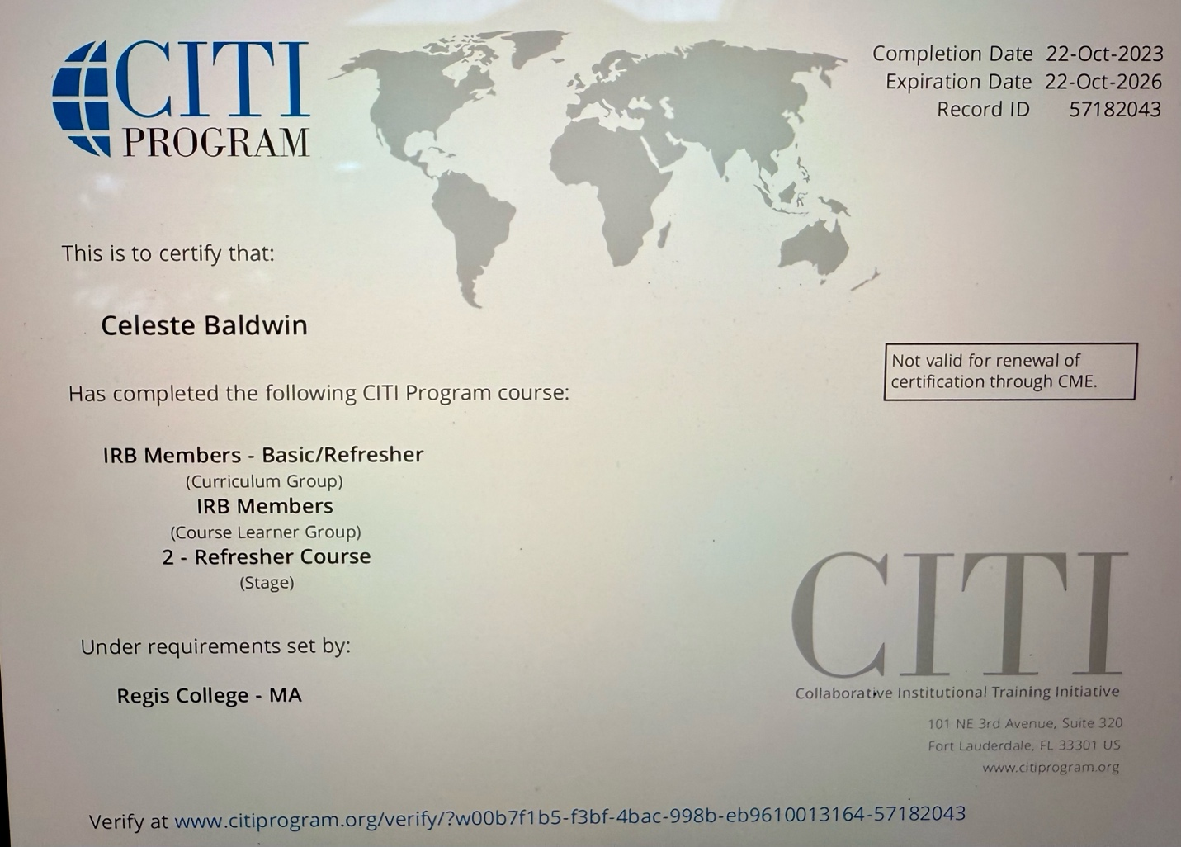

Appendix O-PI Resume

please add

