Using an Educational Approach to Increase the Knowledge, Self-Efficacy and Confidence Levels of Normotensive Non-Hispanic Black Adults, on the Management of the Modifiable Risk Factors for Primary Hypertension

A Scholarly Project

Presented to

The Faculty of Regis College

In Partial Fulfillment
of the Requirements of the
Doctor of Nursing Practice Degree

by

Sterline Desjardins, DNP (c), MPH, BSN, RN

April 23rd, 2025

Scholarly Practice Project Committee Members

Project Chair: Dr. Edmund A. Travers, DNP, MSN, RN in memoriam
Project Chair: Dr. Barbara J. Offner, DNP, MSN-Ed, RN, CRNI
Mentor: Dr. Jasmine Laguerre, DNP, FNP-BC
Second Reader: Dr. Celeste M. Baldwin, Ph.D., M.S., APRN, CNS, GAHN

Abstract
Problem Statement: Essential hypertension (EH) is a significant global health issue that disproportionately affects some racial groups more than others. Research shows Non-Hispanic (NH) Black adults suffer from a greater EH burden compared to their counterparts.
Purpose: This scholarly practice project (SPP) will assess the influence of health education on essential hypertension risk management among normotensive NH Blacks by measuring changes in awareness, confidence and self-efficacy levels.
Methods: A convenience sampling method was used to recruit 27 participants via Facebook. 8 of the participants met the inclusion criteria and were retained. The data was collected via Qualtrics software using a validated 5-point Likert questionnaire. Participants were asked to take a pre and post survey and complete the intervention.
Inclusion Criteria: The inclusion criteria posit that participants must be English speakers, Non-Hispanic Black, and non-health care personnel. Additionally, they must not suffer from certain chronic comorbidities.
Analysis: Descriptive analysis and Inferential analysis were conducted using pie charts, bar charts, measuring average t-test scores and Shapiro Wilk tests using IntellectusStatistics and Microsoft Excel software. The results show statistically significant changes for most of the questions and overall clinical significance.
Implications for Practice: This project reinforces the importance of hypertension education among Non-Hispanic Blacks, to decrease the knowledge gap and promote the endorsement of healthier preventive practices in their daily life.
Keywords: (Health education; Hypertension; Health promotion; Non-Hispanic Black adults; Prevention)

Author Note

This scholarly practice project was made possible by the support and gentle guidance of all the Regis College faculty I have worked with over the past few years, and by the participants who volunteered their time to partake in the project. I particularly want to acknowledge and express my gratitude to my chair, Dr. Travers (in memoriam) and Dr. Offner for their unwavering and nurturing support throughout this arduous journey. I am thankful for my mentor, Dr. Laguerre, and my second reader, Dr. Baldwin, for their guidance and patience. I am beholden to my best friend, Samantha Boursiquot, for her steadfast support and empowering words in my moments of despair. I am grateful for my loved ones, particularly my significant other, Iser E. Barnes Jr., who wholeheartedly believed in me and carried me through this journey. Lastly, I want to thank GOD for granting me the strength needed to persevere and overcome the myriads of hurdles that I encountered.

List of Tables

Table 1. Conceptual & Operational Variables
Table 2. Project Implementation Timetable

List of Figures

Figure 1
The Health Belief Model
Figure 2
Johns Hopkins Evidence Based Practice Model
Figure 3
Age Range
Figure 4
Gender
Figure 5
Ethnicity/Nationality
Figure 6
Education
Figure 7
Employment Status
Figure 8
Perceived Susceptibility
Figure 9
Perceived Severity
Figure 10
Perceived Benefits of Taking Actions
Figure 11
Self-Efficacy
Figure 12
Question 1
Figure 13
Question 2
Figure 14
Question 3
Figure 15
Question 4
Figure 16
Question 5
Figure 17
Question 6
Figure 18
Question 7
Figure 19
Question 8
Figure 20
Question 9
Figure 21
Question 10
Figure 22
Question 11
Figure 23
Question 12
Figure 24
Question 13
Figure 25
Question 14
Figure 26
Question 15

Table of Contents

Chapter I------------------------------------------------------------------------------------------ 11-24
Chapter II------------------------------------------------------------------------------------------25-39
Chapter III-----------------------------------------------------------------------------------------40-50
Chapter IV----------------------------------------------------------------------------------------51-73
Chapter V-----------------------------------------------------------------------------------------74-78
References----------------------------------------------------------------------------------------79-89
Appendix A--------------------------------------------------------------------------------------90-92
Appendix B------------------------------------------------------------------------------------------93
Appendix C------------------------------------------------------------------------------------------94
Appendix D------------------------------------------------------------------------------------------95
Appendix E------------------------------------------------------------------------------------------96
Appendix F--------------------------------------------------------------------------------------97-100
Appendix G------------------------------------------------------------------------------------101-103
Appendix H-----------------------------------------------------------------------------------------104
Appendix I------------------------------------------------------------------------------------------105
Appendix J------------------------------------------------------------------------------------------106

Using an Educational Approach to Increase the Knowledge, Self-Efficacy and Confidence Levels of Normotensive Non-Hispanic Black Adults, on the Management of the Modifiable Risk Factors for Primary Hypertension
Chapter I
Introduction
Primary hypertension is an insidious disease because patients do not always experience the clinical indications (Fatima & Mahmood, 2021). Non-Hispanic (NH) Black individuals are found to be highly susceptible to acquiring primary hypertension at some point in their lifetime (Dougherty et al., 2021). Per the Centers for Disease Control and Prevention (CDC, 2020), 54% of NH Blacks in the United States suffer from elevated blood pressure compared to 46% of Whites. Hypertension can lead to severe sequelae. This condition is complex and multifactorial in etiology. However, one can lessen their risk through the management of modifiable causative lifestyle factors (Diaz et al., 2019). Therefore, it is paramount that Non-Hispanic (NH) Blacks receive comprehensive education on the severity of this significant clinical issue, as well as the preventive practices that they can endorse to promote their health. This scholarly practice project (SPP) aimed to educate normotensive NH Black adults about health promotion and primary hypertension risk reduction strategies to boost their knowledge, self-efficacy and confidence levels.
Background
According to Iqbal and Jamal (2022), primary hypertension is clinically defined as an elevated blood pressure equal to or greater than 130 mmHg (systolic) and 80 mmHg (diastolic). Systolic blood pressure (SBP) is the value of the pressure in the arteries when the cardiac muscles contract, while diastolic blood pressure (DBP) occurs when the heart muscles relax (Desai, 2020). In other terms, individuals that suffer from primary hypertension often have impaired arterial blood flow, which may affect circulation and perfusion. Such phenomenon can disrupt the body’s homeostasis, which can result in the impairment of other vital organs (Nguyen-Huynh et al., 2019).
Iqbal and Jamal (2022) explained that evidence from scientific research has denoted primary hypertension as one of the chronic diseases with the most significant health outcomes. Primary hypertension can lead to the development of “stroke, myocardial infarction, heart failure, and renal failure” (Iqbal & Jamal, 2022, para. 1). Although primary hypertension can occur due to various factors, it is nonetheless known to be idiopathic (Iqbal & Jamal, 2022). This suggests that the etiology for primary hypertension remains unknown as it happens spontaneously without symptoms.
Primary hypertension is a disease process that occurs globally and is often undetected. Iqbal and Jamal (2022) report approximately 45% of the world population is living with primary hypertension. The risks increase with age, as about 60% of those aged 60 years of age or older have high blood pressure (Iqbal & Jamal, 2022). The authors estimated the disease burden would continue to increase by approximately 15% -25% by 2025 (Iqbal & Jamal, 2022). This is an alarming projected rate of worsening numbers afflicted with this disease. According to Iqbal and Jamal (2022), primary hypertension is a non-discriminatory disease because it can potentially affect anyone, regardless of their socio-economic background. While there is some degree of veracity to this statement, Desai (2022) explained in the United States, the risks are much greater among Black individuals.
Per Ogunniyi et al. (2021), there is a remarkable racial divide in the pervasiveness of primary hypertension in the United States. Non-Hispanic (NH) Black people are not well represented in cardiovascular studies. However, they are the principal racial group that is affected by primary hypertension at a disproportionate rate (Ogunniyi et al., 2021). The results of a study on the prediction of atherosclerosis among diverse ethnic groups suggested that Black people were 93% more likely to develop hypertension by the age of forty-five, in contrast to their white counterparts with a predictive value of 86% (Ogunniyi et al., 2021). Moreover, it is explained that those from African and Afro-Caribbean ancestry were at an increased risk of suffering from poorer health outcomes related to hypertension very early in their life (Ogunniyi et al., 2021). These statistics demonstrated a tremendous disparity in hypertension burden by racial and ethnic strata. This is of particular significance because of its severe associative secondary health outcomes such as cardiovascular related diseases.
Primary hypertension is an essential risk factor for cardiovascular diseases (CVD) (Ogunniyi et al., 2021). It has now become the second leading cause of CVD related mortality and morbidity cases (Ogunniyi et al., 2021). Oparil et al. (2018) also stated that per reports from the Global Burden of Disease study, uncontrolled blood pressure remains a contributing factor in the ongoing increase of the disease burden. Primary hypertension can result from “genetic predispositions, pathophysiological and environmental factors” (Oparil et al., 2018, p. 2).
Per Carey et al. (2018), primary hypertension is in part the byproduct of unfavorable life conditions and overall social determinants of health. However, an adjustment of these elements can significantly enhance one’s health outcomes and manage their risks for developing hypertension. Some of the modifiable environmental elements that the authors highlight is, “overweight/obesity, unhealthy diet, excessive dietary sodium, inadequate dietary potassium, insufficient physical activity, and consumption of alcohol” (Carey et al., 2018, p.1). Essentially, the risks for primary hypertension can be managed if modifiable lifestyle factor changes are practiced.
The authors suggested taking a targeted approach to promote the prevention of primary hypertension among normotensive individuals (Carey et al., 2018). The literature supported the use of an education-based intervention that aims to inform those experiencing health illiteracy in relation to primary hypertension. For instance, Azadi et al. (2021) conducted a quasi-experimental study to measure the effectiveness of educating a group of knowledge deficient normotensive staff, at the Iran University of Medical Sciences, about high blood pressure and preventive behaviors. The results of the study indicated statistically significant (p= 0.011) improvement in participants’ intent to take actions, signifying the effectiveness of the educational intervention that was implemented (Azadi et al., 2021). Additionally, Ozoemena et al. (2019) led a quasi-experimental study to assess the effectiveness of a health based educational intervention on promoting preventive behaviors, self-care habits and disease awareness among a group of elderly Nigerian retirees. The findings of the study revealed that the educational intervention successfully accomplished the desired outcomes (Ozoemena et al., 2019).
Significance
Thus far, the literature indicated that blood pressure remains a persistent issue with a projected increase rate in disease burden worldwide. It suggested that due to significant health disparities and genetic predispositions, Black individuals are disproportionately affected by this issue. Disease prevention is a key element of health promotion. Therefore, ongoing education about the disease process, its severity, and preventive measures, can have positive outcomes on behavioral change. The aim of this scholarly practice project (SPP) was to help manage the risks for primary hypertension and promote health among normotensive Non-Hispanic (NH) Black adults. Such intervention is warranted due to the lack of improvement in blood pressure management, and the high prevalence of primary hypertension burden among that group as discussed in the paragraphs.
Nursing Practice
This scholarly practice project (SPP) can influence nursing practice by highlighting the importance of cultural awareness in regard to Black individuals, to better serve them and understand their health needs. Various nursing cultural theories, such as the transcultural theory (Alexander et al., 2020; Tao et al., 2022; Zarzycka et al., 2020), emphasize the importance of understanding patients’ culture in order to provide them with the most appropriate information and assist them with optimizing their health. Foronda (2020) explains that it is important to “recognize diversity and apply cultural humility for successful outcomes” (abstract). This SPP will evaluate the effectiveness of educating Black adults about lifestyle changes and blood pressure prevention. The results can encourage nurses to provide culturally sensitive care to Black individuals and promote their health, based on guidelines found in the literature.
Nursing Research
This SPP will appraise nursing literature in search of evidence-based practices that can be implemented in the care of Black patients. It will influence nursing research by shedding light on the significant contributions that nursing scientists have made and continue to make on nursing practice through their revolutionary discoveries. This project may also highlight areas that further research should be focused on.
Nursing Education
This project will impact nursing education by raising awareness on the severity and pervasiveness of hypertension among Black people. It will provide statistically sound information meant to educate clinical staff about this clinical issue in relation to this vulnerable population. It will also encourage the development of enhanced training on culturally specific care and disease susceptibility among this group, for newly graduate nurses. This will expand on their theoretical knowledge and help them acquire cultural humility and sensitivity.
Nursing Leadership/Administration
Nurses who hold a Doctor of Nursing Practice (DNP) degree are leaders tasked with utilizing their acquired skills to ameliorate patients’ quality of care and optimize their health. A DNP candidate practices that philosophy during their training, with the completion of a scholarly practice project (SPP), which aims to improve patients’ health and delivery of care. This SPP will impact nursing leadership and administration by providing education grounded in scientific findings, to the target patient population. It will also enhance nurses’ knowledge and understanding of Black patients’ beliefs and attitude towards primary hypertension, which will in turn promote better delivery of care. Additionally, this SPP may inspire others to be leaders in preventive community health.
Problem Statement
There is well founded evidence in the literature that indicate that Non-Hispanic (NH) Black individuals are more susceptible to developing primary hypertension (HTN) at some point in their life (Abrahamowicz et al., 2023). Aggarwal et al. (2021) report that NH Black adults have a greater rate of hypertension (45.3%) and a poorer blood pressure (BP) control rate of (39.2%). These statistics are significant when compared to that of their NH white counterparts, who have a HTN prevalence rate of 31.4% and a BP control rate of 49% (Aggarwal et al. 2021). It is estimated that by 2025, over one billion of the world population will suffer from hypertension (Iqbal & Jamal, 2022).
Although preventive, hypertension remains a pervasive global clinical problem that greatly affects this vulnerable group (Abrahamowicz et al., 2023). It is important to investigate this problem and implement preventative measures to manage its risks among that population, because of its severe associated comorbidities. Per Abrahamowicz et al. (2023), NH Blacks “experience greater hypertension-related morbidity and mortality than NH White persons with 30% higher risk of fatal stroke, 50% higher risk of CVD mortality, and more than 4 times higher risk of end-stage renal disease…NH Black persons experience 4–5 times greater hypertension-related mortality when compared to NH White Americans” (p.18).
Per Diaz et al. (2019), healthier lifestyle behaviors contribute to the prevention of primary hypertension. Thus, educating the population about modifiable lifestyle factors can potentially promote a change in behavior and beliefs. It is, therefore, possible to promote hypertension preventive habits among Non-Hispanic Black adults by utilizing an educational program aimed at increasing their confidence and self-efficacy levels regarding hypertension.
Clinical/Practice Question(s)
Does a health education program about the management of modifiable risk factors for primary hypertension increase the knowledge, self-efficacy and confidence levels of normotensive Non-Hispanic Black adults?
The PICO question for this SPP is formatted as shown below,
- P = Normotensive Non-Hispanic Black adults
- I = Educational program on the management of primary hypertension modifiable risk factors
- C = None
- O= Increased knowledge, self-efficacy and confidence levels
Purpose of the Project
This scholarly practice project (SPP) aims to educate normotensive Non-Hispanic Blacks bout the disease process of primary hypertension and its risk factors. It also strives to inform them about the preventive strategies that can be employed in their daily life to manage their risks for primary hypertension. This SPP endeavors to measure the influence of the educational intervention on their awareness level, their beliefs/attitude toward the disease, as well as their intent/willingness to change and embrace healthier habits.
Project Aim/Measurable Objectives
The aim of this SPP is to explore whether an educational approach about hypertension primary preventive measures will enhance the knowledge, self-efficacy and confidence levels of normotensive Non-Hispanic Black adults. The plan is to:
- Develop a health educational intervention utilizing hypertension preventive guidelines that focus on lifestyle changes published by the CDC, MA department of public health, and the American Heart Association for Black adults.
- Gather quantitative data
- Gather subjective data about the barriers and challenges that affect their ability to improve their overall health.
- Recruit participants via a virtual forum.
- Disseminate the findings to healthcare professionals and organizations (such as the American Nurses Association), as well as the general community by publishing the data via the virtual implementation sites.
The findings of this project will be helpful in the primary care setting as it will show the merits in educating all NH Black patients on the importance of lifestyle changes to reduce their risks for primary hypertension. The premise of this SPP is about educating the target population about their susceptibility to hypertension to promote better health habits. The results of this SPP will be shared with clinicians in primary care settings, to educate them about the benefits of early education on hypertension and preventive measures among susceptible normotensive NH Black adults. Additionally, the findings from this SPP can be used to train and educate all clinical staff on the cultural differences and social disparities that exist in regard to hypertension among Black individuals. This will create an environment that promotes ongoing education for both staff and patients.
Theoretical or Conceptual Framework
This SPP is based on the principles of the Health Belief Model (HBM). The HBM is a psychological theory founded by Hochbaum, Rosenstock, and Kirscht in the 1950s (Ghorbani-Dehbalaei et al., 2021). This theory was created with the aim of understanding the rationale behind the reluctance of people who did not partake in accessible preventative health programs (Boslaugh, 2022). HBM has six constructs which are, perceived susceptibility, perceived severity, perceived benefits, perceived barriers, cues to actions and self-efficacy (Melkamu et al., 2021). This SPP will utilize a validated instrumentation that is based on the tenets of HBM to collect pre and post test data (See Figure 1). The health belief model is a theory frequently used in the literature to investigate issues related to health promotion and behavioral change (See Appendices A & B).
Figure 1
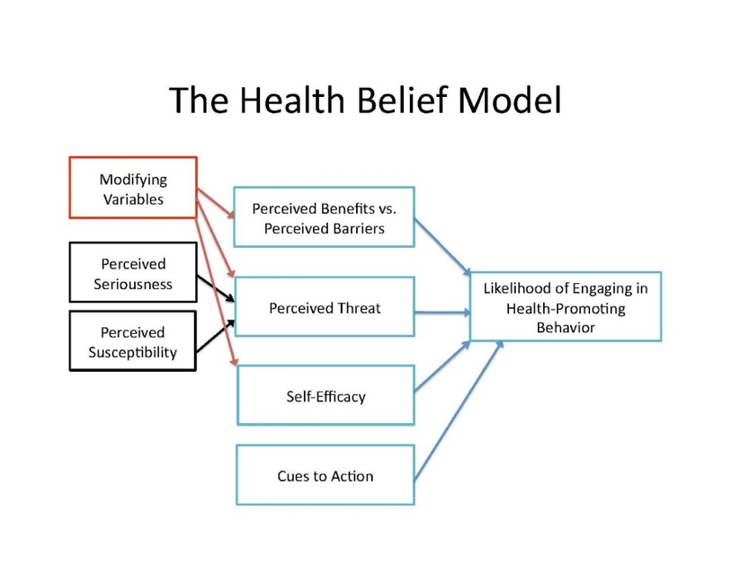
The Health Belief Model
(Urich, 2017)
For instance, Melkamu et al. (2021) conducted a study in which they used the notions of the health belief model to measure self-care practices among patients who suffered from diabetes. The authors explained,
According to the model, for the behavior (self-care practice) to succeed, patients must feel threatened by their poor self-care practice (perceived susceptibility and severity), believe that change in self-care practice result in a valued outcome at an acceptable cost (perceived benefit), and feel competent (self-efficacy) to overcome perceived barriers to action. This means, patient’s engagement in self-care practices increase with high perceived susceptible to the illness, greater severity of the illness and its complications, high perceived benefit of and lower barrier to self-care practices, more cues to action and greater self-efficacy (Melkamu et al., 2021, p. 2147).
The authors used validated questionnaires that are based on HBM concepts to collect their statistics and measure their outcomes. The results of the study indicated that those with awareness of the disease or who have some degree of health literacy, were more likely to practice self-care habits (Melkamu et al., 2021).
Another relevant example is the findings of the study performed by Azadi et al. (2021). They led a quasi-experimental study that intended to explore the impacts of education-based interventions, stemming from the doctrines of the health belief model, on promoting preventive hypertension behaviors among Iranian employees. The authors stated that,
the health belief model (HBM) refers to one of the affective educational models in preventing chronic diseases and health promotion and acted as a practical framework for designing educational interventions and promoting preventive behaviors. This model is a comprehensive model that plays a significant role in disease prevention (Azadi et al. 2021, p.2).
Similar to the previous study, Azadi et al. (2021) used validated pre-test and post-test questionnaires for data collection. The results demonstrated the effectiveness of the implemented educational intervention in promoting behavioral changes among the target population.
Philosophical Assumptions
The philosophical assumption of HBM is that an individual will likely endorse a recommended health behavior if they believe that the illness/disease is a threat to them, and that the recommended behavior is effective and plausible (Melkamu et al., 2021).
In terms of hypertension literacy and awareness, Spikes et al. (2019) explained that African Americans (AA)’ beliefs on hypertension are different from that of clinicians. Some AA patients believe that high blood pressure is a genetic condition that thickens one’s blood, or it’s a response to an extreme emotional state, or a stress response induced by their social conditions (such as poverty and other difficulties) (Spikes et al., 2019). Three of the tenets from the HBM are perceived susceptibility, perceived severity, perceived benefits- will help with designing the intervention for this SPP as they will provide insights into the perceptions related to Black individuals’ understanding of the disease, their susceptibility to it, and the preventive measures that they can practice managing their risks for developing primary hypertension.
Evidence-based Practice (EBP) Model
Li et al. (2019) define evidence-based practice (EBP) as the best available knowledge that is grounded in strong scientific findings. EBP strives to support a specific practice or procedure, with the objective of improving patient care. Additionally, Katowa-Mukwato et al. (2021) explain that the incorporation of evidence-based guidelines into one’s practice has yielded greater patient satisfaction, reduced hospital cost, and enhanced overall patient care/safety.
The EBP model that will be used in this SPP is the Johns Hopkins EBP (JHEBP) nursing model (See Figure 2). Per Brunt and Morris (2023), the Johns Hopkins model is “a problem-solving approach to clinical decision-making with user-friendly tools to guide individual or group use” (para 15). Brunt and Morris (2023) explicated that this model primarily consists of a 3-step process named PET which is defined as practice question, evidence, and translation (See Appendix C & D). The JHEBP process starts with an inquiry, which means assessing for an issue. Once the issue is identified, the PET process then starts, which should yield best practices. These guidelines are then implemented into practice for improvement, which is then constantly reflected on to evaluate the effectiveness. As more insights are gained from these reflections, the JHEBP cycle repeats itself. This is why this EBP model is a recurrent, dynamic process. Overall, it is a relatively straight forward process which tells the user to identify the issue, find evidence in the literature to support the issue and a solution to solve it, then apply those findings into practice.
Figure 2
Johns Hopkins Evidence Based Practice Model
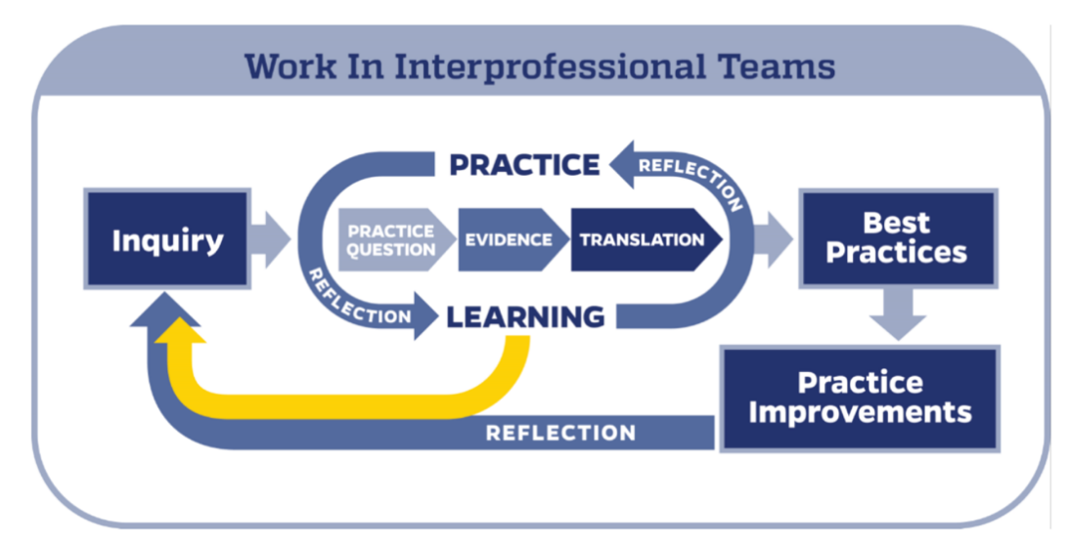
Dang, D., Dearholt, S., Bissett, K., Ascenzi, J., & Whalen, M. (2022).

The clinical question for this SPP seeks to measure the influence of an educational intervention about modifiable hypertension risk factors on the knowledge, self-efficacy and confidence levels of normotensive Non-Hispanic Black adults. As demonstrated in the previous section, this project is grounded in the ideals of the health belief model (HBM) which posits that once one understands their susceptibility to a disease, its effect on their health, and their likelihood for success if they strive for change, then they are likely to endorse healthier habits to promote their health.
Utilizing the Johns Hopkins EBP model in the context of this SPP is a forthright process. The first step entails the aforementioned PICO question, which is used to scope the literature in search of evidence as dictated by the second step in the process. That evidence should effectively support the identified knowledge deficit in relation to the HBM constructs, and the effectiveness of the proposed intervention in bringing about positive change. In the third step of the model, the evidence is translated into practice which will happen in this SPP once the intervention is implemented among the participants and the results are analyzed to measure for effectiveness and sustainability. The findings will be shared with the American Nursing Association (ANA) and community health providers to continue to engage the community in primary preventive behaviors to manage their primary hypertension risks.
Conclusion
Non-Hispanic (NH) Black individuals are more susceptible to primary hypertension and its sequelae in comparison to their counterparts. Research findings suggest that primary prevention measures are effective in preventing, managing, and controlling primary hypertension. Educational interventions based on the principles of the health belief model are shown to effectively enhance disease awareness and promote behavioral changes. In brief, this scholarly practice project will explore the effectiveness of an education-based intervention regarding hypertension, on promoting better health habits among normotensive NH Blacks. In addition, a mixed method design will be used to gather open-ended questions for the participants about their likelihood of engaging in health promoting behavior.

Chapter II: Review of Literature
For this literature review, various databases were explored in search of prevalent and recent articles on hypertension and its risk factors. The databases searched were Google Scholar; PubMed; CINAHL; Regis College Library Power Search; Elsevier; Cochrane Library; NIH. The assistance of the librarians at Regis College and the project site were utilized. Grey literature was retrieved from organizations such as CDC, WHO, and AHA.
Search terms used were “primary prevention”; “preventive measures”; “exercise”; “diet”; “nutrition”; “lifestyle changes”; “education”; “health coaching”; “healthy adults”; “hypertension”; “HTN”; “hypertension risk”; “high blood pressure”; “blood pressure”; “normotensive”; “normal blood pressure”; “African American”; “AA”; “Black”; “adults”; “health education”; “exercise”; “physical activity”; aerobic”; “HIIT”;CVD”; “Cardiovascular diseases”. This search was conducted over the course of Fall 2023, from September to December on the following dates: 09/08/2023; 09/15/2023; 09/22/2023; 10/06/2023; 10/11/2023; 10/20/2023; 10/27/2023; 11/03/2023; 11/10/2023; 11/17/2023; 11/24/2023; 12/1/5/2023; 12/08/2023; 12/09/2023
.
Primary hypertension (HTN) is ramping across the globe and is recognized as a public health crisis (Pius, 2021). It is currently one of the most prominent risk factors for cardiovascular diseases (Joubert et al., 2021; Pius et al, 2021; Ogunniyi et al., 2021). The authors explained that the burden of cardiovascular diseases, as a result of primary hypertension, is projected to significantly increase over the years, with a rise in the toll of fatalities. Primary hypertension is mostly prevalent among Black individuals. Studies showed high percentages of the disease in countries in the African continent such as South Africa, Nigeria, Ghana and many more (Sharma et al., 2021; Okello et al., 2020). According to the authors, many of the factors that contribute to such disparity in disease distribution are related to knowledge deficit concerning the disease process, and adverse elements of social determinants of health. In the United States (U.S.), it is well documented that those from African descent (Non-Hispanic Blacks) suffer the most from this non-communicable disease (Spence & Rayner, 2018; Ogunniyi et al., 2021). Primary hypertension can result from modifiable factors such as genetic predispositions, race and family history, and non-modifiable factors such as lifestyle influences as well as psychosocial elements. It is paramount that health professionals, policy makers, public health specialists and other stakeholders continue to strive for the prevention of primary hypertension by encouraging the endorsement of healthier habits and by continuing to raise awareness on the severity of the disease (Princewel et al., 2019). This literature review will delve further into the risk factors of primary hypertension as a principal causative agent for cardiovascular diseases, which will support the need for preventive outreach efforts.
Comprehensive Literature Review
Genetic Factors
Genetic predisposition significantly contributes to Non-Hispanic (NH) Black individuals’ susceptibility to hypertension (HTN). Black people are innately more sensitive to sodium than their White counterparts. A descriptive review about hormones and biological processes associated with blood pressure regulation, conducted by Zilbermint et al (2019), indicated that Black people’s renal genetic make-up functions differently as it relates to blood pressure control. Another descriptive review by Elijovich et al. (2023) on the genetic history of salt sensitivity in NH Black people suggested that social determinants of health, genetics and epigenetics all play a role in Black people’s renal ability to regulate their blood pressure. In their review, Spence and Rayner (2018) delved further into the biological processes of the kidneys and explained the reasons why Black individuals are prone to retaining salt and water, which contribute to the development of high blood pressure.
Renin-Aldosterone-Angiotensin-System (RAAS)
The risk factors of hypertension among Black people should be understood in order to develop intervention measures to curtail the ongoing rampage. Behavioral, biological, and environmental factors all play a role in an individual’s risk for hypertension (Sharma et al., 2021). The genetic risk factors among individuals of African heritage are not well researched but yet is an important element that can help better understand their susceptibility to this chronic disease (Zilbermint et al 2019). In the renal system, the renin-aldosterone-angiotensin system (RAAS) plays a significant role in normalizing the blood pressure and blood volume in the body. RAAS consists of a mixture of hormones (Aldosterone and Angiotensin II) and enzymes (Renin) that work harmoniously to maintain homeostasis of the body by excreting and reabsorbing water and electrolytes such as sodium and potassium (Zilbermint et al 2019; Spence & Rayner, 2018); Elijovich et al., 2023). In African Americans, the RAAS pathway works at a slower pace, which makes them retain water and expulse sodium out of their system much slower than other races (Zilbermint et al 2019; Spence & Rayner, 2018; Elijovich et al., 2023). Such phenomenon thus leads to elevated blood pressure.
Trans-Atlantic Slave Trade Adaptation Notion
Another hereditary cause of hypertension in Black people is related to the concept of gene adaptation during the Trans-Atlantic slave trade. Such event seems to have occurred to enhance the likelihood of survival during their passage from Africa to America via ship (Zilbermint et al., 2019; Spence & Rayner, 2018; Elijovich et al., 2023). The conditions on the ship decks were extremely arid and coupled with the scorching heat, they caused an increase in illnesses leading to severe dehydration (Zilbermint et al., 2019). It is postulated that the process of natural selection caused the mutation of certain renal gene alleles (i.e epithelial sodium channel- ENaC) to promote the retention of water by heightening the reabsorption process of sodium through the renal system (Zilbermint et al., 2019; Spence & Rayner, 2018; Elijovich et al., 2023). Consequentially, Black people of African descents are found to have a high prevalence of Liddle phenotype (Zilbermint et al., 2019; Spence & Rayner, 2018). Liddle phenotype is defined as low level of renin and low level of aldosterone due to the hyperactivity of the ENaC gene, which results in the impairment of the sodium reabsorption process and enhances the body’s responsiveness to salt (Zilbermint et al., 2019; Spence & Rayner, 2018). Such was noted among both normotensive and hypertensive Black individuals (Spence & Rayner, 2018). This emphasizes the dormant genetic hypertension risk that Black individuals inherently have, despite being in a heathy physical state. Due to this genetic mutation phenomenon, those of African lineage born in America are more likely to suffer from hypertension compared to those born in the homeland (Spence & Rayner, 2018).
Overall, in regard to hypertension, the biological processes between NH Black individuals and other races vary vastly. The renal system which is a key player in the natural regulation of the body’s blood pressure, excretes sodium at a much slower rate in Black people than in White people. As demonstrated in the three articles that were reviewed in this section, Black people are more likely to suffer from hypertension due to sodium retention and salt sensitivity.
Lifestyle Factors
A hypertension (HTN) diagnosis can potentially be fatal, considering the severe secondary health outcomes (kidney disease, CVD, stroke…) that it can spur on (Sharma et al., 2021). It is well established that the hereditary factors cannot be modified to prevent the risk of hypertension among susceptible NH Blacks. However, the modifiable factors that are behavioral such as fitness level and dietary habits, can be adjusted to promote health and prevent hypertension among NH Blacks (Sharma et al., 2021). Therefore, primary preventive measures such as early HTN screenings and ongoing education about lifestyle improvement, should be reinforced to prevent HTN diagnosis and mitigate the risks.
Nutrition/Diet
Nutrition plays a vital role in ensuring the body’s homeostasis. As such, a well-balanced diet is important in the maintenance of normal blood pressure values, as well as the overall prevention of hypertension. There exist various dietary options that can positively influence one’s health outcomes. Research has shown that some are more effective than others at improving blood pressure outcomes and inevitably reduce risk factors for cardiovascular diseases (Ferreira et al., 2021; Filippou et al., 2020; Howard et al., 2018; Tyson et al., 2019). Filippou et al. (2020) and Ferreira et al. (2021) conducted systematic reviews and meta-analysis studies of moderate level of randomized control trials (RCTs) to measure the differential effects of the Dietary Approaches to Stop Hypertension (DASH) diet compared to a control diet on blood pressure outcomes among hypertensive and normotensive adults. The findings indicated statistically significant improvement in both systolic and diastolic blood pressure values among participants in the DASH treatment group. More specific to the target population of this project, the Jackson Heart cross-sectional comparative study by Tyson et al. (2019) showed the DASH diet effectively reduced blood pressure values significantly more among Back individuals than other races. Conversely, Howard et al.’s (2018) longitudinal prospective study evaluated the influence of certain social factors, such as the Southern diet and dietary intake of sodium/potassium, on the development of hypertension among Black and White participants. The results suggested a higher likelihood of hypertension diagnosis among Blacks in relation to those factors.
The DASH diet which contains high level of fruits, vegetables/legumes, whole grains and low level of saturated/trans-fat and sodium, is a healthier and more sustainable dietary regimen that yields positive health benefits, particularly in respect to decreasing blood pressure values (Filippou et al., 2020; Tyson et al., 2019). Another dietary routine which is also a part of the DASH diet is the pulse diet, which Ferreira et al. (2021) explained is derived from plants and primarily consists of a variety of beans and legumes. Considering dietary contents affect the equilibrium of the body because they interact with chemicals produced by the body, both the DASH and pulse diet were shown to positively influence the kidneys’ functions as it relates to hypertension control (Tyson et al., 2019; Filippou et al., 2020; Ferreira et al., 2021). Both diets contain electrolytes/minerals (i.e. potassium) that enhance the excretion of sodium, resulting in improved blood pressure outcomes (Ferreira et al., 2021; Filippou et al., 2020). It is well documented in the literature that electrolyte (such as sodium and potassium) imbalance greatly impact blood pressure regulation (Ferreira et al., 2021; Filippou et al., 2020; Howard et al., 2018; Tyson et al., 2019). As per previous discussion, Black individuals’ biological processes make them susceptible to poor blood pressure regulation, due to the ineffective excretion and balance of the level of sodium/potassium in their system. Unlike the DASH and pulse dietary patterns which are primarily low in fat/sugar and high in fruits/vegetables/whole grains/healthy dairy, the Southern diet is the complete opposite as it consists of fried/processed food, red meat, and lot of sugary/fatty substances that negatively affect blood pressure level and increase CVD risks (Howard et al., 2018). Black individuals were said to be the highest consumers of this diet, which research showed accounted for over 50% of the contributing factors to hypertension development among that population (Howard et al., 2018).
In sum, these studies emphasized the importance of a healthy and well-balanced dietary regimen. Such dietary patterns play a significant role in the prevention and management of hypertension. They are shown to work effectively among both hypertensive and normotensive groups.
Physical Fitness
A sedentary lifestyle is one of the major risk factors for obesity, which is of a public health priority due to its global prevalence. There is a significant burden of obesity among the Black population (Maseko et al., 2018; Hornbuckle et al., 2018;). Obesity is one of the risk factors for hypertension (HTN) and cardiovascular diseases (CVD), which are also prevalent among this group. Numerous studies have shown that physical activity effectively reduces weights/BMIs (obesity risks), blood pressure values and accordingly decreases the risks of CVD (Hong et al., 2018; Hornbuckle et al., 2018; Aghaei Bahmanbeglou et al., 2019; Soltani et al., 2020; Ko et al., 2021; Wilbur et al., 2019; Annesi, 2021).
Aerobic Exercises.
Aerobic exercises (such as running, brisk walking, swimming, biking…) have commonly been encouraged to promote increase movement to prevent certain chronic diseases such as HTN and CVD (Ko et al., 2021; Wilbur et al., 2019; Annesi, 2021). The following randomized control trials have shown the positive correlation between aerobic exercises, weight loss and reduction in blood pressure values. Ko et al. (2021) compared the effectiveness of stretching (as a form of exercise) with brisk walking, on reducing blood pressure level. Wilbur et al. (2019) analyzed the effects of lifestyle walking on blood pressure (BP) control/reduction among a large sample of sedentary African American women. Annesi’s prospective study (2021) examined the correlation between increased exercise output, and decreased BP level, weight loss and mood stabilization.
Aerobic exercises are physical activities of moderate intensity that increase heart rate and oxygen consumption in the body. This category of exercise, which is more recognized and endorsed, significantly impacts mood regulation, body composition and blood pressure control (Ko et al., 2021; Wilbur et al., 2019; Annesi, 2021). Walking is the easiest and most recommended form of aerobic exercise by clinicians because it is a more effective method to encourage adherence, increase physical fitness level and it is a more sustainable physical activity to engage in (Wilbur et al., 2019; Annesi, 2021). However, despite acknowledging that a sustained walking exercise routine results in a reduction in waist circumference, Ko et al. (2021) argued that stretching is proven to be more effective in decreasing blood pressure values than brisk walking. Of such, they highly recommended incorporating the two types of exercises into one routine for greater and more comprehensive health benefits. Mood such as anxiety and depression were found to be linked with high blood pressure, particularly in overweight and obese individuals (Annesi, 2021). According to the author, those who partook in aerobic exercises were found to have enhanced mood, lower blood pressure values, and a decrease in body fat composition, which overall lessened their risk factors for cardiovascular diseases.
High Intensity Interval Training (HIIT) Exercises.
A different category of exercises that is increasing in popularity is HIIT. In a pilot randomized controlled trial (RCT), Hornbuckle et al. (2018) demonstrated that HIIT exercises effectively decreased circumferential fat and increased fitness level among a small sample size of young overweight/obese African American women. Other small sized RCTs about HIIT exercises showed that this type of exercise significantly influences the improvement in blood pressure values, weight loss and reduction of CVD risks. RCTs conducted by Aghaei Bahmanbeglou et al. (2019) and Soltani et al. (2020) among a group of hypertensive men, suggested that any duration of HIIT positively affected BP level, although shorter durations were found to be more significantly effective in Aghaei Bahmanbeglou et al.’s study (2019).
These recent studies have indicated that high intensity interval training (HIIT) is integral in the improvement of fitness level as well as in the prevention/management of lifestyle-based diseases such as obesity, CVD and HTN (Hornbuckle et al., 2018; Aghaei Bahmanbeglou et al., 2019; Soltani et al., 2020). In short, HIIT consists of periods of highly intensive exercises followed by short periods of rest. This training pattern is shown to be more effective at promoting fat loss, which consequentially improves blood pressure values and other CVD markers (Hornbuckle et al., 2018; Aghaei Bahmanbeglou et al., 2019; Soltani et al., 2020). Although any duration of HIIT exercises results in positive health benefits and yields significant favorable blood pressure values (Hornbuckle et al., 2018; Aghaei Bahmanbeglou et al., 2019), the promotion of short duration of HIIT exercises is however encouraged particularly among overweight/obese and physically inactive individuals, to ensure adherence to the training program (Soltani et al., 2020).
Overall, all the studies highlighted the benefits of physical activities in the prevention/management of obesity and high blood pressure, which are major risk factors for cardiovascular diseases. Both aerobic and HIIT activities, when performed consistently and sustainably, are shown to either reduce the risks of developing those conditions or help to better manage them. Black individuals were found to be the greatest sufferers of these chronic illnesses, and they were the least likely to participate in physical activities.
Stress
Stress is another lifestyle factor that affects blood pressure regulation. Numerous studies have shown the effects of stress and stress reducing activities on blood pressure values in hypertensive individuals (Kang et al., 2018; Adams et al., 2018; Burroughs Peña et al., 2019; Spruill et al., 2019; Schneider et al., 2021). Black individuals (particularly Black women) are understood to suffer significantly more from psychosocial stressors (job and financial insecurity, discrimination…) than their White counterparts (Burroughs Peña et al., 2019; Spruill et al., 2019; Schneider et al., 2021). As discussed in previous paragraphs, Black people have the highest percentage of hypertension diagnosis than other races (White, Asian…). Therefore, the high prevalence of stress among this group corroborates their susceptibility to hypertension. Some cross-sectional and cohort observational studies indicated that high level of stress is positively associated with hypertension (Kang et al., 2018; Burroughs Peña et al., 2019; Spruill et al., 2019). A couple of randomized control trials suggested that mindfulness activities such as meditation can significantly lower blood pressure values in hypertensive adults (Adams et al., 2018; Schneider et al., 2021).
Chronic stress is associated with higher rate of hypertension and increased risk of developing hypertension (Kang et al., 2018; Spruill et al., 2019). Many studies emphasized the prevalence of psychosocial stress among Black women (Kang et al., 2018, Burroughs Peña et al., 2019; Schneider et al., 2021). Although, the specific stressors are not identified, it is posited that social constructs and social factors (caregiving, race-related, financial issues…) contribute to enhanced stress level in Black people, with an emphasis on Black women (Kalinowski et al., 2021). The higher the stress level, the greater the systolic blood pressure value was found to be (Kang et al., 2018). To remedy that, research recommends the practice of meditation, which was said to have empirically shown significant effectiveness on reducing blood pressure values (Adams et al., 2018). Although, there was no significant finding on the impact of meditation on blood pressure values in normotensive individuals (Schneider et al., 2021), it was however found that it significantly reduced systolic values in hypertensive adults (Schneider et al., 2021; Adams et al., 2018). Meditation was found to be beneficial even at the lowest duration, however higher duration was found to have greater positive BP outcomes (Adams et al., 2018).
In summary, these studies highlighted the negative impacts of stress on blood pressure values, particularly among Black women. They acknowledged that social determinants of health are amplified stressors that can cause chronic stress among that group. They indicated that stress-relieving activities such as meditation, significantly reduced blood pressure values in hypertensive individuals. They recommended utilizing this intervention as a primary prevention measure in normotensive individuals as well, despite the lack of significant data about its effect among that group.
Health Education
Numerous studies have indicated that health education is an effective intervention that raises awareness about hypertension, its risks factors and secondary health outcomes (Ozoemena et al., 2019; Lynch et al., 2019; Shin et al., 2021; Azadi et al., 2021; Mhlaba et al., 2022; Akuiyibo et al., 2022). Various descriptive (qualitative) and analytical (quasi-experimental) studies performed in some African countries (i.e. Nigeria, South Africa) demonstrated the positive effects of hypertension education on health behaviors/perceptions among young and older Black adults (Ozoemena et al., 2019; Lynch et al., 2019; Shin et al., 2021; Mhlaba et al., 2022; Akuiyibo et al., 2022). Many of these studies emphasized the benefits of grounding these educational interventions in the constructs of the Health Belief Model (HBM) to promote sustainable changes in health habits (Ozoemena et al., 2019; Lynch et al., 2019; Azadi et al., 2021; Akuiyibo et al., 2022; Mhlaba et al., 2022).
Health promotion measures, such as educational interventions, are crucial to public health efforts that aim to manage, prevent, and reduce the prevalence/incidence of hypertension among Black adults (Shin et al., 2021). Per Ozoemena et al. (2019), knowledge deficit in relation to HTN and its associated risks contributed to infrequent participation in preventive activities. Even in regions with high level of hypertension awareness, Akuiyibo et al. (2022) reported that a health education strategy significantly increased knowledge about HTN and secondary health effects. Studies have suggested that in addition to enhancing individuals’ awareness about hypertension and its severity, health education measures also increase confidence level and motivation to endorse healthier habits (Ozoemena et al., 2019; Lynch et al., 2019; Shin et al., 2021; Azadi et al., 2021; Mhlaba et al., 2022; Akuiyibo et al., 2022). Those who partook in health education initiatives were found to have greater level of self-awareness, enriched understanding of their susceptibility to HTN, and higher confidence level in their ability to change certain lifestyle factors that can mitigate their risks for HTN and its sequelae (Mhlaba et al., 2022).
In short, these studies support the implementation of hypertension educational health interventions to promote disease prevention and health maintenance. They demonstrated statistically significant outcomes resulting in change of behavior, attitude, and perspective. They reinforced the importance of outreach efforts in the fight against hypertension.

Supporting Literature
The prevalence of hypertension among Black individuals is well supported in empirical and supplemental research. One of the key prevention factors that is emphatically universally discussed is changes in lifestyle practices. The World Health Organization (WHO) stated that primary and secondary prevention measures should be prioritized globally in all primary care settings to cost-effectively prevent and manage hypertension (2023). The updated 2017 hypertension guidelines released by the American Heart Association (AHA, n.d.) recommend lifestyle changes for all the BP categories (normotensive and hypertensive). Additionally, the Center for Disease Control and Prevention (CDC, 2020) highlights the benefits and effectiveness of public health initiatives such as education and community partnership with organizations such as Church Community Health Awareness Programs (CHAMPS); Healthy Heart Community Prevention Project (HHCPP); and the faith-based Give God a Hand project in predominantly Black neighborhoods to enhance access to care and promote adherence to anti-hypertensive medications. One approach which focuses on coaching and lifestyle changes that the CDC (2020) reports to have been proven effective in that community is the Faith Based Approaches in the Treatment of Hypertension (FAITH).
A noteworthy article by Kaiser Permanente (2022) (a U.S. based healthcare company) discussed the results of an analytical study that was done with Black hypertensive patients who received care at that health facility. They reported that patients who were in the lifestyle coaching group had statistically significant positive blood pressure results than patients who were in the medication and routine care group. More interestingly, they discovered that even after the study and no further contact with the participants, those patients in the intervention group continued to have good blood pressure control likely by maintaining the new health habits they had endorsed. Health education about hypertension and its secondary health events should be routinely provided in primary care settings. However, some of the barriers which Baldwin et al. (2023) for instance noted at the Lafayette VA Medical Center which have hindered delivery/quality of patient care are, burnout (700-900 patient workload per nurse practitioners) leading to high turnover rate, and lengthy hiring process which worsens the staffing shortage issue. Additionally, all the tedious administrative tasks (such as documentations, insurance claims, clinical reminders…) detract the time to perform preventive health education. However, as discussed in the above paragraphs, research shows the benefits of health education in the improvement of blood pressure values. Therefore, it should not be disregarded, particularly with the ever-changing blood pressure guidelines. At the very least, the authors recommended the implementation of telehealth visits for blood pressure management/education among hypertensive patients, as their pilot study showed such intervention to be effective among the participants who completed the study (Baldwin et al., 2023).
Conclusion
In closing, these studies discussed the non-modifiable and modifiable factors that increase NH Black people’s susceptibility to primary hypertension. Most of the studies and guidelines that were reviewed in this chapter underlined the importance of lifestyle changes such as healthy diet, increased physical activity, and stress management to prevent or control high blood pressure. They suggested that educational interventions which center on health promotion, are important measures to raise awareness and encourage behavioral changes among at risk, ill and healthy individuals. The findings support the goals of this Scholarly Practice Project (SPP), which are to enhance normotensive NH Black people’s primary hypertension knowledge, self-efficacy, and confidence levels by educating them on the risk factors of hypertension, its sequalae and their susceptibility to the disease. Many of the studies that were reviewed were conducted with the goal to yield new knowledge based on gaps found in the literature. While it is still research that will be implemented in a sample group, the objectives of the reviewed research articles nonetheless differ from the purpose of this project, which is to utilize existing evidence-based knowledge extracted from the literature, to raise awareness on hypertension and promote behavioral changes among at risk individuals.

Chapter III: Methodology
Introduction
This scholarly practice project (SPP) utilized a health education intervention to provide reinforced teaching to normotensive Non-Hispanic Black adults, with the aim of increasing their hypertension (HTN) knowledge, self-efficacy, and confidence levels. These variables were specifically selected because as shown in the literature review, they helped manage the target population’s risks of developing HTN, which is influenced by their heightened susceptibility resulting from inherent and environmental factors. This methodology section expounded on the project design and the data collection process.
Project Design
This was an evidence-based practice (EBP) project, with a quantitative pre and posttest design. The goal of the project was to evaluate the effectiveness of evidence-based teaching about primary hypertension on enhancing the knowledge, self-efficacy and confidence levels of normotensive non-Hispanic (NH) Black adults. Additionally, open-ended questions were incorporated to obtain insights into the participants’ experience and enlighten this author and other stakeholders about subjective barriers that the participants encounter in daily life. The overall effectiveness of the project was evaluated using a pre/posttest format.
Project Methods/Plan and Procedures
The evidence-based practice (EBP) framework that was utilized in this project was the Johns Hopkins (JH) EBP model. This framework is concise and has user friendly instructions. It primarily consists of a three-step process referred to as PET (practice question-evidence-translation). This process allows for the quick implementation of the best available evidence into practice (Dang et al., 2022). The framework begins with an inquiry which then leads to the PET section, which is understood to be the core of the model. A research question is generated based on that inquiry. The literature is appraised in search of evidence-based practice recommendations and the findings of the literature search are then synthesized. An EBP intervention is then implemented and evaluated prior to disseminating it as the best standard of practice.
This SPP’s incorporation of the JHEBP model was as followed,
- Practice question: This was the PICO/clinical question
- Evidence: The literature was comprehensively reviewed for information about NH Black people’s susceptibility to HTN; risk factors/preventive methods; and the benefits/effectiveness of health promotion to encourage behavioral change. The findings were appraised and synthesized.
- Translation: The evidence from the literature review was used to create an animated health educational video that taught participants about the pathogenesis of the disease/susceptibility, its severity/risks as well as preventive methods to promote health. A pre/post- test (based on the tenets of the health belief model HBM) was administered to participants. The findings were disseminated to appropriate stakeholders (i.e. clinicians, faculty, health educators, peers and participants).
Evidence-Based Clinical/Practice Question
Does a health education program about the management of modifiable risk factors for primary hypertension increase the knowledge, self-efficacy and confidence levels of normotensive Non-Hispanic Black adults? The PICO question for this SPP was formatted as shown below,
- P = Normotensive Non-Hispanic Black adults
- I = Educational program on the management of primary hypertension modifiable risk factors
- C = None
- O = Increased knowledge, self-efficacy and confidence levels

Setting

This project was conducted via a virtual setting. A social media forum-Facebook (FB)- was utilized as the implementation site for this project. More specifically, three FB groups named- 1) Thesis/Survey Questionnaire Filling Group;2) Find Participants for Thesis, Dissertation or Any Research Survey Exchange; 3) Black Community Connection Group - will were used to recruit participants. This online forum facilitated the outreach process as it allowed for communication with a larger group of people.
Sample
The sampling strategy process consisted of the recruitment plan, the sample size, type of sampling, inclusion, and exclusion criteria.
Recruitment Plan
As previously mentioned, the participants were recruited via Facebook (FB). A brief description of the project was posted on the groups’ page. A link to Qualtrics was also included. The link led the participants to the informed consent form, the demographics survey, the pre &posttests, and the educational video.
Sample Size
Per the G*Power calculation that was performed with an 80% transferability and generability, it was recommended that a minimum sample size of ~27 participants be used to obtain statistically significant data. The goal was to recruit as many participants as possible to bolster the credibility of the outcomes.
Sampling
A convenience sampling method was used. Participants were recruited from the FB group based on their availability and willingness to partake in the project. They did not have any direct interaction with the project lead but were informed that they could contact the project lead if more information or clarity was needed.
Inclusion Criteria
The inclusion criteria required that participants be 18+; English speakers; Non-Hispanic (NH) Black; not have a known diagnosis of hypertension, diabetes, chronic kidney disease, high lipid level or cardiovascular disease.
Exclusion Criteria
Participants who did not meet the inclusion criteria and who were healthcare clinicians were omitted from participating in the project. One of the goals of this project was to enhance awareness of essential hypertension and bridge any existing knowledge gap. Thus, excluding people with a healthcare background or who suffered from certain chronic co-morbidities, enhanced the reliability and credibility of the data.
Informed Consent
A comprehensive proposal was submitted to the Regis College Institutional Review Board (IRB) for approval. The virtual implementation site did not have an IRB board. However, they granted written permission to recruit participants. Prospective participants were provided with information about the project and how their privacy would be preserved, to help them make an informed choice when consenting to partake in the project. The following detail was included in the informed consent process.
Purpose of the Project
The purpose of this project was to provide reinforced teaching to normotensive Non-Hispanic Black adults on hypertension, its risks factors, their susceptibility to it, and preventative practices. The goal was to increase the participants’ knowledge, confidence level and capacity to incorporate healthier habits in their daily life.
Description of Project Details
Participants were provided with the following instructions,
If you agree to participate in this project, you will be asked to provide written consent, complete a demographics survey, and a pre-intervention survey to assess your baseline knowledge, attitude, and perception of hypertension. Then you will be re-directed to a brief health education video which will discuss the disease process, its severity, your susceptibility and what you can do to minimize your risks. After watching the video, you will return to the survey page to re-take the questionnaire which will measure for changes in your awareness level, attitude, perception and additionally insights about your willingness/plan to adopt healthier behaviors. This process should be able to be completed in approximately 30 minutes or less.
Privacy
The participants were informed of how their privacy would be safeguarded. They were made aware that the records of this project would be kept private. This project was anonymous and confidential. All electronic information was secured using a password-protected file. The project leads the only one with access to the project records, which will be destroyed in three years per IRB protocal. No published reports included any information that made it possible to identify the participant.
Ethical Considerations
Ethical standards of autonomy, beneficence, anonymity, and confidentiality were upheld throughout this project.

1. Informed consent- Participants were given sufficient information about the goals of the project, data collection method, safeguarding of privacy/confidentiality and option to drop out of the project for any reason.
2. Beneficence – This project did not cause any known harm to the participants. It aimed to enhance their awareness and knowledge about the severity of hypertension, as a chronic disease.
3. Respect for anonymity and confidentiality- Participants were not asked to share any personal identifiers. All the data that was collected were kept on a password protected device with the plan to destroy them after 3 years as required by the IRB.
Evaluation
This section discussed the variables that were measured and the instrumentation that was used to collect the data.
Variables
The key dependent variables that were evaluated in this SPP were HTN awareness/knowledge, confidence level and self-efficacy. The independent variable was the health education intervention, and the remainder were the dependent variables (see table 1). A conceptual and operational definition of health education presented by Pueyo-Garrigues et al. (2019, p.133) explained that,
Health education is a continuous, dynamic, complex, and planned teaching-learning process throughout the lifespan and in different settings that is implemented through an equitable and negotiated client and health professional ‘partnership’ to facilitate and empower the person to promote/initiate lifestyle-related behavioral changes that promote positive health status outcomes. Health education considers individuals’/groups’ internal and external factors that influence their health status through potentially improving their knowledge, skills, attitudes and beliefs in relation to their health-related needs and behavior, within a positive health paradigm.
Table 1
Conceptual & Operational Variables
Variables | Conceptual | Operational
Knowledge (dependent) | acquired information from experience or education (Lin, 2019) | Awareness, understanding and performance level
Confidence (dependent) | Assurance in one’s competence (Grazziotin-Soares et al., 2021) | Performance
Self-efficacy (dependent) | Beliefs in one’s ability to effectively perform certain tasks/behaviors (Mookkiah & Prabu, 2019) | Performance
Health education (independent) | Dynamic teaching process by health professionals to encourage people to endorse behavioral changes that enhance their health outcomes (Pueyo-Garrigues et al.,2019) | Improved knowledge, skills, attitudes and beliefs

Tools/Instruments
A surveying methodology was employed to collect data. Initially, a demographic survey was administered to obtain subjective information about the participants. They were queried about their age, gender, race, ethnicity/nationality, education level, employment status, typical blood pressure range, comorbidities (such as HLD, CKD, DM and CVD) and whether they were healthcare clinicians. Dobosh (2017) explained that a demographic survey was important to complete in a research endeavor where data was being collected. It provided context and allowed for a better analysis and interpretation of the data. Some of the questions that should be asked should be based on the foundational elements that would help personalize and appropriately stratify the data. Hence, the inclusion of these factors (gender, race, age…) in the demographic survey for this SPP. Additionally, Dobosh (2017) encouraged the incorporation of contextual questions that were specific to the topic of interest that could provide further insights about the participants’ baseline status. Questions about blood pressure value, healthcare background and health status were asked in this SPP to help eliminate those who did not meet the inclusion criteria.
Data was collected via a pre and post intervention survey using an adaptation of the standardized questionnaire retrieved from the literature. This questionnaire, titled Hypertension Belief Assessment Tool, was created by Teshame et al. (2021) to assess hypertension beliefs among Ethiopian people to better develop educational materials that adequately inform the target population. The questionnaire was proven to be reliable and valid. To indicate its reliability, the authors reported a Crochan’s alpha of 0.85 for the entire scale. Additionally, Teshame et al. (2021) stated that the validity of the questionnaire was established based on an average all around variance score of 0.5. The questionnaire consisted of 23 questions that were grouped according to the tenets of the Health Belief Model (HBM) and measured in an ordinal method. The responses to the questions were graded according to the 5 points Likert scale (strongly disagree, disagree, neutral, agree and strongly agree). However, considering the length of the questionnaire and due to time constraints, it was adapted to fifteen questions with permission from the journal. Additionally, some open-ended questions about intent to change and barriers to change were included, to obtain subjective insights that were expounded on in the discussion section of this project.
Data Analysis
The quantitative data was analyzed using various statistical tools. Descriptive statistics such as graphics, were used to analyze and display the demographic results. A Shapiro-Wilk test was performed to assess the data normality and distribution. Paired two tailed t-tests were done to analyze the differences in the average scores between the pre and post intervention survey questions. The data was stratified and analyzed based on each of the tenets of the Health Belief Model (HBM) listed on the questionnaire. An online survey tool, Qualtrics, was used to disseminate the surveys and learning material to the participants. Excel and the IntellectusStatistics software were used to analyze the data by measuring for the statistics. Overall, the obtained quantitative data was assessed for quality to measure the difference in response rates before and after the intervention. The findings shed light on the effectiveness of the intervention.
Timetable
This project was executed over the course of approximately 4 months, during the Fall semester of 2024. The intervention portion was estimated to take approximately 20 minutes to complete, as displayed in table 2.
Table 2
Project Implementation Timetable
Tasks | Timeframe/duration
Consenting process | 2 minutes
Demographic survey | 3 minutes
Pre-test | 5 minutes
Participate in intervention | 5 minutes
Post-test | 5 minutes
Project implementation phase duration | October 2024- December 2024

Conclusion
Overall, this scholarly practice project (SSP) aimed to measure the influence of a health education intervention on normotensive Non-Hispanic Black adults’ perception, knowledge, and self-efficacy levels as it relates to hypertension. Data about these variables were collected and analyzed before and after the intervention, to determine its efficacy. Positive changes underscored the importance and benefits of hypertension health education among that group, to promote their health and extend their longevity.

Chapter IV: Results
Introduction
The purpose of this scholarly practice project (SPP) was to assess the effectiveness of a health education intervention on Non-Hispanic (NH) normotensive Black adults’ awareness, confidence and self-efficacy levels as it relates to hypertension risk management. Quantitative data was collected on the demographics of the participants. Further descriptive and inferential (t-test) analyses were performed for each category of the Health Belief Model (HBM) and questions on the questionnaire used to gather the statistics. This chapter delved further into the analysis of the data by presenting and describing the results of the obtained statistics via various graphics (bar and pie charts) that were created using Microsoft Excel and IntellectusStatistics.
A total of 27 participants were initially recruited from 3 different groups on the social media platform known as Facebook. The groups that were used are: 1) Thesis/Survey Questionnaire Filling Group;2) Find Participants for Thesis, Dissertation or Any Research Survey Exchange; 3) Black Community Connection Group. The recruited sample size was statistically significant based on an 80% transferability per the G-power calculation results. However, the data was sanitized based on the eligibility criteria, which led to the exclusion of a total of 19 participants. 5 participants were removed as they declined to sign the consent form. 1 participant was a healthcare clinician. 2 participants reported they suffered from one of the excluded comorbidities (1 was diabetic and the other was not specified). 2 participants did not complete the surveys in their entirety. 9 participants did not meet the racial/ethnic inclusion criteria. This overall led to the retention of 8 Non-Hispanic Black participants who met all the eligibility criteria of the project.
Descriptive Analysis
Demographics
As shown in figure 3, 75% of the sample size were between age 26-35, while the age range 36-46 and 18-25 each represented 12.5 % of the overall sample. The gender distribution was equal, with 50% male and 50% female (figure 4). In terms of ethnic representation, 50% was African American, 12.5% was African, 25% was Haitian, and 12.5% was Haitian American (figure 5). Education was evenly distributed among Bachelor, some college and master’s degrees with each representing 25% of the sample, while Associate and High school credentials were each a subset of 12.5% (figure 6). Most were actively employed (75%) and only 25% identified as students, with the assumption that they were not employed (figure 7).
Figure 3 Figure 4

Figure 5

Figure 6 Figure 7

Inferential Analysis
Health Belief Model Analysis by Strata
The questions on the questionnaire that was used to collect the data were grouped based on the tenets of the Health Belief Model (HBM), which was analyzed by category in this section. The questionnaire used a 5 points Likert scale that measured participants’ attitude toward the questions posed. The scale ranged from strongly disagree (SD), disagree (D), neutral (N), agree (A), to strongly agree (SA). The questionnaire was administered prior to and after the intervention.
Perceived Susceptibility
When comparing the pre and post test results for perceived susceptibility, there was a substantial difference in scores (as displayed in figure 8). The number of disagree and neutral responses greatly decreased and the number of agree responses significantly increased. This indicated the intervention successfully helped participants better understand and perceive their susceptibility to hypertension.

Figure 8

Perceived Severity
In this category, there wasn’t any difference in the strongly disagree, disagree and strongly agree values in both pre and posttests. However, the neutral values noticeably dropped while the agree numbers significantly increased (figure 9). This indicated the intervention effectively conveyed the severity of hypertension to positively influence the participants’ perception of the gravity of the disease.
Figure 9

Perceived Benefits of Taking Actions
As shown in figure 10, there was not any disagreement regarding perceived benefits of taking actions, neither before nor after the intervention. The pretest scores showed a few had a neutral stance on the matter. While majority agree and many strongly agree. However, the posttest values showed a marginal increase in neutral views as it seems a couple of participants changed attitude. Nonetheless, the change was not significant enough to indicate a complete ineffectiveness of the intervention.
Figure 10

Self-Efficacy
The data showed significant improvement in self-efficacy level following the intervention. The pre-test values indicated some disagreement, neutrality and agreement on the matter. However, posttest values showed no disagreement while there was a sharp increase in the overall agreement attitude regarding self-efficacy level. This indicated that the intervention successfully enhanced the participant’s confidence in their ability to manage and promote their health as it relates to hypertension risk management.

Figure 11

Two-Tailed Paired Samples t-Test
A two tailed paired samples t-test was performed for all 15 questions that were administered to participants prior to and after completing the intervention. It aimed to analyze the average difference in pre and post test scores. This helped determine whether there were any statistically significant changes (p =/< 0.05) resulting from the intervention.
Question 1
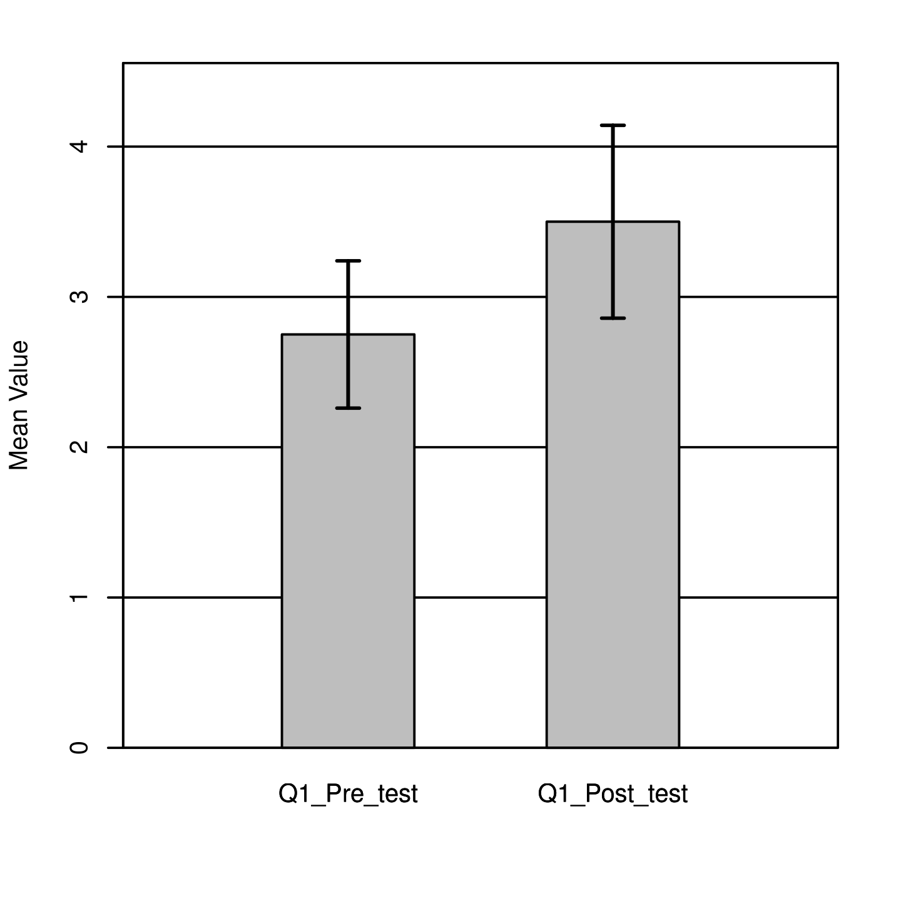
Figure 12
The results of a Shapiro-Wilk test that was performed did not show any significance based on an alpha value of .05, W = 0.83, p = .056. This result suggested the pre and post score differences were likely caused by a normal data distribution. Conversely, the result of the two-tailed paired samples t-test was significant based on an alpha value of .05, t (7) = -3.00, p = .020. This finding suggested the difference in the mean of pre and posttest was meaningfully greater than zero. The mean of the pre-test was significantly lower than the mean of the posttest as shown in Figure 12.
Question 2
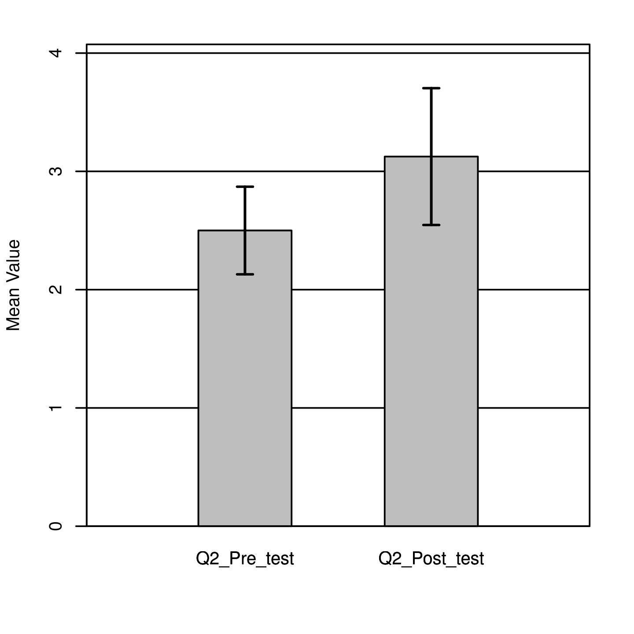
Figure 13
The results of a Shapiro-Wilk test that was performed did show significance based on an alpha value of 0. 05, W = 0.80, p = .027. This result suggested the pre and post score differences were likely not caused by a normal data distribution. The result of the two-tailed paired samples t-test was significant based on an alpha value of .05, t (7) = -2.38, p = .049, indicating the null hypothesis can be rejected. This finding suggested the difference in the mean of pre and posttest was significantly different from zero. The mean of the pre-test was significantly lower than the mean of the posttest as shown in Figure 13.
Question 3
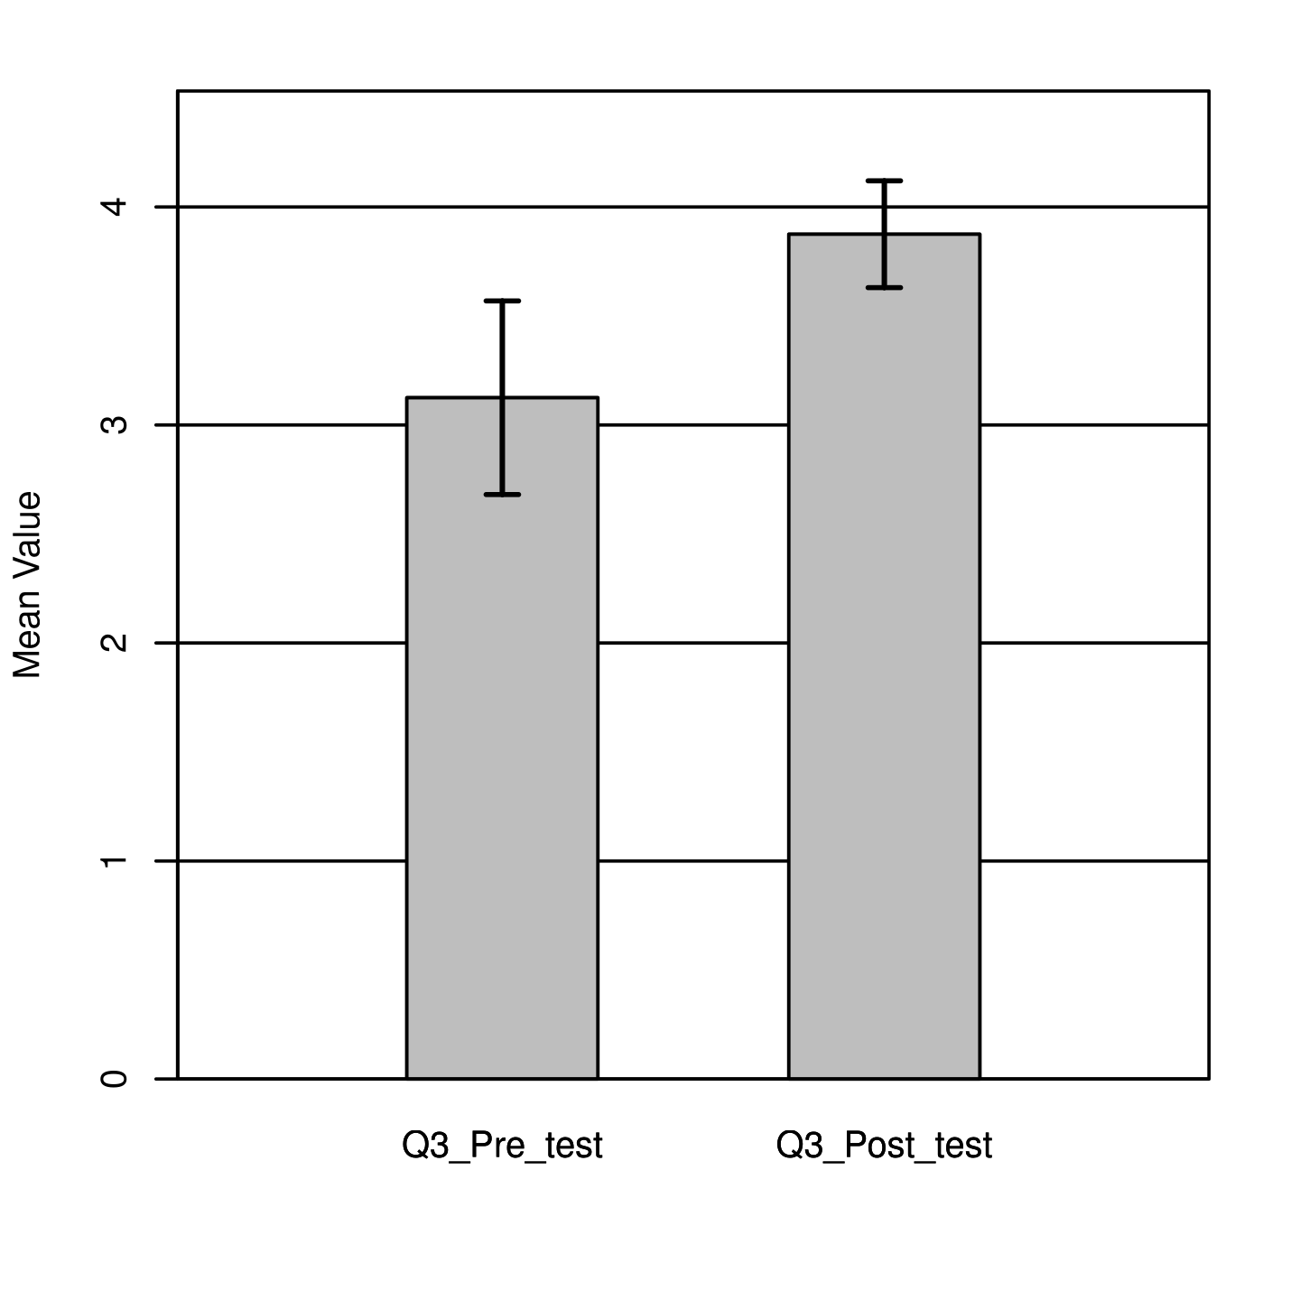
Figure 14
The results of a Shapiro-Wilk test that was performed did not show significance based on an alpha value of. 05, W = 0.83, p = .056. This result suggested the pre and post score differences were likely caused by a normal data distribution. The result of the two-tailed paired samples t-test was significant based on an alpha value of .05, t (7) = -3.00, p = .020, indicating the null hypothesis can be rejected. This finding suggested the difference in the mean of pre and posttest was significantly different from zero. The mean of the pre-test was significantly lower than the mean of the posttest as shown in Figure 14.

Question 4
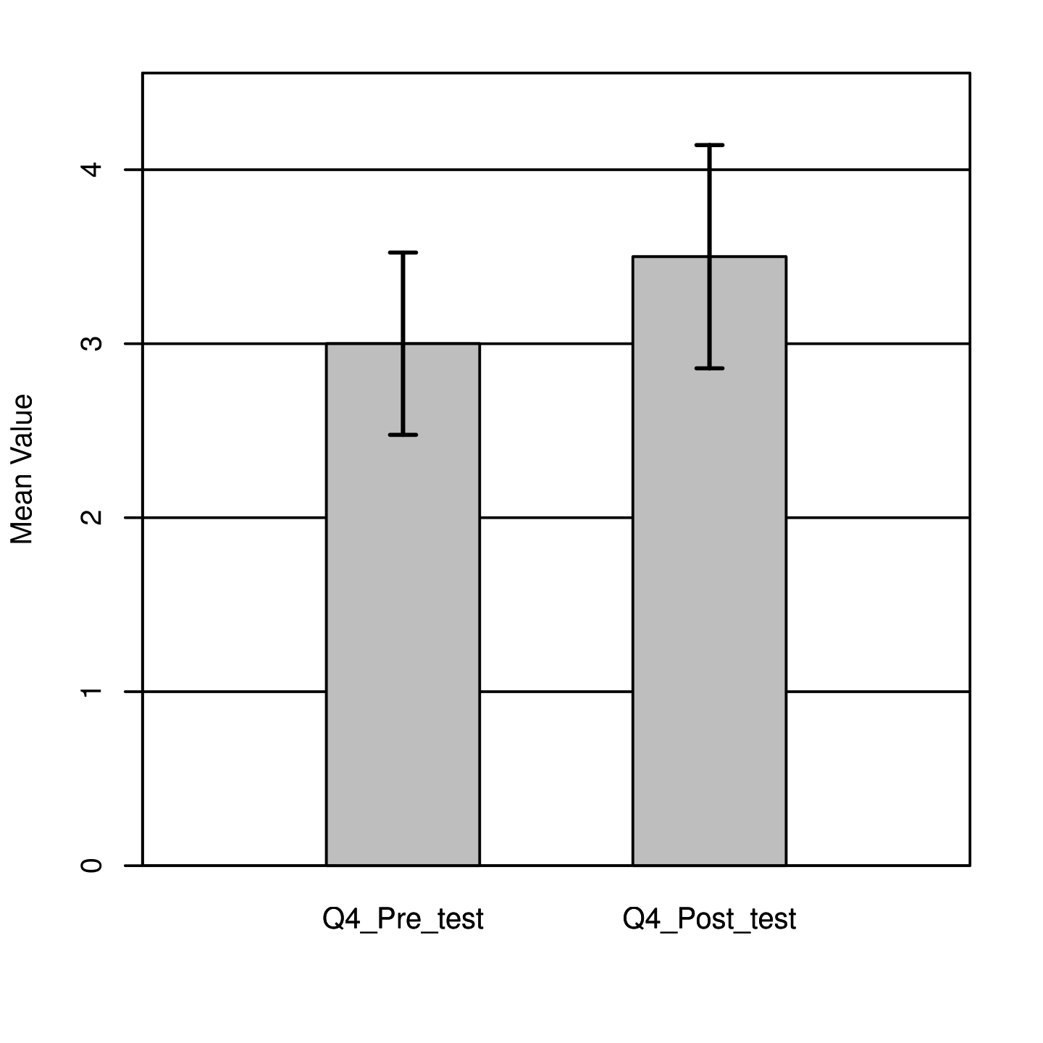

Figure 15
The results of a Shapiro-Wilk test that was performed did show significance based on an alpha value of .05, W = 0.66, p < .001. This result suggested the pre and post score differences were likely not caused by a normal data distribution. The result of the two-tailed paired samples t-test was significant based on an alpha value of .05, t (7) = -2.65, p = .033. This finding suggested the difference in the mean of pre and posttest was significantly different from zero. The mean of the pre-test was significantly lower than the mean of the posttest as shown in Figure 15.

Question 5

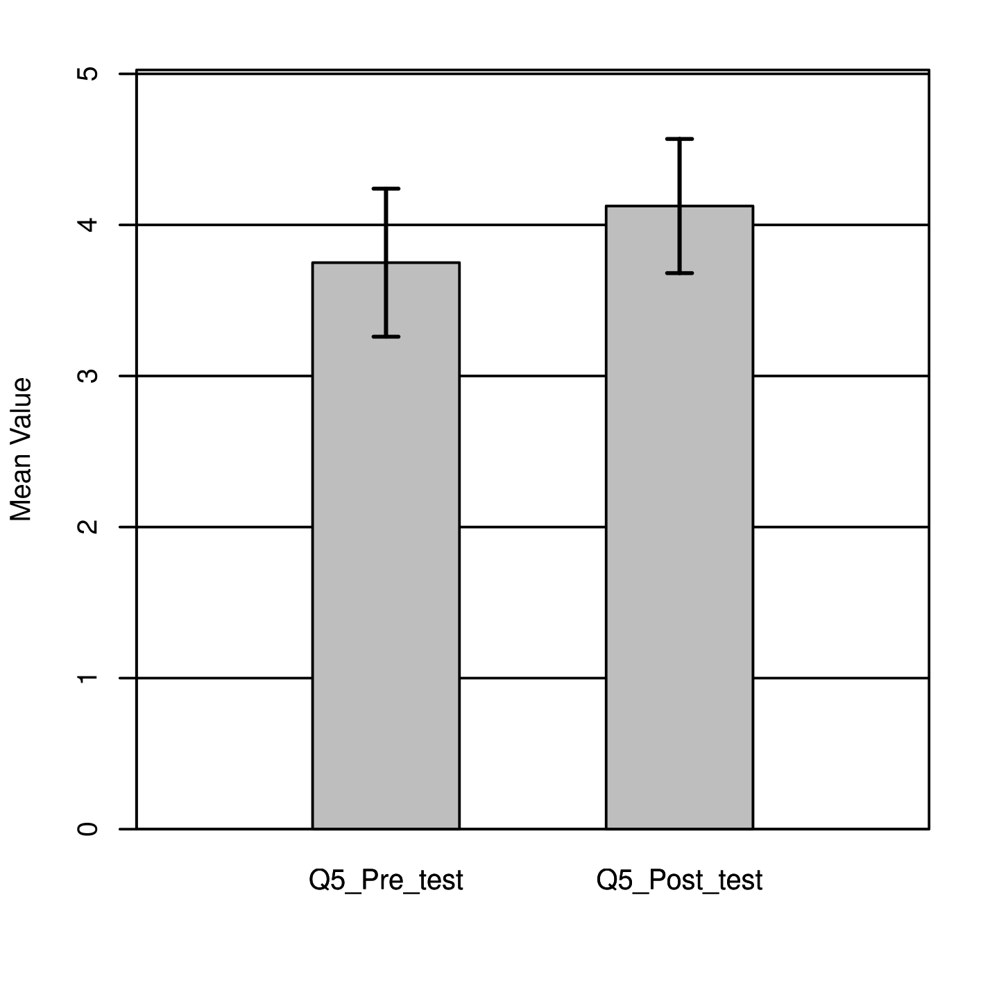
Figure 16
The results of a Shapiro-Wilk test that was performed did not show significance based on an alpha value of .05, W = 0.91, p = .324. This result suggested the pre and post score differences were likely caused by a normal data distribution. The result of the two-tailed paired samples t-test was not significant based on an alpha value of .05, t (7) = -1.16, p = .285. This finding suggested the difference in the mean of pre and posttest was not significantly different from zero. The mean of the pre-test was not significantly different from the mean of the posttest as shown in Figure 16.

Question 6
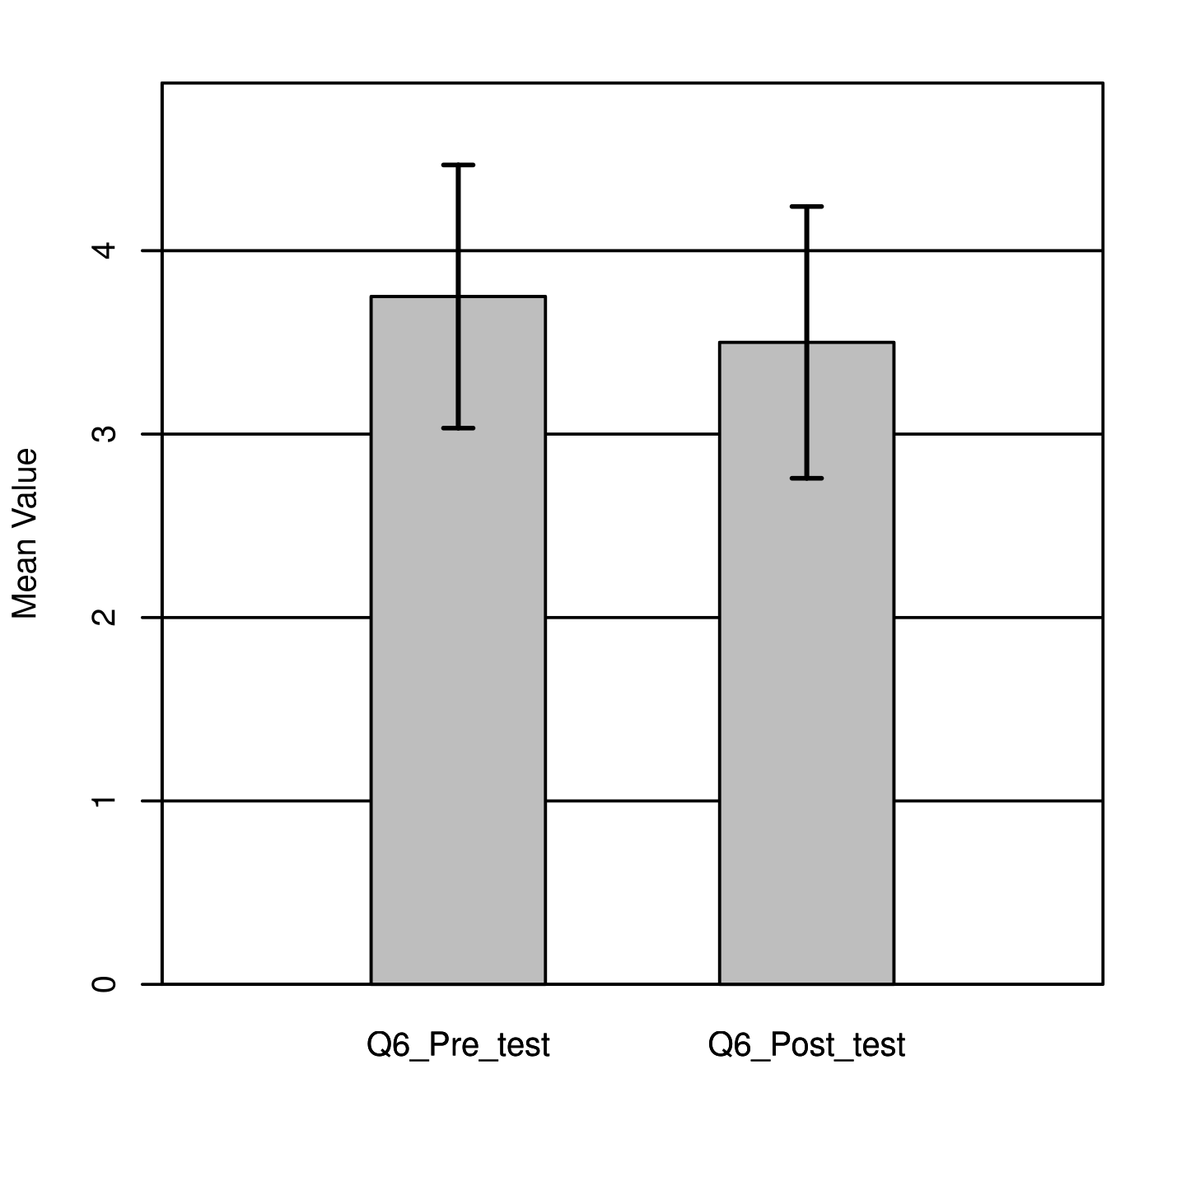
Figure 17
The results of a Shapiro-Wilk test that was performed did not show significance based on an alpha value of .05, W = 0.83, p = .054. This result suggested the pre and post score differences were likely caused by a normal data distribution. The result of the two-tailed paired samples t-test was not significant based on an alpha value of .05, t (7) = 0.80, p = .451. This finding suggested the difference in the mean of pre and posttest was not significantly different from zero. The mean of the pre-test was not significantly different from the mean of the posttest as shown in Figure 17.

Question 7
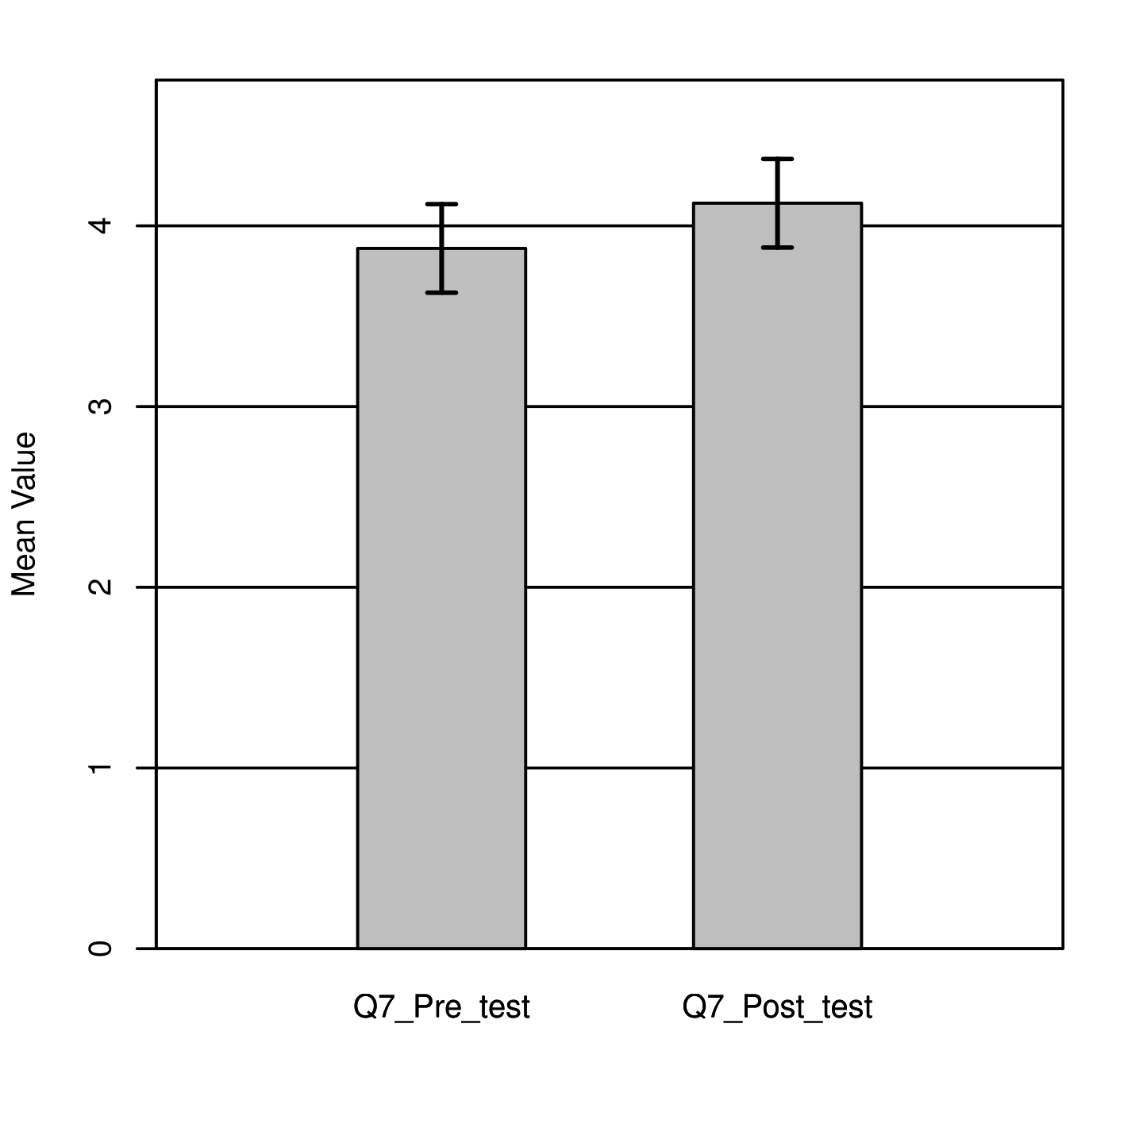
Figure 18
The results of a Shapiro-Wilk test that was performed did show significance based on an alpha value of .05, W = 0.57, p < .001. This result suggested the pre and post score differences were likely not caused by a normal data distribution. The result of the two-tailed paired samples t-test was not significant based on an alpha value of .05, t (7) = -1.53, p = .170. This finding suggested the difference in the mean of pre and posttest was not significantly different from zero. The mean of the pre-test was not significantly different from the mean of the posttest as shown in Figure 18.

Question 8
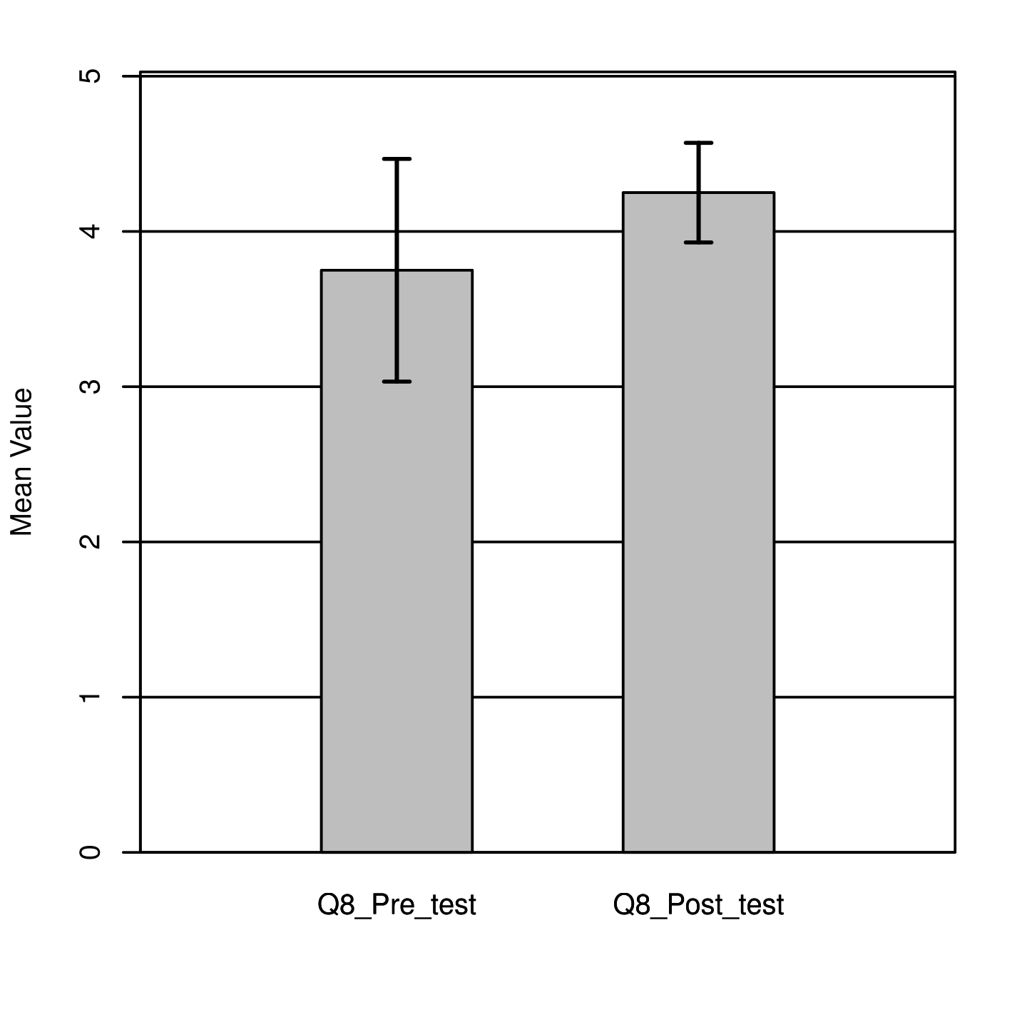
Figure 19
The results of a Shapiro-Wilk test that was performed did not show significance based on an alpha value of .05, W = 0.85, p = .090. This result suggested the pre and post score differences were likely caused by a normal data distribution. The result of the two-tailed paired samples t-test was not significant based on an alpha value of .05, t (7) = -1.18, p = .275. This finding suggested the difference in the mean of pre and posttest was not significantly different from zero. The mean of the pre-test was not significantly different from the mean of the posttest as shown in Figure 19.

Question 9
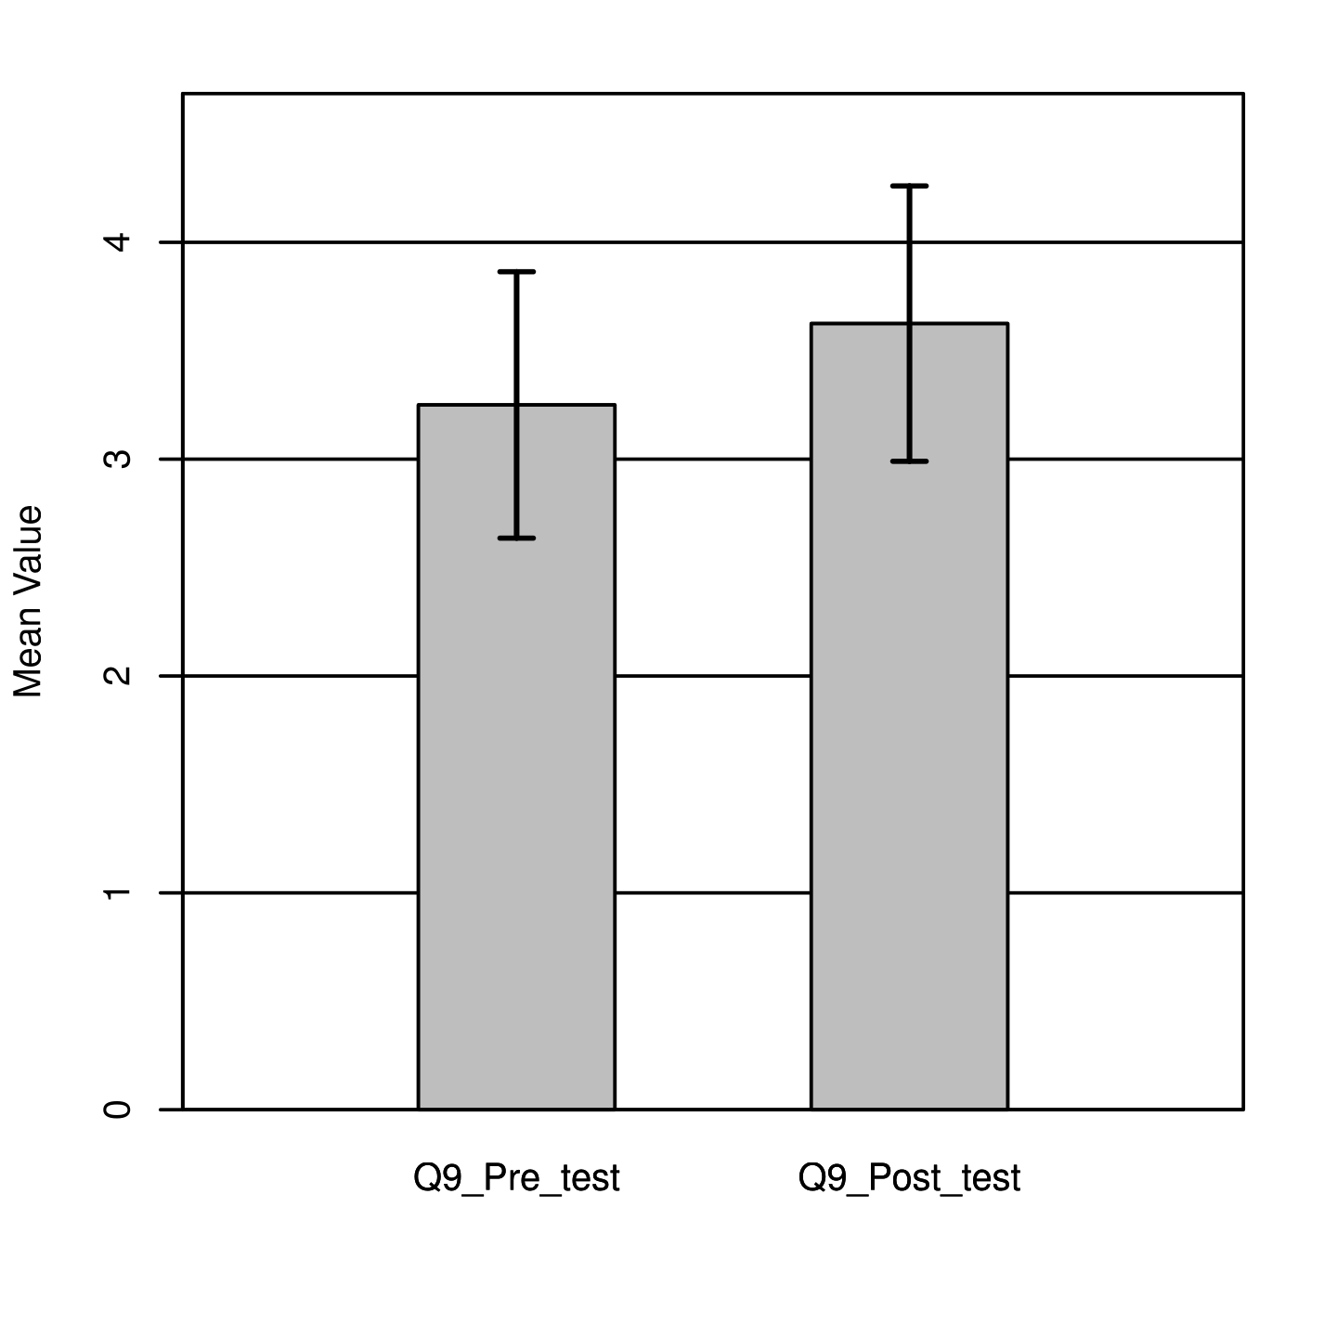
Figure 20
The results of a Shapiro-Wilk test that was performed did not show significance based on an alpha value of .05, W = 0.91, p = .324. This result suggested the pre and post score differences were likely caused by a normal data distribution. The result of the two-tailed paired samples t-test was not significant based on an alpha value of .05, t (7) = -1.16, p = .285. This finding suggested the difference in the mean of pre and posttest was not significantly different from zero. The mean of the pre-test was not significantly different from the mean of the posttest as shown in Figure 20.

Question 10
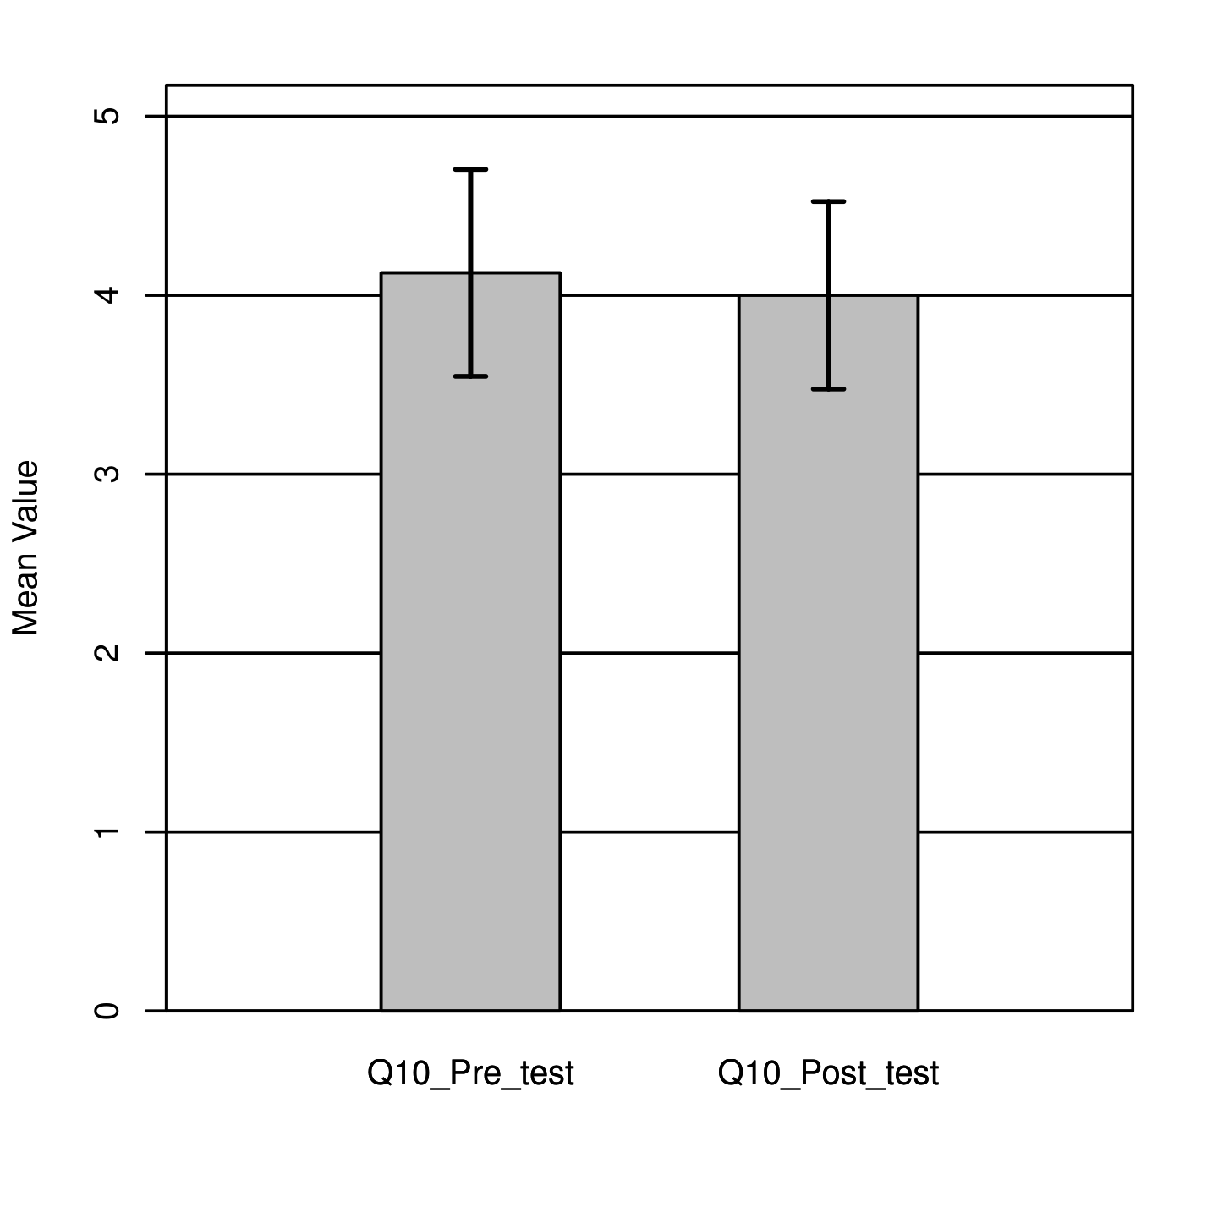
Figure 21
The results of a Shapiro-Wilk test that was performed did show significance based on an alpha value of .05, W = 0.81, p = .037. This result suggested the pre and post score differences were likely not caused by a normal data distribution. The result of the two-tailed paired samples t-test was not significant based on an alpha value of .05, t (7) = 0.55, p = .598. This finding suggests the difference in the mean of pre and posttest was not significantly different from zero. The mean of the pre-test was not significantly different from the mean of the posttest as shown in Figure 21.

Question 11
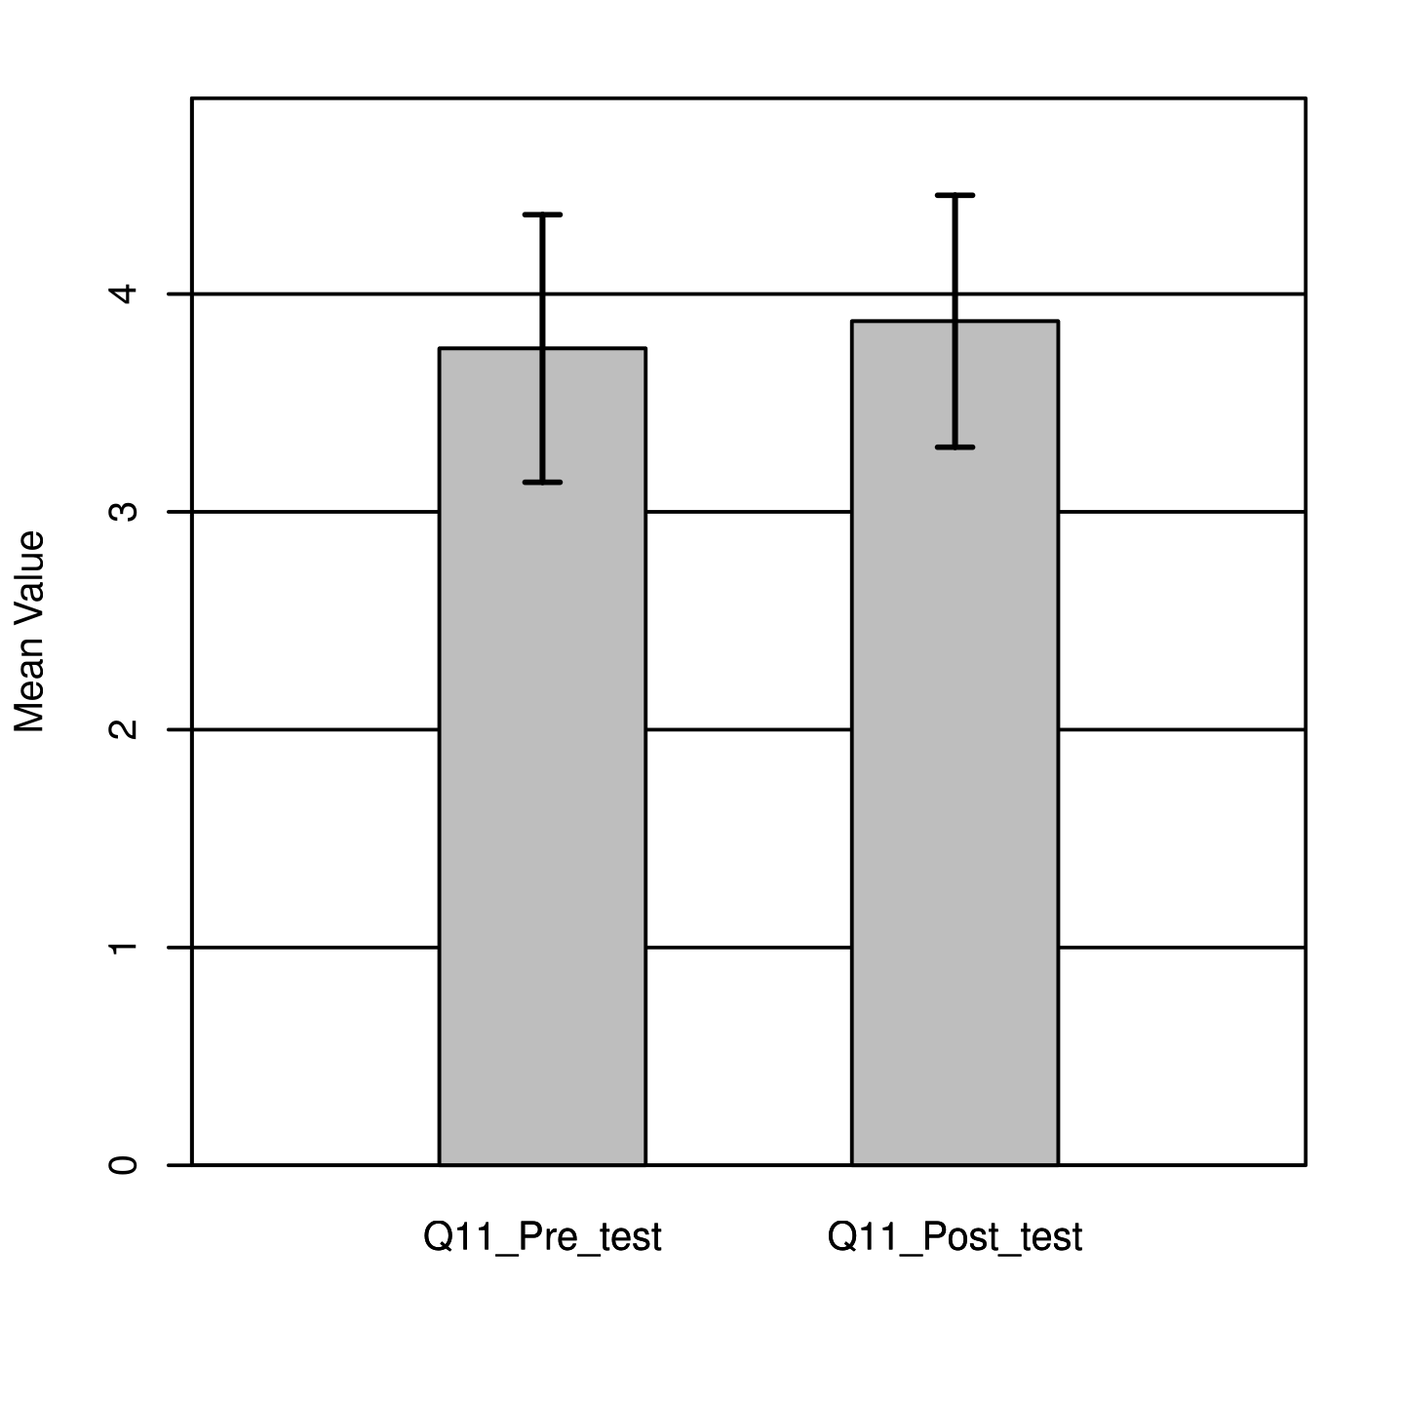
Figure 22
The results of a Shapiro-Wilk test that was performed did show significance based on an alpha value of. 05, W = 0.42, p < .001. This result suggested the pre and post score differences were not likely caused by a normal data distribution. The result of the two-tailed paired samples t-test was not significant based on an alpha value of .05, t (7) = -1.00, p = .351. This finding suggested the difference in the mean of pre and posttest was not significantly different from zero. The mean of the pre-test was not significantly different from the mean of the posttest as shown in Figure 22.

Question 12
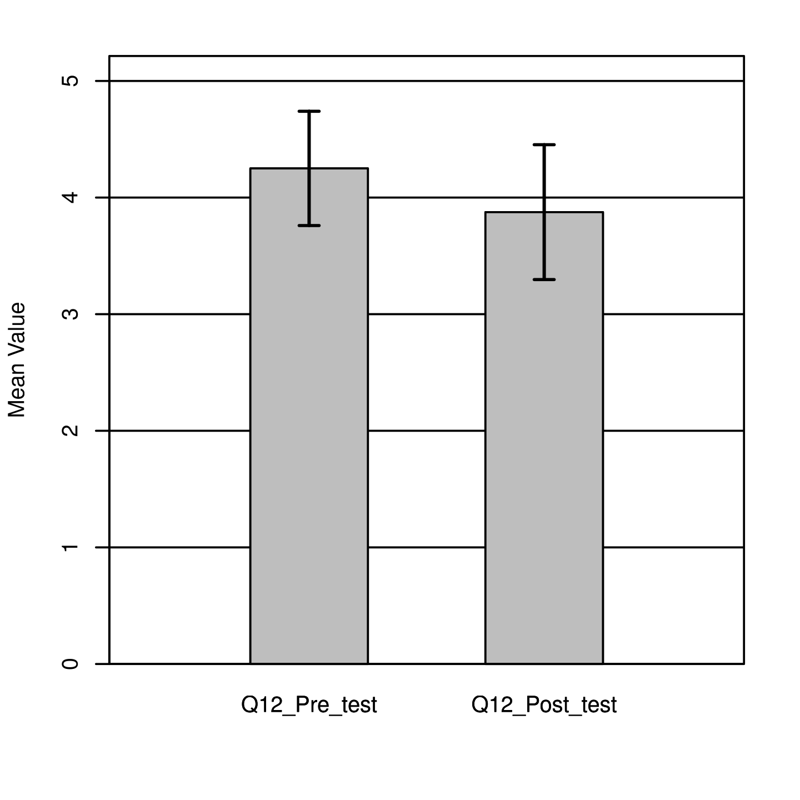
Figure 23
The results of a Shapiro-Wilk test that was performed did show significance based on an alpha value of. 05, W = 0.57, p < .001. This result suggested the pre and post score differences were likely not caused by a normal data distribution. The result of the two-tailed paired samples t-test was not significant based on an alpha value of .05 t (7) = 1.43, p = .197. This finding suggested the difference in the mean of pre and posttest was not significantly different from zero. The mean of the pre-test was not significantly different from the mean of the posttest as shown in Figure 23.

Question 13
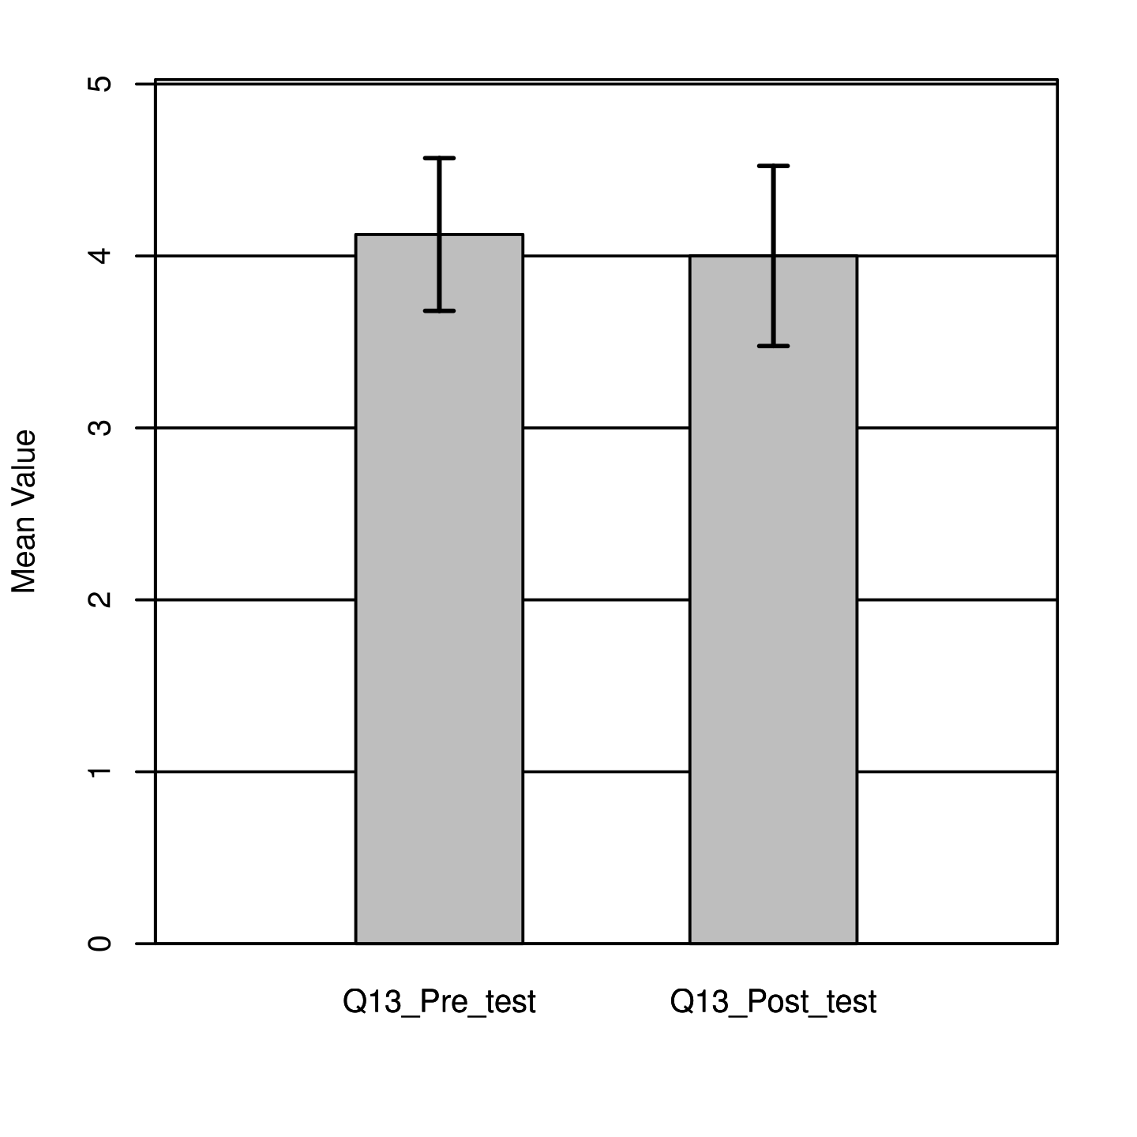
Figure 24
The results of a Shapiro-Wilk test that was performed did show significance based on an alpha value of .05, W = 0.81, p = .037. This result suggested the pre and post score differences were likely not caused by a normal data distribution. The result of the two-tailed paired samples t-test was not significant based on an alpha value of .05, t (7) = 0.55, p = .598. This finding suggested the difference in the mean of pre and posttest was not significantly different from zero. The mean of the pre-test was not significantly different from the mean of the posttest as shown in Figure 23.

Question 14
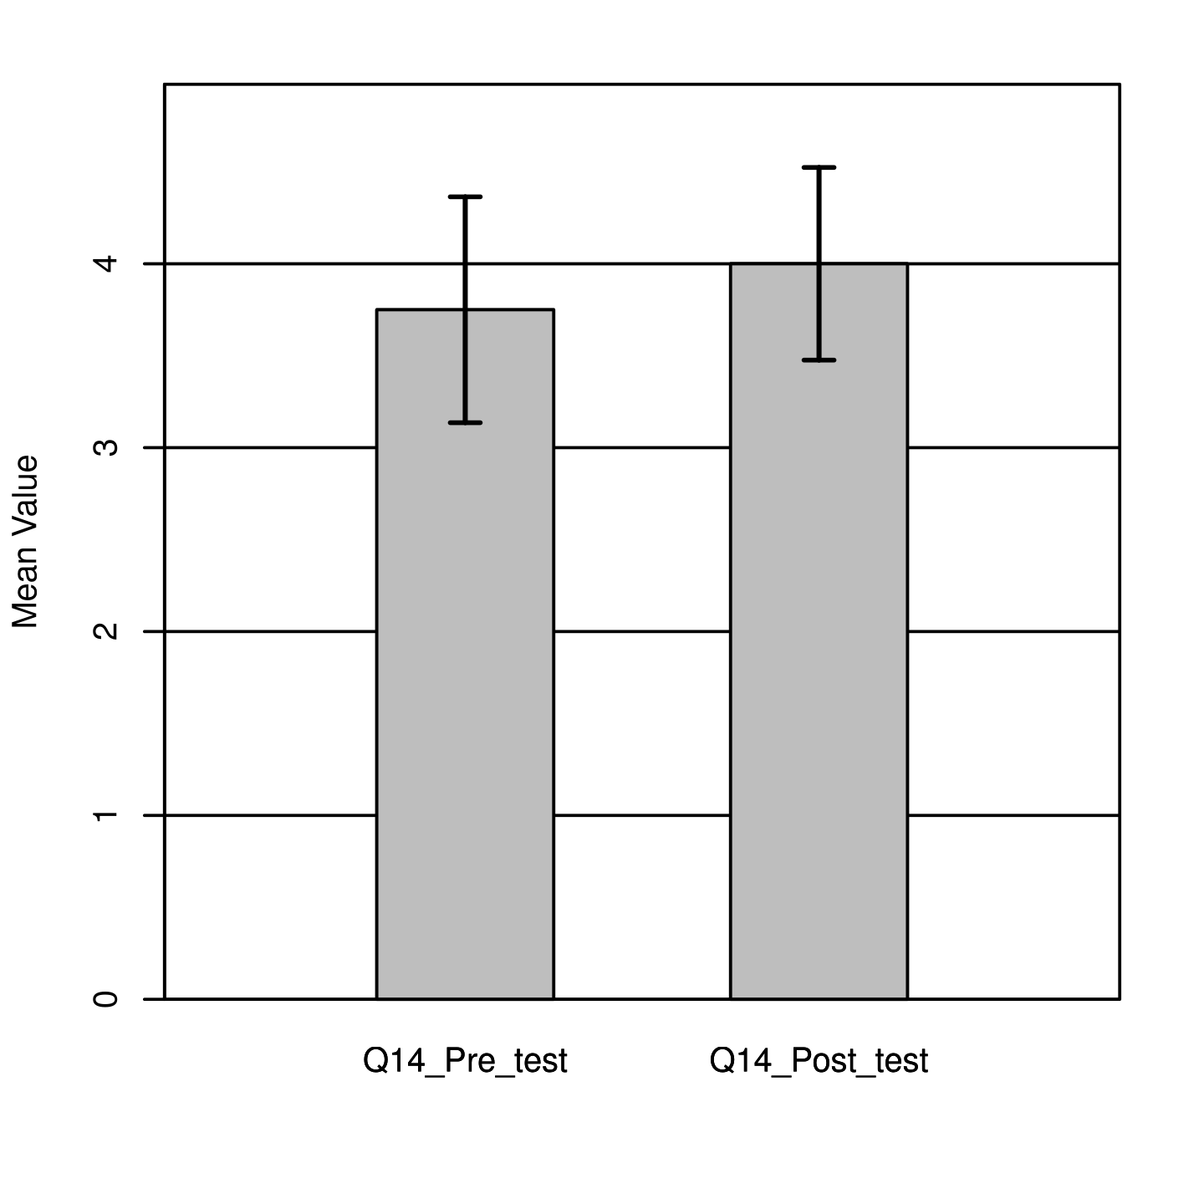
Figure 25
The results of a Shapiro-Wilk test that was performed did show significance based on an alpha value of .05, W = 0.57, p <. 001.This result suggested the pre and post score differences were not likely caused by a normal data distribution. The result of the two-tailed paired samples t-test was not significant based on an alpha value of .05, t (7) = -1.53, p = .170. This finding suggested the difference in the mean of pre and posttest was not significantly different from zero. The mean of the pre-test was not significantly lower than the mean of the posttest as shown in Figure 24.

Question 15
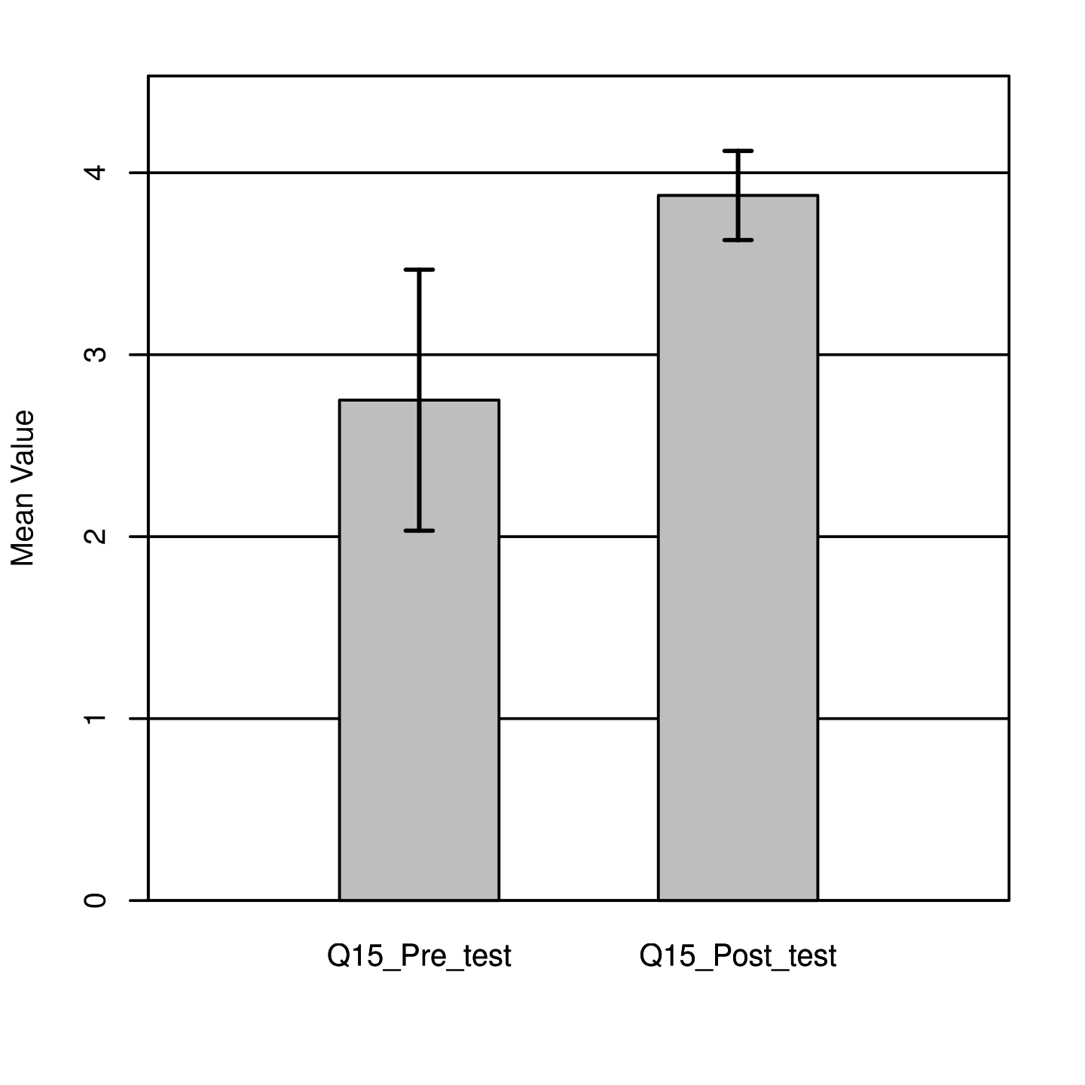
Figure 26
The results of a Shapiro-Wilk test that was performed did not show significance based on an alpha value of .05, W = 0.88, p = .197. This result suggested the pre and post score differences were likely caused by a normal data distribution. The result of the two-tailed paired samples t-test was significant based on an alpha value of .05, t (7) = -2.83, p = .026. This finding suggested the difference in the mean of pre and posttest was significantly different from zero. The mean of the pre-test was significantly lower than the mean of the posttest as shown in Figure 25.
Conclusion
Overall, the data was evenly distributed across gender. It was however primarily represented by the age group 26-35. Majority of the participants were employed and held a college degree. The analysis of each category of the Health Belief Model (HBM) based on the questionnaire that was administered, mainly indicated significant post score changes. However, the two-tailed paired samples t-test and analysis that was performed for each question on the questionnaire, demonstrated statistically significant changes for a third of the questions. The Shapiro-Wilk test of normality indicated normal distribution for almost half of the questions. In sum, many of the questions showed positive changes in response to the intervention.

Chapter V: Discussion and Conclusion
Introduction
This scholarly practice project (SPP) endeavored to appraise the implications of an educative health intervention regarding essential hypertension risk management among normotensive Non-Hispanic (NH) Black adults. This was accomplished by measuring changes in their awareness, confidence and self-efficacy levels. The data analysis suggested successful implementation of the intervention. However, there were some limitations that likely confounded the results. This is further explained in this section and additional recommendations are made for future projects.
Interpretation of Results
Altogether, the results of the data analysis were optimistic as they mainly showed a positive response to the intervention. The t-test results were statistically significant for a third of the questions that were analyzed. Additionally, majority of the results from the HBM analysis displayed clinical significance. Overall, the results suggested that the intervention improved the knowledge, confidence and self-efficacy levels of Non-Hispanic (NH) normotensive Black adults, in relation to the management of their modifiable risks for primary hypertension.
Health education was highlighted as one of the principal public health approaches used in primary prevention for health promotion and disease prevention. Similarly to the intervention used in this scholarly practice project (SPP), Debela et al. (2023) conducted a quasi-experimental study in which they utilized a health education intervention to evaluate the differences in blood pressure, weight and cholesterol values among hypertensive individuals, to manage their risk factors for cardiovascular disease. Their results were statistically significant for reduction in the values of all the variables that were measured, which indicated the health intervention effectively encouraged the endorsement of healthier habits that promoted the overall health of the participants. Comparable to this study, the clinical significance of the results of this scholarly practice project (SPP) reinforced the significance of health education in the promotion of health and prevention of essential hypertension among the target population.
The Health Belief Model (HBM) was the grounding theoretical framework used to guide this SPP. The model is based on the philosophy that changes in health behavior are likely to occur if an individual or group perceives themselves at risk for a disease and feels that acting will mitigate said threat (Alyafei & Easton-Carr, 2024). This notion was supported by the findings of the data analysis for this SPP. The clinical and statistically significant differences that were exhibited in the post survey results following the intervention, indicated the change in perception and attitude of the participants. This was corroborated by the subjective reports of the participants as many expressed their intention to “exercise more, eat better, check their blood pressure regularly, manage their stress level and follow up with their doctor”.
Limitations
Although the project yielded significant positive results, there are some limitations that should be highlighted. Considering the nature of the setting that was used, it is likely that the participants did not watch the educative video in its entirety. The virtual setting prevented direct contact with the participants, which could have otherwise allowed the project led to ascertain for true participation. Additionally, the final sample size was small. However, it should be noted that the initial recruited sample size was statistically significant per the G-power calculation for an 87% transferability. Furthermore, most of the participants had a higher education or some level of college exposure, which could have influenced their existing knowledge of the disease process. Despite so, the enhanced teaching that was provided proved to nonetheless be beneficial, as evidenced by the post survey results and participants’ reports. Lastly, there was not enough research on hypertension prevention among healthy individuals and recent cardiovascular studies about Non-Hispanic Blacks. This project highlighted the need for further empirical research in that arena, considering the pervasiveness of the disease among that group.
Implications for Nursing Practice
This scholarly practice project is significant for nursing practice, research, education and leadership, because it promotes patient teaching, encourages the development of enhanced methods to improve health education in practice, highlights the severity of the disease and empowers nurses to be leaders in health promotion through patient outreach and education.
Nursing Practice
It will encourage nursing clinicians to reinforce hypertension teaching among susceptible population such as normotensive NH Blacks. Although, admittedly in busy settings, such initiative can easily be overlooked as it is not an acute concern. However, as primary hypertension is a progressive disease, it is important to remind these patients of their risks and share resources to help them manage and maintain their health.
Nursing Research
The clinically significant findings of this project underlined health education as an effective method to raise awareness and encourage change in attitude and behavior. Further nursing research should be done on developing more effective methods to implement in practice and streamline that process as an integral part of the care provided to patients.
Nursing Education
The results of this SPP reinforced the importance of culturally sensitive care. It encourages frequent training in the care and need of the target population, particularly for new nursing graduates.
Nursing Leadership
The clinical findings of this SPP emphasized the important role that nurses have as front-line workers and leaders in patient education. It underscored the need for nursing leaders in outpatient/community health settings to educate patients about health matters.
Dissemination of Findings
This scholarly practice project was defended at Regis College in the presence of the project chair, mentor, second readers and peers. The plan is to share the findings with colleagues at the workplace and in other virtual forums. This author will also aim to submit a poster presentation proposal to the American Nursing Association (ANA) annual research symposium for next year, once the application period begins.
Conclusion
In summary, despite the limitations, this scholarly practice project successfully accomplished the set goals of enhancing the awareness, confidence and efficacy levels of the target population, as it relates to the management of the modifiable risk factors for essential hypertension. The findings demonstrated some statistical but overall clinical significance of the educative intervention that was implemented. Further studies and initiatives on policy development are recommended, as many of the participants reported cost of living and poor food choices as some of the barriers that prevent them from adhering to healthier habits.

References
Abrahamowicz, A. A., Ebinger, J., Whelton, S. P., Commodore-Mensah, Y., & Yang, E. (2023). Racial and ethnic disparities in hypertension: Barriers and opportunities to improve blood pressure control. Current Cardiology Reports, 25(1), 17–27. https://doi.org/10.1007/s11886-022-01826-x
Adams, Z. W., Sieverdes, J. C., Brunner-Jackson, B., Mueller, M., Chandler, J., Diaz, V., Patel, S., Sox, L. R., Wilder, S., & Treiber, F. A. (2018). Meditation Smartphone application effects on prehypertensive adults’ blood pressure: Dose-response feasibility trial. Health Psychology, 37(9). https://doi.org/10.1037/hea0000584
Aggarwal, R., Chiu, N., Wadhera, R. K., Moran, A. E., Raber, I., Shen, C., Yeh, R. W., & Kazi, D. S. (2021). Racial/ethnic disparities in hypertension prevalence, awareness, treatment, and control in the United States, 2013 to 2018. Hypertension, 78(6), 1719–1726. https://doi.org/10.1161/hypertensionaha.121.17570
Aghaei Bahmanbeglou, N., Ebrahim, K., Maleki, M., Nikpajouh, A., & Ahmadizad, S. (2019). Short-duration high-intensity interval exercise training is more effective than long duration for blood pressure and arterial stiffness but not for inflammatory markers and lipid profiles in patients with stage 1 hypertension. Journal of Cardiopulmonary Rehabilitation and Prevention, 39(1). https://doi.org/10.1097/HCR.0000000000000377
Akuiyibo, S., Anyanti, J., Amoo, B., Aizobu, D., & Idogho, O. (2022). Effects of behaviour change communication on hypertension and diabetes related knowledge, attitude and practices in Imo and Kaduna States: a quasi-experimental study. BMC Public Health, 22(1). https://doi.org/10.1186/s12889-022-13139-3
Alexander, S., BeLue, R., Kuzmik, A., & Boltz, M. (2020). The evolution of cultural competence theories in American (United States) nursing curricula: An integrative review. Journal of Nursing Education and Practice, 10(12), 30–37. https://doi.org/10.5430/jnep.v10n12p30
Alyafei, A., & Easton-Carr, R. (2024). The health belief model of behavior change. StatPearls - NCBI Bookshelf. https://www.ncbi.nlm.nih.gov/books/NBK606120/
American Heart Association (n.d.). Hypertension highlights 2017 - American Heart Association. AHA. https://www.heart.org/-/media/files/health-topics/high-blood-pressure/hypertension-guideline-highlights-flyer.pdf
Annesi, J. J. (2021). Effects of behaviorally supported exercise and exercise-induced mood changes on elevated blood pressure and hypertension in African American adults with severe obesity. Journal of Immigrant and Minority Health, 24(3), 721–729. https://doi.org/10.1007/s10903-021-01220-9
Azadi, N. A., Ziapour, A., Lebni, J. Y., Irandoost, S. F., Abbas, J., & Chaboksavar, F. (2021). The effect of education based on health belief model on promoting preventive behaviors of hypertensive disease in staff of the Iran University of Medical Sciences. Archives of Public Health, 79(1). https://doi.org/10.1186/s13690-021-00594-4
Baldwin, R., Granger, B., Thompson, J. A., Bowers, M. T., & Kizzie, A. (2023). Improving hypertension using virtual modalities. American Nurse Journal, 18(11), 26–30. https://doi.org/10.51256/anj11232326
Boslaugh, S. E. (2022). Health belief model. Salem Press Encyclopedia.
Brunt, B.A., Morris, M.M. (2023). Nursing professional development evidence-based practice. StatPearls. https://www.ncbi.nlm.nih.gov/books/NBK589676/
Burroughs Peña, M. S., Mbassa, R. S., Slopen, N. B., Williams, D. R., Buring, J. E., & Albert, M. A. (2019). Cumulative psychosocial stress and ideal cardiovascular health in older women: Data by race/ethnicity. Circulation, 139(17). https://doi.org/10.1161/CIRCULATIONAHA.118.033915
Carey, R. M., Muntner, P., Bosworth, H. B., & Whelton, P. K. (2018). Prevention and control of hypertension: JACC Health Promotion Series. Journal of the American College of Cardiology, 72(11), 1278–1293. https://doi.org/10.1016/j.jacc.2018.07.008

Centers for Disease Control and Prevention. (2020). A closer look at African American men and high blood pressure control. https://www.cdc.gov/bloodpressure/aa_sourcebook.htm#:~:text=High%20blood%20pressure%20is%20more,or%20Hispanic%20adults%20(36%25).
Dang, D., Dearholt, S., Bissett, K., Ascenzi, J., & Whalen, M. (2022). Johns Hopkins evidence-based practice for nurses and healthcare professionals: Model and guidelines. 4th ed. Sigma Theta Tau International
Debela, D. B., Dhaba, B., Shumi, G., Abagero, A., Gudina, G., Ayana, Y., Addissie, A., Deressa, W., & Scuteri, A. (2023). Effect of an educational intervention on lifestyle modification of patients with hypertension at Bishoftu General Hospital, Ethiopia, 2021. Preventing Chronic Disease, 20. https://doi.org/10.5888/pcd20.220235
Desai, A. (2020). High Blood Pressure. JAMA, 324(12), 1254. https://doi.org/10.1001/jama.2020.11289
Diaz-Gutierrez, J., Ruiz-Estigarribia, L., Bes-Rastrollo, M., Ruiz-Canela, M., Martin-Moreno, J. M., & Martinez-Gonzalez, M. A. (2019). The role of lifestyle behaviour on the risk of hypertension in the SUN cohort: The hypertension preventive score. Preventive Medicine, 123, 171-178. https://doi.org/10.1016/j.ypmed.2019.03.026
Dobosh, M. (2017). Survey: Demographic questions. In The SAGE Encyclopedia of Communication Research Methods, 4,1702-1704. SAGE Publications, Inc, https://doi.org/10.4135/9781483381411
Dougherty, E. C., Burse, N., Butzner, M., Wu, H., Stuckey, H. L., Allison, J. J., & Cuffee, Y. L. (2021). Examining medication adherence and preferences for a lifestyle intervention among Black and Latinx adults with hypertension: A feasibility study. Pilot and Feasibility Studies, 7(1), 209. https://doi.org/10.1186/s40814-021-00930-z
Elijovich, F., Kirabo, A., & Laffer, C. L. (2023). Salt Sensitivity of Blood Pressure in Black People: The Need to Sort Out Ancestry Versus Epigenetic Versus Social Determinants of Its Causation: Salt Series. Hypertension (Dallas, Tex.: 1979). https://doi.org/10.1161/HYPERTENSIONAHA.123.17951
Fatima, S., & Mahmood, S. (2021). Combatting a silent killer - the importance of self-screening of blood pressure from an early age. EXCLI Journal, 20, 1326–1327. https://doi.org/10.17179/excli2021-4140
Ferreira, H., Vasconcelos, M., Gil, A. M., & Pinto, E. (2021). Benefits of pulse consumption on metabolism and health: A systematic review of randomized controlled trials. Critical Reviews in Food Science and Nutrition, 61(1), 85-96. https://doi.org/10.1080/10408398.2020.1716680
Filippou, C. D., Tsioufis, C. P., Thomopoulos, C. G., Mihas, C. C., Dimitriadis, K. S., Sotiropoulou, L. I., Chrysochoou, A. C., Nihoyannopoulos, I. P., & Tousoulis, D. M. (2020). Dietary approaches to stop hypertension (DASH) diet and blood pressure reduction in adults with and without hypertension: A systematic review and meta-analysis of randomized controlled trials. Advances in Nutrition, 11(5), 1150-1160. https://doi.org/10.1093/advances/nmaa041
Foronda, C. A. (2020). Theory of cultural humility. Journal of Transcultural Nursing, 31(1):7-12. doi:10.1177/1043659619875184
Ghorbani-Dehbalaei, M., Loripoor, M., & Nasirzadeh, M. (2021). The role of Health Beliefs and health literacy in women’s health promoting behaviours based on the health belief model: A descriptive study. BMC Women’s Health, 21(1). https://doi.org/10.1186/s12905-021-01564-2
Grazziotin-Soares, R., Blue, C., Feraro, R., Tochor, K., Ardenghi, T. M., Curtis, D., & Ardenghi, D. M. (2021). The interrelationship between confidence and correctness in a multiple-choice assessment: pointing out misconceptions and assuring valuable questions. BDJ open, 7(1), 10. https://doi.org/10.1038/s41405-021-00067-4
Hong, S., Lee, D., & Lee, G. (2018). Effect of aerobic exercise on blood pressure and arterial compliance in patients with essential hypertension. Journal of Exercise Physiologyonline October 21.
Hornbuckle, L. M., McKenzie, M. J., & Whitt-Glover, M. C. (2018). Effects of high-intensity interval training on cardiometabolic risk in overweight and obese African American women: a pilot study. Ethnicity and Health, 23(7). https://doi.org/10.1080/13557858.2017.1294661
Howard, G., Cushman, M., Moy, C. S., Oparil, S., Muntner, P., Lackland, D. T., Manly, J. J., Flaherty, M. L., Judd, S. E., Wadley, V. G., Long, D. L., & Howard, V. J. (2018). Association of clinical and social factors with excess hypertension risk in Black compared with White US adults. JAMA, 320(13), 1338–1348. https://doi.org/10.1001/jama.2018.13467
Iqbal, A. M., & Jamal, S. F. (2022). Essential hypertension [Ebook]. StatPearls https://www.ncbi.nlm.nih.gov/books/NBK539859/
Joubert, J., Lacroix, P., Preux, P. M., & Dumas, M. (2021). Hypertension in sub-Saharan Africa: A scoping review…. Journal of Clinical and Preventive Cardiology, 10(1), 26-41. https://doi.org/10.4103/jcpc.jcpc_55_20
Kaiser Permanente. (2022). Lifestyle coaching lowers blood pressure in Black adults. https://about.kaiserpermanente.org/health-and-wellness/health-research/news/lifestyle-coaching-lowers-blood-pressure-in-black-adults
Kalinowski, J., Kaur, K., Newsome-Garcia, V., Langford, A., Kalejaiye, A., Vieira, D., Izeogu, C., Blanc, J., Taylor, J., Ogedegbe, O., & Spruill, T. (2021). Stress interventions and hypertension in Black women. In Women’s Health (Vol. 17). https://doi.org/10.1177/17455065211009751
Kang, A. W., Dulin, A., Nadimpalli, S., & Risica, P. M. (2018). Stress, adherence, and blood pressure control: A baseline examination of Black women with hypertension participating in the SisterTalk II intervention. Preventive Medicine Reports, 12. https://doi.org/10.1016/j.pmedr.2018.08.002
Katowa-Mukwato, P., Mwiinga-Kalusopa, V., Chitundu, K., Kanyanta, M., Chanda, D., Mbewe Mwelwa, M., Ruth, W., Mundia, P., & Carrier, J. (2021). Implementing evidence-based practice nursing using the PDSA model: Process, lessons and implications. International Journal of Africa Nursing Sciences, 14, 100261. https://doi.org/10.1016/j.ijans.2020.100261
Ko, J., Deprez, D., Shaw, K., Alcorn, J., Hadjistavropoulos, T., Tomczak, C., Foulds, H., & Chilibeck, P. D. (2021). Stretching is superior to brisk walking for reducing blood pressure in people with high-normal blood pressure or stage I hypertension. Journal of Physical Activity and Health, 18(1). https://doi.org/10.1123/JPAH.2020-0365
Li, S., Cao, M., & Zhu, X. (2019). Evidence-based practice: Knowledge, attitudes, implementation, facilitators, and barriers among community nurses-systematic review. Medicine, 98(39), e17209. https://doi.org/10.1097/MD.0000000000017209
Lin, X. (2019). Review of knowledge and knowledge management research. American Journal of Industrial and Business Management, 09(09), 1753–1760. https://doi.org/10.4236/ajibm.2019.99114
Lynch, H. M., Green, A. S., Clarke Nanyonga, R., Gadikota-Klumpers, D. D., Squires, A., Schwartz, J. I., & Heller, D. J. (2019). Exploring patient experiences with and attitudes towards hypertension at a private hospital in Uganda: A qualitative study. International Journal for Equity in Health, 18(1). https://doi.org/10.1186/s12939-019-1109-9
Maseko, M., Mashao, M., Bawa-Allah, A., Phukubje, E., Mlambo, B., & Nyundu, T. (2018). Obesity masks the relationship between dietary salt intake and blood pressure in people of African ancestry: The impact of obesity on the relationship between sodium and blood pressure. Cardiovascular Journal of Africa, 29(3), 172–176. https://doi.org/10.5830/CVJA-2018-011
Melkamu, L., Berhe, R., & Handebo, S. (2021). Does patients’ perception affect self-care practices? The perspective of health belief model. Diabetes, Metabolic Syndrome and Obesity: Targets and Therapy, Volume 14, 2145–2154. https://doi.org/10.2147/dmso.s306752
Mhlaba, M., Mpondo, F. and Ware, L. (2022). Hypertension perspectives and health behaviors of African youth: The effect of health education and employment [preprint]. doi:10.1101/2022.03.23.22272796.
Mookkiah, M., & Prabu, M. (2019). Self-efficacy -concept in learning. ResearchGate. https://www.researchgate.net/publication/339310575_self-efficacy_-concept_in_learning
Nguyen-Huynh, M. N., Young, J. D., Alexeeff, S., Hatfield, M. K., & Sidney, S. (2019). Shake rattle & roll – design and rationale for a pragmatic trial to improve blood pressure control among blacks with persistent hypertension. Contemporary Clinical Trials, 76, 85–92. https://doi.org/10.1016/j.cct.2018.11.012
Ogunniyi, M. O., Commodore-Mensah, Y., & Ferdinand, K. C. (2021). Race, ethnicity, hypertension, and heart disease. Journal of the American College of Cardiology, 78(24), 2460–2470. https://doi.org/10.1016/j.jacc.2021.06.017
Okello, S., Muhihi, A., Mohamed, S. F., Ameh, S., Ochimana, C., Oluwasanu, A. O., Bolarinwa, O. A., Sewankambo, N., & Danaei, G. (2020). Hypertension prevalence, awareness, treatment, and control and predicted 10-year CVD risk: A cross-sectional study of seven communities in East and West Africa (sevencewa). BMC Public Health, 20(1). https://doi.org/10.1186/s12889-020-09829-5
Oparil, S., Acelajado, M. C., Bakris, G. L., Berlowitz, D. R., Cífková, R., Dominiczak, A. F., Grassi, G., Jordan, J., Poulter, N. R., Rodgers, A., & Whelton, P. K. (2018). Hypertension. Nature Reviews. Disease Primers, 4, 18014. https://www.ncbi.nlm.nih.gov/pmc/articles/PMC6477925/
Ozoemena, E. L., Iweama, C. N., Agbaje, O. S., Umoke, P. C. I., Ene, O. C., Ofili, P. C., Agu, B. N., Orisa, C. U., Agu, M., & Anthony, E. (2019). Effects of a health education intervention on hypertension-related knowledge, prevention and self-care practices in Nigerian retirees: A quasi-experimental study. Archives of Public Health, 77(1). https://doi.org/10.1186/s13690-019-0349-x
Pius, A. B., Dewi, I., & Akhir Yani S, H. (2021). Hypertension: A global health crisis. Annals of Clinical Hypertension, 5(1), 008–011. https://doi.org/10.29328/journal.ach.1001027
Princewel, F., Cumber, S. N., Kimbi, J. A., Nkfusai, C. N., Keka, E. I., Viyoff, V. Z., Beteck, T. E., Bede, F., Tsoka-Gwegweni, J. M., & Akum, E. A. (2019). Prevalence and risk factors associated with hypertension among adults in a rural setting: the case of Ombe, Cameroon. The Pan African Medical Journal, 34, 147.
Pueyo-Garrigues, M., Whitehead, D., Pardavila-Belio, M. I., Canga-Armayor, A., Pueyo-Garrigues, S., & Canga-Armayor, N. (2019). Health education: A Rogerian concept analysis. International Journal of Nursing Studies, 94, 131–138. https://doi.org/10.1016/j.ijnurstu.2019.03.005
Schneider, R. H., Grim, C., Kotchen, T., Marwaha, K., Kotchen, J., Salerno, J. W., King, C. G., Nidich, S., & Alexander, C. N. (2021). Randomized controlled trial of stress reduction with meditation and health education in black men and women with high normal and normal blood pressure. American Journal of Preventive Cardiology, 8. https://doi.org/10.1016/j.ajpc.2021.100279
Sharma, J. R., Mabhida, S. E., Myers, B., Apalata, T., Nicol, E., Benjeddou, M., Muller, C., et al. (2021). Prevalence of hypertension and its associated risk factors in a rural Black population of Mthatha town, South Africa. International Journal of Environmental Research and Public Health, 18(3), 1215. MDPI AG. http://dx.doi.org/10.3390/ijerph18031215
Shin, J., Konlan, K. D., & Mensah, E. (2021). Health promotion interventions for the control of hypertension in Africa, a systematic scoping review from 2011 to 2021. PloS one, 16(11), e0260411. https://doi.org/10.1371/journal.pone.0260411
Soltani, M., Aghaei Bahmanbeglou, N., & Ahmadizad, S. (2020). High-intensity interval training irrespective of its intensity improves markers of blood fluidity in hypertensive patients. Clinical and Experimental Hypertension, 42(4). https://doi.org/10.1080/10641963.2019.1649687
Spence, J. D., & Rayner, B. L. (2018). Hypertension in Blacks. Hypertension, 72(2), 263–269. https://doi.org/10.1161/hypertensionaha.118.11064
Spikes, T., Higgins, M., Quyyumi, A., Reilly, C., Pemu, P., & Dunbar, S. (2019). The relationship among health beliefs, depressive symptoms, medication adherence, and social support in African Americans with hypertension. The Journal of Cardiovascular Nursing, 34(1), 44–51. https://doi.org/10.1097/JCN.0000000000000519
Spruill, T. M., Butler, M. J., Thomas, S. J., Tajeu, G. S., Kalinowski, J., Castañeda, S. F., Langford, A. T., Abdalla, M., Blackshear, C., Allison, M., Ogedegbe, G., Sims, M., & Shimbo, D. (2019). Association Between High Perceived Stress Over Time and Incident Hypertension in Black Adults: Findings from the Jackson Heart Study. Journal of the American Heart Association, 8(21). https://doi.org/10.1161/JAHA.119.012139
Tao, Y., Lin, T., Feng, X., Gao, Y., & Mashino, S. (2022). Cultural competence for disaster nursing: A scoping review of the Chinese and English literature. International Journal of Disaster Risk Reduction, 80, 103188. https://doi.org/10.1016/j.ijdrr.2022.103188
Teshome, D. F., Balcha, S. A., Ayele, T. A., Atnafu, A., & Gelaye, K. A. (2021). Development and psychometric validation of the hypertension beliefs assessment tool among adult population in northwest Ethiopia. Patient Preference and Adherence, Volume 15, 2659–2671. https://doi.org/10.2147/ppa.s335070
Tyson, C. C., Davenport, C. A., Lin, P.-H., Scialla, J. J., Hall, R., Diamantidis, C. J., Lunyera, J., Bhavsar, N., Rebholz, C. M., Pendergast, J., Boulware, L. E., & Svetkey, L. P. (2019). DASH diet and blood pressure among Black Americans with and without CKD: The Jackson heart study. American Journal of Hypertension, 32(10), 975–982. https://doi.org/10.1093/ajh/hpz090
Urich, A. (2017). The health belief model. Methods for stress management. https://psu.pb.unizin.org/kines082/chapter/the-health-belief-model/
Wilbur, J. E., Braun, L. T., Buchholz, S. W., Miller, A. M., Fogg, L., Halloway, S., & Schoeny, M. E. (2019). Randomized Controlled Trial of Lifestyle Walking for African American Women: Blood Pressure Outcomes. American Journal of Lifestyle Medicine, 13(5). https://doi.org/10.1177/1559827618801761
World Health Organization. (2023, September 19). First who report details devastating impact of hypertension and ways to stop it. World Health Organization. https://www.who.int/news/item/19-09-2023-first-who-report-details-devastating-impact-of-hypertension-and-ways-to-stop-it
Zarzycka, D., Chrzan-Rodak, A., Bąk, J., Niedorys-Karczmarczyk, B., & Ślusarska, B. (2020). Nurse cultural competence-cultural adaptation and validation of the Polish version of the nurse cultural competence scale and preliminary research results. PloS one, 15(10), e0240884. https://doi.org/10.1371/journal.pone.0240884
Zilbermint, M., Hannah-Shmouni, F., & Stratakis, C. (2019). Genetics of hypertension in African Americans and others of African descent. International Journal of Molecular Sciences, 20(5), 1081. https://doi.org/10.3390/ijms20051081

Appendix A

Informed Consent
Regis College Young School of Nursing
Informed Consent to Participate in a project titled: Using an Educational Approach to Increase the Knowledge, Self-Efficacy and Confidence Levels of Non-Hispanic Black Adults Who Do Not Have a Known Hypertension Diagnosis, on the Management of the Modifiable Risk Factors for Primary Hypertension.
Project Lead’s Name: Sterline Desjardins
Introduction
Please read this form carefully. You are being asked to participate in a project about high blood pressure. To participate in this project, you must meet certain criteria. You must speak the English language, be 18+ year old and Non-Hispanic (NH) Black. You must not have a known diagnosis of high blood pressure (also called hypertension, which is caused by rapid blood flow through the blood vessels), type 1 or type 2 diabetes mellitus (which is a condition that affects your body’s ability to regulate sugar levels in the blood). You must not have a known diagnosis of high cholesterol (which is caused by eating too much fatty products) or heart diseases (which is when the heart does not function normally). You will not be able to participate if you are healthcare staff or clinician. You will not be able to participate if you have any of the listed conditions and if you do not speak English.

Purpose of the Project
This project will reinforce teaching about high blood pressure to NH Black adults who do not have the disease. The project will educate them on the disease process and health outcomes. The project will educate them on lifestyle changes that they can practice, to manage the changeable risk factors. The goal of the project is to increase the participants’ knowledge and encourage them to practice better health habits.

Description of Project Details
If you agree to participate in this project, you will be asked to sign this informed consent. You will be asked to take a demographics survey and a survey to assess your baseline knowledge and beliefs. Then you will watch a brief educative video about high blood pressure. After watching the video, you will take another survey to re-assess your knowledge and beliefs. You will be able to complete this process in about 30 minutes.

Benefits of Being in this Project
This project is beneficial because it will increase your knowledge about high blood pressure. It will teach you about ways to manage your risk factors.

Risks and Discomforts of Being in this Project
The project does not have any risks or discomfort beyond what you encounter in daily life. To the extent the study requires or involves physical interaction with other people or otherwise occurs within space shared with other individuals, there is a risk of transmission of and/or infection by communicable disease. This includes but is not limited to the 2019 Novel Coronavirus (COVID-19). The project will be conducted in compliance with local, state, and federal guidance related to COVID-19. However, despite these efforts the risks of transmission and/or infection cannot be completely removed.
Payments
There is no payment for taking part in this project.
Cost
There is no cost to you for taking part in this project.
Choosing to participate in the Project and Choosing to Quit the Project
It is voluntary to partake in this project. If you choose not to engage in this project, it will not affect your current or future relations with Regis College. You are free to decline to answer questions or quit at any time. There is no penalty for not joining or for quitting.
Getting Dismissed from the Project
The project lead may remove you from the project at any time. You can get removed if: (1) you do not meet the inclusion criteria; (2) you do not follow the instructions; (3) you do not complete the surveys in their entirety.
Privacy
The records of this project will be kept private. This project will not obtain any personal identifiable information. All electronic data will be coded and safeguarded on a locked device. The project lead will be the only one with access to the device and the project records. The records will be destroyed after three years. No published reports will include any information that will make it possible to identify you.
Contacts and Questions
The lead of this project is: Sterline Desjardins. She will be available to answer any questions about the project. She can be reached at: sdes163@regiscollege.edu. If you have questions or concerns about your rights, you may contact the Regis Institutional Review Board Chair:
Dr. Colleen C. Malachowski, PhD 781-768-7373 colleen.malachowski@regiscollege.edu

Statement of Consent
I have read this form (or have had it read to me). I have been encouraged to ask questions. I have received answers to my questions. I give my consent to participate in this project. I understand the risks and discomforts linked with the above project. I understand that I may quit the project at any time without penalty.

Signature(s)/Date

Participant Printed Name: ___________________________________

Participant Signature: ___________________________________ Date: __________

Appendix B

Hypertension Belief Assessment Tool
Please select how much you agree or disagree with each statement regarding your beliefs towards hypertension.
S. No |  | Items | Responses
 |  | Items | Strongly disagree (1) | Disagree  (2) | Neutral (3) | Agree (4) | Strongly agree (5)
Perceived susceptibility to hypertension
01 | My chance of developing hypertension is high |  | 1 | 2 | 3 | 4 | 5
02 | The possibility that I will develop hypertension in a few years is very high. |  | 1 | 2 | 3 | 4 | 5
03 | I can have hypertension even without the feeling of its symptoms |  | 1 | 2 | 3 | 4 | 5
04 | I am more likely to catch HTN than other people |  | 1 | 2 | 3 | 4 | 5
Perceived severity of hypertension
05 | Hypertension is a serious disease |  | 1 | 2 | 3 | 4 | 5
06 | Hypertension is a lifelong disease |  | 1 | 2 | 3 | 4 | 5
07 | Complication of hypertension can cause permanent damage |  | 1 | 2 | 3 | 4 | 5
08 | Hypertension can cause death |  | 1 | 2 | 3 | 4 | 5
09 | Hypertension can cause sexual dysfunction |  | 1 | 2 | 3 | 4 | 5
10 | Hypertension can cause financial burden |  | 1 | 2 | 3 | 4 | 5
Perceived benefits of taking action
11 | Early detection of HTN makes prevention of complications easier. |  | 1 | 2 | 3 | 4 | 5
12 | Timely initiation of treatment makes prevention of complications easier. |  | 1 | 2 | 3 | 4 | 5
13 | Keeping blood pressure close to normal prevents hypertension complications |  | 1 | 2 | 3 | 4 | 5
Self-efficacy
14 | I can know my status by checking my BP regularly |  | 1 | 2 | 3 | 4 | 5
15 | I follow health information about hypertension |  | 1 | 2 | 3 | 4 | 5
*‘Patient Preference and Adherence 2021 15 2659-2671’ Originally published by, adapted and used with permission from Dove Medical Press Ltd.’

Appendix C

Hypertension Belief Assessment Tool Permission
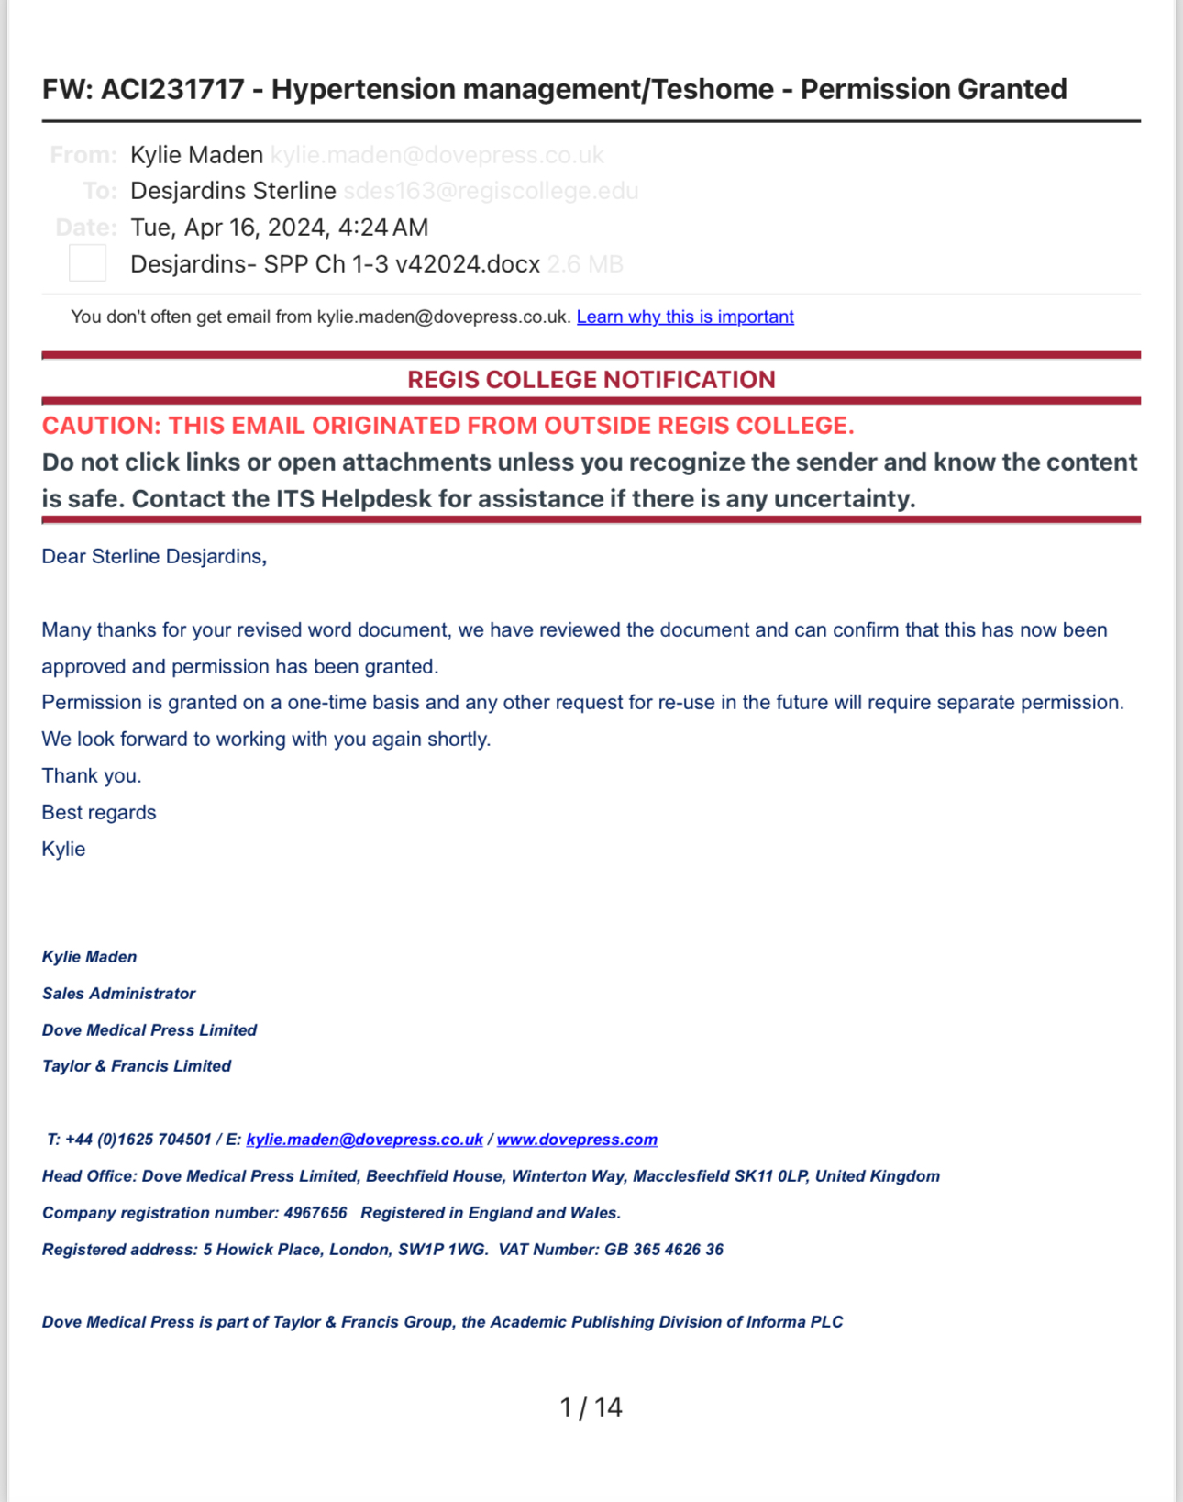
Appendix D
Appendix E

Table of the Levels of Evidence

Level of Evidence | Description | Articles
Level I | Experimental study, randomized controlled trial (RCT), systematic review of RCT’s, with or without meta-analysis | 6
Level II | Quasi-experimental study, systematic review of a combination of RCTs and quasi-experimental, or quasi-experimental studies only, with or without meta-analysis | 9
Level III | Non-experimental study, systematic review of a combination of RCTs, quasi-experimental and non-experimental studies only, with or without meta-analysis. Qualitative study or systematic review with or without a meta-synthesis | 6
Level IV | Opinion of respected authorities and/or nationally recognized expert committees/consensus panels based on scientific evidence  Includes:  Clinical practice guidelines  Consensus panels | 0
Level V | Based on experiential and non-research evidence  Includes: Literature reviews, quality improvement, program or financial evaluation, case reports, opinion of nationally recognized experts(s) based on experiential evidence | 3
Appendix F

Literature Matrix
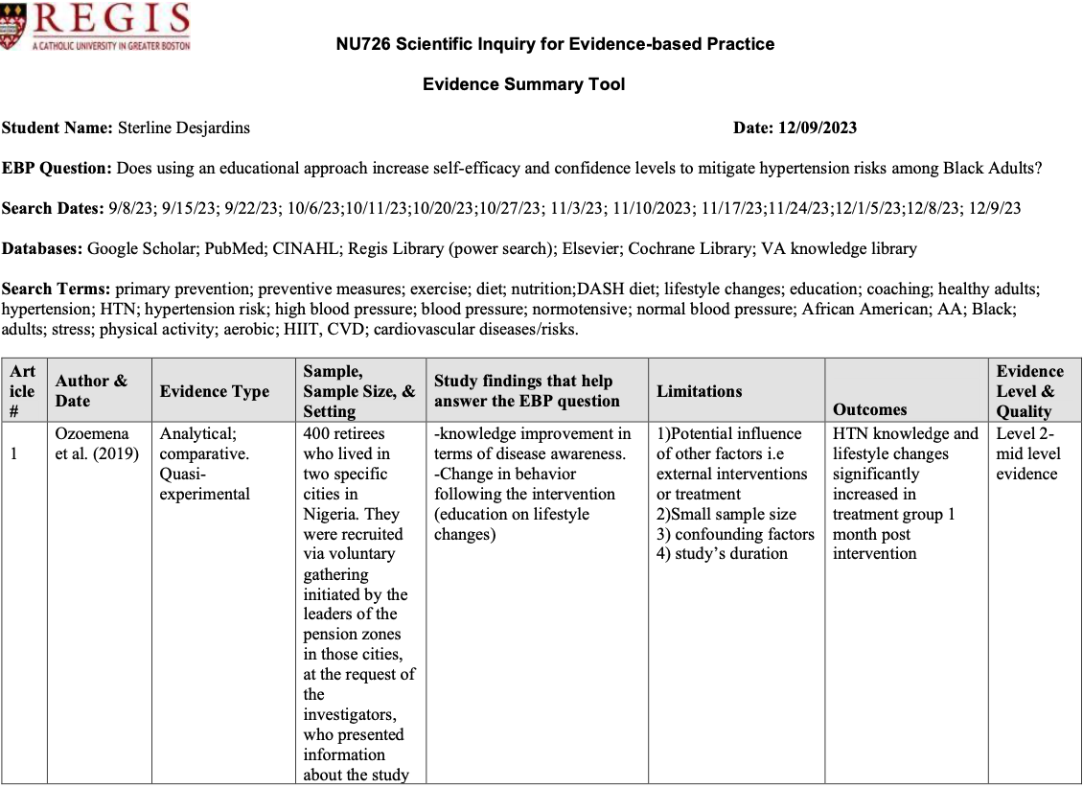
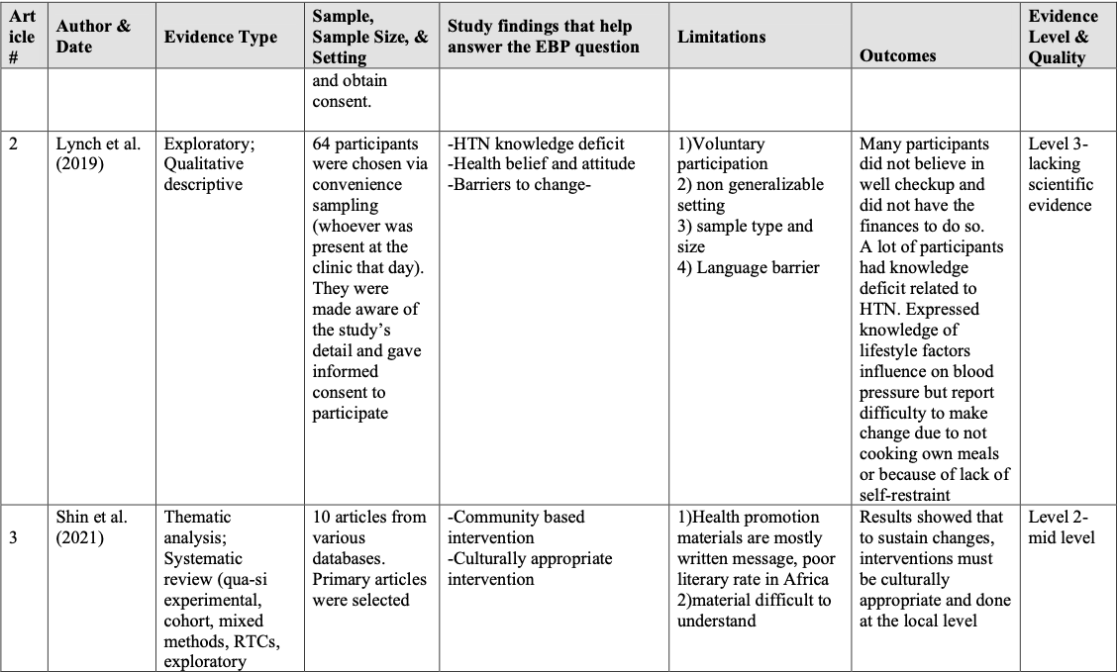

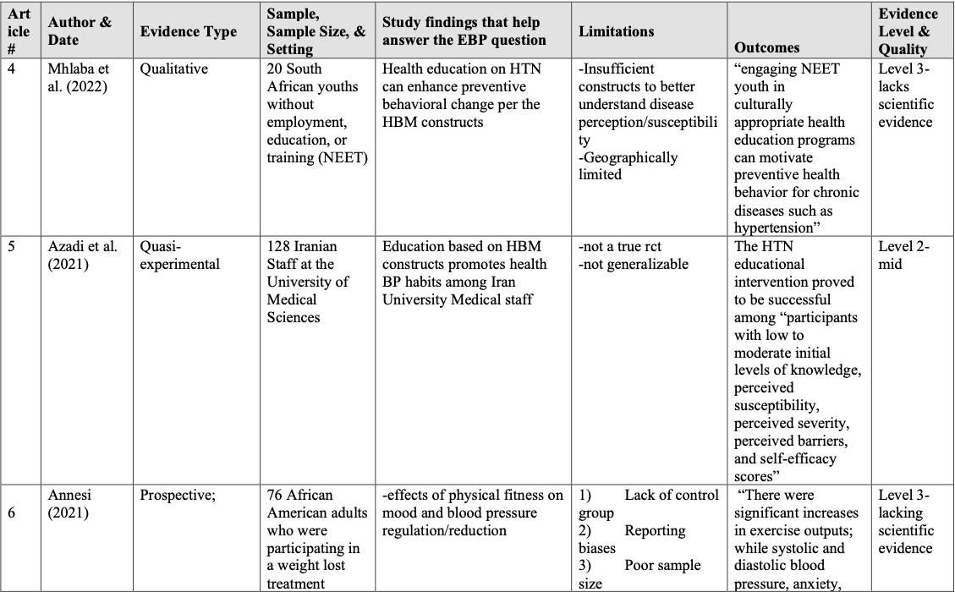
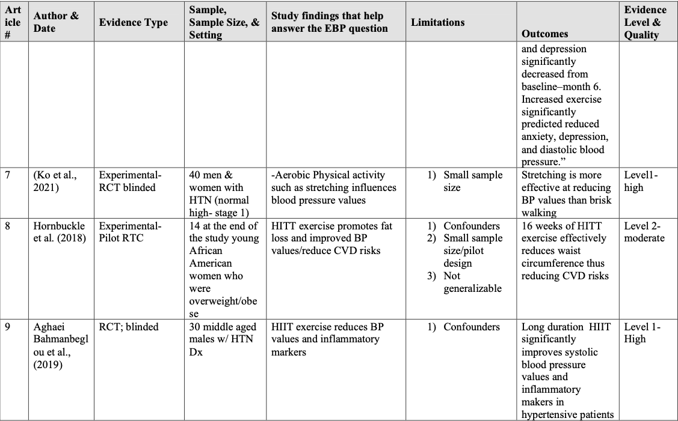

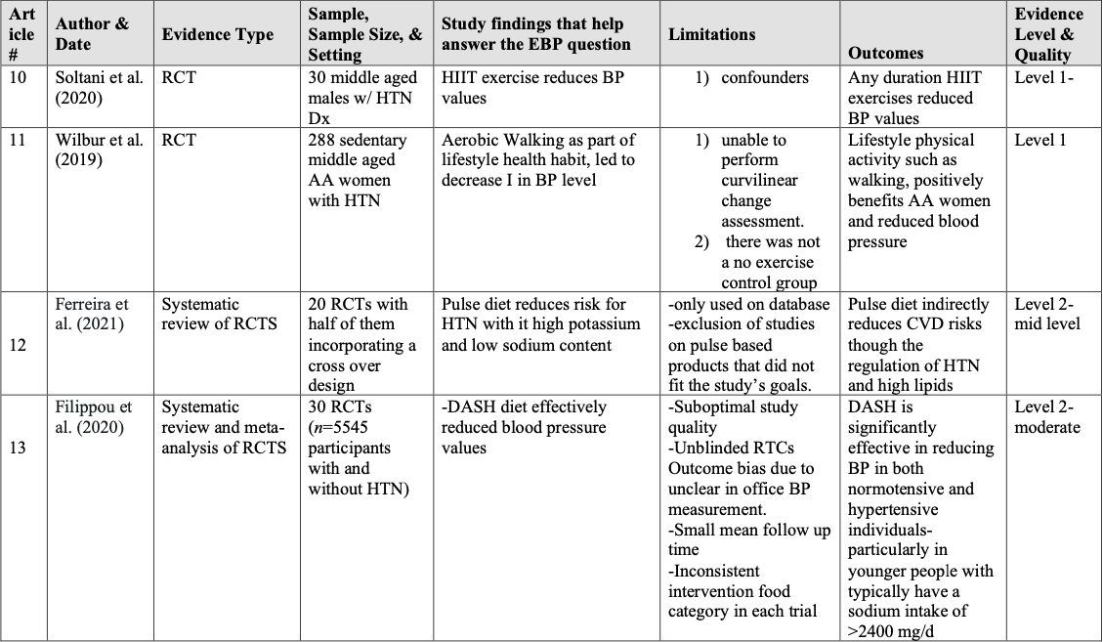
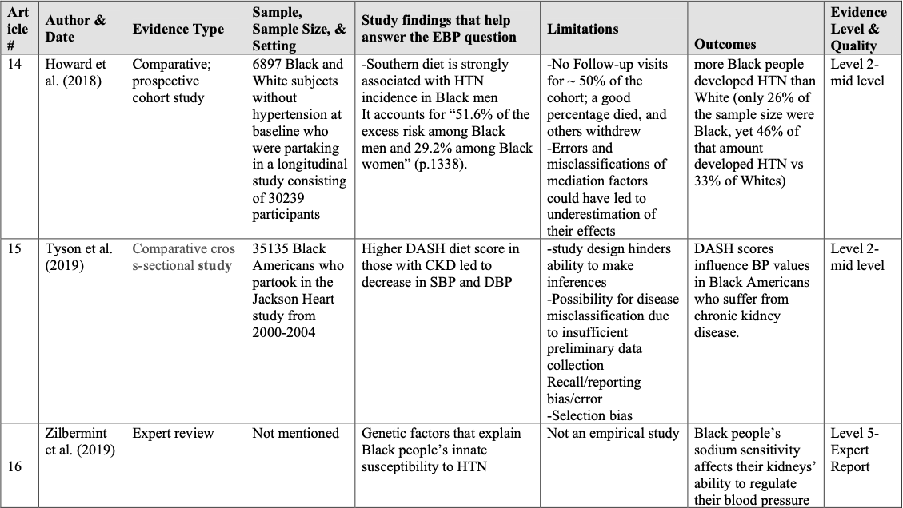

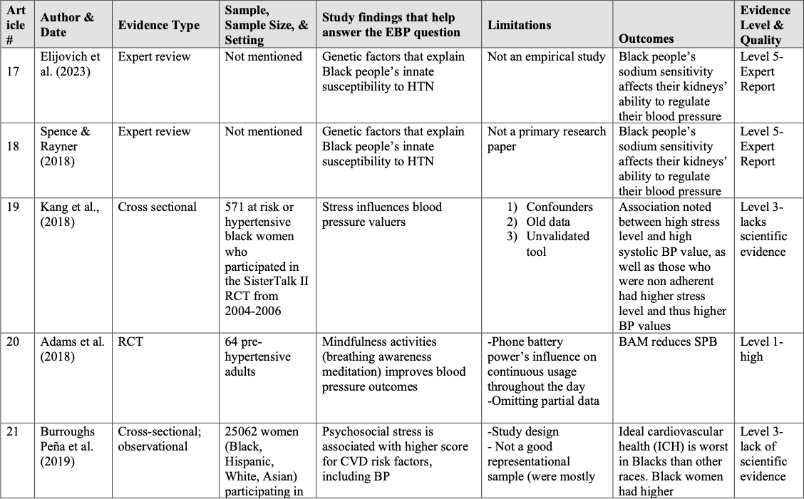
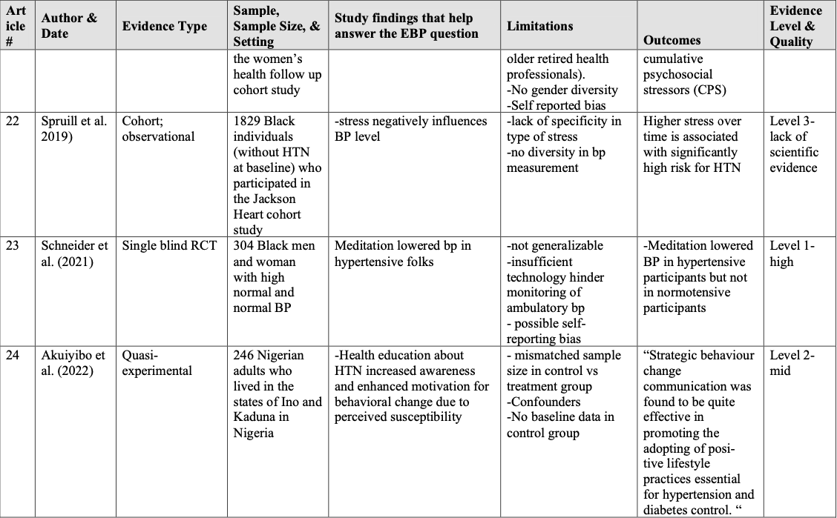

Appendix G

Written Permissions from Implementation Sites

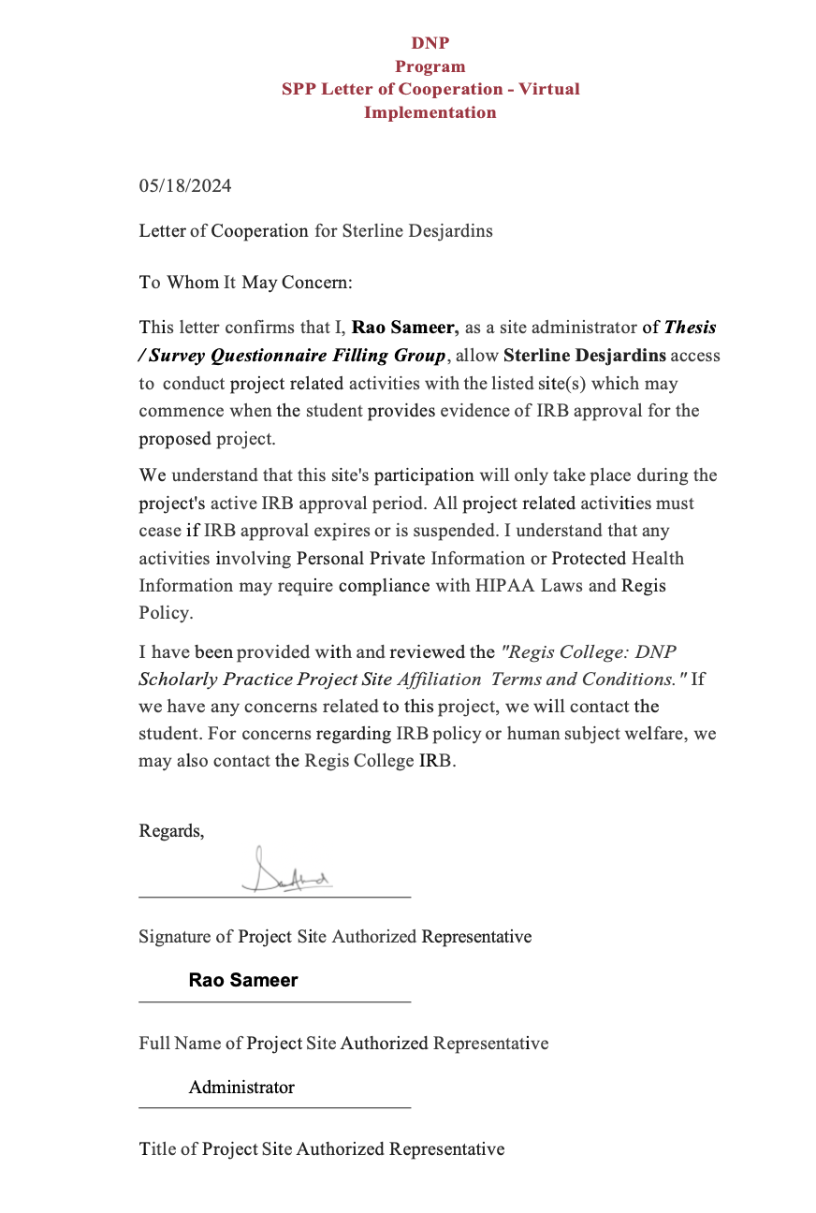
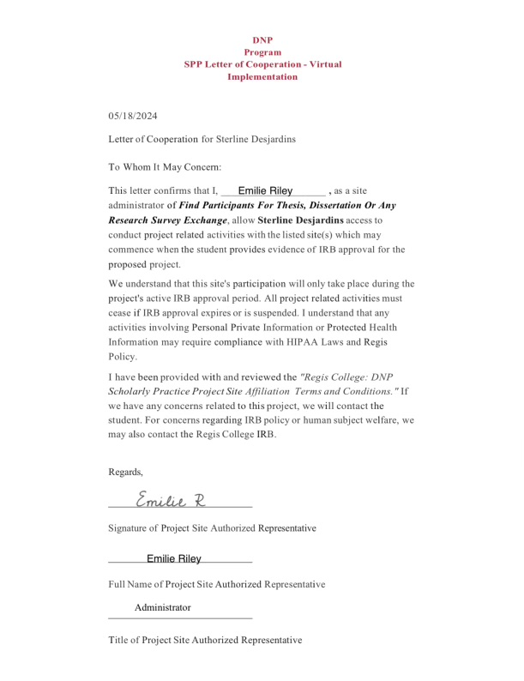

Appendix H

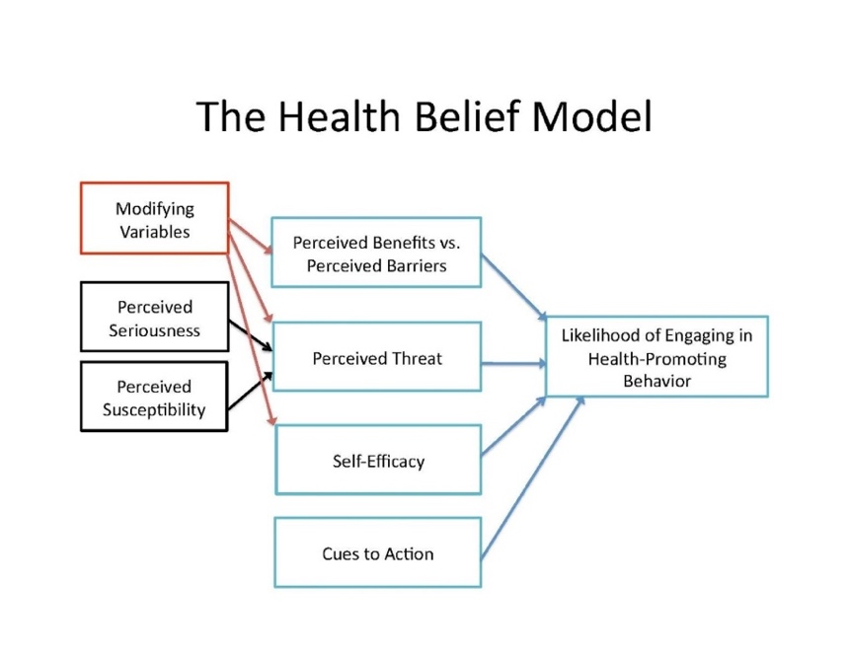
HBM & Permission Figure 1 The Health Belief Model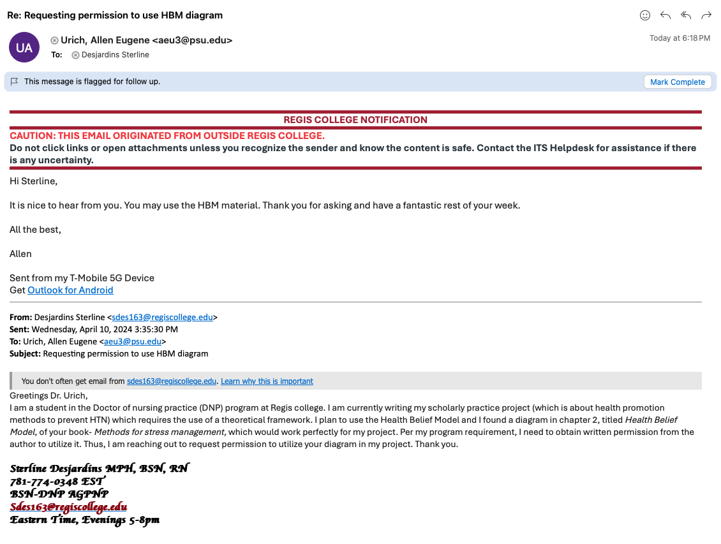
Appendix I

JHEBP Model & Permission

Figure 2
Johns Hopkins Evidence Based Practice Model

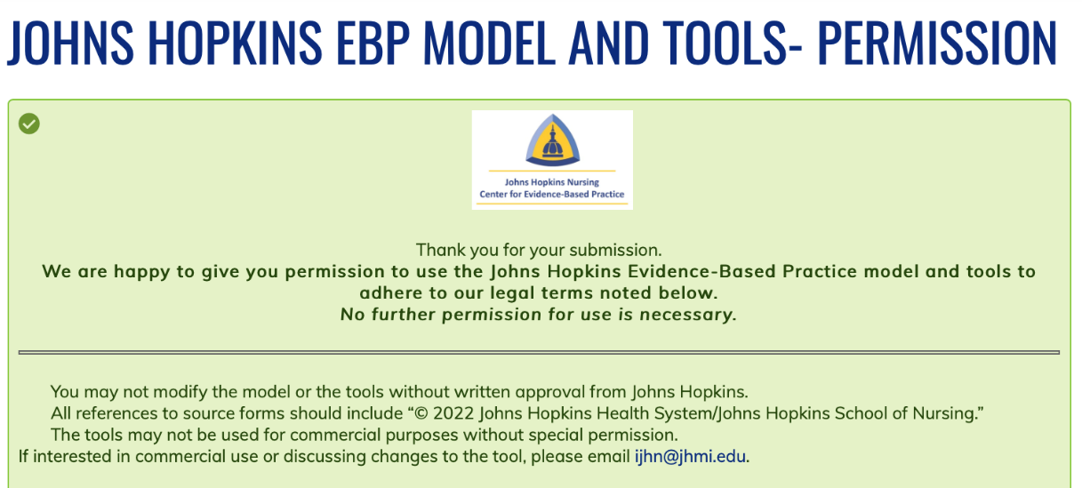

Appendix J

Regis College IRB Approval Letter

