The Implementation of a Cultural Competence Educational Intervention
In a Psychiatric Mental Health Setting

A Scholarly Project
Presented to
The Faculty of Regis College

In Partial Fulfillment
of the Requirements of the
Doctor of Nursing Practice Degree

by

BRUCE P. NSUBUGA, DNP(c), MSN, RN
August 24, 2025

Abstract
Problem Statement: A lack of cultural competence among nurses can hinder their ability to deliver effective care to patients with diverse cultural backgrounds, beliefs, behaviors, and values. However, training improves nurses’ cultural competence levels and lessens cultural inefficiencies, thereby augmenting the quality of equitable care.
Purpose: This project aims to train psychiatric registered mental health nurses, boost their cultural competence and confidence levels in providing culturally competent care.
Methods: A pretest and posttest design grounded on the steps outlined in the John Hopkins Evidence-Based Practice model.
Inclusion Criteria: Registered nurses, licensed practice nurses, PMHNPs, and PMHNPs offering direct patient care.
Analysis: PI will analyze descriptive statistics for the demographic survey. Paired sample t-test will be utilized to analyze the collected data in IntellectusStatistics software with the assistance of a Statistician. A comparison of group means between the pretest and posttest will be conducted, and a p-value will be determined, with a minimum value of <0.05.
Implications for Practice: Improved nurses’ cultural competence and confidence levels.
Keywords: "Cultural competence," "education program or training," "nurses," and "health delivery processes."

Signature Page
This scholarly practice project of _____________, entitled _____________________directed and approved by the faculty chair, has been accepted by the Nursing Faculty of Regis College in fulfillment of the requirements for the Doctor of Nursing Practice.
__________________________________________
Dean, Richard, and Sheila Young School of Nursing
__________________________________________
Chair, Doctoral Scholarly Project Team (credentials)
__________________________________________
Team Member (credentials)
__________________________________________
Team Member (credentials)
___________________________________________
Team Member (credentials)
Add signature line for each additional team member.
[This page is a temporary placeholder which will be replaced with the signature page signed by all project team members.]

Acknowledgments
I am profoundly thankful to God Almighty, whose unwavering grace has sustained me throughout this journey. My heartfelt appreciation goes to my project chair, Dr. Celeste M. Baldwin, PhD, MS, APRN-CNS, SGAHN; my project mentor, Dr. Anne Kabuusu DNP, PMHNP-BC; and the second reader, Dr. William Byansi, MSW, PhD. Your exceptional mentorship, insights, and incessant encouragement continue to shape this project, and I am eternally grateful for unbridled guidance and support.
To my beloved wife, children, and family, your prayers, encouragement, support, and presence have been a pillar of strength. From the deepest recesses of my heart, thank you for your unwavering belief and love. I extend my heartfelt gratitude to the AHHC fraternity for their invaluable support in conducting this project and for their participation. To my colleagues and peers, thank you for your constant cheer and camaraderie. This project is a labor of love, and I am forever grateful.

Table of Contents

Abstract 2
Signature Page 3
Acknowledgments 4
Table of Contents 5
List of Tables 8
Introduction 10
Background 11
Significance 20
Nursing Practice 21
Nursing Education 22
Nursing Leadership 22
Nursing Research 23
Problem Statement 23
Clinical/Practice Question(s) 24
Purpose of the Project 24
Project Objectives/Aims 25
Theoretical or Conceptual Framework 25
Philosophical Assumptions 26
Johns Hopkins Nursing Evidence-Based Practice (JHNEBP) Model 27
PET Steps 28
Conclusion 28
Methodology 30
Project Design 31
PET Procedure: Application of the JHNEBP Model in the Project (See Figure 1) 31
Plans and Procedures 32
Evidence-Based Clinical/Practice Question 33
Setting 33
Sample 33
Recruitment Plan 34
Sample Size 34
Sampling 35
Inclusion Criteria 35
Exclusion Criteria 35
Ethical Considerations 35
Informed Consent 36
Beneficence 36
Anonymity and Confidentiality 37
Respect for Privacy 37
Measurement of Variables 38
Demographic Survey (See Appendix F) 38
Cultural Competence Self-Assessment Checklist (See Appendix G & H) 38
Confidence Scale (See Appendix I & J) 39
Open-ended Questions 39
Educational Intervention 40
Data Collection and Analysis 40
Timetable 40
Conclusion 41
Results 43
References 44
Tables 49
Figures 50
Figure 1. Application of the JHNEBP Model 50
Figure 2. G*Power Analysis 51
Appendices 52
Appendix A: Leininger's Sunrise Model 52
Appendix B-Permission for Use of Leininger's Sunrise Model 53
Appendix C: JHNEBP Model 54
Appendix D: Permission for the use of the JHNEBP Model 55
Appendix E-Invitation to Participate 56
Appendix F-Demographic Survey 57
Appendix G-Instrument #1 58
Appendix H-Permission for Use of the Cultural Competence Checklist 71
Appendix I-Instrument #2 72
Confidence Scale (C-Scale) 72
Appendix J-Permission for Use of the Confidence Scale 76
Appendix K-Open-Ended Questions 77
Appendix L-Educational Intervention Slides, Expert YouTube Links, Additional Resources, and Case Study 78
Appendix M-External Site Permission 85
Appendix N- PI and Project Chair CITI Training Certificates 86
Appendix O-Primary Investigator Resume 87
Appendix P-Flesch-Kincaid Grade Level for Informed Consent 96
Appendix Q-Informed Consent 97

List of Tables

Table 1. Timeline 42

List of Figures
Figure 1. Application of the JHNEBP Model 54
Figure 2. G*Power Analysis 55

The Implementation of a Cultural Competence Educational Program in a Psychiatric Mental Health Setting

Introduction
In the United States, research highlights a considerable demographic shift driven by snowballing cultural diversity, primarily due to the rise in international migration (Sahamkhadam et al., 2023). The transformation presents both opportunities and challenges, particularly in the healthcare sector. The cumulative diversity highlights the need for a proficient nursing workforce that can deliver culturally competent care to its clients. Rice and Harris (2021) postulate that cultural competence serves as an underpinning that empowers patients to feel contented with their clinician and continuously seek out critical care. While the patient population has become more diverse, the healthcare workforce has not kept pace with this growing heterogeneity, which can contribute to disparities in health outcomes (Marcelin et al., 2019). The psychiatric mental health care is still one of the most underutilized services within the continuum of care despite its purported catholicity. Therefore, addressing these challenges is crucial to ensuring the delivery of culturally competent and sensitive care, which is essential for meeting the needs of an increasingly diverse society (Stubbe, 2020). The delivery of culturally competent care is requisite to expedite access to culturally equitable care for the diverse patient cohorts (Fante-Coleman & Jackson-Best, 2020).
Evidence suggests that cultural competency has become a critical prerequisite for mental health nurses serving culturally diverse patient populations. As such, it is vitally important to train psychiatric mental health registered nurses to ensure they provide culturally competent care (Raval et al., 2024). Cultural competence training enhances healthcare delivery processes and mitigates abysmal patient outcomes (Sahamkhadam et al., 2023). Patients seeking mental healthcare frequently encounter manifold stages of society, such as systemic, provider-connected, and individual-linked barriers. Specifically, provider-akin barriers entail racism and discrimination from clinicians, the ineptitude to deliver culturally competent care, and the paucity of organizational backing (Fante-Coleman & Jackson-Best, 2020). Nonetheless, a culturally competent psychiatric nursing workforce serves as enablers of cultural competence.
Training nursing personnel in cultural competence boosts their capacity to deliver culturally effective and sensitive care. The training can lead to optimal outcomes, such as aligned treatment care plans and enhanced patient engagement (Sahamkhadam et al., 2023; Nair & Adetayo, 2019; Stubbe, 2020). Research also suggests that a lack of cultural competence can contribute to unconscious biases, stereotypes, and microaggressions among healthcare providers, which may further alienate patients and discourage them from seeking necessary care (Cruz et al., 2019; Stubbe, 2020). The Scholarly Practice Project (SPP) will investigate the impact of a cultural competence education program in psychiatric and mental health settings. The principal investigator (PI) will implement the intervention in a home care agency that provides comprehensive and holistic medical and mental health services. The cultural competence education program will foster greater cultural understanding among healthcare providers and aim to augment care delivery as well as patient experiences.

Background
Nurses' cultural competence and the cumulative diversity of patient populations directly influence cognitive mental health services (AHRQ, 2019). As such, training nurses in cultural competence can enhance their clinical practice efficiency and reduce healthcare disparities in culturally diverse populations (Eken et al., 2021). Psychiatric nurses, who regularly interact with patients to improve their health, consider themselves moderately culturally competent (Sahamkhadam et al.,2023). Chu et al. (2022) found that engaging with and working in tandem with clients from diverse cultural backgrounds can enhance healthcare providers' cultural competence. However, before collaborating with patients, nurses should identify their individual biases, norms, and prejudices to become well-suited to provide tailored and efficient healthcare services that respect and prioritize patients' cultural identities (Sahamkhadam et al., 2023).
Culturally competent psychiatric personnel are effectively equipped to provide cultural rapport and deliver competent care to their clients, thereby expediting access to care (Fante-Coleman & Jackson-Best, 2020). However, research studies indicate that a lack of cultural understanding can have dire repercussions for providers during client interactions. For instance, they may radiate an unyielding demeanor and cease to recognize their client’s anguish due to a poor therapeutic alliance (Fante-Coleman & Jackson-Best, 2020). As such, the providers may inadvertently dismiss patients by not including them during treatment decisions and tailoring informed care plans. These challenges may lead to inadequate patient outcomes and exacerbate numerous health inequities (Alkhamees & Alasqah, 2023). Patients from marginalized and minority groups often experience barriers to care like stigma and biases, which negatively affect their quality of life and determination to seek appropriate psychiatric care (Cruz et al., 2019; Gopal et al., 2021). Stubbe (2020) opined that most nurses encounter delivery complexities when caring for clients from diverse cultural backgrounds.
The challenges may perpetuate a lack of culturally competent care and workflow ineffectiveness. As such, nurses should utilize these experiences as a driving force to engage in cultural competence training and lifelong learning, addressing the ever-evolving health needs of diverse healthcare clients (Desai et al., 2020). Essentially, the ability to deliver culturally competent care can be attributed to the providers' impeccability in offering culturally holistic, congruent, and sensitive care, making it easier for them to achieve ideal healthcare delivery processes and patient outcomes (Desai et al., 2020). Cultural competence accredits nurses with satisfactory expertise in providing equitable care, which complements the inimitable health necessities of patients from disparate cultural backgrounds (Arruzza & Chau, 2021). Even so, an inadequacy in cultural competence among mental health nurses can lead to redundant medical errors, which can exacerbate incompetence (Chu et al., 2022).
Some clinicians are often adamant in recognizing their biases and may make assumptions that patients are apathetic in receiving necessary care, giving rise to a gamut of health inequalities like discrimination, microaggressions, and unawareness (Handtke et al., 2019). When nurses project their prejudices and biases towards patients from diverse cultural backgrounds, they become culturally insensitive and fail to address the patients’ diversity. As such, they may stereotype their clients, especially those seeking mental health care, and make hurtful statements which may lead to microaggressions (Cruz et al., 2019). These consequences may lead to a misunderstanding of patients’ cultural representations of their experiences, contributing to distrust of the psychiatric healthcare system (Fante-Coleman & Jackson-Best, 2020). It is critically important to note that the outcomes may dishearten clients, making it difficult for them to seek the care they so deserve. Unfortunately, the lack of proper treatment mechanisms can deteriorate their quality of life and upsurge the risk of mortality and morbidity rates (Cruz et al., 2019).
According to Handtke et al. (2019), a variety of nurses report that they struggle with a lack of cultural understanding, particularly in scenarios where clients do not consistently adhere to the prescribed treatment recommendations. The process can reinforce nurses’ negative assumptions and may lead them to presume that patients do not value their own well-being. The misunderstanding may alienate patients from engaging in mental health services and impede access to quality care (Fante-Coleman & Jackson-Best, 2020). Similarly, when clients with pain issues request pain medication, nurses might put labels on the clients by referring to them as drug-seekers rather than individuals grappling with mental health ailments (Cruz et al., 2019). These assumptions and stereotypes can exacerbate healthcare disparities, including discrimination, language barriers, and a lack of cultural awareness (Handtke et al., 2019).
Mental healthcare providers also face difficulties akin to organizational barriers, such as praxis, which makes it challenging to bridge the gap between acknowledging the necessity for equitable care and implementing it within the care paradigm (Fante-Coleman & Jackson-Best, 2020). Therefore, clinicians should introduce cultural competence training at their workplaces to better understand their patients' cultural backgrounds and tailor treatment plans that are aligned with their values (Fante-Coleman & Jackson-Best, 2020). Introducing a cultural competence education program will boost cultural competence among providers. As a result, patients may feel comfortable expressing their health concerns and adhering to the administered treatment plans. As the United States continues to diversify, providers may register an increment in healthcare inequalities, making it paramount for Doctor of Nursing Practice (DNP) scholars and other practitioners to implement cultural competence training within the continuum of care (Sahamkhadam et al., 2023).
The strategic approach ensures that providers are well-equipped to provide culturally competent care. Cultural proficiency plays a crucial role in enabling nurses to recognize their biases and respect the diversity of their patients (Lin & Hsu, 2020). Moreover, cultural competence enhances nurses’ cultural awareness, enabling them to provide more sensitive care and reduce existing healthcare disparities (Rukadikar et al., 2022). As vital affiliates of the healthcare system, nurses are responsible for building trust with patients, streamlining psychiatric care processes, and addressing challenges arising from cultural differences (Lin & Hsu, 2020). On the other hand, healthcare administrators and leaders play a central role in promoting cultural competence by educating nurses to incorporate essential elements, such as cultural understanding, knowledge, motivation, experiences, and skills (Kaihlanen et al., 2019).
Cultural competence is closely linked to cultural awareness, as it fosters effective communication between nurses and patients from diverse backgrounds. It also helps nurses design effective care strategies (Handtke et al., 2019). According to Arruzza and Chau (2021), training healthcare providers in cultural competence enhances their skills, resulting in improved treatment outcomes, increased patient satisfaction, and more efficient information sharing. While cultural competence is an ongoing process that encourages clinicians to tailor their care practices to the needs of diverse patients more effectively, there are still barriers to fully integrating cultural competence education into healthcare (Liu et al., 2021).
Impact of Discrimination on Patient Experiences
It is critical for healthcare organizations to edify their workforce on effective strategies such as cultural competence training and materials to help providers better understand the diverse cultural backgrounds of their patients (Nair & Adetayo, 2019). The lack of culturally competent care can precipitate poor health outcomes, both mentally and physically (Cruz et al., 2019). A significant approach to mitigating this gap is promoting cultural competence discourse to understand the impact of prejudice and discrimination on patients. The training through discussions can help nurses understand the importance of cultural competence education (Chu et al., 2022). On the other hand, healthcare leaders can strengthen more culturally sensitive care by amalgamating training initiatives with organizational guiding principles designed to eradicate racism and discrimination (Chu et al., 2022). The project will assess the impact and significance of cultural competence training on healthcare providers' knowledge, attitudes, and behavior, as well as its effect on patient outcomes. As such, the assessment will help raise awareness on the current gaps and provide practical ways of addressing them.
Improved Nurses' Cultural Awareness
Numerous studies have underscored the importance of cultural competence in educational interventions. Kaihlanen et al. (2019) performed a qualitative study investigating nurses' perspectives on cultural competence training and awareness. The study revealed the importance of inculcating cultural competence in nurses to enhance their cultural awareness and effective communication (Kaihlanen et al., 2019). Although the sample size was limited, the insights can be generalized to specific populations, such as psychiatric nursing, and inform the researcher of educational methods that can enhance nursing practice and promote cultural awareness. Cultural awareness equips clinicians with the ability to self-reflect, identify their biases, and refrain from labeling patients from diverse backgrounds (Kaihlanen et al., 2019).
This study provides valuable insights into nurses’ cultural awareness, which can be integrated into the project to train psychiatric nurses on the importance of cultural competence and addressing health disparities. Manlangit et al. (2022) emphasized the need to examine how cultural awareness, sensitivity, and behaviors impact nurse leaders. The sleuths utilized the Cultural Competence Assessment instrument and the Decision-Making Quality Scale questionnaire, disseminating them to 122 participants affiliated with a Saudi Arabian institution. The findings demonstrated that cultural awareness and sensitivity are inextricably linked to nurses' cultural competence and their ability to make informed, culturally informed decisions (Manlangit et al., 2022).
Additionally, cultural competence training enhances the cultural awareness of nurse leaders and their teams, enabling them to make informed, evidence-based decisions that lead to optimal patient and health outcomes (Manlangit et al., 2022). Mukhalalati et al. (2022) assessed the relevance of cultural competence training to nurses' cultural awareness. The qualitative element of the study implied that healthcare educators have a positive attitude towards cultural competence training. In the meantime, the quantitative results proved a noteworthy increment in cultural awareness, suggesting that cultural competence training also equips nurses with the necessary skills to deliver impartial care (Mukhalalati et al., 2022). Most importantly, these findings support the project's goal of enhancing cultural awareness. As such, the student will leverage these insights to inform psychiatric nurses about the benefits of cultural competence training in enhancing cultural awareness.
The Influence of Cultural Competence Education
The second theme identified in the search strategy was the effect of cultural competence education and training on healthcare providers. Research indicates a positive link between cultural awareness, skills, knowledge, attitudes, and behaviors. Several studies have proven the validity of educational initiatives in enhancing nurses' cultural competencies to achieve optimal health outcomes. Slobodin et al. (2020) tailored a culturally informed educational intervention to improve healthcare students' cultural competence. The qualitative segment of the study involved semi-structured interviews with ten participants. The researchers used interpretative phenomenological analysis to evaluate the data (Slobodin et al., 2020).
In the quantitative phase, participants were divided into two groups: intervention and non-intervention. The study began in September 2018 and lasted two years, addressing gaps in cultural competence curricula and training. Slobodin et al. (2020) reported that incorporating cultural competence education programs can enhance providers' understanding of cultural diversity, reduce cultural dissonance, and foster effective communication and outcomes between patients and providers. The findings support the project's goal of enhancing healthcare providers' cultural competence to positively impact psychiatric settings.
Lin and Hsu (2020) conducted a randomized controlled study in which they randomly assigned respondents to experimental (n = 47) and control (n = 50) groups. The results showed that the experimental group's cultural competence scores of 0.51 were higher than those of the control group, both at follow-up and post-intervention (Lin & Hsu, 2020). The study demonstrated that cultural competence training can significantly improve nurses' cultural aptitude and overall competence.
These findings support the implementation of a cultural competence education program in the project to enhance workflow efficiencies in the mental health unit.
Raval et al. (2024) conducted mixed-methods research to evaluate the effect of training in cultural competence for mental healthcare providers. The researchers postulate that providing culturally competent care to people from diverse backgrounds is necessary due to the universality of mental health care (Raval et al., 2024). Raval et al. (2024) assessed the impact of cultural competence training by investigating the perspectives of graduate students, practitioners, and faculty in India and the United States of America. The investigators employed various data collection approaches, including focus groups (n = 25). In this case, the researchers conducted fifteen focus groups in India, involving 69 participants, and ten focus groups in America, each with 38 participants. They also used a survey with a sample population of 800; 450 participants were from India, while the rest were from the United States (Raval et al., 2024).
The inclusion criteria involved higher education, psychology degrees, and doctoral degrees; most participants identified as cisgender women (Raval et al., 2024). An online survey link was sent via email to all participants in the United States individually, while in India, the email links were sent through the psychology department chairs. Both the qualitative and quantitative findings indicate that training in cultural competence is crucial in addressing disparities, promoting equitable care, and augmenting patient outcomes (Raval et al., 2024). The article supports the objectives of the SPP in training psychiatric registered nurses in cultural competence, ensuring they are well-prepared to deliver culturally competent care.
Cultural Competence on Nurses’ Cultural Knowledge and Skills
Argyriadis et al. (2022) conducted a mixed-methods study to explore the knowledge and skill levels of healthcare professionals in relation to their cultural competence. The researchers utilized the Cultural Competence Self-Assessment Checklist from the Central Vancouver Island Multicultural Society to collect quantitative data, and conducted 62 semi-structured interviews to gather qualitative data (Argyriadis et al., 2022). They found that nurses are often sensitive to cultural competence practices. The training and educational materials can offer providers cultural competence expertise when working with patients from diverse backgrounds (Argyriadis et al., 2022). These findings can be used to tailor a detailed cultural competence educational program, expanding providers' expertise on cultural competence.
Arruzza and Chau (2021) conducted a scoping review study to assess the effectiveness of educational learning materials in enhancing nursing students’ knowledge, skills, attitudes, and practices. The researchers incorporated an experimental study design to review ten experimental research studies. Based on the research findings, nurses with cultural competence reported higher scores, concomitant with adequate cultural knowledge and enhanced skills (Arruzza & Chau, 2021). Furthermore, cultural knowledge and skills gained through training enhance nurses' understanding of cultural concepts during healthcare delivery (Arruzza & Chau, 2021). The findings from the study article align with the project’s purpose of ensuring that nurses, specifically those working in a mental health unit, are culturally competent to deliver effective cognitive mental health care.
Importance of Cultural Competence
The Agency for Healthcare Research and Quality (AHRQ, 2019) reported that cultural competence is a crucial aspect of healthcare that enables health systems to deliver patient-centered care by integrating patients' values, beliefs, and practices. Culturally competent care makes patients feel safe and respected, as they are treated by a workforce that values their cultural journey without judgment (AHRQ, 2019).
The Centers for Disease Control and Prevention (CDC) have elucidated that cultural competence encompasses attitudes, policies, and behaviors that enable healthcare providers to work effectively in cross-cultural situations (NPIN.CDC.gov, n.d.). These merits arouse top-notch quality care and impeccable delivery processes (NPIN.CDC.gov, n.d.). As such, by adopting the concepts of the studies and integrating the recommended principles of cultural competence in educational materials, the project can augment cognitive mental health delivery processes and patient outcomes (AHRQ, 2019; NPIN.CDC.gov, n.d.).

Significance
Cultural competence is a significant topic that healthcare providers are mandated to incorporate in their practice (Rukadikar et al., 2022). Cultural competence enables providers to deliver respectful and empathetic care that respects the diverse beliefs, values, and behaviors of patients with varying characteristics. It is essential for nurses to adopt culturally informed and health-literate approaches to enhance their competence (AHRQ, 2019). For instance, when they fail to adopt cultural competence strategies, they are susceptible to jeopardizing their clients’ safety and instigating adverse disparities, such as diagnostic errors, missed screenings, adverse medication reactions, and substandard cognitive health services (AHRQ, 2019). There are merits associated with cultural competence training, including enhanced nurses’ awareness, understanding, knowledge, and skills, as well as positive behavioral changes and improved patient outcomes (Sahamkhadam et al., 2023). Thus, training nurses in cultural competence can assist nurses in in overcoming cultural differences and build a stronger culture of trust and transparency (AHRQ, 2019). Cultural competence is essential across nursing, research, clinical practice, education, and leadership.

Nursing Practice
Culturally competent nurses demonstrate increased knowledge, behaviors, and attitudes that improve the efficiency of mental healthcare delivery (Nair & Adetayo, 2019; Chae et al., 2020). Additionally, nurses who are culturally aware are better equipped to meet their patients' health needs, resulting in timely diagnoses, effective treatments, and stronger relationships throughout the care process (Stubbe, 2020). In nursing practice, positive communication and affinity between patients and providers enhance patients’ engagement and adherence to treatment plans (Stubbe, 2020). However, biases, stereotypes, and microaggressions can undermine cultural competence, potentially harming the quality of care within the healthcare sector (Stubbe, 2020). Additionally, language and cultural barriers can lead to miscommunication, making patients less likely to follow treatment recommendations and resulting in poorer outcomes (Arruzza & Chau, 2021).
Nurses should prioritize educational programs focused on cultural proficiency to provide patient-centric care (Lin & Hsu, 2020). Regardless of their cultural background, culturally competent nurses can offer care that aligns with patients' values, attitudes, and behaviors, highlighting the importance of ongoing cultural competence education. Healthcare disparities can be addressed when organizations, administrators, and nurse leaders collaborate to promote cultural competence through training and continuous learning. These initiatives help the workforce better understand patients' cultural affiliations, which encourages patients to be more engaged and open about their care (Lin & Hsu, 2020). Cultural competence among providers leads to improved patient outcomes, including treatment adherence, satisfaction, and engagement. Healthcare gaps can be tackled by ensuring the entire team of clinicians are well-educated on the tenets of cultural competence (Sahamkhadam et al., 2023).

Nursing Education
Nursing tutors should assimilate cultural competence training into the nursing curriculum to better prepare nurses to deliver optimal care that aligns with their clients' cultural preferences and needs (Ličen & Prosen, 2023). Therefore, inculcating nurses in cultural competence can boost their cultural knowledge and enable them to address care gaps that arise from cultural differences. Teaching nurses to provide unbiased care creates a more skilled, diverse, and confident nursing workforce capable of addressing the distinct needs of their patients (Arruzza & Chau, 2021). This approach ultimately enhances healthcare delivery and patient outcomes. Nursing institutions face challenges in creating comprehensive curricula that cover all aspects of cultural competency. Therefore, nursing educators must reassess the methods used to teach cultural competence and ensure that future nurses are equipped to provide culturally appropriate care (Arruzza & Chau, 2021).

Nursing Leadership
Culturally competent leadership helps enhance staff engagement and motivation, encourages innovation, and promotes the adaptation of diverse cultural practices, all of which improve patient care (Cerveny et al., 2022). By focusing on patient-centered care, culturally competent leaders create a healthcare environment that values individualized understanding and high-quality care (Gulati & Weir, 2022). Nurse leaders should emphasize the development of skills, knowledge, and attitudes necessary for providing culturally competent care. These efforts can enhance patient-provider relationships and empower nurses to develop culturally appropriate care plans (Arruzza & Chau, 2021). Nurse leaders and managers play a crucial role in advocating for cultural competence within their institutions. They create strategies to implement culturally sensitive practices and inspire culturally competent behavior throughout the workforce (Manlangit et al., 2022).

Nursing Research
Cultural competence is also essential in nursing research, as it helps researchers develop practical training approaches and communicate the importance of culturally competent care (Kaihlanen et al., 2019). Research on cultural competence offers insights into cultural awareness, skills, and knowledge, enabling the effective addressing of differences in cultural expression and enhancing care delivery (Sahamkhadam et al., 2023). Studies consistently show that cultural competence enhances healthcare providers’ ability to navigate multicultural encounters and promote inclusive care (Cerveny et al., 2022).

Problem Statement
A lack of cultural competence among nurses can hinder their ability to deliver effective care to patients with diverse cultural backgrounds, beliefs, behaviors, and values (Nair & Adetayo, 2019). This gap in cultural understanding can lead to challenges such as miscommunication, mistrust, and patient dissatisfaction, ultimately compromising the quality of care (Arruzza & Chau, 2021). Microaggressions and biases toward marginalized populations can further exacerbate these issues, contributing to provider insensitivity and misunderstandings that negatively impact patient outcomes (Cruz et al., 2019). Culturally competent leadership acknowledges the significance of understanding patients' cultural backgrounds and experiences, thereby facilitating the delivery of culturally sensitive care (Gulati & Weir, 2022). It is essential to address the lack of cultural competence to promote inclusivity and equity, ensuring that all patients, regardless of cultural or linguistic differences, receive high-quality mental healthcare.
At the project site, the PI conducted a needs assessment prior to initiating the project, which will be implemented in a psychiatric homecare agency that serves patients with a range of mental health conditions. The needs assessment survey revealed that the cultural competence of mental health nurses fell below expected standards. Nurses reported difficulties in caring for culturally diverse patients, particularly those with limited English proficiency, due to a lack of access to interpreters. These challenges contributed to systemic barriers such as missed appointments, poor medication management, and disruptions in the delivery of mental health care. The principal investigator shared these findings with the unit's charge nurse and hospital administration, identifying gaps in practice and proposing the targeted intervention. This scholarly practice project will implement a cultural competence education program in the mental health unit to evaluate its impact on improving the efficiency and quality of mental healthcare delivery.

Clinical/Practice Question(s)
The project will employ the PICO(T) framework, which is an extensively acknowledged and operative strategy in clinical research. PICO(T) stands for Population (P), Intervention (I), Comparison (C), Outcome (O), and Time (T). The following is the clinical query for this project:
Does the implementation of a culturally competent educational intervention improve the levels of confidence in the use of cultural competence for psychiatric mental health registered nurses?

Purpose of the Project
The overarching determination of the project is to investigate the impact of a cultural competence education program on the effectiveness of cognitive mental health care delivery. Specifically, the project will assess how provider knowledge, motivation, attitudes, and behaviors are impacted by cultural competence training. It will also explore the program's effect on patient outcomes and healthcare disparities.

Project Objectives/Aims
The following objectives are outlined for the project:
1. To create an educational intervention based on current evidence about cultural competence, empathy, and humility.
2. To improve levels of cultural competence.
3. To increase levels of confidence.
4. To work with the stakeholders to achieve sustainability for this project at the external site.
5. To disseminate the findings through conference presentation and publication.

Theoretical or Conceptual Framework
Leininger’s culture care theory serves as a cornerstone of this Doctor of Nursing Practice (DNP) project, which aims to implement a cultural competence educational intervention program (See Appendix A & B). This framework is germane to the project because it supports the objective of providing culturally competent care. Leininger’s framework enables healthcare providers to make evidence-based decisions that respect the diverse cultural beliefs, values, and practices of patients, particularly those who may not share common cultural backgrounds (McFarland & Wehbe-Alamah, 2019). Leininger’s theory interlaces cultural elements into nursing care, creating room for enhancing cultural competence within healthcare environments (McFarland & Wehbe-Alamah, 2019).
Leininger’s framework is based on five key principles: respecting diversity, conducting cultural self-evaluations, understanding the dynamics of cultural changes, integrating cultural knowledge, and adapting to diversity (McFarland & Wehbe-Alamah, 2019). As such, the tenets can be applied in the project to emphasize the importance of cultural competence education. For example, respecting diversity involves embracing and acknowledging cultural differences. Conversely, self-evaluations enable nurses to reflect on their awareness of cultural diversity and confront any biases they may hold. Additionally, grasping cross-cultural dynamics and promoting open communication are essential for enhancing patient care (McFarland & Wehbe-Alamah, 2019). Thus, the PI will draw inferences from these insights and assimilate them into the project as optimal resources (Sahamkhadam et al., 2023).

Philosophical Assumptions
The investigators who coined Leininger’s culture care theory ensured that the framework can be used to frame other projects investigating the efficacy of cultural competence training and inculcations in nursing research. The theory posits that cultural elements have a significant impact on people’s health practices, beliefs, and behaviors (McFarland & Wehbe-Alamah, 2019). Leininger’s culture care theory posits that culture, social structure, and worldviews are intricately linked to well-being, care, and health (McFarland & Wehbe-Alamah, 2019). As such, care is paramount for growth, health, and survival. Care entails emotional, cultural, and spiritual dimensions, allowing individuals to recover from illnesses (McFarland & Wehbe-Alamah, 2019). The theory also assumes that cultural values, practices, and beliefs impact care. Therefore, nurses should understand these cultural distinctions to deliver culturally sensitive and effective care.
The third assumption is that culture is deeply ingrained in every facet of human life and shapes how people perceive, respond to, and experience health, care, and disease. McFarland and Wehbe-Alamah (2019) further elucidate that although cultural care is grounded on universality, it is practiced and perceived differently across cultures. Thus, healthcare providers should acknowledge the catholicity and diverse factors of care to prevent ethnocentrism and deliver culturally sensitive care (McFarland & Wehbe-Alamah, 2019). Additional philosophical assumptions include integrating culturally congruent care within the care paradigm, recognizing individual worldviews and social structures, and acquiring knowledge of diverse cultures.
Leininger’s culture care theory assumes three modes of nursing care actions and decisions. These modes, including cultural care preservation, accommodation, and repatterning, facilitate the achievement of culturally congruent care (McFarland & Wehbe-Alamah, 2019). Culture care preservation empowers professional actions and decisions that aid cultures in retaining valuable care beliefs and principles, thereby preventing mortality, illness, or frailty. Conversely, culture care accommodation enables creative provider care actions or decisions that assist cultures in becoming accustomed to or negotiating with others for culturally congruent and competent care, or addressing mortality and morbidity issues (McFarland & Wehbe-Alamah, 2019). Cultural care repatterning entails modifying harmful cultural practices whilst respecting the patient’s values. Another assumption is the significance of analyzing care within a cultural context to fathom patients’ cultural meanings and practices of adequate care. Lastly, Leininger’s theory advocates for a holistic approach to care, considering the physical, social, emotional, and spiritual aspects of health (McFarland & Wehbe-Alamah, 2019).

Johns Hopkins Nursing Evidence-Based Practice (JHNEBP) Model
The Johns Hopkins Nursing Evidence-Based Practice (JHNEBP) Model is a well-established framework that will guide the project plan for implementation (See Appendix C and D). This model integrates the latest research findings into clinical nursing practices using practical tools (Dang et al., 2022). It follows a systematic approach that empowers nurses to make evidence-based decisions, thereby enhancing patient outcomes and improving the efficiency of cognitive mental health services. The JHNEBP model utilizes user-friendly tools, such as evidence-based practice instruments, which streamline the use of research evidence in clinical settings (Johns Hopkins Nursing, n.d.). The model will support the project’s implementation in the mental health unit by guiding the principal investigator through each step to ensure successful adoption. The JHNEBP model operates in three phases: defining the practice question, finding the best available evidence, and translating that evidence into practice (Dang et al., 2022). These steps form the PET process, which entails the practice question, evidence, and translation stages.

PET Steps
The PET process of the JHNEBP model is essential for guiding healthcare providers through evidence-based practice (EBP) (Johns Hopkins Nursing, n.d.). The first phase begins with identifying the practice question, which involves outlining the issue, formulating the question, and assembling a project team (Dang et al., 2022). This initial step will help the student achieve the project’s goals by clearly defining the objectives and aligning them with EBP principles.
The second phase focuses on evidence, which involves gathering, reviewing, and synthesizing evidence and making practice change recommendations (Dang et al., 2022). Lastly, translation equips researchers with the skills to synthesize evidence and create clinical recommendations. This phase includes planning, securing stakeholder support, implementing the plan, evaluating outcomes, and communicating results (Dang et al., 2022) (See Figure 1).

Conclusion
In summary, the absence of a cultural competence education program in a mental health unit can significantly hinder the effectiveness of mental health services, impact patient outcomes, and limit the cultural knowledge, skills, and awareness of healthcare providers. Some studies suggested that educating healthcare providers in cultural competence expedites effective communication and optimizes health delivery processes. The second theme powerfully demonstrated the impact of cultural competence education, showing its direct effect on nurses' cultural proficiency, which leads to better health outcomes. Ongoing cultural competence training is crucial for practitioners and can lead to improved engagement, ensure patient-centered care, and reduce health disparities. The project aims to provide a discourse on significant gaps in evidence, along with rudiments that contribute to culturally incompetent psychiatric delivery services. Its primary goal is to improve patient outcomes and safety, streamline cognitive mental health delivery processes, and reduce healthcare inequalities. These objectives will be achieved by assessing changes in provider motivation, cultural knowledge, behaviors, and attitudes resulting from cultural competence education programs. Leininger's culture care theory will serve as the guiding framework for the project. The JHNEBP model will provide essential evidence-based practice tools and the PET process to ensure the project's success.

Methodology
Cultural competence is an indispensable skill in healthcare, but many nurses still lack the training necessary to fulfill the cultural requirements of their clients. The paucity of proper training has precipitated an increase in cultural incompetence. As such, this gap in practice can instigate poor patient outcomes, dissatisfaction with care, and misunderstandings in psychiatric settings (Arruzza & Chau, 2021). At the project’s site, many of the psychiatric nurses reported grappling with challenges in delivering culturally appropriate care, which affected their ability to support clients from disparate cultural milieus effectively. Furthermore, the lack of cultural competence has been shown to impact the quality and consistency of mental health care. Intrinsically, the issue of inadequate cultural competence can be tackled by incorporating an evidence-based cultural competence education program to help clinicians provide equitable and culturally tailored care, especially for patients from diverse backgrounds (Arruzza & Chau, 2021).
The educational intervention, based on Leininger’s theory, focused on enhancing key elements of cultural competency, including cultural awareness, knowledge, and skill development. The rudiments of cultural competency aimed to foster positive behavioral change among nurses and improve patient outcomes (Sahamkhadam et al., 2023). The cultural proficiency training enabled psychiatric nurses to understand cultural nuances, utilize effective communication techniques, and incorporate culturally sensitive practices into their care delivery. Leininger's culture care theory and the Johns Hopkins Nursing Evidence-Based Practice (JHNEBP) model guided the project's steps, providing an evidence-based foundation. This chapter will encapsulate the methodology used for the scholarly project (SPP). As such, it will detail the project’s design, guiding EBP model, methods, participant recruitment, ethical considerations, plans and procedures, tools, data analysis, timetable, limitations, and transferability. The goal was to describe the project’s design, implementation, and evaluation of the program to measure its impact on enhancing cultural competence among psychiatric nurses in a Northeastern U.S. home care facility.

Project Design
The principal investigator employed a quality improvement design, thereby assimilating current evidence-based practices to implement and measure the cultural competence educational program within a psychiatric unit. Additionally, the project was tailored to address gaps in culturally competent care by enhancing nurses’ cultural awareness, expertise, and knowledge. The Johns Hopkins Nursing Evidence-Based Practice (JHNEBP) model served as the basis for the project. The model enabled the principal investigator to leverage the PET approach, which comprises the practice question, evidence, and translation procedure, a strategy that is advantageous for structured EBP initiatives (Dang et al., 2022).
The primary goal was to improve cultural competence among psychiatric nurses and by providing culturally sensitive care. The project fostered a more comprehensive clinical environment that acknowledges and respects patients' diverse cultural backgrounds. The probable results include improved cultural competence levels, including knowledge, skills, and attitudes, as evaluated by the Vancouver Cultural Competence Checklist.
The JHNEBP model provided the principal investigator with a blueprint to bolster the identification, collation, translation, and application of evidence akin to cultural competence (Dang et al., 2022). The following model's PET process has three stages that expedite the evidence-based practice (EBP) approach.

PET Procedure: Application of the JHNEBP Model in the Project (See Figure 1)
The first level of the PET process involves categorizing a practice question, which includes delineating the EBP issue, articulating the question, and affirming the project’s goals. This stage enabled the principal investigator to form an interdisciplinary team, assign project roles, engage stakeholders, and prepare for cohort meetings (Dang et al., 2022). The second segment involves the evidence level used to obtain, review, recap, and synthesize evidence, and recommend practice modifications (Dang et al., 2022). The principal investigator thoroughly appraised studies probing cultural competence interventions in psychiatric settings. Some of the keywords used related to the practice question, and credible databases such as PubMed and CINAHL were utilized to locate suitable evidence. The JHNEBP model supported the appraisal of high-quality literature, enabling the principal investigator to utilize studies directly relevant to the practice question (Dang et al., 2022). As such, the process expedited a well-founded synthesis of evidence to assess the effectiveness of a cultural competence program and identify existing gaps in the literature.
At the translation level, the principal investigator incorporated evidence into practice by developing and implementing an actionable plan in the project site. This phase involved collaborating with key stakeholders, including the project mentor and psychiatric nursing staff, to secure support and promote engagement in the initiative. The implementation plan involved tailoring the educational program to fit the practice environment, with pre-and post-intervention assessments conducted using the Central Vancouver Island Multicultural Society’s Cultural Competence Self-Assessment Checklist.

Plans and Procedures
The following are the steps the PI took:
- Created the educational intervention based on Leininger's PowerPoint. Record and narrate the presentation in Zoom. The PI will include YouTube clips from experts, evidence, and supporting literature (See Appendix L).
- Obtained external site permission (See Appendix M).
- Obtained permission to use the instrument of the Vancouver cultural competence self-assessment checklist and confidence scale (See Appendix G & H).
- Created open-ended questions for the nurses about their feelings (See Appendix K).
- Tailored a comprehensive demographic Survey (See Appendix F).
- Became familiar with Qualtrics to collect data.
- Became familiar with Intellectus Statistics and secure a Statistician consultation.

Evidence-Based Clinical/Practice Question
Does the implementation of a culturally competent educational intervention improve the levels of confidence in the use of cultural competence for psychiatric mental health registered nurses?

Setting
The principal investigator introduced the project at a psychiatric home care agency located in the Northeast, once external site approval was obtained (See Appendix M). It is worth noting that the home care agency serves individuals with mental health issues in the community, offering services such as in-home therapy, daily living activities, and medication management. The agency has more than 700 patients and over 50 nurses, delivering comprehensive and personalized treatment with care and compassion to clients facing psychiatric challenges.

Sample
A sample serves as a representative segment of a larger population, allowing researchers to make inferences that can potentially be applied to similar populations (Andrade, 2020). The following are the rudimentary elements akin to a sample. The PI included participants from the intended population of psychiatric-mental health nurses.

Recruitment Plan
The project’s principal investigator obtained approval from the agency’s administrator under the guidance of the quality appraisal committee, which undertakes improvement efforts. In particular, the quality improvement committee’s primary goals include identifying areas that necessitate improvement, facilitating constructive feedback, ensuring compliance with established regulations, educating the workforce and practitioners, and highlighting key areas for enhancement (Polit & Beck, 2021). The committee was briefed on the project. The principal investigator collaborated with psychiatric nurse leaders and a project mentor to identify eligible participants based on established inclusion criteria (Purna Singh et al., 2023). Once the external site permission to conduct the project was obtained and the Regis IRB Board approved the project, each eligible participant received an invitation to participate on Regis College letterhead (See Appendix E). Informed consent and details about the project’s goals, processes, expectations, and the voluntary nature of participation were provided through Qualtrics software. A link to the Qualtrics site was provided in the invitation to participate, and consent must be signed prior to advancing in the site. If consent is not signed, the participants were not be allowed to proceed. No names were used during the survey to protect participants confidentiality and anonymity.

Sample Size
The principal investigator performed a G*power analysis to determine the adequate sample size. Based on the results, the PI incorporated a sample size of 34 participants (See figure 2).

Sampling
A convenience sampling method was employed, facilitating easy participant access. This sampling approach is cost-effective, time-efficient, and practical for involving colleagues already working at the project’s location (Purna Singh et al., 2023). The PI obtained permission from the homecare agency administrator and nurse manager to implement the project. Subsequently, after receiving approval, the PI sent invitation links via Qualtrics to potential participants who are readily available and willing to join the project. The inclusion and exclusion criteria were taken into consideration during sampling.

Inclusion Criteria
The following were the inclusion criteria:
- Direct care for clientele in the psychiatric unit.
- Licensed practice nurses and registered nurses.
- Psychiatric mental health nurses working at the agency.

Exclusion Criteria
The PI used the following criterion to exclude individuals from participating in the project:
- Nurses not working at the project site.
- Those who are not involved with direct patient care in the psychiatric agency
- Administrative personnel.

Ethical Considerations
Ethical considerations are fundamental to the success of any scholarly project, particularly one involving human participants. This project focused on a cultural competence educational intervention for psychiatric-mental health registered nurses, aiming to improve mental health service delivery for diverse patient populations and enhance their cultural competence. The principal investigator adhered to ethical tenets, ensuring that participants are protected, respected, and fully informed about their involvement in the study. The primary ethical considerations in this project included informed consent, beneficence, respect for confidentiality and privacy, and respect for autonomy. The PI ensured that participants were not harmed, were adequately informed about the project, and understood the risks and benefits associated with participating in the study. The following were the ethical considerations the PI upheld throughout the project.

Informed Consent
The principal investigator provided each participant with an informed consent document that clearly outlined and explained all relevant information about the project of cultural competence (See Appendix Q). The reading level for the informed consent was calculated to assure that it is at 8.0 or less (See Appendix P). In addition, the informed consent clearly stated the respondents' right to participate voluntarily or opt out (Polit & Beck, 2021). The document outlined the project's goals and objectives, described the data collection procedures, and detailed how participants were involved. It also included a clause ensuring the discretion and obscurity of the respondents. Crucially, the participants were advised of their choice to withdraw from the project at any time without facing any consequences. The principal investigator obtained approval from the Institutional Review Board (IRB) at Regis College and the project site to guarantee that the project was conducted ethically, and that respondents’ privacy and safety were safeguarded.

Beneficence
The principle of beneficence requires the project investigator not to expose participants to harm and instead maximize benefits while minimizing risks. Therefore, the principal investigator ensured that every effort was made to prevent participant harm (Polit & Beck, 2021). The cultural competence education program was designed to enhance skills and improve patient outcomes, providing potential benefits for participants' professional development, their levels of cultural competence, and the quality of patient care. Risks were anticipated to be minimal as this project involved an educational intervention. Nonetheless, any potential discomfort or unintended negative consequences of the intervention was closely monitored and promptly addressed to ensure the well-being of participants.

Anonymity and Confidentiality
The project investigator respected the participants' anonymity and confidentiality to uphold trust and integrity throughout the research process. In this context, no identifiable data or participants names were used in the surveys. Consequently, only their aggregate data were reported, ensuring no individual can be identified from the findings and data will be stored securely in encrypted files to prevent unauthorized access (Polit & Beck, 2021). These measures were essential in protecting participants’ identities and maintain the confidentiality of their information.

Respect for Privacy
Respecting respondents’ privacy is critical, especially when dealing with sensitive topics such as cultural competence and mental health care. Hence, the participants were informed about the data collected and how the information will be used. Participants had control over the extent of their participation in completing the cultural competence self-assessment questionnaire and the right to refuse to complete any queries they feel uncomfortable with. As a result, this strategy played a focal role in respecting their right to privacy (Polit & Beck, 2021).

Measurement of Variables

Demographic Survey
The PI collected demographic data using a demographic data sheet. This tool captured participant characteristics, including age, gender, and years of experience (See Appendix F). Descriptive statistics, including means, medians, frequencies, and percentages, will summarize the data, ensuring the sample is well-described and contextualized.

Cultural Competence Self-Assessment Checklist
The principal investigator collected pretest and posttest data from the Cultural Competence Self-Assessment Checklist (See Appendix G & H). The tool has been validated for use among healthcare professionals. Its reliability was established using Cronbach’s alpha, with average values of 0.78 across the three sections, indicating excellent internal homogeneity (Argyriadis et al., 2022). A confirmatory factor analysis (CFA) also validates the tool’s structure, confirming its robustness and reliability for assessing cultural competence. These metrics bolster the use of the checklist in the project, ensuring that it provides consistent and accurate data to measure changes in cultural competence (Argyriadis et al., 2022).
Additionally, the cultural competence checklist is grounded on a Likert scale format, in which participants rate their responses to items that assess cultural awareness, knowledge, and skills. In this light, the checklist includes multiple items that address specific aspects of cultural competence across the three domains. The founders of the questionnaire ensured that the Likert scale items are structured to allow participants to indicate the magnitude to which they agree or disagree with the statements (Argyriadis et al., 2022). The checklist enables the capture of the degree of cultural competence among respondents.
It is essential to note that the cultural competence cohort focuses on understanding cultural distinctions, self-awareness, and stereotypes. In this light, more outstanding scores indicate a more developed awareness of cultural differences. On the other hand, the cultural knowledge scale dictates elements that assess understanding of cultural histories, discrimination, and cultural boundaries. As such, a high score reflects enhanced knowledge and vice versa. The cultural expertise section includes questions on diversity acceptance, support for individuals from various backgrounds, and communication skills (Argyriadis et al., 2022).

Confidence Scale
The confidence scale (C-scale) helped measure participants' confidence levels in providing culturally competent care (Grundy, 1993). This instrument is suitable since it strives to evaluate the efficacy of educational interventions, such as the cultural competence educational intervention (See Appendix I & J). The C-scale is a structured Likert scale in which participants rate their confidence level regarding specific statements related to cultural competence across several domains. These domains include cultural awareness, expertise, encounters, and knowledge (Grundy, 1993). The C-scale is a well-validated tool with strong validity and reliability, demonstrating robust psychometric properties. Grundy (1993) elucidates that the C-scale’s internal consistency is bolstered by a superior Cronbach’s alpha value and construct validity, which validate the tool’s accuracy. The PI administered the tool to the participants before and after the intervention to measure their confidence levels. The analysis will help determine the efficacy of the educational intervention.

Open-ended Questions
The PI provided the participants with open-ended questionnaires to gather their perspectives on cultural competence training (See Appendix K). The questionnaires helped the PI understand the participants’ challenges, insights, and areas for improvement. The PI will use descriptive analysis to analyze the open-ended responses.

Educational Intervention
The principal investigator measured the independent variable, which is a cultural competency educational program, using the cultural competence checklist with five-item Likert scale questions. The queries vary from “strongly disagree to strongly agree” to quantify the participants' levels of cultural competency. The cultural competence educational intervention program was designed to boost psychiatric Registered Nurses’ levels of cultural competency, including knowledge, awareness, and expertise (See Appendix L). The educational intervention included a PowerPoint presentation on cultural competence, disparities, and cultural sensitivity. Additionally, the PI incorporated a case study that demonstrated pragmatic scenarios related to cultural diversity, and other educational links to reinforce critical cultural competence concepts.

Data Collection and Analysis
All data were collected using Qualtrics software. Once the participant gave informed consent, they proceeded with the surveys. Only the Primary Investigator (PI) and the Project Chair had access to this data in a password-protected computer. The data will be stored for three years and then destroyed. The data will be downloaded from Qualtrics once it has been cleaned and then securely uploaded to Intellectus Statistics, an online software program for analysis. The PI and Project Chair have each been trained and certified in the protection of human subjects (See Appendix N).

Timetable
The project was scheduled to run for four weeks, starting in Fall 2025. For a detailed timeline, see Table 1.
Table 1. Timeline
Items | Title | Length of Time
Consent | Document | 5 minutes
Demographics | Survey | 5 minutes
Pretest I | Confidence scale | 5 minutes
Pretest II | Central Vancouver Island Multicultural Society Cultural Competence Self-Assessment Checklist | 10 minutes
Intervention | Educational Module/PowerPoint | 30 minutes
Posttest I | Confidence scale | 5 minutes
Posttest II | Central Vancouver Island Multicultural Society Cultural Competence Self-Assessment Checklist | 10 minutes
Open-Ended Questions | Created by DNP Student | 10 minutes
Total Time |  | 80 minutes

Conclusion
In conclusion, the chapter discussed key components, including the project’s site, actions, design, informed consent, inclusion and exclusion measures, IRB approval, tools, and data analysis. The project comprised a sample size of thirty-four human subjects who completed pre- and post-intervention queries. Besides, the principal investigator ascertained that they adhered to the ethical standards required for conducting research with human subjects and foster a trustworthy environment that encourages honest and open participation. The Cultural Competence Self-Assessment Checklist is an effective and unswerving tool for assessing changes in cultural competence among nurses. The instrument provided comprehensive data to gauge the influence of the intervention on nurses' cultural awareness, knowledge, and skills, ultimately supporting the project's aim of boosting cognitive health delivery procedures. Although the project was limited by a small sample size, restricting the generalizability of the results, the sample might provide precise and sophisticated measurements. Most importantly, the findings will allow for transferability to other clinical contexts, ensuring that readers understand the significance of a culturally competent nursing workforce. Ultimately, the timeline provided an ideal structure that enabled the project to advance efficiently, meeting all critical deadlines within the stipulated timeframe.

Results
The PI is currently in the data collection phase and expects to complete the process within one week, after which the data analysis phase will commence. In this case, the PI will update this section once the data collection and data analysis stages have been completed.

References
AHRQ. (2019, December 27). Cultural competence and patient safety. Agency for Healthcare Research and Quality (AHRQ). Patient Safety Network (PSNet). https://psnet.ahrq.gov/perspective/cultural-competence-and-patient-safety
Alkhamees, M., & Alasqah, I. (2023). Patient-physician communication in intercultural settings: An integrative review. Heliyon, 9(12). https://doi.org/10.1016/j.heliyon.2023.e22667
Argyriadis, A., Patelarou, E., Paoullis, P., Patelarou, A., Dimitrakopoulos, I., Zisi, V., Northway, R., Gourni, M., Asimakopoulou, E., Katsarou, D., & Argyriadi, A. (2022). Self-assessment of health professionals’ cultural competence: knowledge, skills, and mental health concepts for optimal health care. International Journal of Environmental Research and Public Health, 19(18). https://doi.org/10.3390/ijerph191811282
Arruzza, E., & Chau, M. (2021). The effectiveness of cultural competence education in enhancing knowledge acquisition, performance, attitudes, and student satisfaction among undergraduate health science students: A scoping review. Journal of Educational Evaluation for Health Professions, 18. https://doi.org/10.3352/jeehp.2021.18.3
Chae, D., Kim, J., Kim, S., Lee, J., & Park, S. (2020). Effectiveness of cultural competence educational interventions on health professionals and patient outcomes: A systematic review. Japan Journal of Nursing Science, 17(3), e12326. https://doi.org/10.1111/jjns.12326
Chu, W., Wippold, G., & Becker, K. D. (2022). A systematic review of cultural competence trainings for mental health providers. Professional Psychology, Research and Practice, 53(4), 362. https://doi.org/10.1037/pro0000469
Cruz, D., Rodriguez, Y., & Mastropaolo, C. (2019). Perceived microaggressions in health care: A measurement study. PLOS ONE, 14(2), e0211620. https://doi.org/10.1371/journal.pone.0211620
Dang, D., Dearholt, S., Bissett, K., Ascenzi, J., & Whalen, M. (2022). Johns Hopkins evidence-based practice for nurses and healthcare professionals: Model and guidelines. 4th ed. Sigma Theta Tau International
Desai, M. U., Paranamana, N., Restrepo-Toro, M., Davidson, L., & Stanhope, V. (2020). Implicit organizational bias: Mental health treatment culture and norms as barriers to engaging with diversity. The American Psychologist, 76(1), 78. https://doi.org/10.1037/amp0000621
Eken H. N., Dee E. C., Powers A. R. III, Jordan A. (2021). Racial and ethnic differences in perception of provider cultural competence among patients with depression and anxiety symptoms: A retrospective, population-based, cross-sectional analysis. The Lancet Psychiatry, 8(11), 957–968. https://doi.org/10.1016/S2215-0366(21)00285-6
Fante-Coleman, T., & Jackson-Best, F. (2020). Barriers and facilitators to accessing mental healthcare in Canada for Black youth: A scoping review. Adolescent Research Review, 5(2), 115-136. https://doi.org/10.1007/s40894-020-00133-2
Gopal, D. P., Chetty, U., Gajria, C., & Blackadder-Weinstein, J. (2021). Implicit bias in healthcare: Clinical practice, research, and decision making. Future Healthcare Journal, 8(1), 40–48. https://doi.org/10.7861/fhj.2020-0233
Handtke, O., Schilgen, B., & Mösko, M. (2019). Culturally competent healthcare – A scoping review of strategies implemented in healthcare organizations and a model of culturally competent healthcare provision. PLoS ONE, 14(7). https://doi.org/10.1371/journal.pone.0219971
Hietapakka, L., & Heponiemi, T. (2019). Increasing cultural awareness: Qualitative study of nurses' perceptions about cultural competence training. BMC Nursing, 18(1). https://doi.org/10.1186/s12912-019-0363-x
Johns Hopkins Nursing. (n.d.). Evidence-based practice. Johns Hopkins Medicine, based in Baltimore, Maryland. https://www.hopkinsmedicine.org/nursing/center-nursing-inquiry/nursing-inquiry/evidence-based-practice
Kaihlanen, A., Hietapakka, L., & Heponiemi, T. (2019). Increasing cultural awareness: Qualitative study of nurses' perceptions about cultural competence training. BMC Nursing, 18(1). https://doi.org/10.1186/s12912-019-0363-x
Ličen, S., & Prosen, M. (2023). The development of cultural competences in nursing students and their significance in shaping the future work environment: A pilot study. BMC Medical Education, 23(1), 819. https://doi.org/10.1186/s12909-023-04800-5
Lin, M., & Hsu, H. (2020). Effects of a cultural competence education program on clinical nurses: A randomized controlled trial. Nurse Education Today, p. 88, 104385. https://doi.org/10.1016/j.nedt.2020.104385
Liu J., Gill E., Li S. (2021). Revisiting cultural competence. The Clinical Teacher, 18(2), 191–197. https://doi.org/10.1111/tct.13269
Manlangit, A. T., Jabonete, F. G. V., & Ridulme, Q. R. (2022). Cultural competence and decision-making of nurse leaders in a university hospital in Saudi Arabia: A descriptive correlational study. Journal of Nursing Management, 30(5), 1215–1224. https://doi.org/10.1111/jonm.13631
Marcelin, J. R., Siraj, D. S., Victor, R., Kotadia, S., & Maldonado, Y. A. (2019). The impact of unconscious bias in healthcare: How to recognize and mitigate it. The Journal of Infectious Diseases, 220(220 Suppl 2), S62–S73. https://doi.org/10.1093/infdis/jiz214
McFarland M. R., Wehbe-Alamah H. B. (2018b). Leininger’s Sunrise Enabler to Discover Culture Care. In McFarland M. R., Wehbe-Alamah H. B. (Eds.), Leininger’s Transcultural Nursing Concepts, Theories, Research, & Practice (4th edition; p. 47). New York, NY: McGraw-Hill Education.
Mukhalalati, B., Ahmed, A., Elshami, S., & Awaisu, A. (2022). Cultural competence among healthcare professional educators: A mixed-methods study. Sustainability, 15(18), 13793. https://doi.org/10.3390/su151813793
Nair, L., & Adetayo, O. A. (2019). Cultural competence and ethnic diversity in healthcare. Plastic and Reconstructive Surgery Global Open, 7(5). https://doi.org/10.1097/GOX.0000000000002219
NPIN.CDC.gov. (n.d.). Cultural competence in health and human services. National Prevention Information Network (NPIN)| Centers for Disease Control and Prevention (CDC). https://npin.cdc.gov/pages/cultural-competence-health-and-human-services
Raval, V. V., Gopal, B., Aggarwal, P., Mohan, M. P., Padmakumari, P., Thomas, E., Luebbe, A. M., & Hay, M. C. (2024). Training in cultural competence for mental health care: A mixed-methods study of students, faculty, and practitioners from India and USA. Culture, Medicine and Psychiatry, 48(4), 699–730. https://doi.org/10.1007/s11013-024-09867-3
Rosumeck, S., Wagner, M., Wallraf, S., & Euler, U. (2020). A validation study revealed differences in design and performance of search filters for qualitative research in PsycINFO and CINAHL. Journal of Clinical Epidemiology, 128, 101-108. https://doi.org/10.1016/j.jclinepi.2020.09.031
Rukadikar, C., Mali, S., Bajpai, R., Rukadikar, A., & Singh, A. K. (2022). A review on cultural competency in medical education. Journal of Family Medicine and Primary Care, 11(8), 4319. https://doi.org/10.4103/jfmpc.jfmpc_2503_21
Sahamkhadam, N., Andersson, A. K., Golsäter, M., Harder, M., Granlund, M., & Wahlström, E. (2023). Testing the assumptions in the process of cultural competence in the delivery of healthcare services using empirical data, focusing on cultural awareness. Journal of Transcultural Nursing, 34(3), 187-194. https://doi.org/10.1177/10436596231152212
Sarvarizadeh, M., Miri, S., Darban, F., & Farokhzadian, J. (2024). Innovative cultural care training: the impact of flipped classroom methods on critical cultural competencies in psychiatric nursing: A quasi-experimental study. BMC Nursing, 23(1), 340. https://doi.org/10.1186/s12912-024-02001-z
Slobodin, O., Clempert, N., Kula, Y., & Cohen, O. (2020). Educating health professionals for cultural competence in emergency situations: A study protocol for a randomized controlled trial. Journal of Advanced Nursing, 76(1), 380–386. https://doi.org/10.1111/jan.14245
Stubbe, D. E. (2020). Practicing cultural competence and cultural humility in the care of diverse patients. Focus: Journal of Life Long Learning in Psychiatry, 18(1), 49-51. https://doi.org/10.1176/appi.focus.20190041

Tables
Table 1

Timeline

Items | Title | Length of Time
Consent | Document | 5 minutes
Demographics | Survey | 5 minutes
Pretest I | Confidence scale | 5 minutes
Pretest II | Central Vancouver Island Multicultural Society Cultural Competence Self-Assessment Checklist | 10 minutes
Intervention | Educational Module/PowerPoint | 30 minutes
Posttest I | Confidence scale | 5 minutes
Posttest II | Central Vancouver Island Multicultural Society Cultural Competence Self-Assessment Checklist | 10 minutes
Open-Ended Questions | Created by DNP Student | 10 minutes
Total Time |  | 80 minutes

Figures

Figure 1

Application of the JHNEBP Model
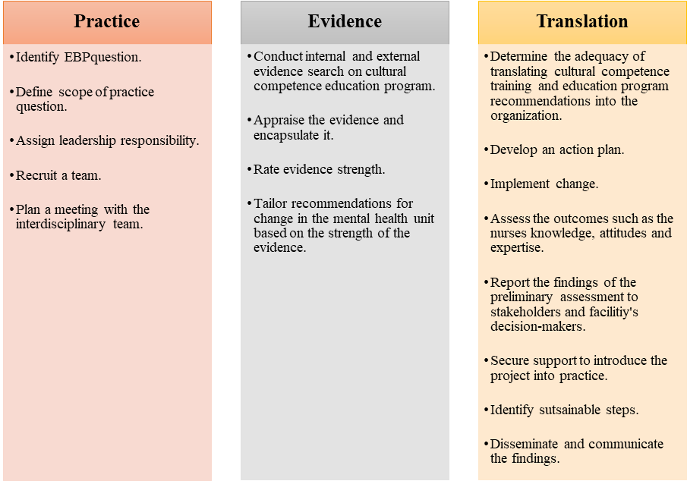

Figure 2

G*Power Analysis
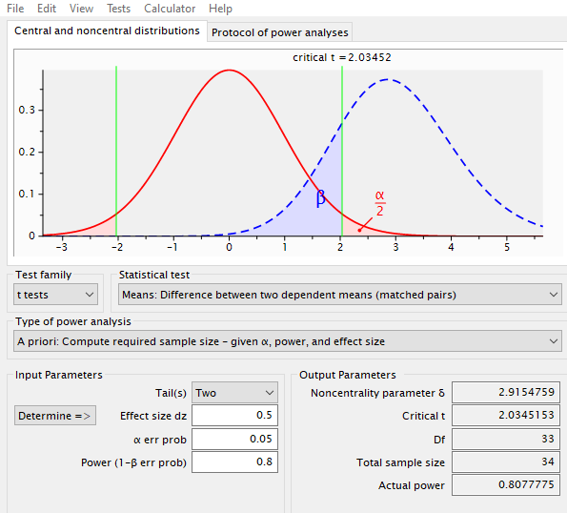

Appendices

Appendix A

Leininger's Sunrise Model
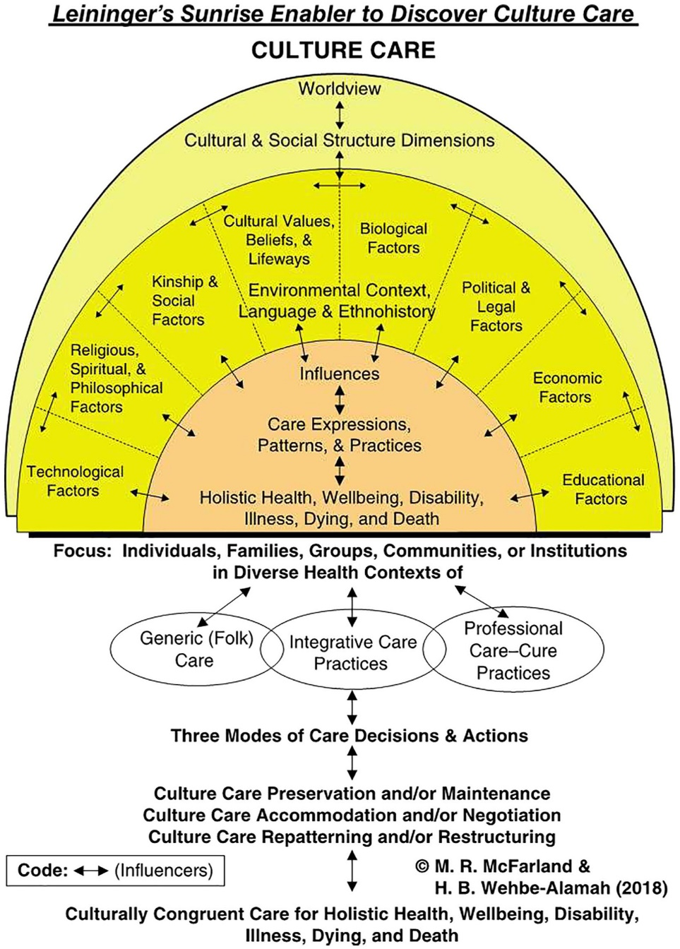

Appendix B

Permission for Use of Leininger's Sunrise Model
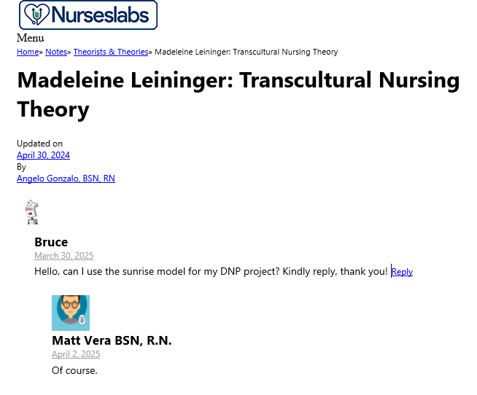

Appendix C

JHNEBP Model
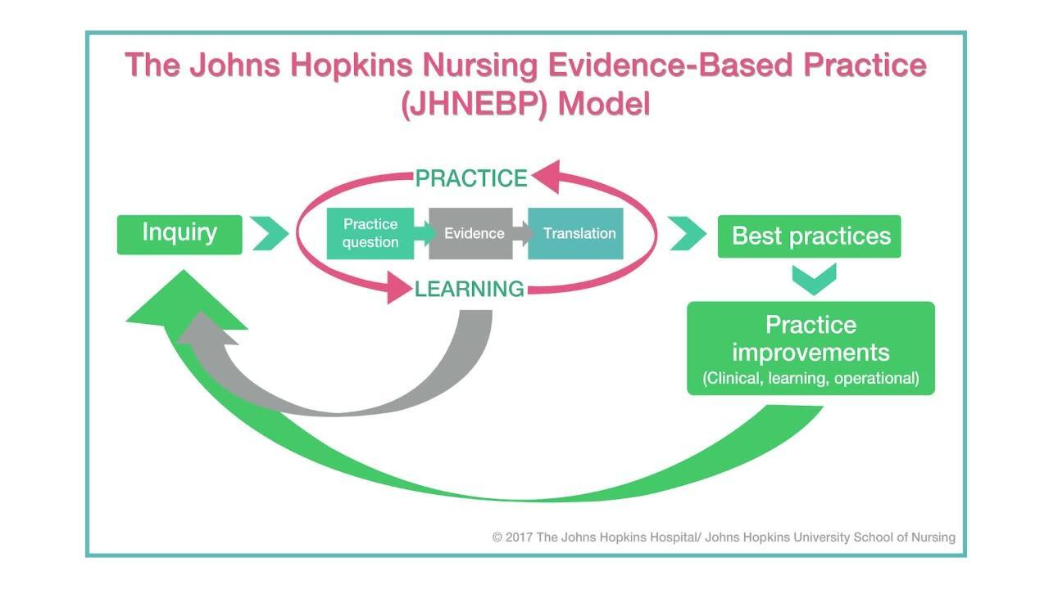

Appendix D

Permission for the use of the JHNEBP Model
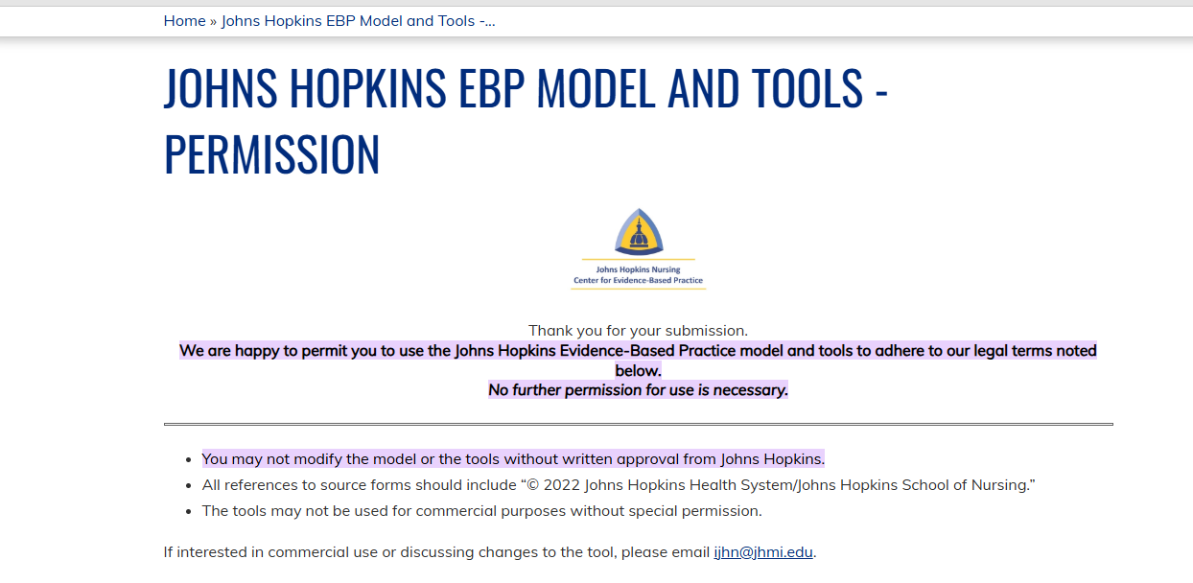

Appendix E

Invitation to Participate

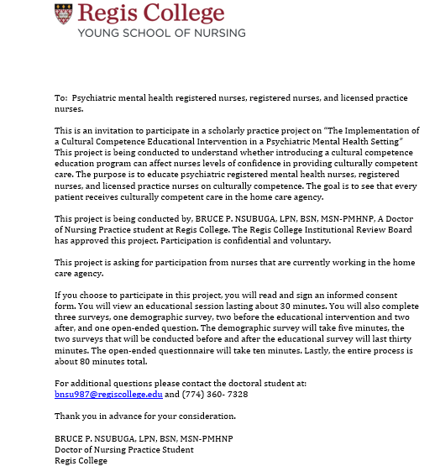

Appendix F

Demographic Survey
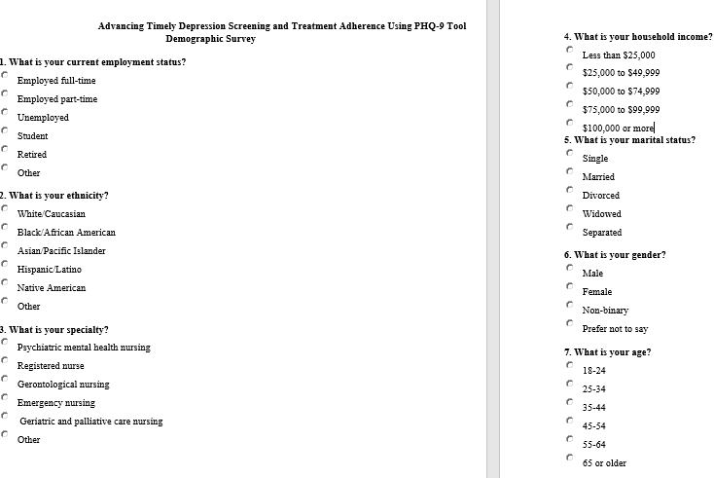

Appendix G

Instrument #1
Central Vancouver Island Multicultural Society Cultural Competence
Self-Assessment Checklist

This self-assessment tool is designed to explore individual cultural competence. This tool allows us to obtain your input on the training series entitled “Culturally Relevant Programs for Probation” which will enable us to tailor this training series to fit your needs. This training supports the Enhanced Outcome-Based Supervision (EBOS) model by helping to enrich interactions with diverse populations. The checklist looks at your general skills, knowledge, and awareness pertaining to culture in the world around you—not necessarily specific to your role in supervision. It is important for us to understand your history and experiences pertaining to people with different cultural backgrounds so please answer these questions honesty. All responses are anonymous.
Please note the term ‘culture’ includes race, ethnicity and ancestry, but also the culture (e.g. beliefs, common experiences and ways of being in the world) shared by people with characteristics in common. It’s important to consider that many of the interpersonal skills you’ve developed during your lifetime through your interactions with people from differing cultural backgrounds are transferable and can be applied across various settings.
Directions: Read each entry and place a check mark in the appropriate column that best represents your opinion.

Awareness | Statement | Never | Sometime/occasionally | Fairly often/pretty well | Always/very well
Value Diversity | I view difference as positive and a reason to celebrate.
Know myself | I have a clear sense of my own ethnic, cultural and racial identity.
Share my culture | I am aware that in order to learn more about others I need to understand and be prepared to share my own culture.
Be aware of areas of discomfort | I am aware of my discomfort when I encounter differences in race, color, religion, sexual orientation, language, and ethnicity.
Check my assumptions | I am aware of the assumptions that I hold about people of cultures different from my own.
Challenge my stereotypes | I am aware of my stereotypes as they arise and have developed personal strategies for reducing the harm they cause.
Reflect on how my culture informs my judgement | I am aware of how my cultural perspective influences my judgment about what are ‘appropriate’, ‘normal’, or ‘admirable’ behaviors, values, and communication styles.
Accept ambiguity | I accept that in cross-cultural situations, there can be uncertainty, and that can cause uneasiness.
 | I take the time needed to get more information in cross-cultural situations.
Be curious | I take any opportunity to put myself in places where I can learn about difference and create relationships.
Aware of racial privilege | I am aware that having “racial privilege” means one’s race does not create barriers to goal attainment or justice.
 | Those who are perceived as having racial privilege may also be perceived as having certain advantages and benefits when compared to those who are perceived as not having racial privilege.
 |  | 1 pt x | 2 pt x | 3 pt x | 4 pt x

Knowledge |  | Never | Sometime/occasionally | Fairly often/pretty well | Always/  very well
Gain from my mistakes | I will make mistakes and will learn from them.
Assess the limits of my knowledge | I recognize that my knowledge of certain cultural groups is limited and will commit to creating opportunities to learn more.
Ask questions | I will really listen to the answers before asking another question.
Acknowledge the importance of difference | If I am working with a person of a different culture, ethnicity, etc. I understand that I may be perceived as a person with different degrees of power or privilege, and that I may not be seen as ‘unbiased’ or as an ally.
Know the historical experiences of non-European Americans | I am knowledgeable about historical incidents in America’s past that demonstrate racism and exclusion towards Americans of non-European heritage (e.g. the Japanese internment, slavery, Jim Crow, Islamophobia…).
Understand the influence culture can have | I recognize that cultures change over time and can vary from person to person, as does attachment to culture.
Commit to life-long learning | I recognize that achieving cultural competence involves a commitment to learning over a life-time.
Understand the impact of racism, sexism, homophobia | I recognize that stereotypical attitudes and discriminatory actions can dehumanize and even encourage violence against individuals because of their membership in groups which are different from myself.
Know my own family history | I know my family’s story of immigration and assimilation into America.
Know my limitations | I continue to develop my capacity for assessing areas where there are gaps in my knowledge of other cultures.
 |  |  | 2 pt x | 3 pt x | 4 pt x

Skills | Statement | Never | Sometime/occasionally | Fairly often/pretty well | Always/  very well
Adapt to different situations | I am developing ways to interact respectfully and effectively with individuals and groups.
Challenge discriminatory and/or racist behavior | I can effectively intervene when I observe others behaving in a racist and/or discriminatory manner.
Communicate across cultures | I am able to adapt my communication style to effectively interact with people who speak in ways that are different from my own.
Seek out situations to expand my skills | I seek out people who challenge me to maintain and increase the cross-cultural skills I have.
Become engaged | I am actively involved in initiatives, big or small, that promote understanding among members of diverse groups.
Act respectfully in cross-cultural situations | I act in ways that demonstrate respect for the culture and beliefs of others.
Practice cultural protocols | I am learning about and put into practice the specific policies and procedures related to culture which are necessary for my work.
Act as an ally | My colleagues who are of a different ethnicity than I am consider me to be an ally and know that I will support them in culturally appropriate ways.
Be flexible | I work hard to understand the perspectives of others and consult with my diverse colleagues about culturally respectful and appropriate courses of action.
Be adaptive | I know and use a variety of relationship building skills to create connections with people who are different from me.
 |  | 1 pt x | 2 pt x | 3 pt x | 4 pt x

Appendix H

Permission for Use of the Cultural Competence Checklist
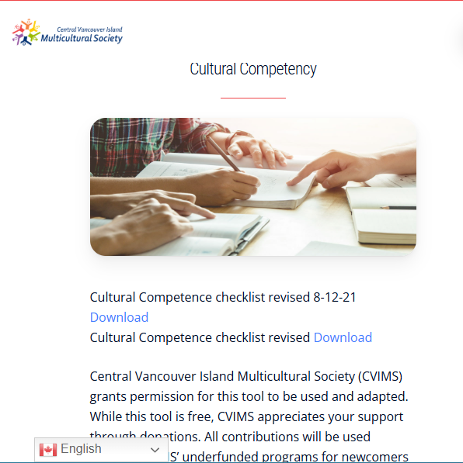

Appendix I-Instrument #2

Confidence Scale (C-Scale)
Directions: Circle the number which best describes how you perceive your current ability to perform strategies to become competent in Cultural Competence while practicing as a nurse.

(NOTE: Make sure that the circle encloses just ONE number.)

1. I am certain that my performance is correct:

1 |  | 2 |  | 3 |  | 4 |  | 5
not at all certain |  | certain for only a few steps |  | fairly certain for a good number of steps |  | certain for almost all steps |  | absolutely certain for all steps
2. I feel that I perform the task without hesitation:

1 |  | 2 |  | 3 |  | 4 |  | 5
I have much hesitation |  | a fair amount of hesitation |  | a good part of it without hesitation |  | almost completely without hesitation |  | absolutely no hesitation
3. My performance would convince an observer that I'm competent at this task:

1 |  | 2 |  | 3 |  | 4 |  | 5
not at all |  | agree, a little |  | for much of it |  | for almost all of it |  | for absolutely all of it
4. I feel sure of myself as I perform the task:

1 |  | 2 |  | 3 |  | 4 |  | 5
not at all |  | very little |  | for much of it |  | for almost all of it |  | for absolutely all of it
5. I feel satisfied with my performance:

1 |  | 2 |  | 3 |  | 4 |  | 5
not at all |  | very little |  | for much of it |  | for almost all of it |  | absolutely satisfied with all of it

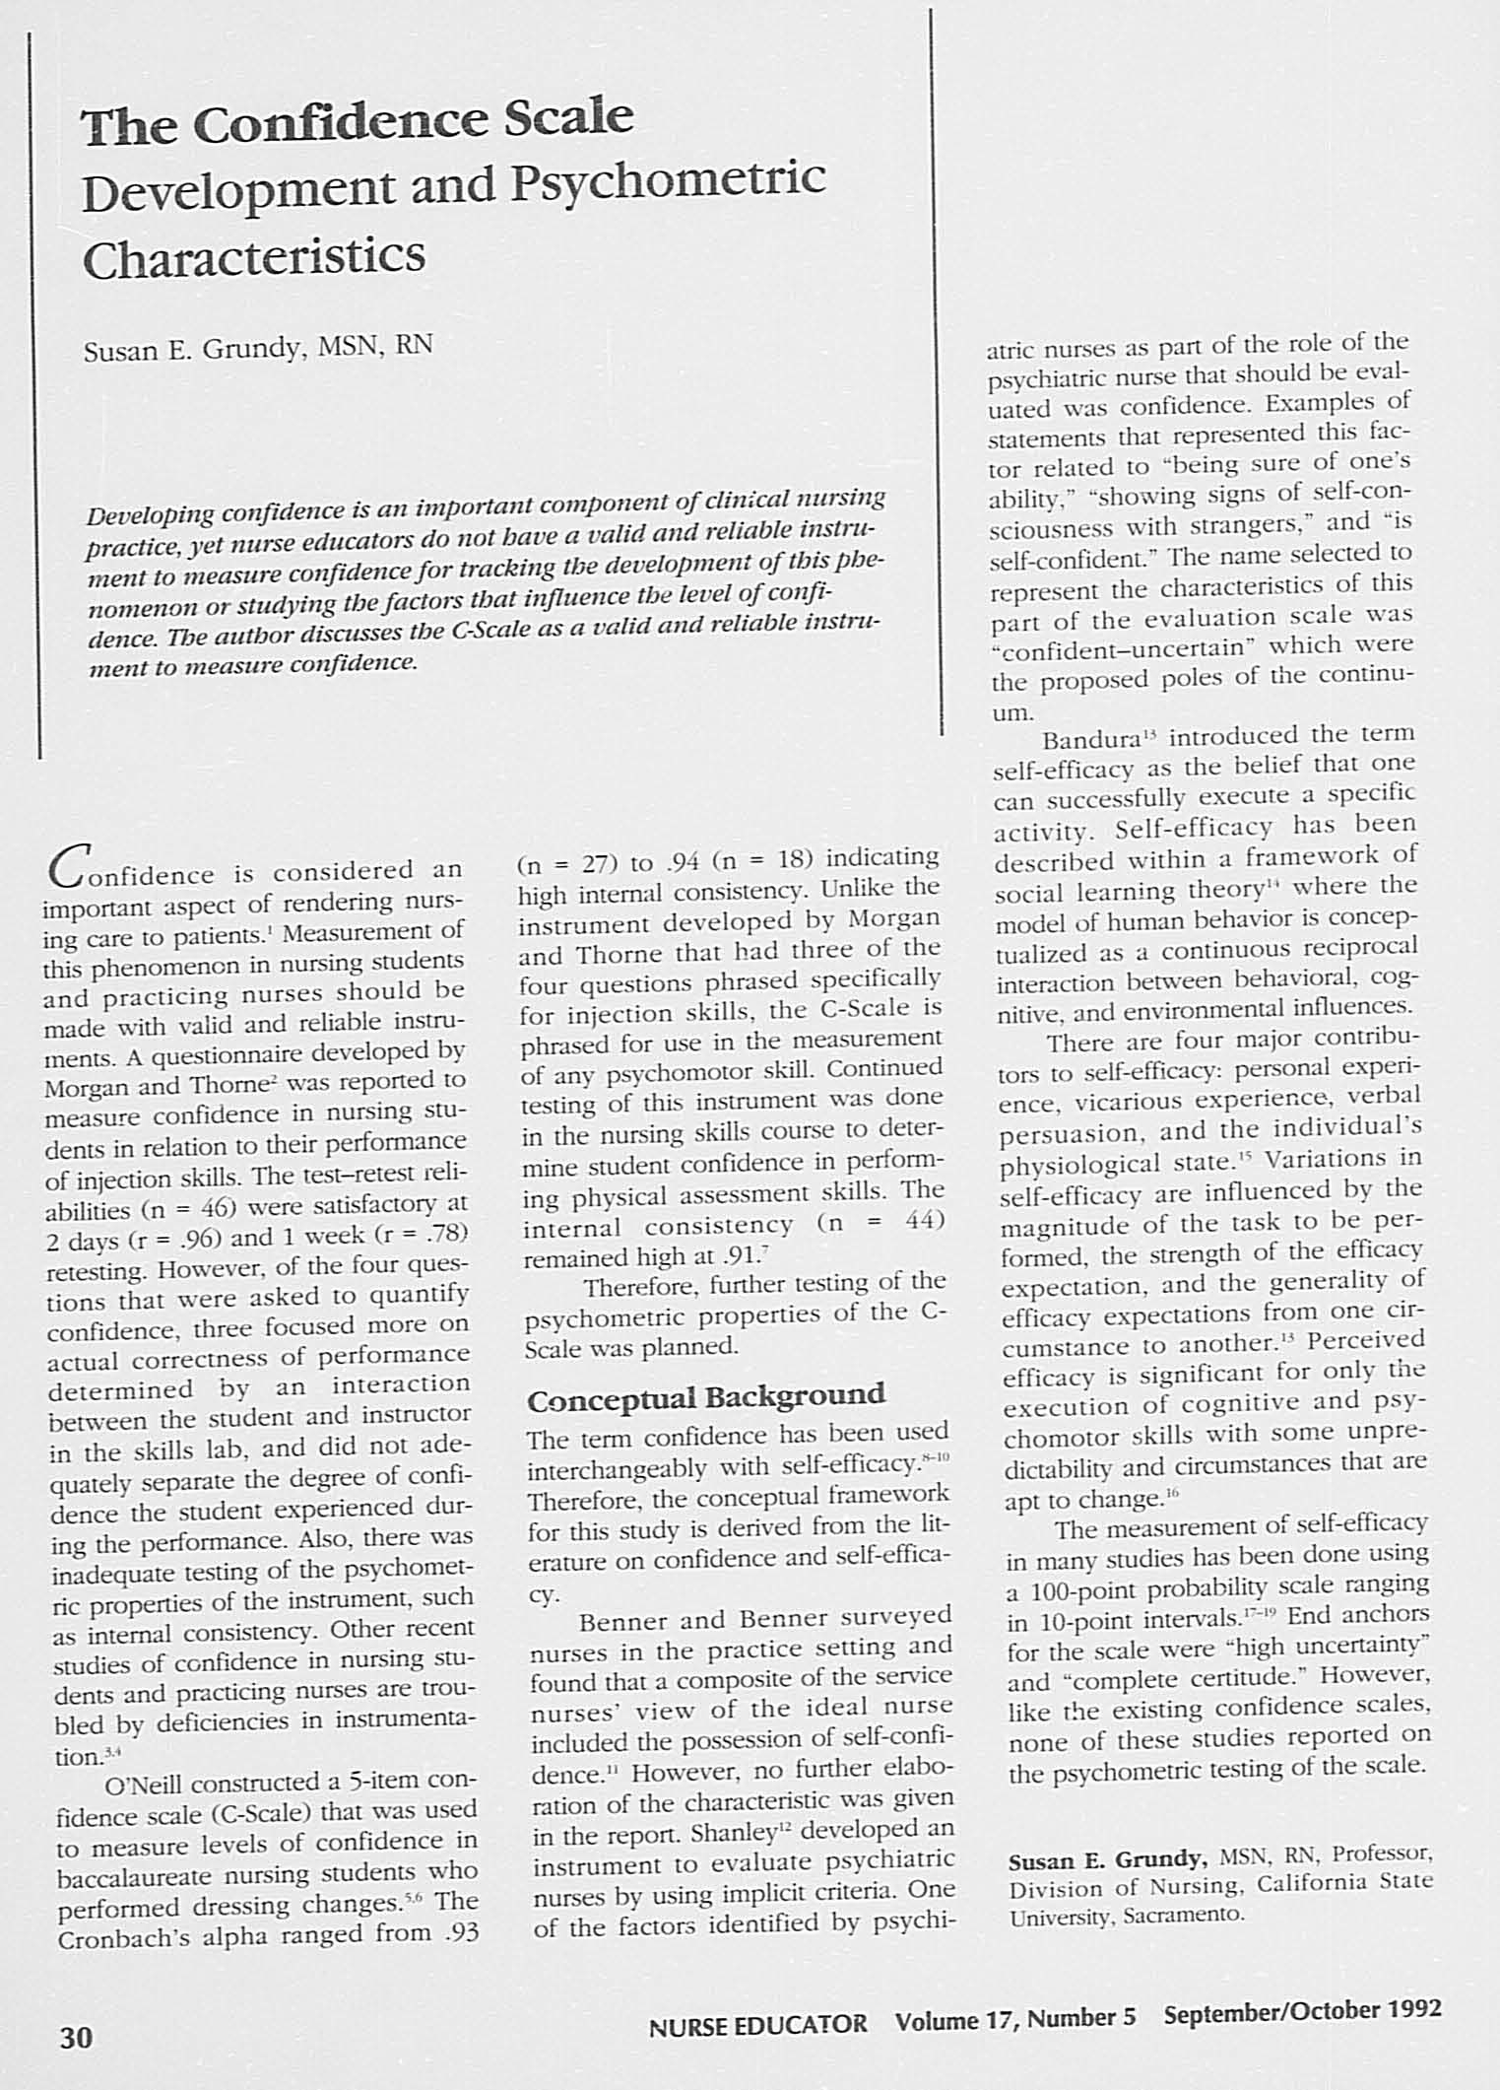

Appendix J

Permission for Use of the Confidence Scale
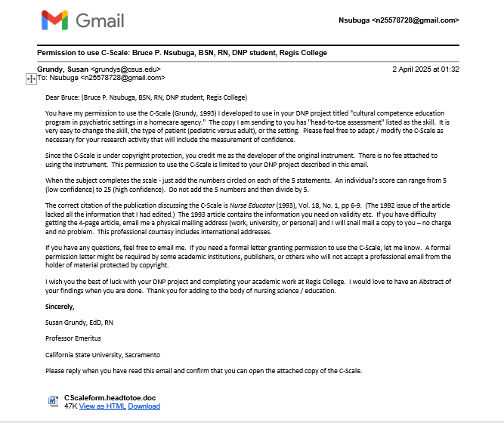

Appendix K

Open-Ended Questions
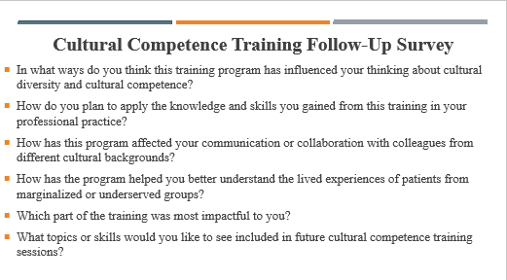

Appendix L

Educational Intervention Slides, Expert YouTube Links, Additional Resources, and Case Study
Educational Intervention Slides
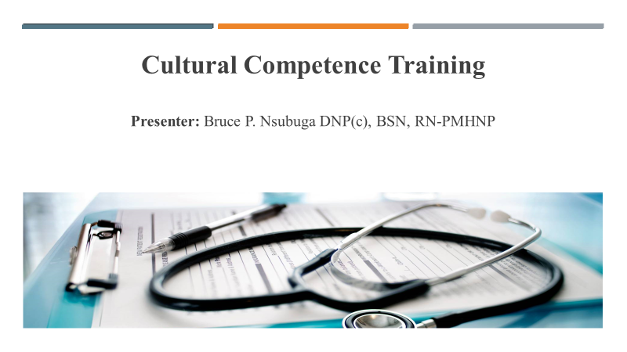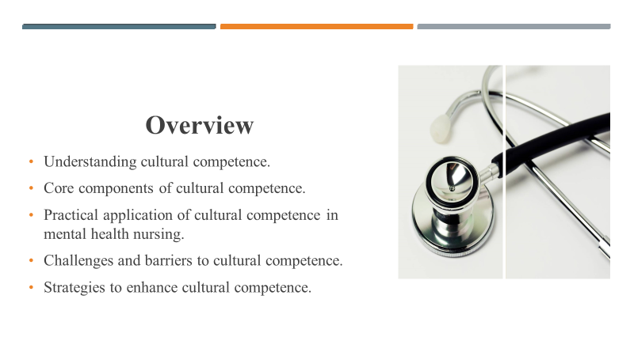
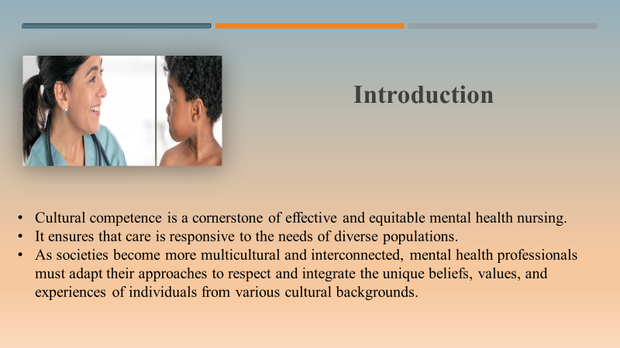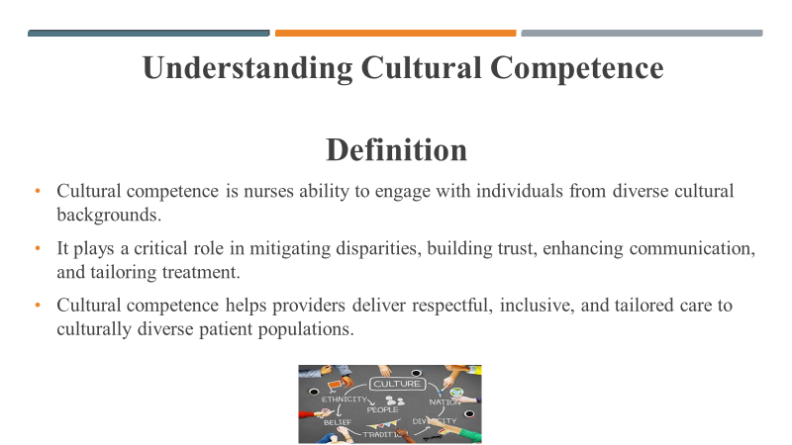
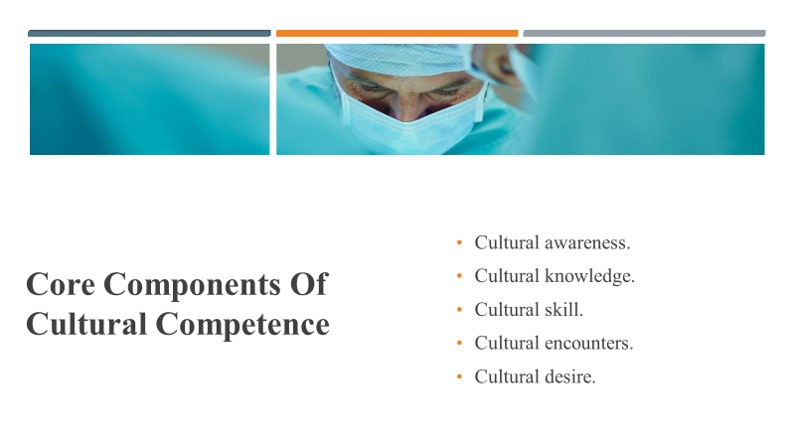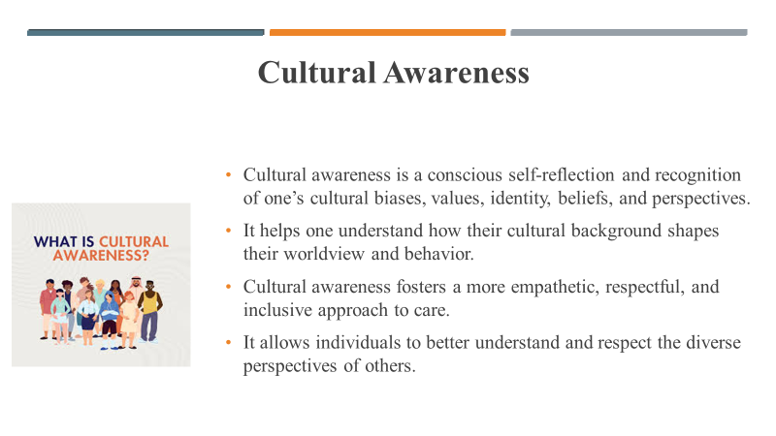

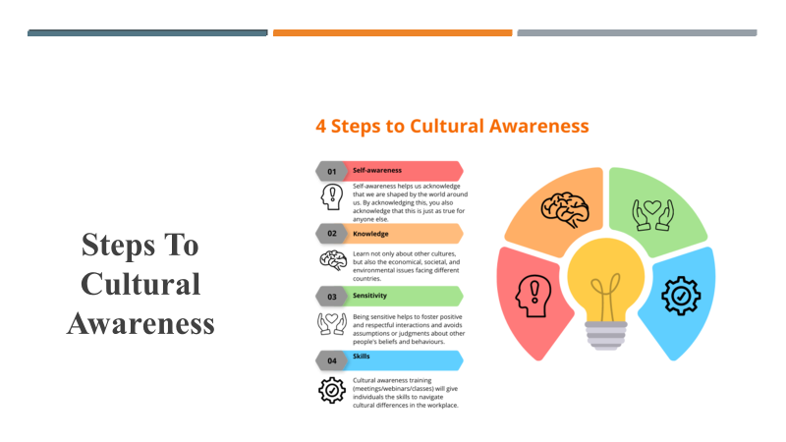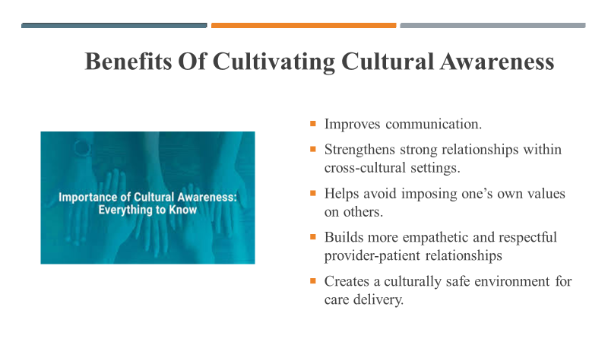
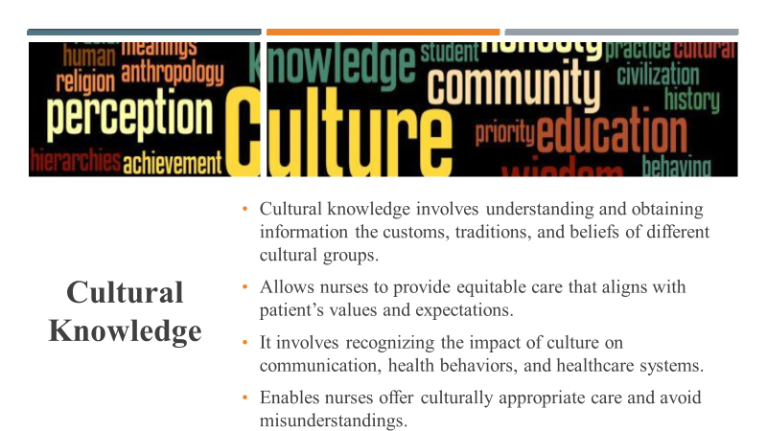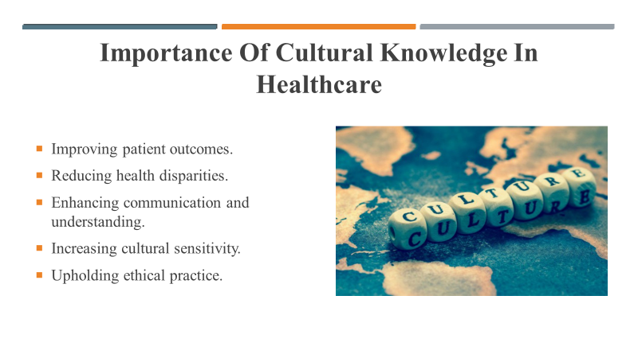
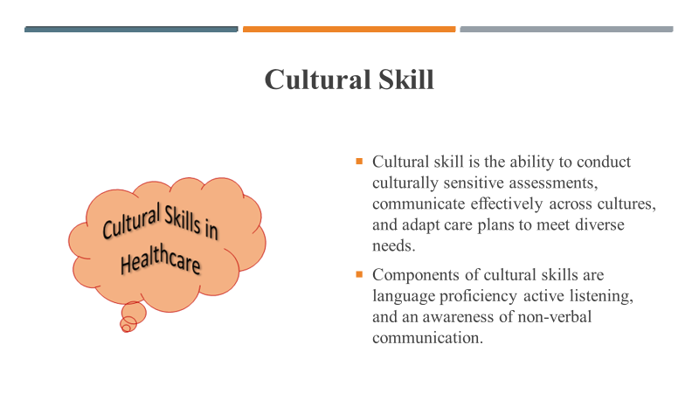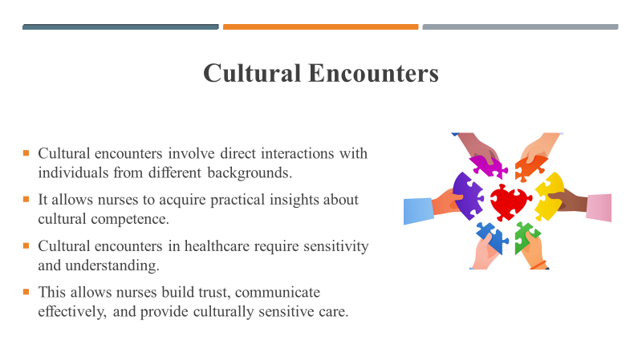
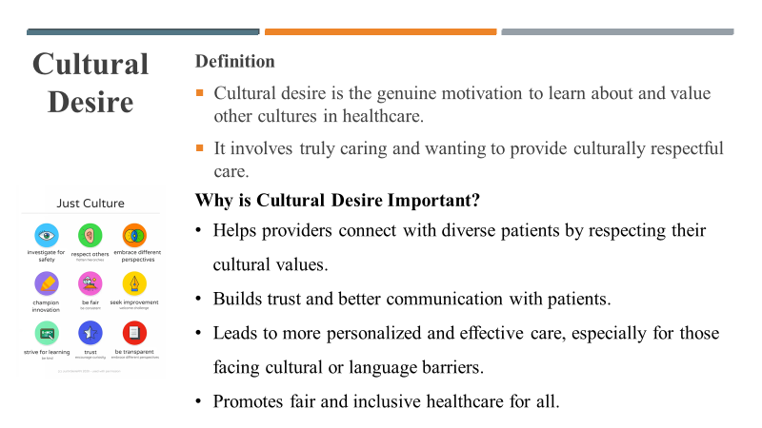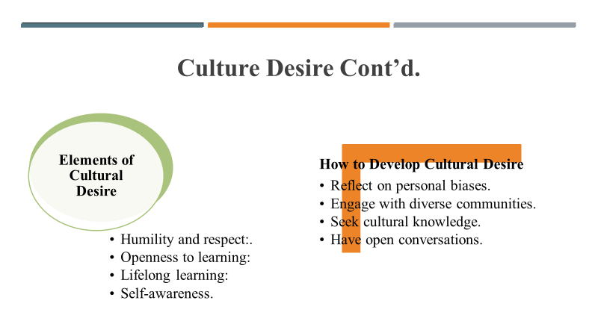
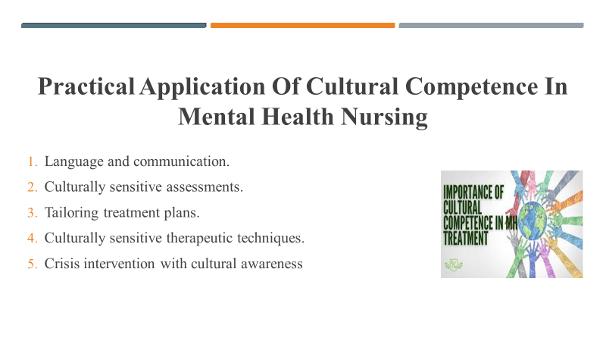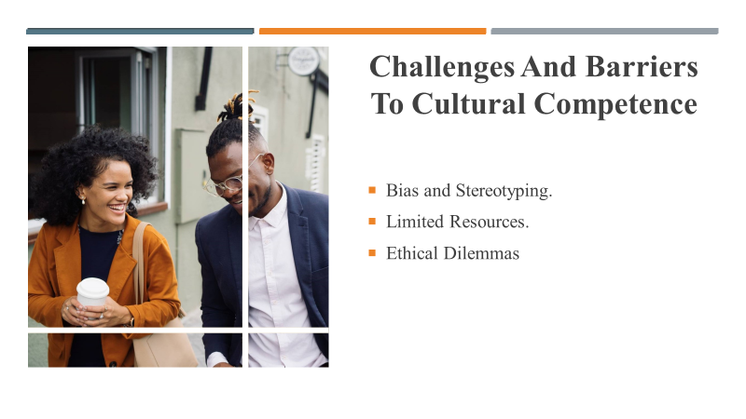
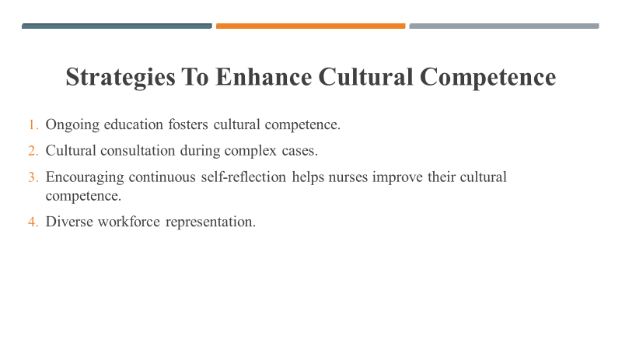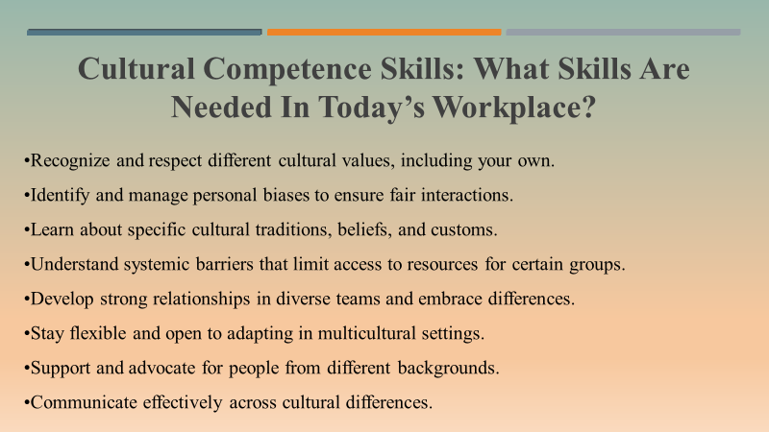
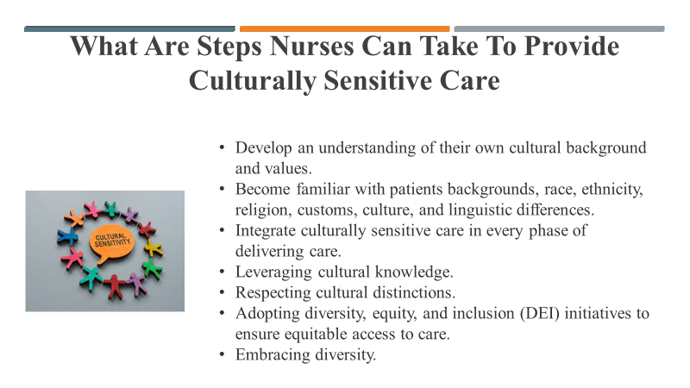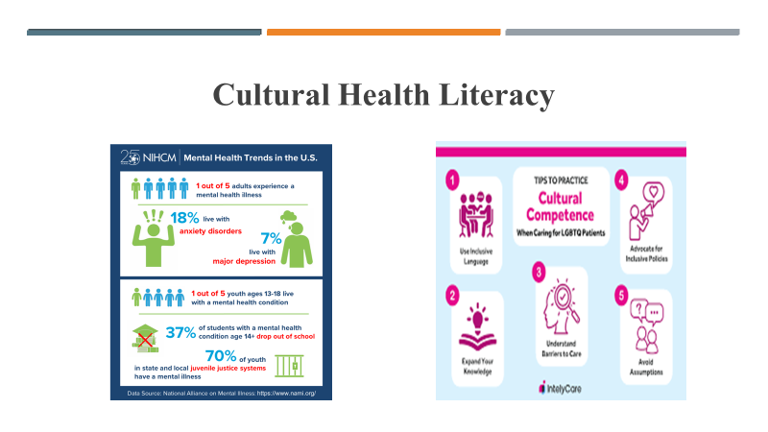
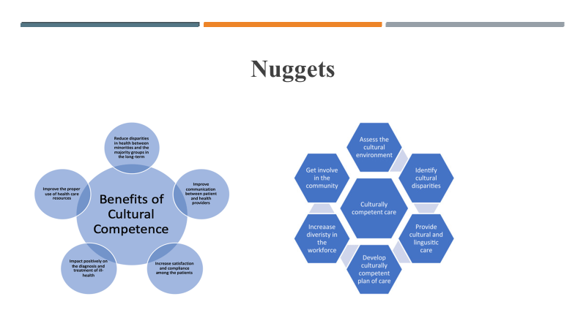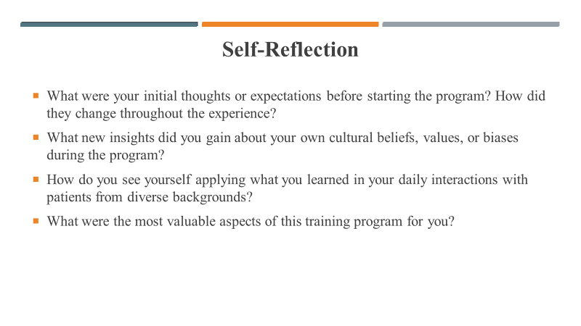
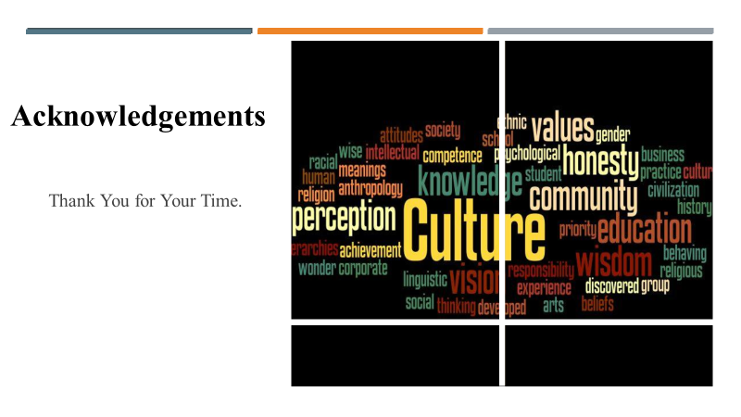

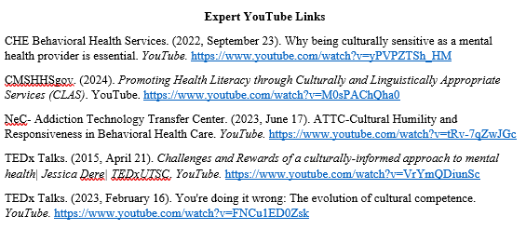

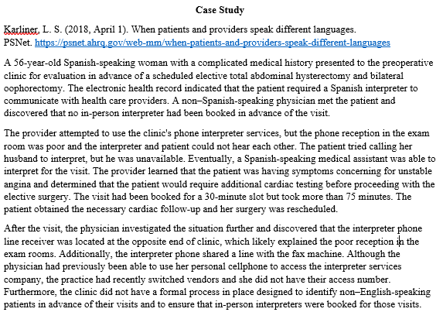

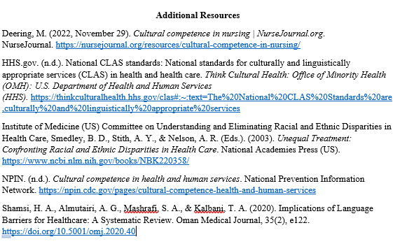

Appendix M

External Site Permission
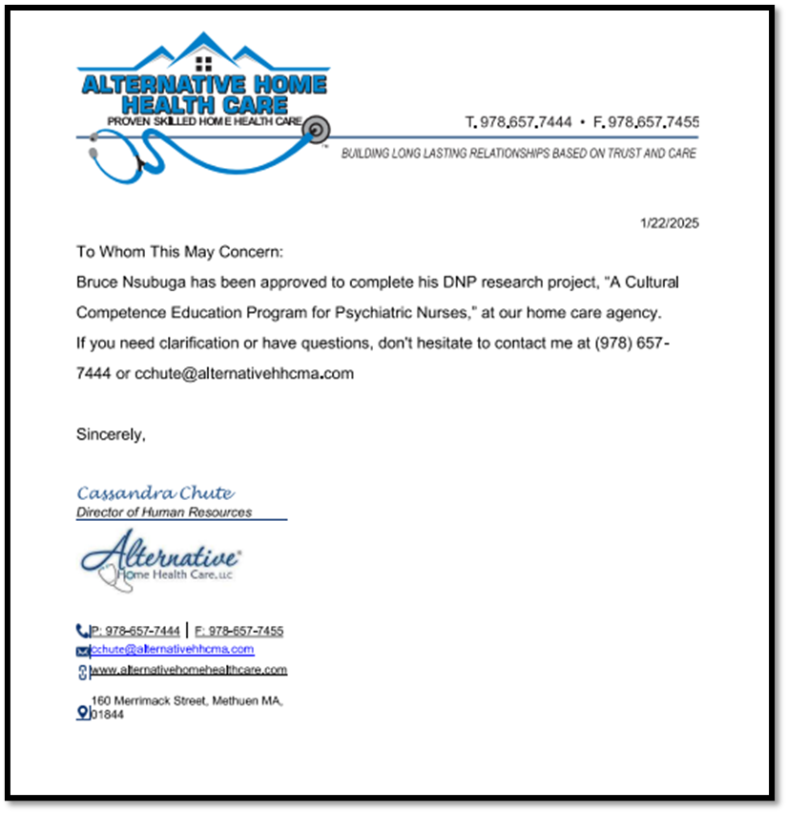

Appendix N

PI and Project Chair CITI Training Certificates
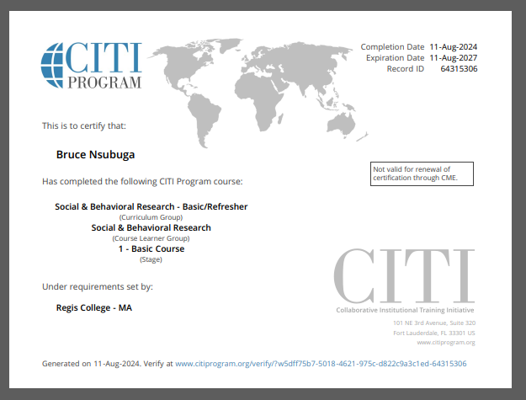
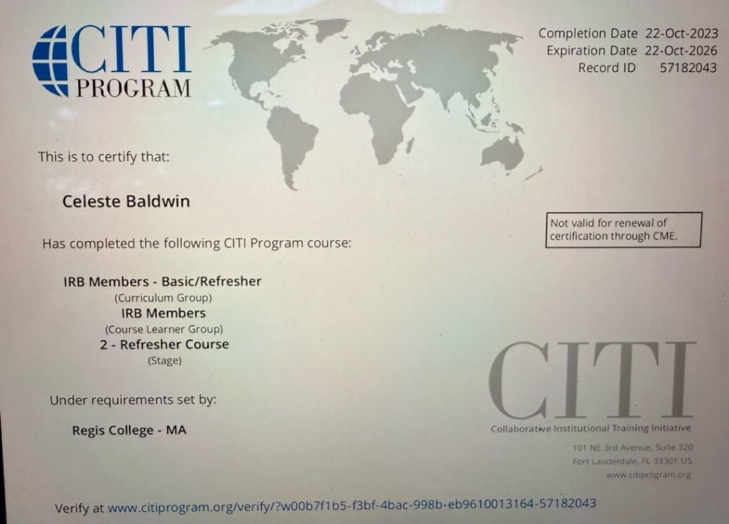

Appendix O

Primary Investigator Resume
BRUCE P. NSUBUGA, DNP(c), MSN, RN
19th Rhodes ST
Billerica, MA 01821
(774) 360- 7328
bnsu987@regiscollege.edu
Profile |  |  | As a highly proficient DNP(c), MSN,RN with over 17 years of nursing expérience, I specialize in delivering bespoke, evidence-based mental health care to clients. I am committed to delivering top-notch patient care through effective education and counseling. I have proven leadership expertise focused on increasing and enhancing patient care and satisfaction. With a strong background in leadership, I specialize in implementing streamlined safety protocols and enhancing the overall quality of care.
KEY SKILLS AND COMPETENCIES |  |  | - Adept supervisory expertise  - Excellent in impeccable communication, and problem-solving skills  - Possess sturdy verbal and written communication skills  - Compassion  - Proficient in cultural awareness  - Provides camaraderie and emotional support  - Patient-focused care  - Competent in recording patients’ vital signs  - Direct patient care expertise  - Proficient at conducting comprehensive patient assessments  - Skillfully manages medical records  - Tube feeding and medications familiarity  - Skilled at wound care  - Possess a gamut of dementia and Alzheimer’s knowledge
EDUCATION |  |  | Doctor of Nursing Practice, Jan 2023 - Current  - Regis College, Weston, MA  Master of Science Psychiatric Mental Health Nurse Practitioner (PMHNP), Jan 2021 – Jan 2023  - Regis College, Weston, MA  Bachelor of Science (BSN), Jan 2008 – Jan 2012  - Salem State University, – Salem, MA.  Licensed Practical Nurse Certificate (LPN: Nursing), Jan 2003 – Jan 2004  - St. Joseph School of Nursing – Nashua, NH  Associate of Arts: Liberal Arts and General Studies, June 2002 – September 2009  - Mass Bay Community College – Wellesley, MA
WORK EXPERIENCE |  |  | Tewksbury State Hospital, Mental Health, Tewksbury, MA, Psychiatric Mental Health Nurse Practitioner (PMHNP), 2018-01 – Current  Roles and Responsibilities  - Participates in continuous improvement by generating suggestions, engaging in problem-solving activities to support teamwork  - Performs frequent, ongoing assessments of patient's status  - Reviews post-operative orders and continuously monitors patients’ post-operative vitals.  - Delivers top-tier quality care to diverse populations while overseeing patient admission and triaging based on acuity and appropriate department admission  - Responsible for administering medications and treatment to patients and monitoring their responses while working with healthcare teams to adjust care plans  - Facilitates therapeutic communication, conflict resolution, and crisis intervention  - Complies with HIPAA laws and prevents information breaches effectively  - Updates patient charts on the EHR with data to keep records current and support accurate treatments  - Observe and document patient factors to understand conditions and actively modify treatment plans  - Recommend patients referrals to different specialists  - Reports findings to the quality department after conducting routine restraint audits  - Assesses patients’ physical and mental status by analyzing complaints and symptoms  - Educates patients and family members about medical conditions and mental health medications, treatment, and preventive measures  - Develops a treatment plan for mental health problems and psychiatric disorders based on evidence-based standards of care, biopsychosocial theories, and current practice guidelines.  - Crisis intervention.  - Perform intake screenings, initial evaluation, and triage.  - Work collaboratively with interdisciplinary teams.  Alternative Home Care Services, Methuen MA, Registered Nurse (Mental Health), 2012-01 – Current  Roles and Responsibilities  - Responsible for assessing patients’ physical and mental status  - Educating patients and family members about medical conditions  - Evaluating, ordering, and interpreting diagnostic tests to assess and identify patients’ conditions  - Performs frequent, ongoing assessment of patients’ status to address changes or any abnormal changes  - Reviews post-operative orders and continuously monitors patients’ post-operative vitals  - Leverages feedback and process improvement opportunities to create a safer and healthier environment and increase patient satisfaction  - Administers medications and treatment to patients  - Adheres to all personal and health data procedures to effectively comply with HIPAA laws  - Updates patient charts using [software]  - Partners with other healthcare providers to develop and implement individualized care plans and document all patient interactions and interventions in electronic charting systems  - Uses first-hand knowledge and clinical expertise to advocate for patients under care and enact prescribed treatment strategies  - Performs and documents a comprehensive psychiatric evaluation that includes evaluation of mental status, current and past history of violence, suicidal or self-harm behavior, substance use, level of functioning, health behaviors, trauma, sexual behaviors, and social and developmental history  - Develops a treatment plan for mental health problems and psychiatric disorders based on evidence-based standards of care, biopsychosocial theories, and current practice guidelines  - Manages patients recovering from medical or surgical procedures  - Provide patients and their families information regarding the benefits and risk of various medications  - Provide consultative psychiatric evaluations and recommendations within the continuum of mental health care  - Develop rapport and trust with patients and their families by using therapeutic communication techniques  Hospice, Danvers, MA, Registered Nurse (Hospice), 2012-01 – Current  Roles and Responsibilities  - Admissions and gathering patients’ history  - Confers with physicians to discuss diagnoses and devise well-coordinated treatment approaches  - Establishing hospice care services for elderly and disabled patients  - Building rapport with patients, families, and physicians by utilizing exemplary communication and active listening  - Provides high-level quality, compassionate care to patients and caregivers during each nursing shift  - Responsible for medication and iv administration, catheter insertion, and airway management  - Reports patients’ status and delegates nurse assignments to achieve optimal outcomes  - Monitoring patient vital signs.  - Appraising clients’ comfort levels  - Acknowledging mechanisms to personalize care  - Offering physical, emotional, and mental support to patients and their families  - Educates family members and caregivers on patient care instructions  - Provides holistic hospice health care
LICENSURE |  |  | - Registered Nurse (BSN-RN), 2012  - Licensed Practice Nurse since 2004
CERTIFICATIONS |  |  | - Phlebotomy  - First aid and CPR  - Palliative care certificate  - Occupational Safety and Health Administration (OSHA) certificate  - Dementia training  - IV start certified.  - CITI training certificate
PROFESSIONAL AFFILIATIONS |  |  | - Sigma Theta Tau International Honor Society of Nursing: Member of Pi Epsilon at-Large Chapter Emmanuel College, Laboure College of Health Care, Regis College
LANGUAGES |  |  | - English
QUALIFICATIONS |  |  | - Admissions.  - Care plan development.  - Precepting.  - Chronic care management.  - Pleura drain care.  - Supervising staff.  - Implementing physician orders.  - Discharge teaching and planning.  - End of life care.  - Emergency response and management.  - Mechanical ventilators.  - IV access of peripheral line infusion.  - Management of peripheral lines, midlines, and PICC lines.  - Wound care.  - Medication administration, management, and documentation.  - Serving as a patient or family advocate.

Appendix P-Flesch-Kincaid Grade Level for Informed Consent
Flesch-Kincaid Grade Level Score
8.0
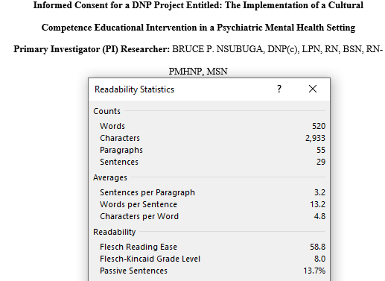

Appendix Q

Informed Consent
Informed Consent for a DNP Project Entitled: The Implementation of a Cultural Competence Educational Intervention in a Psychiatric Mental Health Setting

Primary Investigator (PI) Researcher: BRUCE P. NSUBUGA, DNP(c), MSN, RN
Introduction
Please read this form carefully. The PI is inviting you to participate in a DNP project. This project will provide training on cultural competency. The PI selected you because you work directly with patients suffering from mental health issues, specialize in psychiatric mental health nursing, and are a registered nurse (RN) or licensed practical nurse (LPN). You cannot take part if you are not an RN or LPN and do not work at the AHHC psychiatric agency
Purpose of the Project
The purpose of this project is to train you on cultural competence to elevate your levels of cultural competence. The PI will collect quantitative and demographic data. Quantitative data will be collected using two instruments before and after the intervention. If you join, you will attend training sessions as shown in the timeline table below.
Items | Title | Length of Time
Consent | Document | 5 minutes
Demographics | Survey | 5 minutes
Pretest I | Confidence scale | 5 minutes
Pretest II | Central Vancouver Island multicultural society cultural competence self-assessment checklist | 10 minutes
Intervention | Educational Module/PowerPoint | 30 minutes
Posttest I | Confidence scale | 5 minutes
Posttest II | Vancouver self-assessment cultural competence checklist | 10 minutes
Open-Ended Questions | Created by DNP Student | 10 minutes
Total Time |  | 80 minutes

Benefits of Being in this Project
You will contribute to the body of knowledge about nurses and cultural competence.
Risks and Discomforts of Participating in this Project
You may experience fatigue and need to set aside time to complete the project. You can take breaks as needed. There are no risks beyond what you might typically experience in daily life.
Payments
You will not be paid for participating in the project.
Cost
Participating is free.
Choosing to Participate and Quit the Project
Participating in this project is voluntary. You do not have to answer any question you do not want to answer. You may choose to withdraw from this project at any time without penalty. If you decide to withdraw from this project, please inform the principal investigator. Your decision will not affect your relationship with Regis or your employer.
Getting Dismissed from the Project
The PI may discharge you from the project if you do not adhere to the project’s guidelines, have a busy schedule, cannot make time, or the PI decides to end the project.
Privacy
The PI will ensure that the information you provide as part of this project remains confidential. Your identity will not be revealed in any reports resulting from this project. No names will be used. The PI and project chair will store your data in a password-protected file. You will not use any identifying data. The PI will destroy the collected data after three years.
Contacts and Questions
If you have any questions, please don't hesitate to ask them now. If you have questions later, you may contact the principal investigator, Bruce Nsubuga, DNP(c), MSN, RN at (774) 360-7328 or bnsu987@regiscollege.edu. If you have questions about your rights, please contact Dr. Colleen, the chair of the Regis Institutional Review Board:
Dr. Colleen C. Malachowski, PhD
781-768-7373
colleen.malachowski@regiscollege.edu
Signature(s)/Date
Participant Printed Name: ___________________________________
Participant Signature: ___________________________________ Date: __________

