Oswego Outbreak Investigation
NOTE: The following resource was prepared for class use by replicating portions of the Centers for Disease Control and Prevention's (CDC), "Oswego - An Outbreak of Gastrointestinal Illness Following a Church Supper: Student Guide" (CDC, n.d.), except for the "Questions" section, with the understanding that the CDC document is in the public domain and available for educational use.
Background:
On April 19, 1940, the local health officer in the village of Lycoming, Oswego County, New York, reported the occurrence of an outbreak of acute gastrointestinal illness to the District Health Officer in Syracuse. Dr. A. M. Rubin, epidemiologist-in-training, was assigned to conduct an investigation. When Dr. Rubin arrived in the field, he learned from the health officer that all persons known to be ill had attended a church supper held on the previous evening, April 18. Family members who did not attend the church supper did not become ill. Accordingly, Dr. Rubin focused the investigation on the supper. He completed interviews with 75 of the 80 persons known to have attended, collecting information about the occurrence and time of onset of symptoms, and foods consumed. Of the 75 persons interviewed, 46 persons reported gastrointestinal illness.
Clinical Description:
The onset of illness in all cases was acute, characterized chiefly by nausea, vomiting, diarrhea, and abdominal pain. None of the ill persons reported having an elevated temperature; all recovered within 24 to 30 hours. Approximately 20% of the ill persons visited physicians. No fecal specimens were obtained for bacteriologic examination.
Description of the Supper:
The supper was held in the basement of the village church. Foods were contributed by numerous members of the congregation. The supper began at 6:00 p.m. and continued until 11:00 p.m. Food was spread out on a table and consumed over a period of several hours. Data regarding onset of illness and food eaten or water drunk by each of the 75 persons interviewed [are provided in the Excel "Oswego Line Listing Workbook" (CDC, n.d.)]. The approximate time of eating supper was collected for only about half the persons who had gastrointestinal illness.
Conclusion:
The following is quoted verbatim from the report prepared by Dr. Rubin:
The ice cream was prepared by the Petrie sisters as follows:
On the afternoon of April 17 raw milk from the Petrie farm at Lycoming was brought to boil over a water bath, sugar and eggs were then added and a little flour to add body to the mix. The chocolate and vanilla ice cream were prepared separately. Hershey's chocolate was necessarily added to the chocolate mix. At 6 p.m. the two mixes were taken in covered containers to the church basement and allowed to stand overnight. They were presumably not touched by anyone during this period.
On the morning of April 18, Mr. Coe added five ounces of vanilla and two cans of condensed milk to the vanilla mix, and three ounces of vanilla and one can of condensed milk to the chocolate mix. Then the vanilla ice cream was transferred to a freezing can and placed in an electrical freezer for 20 minutes, after which the vanilla ice cream was removed from the freezer can and packed into another can which had been previously washed with boiling water. Then the chocolate mix was put into the freezer can which had been rinsed out with tap water and allowed to freeze for 20 minutes. At the conclusion of this both cans were covered and placed in large wooden receptacles which were packed with ice. As noted, the chocolate ice cream remained in the one freezer can.
All handlers of the ice cream were examined. No external lesions or upper respiratory infections were noted. Nose and throat cultures were taken from two individuals who prepared the ice cream.
Bacteriological examinations were made by the Division of Laboratories and Research, Albany, on both ice creams. Their report is as follows: "Large numbers of Staphylococcus aureus and albus were found in the specimen of vanilla ice cream. Only a few staphylococci were demonstrated in the chocolate ice cream."
Report of the nose and throat cultures of the Petries who prepared the ice cream read as follows: "Staphylococcus aureus and hemolytic streptococci were isolated from nose culture and Staphylococcus albus from throat culture of Grace Petrie. Staphylococcus albus was isolated from the nose culture of Marian Petrie. The hemolytic streptococci were not of the type usually associated with infections in man."
Discussion as to Source: The source of bacterial contamination of the vanilla ice cream is not clear. Whatever the method of the introduction of the staphylococci, it appears reasonable to assume it must have occurred between the evening of April 17 and the morning of April 18. No reason for contamination peculiar to the vanilla ice cream is known.
In dispensing the ice creams, the same scooper was used. It is therefore not unlikely to assume that some contamination to the chocolate ice cream occurred in this way. This would appear to be the most plausible explanation for the illness in the three individuals who did not eat the vanilla ice cream.
Control Measures: On May 19, all remaining ice cream was condemned. All other food at the church supper had been consumed.
Conclusions: An attack of gastroenteritis occurred following a church supper at Lycoming. The cause of the outbreak was contaminated vanilla ice cream. The method of contamination of ice cream is not clearly understood. Whether the positive Staphylococcus nose and throat cultures occurring in the Petrie family had anything to do with the contamination is a matter of conjecture.
Note: Patient #52 was a child who while watching the freezing procedure was given a dish of vanilla ice cream at 11:00 a.m. on April 18.

Epi Curve
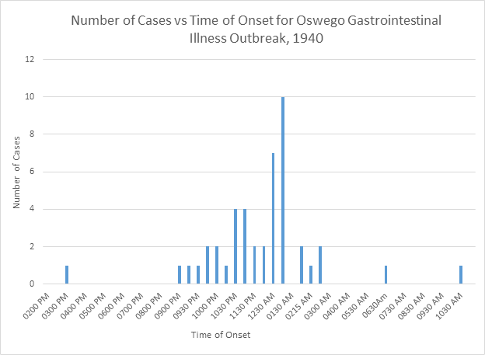

Addendum:
Certain laboratory techniques not available at the time of this investigation might prove very useful in the analysis of a similar epidemic today. These are phage typing, which can be done at CDC, and identification of staphylococcal enterotoxin in food by immunodiffusion or by enzyme-linked immunosorbent assay (ELISA), which is available through the Food and Drug Administration (FDA).
One would expect the phage types of staphylococci isolated from Grace Petrie's nose and the vanilla ice cream and vomitus or stool samples from ill persons associated with the church supper to be identical had she been the source of contamination. Distinctly different phage types would mitigate against her as the source (although differences might be observed as a chance phenomenon of sampling error) and suggest the need for further investigation, such as cultures of others who might have been in contact with the ice cream in preparation or consideration of the possibility that contamination occurred from using a cow with mastitis and that the only milk boiled was that used to prepare chocolate ice cream. If the contaminated food had been heated sufficiently to destroy staphylococcal organisms but not toxin, analysis for toxin (with the addition of urea) would still permit detection of the cause of the epidemic. A Gram stain might also detect the presence of nonviable staphylococci in contaminated food.
Reference
Centers for Disease Control and Prevention. (n.d.). Oswego - An outbreak of gastrointestinal illness following a church supper: Student guide (Case No. 401-303). https://www.cdc.gov/eis/casestudies/xoswego.401-303.student.pdf

