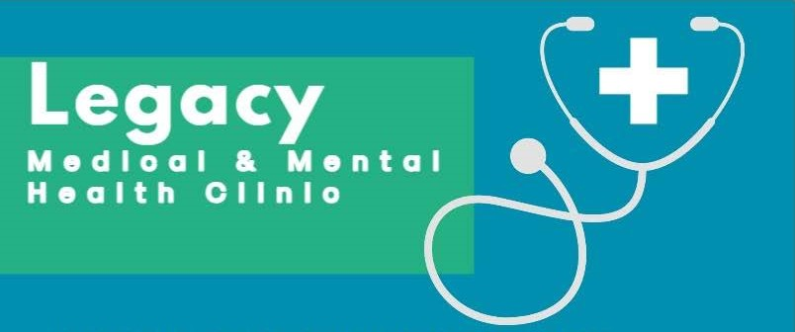
LOOKING FOR PARTICIPANTS
Our clinic is looking for participants for a quality improvement project.
Cognitive Behavioral Therapy (CBT) Study
We are looking for individuals aged 18 or older. who have been diagnosed with depression? to participate in a quality improvement project, focused on evaluating the effectiveness of Cognitive Behavioral Therapy.

Eligibility Requirements
Are 18 years of age. have been diagnosed with depression and are willing to participate in weekly sessions.
Benefits of Participation in

CBT Study
- Receive personalized therapy in 8 weekly FREE 111 sessions from trained professionals
- Learn strategies to manage depression symptoms
- Contribute to advancing mental health research
WE WILL TAKE CARE OF YOUR HEALTH.
"i700 Stamp Road, Suite K Temple Hills, Maryland | 240-547-7966 www.legacymedicalandmental.com

