Re: Week 6 Discussion 1: Technology Assessment
by Gladys Ongori - Monday, 10 February 2025, 9:38 PM
Hello everyone,
DNP projects are often perceived as tedious, from formulating questions or hypotheses to disseminating project findings (Moran et al., 2020). According to the authors, the project design will dictate sample selection, data collection, and analysis methods. The principal investigator (PI) intends to employ a mixed methodology for their project. The PI will distribute a flyer to invite participants. With the support of site mentors and management, the PI aims to increase participant numbers through a snowball sampling approach.
Project implementation will involve data collection, which the Principal Investigator (PI) plans to conduct using Qualtrics, as advised by the project chair. Qualtrics is a robust software platform that consolidates all instruments in a single location, ensuring easy access for participants. In addition to collecting data, this software also securely stores it. This functionality will be accessible throughout the project implementation phase.
Data analysis transforms collected information into meaningful insights that stakeholders can share. Melnyk and Fineout-Overholt (2023) emphasize the importance of the principal investigator (PI) consulting with a statistician to determine the appropriate tests for the project. According to Moran et al. (2020), these tests can be categorized as either parametric or nonparametric. Schroeder et al. (2022) underscore the necessity of collaboration with a statistician, noting that the PI should leverage the statistician's expertise to meet the project's requirements. Last semester, the PI practiced calculating several tests using Intellectus Statistics, a statistical software provided by the school. Although confusing at first, the PI was able to figure it out. The PI will work alongside a statistician for data analysis, which, as highlighted by Schroeder et al. (2022), may entail associated costs. The PI is seeking grant funding to cover the statistician's expenses.

References
Melnyk, B., & Fineout-Overholt, E. (2023). Evidence-based practice in nursing & healthcare: A guide to best practice (5th ed.) Wolters Kluwer
Moran, K., Burson, R., & Conrad, D. (2020). The Doctor of Nursing Practice project: A framework of success. (3rd ed.). Jones and Bartlett Learning
Schroeder, K., Dumenci, L., Sarwer, D. B., Wheeler, D. C., & Hayat, M. J. (2022). Increasing quantitative literacy in nursing: A joint nursing-statistician perspective. Journal of Advanced Nursing, 78(4), e66–e68. https://doi.org/10.1111/jan.15150

Re: Week 6 Discussion 1: Technology Assessment
by Amaris Beeksma - Monday, 10 February 2025, 11:12 PM
For my mixed methods project I will be using both Intellectus Statistics and the Delve Tool. I may end up using Atlas.ti but at this point I have heard the Delve tool is very intuitive and so I would like to try that first. This is data analysis software tool is similar to Atlas.ti where you upload a document and use their quotation analysis to identify themes and subthemes (Dr. USB, 2023). I have already attended one of the open question sessions hosted by Intellectus Statistics and they showed me how to easily buy and schedule an appointment with a statistician on their team. I am excited to see the correlation tests they think will work. I based my participant sample goal on a two tailed t- test finding the difference between two dependent means but there are other tests that check for correlation or significance. Like Vitale and Bradshaw (2021) point out, data visualization is a form of marketing to the audience. The presenter highlights portions of interest in a visually stimulating way which is part of creating an appealing discussion of the data. Utilizing a statistician’s professional help will reveal new aspects of the data and they will be able to give me suggestions on how to map the results in graphs. I do not plan to use a statistician before I collect my data, but I do plan on using one after I collect my data. I am hoping to post my survey link on a Facebook platform but so far, no administrators have responded to my request. I may have to depend on my physical sites for participant recruitment.
References
Bradshaw, M., & Vitale, T. (2021). The DNP project workbook: A step-by-step process for success (1st ed.). Springer.
Delve. (n.d.). Qualitative Data Analysis Software Made Easy. https://delvetool.com/
Dr. USB. (2023). Mastering Qualitative Data Analysis with Atlas. Ti: A step by step model [Video]. Youtube.
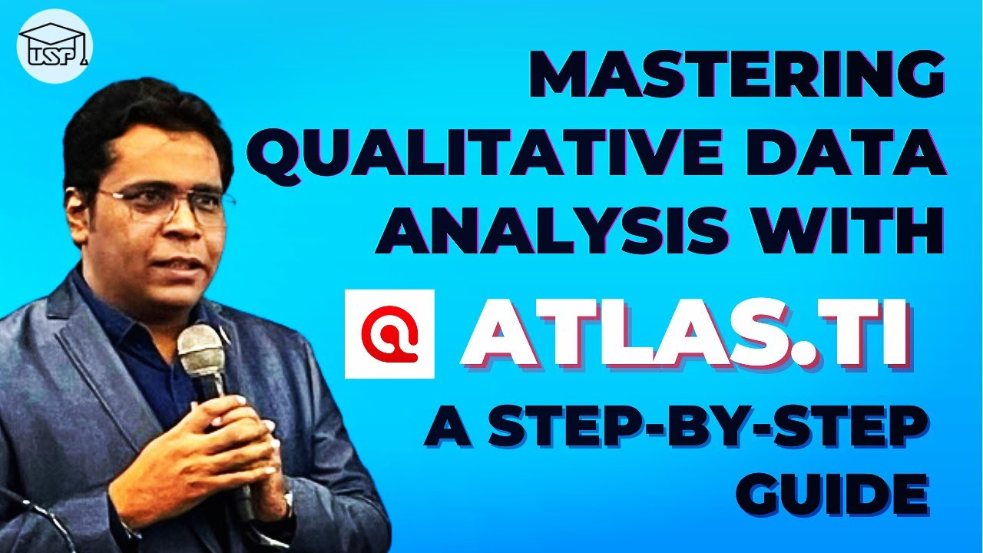
Play Video

