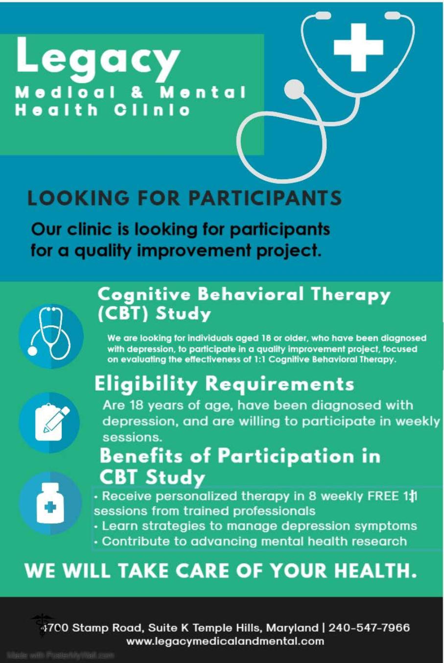

We are looking to recruit individuals aged 18 and older with a confirmed diagnosis of alcohol use disorder, to participate in a quality improvement project about the effectiveness of 1:1 CBT on relapse.
- Receive free personalized 1:1 CBT sessions from experienced professionals.
- Learn strategies of overcoming cravings and response to stimuli
- Advance translation of evidence into practice
Are 18 years of age, have been diagnosed with alcohol use disorder, and are willing to participate in weekly CBT sessions.

