Week 2 NR711 Discussion NR711 EE
Project Scope
Discussion
Purpose
The purpose of this discussion is to explore the scope of the DNP project. Scope is the backbone of any project and must be accurately assessed by the project manager. When issues occur during a project, it is frequently related to the scope. A well-defined goal helps keep everyone on track.

Instructions
Reflect upon your readings and personal or professional experience and address the following:

1,Describe how issues that occur during a project are frequently related to the scope.
2, Examine how poorly defined project scope statements are often linked to project problems or even to failed projects.
3, Propose strategies to manage scope creep.

References you can include
:American Society for Quality. (2021). Quality resources. https://asq.org/quality-resources/articles/search#q=six%20sigma

Dang, D., & Dearholt, S., Bissett, K., Ascenzi, J., Whalen, M. (2022). Johns Hopkins evidence-based practice for nursing and healthcare professionals (4th ed.). Sigma Theta Tau International.

Project Management Institute. (2019). Benefits realization management: A practice guide. Project Management Institute. https://www.pmi.org/pmbok-guide-standards/practice-guides/benefits-realization

WEEK 2 LESSON AS SOME OF YOUR REFERENCE POINTS

Week 2

Lesson 3
Evidence Synthesis Review

Synthesis of Research
As you incorporate published research findings into your writing, you aim to create a synthesis from the multiple studies you gather about a practice problem. Before learning how to write a synthesis, it is important to define this term. At its most basic level, a synthesis involves combining two or more summaries. Synthesis writing is more difficult than it might first appear because this combination must be done in a meaningful way.
A synthesis requires critical reading and thinking to compare different sources, highlighting similarities, differences, and connections. As a DNP-prepared nurse, when you synthesize successfully, you can present new ideas based on interpretations of published research evidence. Conceptually, it can be helpful to think about synthesis at both the local (or paragraph) level and the global (or paper) level. A synthesis is a discussion that presents facts related to a practice problem in an objective manner. A synthesis infers relationships among two or more research studies. A synthesis does not go much beyond what is obvious from a careful reading of the studies. Simply writing a summary of one study after another is not a synthesis. If you are using direct quotes, this is a warning sign you may have strayed from synthesis.
Before developing a synthesis, the best available evidence must be identified and presented to address a practice problem. The Johns Hopkins Individual Summary Tool is a fluid document where you will systematically add evidence and create an ongoing list of research articles. This is a table of articles identifying key points as well as research findings, sample sizes, limitations, and grade and quality of evidence. Using information from the Johns Hopkins Summary Table will help you identify key research concepts related to your practice problem.

Week 2Lesson 2
Project Initiation

Project Initiation and Scope

Week 2Lesson 2
Project Initiation

Project Initiation and Scope
As you begin planning your DNP practice change project, consider each of the elements in the following graphic.
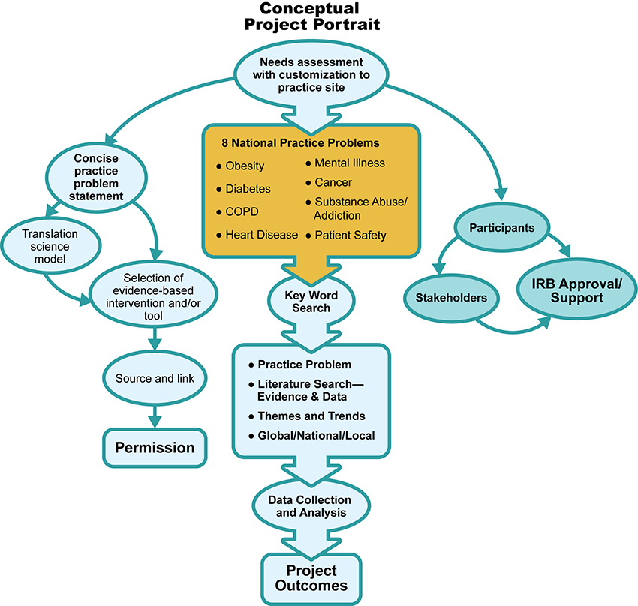

As you begin planning your DNP practice change project, consider each of the elements in the following graphic.

XXX

Conceptual Project
- Needs assessment with customization to practice site
  - Concise practice problem statement – Translation science model – Selection of evidence-based intervention and/or tool
    - Source and link
    - Permission
  - 8 National Practice Problems: Obesity, Diabetes, COPD, Heart Disease, Mental Illness, Cancer, Substance Abuse/Addiction, Patient Safety
    - Key Word Search
    - Practice Problem; Literature Search—Evidence & Data; Themes and Trends; Global/National/Local
    - Data Collection and Analysis
    - Project Outcomes
  - Participants – Stakeholders – IRB Approval/Support

With any project, it is essential first to look at project initiation and scope. During project initiation, there are several considerations, including project selection, prioritization, allocation of resources, and project documentation. Project selection can occur for several reasons ─ perhaps a new method of care, a new priority from senior administration, based on regulatory issues, or a potential new service line that warrants exploration as a profit center for the organization. Regardless of the reason, the commonality is that there is some condition or situation that requires attention from the organization. In most organizations, there are many needs and insufficient resources to fulfill all the needs at one time; therefore, prioritization is necessary. The project must fit with the goals and mission of the organization. It is affected by the environment, and resources must be assessed to evaluate cost versus return on investment. Allocation of resources to funding, physical needs, and the availability of appropriate personnel are all important considerations as adequate staffing and appropriate personnel within the anticipated timeframe are essential. Project sponsors should consider not only the needs of the project under consideration but also potential adverse impacts on existing projects. An important step during the initiation phase of any project is the identification of a senior administrator who can act as a project sponsor and facilitate the acquisition of resources, such as space, staffing, and budgetary resources. This level of commitment is essential to give legitimacy to the effort both in the eyes of senior leadership and to other interested stakeholders, especially those who do not fully support the project. Senior leadership involvement can promote buy-in, especially with skeptical stakeholders. Finally, it is during the initiation of the project that the practice of thorough documentation of the agreements made and decisions reached should be implemented. During this early stage, projects are often fluid. Discussions may cover numerous contingencies that are considered and then either adopted or discarded by those involved. To avoid misunderstandings and enable orderly progress toward the desired goals, decisions must be appropriately memorialized for future reference. Determining the scope of the project is essential and is often given insufficient attention. An initial task for the team leader is to examine the assignment to ensure understanding between the leader and senior management regarding the goal and the measure of success of the project. This is especially important when an interprofessional team is involved due to the different perspectives regarding the relative importance of various aspects of a project. There must be consensus among the team members and with senior administration regarding the weight given to the various aspects of the project. This is important to ensure the team is not overwhelmed by details and does not feel powerless, resulting in withdrawals of support for the work. Another concern is when the project becomes much greater than originally envisioned by the initial sponsor or team leader. This is referred to as scope creep. Scope creep occurs when the project is expanded to add tasks or aspects that may not have been envisioned originally and that may be only tangentially related to the original mission of the group, especially during the early stages. This can result in failure by transforming the project into an unwieldy endeavor due to a lack of material resources, time, or required expertise or skills necessary to address the supplemental objectives. Once the scope of the project is determined, the leader aids the team and remaining focused on the proposed timeline of the project. This is best accomplished through clear communication, which includes documentation of the progress of the project. Frequent references to the originally defined scope of the project assists in ensuring that the ultimate goal is kept at the forefront of activities.

Key Features of Writing a Synthesis Image Description
Let's look at the summary, analysis, and synthesis process more closely. Click on the following tabs to learn about each step:

Summary, Analysis, & Synthesis Interactive Transcript

Summary
The Johns Hopkins Individual Evidence Summary Tool assists you with documenting the main points of each research study (Dang, et. al., 2022). The transfer of findings from the Johns Hopkins Research Appraisal Tool to the Johns Hopkins Individual Evidence Summary Tool captures important details about individual studies. The eight columns guide you to ensure that you record important details about individual research studies. This process is referred to as a summary.

Analysis
After summarizing, the findings from the individual studies recorded on the Johns Hopkins Individual Evidence Summary Tool are reviewed and analyzed. The focus of an analysis lends itself to see how individual research studies relate to each other. Also, themes are identified across each research study source of evidence. In other words, it involves taking information from a variety of research study evidence sources, analyzing that information, and forming new ideas or insights in an original way.
Image Description
Literature not synthesized
- Paragraph 1: Study A – Description and summary
- Paragraph 2: Study B – Description and summary
- Paragraph 3: Study C – Description and summary
Literature synthesized
- Paragraphs 1, 2, and 3
- Comparison of Study A with Study B and Study C
- Presentation of new ideas/synthesis

Synthesis
In your practice change project proposal, you move beyond analysis to synthesis. This is a key point when writing a proposal that successfully articulates the compelling nature of your selected practice problem and the evidence-based intervention you will translate to your local practice setting. Instead of limiting yourself to summarizing individual research study evidence, you analyze across the summaries. In this analysis, you look for ways in which your various research studies agree or disagree and what unique points or insights appear in each. You can then combine (synthesize) the information to write more robust paragraphs. If you only have one article that addresses a particular portion of your proposal, you may need to find additional sources that discuss that part of the topic.

Project Management Institute. (2021). The standard for project management and a guide to the project management body of knowledge (PMBOK® guide) (7th ed.). Project Management Institute.

Smith, C. M. & Johnson, C. S. (2019). Preparing nurse leaders in nursing professional development. Journal for Nurses in Professional Development, 35(3), 160-162. https://doi.org/10.1097/NND.0000000000000549

