Re: Week 2 Discussion 1: IRB
by Amaris Beeksma - Monday, 13 January 2025, 6:30 PM
After reviewing the eight documents, the video, and the Regis IRB application I had many new revelations about the IRB process. The video was excellent. Each IRB committee is tailored to the project to some extent and there is great emphasis on having a team with diverse perspectives (U.S. Department of Health and Human Services, 2018). This video helped me understand the effort required to conduct and maintain IRB committees in academic institutions.
I learned that applicants need to submit their project at least 21 days before the IRB meeting to review the project. I learned that an expedited review does not need all members of the IRB to be present. I wonder if that expedited review applies to projects like mine that are considered minimal risk. I learned that the approval period for a project is maxed out at 12 months. I learned that any increase in physical, psychological, emotional, economic, or social harm must be explained to the IRB committee as soon as possible. The outline of the basic elements of informed consent in the IRB assurance of compliance document directly corresponds to the informed consent template we worked on last semester. This is reassuring that the template is sufficient to meet the IRB approval process. I was confused by the last statement in the attachment B of additional elements of informed consent. The document said the approximate number of participants in the project might be appropriate. This step is complicated for projects like mine that are using snowball sampling methods.
The audit form was interesting, but it was not clear to me if this form was completed by the IRB committee for each project or if it was only completed when a study goes awry. When someone (the complainant) notifies the IRB of possible study misconduct, the IRB sends the person who conducted the study a draft of their investigation. I was surprised that the study leader or respondent only has ten days to write up their comments on the draft. This sounds like ten days to explain their side of the story before the IRB will send the misconduct case to the deciding official whether the IRB will actually complete investigation. The investigation process is based on a precise 120 day timeline which is helpful to all parties because they know the results of one review process will not stall their career for an extended period of time. Interestingly, all falsification of data by a Regis student will be reviewed by each case. In other words, immediate expulsion is not the first course of action, but the board will diligently work to understand exactly what happened. I also appreciated the section in the Misconduct policy that the IRB is to restore any wrong reputational loss due to an inappropriate misconduct allegation. I was surprised that the child assent document required oral assent for patients aged 6 and younger along with written guardian consent. I thought written consent was enough. Barwise et al. (2023) bring up the point that adolescents can feel even more pressure from parents to participate in research compared to direct request by researchers. In other words, if the parent is set on signing consent the pediatric patient may feel like they do not have a true choice because they do not want to go against their parent’s decision.
The debriefing form brought up a few questions. Does each project need a debriefing form? Do I need to include at least a statement at the end of my survey? My project does not need a transcriber, but that role is pivotal to the safety of participants. After reviewing the exemption list, I believe my project qualifies for an exemption, but I will have to confirm that with Dr. B. The renewal application form will be helpful if I cannot complete the summer semester or for some extenuating circumstance my project intervention must be complete during a different semester. The modification request form was very simple which was reassuring. As I think ahead to my IRB proposal, I am nervous about the idea that nothing can change after IRB approval. However, it was reassuring to know that slight modifications can easily be sent to the IRB board. I learned that all PIs must complete the financial interest form and that the process of reporting conflict of interest begins as a discussion between the student and the IRB chair. The qualitative exemplar document was not listed on the website, so it was not reviewed.
References
Barwise, A. K., Allyse, M. A., Hirsch, J. R., McGowan, M. L., Meaghar, K. M., & Riggan, K. A. (2023). Wither Vulnerability? The over/under protection dilemma and research equity. American Journal of Bioethics, 23(6), 113–116. https://doi-org.regiscollege.idm.oclc.org/10.1080/15265161.2023.2201201
(2025). Institutional Review Board. Regis College. https://www.regiscollege.edu/about-regis/administrative-offices/institutional-review-board
U.S. Department of Health and Human Services. (2018). Membership Requirements for Institutional Review Boards [Video]. YouTube.
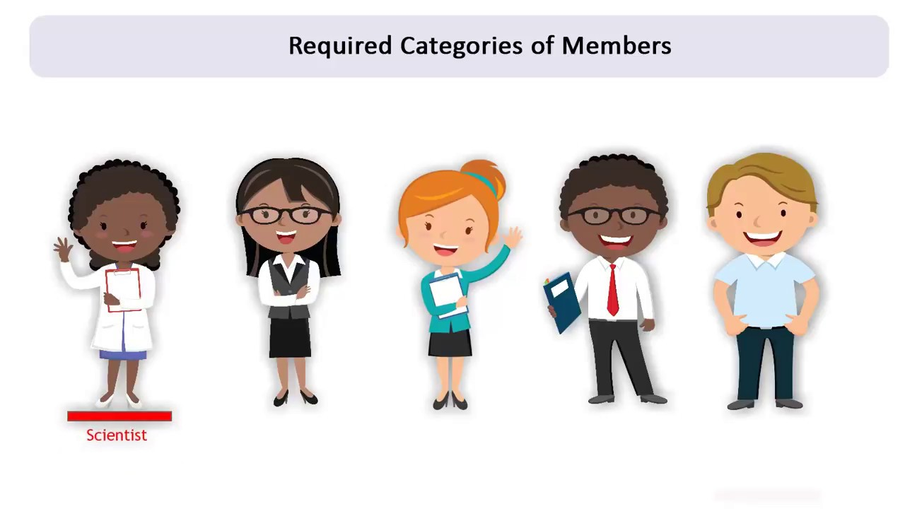
Play Video

Re: Week 2 Discussion 1: IRB
by Gladys Ongori - Tuesday, 14 January 2025, 8:22 PM
Hello everyone,
This week's readings provided me with valuable insights regarding the Institutional Review Board (IRB).
- For instance, I now understand that the IRB committee must have at least five members, one of whom must be a scientist and another a nonscientist.
- I also learned that the IRB may invite experts to provide insights into a study when necessary. My study aims to assess the knowledge and confidence of non-palliative care nurses in palliative care. I would not be surprised if the IRB invited experts in palliative care to review my proposal. This motivates me to create a strong proposal explaining every detail, including the project design, data collection, and dissemination of findings.
- What surprised me the most is that some studies or projects can be exempt from the IRB process, even though they still require proposal hearings. According to the guidelines provided by Regis, my project is not exempt from needing an IRB proposal hearing. This makes me anxious because there is much to prepare before the hearing.
- The audit form includes three protocols: exempt, expedited, and full. For non-exempt projects, what protocol does Regis utilize? What do the expedited and full hearings involve, and how long does the process last? These are some of the questions I would like answered. I won't be using a transcriber for my project, but I understand the importance of signing a confidentiality agreement before starting to ensure participants’ rights are not violated. I appreciate that Regis lists all the requirements to help investigators prepare for proposal hearings.

References
Institutional Review Board. (2025). Regis College. https://www.regiscollege.edu/about-regis/administrative-offices/institutional-review-board
U.S. Department of Health and Human Services. (2018). Membership Requirements for Institutional Review Boards [Video]. YouTube.
Play Video

