Wk 3 NR709
Student Lesson Plan
Overview
- Program Competencies
- Course Outcomes
- Weekly Objectives
- Main Concepts
- Integrates scientific underpinnings into everyday clinical practice. (POs 3, 5)
- Applies organizational and system leadership skills to affect systemic changes in corporate culture and to promote continuous improvement in clinical outcomes. (PO 6)
- Uses analytic methods to translate critically appraised research and other evidence into clinical scholarship for innovative practice improvements. (POs 3, 5)
- Appraises current information systems and technologies to improve health care. (POs 6, 7)
- Creates a supportive organizational culture for flourishing collaborative teams to facilitate clinical disease prevention and promote population health at all system levels. (PO 8)
- Leads others in professional identity, advanced clinical judgment, systems thinking, resilience, and accountability in selecting, implementing, and evaluating clinical care. (POs 1, 4)
Schedule
Section | Read/Review/Complete | Course Outcomes | Due
Prepare | Assigned Readings | COs 2, 4 | Wednesday
Explore | Lesson | COs 2, 4 | Wednesday
Translate to Practice | Discussion: Initial Post | COs 2, 4 | Wednesday
Translate to Practice | Discussion: Follow-Up Posts | COs 2, 4 | Sunday
Reflect | Reflection | COs 2, 4 | No submission
Foundations for Learning
American Association of Colleges of Nursing. (2006). The essentials of doctoral education for advanced nursing practice.Links to an external site. https://www.aacnnursing.org/DNP/DNP-Essentials
Student Learning Resources
Click on the following tabs to view the resources for this week.
- Required Textbooks
- Required Articles
- Additional Resources
Bemker, M., Ralyea, C., & Schreiner, B. (2021). The successful completion of your DNP project: A practical guide with exemplars. DESTech Publications.
- Read Chapter 1
  - Section: Interprofessional Collaboration to Improve Patient and Health Care Outcomes
- Read Chapter 17
  - Section: Bench to Bedside to Bench—Relationships With the PhD Prepared Nurse, Important Collaborative Relationships Between PhD Prepared Nurse and the DNP Prepared Nurse
Learning Success Strategies
- Resources
  - Review the assigned readings to ensure you understand the key terms and can relate them to the role of the DNP-prepared nurse leader.
  - As you review weekly content, consider how each concept and discussion can be translated into practice in your unique setting.
  - You have access to a variety of resources to support your success. Click on the DNP Resources tab on the home page to access program and project resources.
  - Your course faculty is here to support your learning journey. Reach out for guidance with study strategies, time management, and course-related questions. Review rubric feedback and individual comments to optimize performance.
- Forums
  - Let's Check-In: Tips for Success are available several weeks throughout the course. If unable to attend, listen to the recording posted in the announcements.
- Discussions
  - Review the discussion board guidelines and rubric. These will guide your responses and optimize your performance in this course.
  - Be prepared to share your thoughts and leadership experiences through the interactive discussion. It is important to share your thoughts so that we hear your voice. Also, support your responses with evidence from the literature.
- Practicum Hours
  - Check your practicum hours to identify the number of hours remaining to reach the required minimum of 1,024 approved practicum hours for completion of NR709 and the DNP degree program.
  - Practicum hours must be entered in every practicum course.
  - Log your practicum hours weekly.
  - Remember to use the resources in the Project & Practicum section of the DNP Program Resources page for guidance on these entries.
  - Enter no more than 4 hours for each entry and ensure that the activities represent the block of time requested. Be sure to select the correct DNP Essential and activity that matches your activity in your notes.
  - If you do not meet the required hours by the end of Week 8, you will receive an incomplete for this course.
- Project
  - Continue working on your final manuscript this week, as it is due at the end of Week 4. Review your manuscript carefully for grammar, APA, and content prior to submission. After submitting your Final DNP Project Manuscript by the due date and receiving feedback from your course faculty, you will have the opportunity to revise and resubmit your manuscript one time, and your manuscript will then be graded. After receiving feedback from your course faculty, the revised manuscript must be returned to your course faculty in seven (7) days.
  - If consulting with a statistician, if you have not received the data analysis, confirm the completion date and when the analysis will be provided to you.
Interacting with Feedback
Each week your course faculty will provide feedback in the rubric on any assignment you have submitted. Take a moment to review the following video on how to view rubric feedback in Canvas. (After clicking the link, scroll down or click on the title in the Summary area to jump directly to the video.)
- Link (video): Looking at FeedbackLinks to an external site. (2:26)
Review the following video on how to accept/reject track changes when viewing course faculty feedback on your assignment:
- Link (video): Word: Track Changes and Comments (4:19)

Lesson
Professional Support and Collaboration

Introduction
During the design, development, implementation, and evaluation of any practice change or quality improvement project, it is vital to have a network of professionals who can provide support and guidance throughout the project management process. Intraprofessional and interprofessional collaboration is not a new concept to nurses as nurses have collaborated with patients, families, physicians, ancillary services, community services, and other entities throughout the history of the profession. It is through collaboration that diverse ideas and perspectives can be explored to provide a more holistic and equitable approach to practice problems.

Intraprofessional and Interprofessional Collaboration
Intraprofessional and interprofessional collaboration is valuable not only during the lifespan of a DNP practice change project but also as you emerge from your DNP degree program as a DNP-prepared nurse leader. Intraprofessional and interprofessional collaboration is vital to the translation of evidence to practice and continuous quality improvement of healthcare outcomes.
As a DNP-prepared nurse leader, you will be called upon to lead practice change at all system levels (micro, meso, and macro). Developing a network of collaborators who can support a project or process improvement will be valuable to your organization and the community as intraprofessional and interprofessional collaboration has many benefits. These include but are not limited to the following:
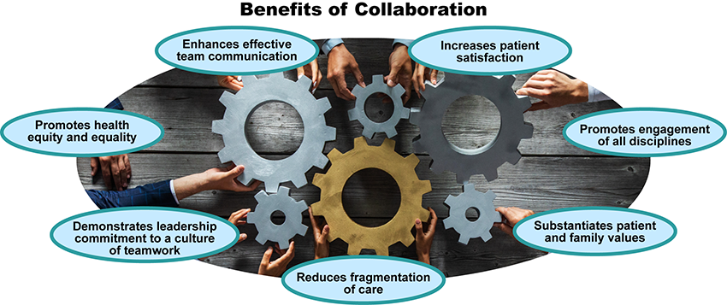

Collaboration Benefits Image Description
Professional Support and Collaboration
Discussion
Purpose
The purpose of this discussion is to identify and evaluate individuals who provided professional support and mentoring throughout your DNP program. These individuals may include your preceptor, mentor, course faculty, or others who assisted you in finding the right direction in your course work, practice change project, and practicum experience.
Instructions
Reflect on your readings this week and respond to the following in 150 words or less:
- Identify 2-3 individuals who provided professional support, mentoring, or who helped guide you throughout your DNP degree program and/or during your DNP practice change project design, development, implementation, and evaluation.
- Evaluate the influence that intraprofessional or interprofessional collaboration with the individuals you identified had on your success in the DNP degree program.
Please click on the following link to review the DNP Discussion Guidelines on the Student Resource Center program page:
- Link (webpage): DNP Discussion GuidelinesLinks to an external site.
Program Competencies
This discussion enables the student to meet the following program competencies:
- Integrates scientific underpinnings into everyday clinical practice. (POs 3, 5)
- Applies organizational and system leadership skills to affect systemic changes in corporate culture and to promote continuous improvement in clinical outcomes. (PO 6)
- Uses analytic methods to translate critically appraised research and other evidence into clinical scholarship for innovative practice improvements. (POs 3, 5)
- Appraises current information systems and technologies to improve health care. (POs 6, 7)
- Creates a supportive organizational culture for flourishing collaborative teams to facilitate clinical disease prevention and promote population health at all system levels. (PO 8)
- Leads others in professional identity, advanced clinical judgment, systems thinking, resilience, and accountability in selecting, implementing, and evaluating clinical care. (POs 1, 4)
Course Outcomes
This discussion enables the student to meet the following course outcomes:
- Develop a comprehensive plan for communicating the results of the evaluation of the DNP project for determination of sustainability and replication. (PCs 1, 2, 3, 4; POs 5, 6)
- Use project management processes to implement the DNP project. (PCs 6 8; POs 4, 8)
Due Dates
- Initial Post: By 11:59 p.m. MT on Wednesday
- Follow-Up Posts: By 11:59 p.m. MT on Sunday
Reply

