NU727 Week 4 Activity 2: G*Power Analysis

Student Name:
Institution:
Course:
Instructor
Due Date:

G*Power Analysis
An adequate calculation of sample size and power analysis is a critical issue in clinical research. Nonetheless, the challenge and complexity of sample size calculation and power that need statistical knowledge and commercial software are too expensive (Kang, 2021). G*Power is a free and easy-to-use tool for calculating the sample estimation process, appropriate sample size, and power analysis, while considering type I and type II errors, power, null hypothesis, alternative hypothesis, and effect size. The paper will discuss sample size and power analysis for a paired t-test for my scholarly practice project (SPP).
The SPP aims to implement a training program on motivational interviewing (MI) on medication adherence to enhance psychotropic medication adherence. quantitative quasi-experimental pre-test post-test design, the estimated sample population is 40 mental health nurses. In calculating the sample size and power for a paired t-test, G*Power was downloaded for free at https://www.psychologie.hhu.de/arbeitsgruppen/allgemeine-psychologie-und-arbeitspsychologie/gpower. The process of sample estimation depends on study goals and the appropriate statistical test.
A priori analysis was conducted before the study commenced and prior to planning the design to calculate sample size (N), determine effect size, anticipated alpha level (α), and power level (1-β- β) to control type I and type II errors, and verify the hypothesis (Kang, 2021). A paired t-test helps match mean values between two samples, while the null hypothesis suggests that the difference between the group means is zero, and the alternative hypothesis denotes that the mean difference between the groups is dissimilar to zero (Kang, 2021).
The illustrations below are the G*Power main window displaying calculation of sample size utilizing effect size.
Fig.1
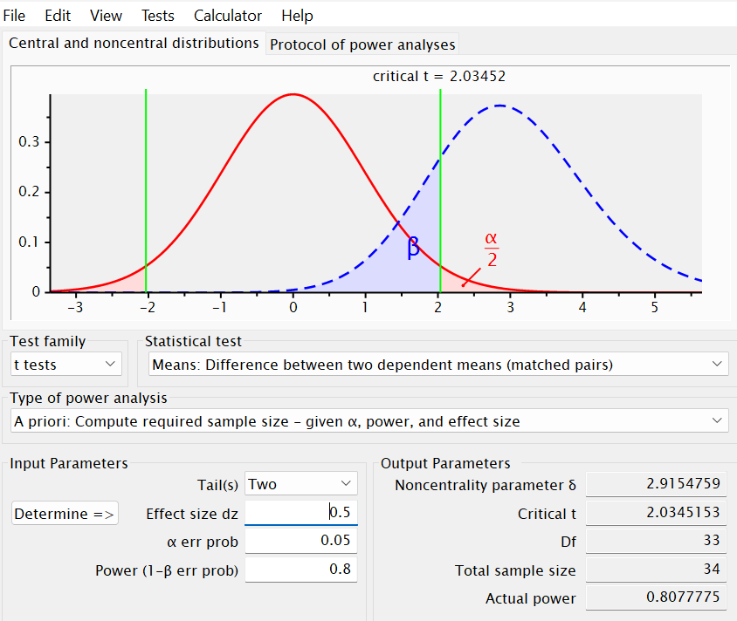
Fig. 2
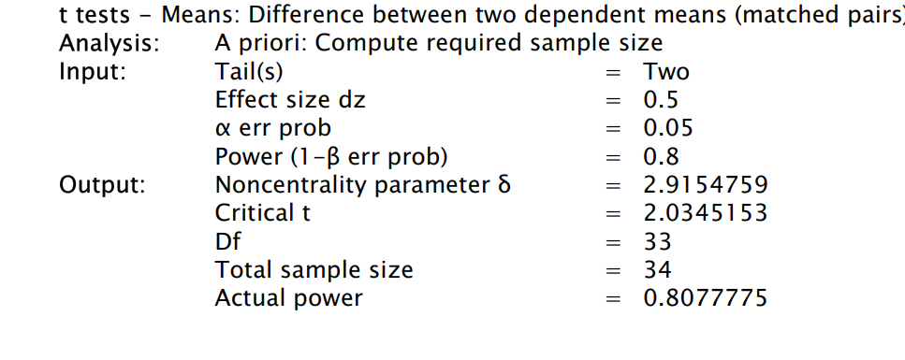
A dependent t-test was conducted comparing the means of two samples. The SPP seeks to determine the sample size of mental health nurses to be equal in the paired t-test. In calculating the sample size, using a medium effect size (0.5), the total sample size was computed as 34 in the output parameter, with input of “α err prob” α=0.05, and β=0.8 power (1-β err prob). The interpretation of these results reveals that the investigator requires a sample size of 34 pairs to identify a medium effect size of 0.5 (dz = 0.5) with a statistical significance level of 0.05 and power of 0.8 in a paired t-test. As such, the sample size achieved an actual power of 80.87%, slightly greater than the targeted power. The results reveal a critical value of 2.035, which matches the verge of statistical significance, while the effect size is reflected in the noncentrality parameter within the test context. In this context, a sample effect size of 0.5 depicts a medium difference from the paired t-test, altering the sample size required to attain adequate statistical power in the SPP.

References
Kang H. (2021). Sample size determination and power analysis using the G*Power software. Journal of educational evaluation for health professions, 18, 17. https://doi.org/10.3352/jeehp.2021.18.17
Universität Dusseldorf (2023, March 14). G*Power. Universität Düsseldorf: Psychologie. https://www.psychologie.hhu.de/arbeitsgruppen/allgemeine-psychologie-und-arbeitspsychologie/gpower

