An Educational Intervention About the Use of the AHRQ Toolkit for Fall Prevention to Improve Knowledge, Confidence, and Motivation Levels for Nurses in a Long-term Care Facility

A Scholarly Project

Presented to

The Faculty of Regis College

In Partial Fulfillment
of the Requirements of the
Doctor of Nursing Practice Degree

By

Keiandra V Bludsaw, DNP(c), BSN, RN

March 23, 2025

Abstract

Problem Statement: Despite the importance of fall prevention in older adults in residential aged care facilities, there is a lack of standardized education and training for nurses on effectively utilizing the AHRQ (Agency for Healthcare Research and Quality) toolkit for the assessment and management of falls. This deficiency in education and training results in suboptimal implementation of evidence-based fall prevention strategies, leading to an increased risk of falls and associated negative outcomes among elderly residents. (Rine, 2023).
Purpose: This project strives to motivate nurses to adopt the AHRQ’s Fall Prevention Toolkit for LTC facilities while building their learning confidence. This initiative raises nurse proficiency in evidence-based fall prevention approaches while boosting their self-assurance and dedication which creates better safety outcomes and decreases falls in LTC facilities.
Methods: The project implements various educational methods from workshops to case simulations to AHRQ Falls Prevention Toolkit training thus enabling nurses to gain knowledge about and develop confidence in fall prevention. The intervention effects are measured through Confidence Scale (C-Scale) assessments and Intrinsic Motivation Inventory (IMI) evaluations before and after the program. The process of feedback and evaluation enables constant enhancement of fall prevention methods throughout long-term care facilities (LTCFs).
Inclusion Criteria: Nurses: Nurses currently employed in long-term care (LTC) settings, including registered nurses (RNs), licensed practical nurses (LPNs) who provide direct patient care and are involved in fall prevention efforts.
Analysis:

Implications for Practice:

Keywords: (list three to five key search words for this project)

Signature Page-Placeholder

This scholarly practice project of _____________, entitled _____________________directed and approved by the faculty chair, has been accepted by the Nursing Faculty of Regis College in fulfillment of the requirements for the Doctor of Nursing Practice.

__________________________________________
Dean, Richard and Sheila Young School of Nursing

__________________________________________
Chair, Doctoral Scholarly Project Team, (credentials)

__________________________________________
Team Member, (credentials)

__________________________________________
Team Member, (credentials)

___________________________________________
Team Member, (credentials)

Add an additional signature line for each additional team member

Acknowledgments

[This page acknowledges those who helped complete the project: colleagues, faculty, project participants, personal assistance. Refer to APA Publication Manual, 2020, p. 36-37.]

Table of Contents
Abstract 2
Signature Page-Placeholder 3
Acknowledgments 4
Table of Contents 5
List of Tables 9
List of Figures 10
Chapter I: Introduction 11
Introduction 11
Problem Statement 12
Background 13
Significance 15
Nursing Practice 16
Nursing Research 17
Nursing Education 17
Nursing Leadership 18
Clinical/Practice Question 19
Purpose of the Project 19
Project Aims 20
Measurable Objectives 21
Theoretical Framework 22
Philosophical Underpinnings 24
Evidence-based Practice (EBP) Model 25
Knowledge Discovery 26
Evidence Summary 27
Translation into Practice Recommendations 27
Integration into Practice 27
Evaluation 28
Conclusion 28
Chapter II: Review of Literature 31
Literature Review Inclusion Criteria 31
Literature Review Exclusion Criteria 31
Introduction 31
Literature Review 32
Prevalence and Consequences of Falls for the Elderly. 33
Risk Factors Contributing to Falls 34
Interventions and Prevention Strategies 35
Nurses' Role in Fall Prevention 36
Education and Awareness Initiatives 37
Supporting Literature 38
Enhancing Nurse Readiness and Confidence 38
Implementation Strategies and Outcomes 39
Barriers to Implementation and Solutions 40
National Guidelines on Fall Prevention in the Elderly 41
Conclusion 42
Chapter III: Methodology 44
Introduction 44
Project Design 44
Project Methods/Plan and Procedures 45
Measurable Objectives 46
Evidence-Based Clinical/Practice Question 47
Setting 47
Sample 47
Sampling Method 48
Recruitment Plan 49
Sample Size 49
Inclusion and Exclusion Criteria 50
Inclusion Criteria 50
Informed Consent 50
Ethical Considerations 51
Intervention 52
Evaluation 53
Variables 53
Tools/Instruments 54
Demographic Survey 55
Instrument #1 Confidence Scale (C-Scale) 56
4. Instrument #3 Intrinsic Motivation Inventory (IMI): 57
Open-Ended Questions (See Appendix N) 58
Data Analysis 58
Conclusion 59
Chapter IV: Results 61
Introduction: Each Chapter should have an introduction. 61
Demographic data 61
EBP Project data analyses 61
Qualitative data analyses 61
Missing data 62
Conclusion 62
Chapter V: Discussion and Conclusion 63
Interpretation of Results 63
Implications for Nursing Practice 63
Limitations 63
Dissemination of Findings 63
Conclusion 64
References: 65
Appendices 69
Appendix A-Theoretical Framework 69
ppendix B-Permission for Use 70
Appendix C-Evidence Based Model 71
Appendix D-Permission for Use 72
Appendix E-Levels of Evidence Table 73
Appendix F: Invitation to Participate 74
Appendix G-Informed Consent 75
Appendix H-Flesch-Kincaid Grade Level 79
Appendix I-Demographic Survey-please fix these with numbers 80
Appendix J-Instrument #1 Confidence Scale (C-Scale) 83
Appendix K-Permission for U 85
Appendix L-Instrument #2 86
Appendix M: Permission for use 89
Appendix N-Open-Ended Post Questions 90
Appendix O- Educational Intervention Powerpoint 91
Appendix P-External Site Permission 93
Appendix Q-CITI Training Certificate 94
Appendix R-Primary Investigator Resume 97
Appendix Q - External Site Permission 99
Appendix R – Summary of Literature Review 101
Appendix S - Project Timeline and Implementation Plan 104
Appendix U - Sample Workshop Agenda 106
Appendix V- Data Analysis Plan 107
Appendix W - Statistical Results 108
Appendix X-Analysis Results 109
Appendix Y - Ethical Considerations and IRB Approval 110

List of Tables

Table 1 58

List of Figures

Figure 1 23
Figure 2 26
Figure 3 115

An Educational Intervention

About the Use of the AHRQ Toolkit for Fall Prevention to Improve Knowledge, Confidence, and Motivation Levels for Registered Nurses in Long-Term Care

Chapter I: Introduction

Introduction
The Agency for Healthcare Research and Quality (AHRQ) suggests that between 700,000 and 1 million patients suffer from nursing home or hospital falls annually, of which 250,000 sustain an injury, and between 8,000 and 11,000 die from such falls. Falls and injuries in Long-term Care facilities (LTCFs) are preventable if patient care is focused on utilizing appropriate fall and injury risk reviews for each shift (Orts-Cortés et al., 2024). The Agency for Healthcare Research and Quality (AHRQ) has created a fall prevention toolkit via webinar and PowerPoint that is the model for system performance for implementing a systematic quality improvement that will guide all nurses with the assessments and scales taught via modules on the webinar (AHRQ's Quality & Patient Safety Programs by Setting: Long-term Care Facility, 2021). For this reason, AHRQ's Fall Prevention Toolkit is an excellent resource for nurses because it contains straightforward measures that can assist in preventing falls in Long-term Care facilities over time (See Appendix A).
The AHRQ toolkit offers interventions and assessments for nurses regarding diagnoses and interactions. For instance, through the help of AHRQ, Madonna Facility has been able to reduce patient falls by 21%, as was noted in 2015 (Preventing Falls in Hospitals Toolkit, 2018). The AHRQ's Fall Prevention Toolkit is offered through examples, oral communication, and physical materials. The purpose of this project is to increase nurse’s readiness and awareness of the AHRQ’s Fall Prevention Toolkit and reintroduce AHRQ’s resources for nurses. When nurses working in LTC settings receive proper assessment and tools such as the Agency for Healthcare Research and Quality (AHRQ), they will better understand how to prevent falls and share with colleagues. Concerns that recur include the lack of compliance concerning the provision of fall education and toolkits, which offer a specific set of guidelines to prevent fall incidents (Trinh et al., 2023). Referring to the project of Trinh et al. (2023), the institutions that provide measures against such risks as patient falls have experienced a decrease in incidents and falls in acute care. LTC patients are admitted to facilities to ensure that they deal with and minimize the patient's risk of causing harm to themselves. Thus, it is estimated that 10–30% of falls might be associated with injury and that this lowers the positive rehabilitation outcomes for these patients (Musculoskeletal Key, 2024).
Despite all the commitments made towards reducing the incidence of falls in LTC facilities, new injuries occur and affect patients, with most of them being fatal (Agency for Healthcare Research and Quality [AHRQ], 2023) This project aims to find the potential of readiness to nurses offering information about resources that can help them in taking care of the patients to avoid injuries. This project aims to reconsider the AHRQ education with nurses in Long-term Care Facility and address the concept of altruism to include in their standard of practice.

Problem Statement
According to AHRQ, 2023), around 1.6 million residents in the nursing home fall every year, and more than half of these patients fall. Maintaining an unrelenting approach to educating patients, providing them with necessary tools, ensuring suitable infrastructure, and including other fall prevention methods in healthcare, the rates of falls have not changed. Other stakeholders in healthcare understand safety measures regarding themselves, their patients, and safe patient handling through their nursing education and practice (Cho et al., 2023). The Healthy People 2030 target of reducing the rate of falls among both inpatient and outpatient populations as a main concern of the country's health objectives remain unmet (Rine, 2023).
The AHRQ's Fall Prevention Toolkit aims to promote and remind fall prevention methods for nurses in Long-term Care facilities. This toolkit equips staff with the necessary knowledge on assessment and encourages them to adhere to best practices of assessment in different Long-term Care facilities. The primary goal of this project is to raise awareness about the AHRQ's Fall Prevention Toolkit for all nurses by providing confidence-building lessons that will help them accept and effectively implement the toolkit in their nursing practice. It is possible that through mastery of the toolkit, nurses may gain improved confidence and competency in the prevention of falls.

Background
In the past, Healthy People 2030 estimated that in 2016, there were 6,052.2 emergency department visits for falls per 100,000 adults over the age of 65 years (Centers for Disease Control and Prevention, National Center for Injury Prevention and Control, 2015). COVID-19 has presented an understanding that maintaining systematic fall prevention within healthcare requires educating nurses about specific protocols, assessments, and strategies. The delegation of these responsibilities to essential workers that are not nurses alone cannot minimize the occurrence of falls for patients (Watkins Neubrander, 2020). The entire healthcare team has to be educated and have this knowledge reinforced periodically to be effective in reducing fall incidents.
Healthy People 2030 has outlined Long-term Care settings as having a high incidence of patient harm (AHRQ, 2019). According to the Agency for Healthcare Research and Quality (AHRQ), patients admitted to the rehabilitation unit experienced a fall rate of 7.15 per 1000 patients per day (AHRQ, 2023). To resolve these problems, it is vital to strengthen nurse's knowledge in the context of Long-term Care settings to apply functional interventions and toolkits that can be understood and transferred between the healthcare staff. It becomes crucial to focus on the prevention of falls and injuries for the maintenance and management of patients. AHRQ's Quality and Patient Safety Work, organized by the federal government sector, aims to bridge the gap between clinical research and patient health outcomes (AHRQ's Quality & Patient Safety Programs by Setting: Long-term Care, 2021).
Furthermore, conditions like confusion, imbalance, and pharmacological opioids predispose patients to fall accidents. These falls can be avoided through the use of educational interventions and toolkits based on evidence. Full-set fall toolkits outline populations that are vulnerable and how these risks could be addressed (Zubkoff et al., 2019). More information about fall assessments and prevention scales should be shared periodically with all caregivers. By increasing awareness among nurses, such serious injuries as intracerebral hemorrhage, hip fractures, and death may be significantly diminished. Today's fall prevention education in LTC may be comprised of PowerPoint teaching modules on assessment and medication administration. Educational measures in the past included video lessons during the COVID-19 pandemic (Dubé et al., 2023). Educational programs were confusing during this period and may have impaired the acquisition of knowledge by nurses, leading to a drop in fall prevention rates (Ystaas et al., 2023). For fall prevention education to make an impact on fall rates, it must be practical and is best administered in a face-to-face modality with role modeling and demonstrations (Liu et al., 2023; Ystaas et al., 2023).
The problem of preventing patient falls and injuries is still important in the healthcare environment. The design of educational guides for preventing falls and injuries must be unique to each establishment. The literature shows that falls often happen because of flawed evaluations and insufficient rounding (Hyesil et al., 2023). The essentials of effective hourly rounding incorporate the aspects of varied patient needs, including toileting, positioning, administration of analgesics, and other comfort care measures (Albasha et al., 2023). The AHRQ's Fall Prevention Toolkit emphasizes the importance of understanding fall scales and implementing comprehensive fall prevention strategies (AHRQ's Quality & Patient Safety Programs by Setting: Long-term Care, 2021).

Significance
According to the objectives of Healthy People 2030, reducing mortality due to falls among elderly patients remains a critical public health priority. Current data indicate a mortality rate of 78.0 deaths per 100,000 falls, surpassing the Healthy People 2030 target of 63.4 deaths per 100,000 falls (Centers for Disease Control and Prevention [CDC], 2023). The high prevalence of fall-related injuries underscores the urgent need for evidence-based interventions to mitigate fall risks, particularly in long-term care settings.
Falls that cause injuries happen by accident and create serious safety threats that result in longer hospital stays with reduced quality of life and higher medical costs (Huang et al., 2022). Preexisting health conditions make patients more likely to fall and their recovery outcomes can be difficult to forecast (Rine, 2023). The proper protection from slips and falls depends on combining staff learning programs with risk assessment standards and tested AHRQ Falls Prevention Toolkit action methods (Agency for Healthcare Research and Quality [AHRQ], 2021).
Healthcare facilities must begin using specific fall protection programs as their primary method to stop these incidents. Collaboration between nurses doctors and physical therapists makes important progress in lowering falls among patients (LeLaurin & Shorr, 2019). Regular staff training plus skill evaluations help nurses stay committed to top fall protection methods which boosts staff confidence in fall prevention (Titler et al. 2016).

Nursing Practice
Reducing patient falls remains essential for safe nursing practice, and it saves money in healthcare while improving treatment quality today. Health People 2030 strive to decrease fall accidents, but various studies, including March 2023 indicators and Feb 2022 statistics, show falls continue to happen excessively, especially in nursing homes when patients have weak bones and thinking problems. People who fall experience dangerous injuries plus longer hospital stays while developing disability and die sooner, especially after hip fractures, as research by Morris et al. (2024) found 50% of patients may not survive in one year.
Under legal and ethical standards, healthcare organizations must pay penalties and suffer reputation damage when falls happen since they can be prevented as never events (CMS, 2022). Frontline nurses lead patient safety efforts by checking for fall risks and teaching patients while checking medicines with other hospital teams (Titler et al., 2016; Hempel et al., 2013). Training deficiencies and varied application of optimal care interrupted our findings show that half the nurses do not feel sure assessing fall risks properly (Alsaad et al., 2024).
Healthcare organizations should create consistent fall prevention education and nursing protocols while giving nurses evidence-backed tools that help prevent patient harm (Dykes et al., 2017). The nursing team can protect patients more effectively and save resources by giving better training to staff, helping different departments, and following standard procedures.

Nursing Research
Recent research proves that applying data-driven solutions helps decrease patient falls in different healthcare facilities. Practice settings worldwide depend on the Johns Hopkins Fall Risk Assessment Tool for accurate patient fall risk evaluation because it helps deliver precise fall prevention solutions (Poe et al., 2023). Nurses benefit from using the AHRQ Falls Prevention Toolkit combined with the Johns Hopkins Fall Risk Assessment Tool as it gives them clear evidence-based methods to watch for and stop fall dangers in patients (Agency for Healthcare Research and Quality [AHRQ], 2023).
Today's research requires nurses to regularly update their approaches for preventing falls in their daily work. Research demonstrates that addressing various fall risks by assessing patients, teaching safety practices, creating walking guidelines and adapting patient rooms helps reduce injuries (Titler et al. 2023; Heng et al. 2022). Research demonstrated by O’Connor et al. in 2022 shows how technology benefits patients and nurses through advanced monitoring systems.
Researchers develop better evidence-based systems for nurses to make decisions and prevent more falls. Structured toolkits from Johns Hopkins and Agency for Healthcare Research and Quality enable nurses to perform consistent fall risk evaluations while connecting better with colleagues and creating safer healthcare workplaces. Modern research findings and advanced assessment methods help nurses adjust their work regularly to keep patient safety high and achieve better results in preventing falls.

Nursing Education
Nursing education and clinical experiences link powerfully which means LTC facilities need full evidence-based training programs to protect patients from falls better. Nursing programs that use dynamic learning models based on competency demonstrate equip nurses to properly put fall prevention techniques into clinical practice.
The fast changes in healthcare surroundings require nursing programs to keep updating their teachings to include new medical knowledge and technology (Christine & Athene, 2023). Nurses need to practice medicine management techniques that minimize fall risks along with spotting cognitive and movement changes that make patients fall prone. Simulation training and case-based exercises teach nurses better ways to assess and handle patients at risk of falling. Collaboration between different healthcare professionals is essential in nursing training. Nurses need team-based learning partnerships with physical therapists, occupational therapists, and pharmacists to teach full patient fall prevention methods. Nurses need to keep learning through continued education events which helps them maintain knowledge of recent innovations in patient protection from falling (Heng et al., 2022).
Nursing education programs should develop expert-designed training to let nurses feel more self-assured in their clinical abilities and apply proven ways to stop falls in LTC facilities and other dangerous healthcare locations.

Nursing Leadership
Strong nursing leadership team must lead fall prevention because they direct Quality Improvement (QI) activities while training staff members to recognize and mitigate risks. The project demonstrates why leaders must educate LTC nurses about patient safety and fall prevention to make better patient outcomes.
Research shows nurse leaders need to review patient fall data to recognize at-risk patients and base new preventive measures on actual evidence (Elsheikh et al. 2023). Organizations achieve better patient outcomes from fall prevention programs when leaders back quality improvement efforts thoroughly (Hughes 2022). By watching fall incident patterns administrators know how to use their resources properly and train their staff to lower this safety risk (Patrician et al., 2023).
Nurse leaders should create a safe environment by adding the Johns Hopkins and AHRQ toolkits to staff training and daily operations. Strong nurse leadership involvement in quality improvement programs and staff training keeps nurses knowledgeable about detecting and handling potential fall hazards (Titler et al., 2023).
To build nurses' fall prevention skills better administrators should establish organized leadership methods that mix coaching plans with performance rating systems plus pair-working solutions. The leadership of quality improvement steps must be strengthened to lower fall numbers while enhancing patient safety and care throughout nursing homes.

Clinical/Practice Question
Does An educational intervention about the use of the AHRQ Toolkit for fall prevention improve knowledge, confidence, and motivation levels for nurses in Long-term Care?

Purpose of the Project
This project focuses on the use of The AHRQ Fall Prevention Toolkit for nurses in Long-term Care. The educational intervention is based on the AHRQ fall prevention toolkit. It aims to improve nurse’s levels of knowledge, confidence, and motivation to use the toolkit in practice. The goal is to have the Nurses confident and motivated enough to be champions for sharing the essential knowledge found in the AHRQ toolkit.
Through the program, the project seeks to inspire nurses with confidence of what AHRQ identifies as the best practices and tools for preventing patient falls. In addition to learning about the importance of fall prevention and patient safety in the educational program, the nurse will be more skilled and ready to conduct assessments for fall risks, create fall prevention care plans, and engage with other health care professionals, which may include physical therapists as well as pharmacists to implement measures to reduce risk factors for patients from experiencing falls while in health care facilities. This endeavor aims to nurture the nurses’ capacity to effectively translate skills of the AHRQ Falls Toolkit into the contexts of healthcare organizations. By providing guidance on implementation, communication, and monitoring, the project hopes to enable nurses to take charge and lead efforts to improve fall prevention while improving the quality of care. The primary goal of this project is to improve the fall prevention practices within healthcare organizations, such as Long-term Care to prevent and avoid falls.

Project Aims
This project aims to deliver a comprehensive educational program tailored for nurses to introduce them to the Agency for Healthcare Research and Quality (AHRQ) Falls Toolkit. The primary objective is to equip nurses with the readiness, knowledge, competencies, and resources to effectively apply evidence-based fall prevention strategies and interventions. The project is focused on reducing falls in healthcare settings and improving safety. Through training sessions, workshops, and educational materials, the project seeks to empower nurses to understand fall risk factors and best practices AHRQ recommends. By fostering a culture of awareness and proactive prevention, nurses can actively conduct fall risk assessments, develop prevention plans, and collaborate with interdisciplinary teams to establish a safe and supportive care environment.
Furthermore, the project aims to support nurses in translating their grasp of the AHRQ Fall Toolkit into strategies that seamlessly integrate into their practices. This involves offering guidance on implementation approaches, communication skills, and evaluation methods to ensure the long-term effectiveness of fall prevention initiatives. By investing in the education and training of nurses through the AHRQ Falls Toolkit, this project aims to improve healthcare practices, reduce falls, and enhance outcomes across care settings. By promoting evidence-based practices and fostering a culture of safety and teamwork, the project seeks to enhance fall prevention efforts and contribute to the overarching goal of enhancing patient care quality in healthcare settings. The sustainability plan entails implementing established strategies that all nurses can adopt and uphold to ensure long-term success and impact. This plan includes embracing proven strategies for all nurses to learn and incorporate into their practice, ensuring success and impact over time.

Measurable Objectives
This project seeks to:
- Create an educational intervention based on the AHRQ toolkit for fall prevention.
- Increase nurses' knowledge levels about fall prevention using current evidence.
- Improve nurse's confidence levels about fall prevention.
- Inspire motivation levels in Nurses to use the AHRQ toolkit for fall prevention in practice.
- Disseminate the findings of this project to local and regional nursing conferences and submit the findings for publication to an appropriate nursing journal.
An essential component of initiatives for preventing falls involves educating nurses about the current tools and methodologies. By equipping nurses with the knowledge and skills to implement measures, nursing research seeks to enhance patient safety and well-being across various healthcare settings. Studies supported by government funding have delved into developing assessments and scoring systems tailored specifically for fall prevention in Long-term Care facilities. This project endeavors to strive to pinpoint practices and evidence-based interventions that can be integrated into nursing practice, ultimately reducing fall incidents, and enhancing the standard of patient care. By scrutinizing the impact of falls in healthcare environments, this project aims to establish an evidence base that steers the implementation of strategies for preventing falls. Nursing researchers assist nurses in addressing fall risks by adhering to evidence-based protocols and fostering a culture centered on safety and well-being within healthcare settings.

Theoretical Framework
This Doctoral Scholarly Practice Project (SPP) is grounded in the Nursing Role Effectiveness Model (NREM, ?year). This exhaustive framework identifies the extent to which care practices in nursing are efficient in the healthcare sector (See Figure 1). In relationship with this proficiency, the NREM strengthens nurses by articulating their duties in the charge of patient care, working with providers and families (Julia et al., 2019). It divides these roles and responsibilities into sectors within the system, and each contributes to certain achievements in nursing practice (See Appendices B & C)). For example, one can work as a caregiver, coordinator, teacher, announcer, or health promoter when one is a nurse (Toshniwal et al., 2022).
Within the context of this project that aims at providing information to nurses regarding The AHRQ's Fall Prevention Toolkit, the NREM will guide the development of the tool to ensure that all the tools, as well as functions, are within reach of nurses to apply during their practice especially when attending to patients in long term care units. It will give them more confidence in performing their tasks.
Figure 1
Nursing Role Effectiveness Model
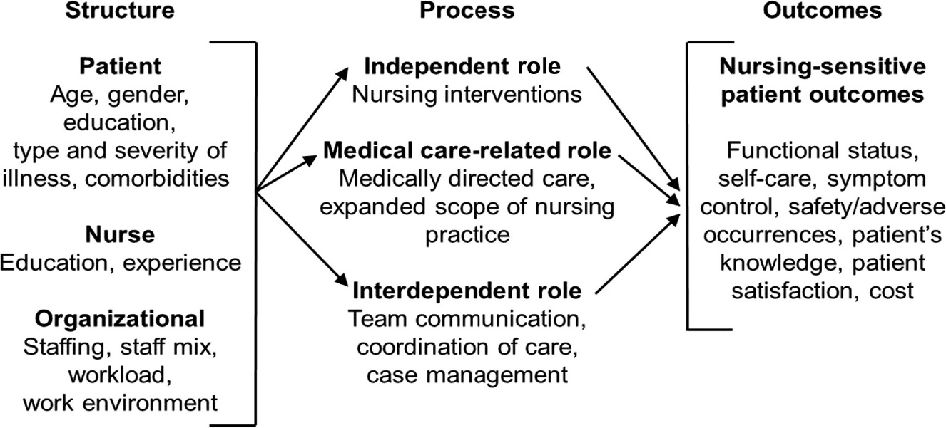
Note. Adapted from the Nursing Role Effectiveness Model (Irvine, Sidani, & Hall, 1998b).

The Nursing Role Effectiveness Model is a source of guidance for nurses, making it easier to smooth health practices and enhance the efficiency of successful roles (Julia et al., 2019). The NREM highlights three areas: The Structural, Process, and Impact. It incorporated the model's structure as far as the nurses are concerned in tackling a certain practice level, which depends on the expert, professional training, work, environment, or available education. It also considers factors that influence the present practice and the roles of the nurse. With the NREM, nurses can handle their tasks and duties best, improve outcomes and insubstantial learning experiences, and have more confidence in their practice while ensuring comfort.
The third element of the NREM model relates to the outcomes, and functionality and efficacy are used to measure the outcome. A survey will be conducted before. The following training will ascertain how nurses can adjust to using The AHRQ's Fall Prevention Toolkit. This survey will assist in measuring the impact of the intended NREM model assessment and dealing with the toolkit features and layout for nurses' dedication and confidence. The educational outcomes of the model aim to support nurses in accomplishing desirable conduct and efficient outcomes in patients, as well as satisfying the experience of their work.
The Nursing Role Effectiveness Model was a tool in a 2022 study where the author explained the significance of virtual care during COVID-19. This project explored how a model focusing on nursing understood how to influence outcome indicators in the application of virtual care, especially within a primary care context. An example was the NREM involvement in mobilizing practicing nurses to deliver holistic virtual peripheries care augmented by data analysis outlining virtual care, primary care, and the nursing profession nexus (Vaughan et al., 2022). The study recommended coordinating platforms in healthcare practices, enabling nursing professionals to succeed in the roles of caregivers (Vaughan et al., 2022).

Philosophical Underpinnings
In the context of nursing education topics related to patient falls are important as the problem affects the safety of vulnerable patients (Haines & Kearns, 2021). Harm prevention specialists consider it crucial to identify the factors that explain falls, which can stem from environmental deficits or a patient’s impaired mobility, or complications related to medications (Alzubaidi & Alzahrani, 2021). When planning curricula, nursing programs try to incorporate project findings and guidelines intended to help future nurses recognize risk factors for falls, as well as prevention and intervention measures in case of falls (Tzeng & Yin, 2022).
The nursing role effectiveness model is essential to this education process, which provides the philosophical foundation for systemizing the nursing practice process (McCoy & Theeke, 2022). The NREM suggests that managerial roles of the nurse and the experienced professional ideas rely on competency, environment interaction, and patient and families. This model makes care for the patients’ rounded care needs possible, because a nurse is required to not only treat a patient’s physical issue but to look into their mental state as well (Haines & Kearns, 2021). Developing awareness of such philosophical premises, therefore, enables nursing education to strengthen the averment for advanced precision of nursing roles in preventing falls, and therefore a safer clinical setting for patients.

Evidence-based Practice (EBP) Model

The STAR Model of Knowledge Transformation is an evidence-based practice model created to help translate project discoveries into real world uses in healthcare environments (Brunt & Morris 2023). It proves valuable in developing this project regarding educating Nurses about the AHRQ Falls Toolkit (See Figure 2). Implementing the STAR Model of Knowledge Transformation in educating nurses about AHRQs falls toolkit establishes an efficient process for translating research into practice (See Appendix D & E). Each stage of the model—Knowledge Discovery, Evidence Summary, Translation into Practice Recommendations, Integration into Practice and Evaluation—is vital for providing nurses with the knowledge, skills, and resources necessary to prevent falls and enhance safety. By adhering to this model healthcare institutions can establish an educational framework that educates nurses about cutting edge evidence-based practices and ensures their effective integration into patient care. This comprehensive approach enhances nurses’ proficiency and self-assurance while significantly contributing to the overarching objective of reducing falls and enhancing patient outcomes.
Figure 2
ACE Star Model of EBP: The Cycle of Knowledge Transformation
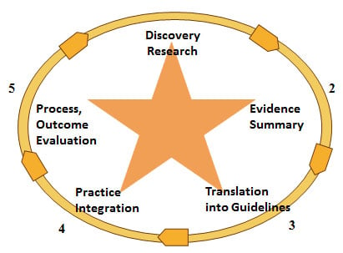

Note. Stevens, K. R. (2004). ACE Star Model of EBP: The Cycle of KnowledgeTransformation. Academic Center for Evidence-based Practice. http://www.acestar.uthscsa.edu/Goals/www.acestar.uthscsa.edu
A thorough analysis of how each phase of the STAR Model relates to this journey is outlined below:

Knowledge Discovery
The initial stage of the STAR Model is gathering and creating new knowledge through thorough projects. In the context of AHRQs fall toolkit this phase entails identifying. Compiling recent project related to fall prevention risk factors and effective interventions as outlined by Brunt & Morris (2023). Educating nurses during this phase involves introducing them to the project that serves as the basis for the toolkit. This may encompass studies, clinical trials and meta-analyses that showcase strategies and their efficacy in reducing falls, within healthcare environments (Brunt & Morris 2023).

Evidence Summary
After uncovering the knowledge, the following task involves condensing this information into easy-to-understand summaries. The falls toolkit from AHRQ accomplishes this by simplifying the project into practical guidelines and effective approaches (Brunt & Morris 2023). Teaching nurses during this phase emphasizes grasping these summaries (Brunt & Morris 2023). Instructional sessions could cover examining discoveries comprehending the reasons behind suggested practices and conversing about how these practices stem from thorough project.

Translation into Practice Recommendations
During this phase, the focus shifts to turning evidence summaries into specific and actionable practice suggestions as described by Song and colleagues in 2021. The falls toolkit offers practical steps, checklists, and protocols to help prevent falls. At this point education is centered on instructing nurses on how to put these recommendations into practice in their work routines. This involves engaging in hands on workshops role playing exercises and interactive modules that illustrate the application of the toolkit’s strategies, in real life situations. This step ensures that theoretical knowledge is effectively translated into skills according to Song et al. (2021).

Integration into Practice
Implementing the suggestions in real world scenarios is crucial for integrating them into the care procedures. For nurses this entails incorporating the fall prevention techniques outlined in the toolkit into their routines (Song et al., 2021). Educating nurses requires offering guidance on seamlessly blending these methods into patient care. This may involve hands on training, mentorship initiatives and ongoing opportunities for growth. Through practicing these approaches in a controlled setting nurses gain proficiency in effectively applying them (Song et al., 2021).

Evaluation
The final phase of the STAR Model concentrates on assessing how the combined strategies impact patient outcomes in reducing fall incidents using the fall toolkit. Educating nurses at this point involves training them to monitor and assess the effectiveness of their fall prevention efforts as mentioned by Song et al. (2021). This could involve teaching them how to gather and analyze data, comprehend performance indicators and engage in quality improvement projects. Continuous evaluation ensures that practices are refined and enhanced leading to improved safety and care quality according to Song et al. (2021).

Conclusion
In summary, the ongoing problem of patient falls and associated injuries in community hospital care facilities highlights the necessity for efficient strategies to prevent falls. The Agency for Healthcare Research and Quality (AHRQ) reports that a significant number of patients in hospitals experience falls each year leading to injuries and fatalities. Statistics indicate that 700,000 to 1 million hospitalized patients fall annually resulting in around 250,000 injuries and up to 11,000 deaths. However, these incidents can largely be prevented through assessments and interventions carried out during every shift.
The AHRQ has created a toolkit for fall prevention that serves as a model for enhancing quality improvement in healthcare environments. This toolkit is shared through webinars and PowerPoint presentations offering guidelines and strategies to reduce fall occurrences. It stresses the importance of educating nurses on fall prevention methods and equipping them with the necessary knowledge to conduct accurate assessments and implement successful interventions. Despite the availability of valuable resources, challenges persist in providing consistent education on fall prevention and implementing these measures across community hospital care settings. These challenges often arise from training, familiarity, with fall prevention tools and obstacles presented by the ongoing COVID 19 pandemic.
The pandemic made things worse in nursing homes by leading to a shortage of nurses and bringing in newbies who lack hands on skills especially for assessing falls and monitoring medications. The switch to online learning platforms also made it harder for nurses to develop nursing skills. To tackle these issues, it is essential to reintroduce and reinforce AHRQs guidelines on preventing falls among nurses making sure they have the knowledge and tools to effectively reduce fall risks. Offering in person training sessions with practical demonstrations, open discussions and useful resources can significantly enhance how well nurses retain and apply fall prevention techniques. This method helps them grasp the factors contributing to falls, such as changes in mental state, poor balance control and sedation from medications empowering them to address these issues proactively.
Furthermore, the project emphasizes the significance of compassion in nursing practice by urging nurses to integrate fall prevention strategies into their caregiving routines and educate their colleagues on these crucial actions. As nurses working in community hospital care settings become more skilled in using AHRQs Fall Prevention Toolkit they can share this knowledge with their peers raising the quality of patient care, across the board.
The importance of this project is further emphasized by the concerning data from Healthy People 2030 which aims to decrease fall related deaths in adults. With the rate of 78.0 deaths per 100,000 falls exceeding the target of 63.4 deaths per 100,000 falls there is a pressing need for effective interventions. Falls not put patient safety at risk but also complicate existing health issues potentially resulting in serious consequences such as hindered rehabilitation or even loss of life. This sense of urgency underscores the requirement for successful fall prevention strategies.
Nursing practice plays a role in preventing falls and ensuring patient safety. When patients come to healthcare facilities they anticipate recovering and going back to a active lifestyle. Unfortunately falls during treatment increase their susceptibility to harm and complications. Therefore, this academic practice project aims to make an impact on nursing practice by reducing fall occurrences through extensive education and effectively sharing the AHRQ toolkit with nurses. In summary the objective of this project is to decrease fall incidents and enhance safety in healthcare settings.
Nursing research is continuously advancing, concentrating on refining systems and toolkits to boost safety. National studies have explored assessments and scoring systems developed to reduce fall risks, in community hospital care environments. Projecting the importance and consequences of falls, nursing research strives to create evidence-based approaches that enable nurses to implement efficient preventive measures. This project plays a role in grasping the wider impact of falls and devising methods to ensure patient well-being.
Essentially according to the AHRQ providing nurses with education and resources for fall prevention is crucial for enhancing patient safety in community hospital care facilities. By promoting a culture focused on managing fall risks and encouraging collaboration among healthcare professionals’ providers can enhance protection for at risk patients and elevate the overall quality of care. Continuously educating and empowering nurses with skills and knowledge is key to minimizing falls and injuries ultimately fostering safer and more efficient healthcare environments.

Chapter II: Review of Literature

Literature Review Inclusion Criteria
The selection of articles for the literature review about educating Nurses about fall prevention in healthcare settings was based on how each article addressed the topic of nursing education about fall prevention. Studies included in the review were restricted to those published from the past five years as peer-reviewed journal articles, and clinical guidelines. Specifically, it focused on adult patients in healthcare settings and studied a variety of project designs to understand fall-related outcomes as well as educational impacts. All of the articles were in English. Included areas covered relevant geographic areas for accessibility. Given that these studies were not complete texts, they must be accessible.

Literature Review Exclusion Criteria
Criteria for the selection of the studies for educating nurses about a fall toolkit regarding falls, fall prevention, and nursing education were used in the following project to review studies on educating nurses about fall prevention. Studies on pediatric populations or nonhealthcare settings published before five years old were excluded, as were peer-reviewed sources articles. Studies with methodological issues and additions, anecdotal reports, and commentaries were not considered. To ensure that the review included high-quality and relevant research, articles in languages other than English were omitted, and studies that duplicate were included those lacking relevant outcomes or those with inaccessible full texts.

Introduction
As the global population makes more people old, there are concerns about the health and well-being of the senior population. Falling is a problem in older individuals, including risks for fractures or head injuries, which can compromise the overall quality of life.
It is important to understand the reasons why elderly people fall in order to help prevent them from doing so. This review closely examines the existing body of project conducted on adult falls, focusing on how many occur, what causes them, what the consequences are, and what prevents them. Research is undertaken in this area to learn more about falls in the elderly and to discover areas requiring further research. By laying a foundation for further project of how nurses may take an active role in educating and supporting older adults in care facilities to reduce fall risks and promote patient safety, this chapter serves to do just that.
This literature review systematically reviews a number of papers published between 2020 and 2025 in the CINAHL database based on predefined keywords like falls, prevention, nurses, fall assessments, fall scales, fall injuries, and patient education. This selection of these sources is to ensure the project's credibility and reliability. To inform evidence-based strategies and best practices for preventing falls among older adults, this review considers key studies, theories, and empirical evidence concerning falls among older people. In this section, existing knowledge is utilized to support the efforts in preventing the health, well-being, and independence of elderly individuals prone to falls by identifying future project directions in this area.

Literature Review
A typical and risky issue concerning the older adult is the fear of falls. These statistics show that falls can cause sickness and death in this age group and often results in fractures, head injuries, or a diminished quality of life. Preventing mammographic breast density change is important to establish the causes that may lead to falls in elderly female patients. This chapter undertakes a review of the literature in an attempt to assess the prevalence and consequences of falls in the elderly while making a specific endeavor to consider epidemiology, risk factors, outcomes and preventive measures associated with the problem at hand. The purpose of this review is to systematically compare and discuss previous project on falls in older people and to discuss the remaining questions that have emerged during this study.
The section is simply an introduction of the section that discusses the literature review in detail, stressing the rigor of the project proposed. It enables conversations about the substitution of nurses with best practices for the older adult in long-term care facilities. Keywords used in this literature review were falls, preventive strategies, the role of nurses, fall risk assessment tools for assessing failure, falls and injuries, and patient education. This makes the project credible and significant to the development of industrial relations theory and practice.
This review of literature explores project theories and findings in relation to falls in the elderly population. The purpose is to offer suggestions for developing interventions and procedures to eliminate falls in this high-risk population, as well as extend the knowledge base and identify future project prospects. This section aims to contribute to the promotion of initiatives that would improve the quality of life, security, and the level of independence of elderly people susceptible to falls.

Prevalence and Consequences of Falls for the Elderly.
Falls in the elderly cause extensive morbidity and mortality. These lead to fractured skulls, head injuries, and poor quality of life. So, preventing falls requires a knowledge of epidemiology, risk factors, outcomes and effective interventions. Falls in the healthcare setting raise hospitalization costs, length of stay and rate of institutionalization. The fall related complications research calls for early intervention and risk assessment strategies (Lopez et al., 2023; Schober et al., 2022). In the long-term care facilities, falls have been observed more often as the environmental factor, frailty, cognitive impairment, and polypharmacy are some of the factors that increase risk of falls (Baixinho et al., 2022). According to data, it is estimated that around 30% of adults over 65 falls at least once per year and 10% of these falls end in serious injury (Haines et al., 2021). Furthermore, falls are among the major causes of traumatic brain injuries in the older adults leading to higher disability and functional dependence (Baixinho et al., 2022). Falls also add to the risk of premature mortality; the studies have found that there is a 50% one-year mortality increase in those who are older and sustain a hip fracture due to falls (Morris et al., 2024).
Most often, the injuries resulting from a fall require long periods of rehabilitation and are associated with long term functional limitations, increased dependence on caretakers, and lower quality of life. Self imposed activity restriction in order to avoid falls is a common consequence resulting in physical deconditioning and further increasing fall risk (Schober et al., 2022). In addition, falls place additional stress on the healthcare system, because fall related injuries cost billions of dollars in medical expenses each year. Fall related disabilities are not only striking financially but also to families and long term care facilities that are becoming responsible for supporting fall related disabilities (Baixinho et al., 2022).

Risk Factors Contributing to Falls
There are intrinsic and extrinsic factors which are related to falls. Age related physiological changes including impaired balance, decreased muscle strength, vision impairment and cognitive decline are intrinsic factors (Alsaad et al., 2024). They also suffer from chronic conditions like diabetes, arthritis, cardiovascular disease, that contributed to instability and increased fall risk (Schober et al., 2022). Falls are said to be attributed by medications like sedatives, antihypertensives and psychotropics (Heng et al., 2022). Nutritional deficiencies, especially in vitamin D, have been also associated with impaired muscle function and increased fall susceptibility (Lopez et al., 2023). Thus, dehydration and poor hydration status are also considered risk factors because they cause orthostatic hypotension and dizziness, both of which are associated with falls (Baixinho et al., 2022).
Environmental hazards like inadequate lighting, cluttered walkways, slippery floors, no assistive devices are all examples of extrinsic factors (Heng et al., 2022). Apart from excitement, poor footwear choices, including high heels or loose earned shoes also add to the risk of falling (Schober et al., 2022). In addition, poor home and institutional safety measures including unsecured rugs, the absence of handrails, and the wrong bed height greatly increases fall risks (Morris et al., 2024). Risk assessment tools such as the Morse Fall Scale and the Hendrich II Fall Risk Model are stressed in studies as the means to anticipate high risk patients and guide specific intervention (Schober et al., 2022; Alsaad et al., 2024). Therefore, implementing regular risk assessments have been proven to reduce falls in the healthcare and community settings (Morris et al., 2024). Although the use of institutional policies that encourage actions such as routine fall assessments and proactive intervention strategies can reduce fall related injuries on populations that are in risk, these remain those that dominate (Baixinho et al., 2022).

Interventions and Prevention Strategies
Targeted risk factors for multifactorial interventions include fall prevention programs. Interventions based on exercise, like balance and strength training, have reduced fall risk of falling postural stability (Heng et al., 2022). Resort to Tai chi and resistance training programs showed remarkable improvements in balance control and gait stability, lowering the fall rates among the elderly (Lopez et al., 2023). Pharmacists and physicians conduct medication reviews to spot high-risk medication and modify dosages (Lopez, et al., 2023). Most environmental modifications to decrease fall incidents, for instance, placing grab bars, improving lighting, and removing trip hazards, have been in home and institutional settings and have been effective (Schober et al., 2022). Early fall detection and prevention is already implemented using assistive technologies; for example, implementing motion sensors, pressure sensitive floor mats (Baixinho et al., 2022).
Thus, fall reduction programs were developed in the community aimed at increasing awareness and encouraging participation in fall risk reduction activities. The activities of these programs include group exercise sessions, home safety assessments, and educational workshops (Morris et al., 2024). Furthermore, telehealth interventions have already served as a way of delivering fall prevention education and fall-monitoring to older adults at home (Ojo & Thiamwong, 2022). More recently, the use of artificial intelligence driven alert systems in long term care facilities has also facilitated a quicker fall detection and a faster response time (Baixinho et al., 2022).

Nurses' Role in Fall Prevention
Fall prevention by nurses includes assessing the risk and educating the patients as well as implementing preventive measures that will help the elderly to reduce the fall. Nurses are recommended by clinical guidelines to continuously monitor, reassess individual patient’s mobility levels, and in collaboration with interdisciplinary teams develop individualized fall prevention plans (Alsaad, Kocal, Bloor, and Mhanna, 2024). Lopez et al. (2023) indicate that studies indicate gaps between what nurses know about, their attitudes toward, and their current practices in fall prevention. In certain circumstances, appropriate execution of fall avoidance programs (Schober et al., 2022) is hampered by lack of staff on hand or time restrictions. Nurses who have access to adequate resources, sufficient training and support as provided by workplace policies are more effective in preventing falls (Baixinho et al., 2022).
Promising results have been reported to expand the role of advanced practice nurses (APNs) for fall prevention (Narr and Dunton, 2018). Specialized fall prevention teams can be led by APNs to conduct patient specific assessments and provide comprehensive intervention plan (Heng et al., 2022). Furthermore, fall prevention training should be included in nursing curricula to improve the future nurses’ management of fall risks (Morris et al., 2024).

Education and Awareness Initiatives
Education of patient and caregiver reduce fall incidence. Interventions that target the community and hospital education programs lead to enhanced awareness and better adherence to fall prevention methods. Mobility exercises, medication management and environmental safety are what patients are taught to prevent falls, which increases their self efficacy (Heng et al., 2022; Chidume, 2021). Virtual learning modules and mobile applications for educating patients have proved to be interactive and useful with the potential of enhancing patient engagement and retention (Ong et al., 2021). In furtherance of the foregoing, caregiver training programs have been demonstrated to enhance the capacity of family members or home caregivers to participate in elderly individuals’ fall prevention strategies at home (Ojo & Thiamwong, 2022).
Mass media, social network, and community outreach programs have proven to be useful for educating a wider audience about fall prevention strategies (Schober et al., 2022). The implementation of the multilingual fall prevention resources promotes an increased accessibility for underrepresented populations, tending to unequal healthcare education (Baixinho et al., 2022). Future studies should examine long term effectiveness and scalability of educational interventions in the target populations (e.g., older adults with cognitive impairment) (Ojo & Thiamwong, 2022). Increasing the awareness of fall prevention through initiatives in the city's healthcare institutions to community settings, senior centers, and even among family networks may also assist in the prevention of fall related injuries to the elderly population.

Supporting Literature

Enhancing Nurse Readiness and Confidence
Dykes and team members developed a nurse-managed fall prevention toolkit that decreased patient falls in hospitals. The nurses grew stronger in their ability to protect patients from falls through proven methods. A systematic fall prevention process lets nursing staff develop their ability to analyze risks and solve problems in their daily work.
Duckworth and colleagues examined targeted workshops for nurses by checking their preparedness before and after specific intervention to show how training gets nurses ready and follows step-by-step fall prevention actions. A structured teaching format lets nurses learn better about patient fall risks plus how to check and respond to these risks. Project results show that multiple workshops and continuing education classes improve nurse retention of fall prevention knowledge for making it part of their routine work.
Through their evaluation Spoelstra and colleagues (2012) discovered that educating nurses boosted their important role in reducing patient falls. The program used proven fall prevention methods by adding them to regular hospital procedures. Nursing staff must be meaningfully involved in creating and applying fall prevention solutions to see better success in patient care.
According to Tzeng et al. (2011) nurses who attended fall prevention training reported better preparedness to take active steps in protecting patients from falls. Research confirmed the need for ongoing nurse education to keep them skills up to date on fall prevention methods. Nurses with direct engagement during training workshops and patient simulators reached higher levels of problem-solving in-patient safety issues.
Hill et al. (2015) revealed through their work that nurses who received fall prevention simulation training became better equipped to apply those safety strategies. Through simulation-based learning nurses could practice exactly what they had learned in theory and put it into practical use for better skill retention. Our data shows that specific medical situations help students better connect what they learned in class with their patient care duties to serve patients better.

Implementation Strategies and Outcomes
Hempel et al. (2013) analyzed fall prevention toolkits through their complete research process to discover what educational approaches and leadership backing produced the best results. The project shows that maintaining effective fall prevention needs standard educational programs plus leadership backing and safety awareness across the team. The review recommended nursing staff should include proven fall prevention methods in their regular work procedures to ensure ongoing success.
Miake-Lye et al. (2013) researched multiple fall reduction programs showing that those with nurse instruction yielded better results in falling incidents decrease. Their research proves that hospitals must offer both new staff and experienced nurses fall prevention lessons as part of their training schedule. The medical centers that kept fall prevention training active achieved a 30% decline in patient falls during their first year of operation.
Titler et al. (2016) showed that continuous nurse education and hospital backing help keep patient fall rates low through their project. Through their research the experts found that patient falls rise when health facilities stop implementing consistent fall protection plans. The researchers suggested performing annual skill checks and educational updates to keep nurses involved in and following fall prevention guidelines.
According to Oliver et al. (2010) comprehensive training sessions for nurses along with other fall prevention approaches delivered the most falls reductions. Research showed that both single training methods and comprehensive patient assistance measures worked better than workplace changes alone. Physical therapy and pharmacy partnership helped teams achieve better patient results during fall prevention activities.
Ganz et al. (2013) based their recommendations on evidence to show that nurses need proper training to make fall prevention work. Their project proved that regular evaluation will help nurses supervise medical teams to follow recommended fall protection procedures. Nursing units built dedicated fall prevention champions to maintain nurse adherence to safety practices while creating safer work environments across their departments.

Barriers to Implementation and Solutions
Koh et al. (2008) uncovered regular obstacles that nurses encounter while using fall prevention toolkits including time problems and shortages which they solved with leader backing and practical system improvements. Their research discovered that nurses spend most of their time handling daily duties and treating many patients which makes them struggle to prevent falls without help from their employers. The research shows administration needs to supply enough staff and supplies so nurses can fully use new fall prevention methods.
Dykes and colleagues studied the problems hospital staff experienced when using toolkits to prevent falls so they suggested training for unique operating requirements. Customized educational programs that match organizational differences lead to better results in boosting healthcare staff compliance. Digital learning materials helped us deliver training programs to all employees working different shifts and locations.
According to research by Spoelstra and associates (2012), mentorship programs with peer support produce better results in falling prevention teaching for nurses. Their research revealed peer teachers help nurses both apply and remember their learnings better. Hospitals using mentorship programs helped nurses stick to their fall prevention rules better and built up their skills after new staff training.
Hill et al. (2016) showed that nurses needed regular feedback and praise to implement better fall protection techniques. Giving nurses regular appraisals of their work performance and feedback keeps them committed to proper practice methods. Nurses showed greater responsibility and motivation when their work received recognized through rewards.
According to Tzeng et al. (2012) a nurturing work environment makes nurses more eager to put fall prevention methods into action. They demonstrated that leaders who support their teams and engage staff in quality improvements help create strong safety environments and get staff to follow fall protection steps.

National Guidelines on Fall Prevention in the Elderly
The Agency for Healthcare Research and Quality (AHRQ) develops all-inclusive standards to prevent falls among senior patients. The government guidelines promote proven strategies by asking staff members to evaluate patients while giving all workers training and helping different medical teams work with patients. The AHRQ Fall Prevention Toolkit stands as the essential learning tool for nurses to acquire skills that lower fall hazards at patient care areas. AHRQ recommends training health staff regularly while implementing a uniform fall risk evaluation process and constructing personalized protection methods to achieve improved patient protection in medical environments.

Conclusion
In conclusion, the trip to prevent falls among the elderly has been educating, thereby enriching understanding of the extent of this problem. Healthcare workers, caregivers, lay people, and policymakers were therefore assembled for the project to underscore to them a model for an approach to promoting preventive measures for adults’ welfare. Having discussed the aspects of the fall risks and the measures that may be appropriate more carefully, we have highlighted the importance of the clients ‘centered and targeted approaches, including exercise, environmental, vision, and medication management. Such specific interventions may help considerably to prevent falls. Reduce the impacts they have on persons.
Furthermore, the present literature review has revealed the role of healthcare workers, caregivers, and members of society. Preventing falls requires a lot of determination and cooperation between the patient and the physician. Nurses ensure senior safety by fostering and encouraging correct care measures and arming people with information that would enable them to make proper health decisions. By providing older people with a safe environment with close to total independence, nurses can help them achieve this.
According to the findings of this study, it is essential to continue the cooperation of many interested parties to ensure the continuation of work begun by this project. For this, caregivers, healthcare professionals, members of the community, and policymakers need to come together and use measures for dealing with the risk of falling. It is for this reason that, by bringing together various disciplines and enhancing the way we interact with communities, we can strive to reduce the number of injuries and hospitalizations caused by falls.

Chapter III: Methodology

Introduction

This chapter provides a description of the methodological approach to the scholarly practice project on The AHRQ's Fall Prevention Toolkit for nurses in a selected Long-term Care unit (LTC). This chapter will provide details of the project design features, the techniques, and the process that will be used to implement the project goals. This chapter also outlines steps of the evidence-based practice (EBP) model, which serves to underpin the practical evaluation of the project.
This methodological approach is a helpful guide to achieving practical implementation and programming of the educational program evaluation. The approach taken in this chapter is to describe what was done and explain why certain methods and approaches were implemented. The purpose is to define clear objectives that reflect a logical framework to achieve the goals of the project dedicated to increase patient safety due to the improvement of the nursing procedures.

Project Design

This project uses a mixed project design of quantitative (pretest and posttest design) and qualitative design (open-ended answers). This project is described as a mixed methods project design consisting of quantitative and qualitative components. Evidence-based practice (EBP) project where the focus is on the enhancement of nursing practices concerning fall prevention. The practice change proposal requires developing an educational session to provide nurses with the readiness and confidence for using a fall toolkit (Huang et al., 2021). The educational intervention aims to address the issues of fall risk factors, environmental interventions in the long-term facilities, and stimulating intervention techniques to address falls.

Project Methods/Plan and Procedures
The Evidence-Based Practice (EBP) STAR model, as described by Moran, Gates, Burson, Allen, and Pence (2020), will be used to guarantee a logical workflow for the project.
- Identify the Problem: The first step is acknowledging that patient falls are standard in LTCs and, therefore, constitute a safety problem. This identification anchors the problem with available knowledge and best practices for fall prevention (Huang et al., 2021).
2. Gather Evidence: A literature search was performed to gather available information on fall prevention and educational intervention for nurses. This evidence was useful for forming the educational program, and it is said that such evidence is supported by the results of the project in the works of Davis et al., 2022.
3. Appraise Evidence: The collected data was critically analyzed in terms of its validity, reliability, and usefulness relevant to the Long-term Care setting. It was also important at this point to note that if the issue is reformulated, this evaluation is crucial for establishing that the evidence selected is appropriate to address the given problem (Bowers et al., 2023).
4. Design the Practice Change: According to the outlined evidential appraisal, an individual educational program that encompasses curriculum content, teaching methodologies, and forms of assessment will be developed. This program will be unique and cater to the nurses' training needs in the selected geriatric units (Huang et al., 2021).
5. Implement the Practice Change: A pre-test assessment will be given to evaluate existing knowledge and practices in fall prevention to implement the educational initiative for nursing staff on the AHRQ's Falls Toolkit. This assessment involved conducting surveys and facilitating discussions to identify knowledge gaps and areas for improvement.
Furthermore, an effective sequence of training sessions was planned and implemented to verbally present information and have group discussions with nurses. In these sessions, a brief of the Falls Toolkit which has been designed by the Agency for Healthcare Research and Quality (AHRQ) to help the healthcare professionals prevent or minimize the risk of the patient falls. This is comprised of best practices, screening and assessment, and interventions. After the training, the posttest is administered and feedback from the participants will be collected to assess their knowledge of the toolkit as well as their readiness toward it. This integrative approach was designed to increase the current extent of knowledge and actual practice of the nurses in preventing the occurrences of fall among the patients, hence boosting the safety of the patients.
6. Evaluate the Outcomes:
this is analysis
7. Disseminate: The last approach will be to incorporate measures that will ensure that the practice change is continued after the project's completion. This might require the development of a plan for follow-up training for new staff to encourage growth. These results will be shared with the department staff and the heads of facilities and may also be published in a peer-reviewed Journal of Nursing (Moran et al., 2020).

Measurable Objectives
This project seeks to:
- Create an educational intervention based on the AHRQ toolkit for fall prevention.
- Increase nurse's knowledge levels about fall prevention using current evidence.
- Improve nurse's confidence levels about fall prevention.
- Inspire motivation levels in Nurses to use the AHRQ toolkit for fall prevention in practice.

Evidence-Based Clinical/Practice Question
Does An educational intervention about the use of the AHRQ Toolkit for fall prevention improve knowledge, confidence, and motivation levels for nurses in Long-term Care?

Setting

The proposed site for this project is a Long-term Care, acute care geriatric care center, on the east coast in The United States of America. This LTC care center serves many clients and offers almost all the specialties and facilities of a rehabilitation center, such as palliative care, geriatric care, and a rehabilitation services unit. These units are known to hold occupancy 85%-90% as there is constant inflow of patients requiring acute care. Falls pose increased risk to this population of patients’ health and wellbeing; thus, the LTC is the right setting to make use of the AHRQ falls toolkit.

Sample

The small number of participants available in the chosen long-term care facility sets the practical sample range at 25 to 30 nurses. Results will be assessed for real-world importance through their connection to statistical data as we aim to prevent errors in conclusion. The research team will work towards maintaining perfect data records in order to build sound analytical outcomes.
In identifying 25-30 participants, nurses with experience in Long-term Care settings for this scholarly project on the AHRQ’s Falls Toolkit, the primary investigator (PI) has a broad awareness of the issues and the approaches useful in implementing fall prevention across the population of interest.

Sampling Method
Participant recruitment for the project will involve using a convenient sampling method. This approach has several advantages:
1. Efficiency: Convenience sampling enables quick identification of nurses who are easily accessible in the units of LTCs. This is a boost to the one side given the requirement that begin the fall prevention toolkit.
2. Accessibility: Since the participants will be drawn from nurses working in the identified units, the project can guarantee that participants are well acquainted with the practices and issues concerning fall prevention within their arena. Such familiarity means an increased ability to make the educational program relevant and effective in meeting the learner’s needs.
3. Immediate engagement: Convenience sampling promotes the use of immediate access to participants who have an interest in their setting. This investment may result in better chances of nurses’ stake holding in the educational program since they can easily associate the training with their work.
4. Limitations: It is necessary to state that convenient sampling has its drawbacks. On the one hand, it is effective in terms of the time required to implement the project. This method may also introduce bias because, during the project, only nurses who are association members will be contacted. The project could not capture the views of nurses from a few selected units or nurses with different working experience levels. The project involves a sample of 20-30 nurses and convenience sampling to guarantee the consideration of the project’s value for fall prevention education while remaining feasible and timely.

Recruitment Plan
Participants will be recruited via flyer invitation located on break room tables and nursing station bulletin boards across the facilities (See Appendix F). In the invitation, the scope of the project and its goals and possible outcomes if people participate will be also briefly described. The educational intervention will be provided in a power point that will be provided in Qualtrics software, once the Regis informed consent (See Appendix G), Flesch-Kincaid Grade Level for the informed Consent (See Appendix H), demographic survey (See Appendix I), pretests (See Appendices ???) are complete. This will then be followed by the posttests and open-ended questions (See Appendix M). Once the consent is signed, the participants will be deidentified and given a random numerical value. This protects the confidentiality and anonymity of the participants. Only the PI and the Project Chair will have access to the data collected in Qualtrics.

Sample Size

The G*Power tool helped find the correct number of participants for the project. The research uses a paired t-test to examine how nurses develop their subject matter expertise, comfort levels, and drive as they consume the AHRQ Fall Prevention Toolkit knowledge materials. The necessary power to distinguish important statistical results came from this sample size calculation based on these properties:
The effect this project produced was moderate (Cohen's d = 0.5)
Alpha (α): 0.05
Power (1 - β): 0.80
Test: Paired t-test
Sample Size Range: 25-30 participants

A project of 25 nurses has a statistical power value of 0.41, whereas a project of 30 nurses increases power to 0.46. Based on these values, the project can find significant effects of medium size and up but struggles to uncover minor effects.

Inclusion and Exclusion Criteria

To be considered as a participant in this project the following inclusion and exclusion criteria will be used to determine entry into this project.

Inclusion Criteria
1. Must be a Registered Nurse (RN) or Licensed Practical Nurse (LPN).
2. Must work in Long-term Care (LTC).
3. Must be willing to complete the entire project.
4. Must be able to read and speak English.
Exclusion Criteria
1. Not a Registered Nurse (RN) or Licensed Practical Nurse (LPN).
2. Not work in Long-term Care (LTC).
3. Not willing to complete the entire project.
4. Not able to read and speak English.

Informed Consent
Informed consent and permission from the Regis IRB for this scholarly project will be obtained prior to beginning implementation of the project (See Appendix G). The informed consent document will discuss the goals, risks, benefits, time allotted, and confidentiality measures for the project. In addition, the Flesch-Kincaid grade level determination will be compiled regarding the informed consent readability (See Appendix H).

Ethical Considerations
Several ethical considerations are crucial in implementing this project to safeguard respondents and the general research process. The following areas of ethical considerations: consent, doing good and minimizing harm, anonymity, confidentiality, and privacy will be discussed:
1. Informed Consent: There must be documented consent from all the participating nurses. Included in this process is a detailed description of the purpose, nature, and plan of the project, possible risks or hazards inherent in the project, and likely positive outcomes of the project for the participants.
2. Beneficence-Do Not Do Harm: The principle of beneficence entails the fact that the given project must be structured in a way that optimizes benefits, while minimizing harm upon participants. The format of the educational session and the resulting evaluation should be designed to increase the knowledge of the nurses without creating burden within the setting.
3. Respect for Anonymity and Confidentiality: This project also means that participants’ anonymity and confidentiality must be guaranteed to a certain extent. The questionnaires are designed in such ways that information collected bare no identifiable resemblance of people who filled them. Feedback is honest and receptive because of this protection. Anonymity and confidentiality will be maintained by PI only having access to the answers the participants complete.
4. Respect for Privacy: There is the need to ensure that participants' privacy is protected during the conduct of the project. This ranges from the way data are collected, processed, analyzed, and reported. Self-information is important to protect especially its privacy, while this educational session is vital. Ensuring that all listed above are protected, the PI will be the only person who has access to the vital private information of participants. The usage of participants' names and working locations will not be used to assist in securing their identity.

Intervention
Through PowerPoint slides the Principal Investigator will teach nurses in LTC facilities about the AHRQ Fall Prevention Toolkit (See Appendix O). This presentation relies on proven research to teach LTC nurses about fall prevention techniques including how to spot risks, when to act, and how their team should work together after falling patients (AHRQ, 2023). A PowerPoint including proven fall prevention methods and valid evaluation tools such as the Morse Fall Scale will guide nurses through real-world practice implementations (Morse, 2009). Through the presentation the PI wants nurses to learn the same training methods that work best when putting fall prevention into their regular work tasks. Nurses will learn about fall prevention properly through viewing toolkits on slides and discussing real examples in the educational presentation. The new approach will let nurses recognize fall hazards better and use validated methods while joining LTC quality improvement works (Tzeng & Yin, 2021).
Nurses who participate will learn how to properly use the AHRQ Fall Prevention Toolkit at LTC facilities through training sessions. The program teaches nurses how to recognize patient fall risks and manage them with team support along with helping patients recover after falls. Fall prevention demands all healthcare personnel work together with hospital management while improving care quality daily (AHRQ, 2023).
The training helps nurses properly use validated fall risk assessment systems like the Morse Scale and Timed Up and Go (TUG) Test plus the Hendrich II Model (Morse, 2009; Hendrich, 2013; CDC, 2022). Using these assessment tools healthcare providers determine what causes falls for individual patients by detecting both body (intrinsic) and facility (extrinsic) risks before developing personalized protection plans (AHRQ, 2023).
Nurses will learn to use various approaches such as environment changes, medication analysis and physical therapy assistance to prevent falls (LeLaurin & Shorr, 2019). The program will teach nurses to work together with CNAs pharmacists and rehabilitation teams through integrated training (Tzeng & Yin, 2021). Nurses will project leadership methods at work and home through the program to command care delivery and champion fall prevention throughout their daily routines (AHRQ, 2023).
Through the planned program nurses will start as quality improvement professionals to advocate for health policies while implementing solutions that navigate system obstacles and keep fall prevention active (Tzeng & Yin, 2021). Part of nurse's training will involve monitoring post-fall routines by hosting huddles to examine root causes while analyzing fall data for quality improvement purposes (AHRQ, 2023).
The complete training helps nurses become experts in spotting and stopping falls plus leading staff and delivering follow-up care for patients who have fallen. They will lead the way in decreasing patient falls while enhancing healthcare results and promoting safety throughout LTC facilities (CDC, 2022).

Evaluation

Variables

The demographic data of nursing staff are established as the first independent variable defined by Polit and Beck (2017) as participants’ characteristics, such as age, gender, experience, training, etc. This profile will be assessed with the help of the demographic questionnaire that will reveal special data concerning the given factors. The level of adoption of the AHRQ Falls Toolkit is a measure of readiness, defined as the extent to which nursing staff support the use of the falls toolkit in practice based on the AHRQ (2019). Readiness will be measured by the C-Scale, which will be given to the participants before and after the education session, and the scores will show different levels of readiness. Another dependent variable is the perceived implementation climate which Barker et al. (2020) describe as the beliefs that nursing staff has about factors that inhibit or facilitate use of the toolkit. These barriers would be discovered from general survey responses that include an open answer question. Finally, the willingness to implement the toolkit is another dependent variable which is defined as the readiness and intention of nursing staff to use the toolkit after receiving the educational interventions. This willingness is going to be assessed by using the Intrinsic Motivation Inventory (IMI) survey using questionnaires before and after giving the educational sessions so that we can determine if there are any changes in the intent. In general, this structured methodology provides sufficient clarity in the identification and operationalization of the variables considered essential for the project.

Tools/Instruments

This project begins with nurse readiness as the trigger for adoption of the toolkit. Falls are still a major issue in LTC, where they are a source of great safety and cost issues. In the prevention of similar incidents, nurses can succeed only when they are confident and equipped.
LTC nurses will be provided education by the principal investigator on the AHRQ’s Falls Toolkit; perceived barriers are strength to implementation will be evaluated. The outcome of nurse preparedness and confidence is measured using standardized surveys. Customized educational programs are informed by the prior evaluations and are used to increase staff commitment (Melnyk & Fineout-Overholt, 2022). There are pretest and posttest surveys that indicate the changes in nurse readiness and confidence. The data from the surveys offer areas where further support is needed to maintain the use of the toolkits.
The numerical data as to the nurses’ perspectives at different stages before and after the training will be tracked and the implementation barriers identified (Titler, 2021). Through data analysis, it is determined that workplace challenges, resource limitations, training needs can be identified (Cullen et al., 2023).

Demographic Survey
To assess the findings of this educational intervention, a demographic data sheet will capture essential information about participants, including age, gender, years of nursing experience, and prior training in fall prevention (See Appendix I).
Age:
A project will evaluate how participant age impacts their usage readiness and self-confidence and motivation regarding the AHRQ Fall Prevention Toolkit.
Gender:
The evaluation determines whether staff members display different levels of perception and execution for fall prevention approaches.
Years of Nursing Experience:
The project aims to determine whether nurses with different working levels demonstrate various levels of confidence and preparedness when implementing fall prevention methods.
Prior Training in Fall Prevention:
The previous education nurses received is being assessed for its effect on their present-day knowledge base and confidence levels.
Primary Role in the Facility:
The data collection consists of collecting responses according to different healthcare staff designations such as registered nurse, licensed practical nurse and nurse aide.
Shift Schedule:
The project aims to determine if nurses working different shifts (day, evening or night) display different assessments regarding both fall risks and intervention methods.
Highest Level of Nursing Education:
The project determines how education level influences the preparedness and self-assurance of nurses when applying fall prevention approaches.
Previous Use of the AHRQ Fall Prevention Toolkit:
Staff members will be evaluated on their understanding of the toolkit alongside their experience with adopting the toolkit before.
Facility Type and Unit:
The Project seeks to identify what type of unit’s participants work in between skilled nursing and rehabilitation and memory care because these affect both risk factors for falls and intervention methods.
This demographic information will reveal patterns and relationships as well as possible hindrances that influence successful implementation of fall prevention methods in long-term care (LTC) facilities.
2.

Instrument #1 Confidence Scale (C-Scale)
According to Grundy (1992), nurses must have confidence to provide adequate care to their patients and clients (See Appendices J & K). Ramezanzade et al. (2024) emphasize that self-confidence among nursing students and practicing nurses leads to better patient outcomes. Enhancing self-confidence requires education and training. Furthermore, Parekh de Campos et al. (2020) point out that nursing students and practicing nurses frequently feel inadequate in palliative care. This challenge can be met by incorporating palliative care into nursing curricula and offering ongoing training and support to clinicians.
The Confidence Scale (C-scale), developed and published by Dr. Grundy in 1992, is a key tool for systematically assessing individual confidence levels (Grundy, 1992). This scale consists of five statements evaluated with a Likert-type format. Participants respond to each statement by assigning a rating that ranges from 1 (representing no confidence) to 5 (representing extremely high confidence). The C-scale offers a structured method for quantifying subjective confidence, supporting research and practical applications across various fields.

4. Instrument #3 Intrinsic Motivation Inventory (IMI):
According to the Center for Self-Determination Theory (CSDT, 2024), the Intrinsic Motivation Inventory (IMI) is a psychometric scale designed to assess participant's subjective experiences and levels of intrinsic motivation at the end of the project (See Appendices L & M). This inventory is an invaluable tool for researchers to quantify and analyze the motivational dynamics underpinning participant engagement within experimental contexts. The IMI encompasses the assessment of several subscales, including interest/enjoyment, perceived competence, effort, value/usefulness, felt pressure and tension, and perceived choice. Additionally, the organization incorporates a subscale related to relatedness; however, it asserts that the validity of this subscale has yet to be established.
The principal investigator (PI) will utilize the activity perception questionnaire to evaluate participants’ experiences during data collection. This questionnaire consists of 25 items, categorized into three sections: interest/enjoyment (items 3, 5, 7, 11, 12(R), 15, 17, 23), value/usefulness (items 1, 4, 6, 10, 13, 16, 19, 21, 25), and perceived choice (items 2, 8(R), 9, 14(R), 18(R), 20(R), 22, 24(R)). Each item is rated on a scale from 1 (not at all true) to 7 (very true). Certain items, precisely 12, 8, 14, 20, and 24 are marked with an (R), indicating that their scoring is reversed; this means the score is subtracted from 8. The average scores from these subscales will then be recorded.

Open-Ended Questions (See Appendix N)
use about five questions you create to ask each nurse

Data Analysis

Quantitative data will be analyzed using Intellectus Statistics software. while qualitative data will involve summarizing and listing constant themes and patterns of the participant's views about fall prevention. The data collected in Qualtrics will be cleaned and downloaded to an Excel spreadsheet and uploaded to IntellectusStatistics for analysis. Descriptive statistics will be used to determine the percentages of the demographic data to create a profile of the population. For the quantitative data, paired t-tests will be conducted to analyze the group means from the pretests to the posttests. The IMI will be calculated as a posttest data point alone, with a score of 5 indicating high levels of intrinsic motivation. The alpha will be set for the p-value at <0.05.
Qualitative data including responses to the five open-ended questions will be collected in Qualtrics and downloaded to review for common themes. These will be presented in a table for Chapter IV.
Table 1
Timetable
DNP Activity/Task | NU740 | NU726 | NU727 | NU741 | NU742 | NU743
Choose your practice problem for EBP Project | Decide & Completed
SPP PowerPoint | Started | Refining | Refining | Refine | Refine | Pending the completion
SPP Paper | Started | Refining | Refining | Refine | Refine | Pending the completion
SPP Poster | Started | Refining | Refining | Refine | Refine | Pending the completion
Chapter I | Started | Refining | Refining | Refine | Refine | Pending the completion
Chapter II |  | Started | Refining | Refine | Refine | Pending the completion
Chapter III |  |  | Started | Refine | Refine | Pending the completion
Chapter IV |  |  |  | Begin | Refine | Pending the completion
Chapter V |  |  |  |  | Begin | Pending the completion
Proposal Defense | Started |  |  | Refine |  | Pending the completion
IRB/ Site Permission |  |  | Started | Pending the completion
IRB Regis |  |  | Begin | Pending the completion
Spp Conduct the Project |  |  |  |  | Begin | Pending the completion
Portfolio | Started | Refining | Refining | Refine | Refine | Pending the completion

Conclusion
This chapter offers a framework to implement educational strategies of the AHRQ Fall Prevention Toolkit implementation among nursing staff working in an LTC unit. The project design utilizes mixed methods with pre-test and post-test measurements combined with qualitative open-ended responses to examine knowledge growth as well as gather nurse feedback about their thoughts regarding fall prevention strategies. Through the Evidence-Based Practice (EBP) STAR model, healthcare organizations can systemically handle problems by evaluating evidence to generate interventions and perform implementation and evaluation.
The project runs a step-by-step process where base assessment tests determine initial knowledge and readiness, followed by training with AHRQ Fall Prevention Toolkit PowerPoint before concluding with end assessment tests that gauge knowledge and attitude modifications. The Iowa EBP Model functions as a theoretical systematic approach to evaluate confidence levels and readiness by using the C-Scale assessment and Intrinsic Motivation Inventory (IMI) to generate quantitative data about the intervention outcomes. Through open-ended surveys, the project team can collect qualitative information that reveals factors that assist or obstruct nurses in implementing fall prevention practices. The analysis of demographic data by Intellectus Statistics uses descriptive statistics, but paired t-tests monitor pretest-posttest changes. The follow-up analysis through the Intrinsic Motivation Inventory (IMI) assesses the nursing staff's intrinsic drive toward using the fall prevention toolkit. The open-ended response analysis through the thematic method will identify what barriers exist and what elements create favorable conditions for implementing positive practices.
The intervention receives comprehensive evaluation through research methods that track nursing knowledge development together with measuring their increasing confidence levels and motivation in fall prevention. The produced research findings will contribute to the scientific understanding of effective educational methods that facilitate the adoption of evidence-based practice in long-term care facilities. Research findings will provide guidance for quality enhancement activities aiming to reduce fall hazards as well as strengthen patient protection practices in long-term care facilities.

Chapter IV: Results

Introduction: Each Chapter should have an introduction.

This Chapter may be developed from the statistical analysis results from Intellectus StatisticsTM, SPSS, another software data analysis, or the steps used to do qualitative data analysis. However, the DNP student is expected to explain, in their own words, what each analysis means.

An opening statement on the overall purpose or intent of the project/project will prepare the reader to focus on the results presented. (Two to three sentences are usually sufficient.) In general, present the results starting with the demographics and the next most important findings as they relate to your project.

Types of results to include:

Demographic data
Who made up your sample? Discuss age, gender, and other collected demographics, expressed in frequencies and any categorization as appropriate for clarity. Discuss relevance of the collected demographics.

EBP Project data analyses
Present your results as it relates to each clinical/practice question, aim, or objective. Avoid stringing numbers and statistics together, as it can confuse the reader.

Qualitative data analyses
Present your results as themes with quotes from participants to support these themes. It is expected to have approximately 2-3 quotes per theme to fully support the phenomenon of interest. For qualitative projects, identify transcription management to assure integrity and control.

Missing data
How were questionnaires or surveys treated that had missing data? When was a respondent’s questionnaire or survey eliminated from the project/project and for what reasons were any adjustments made to any of the data collected?

Unlike writing for publication, the tables, charts, and graphics are placed as close as possible to the narrative concerning the display. [Refer to APA Publication Manual, 2020, Chapter 7]

Conclusion
Bring closure to Chapter IV here.

Chapter V: Discussion and Conclusion

Each chapter should have an introduction.

Interpretation of Results
1. The student’s interpretation of what the results indicate in summary form—no statistics are repeated. Avoid over-reaching, stay grounded and support your statements. Although you may have reached statistical significance, remember you have NOT PROVEN anything. Bring in examples from other studies for comparison or contrast. Discuss how your results differed from or resembled other similar studies or projects.
2. The student discusses what they interpret the findings to mean for each of the clinical/practice questions, aim, or objectives. This may include discussing findings that were expected or unexpected. The student tries to account for the findings. In addition, the student relates findings to other studies relevant to project focus. This is written as a synthesis.
3. If a theoretical or conceptual framework was part of your SPP, discuss how useful or supportive the ideas of the theorist were in explaining the findings or assisted in the interpretation of the results.
4. Once you discuss the most relevant aspects of your SPP, describe what might have caused project/project limitations—instruments, sample, and data collection method. Are there any internal or external validity issues (bias, control, generalizability)?

Implications for Nursing Practice
[Refer to Moran et al., 2020, p. 293]
This is an important part of the SPP. Describe contributions and significance of the knowledge gained in the project. What new knowledge gains did the project/project provide?
Nursing practice, nursing research, nursing education, and nursing leadership should each be discussed. Recommendations for further project are discussed.

Limitations
Describe limitations to your project, such as sample size and sample type being non-representative of the population, geographic, setting, or use of a tool with lack of reliability. What factors contributed to or threatened the intent of the project? Where there any uncontrollable circumstances such as pandemic, national disasters, lack of access to participants, or unintended changes in the project?

Dissemination of Findings
An important component of conduction of an EBP project is dissemination of findings so practice can be improved. The student presents findings of the SPP project to the stakeholders (clinical practitioners, educators, leaders/administrators) including defending your project at Regis College in front of your Project Chair, Mentor, Second Readers, and peers. Where do you intend to present or publish? Examples may be on your unit, a local conference, regional conference, national conference, international conference, or submission for publication.

Conclusion
Bring closure to Chapter V here.

References:

Agency for Healthcare Research and Quality. (2019). Preventing falls in hospitals: A toolkit for improving quality of care. U.S. Department of Health & Human Services. https://www.ahrq.gov/patient-safety/resources/fall-prevention/toolkit.html
Agency for Healthcare Research and Quality. (2021a). AHRQ's quality & patient safety programs by setting: Long-term care. U.S. Department of Health & Human Services. https://www.ahrq.gov/patient-safety/settings/long-term-care/index.html
Agency for Healthcare Research and Quality. (2021b). Preventing falls in hospitals: A toolkit for improving quality of care. U.S. Department of Health & Human Services. https://www.ahrq.gov/professionals/systems/hospital/fallpxtoolkit/index.html
Agency for Healthcare Research and Quality. (2023). Fall prevention toolkit: Best practices for long-term care. U.S. Department of Health & Human Services. https://www.ahrq.gov
Ajzen, I. (1991). The theory of planned behavior. Organizational Behavior and Human Decision Processes, 50(2), 179–211. https://doi.org/10.1016/0749-5978(91)90020-T
Albasha, N., Curtin, C., McCullagh, R., Cornally, N., & Timmons, S. (2023). Staff’s insights into fall prevention solutions in LTCF: A cross-sectional project. BMC Geriatrics, 23(1), 44-35. https://doi.org/10.1186/s12877-023-04435-7
Albasha, N., Ahern, L., O’Mahony, L., McCullagh, R., Cornally, N., McHugh, S., & Timmons, S. (2023). Implementation strategies to support fall prevention interventions in LTCF for older persons: A systematic review. BMC Geriatrics, 23(1), 47. https://doi.org/10.1186/s12877-023-03738-z
Alsaad, S. M., Alabdulwahed, M., Rabea, N. M., Tharkar, S., & Alodhayani, A. A. (2024). Knowledge, attitudes, and practices of nurses toward risk factors and prevention of falls in older adult patients in a large-sized tertiary care setting. Healthcare, 12(4), 472. https://doi.org/10.3390/healthcare12040472
Alzubaidi, H., & Alzahrani, M. (2021). Fall prevention strategies in nursing education: A systematic review. Nursing Open, 8(1), 123–135. https://doi.org/10.1002/nop2.676
Baixinho, C. L., Madeira, C., Alves, S., Henriques, M. A., & Dixe, M. D. A. (2022). Falls and preventive practices among institutionalized older people. International Journal of Environmental Research and Public Health. https://doi.org/10.3390/ijerph19137577
Barker, A., et al. (2020). Barriers to the implementation of evidence-based practices in nursing: A systematic review. Nursing Outlook, 68(1), 1–12. https://doi.org/10.1016/j.outlook.2019.08.003
Centers for Disease Control and Prevention. (2022). Older adult falls. U.S. Department of Health & Human Services. https://www.cdc.gov
Centers for Disease Control and Prevention. (2023). Older adult falls: Data and statistics. U.S. Department of Health & Human Services. https://www.cdc.gov
Duckworth, M., Rizzo, J., Mion, L. C., & Ludlow, S. (2019). Falls and hospital-acquired injury: A review of evidence-based practices. Nursing Clinics of North America, 54(4), 481–492. https://doi.org/10.1016/j.cnur.2019.08.006
Dykes, P. C., Burns, Z., Adelman, J., Benneyan, J., Middlemass, J., & Garg, A. (2017). Evaluation of a patient-centered fall-prevention tool kit to reduce falls and injuries: A nonrandomized controlled trial. JAMA Network Open, 2(10), e191084. https://doi.org/10.1001/jamanetworkopen.2019.1084
Hempel, S., Newberry, S., Wang, Z., Booth, M., Shanman, R., Johnsen, B., & Ganz, D. A. (2013). Hospital fall prevention: A systematic review of implementation, components, adherence, and effectiveness. Journal of the American Geriatrics Society, 61(4), 483–494. https://doi.org/10.1111/jgs.12169
Koh, S. S. L., Manias, E., Hutchinson, A. M., & Johnston, L. (2008). Nurses’ perceived barriers to the implementation of a fall prevention clinical practice guideline in Singapore hospitals. BMC Health Services Research, 8, 105. https://doi.org/10.1186/1472-6963-8-105
Morse, J. M. (2009). Preventing patient falls: Establishing a fall intervention program (2nd ed.). Springer Publishing.
Oliver, D., Healey, F., & Haines, T. P. (2010). Preventing falls and fall-related injuries in hospitals. Clinical Geriatric Medicine, 26(4), 645–692. https://doi.org/10.1016/j.cger.2010.06.005
Rine, R. M. (2023). Fall prevention strategies and their impact on elderly health outcomes. Geriatric Nursing, 44(1), 45-51. https://doi.org/10.1016/j.gerinurse.2022.11.008
Spoelstra, S. L., Given, B. A., & Given, C. W. (2012). Fall prevention in hospitals: An integrative review. Clinical Nursing Research, 21(1), 92–112. https://doi.org/10.1177/1054773811418106
Tzeng, H. M., & Yin, C. Y. (2011). Nurses’ solutions to prevent inpatient falls in hospital patient rooms. Nursing Economics, 29(5), 299–304.
Vechter, T., & Drach, Z. A. (2021). Effect of nurses’ resilience on fall prevention in acute-care hospital: A mixed-methods qualitative project. Journal of Nursing Management, 29(7), 2199–2207. https://doi.org/10.1111/jonm.13373
Watkins, S., & Neubrander, J. (2020). Registered nurse education in primary care: Barriers and resolutions. Nursing Forum, 55(3), 362–368. https://doi.org/10.1111/nuf.12436
Ystaas, L. M. K., Nikitara, M., Ghobrial, S., Latzourakis, E., Polychronis, G., & Constantinou, C. S. (2023). The Impact of Transformational Leadership in the Nursing Work Environment and Patients’ Outcomes: A Systematic Review. Nursing Reports, 13(3). https://doi.org/10.3390/nursrep13030108
Zubkoff, L., Neily, J., Delanko, V., Young-Xu, Y., Boar, S., Bulat, T., & Mills, P. D. (2019). How to Prevent Falls and Fall-Related Injuries: A Virtual Breakthrough Series Collaborative in Long Term Care. Physical & Occupational Therapy in Geriatrics, 37(4), 234–246.

Appendices

Appendix A-Theoretical Framework
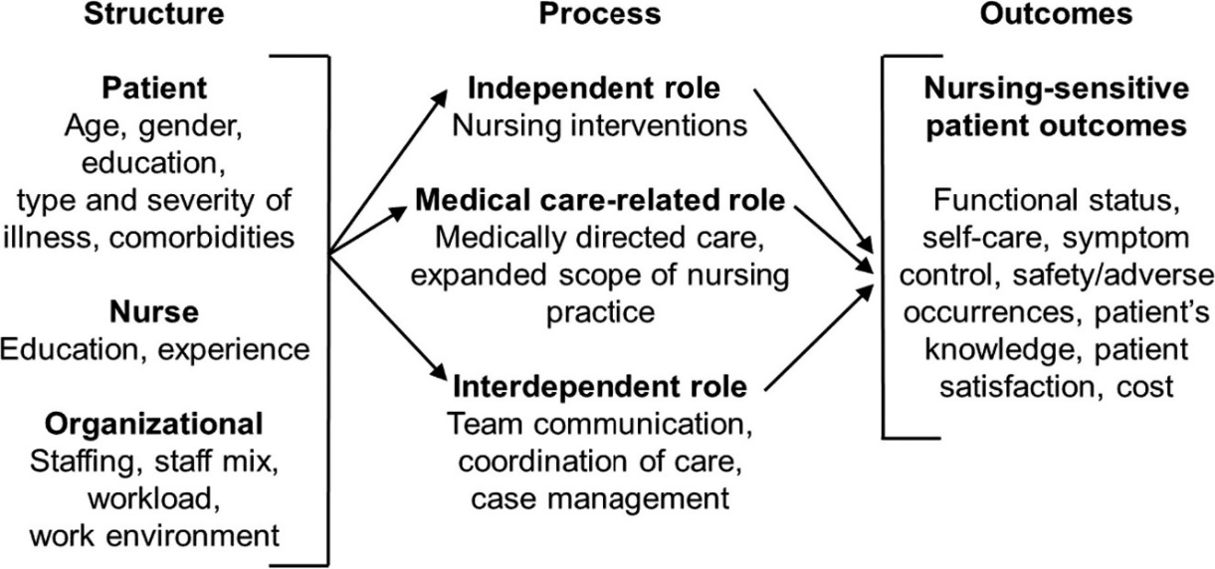
Note. Adapted from the Nursing Role Effectiveness Model (Irvine, Sidani, & Hall, 1998b).

A

ppendix B-Permission for Use
To use the Nursing Role Effectiveness Model (NREM), you generally need to cite the original authors and use it for non-commercial purposes, as it is often distributed under Creative Commons licenses that permit non-commercial use, reproduction, and distribution, provided the original work is properly attributed

Appendix C-Evidence Based Model
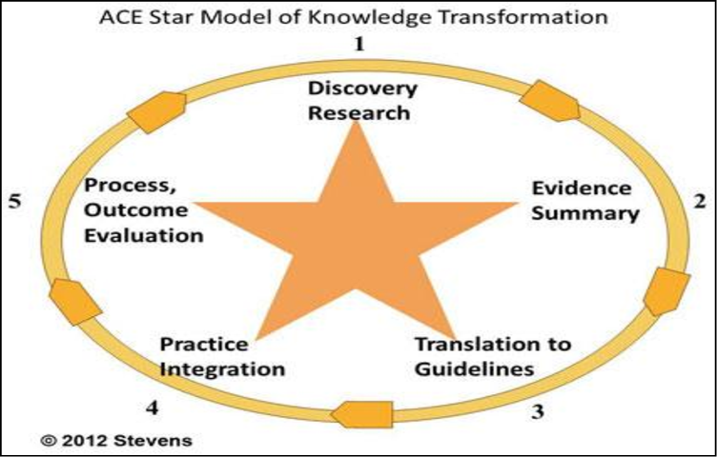
Stevens, K. R. (2004). ACE Star Model of Knowledge Transformation: The Cycle of Knowledge Transformation. The University of Texas Health Science Center at San Antonio. Retrieved from https://uthscsa.edu/nursing/research/resources-scholarly-support/star-model

Appendix D-Permission for Use
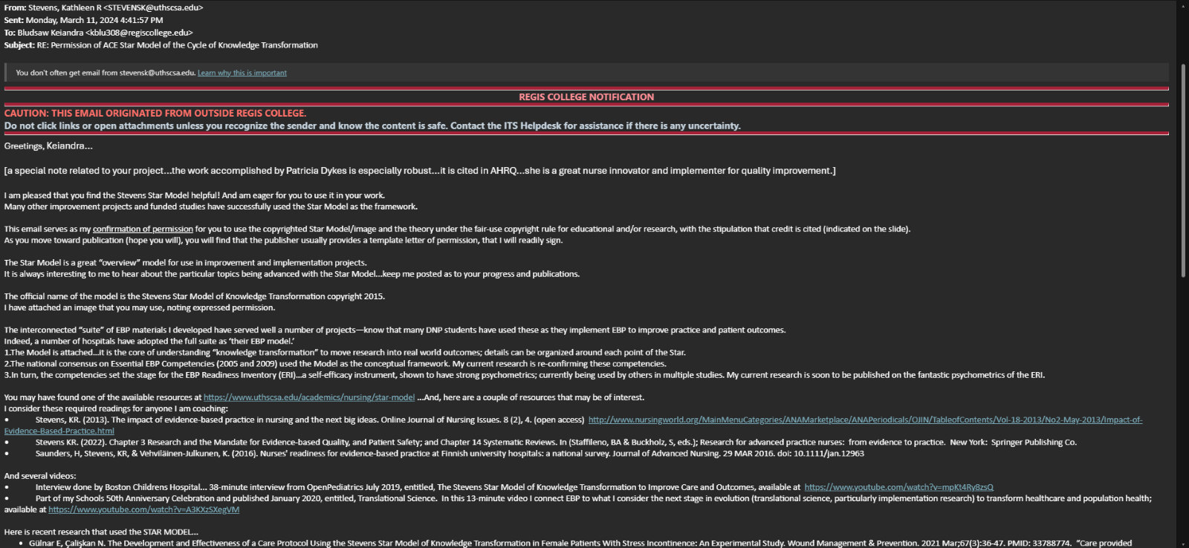

Appendix E-Levels of Evidence Table
Level of Evidence | Description | Articles
Level I | Experimental project, randomized controlled trial (RCT), systematic review of RCT’s, with or without meta-analysis | 3
Level II | Quasi-experimental project, systematic review of a combination of RCTs and quasi-experimental, or quasi-experimental studies only, with or without meta-analysis | 12
Level III | Non-experimental project, systematic review of a combination of RCTs, quasi-experimental and non-experimental studies only, with or without meta-analysis. Qualitative project or systematic review with or without a meta-synthesis | 9
Level IV | Opinion of respected authorities and/or nationally recognized expert committees/consensus panels based on scientific evidence  Includes:  Clinical practice guidelines  Consensus panels | 7
Level V | Based on experiential and non-research evidence  Includes: Literature reviews, quality improvement, program or financial evaluation, case reports, opinion of nationally recognized experts(s) based on experiential evidence | 2

Appendix F: Invitation to Participate


Invitation to Participate in a Scholarly Practice Project
To: Nurses Working in Long-Term Care Settings
This is an invitation to participate in a scholarly practice project titled “An Educational Intervention About the Use of the AHRQ Toolkit for Fall Prevention to Improve Knowledge, Confidence, and Motivation Levels for Nurses in a Long-term Care Facility “This project is being conducted to understand the readiness, confidence, and motivation of nurses in implementing evidence-based fall prevention strategies.
The purpose of this project is to assess how educational intervention impacts nurse readiness, motivation, and perceived organizational support for adopting the AHRQ Fall Prevention Toolkit. The goal is to determine whether education improves nurse confidence and motivation to integrate fall prevention strategies into daily practice.
This project is being conducted by Keiandra Bludsaw, BSN-RN, a Doctor of Nursing Practice student at Regis College. The Regis College Institutional Review Board has approved this project. Participation is confidential and voluntary.
This project is seeking participation from nurses currently working in long-term care settings, including skilled nursing facilities, and assisted living centers, who are involved in patient care and fall prevention initiatives. Thank you for your time and consideration!
If you choose to participate, you will:
Items | Title | Length of Time
Consent | Document | 5 minutes
Demographics | Survey | 5 minutes
Pretest I | C-Scale | 5 minutes
Intervention | Educational Module/PowerPoint | 40 minutes
Posttest I | C-Scale | 5 minutes
Posttest II | IMI | 10 minutes
Open-Ended Questions | Created by DNP Student | 10 minutes
Total Time |  | 80 minutes

For additional questions, please contact:
Keiandra Bludsaw BSN-RN
609-674-3647
kblu308@regiscollege.edu

Appendix G-Informed Consent


Informed Consent to Participate in a DNP Project entitled:

An Educational Intervention About the Use of the AHRQ Toolkit for Fall Prevention to Improve Knowledge, Confidence, and Motivation Levels for Registered Nurses in Long-Term Care

Primary Investigator (PI): Keiandra Bludsaw, DNP(c), BSN, RN

Introduction
Please read this form carefully.
You are being asked to participate in a project about the use of the Agency for Healthcare Research and Quality (AHRQ) Falls Toolkit, which aims to empower nurses with appropriate interventions that help implement effective fall prevention strategies in clinical facilities. When imparted to nurses, this toolkit provides insight into the operational know-how needed to prevent avoidable harm and thus improve patient care.

You were selected to participate in this project because you are:

1. A Registered Nurse (RN) or Licensed Practical Nurse (LPN).
2. Employed and work in Long-term Care (LTC).
3. Willing to complete the entire project.
4. Able to read and speak English.
You may not participate if you are:
1. Not a Registered Nurse (RN) or Licensed Practical Nurse (LPN).
2. Not work in Long-term Care (LTC).
3. Not willing to complete the entire project.
4. Not able to read and speak English.

Please ask any questions you may have before you agree to participate in the project.

Purpose of the Project

To implement an educational intervention about falls in the older adult in long-term care for RNs and LPNs working in such facilities. The intervention is based on the national organization guidelines from AHRQ. Below is the time committment to participate.

Items | Title | Length of Time
Consent | Document | 5 minutes
Demographics | Survey | 5 minutes
Pretest I | C-Scale | 5 minutes
Intervention | Educational Module/PowerPoint | 40 minutes
Posttest I | C-Scale | 5 minutes
Posttest III | IMI | 10 minutes
Open-Ended Questions | Created by DNP Student | 10 minutes
Total Time |  | 80 minutes

Benefits of Being in this Project
The benefits of being in this project are:
Participants will learn more about fall prevention using the AHRQ Falls Toolkit, which will enhance their nursing practice.

Risks and Discomforts of Being in this Project
There are no risks beyond what the participant experiences in daily life. You may have fatigue because this is an 80 minute project and breaks will be encouraged.

Payments
There is no payment for being in this project

Cost
There is no cost to you for being in this project.

Choosing to participate in the Project and Choosing to Quit the Project
It is your choice to participate in this project. If you choose not to participate in this project, it will not affect your current or future relations with Regis. You are free to decline to answer questions or quit at any time, for any reason. There is no penalty for not taking part or for quitting. The practice of this project is purely and implicitly voluntary. If you decide not to participate, it won’t impact your existing and future interactions with Regis. You also have the right not to answer any questions and provided you have not signed any consent needed for this project, you can withdraw from the project at any time you want for any reason and no penalties will be taken against you. If you are a student, all I want to tell you is that your decision on whether to participate or not to participate in this project will in no way influence your academic performance. Using the employee-template, you will remain an employee if you participate or do not participate. If you prefer to quit the project in advance, there may be non-sequent effects yet regarding your participation; however, it is desirable to speak with you regarding any modified states of financial incentives linked to your participation by the time of withdrawal. It is also important for us that you are as comfortable and independent as possible throughout this process.
Getting Dismissed from the Project
The PI may dismiss you from the project at any time for the following reasons:

You have not complied with the project rules.
The PI stopped the project.

Privacy
The records of this project will be kept private. This project data will not be disclosed to anyone but the PI and Project Chair. To ensure that the participants identities are kept anonymous, all data will be locked in password protected computer in a secure platform called Qualtrics. All data will be deidentified once the consent is signed and a random numerical value will be assigned. All information collected will not be linked to your responses and the PI and Project Chair will not know your name. No published reports will include any information that will make it possible to identify you.

Contacts and Questions

The PI conducting this project is: Keiandra Bludsaw, DNP(c), BSN, RN.
The PI will be available to answer any questions about the project at: 609-674-3647 and kblud308@regiscollege.edu
If you have questions or concerns about your rights, you may contact the Regis Institutional Review Board Chair:
Dr. Colleen C. Malachowski, PhD
781-768-7373
colleen.malachowski@regiscollege.edu

Statement of Consent

I have read this form. I have been encouraged to ask questions. I have received answers to my questions. I give my consent to participate in this project. I understand the risks and discomforts associated with the above project and understand that I may quit the project at any time without penalty.

If applicable to your project:

I agree to be audio and/or video recorded (Check One):

_____Yes _____No

Signature/Date

Adult Participant Informed Consent

Participant Printed Name: ___________________________________

Participant Signature: ___________________________________ Date: __________

Appendix H-Flesch-Kincaid Grade Level

Appendix I-Demographic Survey-please fix these with numbers
Demographic Survey for nurses in Long-Term Care Settings
Instructions: Please answer the following questions to the best of your ability.

1. What is your age?
1. 18- 20
2. 21-30
3. 31-40
4. 41-50
5. 51-60
6. 61-70
7. 71 or older

2. What is your gender?
- Female
- Male
- Non-binary

- Other

3. Ethnicity:
- White/Caucasian
- Black/African American
- Hispanic/Latino
- Asian
- Native American
- Other (please specify): ___________

4. Years of Nursing Experience:
- Less than 1 year
- 1-5 years
- 6-10 years
- 11-20 years
- More than 20 years

5. Current Position:
- Staff Nurse
- Charge Nurse
- Nurse Manager
- Other (please specify): ___________

6. Highest Level of Education:
- Associate Degree in Nursing (ADN)
- Bachelor of Science in Nursing (BSN)
- Master of Science in Nursing (MSN)
- Doctorate in Nursing (DNSc/PhD)
- Other (please specify): ___________

7. Have you received training related to fall prevention in elderly care?
- Yes
- No

8. If yes, please specify the type of training:
- AHRQ Falls Toolkit
- Other (please specify): ___________

9. Type of Long-Term Care Setting:
- Nursing Home
- Assisted Living Facility
- Rehabilitation Center
- Home Health Care
- Other (please specify): ___________

10. Average number of elderly patients you care for daily:
- 1-5
- 6-10
- 11-15
- 16-20
- More than 20

11. What is the nurse-to-patient ratio in your facility?
- 1:5 or better
- 1:6-10
- 1:11-15
- 1:16 or worse

12. What challenges do you face regarding fall prevention in your work? (Select all that apply)
- Lack of training/resources
- High patient acuity
- Staff shortages
- Inadequate communication with interdisciplinary teams
- Other (please specify): ___________

13. Are you familiar with the AHRQ Falls Toolkit?
- Yes
- No

14. If yes, how would you rate your understanding of the toolkit?
- Excellent
- Good
- Fair
- Poor

15. Any additional comments or suggestions regarding fall prevention in elderly care?

Appendix J-Instrument #1 Confidence Scale (C-Scale)
C-Scale

Directions: Circle the number which best describes how you perceive your current ability to perform strategies to become competent in the use of the Agency for Healthcare Research and Quality Fall Prevention Toolkit for the older adult.

(NOTE: Make sure that the circle encloses just ONE number.)

1. I am certain that my performance is correct:

1 |  | 2 |  | 3 |  | 4 |  | 5
not at all certain |  | certain for only a few steps |  | fairly certain for a good number of steps |  | certain for almost all steps |  | absolutely certain for all steps
2. I feel that I perform the task without hesitation:

1 |  | 2 |  | 3 |  | 4 |  | 5
I have much hesitation |  | a fair amount of hesitation |  | a good part of it without hesitation |  | almost completely without hesitation |  | absolutely no hesitation
3. My performance would convince an observer that I'm competent at this task:

1 |  | 2 |  | 3 |  | 4 |  | 5
not at all |  | agree, a little |  | for much of it |  | for almost all of it |  | for absolutely all of it
4. I feel sure of myself as I perform the task:

1 |  | 2 |  | 3 |  | 4 |  | 5
not at all |  | very little |  | for much of it |  | for almost all of it |  | for absolutely all of it
5. I feel satisfied with my performance:

1 |  | 2 |  | 3 |  | 4 |  | 5
not at all |  | very little |  | for much of it |  | for almost all of it |  | absolutely satisfied with all of it

Appendix K-Permission for U

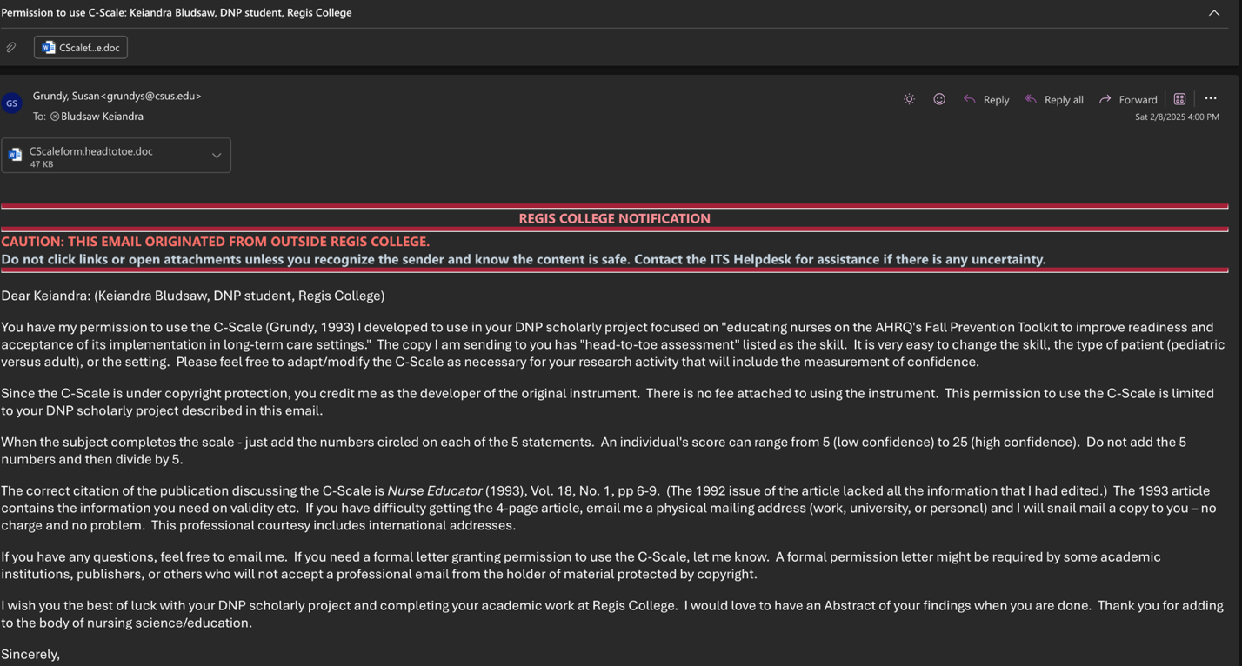se

Appendix L-Instrument #2
Intrinsic Motivation Inventory (IMI)
ACTIVITY PERCEPTION QUESTIONNAIRE
The following items concern your experience with the task. Please answer all items. For each item, please indicate how true the statement is for you, using the following scale as a guide. Select the number below and place it in the box provided.
1 2 3 4 5 6 7
not at all true somewhat true very true
Statement | Answer
1. I believe that doing this activity could be of some value for me.

2. I believe I had some choice about doing this activity.

3. While I was doing this activity, I was thinking about how much I enjoyed it.

4. I believe that doing this activity is useful for improved concentration.

5. This activity was fun to do.

6. I think this activity is important for my improvement.

7. I enjoyed doing this activity very much.

8. I really did not have a choice about doing this activity.

9. I did this activity because I wanted to.

10. I think this is an important activity.

11. I felt like I was enjoying the activity while I was doing it.

12. I thought this was a very boring activity.

13. It is possible that this activity could improve my studying habits.

14. I felt like I had no choice but to do this activity.

15. I thought this was a very interesting activity.

16. I am willing to do this activity again because I think it is somewhat useful.

17. I would describe this activity as very enjoyable.

18. I felt like I had to do this activity.

19. I believe doing this activity could be somewhat beneficial for me.

20. I did this activity because I had to.

21. I believe doing this activity could help me do better in school.

22. While doing this activity I felt like I had a choice.

23. I would describe this activity as very fun.

24. I felt like it was not my own choice to do this activity.

25. I would be willing to do this activity again because it has some value for me.

Scoring information
Begin by reverse scoring items # 8, 12, 14, 18, 20, and 24 by subtracting the item
response from 8 and using the result as the item score for that item. Then calculate subscale scores by averaging the items scores for the items on each subscale. They are shown below. The (R) after an item number is just a reminder that the item score is the reverse of the participant's response on that item.
Interest/enjoyment: 3, 5, 7, 11, 12(R), 15, 17, 23
Value/usefulness: 1, 4, 6, 10, 13, 16, 19, 21, 25
Perceived choice: 2, 8(R), 9, 14(R), 18(R), 20(R), 22, 24(R)

Appendix M: Permission for use



Appendix N-Open-Ended Post Questions
Readiness and Knowledge
1. How familiar are you with the AHRQ Falls Toolkit, and what aspects of the toolkit do you find most useful in your current practice?
2. In what ways do you think the toolkit can enhance patient safety and fall prevention efforts in your facility?
Confidence in Implementation
3. How confident do you feel in assessing fall risks and applying fall prevention strategies outlined in the AHRQ Falls Toolkit?
4. Can you describe a time when you successfully implemented a fall prevention strategy? What factors contributed to your confidence in that situation?
Motivation and Willingness to Use the Toolkit
5. What motivates you to integrate the AHRQ Falls Toolkit into your practice?
Perceived Effectiveness and Practicality
6. What impact do you believe a more structured approach to fall prevention would have on patient outcomes in long-term care settings?

Appendix O- Educational Intervention Powerpoint
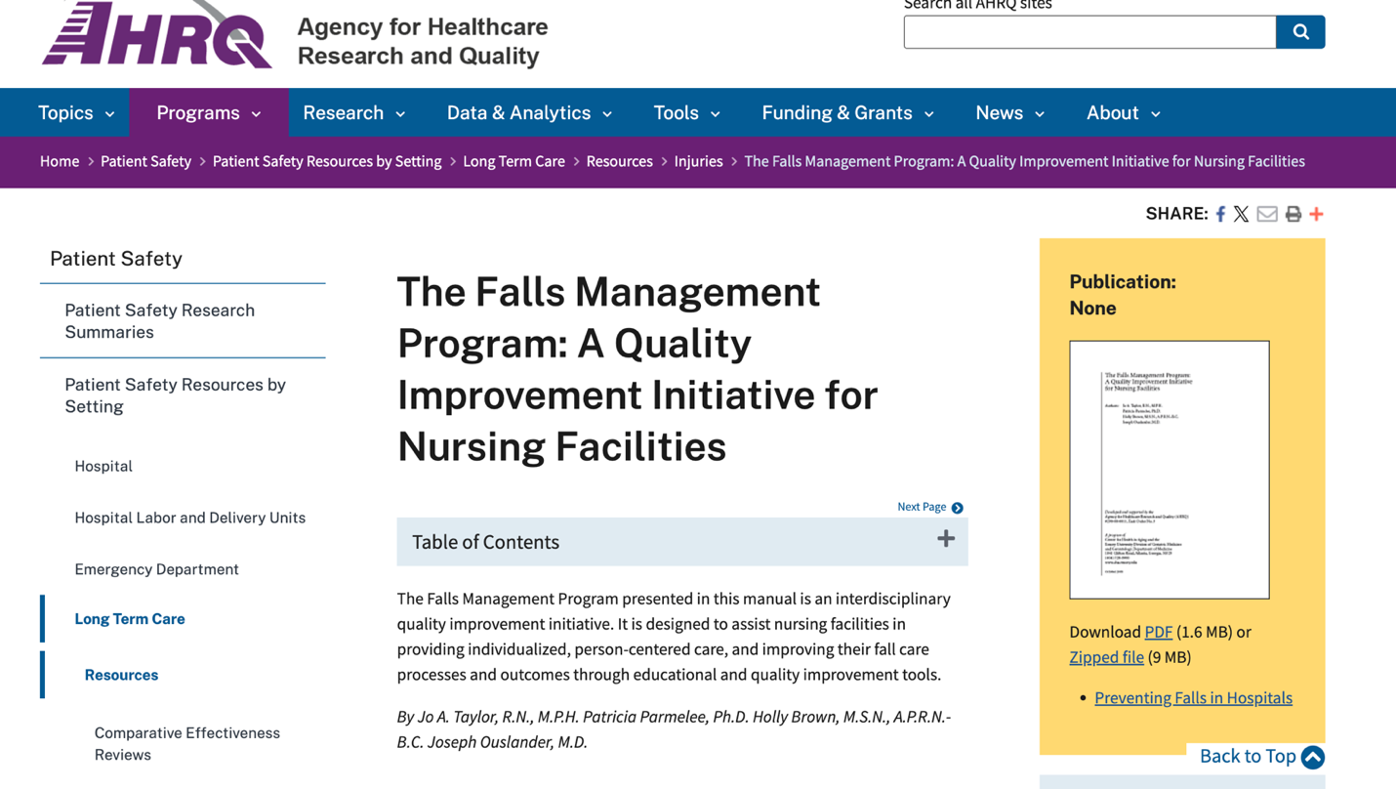
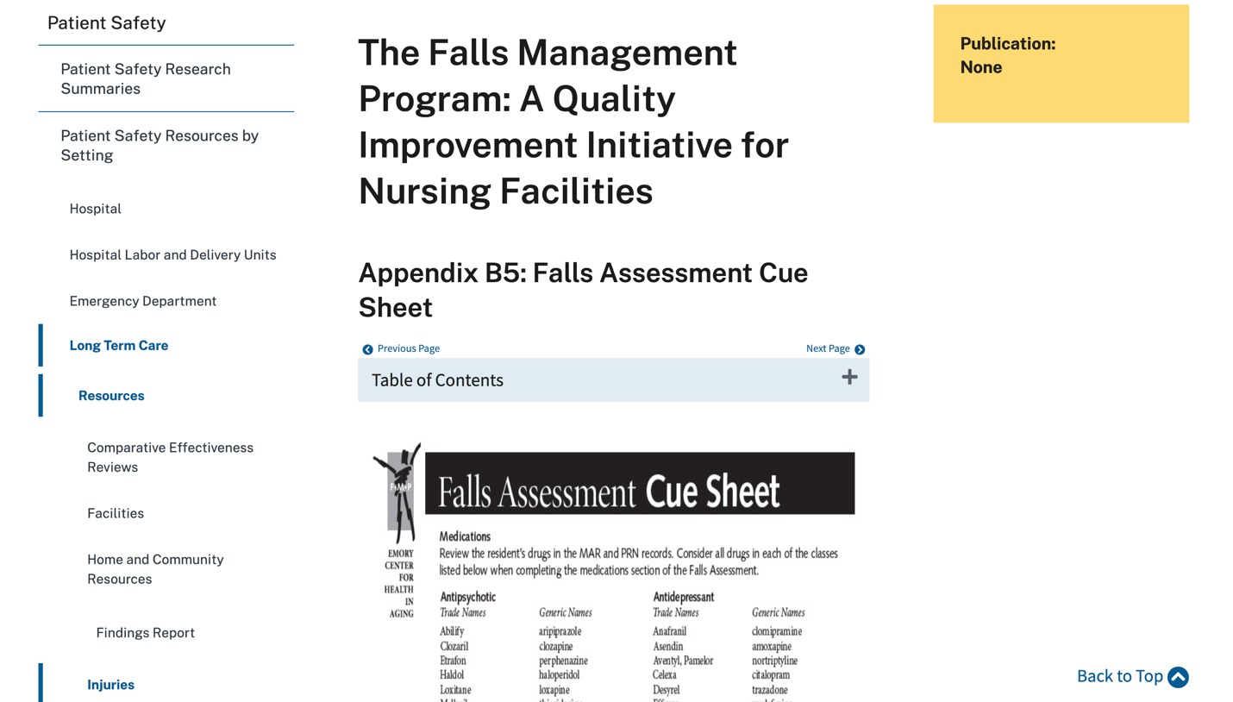
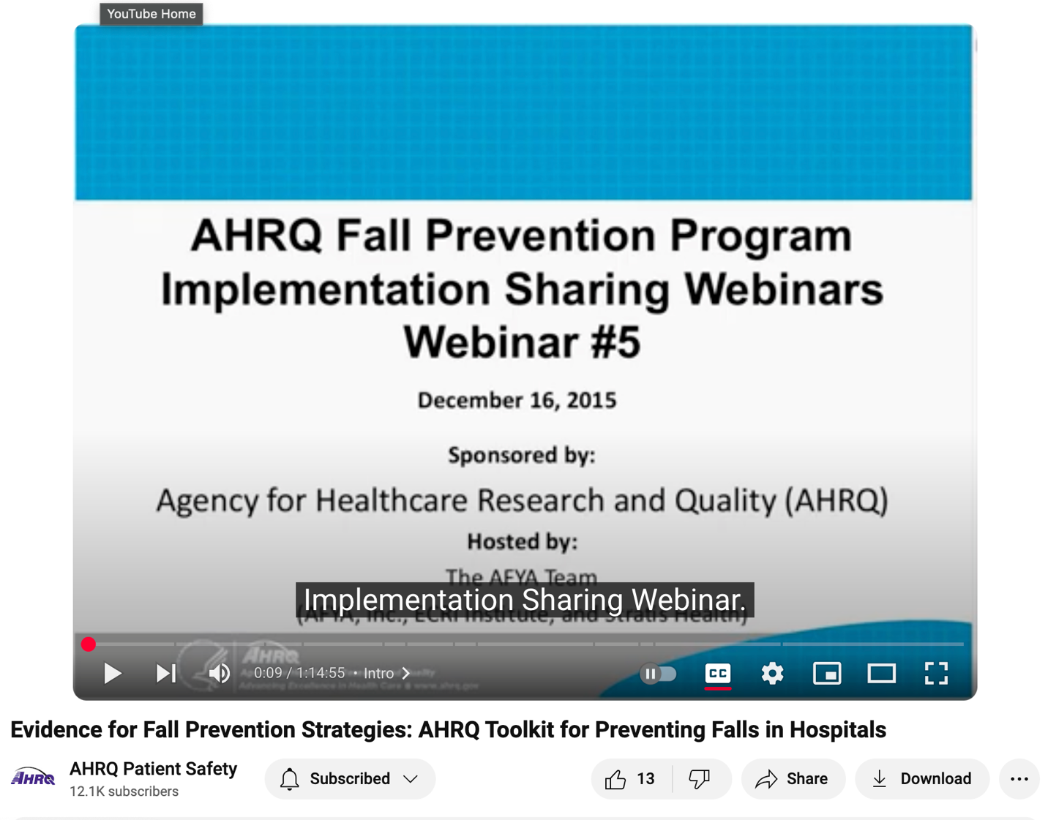

Appendix P-External Site Permission

Appendix Q-CITI Training Certificate
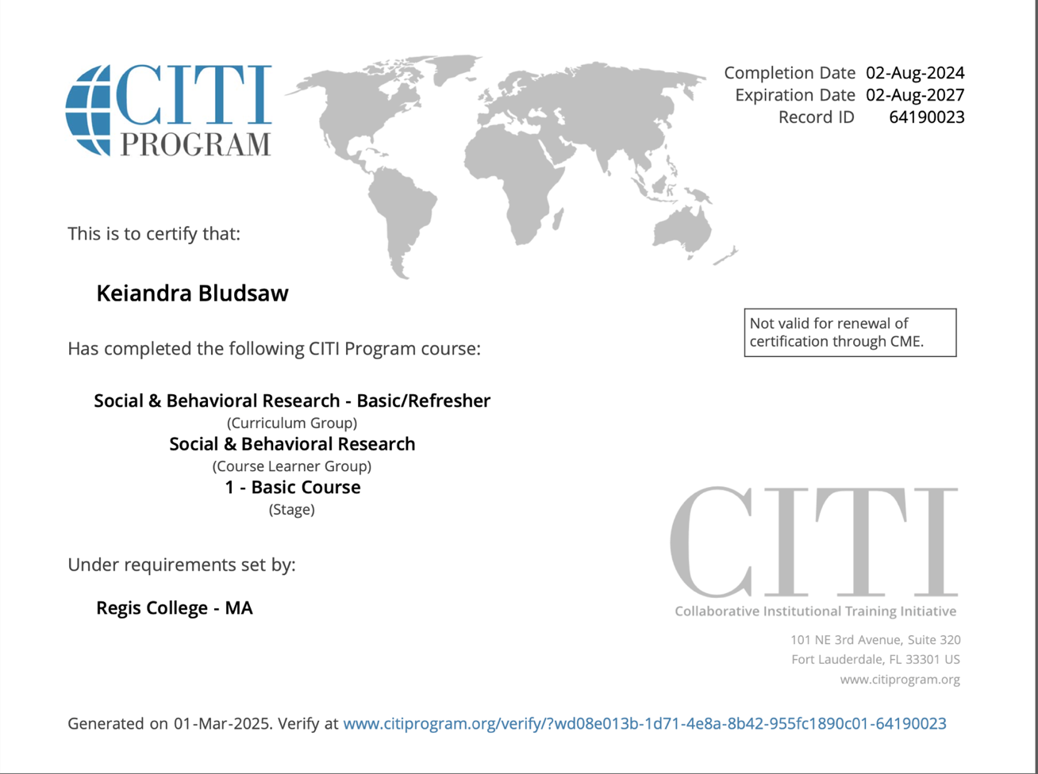

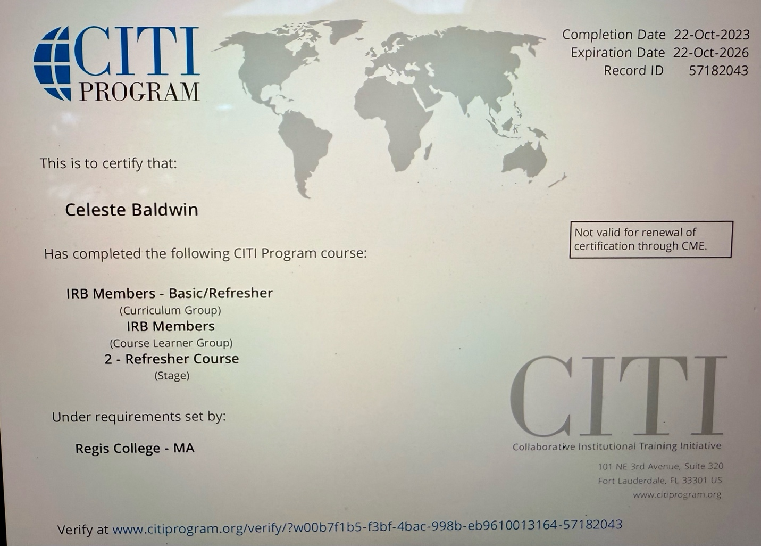

Appendix R-Primary Investigator Resume
Keiandra Bludsaw, DNP Candidate, BSN-RN
Absecon, NJ
609-674-3647 | kblu308@regiscollege.edu
Professional Summary
Dedicated and experienced Registered Nurse with a strong background in acute care and long-term care settings. Proven ability to provide high-quality patient care, collaborate with interdisciplinary teams, and implement evidence-based practices to improve patient outcomes. Currently pursuing a Doctor of Nursing Practice (DNP) in Mental Health to advance expertise in psychiatric and mental health nursing.
Licensure & Certifications
• Registered Nurse (RN) – Active License
• Basic Life Support (BLS) Certification
• Advanced Cardiac Life Support (ACLS) Certification
Work Experience
Registered Nurse
Atlanticare Regional Medical Center | 2021 – Present
• Provide direct patient care in a fast-paced acute care environment, ensuring adherence to clinical protocols and safety measures.
• Collaborate with interdisciplinary healthcare teams to optimize patient treatment plans and improve patient outcomes.
• Educate patients and families on disease management, medication adherence, and discharge planning.
Registered Nurse
Complete Care Linwood | 2022 – 2024
• Delivered high-quality nursing care to residents in a long-term care setting, focusing on fall prevention, medication management, and chronic disease management.
• Assisted in implementing quality improvement initiatives to enhance patient safety and staff efficiency.
• Provided mentorship and guidance to new nurses and support staff.

Education
- Doctor of Nursing Practice (DNP) – Mental Health
- Regis College | 2021 – Present
- Bachelor of Science in Nursing (BSN)
- Stockton University | 2020 – 2021
- Master of Business Administration (MBA)
- University of Phoenix | 2016 – 2018
- Bachelor of Science in Psychology
- Rutgers University | 2011 – 2015
Skills & Competencies
• Patient-Centered Care
• Mental Health Nursing
• Fall Prevention Strategies
• Medication Management
• Evidence-Based Practice
• Interdisciplinary Collaboration
• Staff Training & Development
• Quality Improvement Initiatives
• Electronic Health Records (EHR)
References
Available upon request.

Appendix Q - External Site Permission
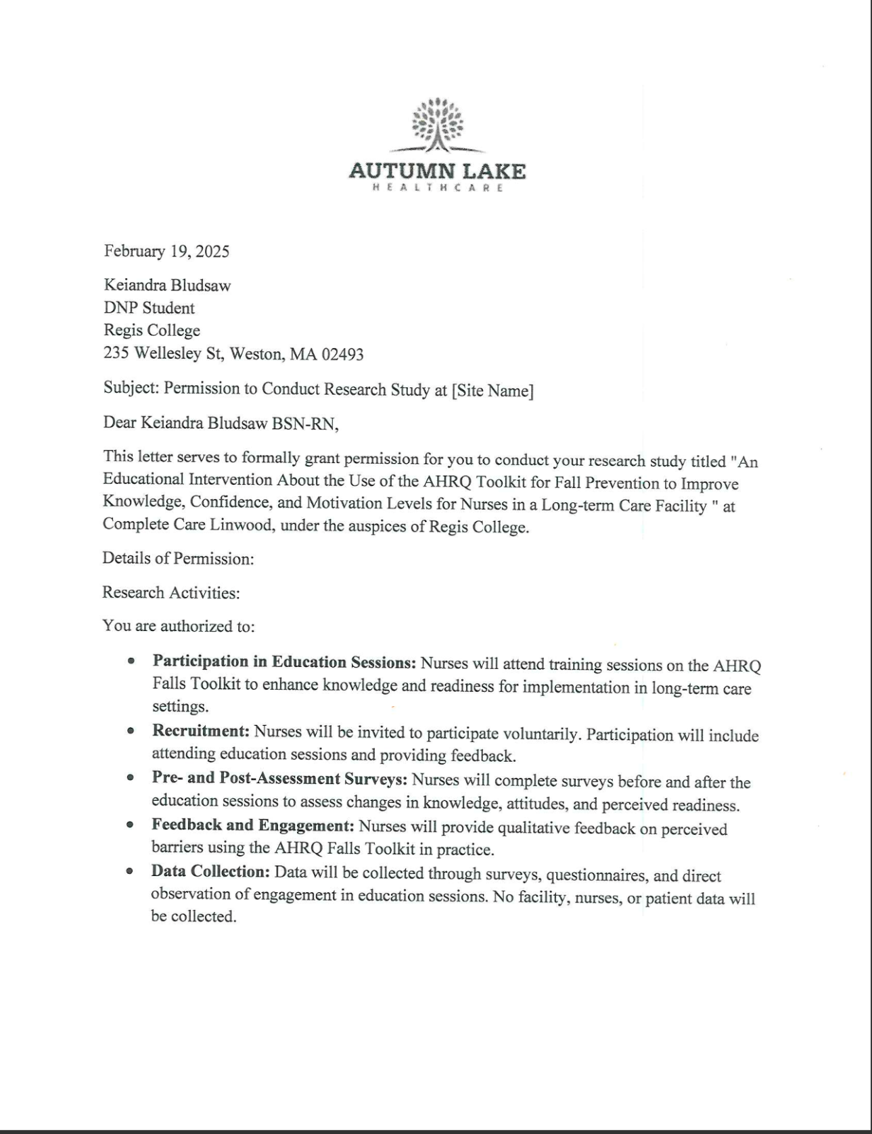

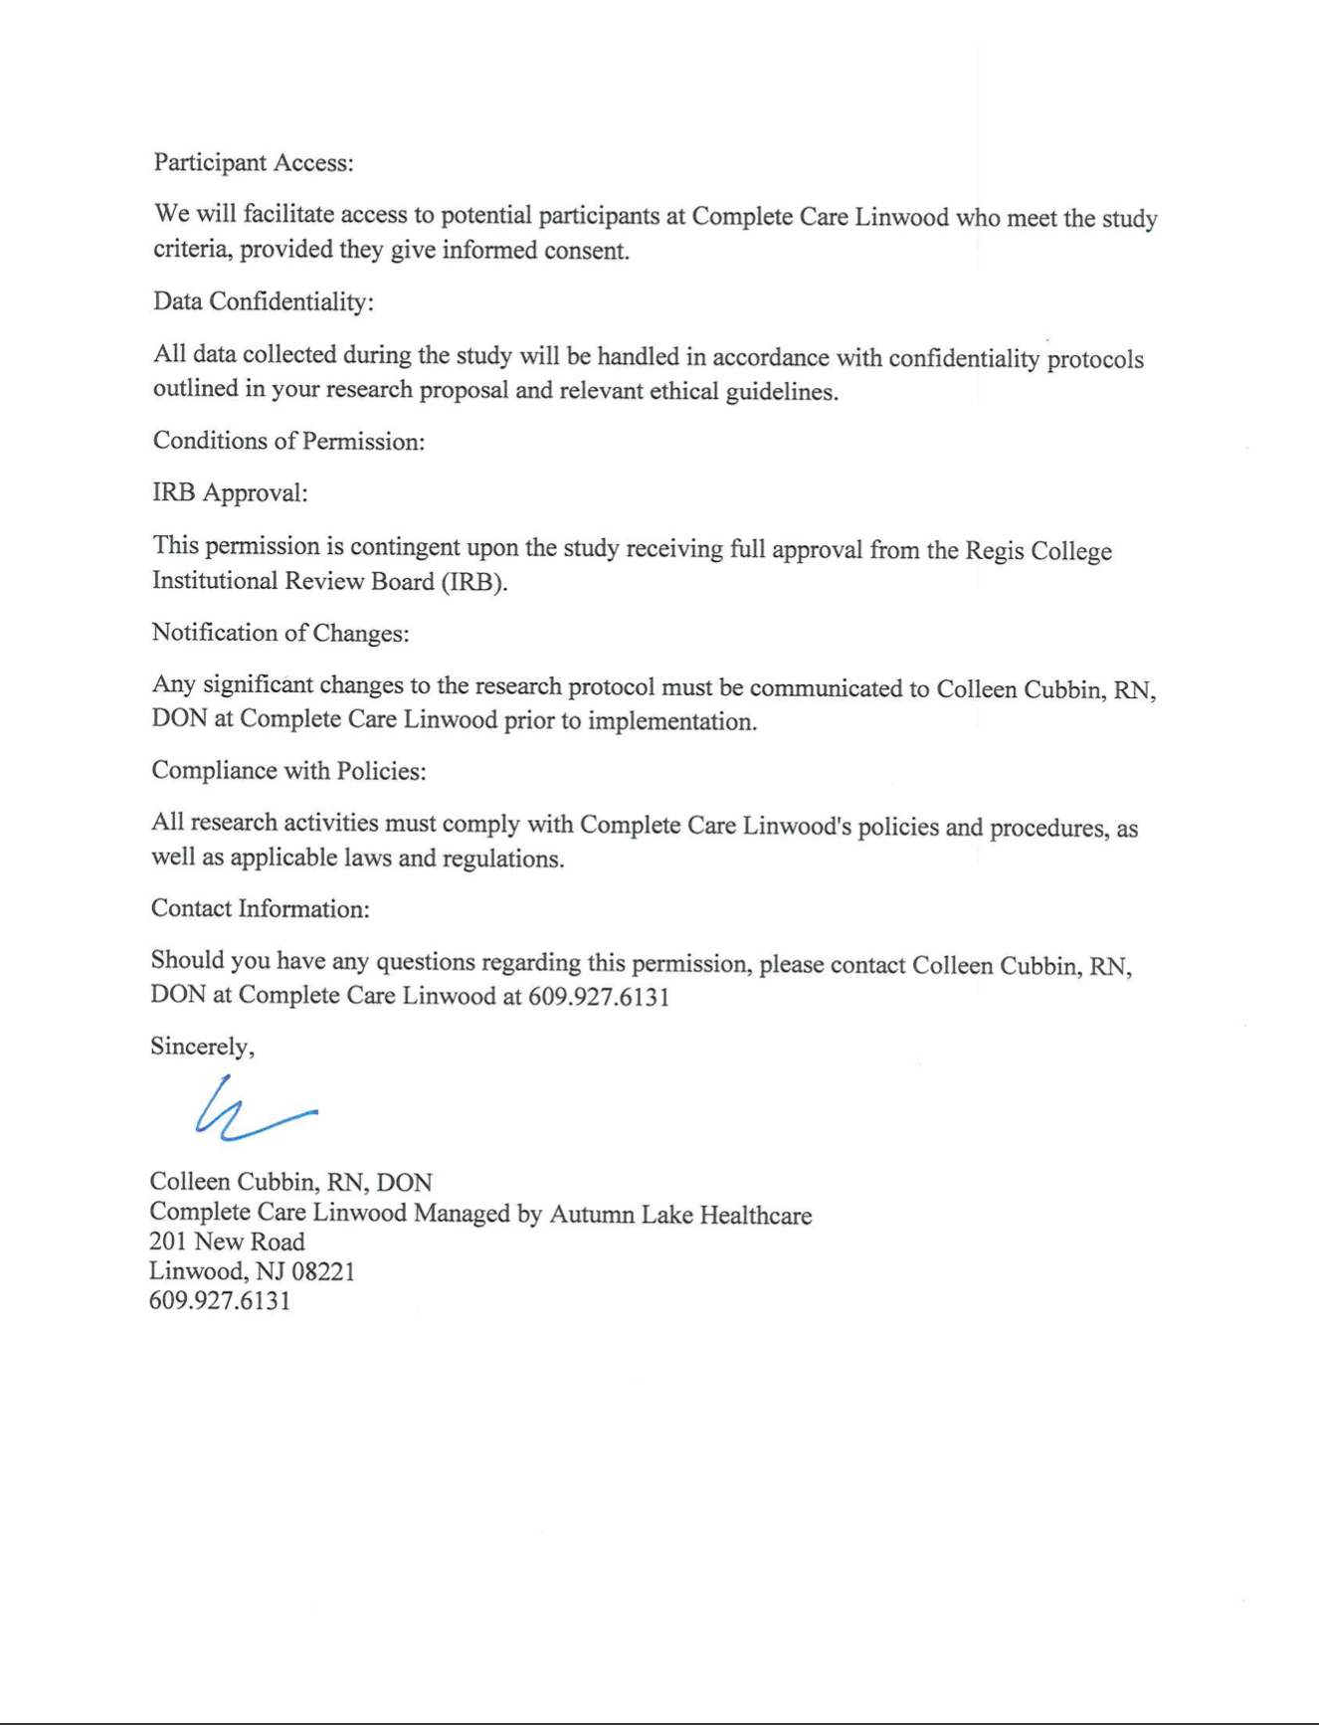

Appendix R – Summary of Literature Review
This appendix provides a comprehensive summary of the literature review that informed the development of the AHRQ Fall Prevention Toolkit educational intervention for nurses in long-term care (LTC) settings. The review synthesizes current research on the prevalence, risk factors, and consequences of falls, as well as evidence-based prevention strategies and educational interventions designed to enhance nurses' knowledge, confidence, and motivation in fall prevention practices.
Prevalence and Consequences of Falls in Older Adults
Falls are a leading cause of morbidity and mortality among older adults, particularly in long-term care settings. Research indicates that approximately 30% of adults aged 65 and older experience a fall each year, with 10% resulting in serious injuries such as fractures or traumatic brain injuries (TBIs) (Haines et al., 2021). Additionally, falls contribute to higher healthcare costs, increased length of hospital stays, and higher mortality rates, with studies showing a 50% increase in one-year mortality following hip fractures (Morris et al., 2024).
Risk Factors Contributing to Falls
The literature identifies intrinsic and extrinsic risk factors associated with falls:
- Intrinsic Factors:
  - Age-related balance impairments, muscle weakness, and cognitive decline (Alsaad et al., 2024)
  - Chronic conditions such as diabetes, cardiovascular disease, and arthritis, which contribute to instability (Schober et al., 2022)
  - Medication use, including sedatives, antihypertensives, and psychotropics, which increase fall risk (Heng et al., 2022)
- Extrinsic Factors:
  - Environmental hazards such as poor lighting, slippery floors, and cluttered pathways (Schober et al., 2022)
  - Institutional safety concerns, including improper bed heights and lack of assistive devices (Morris et al., 2024)
Fall risk assessment tools, such as the Morse Fall Scale and Hendrich II Fall Risk Model, are widely recommended for identifying high-risk patients and guiding preventive interventions (Alsaad et al., 2024).
Interventions and Prevention Strategies
To reduce fall-related injuries, multifactorial fall prevention interventions have been recommended:
- Exercise Programs: Strength and balance training, including Tai Chi and resistance training, improve postural stability and reduce fall risk (Lopez et al., 2023).
- Medication Review: Regular pharmacist-led medication assessments help modify or discontinue high-risk medications (Lopez et al., 2023).
- Environmental Modifications: Installation of grab bars, better lighting, and removal of trip hazards significantly decreases fall risk (Schober et al., 2022).
- Assistive Technology: Implementation of motion sensors, bed alarms, and AI-driven alert systems enhances early fall detection and response time (Baixinho et al., 2022).
- Community-Based and Telehealth Programs: Education initiatives that include caregiver training, home safety assessments, and telehealth consultations show promising results in preventing falls (Ojo & Thiamwong, 2022).

The Role of Nurses in Fall Prevention
Nurses play a pivotal role in fall risk assessment, patient education, and implementation of preventive strategies. However, studies reveal gaps in nurses' knowledge, attitudes, and adherence to fall prevention protocols (Lopez et al., 2023).
Key barriers to fall prevention implementation in LTC settings include:
- Staff Shortages and Time Constraints: High patient loads limit nurses' ability to focus on fall prevention measures (Koh et al., 2008).
- Lack of Institutional Support: Leadership involvement is crucial for ensuring adherence to evidence-based fall prevention strategies (Dykes et al., 2010).
- Resistance to Change: Nurses may be reluctant to adopt new protocols due to lack of training or perceived complexity (Spoelstra et al., 2012).
To overcome these barriers, peer mentorship programs, leadership support, and ongoing training are recommended to increase nurse engagement in fall prevention efforts (Hill et al., 2016).
Implementation of the AHRQ Fall Prevention Toolkit
The AHRQ Fall Prevention Toolkit serves as a structured approach for integrating evidence-based fall prevention practices in healthcare settings. Studies demonstrate that structured training programs using the AHRQ toolkit significantly improve nurses' knowledge, confidence, and adherence to best practices (Dykes et al., 2017).
Key components of successful implementation include:
- Regular Training and Staff Education: Continuous education ensures that nurses stay updated on best practices.
- Interdisciplinary Collaboration: Engaging physical therapists, pharmacists, and caregivers in fall prevention efforts enhances outcomes.
- Data-Driven Decision Making: Regular monitoring and evaluation of fall rates help refine intervention strategies (Titler et al., 2016).

National Guidelines on Fall Prevention
The Agency for Healthcare Research and Quality (AHRQ) outlines evidence-based guidelines for fall prevention, emphasizing:
- Standardized Fall Risk Assessments upon patient admission
- Regular Staff Training to maintain competency in fall prevention
- Interdisciplinary Team Collaboration in developing individualized fall prevention plans
- Ongoing Evaluation and Quality Improvement Measures

Appendix S - Project Timeline and Implementation Plan

DNP Activity/Task | NU740 | NU726 | NU727 | NU741 | NU742 | NU743
Choose your practice problem for EBP Project | Decide & Completed
SPP PowerPoint | Started | Refining | Refining | Refine | Refine | Pending the completion
SPP Paper | Started | Refining | Refining | Refine | Refine | Pending the completion
SPP Poster | Started | Refining | Refining | Refine | Refine | Pending the completion
Chapter I | Started | Refining | Refining | Refine | Refine | Pending the completion
Chapter II |  | Started | Refining | Refine | Refine | Pending the completion
Chapter III |  |  | Started | Refine | Refine | Pending the completion
Chapter IV |  |  |  | Begin | Refine | Pending the completion
Chapter V |  |  |  |  | Begin | Pending the completion
Proposal Defense | Started |  |  | Refine |  | Pending the completion
IRB/ Site Permission |  |  | Started | Pending the completion
IRB Regis |  |  | Begin | Pending the completion
Spp Conduct the Project |  |  |  |  | Begin | Pending the completion
Portfolio | Started | Refining | Refining | Refine | Refine | Pending the completion

Procedures:
- Participation:
- Go to the educational sessions and give their opinion.
- Educational Sessions:
- Duration: 80 minutes for 1 day.
- Location: Healthcare facility training room.
- Feedback:
- The students must take post-session self-administered questionnaires to determine their comprehension and usability.
- Recommendation likelihood.
- Timeline:
- About 1 day: start to finish.

Appendix U - Sample Workshop Agenda

Time | Topic | Principal Investigator (PI) | Description
12:00 – 12:05 PM | Welcome & Opening Remarks | Principal Investigator (PI) | Quick introduction, purpose of the session, and objectives while lunch is served
12:05 – 12:15 PM | Understanding Fall Risks in LTC | Principal Investigator (PI) | Brief discussion on fall statistics, risk factors, and patient impact
12:15 – 12:25 PM | Overview of AHRQ Fall Prevention Toolkit | Principal Investigator (PI) | Key components of the toolkit, evidence-based strategies, and practical application
12:25 – 12:40 PM | Case Project & Table Discussion | Principal Investigator (PI) | Nurses analyze real-life scenarios and apply toolkit strategies in small groups
12:40 – 12:50 PM | Assessment & Monitoring Best Practices | Principal Investigator (PI) | Discussion of AHRQ's Fall Toolkit Youtube + Powerpoint Presentation
12:50 – 1:00 PM | Overcoming Implementation Barriers | Principal Investigator (PI) | Identifying challenges and solutions for integrating AHRQ guidelines in LTC practice
1:00 – 1:10 PM | Post-Training Assessments & Feedback | Principal Investigator (PI) | Participants complete C-Scale & IMI Survey via Qualtrics to evaluate knowledge gain and motivation
1:10 – 1:20 PM | Q&A & Closing Remarks | Principal Investigator (PI) | Open discussion, participant feedback, and next steps for ongoing learning

Appendix V- Data Analysis Plan

Appendix W - Statistical Results

Appendix X-Analysis Results

Appendix Y - Ethical Considerations and IRB Approval

Variables of Scholarly Project

Variables | Type | Conceptual Definition | Operational Definition
Demographic Profile | Independent | The characteristics of the nursing staff participating in the project, including age, gender, experience, and training (Polit & Beck, 2017). | Collected via a demographic questionnaire including specific questions about age, gender, years of experience, and prior training received
Readiness of AHRQ Falls Toolkit | Dependent | The degree to which nursing staff endorse and are willing to utilize the AHRQ Falls Toolkit in practice (AHRQ, 2019). | Measured using a Likert scale survey assessing readiness levels post-education, with scores indicating varying degrees of readiness.
Perceived Barriers | Dependent | Factors that nursing staff believe hinder the effective implementation of the AHRQ Falls Toolkit (Barker et al., 2020). | Identified through thematic analysis of open-ended survey responses regarding perceived obstacles to toolkit implementation.
Willingness to Implement | Dependent | The readiness and intention of nursing staff to adopt the AHRQ Falls Toolkit after educational interventions (Ajzen, 1991). | Measured using a Likert scale survey administered pre- and post-education to evaluate changes in willingness to implement the toolkit.

Tools/Instruments

Research Questions | Sub-Questions | Variables | Level of Measurement | Statistical Test/Method of Analysis
What is the demographic profile of nursing staff participating in the project? | None | Age, Gender, Experience, Previous Training | Nominal, Ordinal | Descriptive Statistics (mean, median, mode, frequency distribution)
What is the level of readiness of the AHRQ Falls Toolkit among nursing staff post-education? | What factors influence readiness? | Likert scale | Ordinal | Descriptive Statistics, T-tests
What barriers do nursing staff perceive regarding the implementation of the toolkit? | None | Perceived Barriers (open-ended) | Qualitative | Thematic Analysis
How do educational sessions influence the willingness to implement the toolkit? | Are there significant changes in willingness pre- and post-education? | Likert scale | Ordinal | Paired T-test

Figures
Figure 3
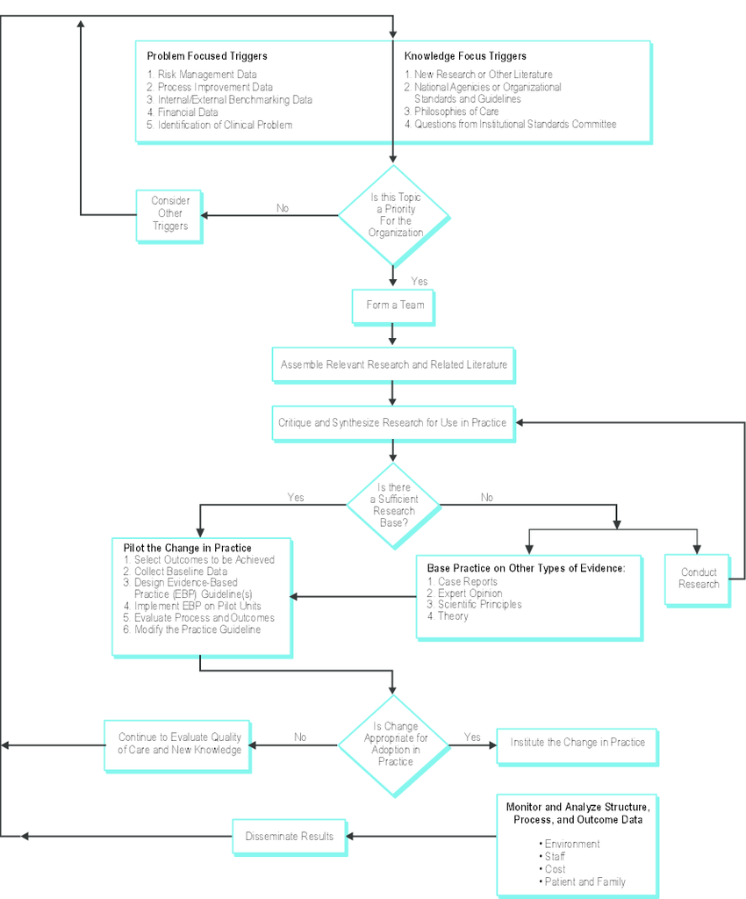

Figure 2
ACE Star Model of EBP: The Cycle of Knowledge Transformation
Note. Stevens, K. R. (2004). ACE Star Model of EBP: The Cycle of Knowledge Transformation. Academic Center for Evidence-based Practice. http://www.acestar.uthscsa.edu/Goals/www.acestar.uthscsa.edu

