

IRB Expedited and Full Review Application Form
 | Instructions: Complete this form to request an expedited IRB review of research involving human participants. The checklist below is for general guidance to help researchers submit complete application materials and facilitate the review process. Incomplete or unreadable applications will extend the IRB review process. If you are collecting data at a hospital, please seek hospital IRB approval prior to Regis College IRB approval. Please note, pilot studies and scale development studies should be submitted to the IRB as well. Please submit an electronic application and all research materials (consent form, surveys, interview guides, etc.) to irb@regiscollege.edu.
A Complete Application Packet Should Include:
An electronic copy of the IRB application form, research summary, and research instruments. Types of research instruments that should be attached include:
- Recruitment materials: emails, letters, recruitment scripts, flyers, posters, brochures, etc.
- Data collection materials: questionnaires, surveys, data collection forms, focus group scripts, interview
scripts, etc.
Signature page with faculty advisor and student signatures
(Approval will be withheld without signatures.)
Copies of CITI training certificates for all key research personnel who will interact with subjects or collect data
Consent forms(s)—You must use the Regis College IRB Informed Consent Template found on the Regis College IRB website when creating your informed consent form(s).
If minors (under 18) will be research participants, you must create a Child Assent Form and a Debriefing Form using the templates found on the Regis College IRB website.
All appendices are labeled and are in order.

NOTE: DO NOT REMOVE THE HEADINGS FROM THIS APPLICATION!

Student Researchers:
Faculty research advisor was consulted in the study design and has reviewed and signed the application.

Research in Hospitals or HIPAA-Covered Entities
Submit copies of the IRB approval letter and IRB approved consent form(s) from the participating institution(s).

Research in Public Schools:
Submit copies of the permission letter to perform research from each school principal via email.
Submit copies of IRB approval if the school has an IRB.

Research at sites other than Regis College:
Submit copies of the site permission letter to perform research from administrator via email.
Submit copies of IRB approval if the site has an IRB.

Federally funded research: Wait until you have been funded before submitting an IRB Application.
Submit documentation of funding status with this protocol application.
Submit a complete copy of the federal grant/contract proposal including face page.

Regis College Institutional Review Board
Office of Academic Affairs
235 Wellesley Street
Weston, MA 02493-1571
(781) 768-7430
email: irb@regiscollege.edu
IRB Expedited and Full Application Form
For Initial IRB Review Only
I. Study Title:  (If funded, the study title must match the sponsored title.) |  |  | Implementing a Patient Health Questionnaire Nine-Items Education Program in Primary Care |  |  |  |  |  |  |  | Today's Date: 06/22/2025
II. Principal Investigator Information
A. Name of Principal Investigator |  |  |  |  | Annette Gillian Kivumbi, DNP (c), LPN, BSN, PMHNP |  |  |  |  |  |  | B. Are You? (Please check)
 |  |  |  |  |  |  |  |  |  |  |  | Faculty
C. Mailing Address: |  |  |  |  | 39 Country Club Drive Tewksbury, MA 01876 |  |  |  |  |  |  | Staff
 |  |  |  |  |  |  |  |  |  |  |  | Undergraduate Student
D. Department: |  |  |  |  | Young School of Nursing |  |  |  |  |  |  | Graduate Student
 |  |  |  |  |  |  |  |  |  |  |  | Postdoctoral fellow
E. Email address: |  |  |  |  | Akiv891@regiscollege.edu |  |  |  |  |  |  | Other:
F. Primary Phone Number: |  |  |  |  | (781)5215633 | G. Alternate Phone:
H. Faculty Advisor's Name: |  |  |  |  | Dr. Kim Chapman DNP APRN FNP-BC | I. Faculty Advisor's Phone: |  | 417-536-5043
J. Faculty Advisor's E-mail: |  |  |  |  | Kim.chapman@regiscollege.edu
III. Funding
A. None (Go on to Section IV)
Do you plan to apply for funding in the future? Yes No If yes, please explain:
B. University Funded: List source:
C. External, non-federal*: List source and grant number:
D. Federal*: List agency, department, and sponsor's award number: Global behavioral Health care

*Wait until you have been notified that your project will be funded before seeking IRB approval unless otherwise instructed by the funding source. If federal funding is involved, submit documentation of funding status with a complete copy of the funding proposal with this form.

E. Is Regis College the primary awardee for the grant? Yes No If no, please list primary awardee:
F. Are there subcontracts? Yes No If yes please list sub-contractors:

IV. General Study Information
A. Anticipated number of participants:  34.  B. Participant Ages (please check)  0-7 (requires written parental informed consent and oral child assent)  7-17 (requires written parental informed consent and child written assent)  18-65 (requires written informed consent)  65+ (requires written informed consent) |  |  |  |  |  |  |  |  | C. Estimated Project Duration  *Start Date: September, 2025 End Date: November, 2025  D. Why is this project being conducted?  Faculty/Staff Research  Undergraduate Coursework  Master's Thesis  Doctoral Research  Quality Improvement or Evaluation  Other:  *Project cannot start without IRB approval.
E. Will this study involve long-term follow-up with participants? Yes No
If yes, please describe:

F. Vulnerable Populations (Check if applicable.)
Minors (under 18 years)
Pregnant women and fetuses
Neonates
Prisoners
Cognitively impaired (Diminished capacity for consent)
Other:

V. Research Risk
Research must present no more than minimal risk to human participants in order to qualify for expedited review. Minimal risk means that the "probability and magnitude of harm or discomfort anticipated in the research are not greater in and of themselves than those ordinarily encountered in daily life or during the performance of routine physical or psychological examinations or tests." (45 CFR 46.102)
A. Does the research propose greater than minimal risk to participants? Yes* No
*If yes, skip to part C of this section.

B. Does the research include prisoners? Yes* No
*If research includes prisoners, the application must be reviewed by the full IRB.

C. Check all procedures that apply to the research:
(1) Clinical studies of drugs and medical devices.
(2) Collection of blood samples by finger stick, heel stick, ear stick, or venipuncture.
(3) Prospective collection of biological specimens for research purposes by noninvasive means. Examples: hair and nail clippings; saliva; deciduous teeth at time of exfoliation or extracted during routine care; excreta and external secretions (including sweat); un-cannulated mucosal and skin cells collected by buccal scraping or swab, skin swab, or mouth washings; sputum collected after saline mist nebulization.
(4) Collection of data through noninvasive procedures routinely employed in clinical practice, excluding procedures involving x-rays or microwaves. Examples: physical sensors that are applied either to the surface of the body or at a distance and do not involve input of significant amounts of energy into the participant or an invasion of the participant's privacy; weighing or testing sensory acuity; magnetic resonance imaging; electrocardiography, electroencephalography, thermography, detection of naturally occurring radioactivity, electroretinography, ultrasound, diagnostic infrared imaging, doppler blood flow, and echocardiography; moderate exercise, muscular strength testing, body composition assessment, and flexibility testing where appropriate given the age, weight, and health of the individual.
(5) Research involving materials (data, documents, records, or specimens) that have been collected, or will be collected, solely for non-research purposes (such as medical treatment or diagnosis).
(6) Collection of data from voice, video, digital, or image recordings made for research purposes.
(7) Research on individual or group characteristics or behavior (including, but not limited to, research on perception, cognition, motivation, identity, language, communication, cultural beliefs or practices, and social behavior) or research employing survey, interview, oral history, focus group, program evaluation, human factors evaluation, or quality assurance methodologies.
(8) Continuing review of research previously approved by the convened IRB as follows: (a) where (i) the research is permanently closed to the enrollment of new participants, (ii) all participants have completed all research-related interventions, and (iii) the research remains active only for long-term follow-up of participants; or (b) where no participants have been enrolled and no additional risks have been identified; or (c) where the remaining research activities are limited to data analysis.
None of the above categories apply.

For a comprehensive list of expedited categories see http://www.hhs.gov/ohrp/policy/expedited98.html

D. Does this study involve any of the following? (Check all that apply.)
Deception
Punishment
Use of drugs
Covert observation
Induction of mental and/or physical stress
Procedures which may risk physical/mental harm to the participant
Materials/issues commonly regarded as socially unacceptable
Information relating to sexual attitudes, sexual orientation, or practices
Information relating to the use of alcohol, drugs, or other addictive products
Procedures that might be regarded as an invasion of privacy
Information pertaining to illegal conduct
Genetic information that may be linked to a participant's health status, such as genetic markers for cancer, heart disease, etc.
Information normally recorded in a patient's medical record, which if disclosed could reasonably lead to social stigmatization or discrimination
Information pertaining to an individual's psychological wellbeing or mental health
Information that if released could reasonably damage an individual's financial standing, employability, or reputation within the community

Please provide details on all procedures checked above: How are they integral to the study?

VI. Research or EBP Summary:
Please insert responses to each question using the topic headers A-I below (do NOT attach separate answers for each question – answer ON this form). Be sure to dedicate about 1 page to the review of literature and include 3-5 references at the end of this review. Please use simple language and avoid technical jargon. Be sure to address each item.

Note: Grant, thesis, dissertation or course work proposals may not be submitted in lieu of the Research Summary because traditional proposals do not include specific information on risks, benefits and detailed informed consent procedures. Please insert responses to each question under each question on this
A. Introduction and Background:
1. State the research, clinical practice, or evaluation question.
Does implementing a PHQ-9 educational intervention in primary care affect registered nurses' confidence levels in diagnosing and screening for depression?

2. Provide the scientific or scholarly literature for this study and background on the topic (maximum of one page with 3-5 references).
In primary care settings, a critical barrier in treating depression is underdiagnosis and under-detection. Research indicates that depression is significantly unidentified, with one-half of patients living with undetected depression due to the absence of systematic screening practices (Jha et al., 2019). Primary care providers fail to use standardized screening tools, resulting in missed opportunities for timely screening and diagnoses (Jha et al., 2019). As a result, patients experience worsening mental and physical health implications that interfere with their quality of life such as a heightened risk for comorbidities like stroke and obesity (Jha et al., 2019). These dire health complications may further exacerbate the health burden of underdiagnosed and untreated depression across the continuum of primary care (Jha et al., 2019).
Greenberg et al. (2021) articulated that MDD adversely affects roughly seventeen point three million Americans annually and may induce disability and functional decline among patients. Financial burdens result from increased healthcare costs, making it difficult for patients to access affordable healthcare services (Greenberg et al., 2021). In addition, most insurance companies provide caveats on health insurance, which compel patients to incur hefty out-of-pocket costs they cannot afford (Limenih et al., 2024). Research reveals that the issue of unnoticed depression can intensify and disrupt a person's daily activities and trigger intense depression symptoms (Jha et al., 2019). The patient health questionnaire (PHQ-9) is an evidence-based and validated screening tool that enhances early depression identification and management. PHQ-9 has a high sensitivity and specificity that makes it ideal to screen for depression (Sun et al., 2020). Regardless of these merits, the integration of the PHQ-9 tool into routine practice in primary care is still limited (Jha et al., 2019).
When healthcare providers fail to use a validated screening tool like the PHQ-9, patients report increased cases of undetected depression and unwarranted healthcare costs precipitated by uncoordinated care, lost productivity, high workplace costs, and suicide-linked costs. Consequently, these implications may cause healthcare facilities to incur two hundred and ten billion dollars in estimated medical expenses and indirect costs (Siniscalchi et al., 2020). The under-identification of MDD among adults, specifically those not diagnosed by their attending physician, is a key gap in practice that researchers ought to examine. Nguh (2024) elucidate that a shortfall of provider knowledge in screening for depression contributes to the under-screening and under-diagnoses of depression.
The USPSTF urges clinicians to screen for depression regularly, specifically among adults seeking primary care healthcare services (Blackstone et al., 2022). The increase in psychiatric conditions within the continuum of care necessitates providers to use the PHQ-9 tool to enhance depression screening and detection in primary care settings (Blackstone et al., 2022). Therefore, it is pertinent to appraise the efficacy of the educational intervention to determine whether it can improve early adult detection of depression along with treatment adherence among adult patients within a mental health unit in a primary care facility. VanderWall et al. (2020) note that training nurses not only enhances the provision of prenatal depression screening but also the accurate and timely recognition and treatment of depression. Furthermore, consistent utilization of PHQ-9 elevates the accuracy of identifying depressive symptoms and monitoring treatment efficiency over time (Siniscalchi et al., 2020).
Aslan et al. (2020) aimed to evaluate the measurement factors of PHQ-9, including dependability, facet structure, and principle as a screening tool for MDD in mature patients in Chile. Approximately 582 patients aged 65-80 years participated. PHQ-9 demonstrated a satisfactory internal evenness (ω = 0.79 [95% CI: 0.75–0.80]. The results further revealed a very high link between somatic and perceptive practical concealed aspects (r = 0.97, p < 0.001), indicative that one archetypal feature was more parsimonious. An ideal cutoff score of ≥ 6 demonstrated good sensitivity (0.95) and specificity (0.76). The PI will integrate this study's findings into the SPP due to its sufficient psychometric properties for adult patients and optimal efficacy in excluding the diagnosis of MDD. The knowledge will help inform the participants about the PHQ-9 tool.
Blackstone et al. (2022) describe a QI initiative including the Plan-Do-Study-Act cycles to increase depression screening in five medical clinics. Twenty-three thousand seven hundred and forty-five clinic encounters were reported between September 2020 and April 2021 to establish if clients were conversant on categorizing depression following their visit. The results revealed a typical sum of informed clients from 61.03% to 82.33%. As such, the study findings indicate that PHQ is a feasible and practical approach to advanced screening of depression in patients with comorbidities and a high probability to be up-to-date screening.
References
Aslan, J., Cova, F., Saldivia, S., Bustos, C., Inostroza, C., Rincón, P., ... & Bühring, V. (2020). Psychometric properties of the patient health questionnaire-9 in elderly Chilean primary care users. Frontiers in Psychiatry, 11, 555011. https://doi.org/10.3389/fpsyt.2020.555011
Blackstone, S. R., Sebring, A. N., Allen, C., Tan, J. S., & Compton, R. (2022). Improving depression screening in primary care: A quality improvement initiative. Journal of Community Health, 47(3), 400–407. https://doi.org/10.1007/s10900-022-01068-6
https://doi.org/10.1007/s11606-019-05383-y
Greenberg, P. E., Fournier, A. A., Sisitsky, T., Simes, M., Berman, R., Koenigsberg, S. H., & Kessler, R. C. (2021). The economic burden of adults with major depressive disorder in the United States (2010 and 2018). PharmacoEconomics, 39(6), 653–665. https://doi.org/10.1007/s40273-021-01019-4
Jha, M. K., Grannemann, B. D., Trombello, J. M., Clark, E. W., Eidelman, S. L., Lawson, T., Greer, T. L., Rush, A. J., & Trivedi, M. H. (2019). A Structured approach to detecting and treating depression in primary care: VitalSign6 project. Annals of Family Medicine, 17(4), 326–335. https://doi.org/10.1370/afm.2418
Limenih, G., MacDougall, A., Wedlake, M., & Nouvet, E. (2024). Depression and global mental health in the global south: A critical analysis of policy and discourse. International Journal of Social Determinants of Health and Health Services, 54(2), 95-107. https://doi.org/10.1177/27551938231220230
Siniscalchi, K. A., Broome, M. E., Fish, J., Ventimiglia, J., Thompson, J., Roy, P., Pipes, R., & Trivedi, M. (2020). Depression screening and measurement-based care in primary care. Journal of Primary Care & Community Health, 11, 2150132720931261. https://doi.org/10.1177/2150132720931261
VanderWall, R., Haefner, J., & Wehbe-Alamah, H. (2020). Use of an educational intervention to increase screening for antenatal depression in an obstetrics and gynecology practice. Journal of the American Association of Nurse Practitioners, 33(11), 1093–1099. https://doi.org/10.1097/JXX.0000000000000494

B. Specific Aims/Study Objectives:
1. List the purpose(s) of the study (What you are hoping to learn or discover as a result of the study?).
The purpose of the SPP is to train registered nurses on proper PHQ-9 administration practice. The desired result of the SPP is increased nurse's confidence levels in screening for depression. The project will include a holistic approach incorporating stakeholders, training the staff, implementing the intervention, and evaluating outcomes. Training the registered nurses will promote early depression detection and adequate adherence to depression management. As such, this could advance patient outcomes and mitigate the health burdens associated with a lack of timely depression screening.
C. Materials, Methods, and Analysis (quantitative and qualitative):
1. Describe data collection methods (procedures)—Be specific.
The principal investigator will collect quantitative data for the pretest and posttest survey using Dr. Grundy's confidence scale and demographic data will be collected using a demographic survey. The confidence scale will be completed twice; one before the PHQ-9 educational training, and the second one after the training intervention. Qualitative data will be collected using an open-ended questionnaire created by the principal investigator. All the content and completing the surveys will be accessed through Qualtrics software.
2. Describe the specific materials or tools that will be used to collect the data. Include proposed measures as an appendix.
The PI will use the confidence scale (C-scale) to measure nurses' confidence in administering the PHQ-9 to patients (Walsh et al., 2021). The C-scale will be administered before and after the intervention to measure the changes in scores. The tool will help establish whether the educational intervention will successfully equip participants with the requisite skills and confidence to recognize patients' symptoms and manage the illness. Walsh et al. (2021) indicates that the confidence scale could be modified and used to a diverse disciplines. The confidence scale has been tested in nursing skills course to recognize participants confidence in conducting physical evaluation skills. Based on the findings, the tool maintained its high internal consistency and specificity, maintaining its validity and reliability (Grundy, 1993). The C-scale is a structured Likert scale with five statements and helps measure nurses levels of confidence.
The five item Likert scale comprises five statements including, "I am certain that my performance is correct, I feel that I perform the task without hesitation, My performance would convince an observer that I'm competent at this task, I feel sure of myself as I perform the task, I feel satisfied with my performance" (Grundy, 1993). Each item has different responses which the participants are expected to circle just one number on the one to five scale that describes how they perceive the current confidence levels. The five indicates a higher score on each statement entailing confidence. The scores are then added, resulting in a total score for the level confidence that can range from five which is considered a love confidence levels to twenty-five which is perceived as high confidence level (Grundy, 1993).
Higher confidence scores post-intervention will postulate that the educational intervention was effective and boosted their confidence (Grundy, 1993). This tool has a Cronbach's alpha that ranges from .93 to .94, signifying high internal consistency. The C-scale has high test-retest, reliability, and construct validity in measuring confidence levels (Grundy, 1993) (See Appendix G). The principal investigator will adapt this tool to align with the project with permission from the author.
The second tool that the principal investigator will use is a demographic data questionnaire to obtain subjective information about the participants. A demographic survey is crucial in a research project because it allows for better data analysis and interpretation (Polit & Beck, 2021). The principal investigator will collect the demographic data using Qualtrics, an online software program. This survey will gather the attributes of participants like age, sex, education, race, ethnicity, employment status, prior experience using the PHQ-9, and years of nursing experience (See Appendix F). Thereafter, the PI will analyze the demographic data's means, medians, percentages and frequencies to ensure the sample is effectively contextualized. The results from the demographic survey will inform the generalizability and analysis of the findings. The PI will also create a four to five open-ended questionnaire based on Bloom's taxonomy verbs to gain insights about participants experiences with the intervention (See Appendix I).

3. Describe timeline of the procedures and how long each procedure will last.
The project will run over four weeks and the intervention will be done via Qualtrics. The PI will present the project during the proposal hearing, and once the project is approved, the PI will obtain IRB approval from the institution. Participants will be recruited based on the inclusion and exclusion criteria and obtain informed consent. The informed consent will be distributed to participants via Qualtrics, whereby each individual receives a link. The PI will train the participants and collect pretest and posttest surveys using the confidence scale to measure nurses' confidence levels in administering the PHQ-9. Pretests will include a demographic survey and a confidence scale. The posttests will include re-administering the confidence scale and a four to five post open-ended questionnaire. The PI will create the open-ended questionnaire based on Blooms taxonomy verbs to formulate the questions. The Purpose of the open-ended questionnaire is to gain insights into how the intervention affected the participants. The PI will also monitor the project and conduct a data analysis using Intellectus Statistics software. The educational intervention will include a PowerPoint presentation, YouTube clips, and supporting literature on PHQ-9 administration and interpretation. Lastly, the PI will compile and disseminate the findings to the stakeholders, enlightening them about the project's outcomes (See table 2 and 3 below).
Table 2. Project Timetable
Activity | Timeline | Project Information
Proposal Hearing | Week 1 | Present the project via PowerPoint presentation to the project committee for approval.
IRB Approval | Weeks 1 | Submit Regis IRB application to acquire approval to proceed with the project implementation.
Recruitment | Weeks 2 | Recruit eligible participants using convenience sampling. Thereafter, inclusion and exclusion criteria will be used to ensure that the target population is selected. Send informed consent forms via Qualtrics to participants to get their consent.
Pretest Survey | Week 2 | Administer the participants with demographic survey and confidence scale to establish the baseline data on their current confidence regarding the PHQ-9 administration process.
Educational Intervention | Weeks 2 | Provide participants with educational materials and conduct Zoom calls.
Posttest Survey | Week 3 | Re-administer the confidence scale and a post open-ended questionnaire.
Data Analysis | Week 3 | Use Intellectus Statistics with the guidance of a statistician to conduct paired t-tests to evaluate participants confidence levels.
Findings | Week 4 | Complete the project and share the findings with the stakeholders and academic appraisers. Disseminate the project outcomes.
Table 3. Implementation Timeline
Tasks | Title | Duration
Informed Consent | Document | 5 minutes
Demographics | Survey | 5 minutes
Pretest I | Confidence scale | 5 minutes
Intervention | PHQ-9 Educational PowerPoint Presentation | 30 minutes
Posttest | Confidence scale | 5 minutes
Open-ended Questionnaire | Created by DNP Student | 10 minutes
Total Time |  | 60 minutes

4. Describe how you will analyze your data based on the modality; describe the analysis type and procedures including statistics and scientific or scholarly justification for the use of these analyses—be specific.
The principal investigator will collect data using Qualtrics online software and analyze the data using Intellectus Statistics. Only the principal investigator will have access to the data, which will be safeguarded in a password-protected laptop. The users will scan a QR code accessed via flyer or email invitations sent out to participants and they scan this and go through each step of the process within Qualtrics to answer your questions and watch the educational intervention in the form of a PowerPoint presentation. The PI will store the data for three years and then destroy to uphold ethical considerations of protecting participants' privacy. The collected survey data from Qualtrics will be downloaded and securely uploaded into Intellectus Statistics to analyze it. Before completing the PHQ-9 educational intervention, participants will complete a demographic survey and the pre-test confidence scale survey. Participants will then access the educational training through Qualtrics QR code. Immediately after the educational intervention, the participants will complete a posttest confidence scale survey and four to five open-ended questionnaire created by the DNP student within one week of completing the educational training. The pretest and posttest will be done anonymously. Prior to using the confidence scale, the PI will seek permission and ascertain the tool is validated prior to using. This will ensure the instrument's accuracy and adequacy for the intended population.
The confidence scale (C-scale) is one page in length and comprises five statements that are in Likert scale form (Grundy, 1993). Each statement provides participants a number range to choose from, ranging from one (no confidence) to five (highly confident) (Grundy, 1993). Participants circle the numbers they selected from the tool and add for each of the five statements. A person's score can range from five which implies low confidence to twenty-five, meaning high confidence (Grundy, 1993). Individual scores for overall confidence will be calculated with each participant's pretest and posttest. The mean scores will then be compared using a paired t-test. Four to five post open-ended questions will be completed after the posttest survey, allowing participants to reflect on their experiences.
The open-ended questionnaires will be based on Blooms taxonomy verbs and the responses will be analyzed using thematic analysis. In this case, participants open-ended responses will be compiled, categorized, and coded into themes based on common patterns. Raw data from the pretest and posttest surveys, demographic survey, and open-ended questionnaire will be exported from Qualtrics in .CSV format and uploaded into Intellectus Statistics.
The principal investigator will use descriptive statistics like means, frequencies, standard deviations, and percentages to analyze and demonstrate the participants findings from the demographic survey. A Shapiro-Wilk test will be conducted to evaluate data normality and distribution. The PI will also conduct a paired two tailed t-test to analyze the differences in the average scores between the pretest and posttest confidence scale survey. As such, the paired t-tests will be used to evaluate the effectiveness of the educational intervention. The participants will access the surveys and educational materials through Qualtrics. The short timeline could limit long-term confidence assessment. Participants self-reported data could introduce bias, especially about their experiences with the educational intervention.
Self-reporting bias occurs when participants provide data that does not correctly reflect true experiences, attitudes, or behaviors (Lira et al., 2022). The bias could transpire either intentionally or unconsciously. In addition, since the C-scale comprises statements, reference bias could arise when participants select different standards when answering the questions (Lira et al., 2022). The PI will mitigate self-reporting bias by ensuring participants bias and confirming the C-scale is a validated tool prior to administering to participants. According to Grundy (1993) the C-scale is a validated tool with an internal consistency indicating high reliability with Cronbach's alpha varying from .84 to .93. Grundy (1993) conducted a study that revealed the test-retest correlation coefficient (n=31) using Spearman's rank order as .89 for one-hour retest and .84 for the second re-test nine days later (Grundy, 1993). These findings establish that the confidence scale is a valid tool which can be used to assess nurses confidence levels, mitigating reference-bias.
References
Grundy S. E. (1993). The confidence scale: Development and psychometric characteristics. Nurse Educator, 18(1), 6–9. https://doi.org/10.1097/00006223 199301000-00004
Walsh, P., Owen, P., & Mustafa, N. (2021). The creation of a confidence scale: The confidence in managing challenging situations scale. Journal of Research in Nursing, 26(6), 483. https://doi.org/10.1177/1744987120979272

D. Research Population & Recruitment Methods:
Describe:
1. Inclusion and exclusion criteria (What participant traits are needed to be included? What traits exclude participants?) (please put in a list format)
Inclusion Criteria
Registered nurses.
Licensed practice nurses.
Proficient in reading and writing English.
Age 18 years or older.
Direct patient care.
Exclusion Criteria
- Non-registered or non-licensed practice nurses.
- Not proficient in reading and writing English.
- Under the age of 18.
- No direct patient care.
2. What is the scientific or scholarly justification for the number, gender, age, or race of the population you intend to recruit?
A G* power analysis for a two-tailed, paired-sample t-test indicated a sample size of 34 participants.
t tests - Means: Difference between two dependent means (matched pairs)
Analysis: A priori: Compute required sample size
Input: Tail(s) = Two
Effect size dz = 0.5
α err prob = 0.05
Power (1-β err prob) = 0.8
Output: Noncentrality parameter δ = 2.9154759
Critical t = 2.0345153
Df = 33
Total sample size = 34
Actual power = 0.8077775 (See Appendix M).
No gender or race restrictions will be used.
3. How did you choose the source of participants or data?
The source was chosen after performing a needs assessment at the project location. The primary care facility caters to patients from diverse populations with different health needs. Convenience sampling will be used to select registered at the project site.
nurses4. Recruitment procedure (if applicable) including who will recruit participants.
The participants will be recruited through a letter to participate whereby the PI will distribute the letters with a description of the project at the project site. The PI will also include a link to Qualtrics in the letters to participate. Interested participants will access the informed consent, demographic survey, and the pretest and posttest surveys using the Qualtrics link.

5. Tools that will be used to recruit (payment, advertisements and flyers—Attach copies to this application.)
(Note: participant payment beyond $600 must be reported to the IRS, and this requirement must be added to the consent form. Incentives should not exceed $50 per participant)
The PI will use a letter to participate to recruit the participants. Eligible participants will receive an invitation email link to Qualtrics survey. The participants will then click the link and sign the Regis IRB approved informed consent. Participants will not receive any payment.
E. Informed Consent Procedure:
Describe:
1. Who will perform the informed consent procedure?
The DNP student who is the principal investigator will perform the informed consent procedure via Qualtrics.
2. How will that person be trained? (previous related coursework, previous experience, one-on-one training with PI or faculty, etc.)
The principal investigator has already completed CITI training and has a current certificate.
3. How will the prospective participant's competence or understanding of the procedures be assessed? Will participants be asked questions about the procedures or encouraged to ask questions?
The participants will be asked to read and sign the informed consent to guarantee they understand.
The participants will be encouraged to ask questions and will be asked questions pertaining the procedures.
F. Confidentiality:
Describe the provisions for participant and data confidentiality:
1. Where will the data be stored, and who will have access to the data and the area (note: data should be kept for a minimum of three years)?
The data will be stored in a password protected computer for three years, then the data will be destroyed. Only the principal investigator and project chair will have access.
2. How and in what format (hard or electronic copy, identifiable or de-identified) will the data be stored?
The data will be transferred from Qualtrics to Intellectus Statistics and then stored on the PI's computer.
3. Will the participants' identities be coded? Will the codes to identify participants be stored with the data? (Note: If you are working with a hospital or clinic, please see information on HIPAA and research at http://privacyruleandresearch.nih.gov/ )
Participants' identities will be deidentified and receive numerical codes.
G. Potential Research Risks or Discomforts to Participants:
1. Indicate the type of risk that may result from participation. Consider psychological or emotional risks, social stigma, change in status or employment, physical risks or harms, information risks including breach of confidentiality and any effect loss of confidentiality may have on status, employment, or insurability. If the protocol involves treatment, what are the risks compared to other treatments in terms of "standard of care"? (For example: Psych Referral 24 hours 7 days a week; This study poses minimal risks to participants. Two potential but unlikely risks that you may experience are fatigue and possible emotional distress about the topic. Should the intervention make you feel distressed or upset, please utilize the National Institute of Health link here to access counseling or providers immediately nationwide https://www.nimh.nih.gov/health/find-help)
The participants may experience fatigue and additional time to complete the project. The principal investigator will provide the NIH that is noted above in the application to the participants within the Informed Consent should they feel stressed or triggered by the content.

2. Consider the likelihood and magnitude of the risks or discomforts occurring? Are they unlikely or likely to occur, and what effect would the discomforts or risks have on the individual should they occur?
There is a likelihood for participants to experience fatigue since the project will take four weeks.
3. How will you minimize risks? Some examples include informed consent, adequate staff training and experience, debriefing, and monitoring adverse effects on participants.
Providing the participants with a comprehensive informed consent and monitoring fatigue effects on the participants.

H. Potential Research Benefits to Participants:
1. Indicate the type of benefit that may result from participation. Consider psychological or emotional benefits, learning benefits, physical benefits and discuss if participant will benefit directly or if the benefit is largely to gather generalizable knowledge or provide scientific or social information on a topic that may benefit society. DO NOT OVERSTATE the benefit.
Increased confidence levels and adding to the body of knowledge about proper PHQ-9 administration practices when screening for depression.

I. Investigator Experience. Please complete the NIH Bio Sketch below for the PI.

BIOGRAPHICAL SKETCH for PI
Provide the following information for the PI and other significant contributors.
Follow this format for each person. DO NOT EXCEED ONE PAGE.
NAME: Annette Gillian Kivumbi, DNP (c), LPN, BSN, PMHNP
POSITION TITLE:DNP Student.
EDUCATION/TRAINING (Begin with baccalaureate or other initial professional education, such as nursing, include postdoctoral training and residency training if applicable. Add/delete rows as necessary.)
INSTITUTION AND LOCATION | DEGREE  (if applicable) | Completion Date  MM/YYYY | FIELD OF STUDY
Regis College, Weston, Massachusetts: 2023: | DNP | Current | Nursing.
Regis College, Weston, Massachusetts | PMHNP | Jan, 2023 | Nursing.
Salem State University, Salem, Massachusetts | BSN | Dec, 2011 | Nursing.
Mass-Bay Community College, Framingham Massachusetts | LPN | Dec, 2006 | Nursing.
International Correspondence School, Scranton, Pennsylvania | Personal Computer Specialist | 2004 | IT.
American Red Cross, Boston, Massachusetts | Nursing Assistant and Home Health Aide | 1996 | Nursing.

A. Personal Statement: I am a dedicated Board-Certified Psychiatric Mental Health Nurse Practitioner seeking an employment opportunity where I can fully utilize my potential in assessing, diagnosing, and treating patients with mental health conditions. Proven ability to manage intricate conditions, intervene during crises, and deliver patient-centric care. Devoted about enhancing mental health outcomes. As an advocate for mental health, I chose to conduct this PHQ-9 educational project because of the growing and often overlooked impact of depression in primary care settings. During my clinical practice, I observed firsthand how depression affects people and their overall well-being when left undiagnosed and untreated. I often encountered nurses who lacked the confidence or structured protocols to initiate mental health screenings, resulting in missed opportunities for early intervention. This gap inspired me to focus my DNP project on educating nurses to administer and interpret the PHQ-9. My passion for this work stems not only from clinical observation but also from a personal commitment to holistic and patient-centric care. Empowering nurses through education fosters professional confidence and ultimately enhances patient care. Through this project, I hope to improve depression screening rates and contribute to clinical excellence.

B. Positions and Honors:
• Psychiatric-Mental Health Nurse Practitioner (PMHNP-BC)-American Nurses Credentialing Center (ANCC)
• MCSR - Massachusetts Controlled Substance Certificate
• DEA Controlled Substance Certificate
• Basic Life Support (BLS)-American Heart Association.
• Sigma Theta Tau International Honor Society of Nursing.
• FEMA by the Emergency Management Institute.
• Smallpox Vaccination Administration.
• Geriatrics Fall Prevention.

C. Contributions to Science
• Sigma Theta Tau International Honor Society of Nursing.
• American Nurses Association (ANA).
D. Additional Information: Research Support and/or Scholastic Performance

VII. Informed Consent
A. The informed consent document should include all required elements of consent (See the Regis IRB informed consent template on our website and/or below). Confirm that each element is included in your consent form:

A statement that the study involves research
A statement that they are being asked to participate in research and how they were selected to participate
The purpose of the research in lay terms (in language understandable to the participants)
The expected duration of the participants' participation (e.g., "You will be asked to complete a survey every month for 1 year.”)
The total time commitment of participation in the procedures (e.g., "The survey will take 20 minutes to complete.”)
A brief but complete description of all procedures to be followed (Invasive biological, clinical, or behavioral interventions require specific descriptions of the procedure. If research includes treatment, describe which procedures are experimental and alternatives to those procedures.)
The benefits to the participant or others that are reasonably expected from the research
The risks or discomforts that are reasonably expected from the research and a statement that "There may be unknown risks."
A statement describing any payments for being in the study or that there is no payment for being in the study
A statement indicating that there is no cost to the participant for being in the study
A statement that participation is entirely voluntary and may be discontinued at any time
A statement that withdrawal from participation will not result in denial of entitled benefits or harm the participant's relationship with Regis
A statement of confidentiality describing how the participants' personal information will be kept private
A statement that provides the participants with a contact at the institution who may be reached if injury occurs or confidentiality is breached
The consent form must be signed and dated, or oral consent must be witnessed and signed and dated by the witness.

Note: Individuals with added protections require both permission of a legal representative and assent of the individual.



Regis College [Young School of Nursing]
Informed Consent to Participate in the Project of Implementing a Patient Health Questionnaire Nine-Items Education Program in Primary Care
Researcher: Annette Gillian Kivumbi, DNP (c), LPN, BSN, PMHNP
Introduction
Please read this document carefully. You are being asked to participate in a research project on how patient health Questionnaire Nine (PHQ-9) training affects early depression screening.
You were selected for this project because you meet the following inclusion criteria:
- You are a registered nurse or licensed practice nurse working.
- You are proficient in reading and writing English.
- You are 18 years or older.
- You provide direct patient care.
You are not eligible to participate if:
- You are not a registered or licensed practice nurse.
- You are not proficient in reading and writing English.
- You are under the age of 18.
- You do not provide direct patient care.
You may ask any questions before you agree to participate in this project.
Purpose of the Project
This project aims to educate registered nurses on administering the Patient Health Questionnaire Nine (PHQ-9) tool to screen for depression.
Description of Project Details
If you agree to participate in this project, you will attend a 30-minute PHQ-9 training. You will also complete a survey before and after the PHQ-9 training. The surveys will take a maximum of thirty minutes to complete. You will also complete a demographic survey and an open-ended questionnaire.
Tasks | Title | Duration
Informed Consent | Document | 5 minutes
Demographics | Survey | 5 minutes
Pretest I | Confidence scale | 5 minutes
Intervention | PHQ-9 Educational PowerPoint Presentation | 30 minutes
Posttest | Confidence scale | 5 minutes
Open-Ended Questionnaire | Created by the Principal Investigator | 10 minutes
Total Time |  | 60 minutes

Benefits of Being in this Project
You will learn how to screen for depression using a validated screening tool accurately.
Risks and Discomforts of Being in this Project
Fatigue and loss of time are potential risks. Should you feel distressed or upset, please use the National Institute of Health link here to access counseling or providers immediately nationwide: https://www.nimh.nih.gov/health/find-help)
Payments
There is no payment for participating in the project.
Cost
There is no cost to you for participating in the project.
Choosing to Participate in the Study and Choosing to Quit the Project
- It is your choice to participate in this project.
- Joining or not joining will not affect your employment with GBH.
- You may quit at any time for any reason.
- You may choose not to answer questions.
- There is no penalty for not joining or for quitting the project.
Getting Dismissed from the Project
The researcher may discharge you from the project at any time for the following reasons:
- If you request to quit.
- If you have an emergency.
- If you do not complete the training.
Privacy
- The records of this project will remain private and anonymous.
- Your electronic data will be protected in a safe and secure computer and deleted after three years.
- The investigator will be the only person with the computer's password.
- No published reports will include any information that would identify you.
Contacts and Questions
The researcher conducting the project is Annette Gillian Kivumbi, DNP(c) LPN, BSN, PMHNP. You can contact the researcher anytime via Akiv891@regiscollege.edu and (781) 521-5633. If you have questions about your rights, you may contact the Regis Institutional Review Board Chair:
Dr. Colleen C. Malachowski, PhD
781-768-7373
colleen.malachowski@regiscollege.edu
Statement of Consent
I have carefully read this informed consent. I have been encouraged to ask questions. I have received answers to my questions. I agree to participate in this project. I understand the risks and concerns of the above project and that I may leave without being penalized.

Participant Printed Name: ___________________________________

Participant Signature: ___________________________________ Date: __________

C. The Regis IRB recommends that the reading level of the informed consent document should be no higher than an 8th grade level. The IRB recognizes that some consent forms are of such a technical nature that it may not be possible to keep to an 8th grade reading level. The comprehension level of the consent document must be verified to ensure it is consistent with the comprehension level of the participants. Please use the Flesch-Kincaid Grade Level score to verify the comprehension level and insert it below. Instructions for assessing the Flesch-Kincaid Grade Level score using MSWord are on the first page of the informed consent and child assent templates, or you can paste your text into www.readability-score.com . (After pasting the text in the box, place the curser at the end of the text and hit "Enter" or you will not get a reading from the website.)
 |  | Flesch-Kincaid Grade Level Score:
 |  | 7.7 (See Appendix L)
VIII. Research Staff (e.g., PI, Co-PI, Research Assistant, etc.). Please attach a list and submit CITI certificates for all personnel who will interact or collect data. The CITI Training is required.
Name and Credentials |  |  |  | Date of CITI Training Certificate |  | Research Role |  | University/Department
Annette Gillian Kivumbi DNP(c), LPN,  BSN, PMHNP |  |  |  | 08/12/2024 |  | Principal Investigator |  | Regis College, Young School of Nursing
Dr. Kim Chapman DNP APRN FNP-BC |  |  |  | 4/15/2022 |  | Project Chair |  | Assistant Professor DNP Online Graduate Nursing Faculty  Project Director, Graduate Nurse Service Loan (NSL) Program  Regis College, Young School of Nursing
IX. Performance Sites:
If the institution has an IRB, IRB approval may have to be received from that institution as well as Regis College. If the institution does not have an IRB, the institution must authorize or provide permission for the research activities (Please include a site permission letter from an institutional official – these letters should be signed by an official on the institutions letterhead. If you are using social media sites, please include permission from the administrator of that site). If you are collecting data at a hospital with an IRB, seek hospital approval prior to submitting the Regis IRB initial application form. Please also include any data use agreements and/or review agreements.
Name of Institution |  |  |  |  |  |  |  |  |  | Date of IRB Approval
Global Behavioral Health Care |  |  |  |  |  |  |  |  |  | 04/01/2025

X. Acknowledgement
SUBMISSION OF A PROPOSAL TO THE REGIS COLLEGE IRB REQUIRES THAT THE PRINCIPAL INVESTIGATOR (AND MENTOR IF THE PI IS A STUDENT OR FELLOW) READ THE DEFINITION OF "SCIENTIFIC MISCONDUCT" AND ANSWER ALL "CONFLICT OF INTEREST" QUESTIONS BELOW.

Scientific Misconduct
"Scientific Misconduct" shall be considered to include:
- Fabrication, falsification, plagiarism or other unaccepted practices in proposing, carrying out, or reporting results from research;
- Material failure to comply with federal requirements for the protection of human participants, researchers and/or the public;
- Failure to meet other material legal requirements governing research;
- Failure to comply with established standards regarding author names on publications;
- Failure to adhere to issues of confidentiality as provided in the participant consent form, the study protocol, and as outlined in the Code of Federal Regulations (45 CFR 46).

B. Conflict of Interest

1. Are you or any member of your immediate family (spouse or domestic partner and/or dependent children) an officer, director, partner, trustee, employee, advisory board member, or agent of any of the following: (Check all that apply.)
An external organization funding this project
Any external organization from which goods and services will be obtained under this project (including
those to which you may be subcontracting a portion of the project work)
Any external organization whose financial condition could benefit from the results of this project
Any external organization having business dealings in an area related to the work under this project

2. Are you or any immediate family member the actual or beneficial owner of more than five percent (5%) of the voting stock or controlling interest of (a) the external organization funding this project, (b) any external organization from which goods and services will be obtained under this project (including those to which you may be subcontracting a portion of the project work), (c) any external organization whose financial condition could benefit from the results of this project, or (d) any external organization having business dealings in an area related to the work under this project? Yes No

3. Have you or any member of your immediate family derived income within the past year, or do you or any member of your immediate family anticipate deriving income, exceeding $10,000 per year from: (Check all that apply.)
An external organization funding this project
Any external organization from which goods and services will be obtained under this project (including those to which you may be subcontracting a portion of the project work),
Any external organization whose financial condition could benefit from the results of this project
Any external organization having business dealings in an area related to the work under this project
Do not include funds that would pay your university salary under a sponsored project budget.

*If you checked any of the above, please specify the extent of involvement:

4. For those projects funded by any external entities, do you have a current, up-to-date Conflict of Interest Disclosure on file with the Office of Academic Affairs that describes this financial relationship? Yes No (If no, you must submit an undated COI disclosure before IRB review.)

SIGNATURES
SIGNATURE OF PRINCIPAL INVESTIGATOR
The undersigned accept(s) responsibility for the study, including adherence to the ethical guidelines set forth in the Belmont Report, Declaration of Helsinki, the Nuremberg Code, the ethical principles of your discipline, the Common Rule and Regis policies regarding protections of the rights and welfare of human participants participating in this study. In the case of student protocols, the faculty supervisor and the student share responsibility for adherence to policies.

Annette Gillian Kivumbi | Annette Gillian Kivumbi | 05/25/2025
Printed Name of Principal Investigator | Signature of Principal Investigator | Date
SIGNATURE OF FACULTY RESEARCH SUPERVISOR--REQUIRED FOR STUDENT RESEARCH
By signing this form, the faculty research supervisor attests that s/he has read the attached protocol submitted for Regis IRB review and agrees to provide appropriate education and supervision of the student investigator and share the above Principal Investigator responsibilities.
Dr. Kim Chapman DNP APRN FNP-BC

Printed Name of Faculty Research Supervisor | Signature of Faculty Research Supervisor | Date
SIGNATURE OF DEPARTMENT CHAIR OR ASSISTANT/ASSOCIATE DEAN--REQUIRED FOR FACULTY RESEARCH ONLY
Your signature below affirms that you have been informed of the research.
Printed Name of Department Chair or Dean | Signature of Department Chair or Dean | Date

Appendices
Appendix A: Bandura Self-Efficacy Theory

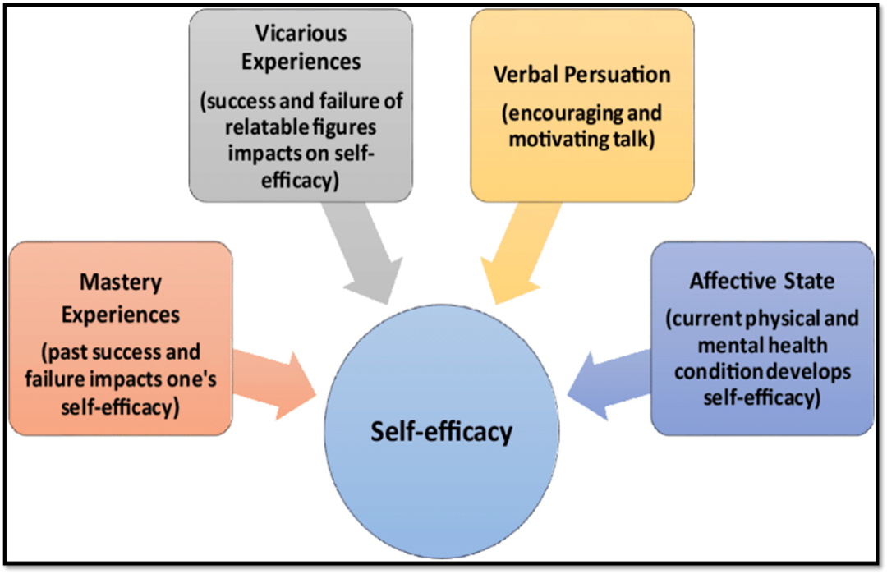

Appendix B: Permission for the Use of Bandura Self-Efficacy Theory
The PI is presently awaiting approval to use Bandura’s Self-efficacy theory

Appendix C: KTA Model

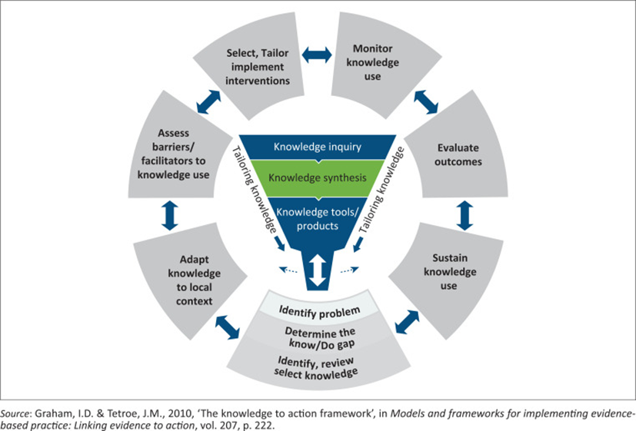

Appendix D: Permission for the Use of the KTA Model
The PI is presently awaiting a response to use the KTA model

Appendix E: Invitation to Participate Letter


To: Registered nurses, and licensed practice nurses providing direct patient care.

This is an invitation to participate in a scholarly practice project titled “Implementing a Patient Health Questionnaire Nine (PHQ-9) Education Program in Primary Care.” This project is being conducted to understand whether introducing a PHQ-9 educational program can affect nurses levels of confidence in screening for depression accurately. The purpose is to educate registered nurses on administering the Patient Health Questionnaire Nine (PHQ-9) tool to screen for depression in a timely manner. The goal is to see that every patient receives timely depression screening and diagnosis.

This project is being conducted by, Annette Gillian Kivumbi, LPN, BSN, PMHNP. Annette is a Doctor of Nursing Practice student at Regis College.
If you choose to participate in this project, you will read and sign an informed consent form. You will view an educational PowerPoint presentation, lasting about 30 minutes. You will also complete one demographic survey, Dr. Grundy’s confidence scale survey before the educational intervention and after, and one open-ended questionnaire. The demographic survey will take five minutes, Dr. Grundy’s confidence scale survey will last thirty minutes. The open-ended questionnaire will take ten minutes. Lastly, the entire process is about 60 minutes total.
Participation is confidential and voluntary.
For additional questions please contact the doctoral student at:
via Akiv891@regiscollege.edu and (781) 521-5633.
Thank you in advance for your consideration.

Annette Gillian Kivumbi, LPN, BSN, PMHNP
Doctor of Nursing Practice Student
Regis College

Appendix F: Demographic Survey
1. What is your current employment status?
Employed full-time
Employed part-time
Unemployed
Student
Retired
Other

2. What is your ethnicity?
White/Caucasian
Black/African American
Asian/Pacific Islander
Hispanic/Latino
Native American
Other

3. What is your highest level of education?
Less than high school
High school graduate
Some college
Associate degree
Bachelor’s degree
Graduate or professional degree

4. What is your household income?
Less than $25,000
$25,000 to $49,999
$50,000 to $74,999
$75,000 to $99,999
$100,000 or more

5. What is your marital status?
Single
Married
Divorced
Widowed
Separated

6. What is your gender?
Male
Female
Non-binary
Prefer not to say

7. What is your age?
18-24
25-34
35-44
45-54
55-64
65 or older

Appendix G: Dr. Grundy’s Confidence Scale

Directions: Circle the number which best describes how you perceive your current ability to administer the Patient Health Questionnaire 9-Item Tool to screen for depression.

(NOTE: Make sure that the circle encloses just ONE number.)

1. I am certain that my performance is correct:

1 |  | 2 |  | 3 |  | 4 |  | 5
not at all certain |  | certain for only a few steps |  | fairly certain for a good number of steps |  | certain for almost all steps |  | absolutely certain for all steps
2. I feel that I perform the task without hesitation:

1 |  | 2 |  | 3 |  | 4 |  | 5
I have much hesitation |  | a fair amount of hesitation |  | a good part of it without hesitation |  | almost completely without hesitation |  | absolutely no hesitation
3. My performance would convince an observer that I'm competent at this task:

1 |  | 2 |  | 3 |  | 4 |  | 5
not at all |  | agree, a little |  | for much of it |  | for almost all of it |  | for absolutely all of it
4. I feel sure of myself as I perform the task:

1 |  | 2 |  | 3 |  | 4 |  | 5
not at all |  | very little |  | for much of it |  | for almost all of it |  | for absolutely all of it
5. I feel satisfied with my performance:

1 |  | 2 |  | 3 |  | 4 |  | 5
not at all |  | very little |  | for much of it |  | for almost all of it |  | absolutely satisfied with all of it

Appendix H: Permission for the Use of Dr. Grundy’s Confidence Scale
The PI is presently awaiting approval to use this tool.

Appendix I: Open-Ended Questionnaire

- Describe how the PHQ-9 educational training impacted your understanding of depression screening in primary care.
- Explain how confident you feel in administering the PHQ-9 to patients following the training.
- Apply what you learned in this training to describe how you would approach a patient exhibiting signs of depression.
- Create a brief action plan outlining how you will incorporate PHQ-9 screening into your routine practice.
- How has your approach to identifying or managing depression changed compared to before the PHQ-9 educational intervention? (Explain)

Appendix J: External Site Permission

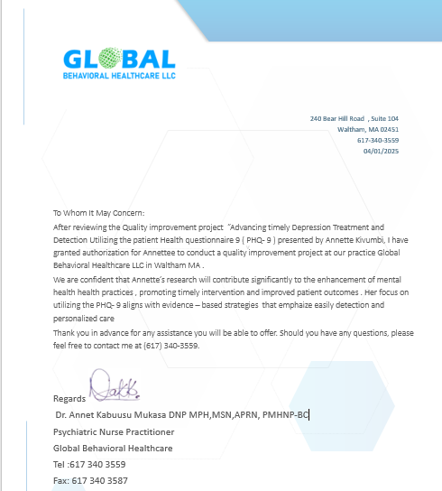

Appendix K: CITI Training Certificate and the Project’s Chair Nurse Educator Certificates

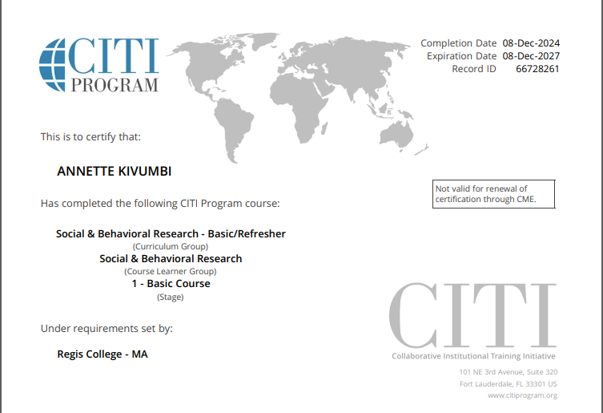

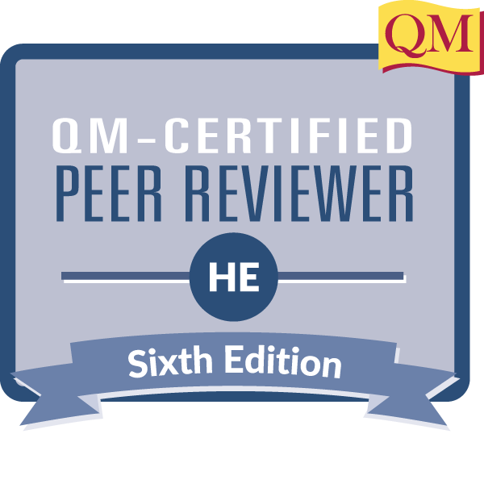



Appendix L: Flesch-Kincaid Grade Level for Informed Consent

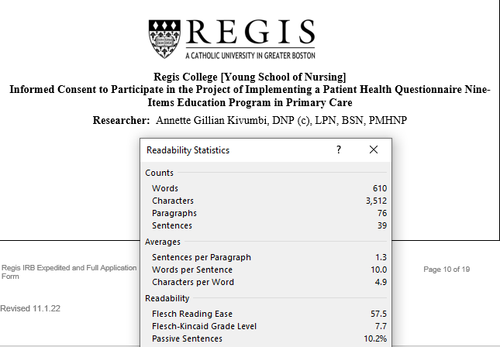

Appendix M: G* Power Analysis

