T-test

Annette Kivumbi

Regis College, Young School of Nursing

NU727: Advanced Research Methods for EBP II

3.9.2025

T-test

Included Analyses
- Two-Tailed Paired Samples t-Test between Pre_test_Score and Post_test_score

Results
Two-Tailed Paired Samples t-Test
Introduction
A two-tailed paired samples t-test was conducted to examine whether the mean difference of Pre_test_Score and Post_test_score was significantly different from zero.
Assumptions
Normality. A Shapiro-Wilk test was conducted to determine whether the differences in Pre_test_Score and Post_test_score could have been produced by a normal distribution (Razali & Wah, 2011). The results of the Shapiro-Wilk test were not significant based on an alpha value of .05, W = 0.98, p = .853. This result suggests the possibility that the differences in Pre_test_Score and Post_test_score was produced by a normal distribution cannot be ruled out, indicating the normality assumption is met.
Results
The result of the two-tailed paired samples t-test was significant based on an alpha value of .05, t(29) = -16.49, p < .001, indicating the null hypothesis can be rejected. This finding suggests the difference in the mean of Pre_test_Score and the mean of Post_test_score was significantly different from zero. The mean of Pre_test_Score was significantly lower than the mean of Post_test_score. The results are presented in Table 1. A bar plot of the means is presented in Figure 1.
Table 1
Two-Tailed Paired Samples t-Test for the Difference Between Pre_test_Score and Post_test_score
Pre_test_Score |  | Post_test_score
M | SD | M | SD | t | p | d
79.87 | 8.61 | 91.17 | 6.93 | -16.49 | < .001 | 3.01
Note. N = 30. Degrees of Freedom for the t-statistic = 29. d represents Cohen's d.
Figure 1
The means of Pre_test_Score and Post_test_score with 95.00% CI Error Bars
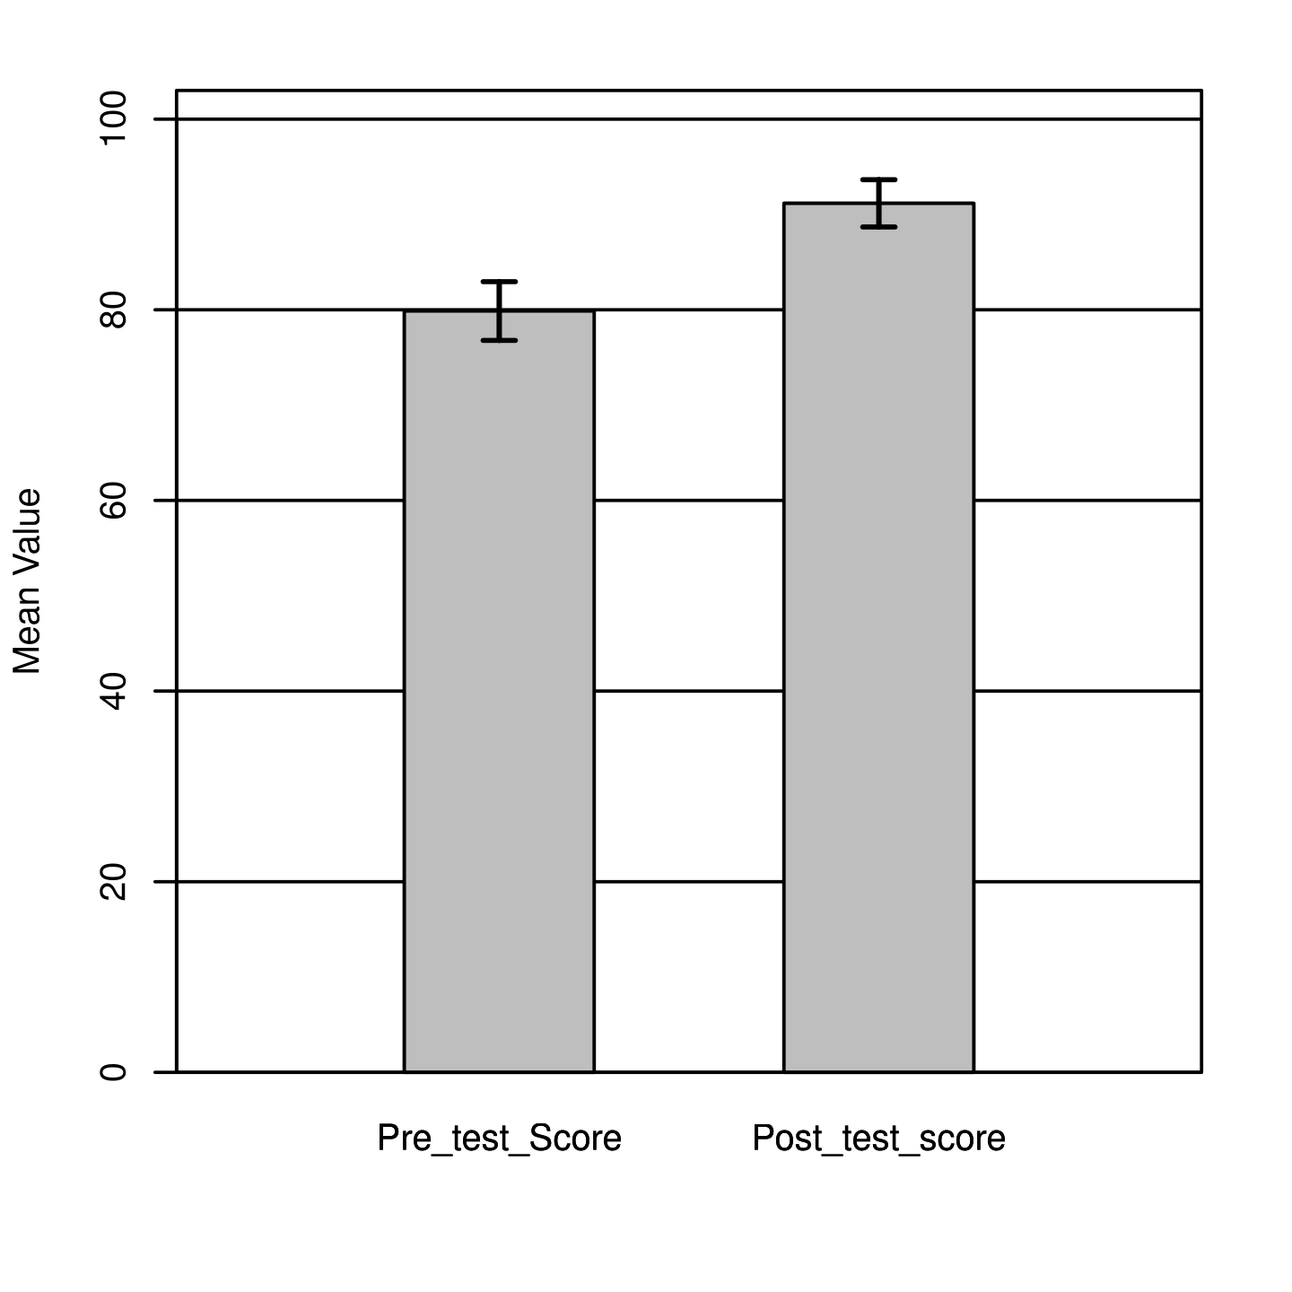

References
Intellectus Statistics [Online computer software]. (2023). Intellectus Statistics. https://statistics.intellectus360.com
Razali, N. M., & Wah, Y. B. (2011). Power comparisons of Shapiro-Wilk, Kolmogorov-Smirnov, Lilliefors and Anderson-Darling tests. Journal of Statistical Modeling and Analytics, 2(1), 21-33.

Glossaries
Paired Samples t-Test
The paired (dependent) samples t-test is used to assess for significant differences between two scale variables that can be matched. Typically, the scale variables are matched by time (e.g. pretest vs. posttest), but the data can also be matched in other ways (e.g. husband vs. wife). The test uses the average difference between each pair of matched scores to compute the t statistic, which is used with the df to compute the p-value (i.e., significance level). A significant result indicates the observed test statistic would be unlikely under the null hypothesis. The dependent samples t-test assumes that the differences between pairs of matched scores are normally distributed (i.e., normality).
Paired Samples t-Test Formula:
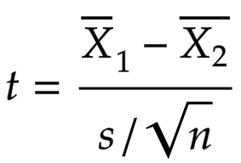
X̄₁ = sample 1 mean
X̄₂ = sample 2 mean
s = sample standard deviation
n = sample size
Fun Fact! This test is based on the Student's t distribution. This distribution was named after William Sealy Gosset, who published a paper about the distribution in 1908 under the pseudonym "Student."
Cohen's d: Effect size for the t-test; determines the strength of the differences between the matched scores. The larger the effect size, the greater the differences in the matched scores.
Degrees of Freedom (df): Refers to the number of values used to compute a statistic. The df is determined by the number of observations in the sample and equal the number of observations - 1; used with t to compute the p-value.
Mean (M): The average value of a scale-level variable.
Normality: Refers to the distribution of the data. The assumption is that the data follows the bell-shaped curve.
p-value: The probability of obtaining the observed results if the null hypothesis is true. A result is usually considered statistically significant if the p-value is ≤ .05.
Shapiro-Wilk Test: A test to assess if the assumption of normality is met. If statistical significance is found in this test, the data is not normally distributed.
Standard Deviation (SD): The spread of the data around the mean of a scale-level variable.
t-Test Statistic (t): Used with the df to determine the p value.

Raw Output
Paired t-Test for Pre_test_Score and Post_test_score
Included Variables:
Pre_test_Score and Post_test_score
Sample Size (Complete Cases):
N = 30
Shapiro-Wilk Test:
W = 0.981, p = 0.853
Results:
Pre_test_Score |  | Post_test_score
M | SD | M | SD | t | p | d
79.867 | 8.609 | 91.167 | 6.929 | -16.495 | 2.827 × 10⁻¹⁶ | 3.012
Note. n = 30, df = 29.
Confidence Interval Based on α = 0.0500:
Lower Limit = -12.701, Mean Difference = -11.300, Upper Limit = -9.899

