Chapter III: Methodology
Introduction
Cultural competence is an indispensable skill in healthcare, but many nurses still lack the training necessary to fulfill the cultural requirements of their clients (Sahamkhadam et al., 2023). The growing population diversity paucity necessitates a culturally diverse nursing workforce to warrant the provision of culturally competent care. The deficiency of cultural competence in practice can instigate poor patient outcomes, dissatisfaction with care, and misunderstandings in psychiatric settings (Arruzza & Chau, 2021). At the project’s site, many of the psychiatric nurse’s report grappling with challenges in delivering culturally appropriate care, which affects their ability to effectively support clients from disparate cultural milieus. Furthermore, the lack of sufficient cultural competence has been shown to impact the quality and consistency of mental health care. Intrinsically, the issue of insufficient cultural competence can be tackled by incorporating an evidence-based cultural competence education program to help clinicians provide equitable and culturally tailored care, especially for patients from diverse backgrounds (Arruzza & Chau, 2021).
The educational intervention based on Leininger’s theory will focus on enhancing key elements of cultural competency such as cultural awareness, knowledge, and skill development. The rudiments of cultural competency aim at fostering positive behavioral change among nurses and improving patient outcomes (Sahamkhadam et al., 2023). The cultural proficiency training will help psychiatric nurses understand cultural nuances, utilize effective communication techniques, and incorporate culturally sensitive practices into their care routines. Leininger's culture care theory and the Johns Hopkins Nursing Evidence-Based Practice (JHNEBP) model will guide the steps of the project, providing an evidence-based foundation. The third chapter will encapsulate the methodology which will be used for the scholarly project (SPP). As such, it will detail the project’s design, guiding EBP model, methods, participant recruitment, ethical considerations, plans and procedures, tools, data analysis, timetable, limitations and transferability. The goal is to describe the project’s design, implementation, and evaluation of the program to measure its impact on enhancing cultural competence among psychiatric nurses in a Northeastern U.S. home care facility.
Project Design
The principal investigator will employ a quality improvement design, thereby assimilating current evidence-based practices to implement and measure the cultural competence educational program within a psychiatric unit. In addition, the project will be customized to address gaps in culturally competent care by augmenting nurses’ cultural awareness, expertise, and knowledge. The Johns Hopkins Nursing Evidence-Based Practice (JHNEBP) model will serve as the project’s basis. The model will enable the principal investigator to leverage the PET approach which comprises the practice question, evidence, and translation procedure, which is advantageous for structured EBP initiatives (Dang et al., 2022).
The primary goals are to improve cultural competence among psychiatric nurses and the delivery processes of patient care by providing culturally sensitive care. The project will also foster a more all-encompassing clinical milieu that acknowledges and respects patients varied cultural upbringings. The probable results include improved cultural competence levels including knowledge, skills, and attitudes, as evaluated by the Vancouver Cultural Competence Checklist.
The JHNEBP model will provide the principal investigator with a blueprint which will bolster the identification, collation, translation, and application of evidence akin to cultural competence (Dang et al., 2022). The following model's PET process has three stages that expedite the evidence-based practice (EBP) approach.
PET Procedure
The first level of the PET process involves categorizing a practice question, which includes delineating the EBP issue, articulating the question, and affirming the project’s goals. This stage will help the principal investigator form an interdisciplinary team, designate project roles, involve stakeholders, and prepare for cohort meetings (Dang et al., 2022).
The second segment consists of the evidence level which was used to obtain, review, recap and synthesize evidence, as well as recommend practice modifications (Dang et al., 2022). The principal investigator conducted a thorough appraisal of studies probing cultural competence interventions in psychiatric settings. Some of the keywords used related to the practice question, and using credible databases like PubMed and CINAHL to locate suitable evidence. The JHNEBP model buttressed the appraisal of quality literature, allowing the principal investigator to utilize first-class studies that are directly relevant to the practice question (Dang et al., 2022). As such, the process expedited a well-founded synthesis of evidence to assess the effectiveness of a cultural competence program and identify existing gaps in literature.
At the translation level, the principal investigator will bring evidence into practice by developing and implementing an actionable plan in the psychiatric unit. This phase will involve working in tandem with key stakeholders, including the project mentor and psychiatric nursing staff, to gain support and foster engagement in the initiative. The implementation plan will involve tailoring the educational program to fit the practice environment, with pre-and post-intervention assessments conducted using the Central Vancouver Island Multicultural Society’s Cultural Competence Self-Assessment Checklist.
Application of the JHNEBP Model in the Project
Figure 3
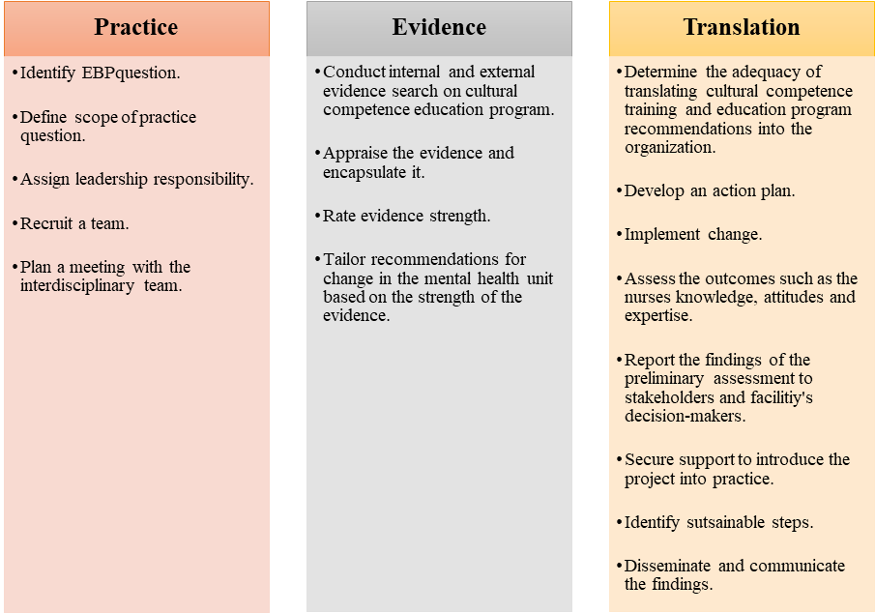
Plans and Procedures
The following are the steps the PI will take:
- Create the educational intervention based on Leininger power point. The presentation will be recorded and narrated it in Zoom. PI will include YouTube clips from experts, evidence, supporting literature.
- Obtain external site permission.
- Obtain permission to use instrument the Vancouver cultural competence self-assessment checklist and confidence scale.
- Create open-ended questions for the nurses about their feelings.
- Tailor a comprehensive demographic Survey.
- Familiarize with Qualtrics to collect data.
- Become familiar with Intellectus Statistics and secure a Statistician consult.
Evidence-Based Clinical/Practice Question
“Does the implementation of a culturally competent educational intervention improve the levels of confidence in the use of cultural competence for psychiatric mental health registered nurses?”
Setting
The principal investigator will launch the project at a psychiatric home care agency, which is located in the Northeast, once external site approval is obtained. It is worth noting, that the home care agency serves individuals with mental health issues in the community, offering services such as in-home therapy, daily living activities, and medication management. The facility has a capacity of 370 beds, more than 50 registered nurses, and delivers rounded and wide-ranging treatment, with ease, and care to clients facing psychiatric challenges.
Sample
A sample serves as a representative segment of a larger population, allowing researchers to make inferences that can potentially be applied to similar populations (Andrade, 2020). The following are the rudimentary elements akin to a sample. The intended population from which the PI will draw the participants are psychiatric mental health registered nurses.
Recruitment Plan
The project’s principal investigator will obtain approval from the facility’s administrator under the guidance of the quality appraisal committee, which undertakes improvement efforts. In particular, the quality improvement committee’s primary goals include classifying areas necessitating improvement, enabling constructive vicissitudes, guaranteeing compliance with established regulations, inculcating the workforce and practitioners, and accentuating key enhancement prospects (Polit & Beck, 2021). The committee will be briefed on the study’s purpose and significance, rationale for selecting the location, details of the research, and the commitment to upholding ethical standards. Besides, the principal investigator will then collaborate with psychiatric nurse leaders and a project mentor to identify eligible participants based on established inclusion criteria (Purna Singh et al., 2023). The eligible respondents will receive informed consent documents via an email link, detailing the project’s goals, processes, expectations, and the voluntary nature of participation.
Sample Size
The principal investigator performed a G*power analysis to determine the effective sample size. Based on the results, the PI will incorporate a sample size of 34 participants (See figure 3).
Figure 4
G*Power Analysis
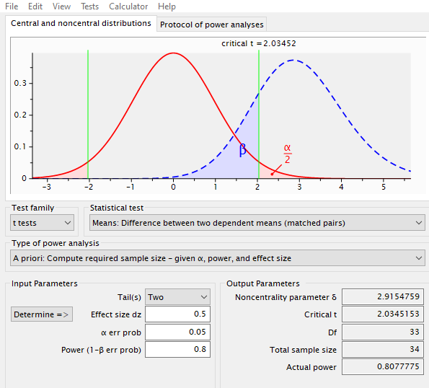
Sampling
A convenience sampling method will be used, allowing for easy access to participants. This sampling approach is cost-effective, time-efficient, and practical for involving colleagues already working at the project’s location (Purna Singh et al., 2023). The PI will seek permission from the homecare agency administrator and nurse manager to implement the project. Subsequently, the PI after receiving approval will send invitation links via Qualtrics to potential participants who are readily available and willing to join in the project. Those interested will be sent an informed consent document with detailed information about the project. The inclusion and exclusion criteria will be considered during sampling.
Inclusion Criteria
The following is the inclusion criteria:
- Psychiatric mental health registered nurses working at the project site. Individuals must have a minimum of two years of nursing experience.
- Direct care for clientele in the psychiatric unit.
- A bachelor’s degree in nursing.
Exclusion Criteria
The PI will use the following criterion to exclude individuals from participating in the project.
- Psychiatric mental health registered nurses with less than two years of nursing experience.
- Nurses working in other departments.
- Those holding directorial positions.
- Nurses not directly engaged in psychiatric patient care.
Ethical Considerations
Ethical considerations are fundamental to the success of any scholarly project, particularly one involving human participants. This project will focus on a cultural competence educational intervention for psychiatric mental health registered nurses, aiming to improve mental health service delivery for diverse patient populations and levels of cultural competence. The principal investigator will adhere to ethical tenets, ensuring that participants are protected, respected, and fully informed about their involvement in the study. The primary ethical considerations in this project include informed consent, beneficence, respect for secrecy and confidentiality, and respect for privacy. The PI will ensure that the participants are not harmed, adequately informed about the project, and understand the risks and benefits of participating in the study. The following are the ethical considerations that the PI will uphold throughout the project.
Informed Consent
The principal investigator will provide each participant with an informed consent document that clearly demarcates and elucidates all relevant information about the project of cultural competence. In addition, the informed consent will also be concise on the respondents' right to voluntarily participate or opt-out (Polit & Beck, 2021). The document will detail the project's goals and objectives, explain the data collection procedures, and describe how participants will be involved. It will also include a clause ensuring the discretion and obscurity of the respondents. Crucially, the participants will be advised of their own choice to pull out of the study at any period without facing any consequences. The principal investigator will seek approval from the Institutional Review Board (IRB) at Regis College and the hospital’s quality improvement committee to guarantee that the project is conducted morally, and that respondents’ privileges and safety are safeguarded.
Beneficence
The principal of beneficence requires the project investigator to not expose participants to harm and instead maximize benefits while minimizing risks. Therefore, the principal investigator will ascertain that every effort will be made to prevent any form of harm to participants (Polit & Beck, 2021). The cultural competence education program is designed to enhance skills and improve patient outcomes, providing potential benefits for participants' professional development, levels of cultural competence and patient care quality. Risks are anticipated to be minimal, as this study involves an educational intervention. Nonetheless, any potential discomfort or unintended negative consequences of the intervention will be monitored and addressed promptly to ensure participants’ well-being.
Anonymity and Confidentiality
The project investigator will respect the participants' anonymity and confidentiality to uphold trust and integrity throughout the research process. Per se, the respondents’ data will be de-identified by assigning codes to participants rather than using personal identifiers. Consequently, only their aggregate data will be reported, ensuring that no individual can be identified from the findings. Furthermore, access to any identifying information will be restricted to the research investigator, and data will be stored securely in encrypted files to prevent unauthorized access (Polit & Beck, 2021). These measures will help protect participants’ identities and maintain the confidentiality of their information.
Respect for Privacy
Respecting respondents’ privacy is critical, particularly when dealing with sensitive topics such as cultural competence and mental health care. Hence, the participants will be informed about the types of data being collected and how the information will be used. They will have control over the extent of their participation in completing the cultural competence self-assessment questionnaire and the volition to refute to complete any queries they feel uncomfortable with. As a result, this strategy will play a focal role in respecting their right to privacy (Polit & Beck, 2021).
Measurement of Variables
1. Demographic Survey
The PI will collect demographic data using a demographic data sheet. This tool will capture participant characteristics such as age, gender, and years of experience. Descriptive statistics, including means, medians, frequencies, and percentages, will be used to summarize the data, ensuring that the sample is well-described and contextualized (see figure 5).
Figure 5
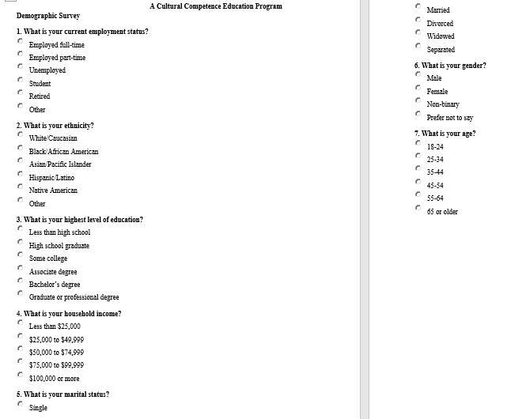

2. Cultural Competence Self-Assessment Checklist
The principal investigator will use the Cultural Competence Self-Assessment Checklist to collect pretest and posttest data. The tool has been validated for use among healthcare professionals and its reliability was established using Cronbach’s alpha with average values of 0.78 across the three sections, indicative of a great level of internal homogeneity (Argyriadis et al., 2022). Additionally, a confirmatory factor analysis (CFA) validates the tool’s structure, confirming its robustness and reliability for assessing cultural competence. These metrics bolster the use of the checklist in the project, ensuring that it provides consistent and accurate data to measure changes in cultural competence (Argyriadis et al., 2022).
Additionally, the cultural competence checklist is grounded on a Likert scale format, in which participants rate their responses to items that assess cultural awareness, knowledge, and skills. In this light, the checklist includes multiple items that address specific aspects of cultural competence across the three domains. The founders of the questionnaire ascertained that the Likert scale items are structured in a way that the participants can indicate the magnitude to which they agree or disagree with statements (Argyriadis et al., 2022). The checklist enables capturing the degree of cultural competence among respondents.
It is essential to note that the cultural competence cohort focuses on understanding cultural distinctions, self-awareness, and stereotypes. In this light, greater scores indicate a more developed awareness of cultural differences. On the other hand, the cultural knowledge scale dictates elements which assess understanding of cultural histories, discrimination, and cultural boundaries. As such, a high score reflects enhanced knowledge, and vice versa is true. The cultural expertise section includes questions on diversity acceptance, support for individuals from various backgrounds, and communication skills (Argyriadis et al., 2022).
3. Confidence Scale (C-Scale, Grundy 1993)
The confidence scale (C-scale) will help measure the participants confidence levels in providing culturally competent care (Grundy, 1993). This instrument is suitable since it strives to evaluate the efficacy of educational intervention such as the cultural competence educational intervention. The C-scale is a structured Likert-scale questionnaire in which participants rate their level of confidence about specific statements akin to cultural competence across several domains. These domains include cultural awareness, expertise, encounters, and knowledge (Grundy, 1993). The C-scale is a corroborated tool with a strong validity and dependability, demonstrating strong psychometric properties. Grundy (1993) elucidates that the C-scale’s internal consistency is bolstered by a superior Cronbach’s alpha value and construct validity which validate the tool’s accuracy. The PI will administer the tool to the participants before and after the intervention to measure their confidence levels. The analysis will help determine the efficacy of the educational intervention
4. Open-ended Questions
The PI will provide the participants with open-ended questionnaires to gather their perspectives on cultural competence training. As such, the questionnaires will help understand participants’ challenges, insights, and areas for improvement. The PI will use thematic analysis to recognize emerging patterns and themes akin to cultural competence in psychiatric care settings (see figure 6).
Figure 6
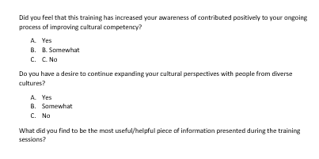
5. Educational Intervention
The principal investigator will measure the independent variable which is a cultural competency educational program using the cultural competence checklist with five item Likert scale questions. The queries vary from “strongly disagree to strongly agree” to quantify the participants levels of cultural competency. The cultural competence educational intervention program will be designed to boost psychiatric Registered Nurses’ levels of cultural competency including knowledge, awareness, and expertise. The educational intervention will include a PowerPoint presentation on cultural competence, disparities, and cultural sensitivity. Additionally, the PI will incorporate case studies demonstrating pragmatic scenarios about cultural diversity, and poster to reinforce critical cultural competence concepts. Supplementary information will also include URL links and resources akin to implicit bias, cross-cultural encounter, and transcultural care.
Data Collection and Analysis
All data will be collected in Qualtrics software. Once the participant is given access to the informed consent, they will agree to participate, they will be deidentified, and given a random numerical value. Only the Primary Investigator (PI) and the Project Chair will have access to this data in a password protected computer. The data will be stored for three years and then destroyed. The data will be downloaded from Qualtrics once it has been cleaned and then securely uploaded to Intellectus Statistics, an online software program for analysis.
Timetable
The project is intended to take fourteen weeks starting in May of 2025. See table 1 for a detailed timeline.
Table 1
Activity | Timeline | Details
Proposal Hearing | Week 1 | Present project to committee, gather feedback.
IRB Approval | Weeks 2–6 | Submit IRB application to secure approval from the Institution’s IRB and await approval.
Participant Recruitment and Distribution of Informed Consent Forms | Weeks 7–8 | Recruit eligible participants based on the inclusion and exclusion criteria, obtain informed consent. Disseminate informed consent to participants via Qualtrics
Pre-Intervention Survey | Week 9 | Administer the Cultural Competence Self-Assessment Checklist pre-intervention survey to establish baseline data on participants’ current cultural competence status.
Educational Intervention | Weeks 10–12 | Conduct cultural competence training sessions via Zoom and distribute educational materials.
Post-Intervention Survey | Week 13 | Re-administer the Cultural Competence Self-Assessment Checklist.
Data Analysis | Week 14 | Use Intellectus Statistics, conduct paired t-tests to evaluate changes in cultural competence levels.
Compile and Disseminate Findings | Week 14 | Present findings to stakeholders and academic reviewers. Share outcomes with stakeholders.
Summary
In conclusion, the chapter discussed key components such as the project’s site, actions, design, informed consent, inclusion and exclusion measures, IRB approval, tool, and data analysis. The project will comprise a sample size of forty human subjects who will complete pre-and post-intervention queries. Besides, the principal investigator will ascertain they adhere to the ethical standards required for conducting research with human subjects and foster a trustworthy environment that encourages honest and open participation. The Cultural Competence Self-Assessment Checklist is an effective and unswerving tool for assessing changes in cultural competence among nurses. The instrument will provide comprehensive data to gauge the influence of the intervention on nurses' cultural awareness, knowledge, and skills, ultimately supporting the project's aim of boosting cognitive health delivery procedures. Although the project is marred by a small sample which may restrict the generalizability of the results, the sample may provide precise and sophisticated measurements. Most importantly, the findings will allow for transferability to other clinical contexts, ensuring that readers draw insights on the significance of culturally competent nursing workforce. Ultimately, the timeline provides an ideal structure in which the project advances efficiently, meeting all critical deadlines within the stipulated timeframe.

References
Andrade, C. (2020). Sample size and its importance in research. Indian Journal of Psychological Medicine, 42(1), 102. https://doi.org/10.4103/IJPSYM.IJPSYM_504_19
Argyriadis, A., Patelarou, E., Paoullis, P., Patelarou, A., Dimitrakopoulos, I., Zisi, V., Northway, R., Gourni, M., Asimakopoulou, E., Katsarou, D., & Argyriadi, A. (2022). Self-assessment of health professionals’ cultural competence: knowledge, skills, and mental health concepts for optimal health care. International Journal of Environmental Research and Public Health, 19(18). https://doi.org/10.3390/ijerph191811282
Dang, D., Dearholt, S., Bissett, K., Ascenzi, J., & Whalen, M. (2022). Johns Hopkins evidence-based practice for nurses and healthcare professionals: Model and guidelines. 4th ed. Sigma Theta Tau International
Grundy S. E. (1993). The confidence scale: Development and psychometric characteristics. Nurse Educator, 18(1), 6–9. https://doi.org/10.1097/00006223-199301000-00004
Purna singh, A., Vadakedath, S., & Kandi, V. (2023). Clinical research: A review of study designs, hypotheses, errors, sampling types, ethics, and informed consent. Cureus. https://doi.org/10.7759/cureus.33374
Polit, D. F., & Beck, C. T. (2021). Nursing Research: Generating and Assessing Evidence for Nursing Practice (11th ed.). Philadelphia, PA: Lippincott, Williams, & Wilkins. Chapter 7: Ethics in nursing research.
Sahamkhadam, N., Andersson, A. K., Golsäter, M., Harder, M., Granlund, M., & Wahlström, E. (2023). Testing the assumptions in the process of cultural competence in the delivery of healthcare services using empirical data, focusing on cultural awareness. Journal of Transcultural Nursing, 34(3), 187-194. https://doi.org/10.1177/10436596231152212

