Cultural Competence Educational Program in Psychiatric Mental Health Settings

A Scholarly Project

Presented to

The Faculty of Regis College

In Partial Fulfillment
of the Requirements of the
Doctor of Nursing Practice Degree

by

Bruce Nsubuga, MSN, RN

3/9/2025

This scholarly practice project of _____________, entitled _____________________directed and approved by the faculty chair, has been accepted by the Nursing Faculty of Regis College in fulfillment of the requirements for the Doctor of Nursing Practice.

__________________________________________
Dean, Richard and Sheila Young School of Nursing

__________________________________________
Chair, Doctoral Scholarly Project Team, (credentials)

__________________________________________
Team Member, (credentials)

__________________________________________
Team Member, (credentials)

___________________________________________
Team Member, (credentials)

Add an additional signature line for each additional team member.

[This page is a temporary placeholder which will be replaced with the signature page signed by all project team members.]

Cultural Competence Educational Program in Psychiatric Mental Health Settings
Chapter I
Introduction
In the United States, research highlights a considerable demographic shift driven by snowballing cultural diversity, largely due to the rise in international migration (Sahamkhadam et al., 2023). The transformation presents both opportunities and challenges, particularly in healthcare. The cumulative diversity provides a need for a proficient nursing workforce that can provide culturally competent care to their clients. Rice and Harris (2021) postulate that cultural competence serves as an underpinning that empowers patients to feel contented with their clinician and continuously seek out critical care. While the patient population has become more diverse, the healthcare workforce has not kept pace with this growing heterogeneity, which can contribute to disparities in health outcomes (Marcelin et al., 2019). Psychiatric mental health care is still one of the most underutilized services within the continuum of care despite its purported catholicity. Therefore, addressing these challenges is critical to ensuring the delivery of culturally competent and sensitive care, essential for meeting the needs of an increasingly diverse society (Stubbe, 2020). The delivery of culturally competent care is requisite to expedite access to culturally equitable care for diverse patient cohorts (Fante-Coleman & Jackson-Best, 2020).
Evidence indicates that cultural competency has become a critical prerequisite for mental health nurses catering to culturally divergent patient groups. As such, it is vitally important to train psychiatric mental health registered nurses to ascertain they provide culturally competent care (Raval et al., 2024). Cultural competence training enhances healthcare delivery processes and mitigate abysmal patient outcomes (Sahamkhadam et al., 2023). Patients seeking mental healthcare frequently occur at manifold stages of society such as systemic, provider-connected, and individual-linked barriers. Specifically, provider-akin barriers entail racism and discrimination from clinicians, the ineptitude to deliver culturally competent care, and the paucity of organizational backing (Fante-Coleman & Jackson-Best, 2020). Nonetheless, a culturally competent psychiatric nursing workforce serves as an enabler of cultural competence.
Training nursing personnel in cultural competence boosts their capacity to deliver culturally effective and sensitive care. The training can result in optimal outcomes such as aligned treatment care plans and enhanced patient engagement (Sahamkhadam et al., 2023; Nair & Adetayo, 2019; Stubbe, 2020). Research also suggests that a lack of cultural competence can contribute to unconscious biases, stereotypes, and microaggressions among healthcare providers, which may further alienate patients and discourage them from seeking necessary care (Cruz et al., 2019; Stubbe, 2020). The scholarly practice project (SPP) will explore the effect of a cultural competence education program in a psychiatric mental health setting. The principal investigator (PI) will implement the intervention in a homecare agency that provides comprehensive and holistic medical and mental health services. The cultural competence education program will foster greater cultural understanding among healthcare providers and aim to augment care delivery as well as patient experiences.
Background
Nurses' cultural competence and the cumulative diversity of patient populations directly influence cognitive mental health services (AHRQ, 2019). As such, training nurses on cultural competence can improve their clinical practice efficiency and lessen healthcare disparities in culturally diverse populations (Eken et al., 2021). Psychiatric nurses, who regularly interact with patients to improve their health, consider themselves moderately culturally competent (Sahamkhadam et al.,2023). Chu et al. (2022) discovered that engaging and working in tandem with clients from different cultural settings can boost healthcare providers' cultural competence. However, prior to collaborating with patients, nurses should identify their individual biases, norms, and prejudices to become well-suited to provide bespoke and efficient healthcare services that esteem and prioritize patients' cultural identities (Sahamkhadam et al., 2023).
Culturally edified psychiatric personnel are effectively equipped to provide cultural rapport and competent care to their clients, expediting access to care (Fante-Coleman & Jackson-Best, 2020). However, research studies state that during client interactions, a paucity of cultural understanding can have dire repercussions for the providers. For instance, they may radiate an unyielding demeanor and cease to recognize their client’s anguish on account of the poor therapeutic alliance (Fante-Coleman & Jackson-Best, 2020). As such, the providers may inadvertently dismiss patients by not including them during treatment decisions and tailoring informed care plans. These challenges may precipitate inadequate patient outcomes and instigate numerous health inequities (Alkhamees & Alasqah, 2023). Patients from marginalized and minority groups often experience barriers to care like stigma and biases, which negatively affect their quality of life and determination to seek appropriate psychiatric care (Cruz et al., 2019; Gopal et al., 2021). Stubbe (2020) opined that most nurses experience delivery complexities when caring for clients from varied cultural affiliations.
The challenges may perpetuate a lack of culturally competent care, and workflow ineffectiveness. As such, nurses should use these experiences as a driving force to engage in cultural competence training and lifelong learning to address the ever-evolving health requirements of divergent healthcare clientele (Desai et al., 2020). Essentially the aptitude to deliver culturally competent care can be attributed to the impeccability of providers in offering culturally holistic, congruent, and sensitive care, making it easier for them to accomplish ideal healthcare delivery processes and patient outcomes (Desai et al., 2020). Cultural competence accredits nurses with satisfactory expertise in providing equitable care which complements the inimitable health necessities of patients from disparate cultural backgrounds (Arruzza & Chau, 2021). Even so, an inadequacy in cultural competence among mental health nurses can prompt redundant medical blunders which can increase incompetence (Chu et al., 2022).
Some clinicians are often adamant in recognizing their biases and may make assumptions that patients are apathetic in receiving necessary care, giving rise to a gamut of health inequalities like discrimination, microaggressions, and unawareness (Handtke et al., 2019). When nurses project their prejudices and biases towards patients from diverse cultural backgrounds, they become culturally insensitive and fail to address the patients’ diversity. As such, they may stereotype their clients, especially those seeking mental health care, and make hurtful statements which may lead to microaggressions (Cruz et al., 2019). These consequences may lead to misunderstanding patients’ cultural representations of their experiences, contributing to distrust of the psychiatric healthcare system (Fante-Coleman & Jackson-Best, 2020). It is critically important to note that the outcomes may dishearten clients, making it difficult for them to seek the care they so deserve. Unfortunately, the lack of proper treatment mechanisms can deteriorate their quality of life and upsurge the risk of mortality and morbidity rates (Cruz et al., 2019).
According to Handtke et al. (2019), a variety of nurses report that they grapple with a lack of cultural understanding, particularly in scenarios in which clients do not constantly adhere to the stipulated treatment recommendations. The process enhances nurse’s negative assumptions and may presume the patients do not value their well-being. The misunderstanding may alienate patients from engaging in mental health services and impede access to quality care (Fante-Coleman & Jackson-Best, 2020). Similarly, when clients with pain issues request pain medication, nurses might put labels on the clients by referring them to as drug-seekers rather than individuals grappling with mental health ailments (Cruz et al., 2019). These assumptions and typecasts can aggravate healthcare disparities, such as discrimination, language impediments, and lack of cultural awareness (Handtke et al., 2019).
Mental healthcare providers also face difficulties akin to organizational barriers such as praxis which makes it difficult to bridge the gap between acknowledging the necessity for equitable care and implementation within the paradigm of care (Fante-Coleman & Jackson-Best, 2020). Therefore, clinicians ought to introduce cultural competence training at their workplaces to better fathom their patients' cultural behaviors and tailor treatment plans that are reliant on their values (Fante-Coleman & Jackson-Best, 2020). Introducing a cultural competence education program will boost cultural competence among providers. As a result, patients may feel comfortable expressing their health concerns and adhering to the administered treatment plans. As the United States continues to diversify, providers may register an increment in healthcare inequalities, making it paramount for Doctor of Nursing Practice (DNP) scholars and other practitioners to implement cultural competence training within the continuum of care (Sahamkhadam et al., 2023).
The strategic approach ensures that providers are well-equipped to provide culturally competent care. Cultural proficiency plays a critical role in helping nurses recognize their biases and respect the diversity of their patients (Lin & Hsu, 2020). More so, cultural competence improves nurse’s cultural awareness, enabling them to provide more sensitive care and lessen existing healthcare disparities (Rukadikar et al., 2022). As vital affiliates of the healthcare system, nurses are responsible for building trust with patients, streamlining psychiatric care processes, and addressing challenges arising from cultural differences (Lin & Hsu, 2020). On the other hand, healthcare administrators and leaders are central to promoting cultural competence by educating nurses to espouse essential elements such as cultural understanding, knowledge, motivation, experiences, and skills (Kaihlanen et al., 2019).
Cultural competence is closely linked to cultural awareness because it develops effective communication between nurses and patients from diverse backgrounds. It also helps nurses design effective care strategies (Handtke et al., 2019). According to Arruzza and Chau (2021), training healthcare providers in cultural competence elevates their skills, leading to better treatment outcomes, higher patient satisfaction, and efficient information sharing. While cultural competence is an unending procedure that inspires clinicians to familiarize their care practices with the needs of diverse patients more effectively, there are still barriers to fully integrating cultural competence education into healthcare (Liu et al., 2021).
Impact of Discrimination on Patient Experiences
It is critical for healthcare organizations to edify their workforce, on effective strategies such as cultural competence training and materials to help providers better understand the diverse cultural backgrounds of their patients (Nair & Adetayo, 2019). The lack of culturally competent care can precipitate poor health outcomes, both mentally and physically (Cruz et al., 2019). A major approach to mitigating this gap is promoting cultural competence discourse to understand the impact of prejudice and discrimination on patients. The training through discussions can help nurses understand the eminence of cultural competence education (Chu et al., 2022). On the other hand, healthcare leaders can strengthen more culturally sensitive care by amalgamating training initiatives with organizational guiding principles designed to eradicate racism and discrimination (Chu et al., 2022). The project will assess the impact and significance of cultural competence training on healthcare providers' knowledge, attitudes, and behavior, as well as its effect on patient outcomes. As such, the assessment will help raise awareness of the current gaps and provide effective ways of addressing them.
Significance
Cultural competence is a significant topic that healthcare providers are mandated to incorporate into their practice (Rukadikar et al., 2022). Cultural competence allows providers to deliver respectful and empathic care that holds in high regard the diverse beliefs, values, and behaviors of patients with dissimilar characteristics. Nurses need to espouse culturally informed and health-literate approaches to enhance competence (AHRQ, 2019). For instance, when they fail to adopt cultural competence strategies, they are susceptible to jeopardizing their clients’ safety and instigating adverse disparities, such as diagnostic errors, missed screenings, adverse medication reactions, and substandard cognitive health services (AHRQ, 2019). There are merits associated with cultural competence training such as augmented nurses’ awareness, understanding, knowledge, and skills, positive behavioral vicissitudes, and better patient outcomes (Sahamkhadam et al., 2023). Thus, training nurses in cultural competence can assist nurses, in overcoming cultural differences and building a stronger culture of trust and transparency (AHRQ, 2019). Cultural competence is essential across nursing, research, clinical practice, education, and leadership.
Nursing Practice
Culturally competent nurses demonstrate increased knowledge, behaviors, and attitudes that improve the efficiency of mental healthcare delivery (Nair & Adetayo, 2019; Chae et al., 2020). Additionally, nurses who are culturally aware are better equipped to meet their patients' health needs, resulting in timely diagnoses, effective treatments, and stronger relationships throughout the care process (Stubbe, 2020. In nursing practice, positive communication and affinity between patients and providers enhance patients’ engagement and adherence to treatment plans (Stubbe, 2020). However, biases, stereotypes, and microaggressions can undermine cultural competence, potentially harming the quality of care within the healthcare sector (Stubbe, 2020). Additionally, language and cultural barriers can lead to miscommunication, making patients less likely to follow treatment recommendations and resulting in poorer outcomes (Arruzza & Chau, 2021).
Nurses should prioritize educational programs associated with cultural proficiency to provide adequate patient-centric care (Lin & Hsu, 2020). Regardless of their cultural background, culturally competent nurses can offer care that aligns with patients' values, attitudes, and behaviors, highlighting the importance of ongoing cultural competence education. Healthcare disparities can be addressed when organizations, administrators, and nurse leaders collaborate to promote cultural competence through training and continuous learning. These initiatives help the workforce better understand patients' cultural affiliations, which encourages patients to be more engaged and open about their care (Lin & Hsu, 2020). Cultural competence among providers gives rise to positive patient outcomes such as treatment adherence, satisfaction, and engagement improvement. Healthcare gaps can be tackled by ensuring the entire team of clinicians is well-educated on the tenets of cultural competence (Sahamkhadam et al., 2023).
Nursing Education
Nursing tutors should assimilate cultural competence training into the nursing curriculum to better prepare nurses to deliver optimal care that aligns with their clients' cultural preferences and needs (Ličen & Prosen, 2023). Therefore, inculcating nurses' cultural competence can boost their cultural knowledge and enable them to address care gaps that arise from cultural differences. Teaching nurses to provide unbiased care creates a more skilled, diverse, and confident nursing workforce capable of addressing the distinct needs of their patients (Arruzza & Chau, 2021). This approach ultimately enhances healthcare delivery and patient outcomes. Nursing institutions face challenges in creating comprehensive curricula that cover all aspects of cultural competency. Therefore, nursing educators must reassess the methods used to teach cultural competence and ensure that future nurses are equipped to provide culturally appropriate care (Arruzza & Chau, 2021).
Nursing Leadership
Culturally competent leadership helps enhance staff engagement and motivation, encourages innovation, and promotes the adaptation of diverse cultural practices, all of which improve patient care (Cerveny et al., 2022). By focusing on patient-centered care, culturally competent leaders create a healthcare environment that values individualized understanding and high-quality care (Gulati & Weir, 2022). Nurse leaders should emphasize the development of skills, knowledge, and attitudes necessary for providing culturally competent care. These efforts can improve patient-provider relationships and empower nurses to design culturally appropriate care plans (Arruzza & Chau, 2021). Nurse leaders and managers play a crucial role in advocating for cultural competence within their institutions. They create strategies to implement culturally sensitive practices and inspire culturally competent behavior throughout the workforce (Manlangit et al., 2022).
Nursing Research
Cultural competence is also essential in nursing research, as it helps researchers develop effective training approaches and communicate the importance of culturally competent care (Kaihlanen et al., 2019). Research on cultural competence provides insights into cultural awareness, skills, and knowledge, helping address differences in cultural expression and improving care delivery (Sahamkhadam et al., 2023). Studies consistently show that cultural competence enhances healthcare providers’ ability to navigate multicultural encounters and promote inclusive care (Cerveny et al., 2022).
Problem Statement
Many nurses lack formal training in cultural competence, leading to challenges in communication, reduced trust between patients and nurses, and potential disparities in care quality (Červený et al., 2022). When nurses do not have adequate opportunities to develop cultural competence, like training, they may not adapt to their local cultural context. As a result, they may fail to promote cultural sensitivity, awareness, attitudes, adaptability, and motivation, which may negatively affect patient outcomes. A lack of cultural competence among nurses can hinder their ability to deliver effective care to patients with diverse cultural backgrounds, beliefs, behaviors, and values (Nair & Adetayo, 2019). This gap in cultural understanding can lead to challenges such as miscommunication, mistrust, and patient dissatisfaction, ultimately compromising the quality of care (Arruzza & Chau, 2021).
Microaggressions and biases toward marginalized populations can further exacerbate these issues, contributing to provider insensitivity and misunderstandings that negatively impact patient outcomes (Cruz et al., 2019). Culturally competent leadership recognizes the importance of comprehending patients' cultural backgrounds and experiences, facilitating the delivery of culturally competent care (Gulati & Weir, 2022). According to evidence, roughly 13.4% of the U.S. population identify as African Americans, yet there are only 5.6% of registered psychiatric nurses. These statistics show that there is a systemic issue in which minority populations are underserved in mental health care (APA, 2020). As such, the underrepresentation of minority healthcare workforce suggests a lack of diversity in the workforce. Insufficient diversity within the workforce may contribute to cultural and linguistic barriers, decreasing the probability that minority patients receive culturally competent care (APA, 2020). It is essential to address the lack of cultural competence to promote inclusivity and equity and ensure that all patients, regardless of cultural or linguistic differences, receive high-quality mental healthcare.
At the project site, the PI conducted a needs assessment prior to initiating the project which will be implemented in a psychiatric homecare agency that serves patients with a range of mental health conditions. The needs assessment survey revealed a shortfall of cultural competence of mental health nurses. Nurses reported difficulties in caring for culturally diverse patients, particularly those with limited English proficiency, due to a lack of access to interpreters. These challenges contributed to systemic barriers such as, missed appointments, poor medication management, and disruptions in the delivery of mental health care. The principal investigator shared these findings with the unit's charge nurse and hospital administration, identifying gaps in practice and proposing the targeted intervention. This scholarly practice project will implement a cultural competence education program in the mental health unit to evaluate its impact on improving the efficiency and quality of mental healthcare delivery.
Clinical/Practice Question(s)
The project will employ the PICO(T) framework, which is an extensively acknowledged and operative strategy in clinical research. PICO(T) stands for Population (P), Intervention (I), Comparison (C), Outcome (O), and Time (T). The following is the clinical query for this project:
“Does the implementation of a culturally competent educational intervention improve the levels of confidence in the use of cultural competence for psychiatric mental health registered nurses?”
Purpose of the Project
The overarching determination of the project is to investigate the impact of a cultural competence education program on the effectiveness of cognitive mental health care delivery. Specifically, the project will evaluate how provider knowledge, motivation, attitudes, and behaviors change as a result of cultural competence training. It will also explore the program's effect on patient outcomes and healthcare disparities.
Project Objectives/Aims
The main goal of this project is to train psychiatric-mental health nurses in culturally competent care to enhance their competence levels based on Leininger’s cultural care theory. The objectives can be achieved by collating quantitative data using the cultural competence self-assessment checklist from the Central Vancouver Island Multicultural Society. Pre- and post-assessments will be carried out to gauge the program's effectiveness in improving the efficiency of cognitive mental health care. As the lead investigator, the DNP student will manage the ongoing cultural competence training sessions within the mental health unit.
Theoretical or Conceptual Framework
Leininger’s culture care theory is a cornerstone of this Doctor of Nursing Practice (DNP) project, which aims to implement a cultural competence educational intervention (See Figure 1; See Appendix A & B) program. This framework is germane to the project because it supports the objective of providing culturally competent care. Leininger’s framework helps healthcare providers make evidence-based decisions that honor the diverse cultural beliefs, values, and practices of patients, particularly those who may not share common cultural backgrounds (McFarland & Wehbe-Alamah, 2019). Leininger’s theory interlaces cultural elements into nursing care, creating room for enhancing cultural competence within healthcare environments (McFarland & Wehbe-Alamah, 2019).
Leininger’s framework is based on five key principles: respecting diversity, conducting cultural self-evaluations, understanding the dynamics of cultural changes, integrating cultural knowledge, and adapting to diversity (McFarland & Wehbe-Alamah, 2019). As such, the tenets can be used in the project to stress the relevance of a cultural competence education. For example, respecting diversity suggests embodying cultural differences. Conversely, self-evaluations allow nurses to ruminate on their cognizance of cultural diversity and confront any biases they may hold. Additionally, grasping cross-cultural dynamics and promoting open communication is essential for enhancing patient care (McFarland & Wehbe-Alamah, 2019). Thus, the PI will draw inferences from these insights and assimilate them into the project as optimal resources (Sahamkhadam et al., 2023).
Figure 1
Leininger's Sunrise Model
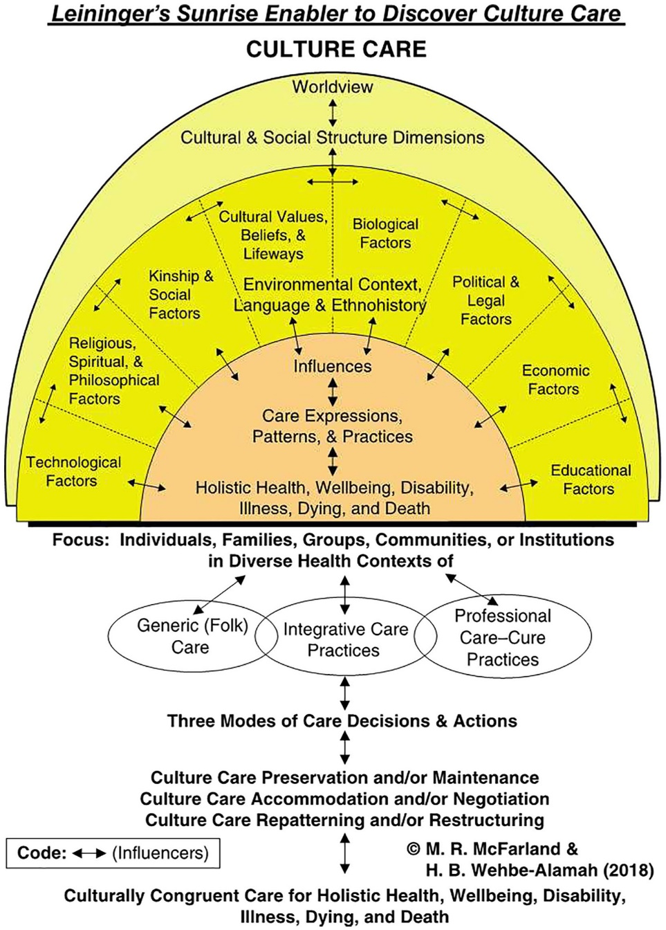
(McFarland & Wehbe-Alamah, 2018b, p. 47).
Philosophical Assumptions
The investigators who coined Leininger’s culture care theory made certain that the framework can be used to frame other projects that seek to investigate the efficacy of cultural competence training and inculcations in nursing research. The theory articulates that cultural elements have a greater effect on people’s health practices, beliefs, and behaviors (McFarland & Wehbe-Alamah, 2019). Leininger’s culture care theory assumes that culture, social structure, and worldviews are meticulously affiliated with well-being, care, and health (McFarland & Wehbe-Alamah, 2019). As such, care is a paramount human need that is necessary for growth, health, and survival. Care entails emotional, cultural, and spiritual dimensions, allowing individuals to recover from illnesses (McFarland & Wehbe-Alamah, 2019). The theory also assumes that care is impacted by cultural values, practices, and beliefs. Thus, nurses ought to comprehend these cultural distinctions to deliver culturally meaningful and effective care.
The third assumption is that culture is entrenched in every facet of human life and shapes how people perceive, respond, and experience health, care, and diseases. McFarland and Wehbe-Alamah (2019) further elucidate that although cultural care is grounded in universality, it is practiced and perceived differently across cultures. Thus, healthcare providers ought to acknowledge the catholicity and divergent factors of care to thwart ethnocentrism and deliver culturally sensitive care (McFarland & Wehbe-Alamah, 2019). Additional philosophical assumptions include integrating culturally congruent care within the paradigm of care, recognizing individual worldviews and social structures, and acquiring cultural knowledge.
Leininger’s culture care theory assumes that there are three modes of nursing care actions and decisions. These modes including cultural care preservation, accommodation, and repatterning assist in achieving culturally congruent care (McFarland & Wehbe-Alamah, 2019). Culture care preservation empowers professional actions or decisions that aid cultures to retain valuable care beliefs and principles or face mortality, illness, or frailty. Conversely, culture care accommodation enables creative provider care actions or decisions that assist cultures to become accustomed to or negotiate with others for culturally congruent and competent care or address mortality and morbidity issues (McFarland & Wehbe-Alamah, 2019). Cultural care repatterning entails modifying harmful cultural practices whilst respecting patients’ values. Another assumption is the significance of analyzing care within a cultural context to fathom patients’ cultural meanings and practices of effective care. Lastly, Leininger’s theory assumes a holistic strategy for care by taking into consideration the physical, social, emotional, and spiritual components of health (McFarland & Wehbe-Alamah, 2019).
Johns Hopkins Nursing Evidence-Based Practice (JHNEBP) Model
The Johns Hopkins Nursing Evidence-Based Practice (JHNEBP) Model is a well-established framework that will guide the project plan for implementation (See Figure 2; See Appendix C and D). This model integrates the latest research findings into clinical nursing practices using practical tools (Dang et al., 2022). It follows a systematic approach that empowers nurses to make evidence-based decisions, which enhance patient outcomes and improve the efficiency of cognitive mental health services. The JHNEBP model utilizes user-friendly tools, such as evidence-based practice instruments, that streamline the use of research evidence in clinical settings (Johns Hopkins Nursing, n.d.). The model will support the project’s implementation in the mental health unit by guiding the principal investigator through each step to ensure successful adoption. The JHNEBP model operates in three phases: defining the practice question, finding the best available evidence, and translating that evidence into practice (Dang et al., 2022). These steps form the PET process which entails the practice question, evidence, and translation stages.
PET Steps
The PET process of the JHNEBP model is essential for guiding healthcare providers through evidence-based practice (EBP) (Johns Hopkins Nursing, n.d.). The first phase begins with identifying the practice question, which involves outlining the issue, formulating the question, and assembling a project team (Dang et al., 2022). This initial step will help the student achieve the project’s goals by clearly defining the objectives and aligning them with EBP principles.
The second phase focuses on evidence, which involves gathering, reviewing, and synthesizing evidence, followed by making practice change recommendations (Dang et al., 2022). Lastly, translation, equips researchers with the skills to synthesize evidence and create clinical recommendations. This phase includes planning, securing stakeholder support, implementing the plan, evaluating outcomes, and communicating results (Dang et al., 2022).
Figure 2
JHNEBP Model
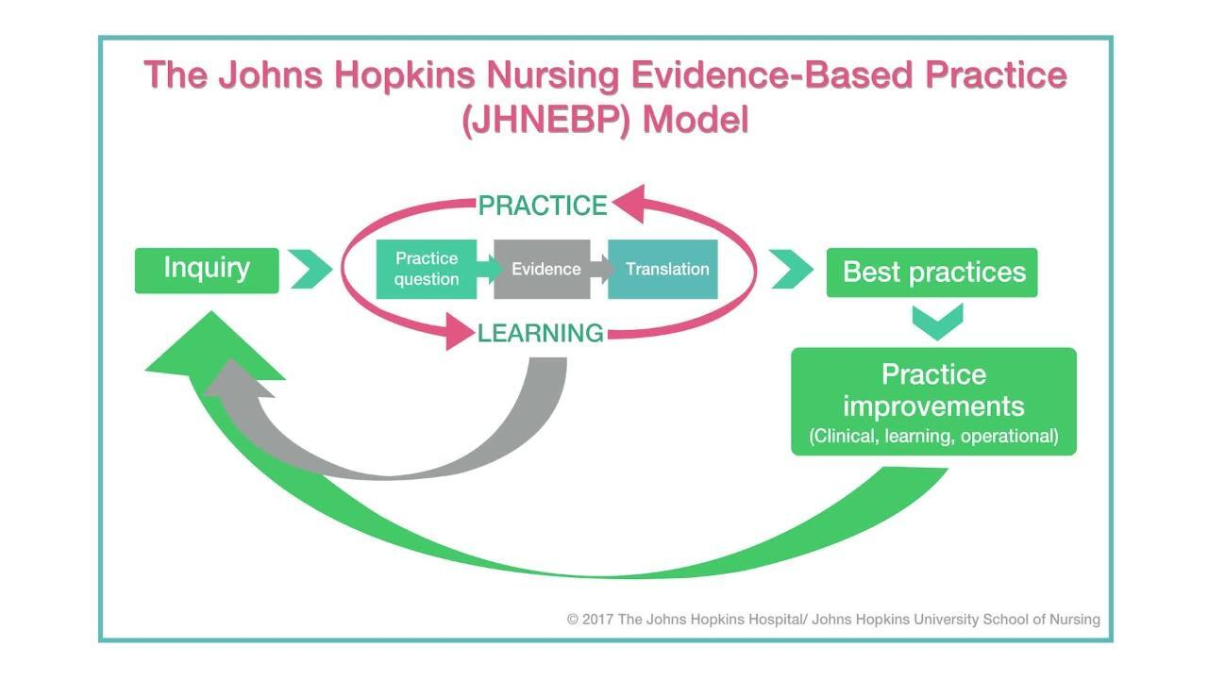
(Dang et al., 2022).
Conclusion
In summary, the absence of a cultural competence education program in a mental health unit can significantly hinder the effectiveness of mental health services, impact patient outcomes, and limit the cultural knowledge, skills, and awareness of healthcare providers. The project aims to provide a discourse on momentous significant gaps in evidence along with rudiments that contribute to culturally incompetent psychiatric delivery services. Its primary goal is to improve patient outcomes and safety, streamline cognitive mental health delivery processes, and reduce healthcare inequalities. These objectives will be achieved by assessing changes in provider motivation, cultural knowledge, behaviors, and attitudes resulting from cultural competence education programs. Leininger's culture care theory will serve as the guiding framework for the project. The JHNEBP model will provide essential evidence-based practice tools and the PET process to ensure the project's success.

Chapter II: Review of Literature
Introduction
The second chapter adds to what is known about the scholarly project topic of cultural incompetence among mental health nurses. The chapter will encapsulate the literature underpinning the study including the search strategy along with the most pertinent themes. Yu et al. (2023) suggested the paucity of cultural competence in mental health services negatively affects patient outcomes and the general healthcare delivery process. However, educating providers on cultural competence can elevate their competence levels such as cultural knowledge, expertise, and attitudes. These positive implications enable nurses to fathom the cultural differences and experiences of their patients, improving patient outcomes, engagement, and health equity (Raval et al., 2024).
Literature Review Overview
A literature evaluation is a crucial element of nursing research since it enables investigators to judiciously appraise and amalgamate findings from manifold studies evidence (Snyder, 2019).
Search Strategy
The PI selected academic databases such as PubMed, Google Scholar, Cumulative Index of Nursing and Allied Health Literature (CINAHL), and PsycINFO to find relevant literature. These databases selected had advanced search features, such as Medical Subject Headings (MeSH), article type, publication year, language, and text format. The PI applied Boolean operators to refine searches and focus on the most current and relevant evidence. The keywords were "cultural competence," "education program or training," "nurses," and "health delivery processes."
The literature search was initiated in the summer of 2024, whereby the student included articles published between August 1, 2019, and 2024. Inclusion criteria required full-text articles in English related to the clinical question, while exclusion criteria removed articles older than five years, abstract-only publications, and those unrelated to the clinical question. The student also conducted a manual search of key references to ensure all relevant studies were included. The clinical question, framed using the PICO(t) model, is: “Does the implementation of a culturally competent educational intervention improve the levels of confidence in the use of cultural competence for psychiatric mental health registered nurses?”
Comprehensive Literature Review
The principal investigator used the selected databases, keywords, and Boolean operators to perform a comprehensive literature search following the Preferred Reporting Items for Systematic Reviews and Meta-Analyses (PRISMA) guidelines. The initial search produced 352 articles, which were screened for duplicates and irrelevant content that did not align with the clinical question. After removing 152 irrelevant articles, 200 articles remained. The inclusion and exclusion criteria were applied, eliminating 158 more articles for reasons such as being older than five years, only available as abstracts, not peer-reviewed, or unrelated to the clinical question. The remaining 48 full-text studies were further evaluated against more detailed inclusion and exclusion criteria. Ten studies were excluded for lacking peer review, and 26 did not focus on cultural competence education interventions. Ultimately, 12 studies were included in the final literature review as they met all the necessary criteria. These studies highlighted key themes that aligned with the project's clinical research question.
Improved Nurses' Cultural Awareness
Numerous studies have underscored the importance of cultural competence educational interventions. Kaihlanen et al. (2019) performed a qualitative study to investigate nurses' perspectives on cultural competence training and awareness. The study revealed the importance of inculcating nurses' cultural competence to boost their cultural awareness and effective communication (Kaihlanen et al., 2019). Although the sample size was localized, the insights can be generalized to specific populations such as psychiatric nursing, and inform the researcher of educational methods which can elevate nursing practice and promote cultural awareness. Cultural awareness equips clinicians with the aptitude to self-reflect, identify their prejudices, and stop labeling patients from different backgrounds (Kaihlanen et al., 2019).
This study offers valuable insights into nurses’ cultural awareness, which can be integrated into the project and train psychiatric nurses about the relevance of cultural competence and addressing health disparities. Manlangit et al. (2022) imposed the necessity of scrutinizing how cultural awareness, sensitivity, and behaviors affect nurse leaders. The sleuths used the Cultural Competence Assessment instrument and the Decision-Making Quality Scale questionnaire and disseminated it to 122 participants who were affiliated with a Saudi Arabian institution. The findings showcased that cultural awareness and sensitivity are inextricably entangled with nurses' cultural competence and their capacity to make informed culturally founded decisions (Manlangit et al., 2022).
Additionally, cultural competence training proliferates cultural awareness of nurse leaders and their teams, making it easier for them to make informed, evidence-based decisions that can achieve ideal patient and health outcomes (Manlangit et al., 2022). Mukhalalati et al. (2022) appraised how cultural competence training is pertinent to nurses' cultural awareness. The qualitative element of the study implied that healthcare educators have a positive attitude toward cultural competence training. In the meantime, the quantitative results proved a noteworthy increment in cultural awareness suggesting that cultural competence training also equips nurses with the necessary skills to deliver impartial care (Mukhalalati et al., 2022). Most importantly, these findings bolster the project's aim of improving cultural awareness. As such, the student will leverage these insights to inform psychiatric nurses about the benefits of cultural competence training in enhancing cultural awareness.
The Influence of Cultural Competence Education
The second theme identified in the search strategy was the effect of cultural competence education and training on healthcare providers. Research indicates a positive link between cultural awareness, skills, knowledge, attitudes, and behaviors. Several studies prove the validity of educational initiatives in boosting nurses' cultural competencies to achieve the best health results. Slobodin et al. (2020) tailored a culturally informed educational intervention to improve healthcare students' cultural competence. The qualitative segment of the study involved semi-structured interviews with ten participants. The researchers used interpretative phenomenological analysis to evaluate the data (Slobodin et al., 2020).
In the quantitative phase, participants were divided into intervention and non-intervention groups. The study began in September 2018 and lasted for two years, focusing on addressing gaps in cultural competence curricula and training. Slobodin et al. (2020) reported incorporating cultural competence education programs can develop providers' understanding of cultural diversity. Therein lessens cultural dissonance and fosters efficient communication and outcomes between patients and providers. The findings support the project's goal of enhancing healthcare providers' cultural competence, to positively impact psychiatric settings.
Lin and Hsu (2020) conducted a randomized control study where they randomly assigned respondents to experimental (n=47) and control (n=50) groups. The results showed that the experimental group's cultural competence scores of 0.51 were higher than the control groups, both at follow-up and post-intervention (Lin & Hsu, 2020). The study demonstrated that cultural competence training can significantly improve nurses' cultural aptitude and overall competence.
These findings support the project's purpose of implementing a cultural competence education program to enhance workflow efficiencies in the mental health unit.
Raval et al. (2024) conducted a mixed-methods research to evaluate the effect of training in cultural competence for mental healthcare providers. The researchers postulate that there is a necessity to provide culturally competent care to people from diverse backgrounds due to the universality of mental health care (Raval et al., 2024). Raval et al. (2024) assessed the impact of cultural competence training by investigating the perspectives of graduate students, practitioners, and faculty in India and the United States of America. The investigators used various data collection approaches such as focus groups (n=25). In this case, the researchers included fifteen focus groups in India with 69 participants, and ten focus groups in America each with 38 participants. They also used a survey with a sample population of 800, 450 of the participants were from India, while the rest were from the United States (Raval et al., 2024).
The inclusion criteria involved higher education, psychology degrees, and doctoral degrees. Most of the participants identified as cisgender women (Raval et al., 2024). An online survey link was sent via email to all participants in America individually, whilst in India, the email links were sent through the psychology department chairs. Both the qualitative and quantitative findings indicate that training in cultural competence is crucial in addressing disparities, promoting equitable care, and augmenting patient outcomes (Raval et al., 2024). The article bolsters the objectives of the SPP of training in cultural competence to ensure that psychiatric registered nurses are well-prepared to engage in culturally competent care.
Cultural Competence in Nurses’ Cultural Knowledge and Skills
Argyriadis et al. (2022) conducted a mixed-methods study to explore healthcare professionals’ knowledge and skill levels associated with their cultural competence. The researchers used the Cultural Competence Self-Assessment Checklist from the Central Vancouver Island Multicultural Society for the quantitative data and 62 semi-structured interviews to collect data qualitative data (Argyriadis et al., 2022). They found that nurses are often sensitive to cultural competence practices. The training and educational materials can offer providers culturally competent expertise when working in tandem with patients from diverse backgrounds (Argyriadis et al., 2022). These findings can be used to tailor a detailed cultural competence educational program, which can expand providers' expertise on cultural competence.
Arruzza and Chau (2021) conducted a scoping review study to appraise the usefulness of educational learning materials in boosting nursing students’ knowledge, skills, attitudes, and routines when they conducted a scoping review. The researchers incorporated an experimental study design in which they reviewed ten experimental research studies. Based in the research verdicts, nurses who were inculcated on cultural competence reported higher scores concomitant with adequate cultural knowledge and heightened skills (Arruzza & Chau, 2021). Furthermore, cultural knowledge and skills gained through training enhance nurses' understanding of cultural concepts during healthcare delivery (Arruzza & Chau, 2021). The findings from the study article correspond with the project’s purpose of ensuring nurses, specifically those working in a mental health unit are culturally competent to successfully deliver cognitive mental health care.
Supporting Literature
Importance of Cultural Competence
Agency for Healthcare Research and Quality (AHRQ, 2019) reported that cultural competence is a crucial aspect of healthcare that enables health systems to deliver patient-centered care by integrating patients' values, beliefs, and practices. Culturally competent care makes patients feel safe and respected, as they are treated by a workforce that values their cultural journey without judgment (AHRQ, 2019).
The Centers for Disease Control and Prevention (CDC) elucidated that cultural competence is a combination of attitudes, policies, and behaviors that enable healthcare providers to work effectively in cross-cultural situations (NPIN.CDC.gov., n.d.). These merits arouse top-notch quality care and impeccable delivery processes (NPIN.CDC.gov., n.d.). As such, by adopting the concepts of the studies and integrating the recommended principles of cultural competence in educational materials, the project can augment cognitive mental health delivery processes and patient outcomes (AHRQ, 2019; NPIN.CDC.gov., n.d.).
American psychological association (APA) underscores that cultural competence training allows providers to connect with their clients on a deeper level and respect cultural differences (Chu et al., 2022). Subsequently, the patients actively engage in mental healthcare, leading to impeccable patient outcomes and elevated quality of mental healthcare. Cultural competence is vital since it helps address health inequalities by ascertaining healthcare providers are fully equipped to provide culturally sensitive care to patients from divergent cultural affiliations (APA, 2017). Training providers in cultural competence is a critical strategy for enhancing the quality of care that providers deliver to patients from different cultural backgrounds. Cultural competence educational intervention helps providers snowball their self-awareness, understand their patient’s cultural identity, and learn about culturally and linguistically apt interventions to build stronger therapeutic connections with clients from distinct backgrounds (HHS.gov, 2001). These studies emphasize the significance of educating providers on cultural competence which is a focal theme of this project.
Conclusion
In conclusion, the chapter includes a literature review and synthesizes important themes that relate to the clinical question used in the project. Some of the studies suggested that educating healthcare providers in cultural competence expedites effective communication and optimizes health delivery processes. The second theme greatly demonstrated the impact of cultural competence education, showing its direct effect on nurses' cultural proficiency, which leads to better health outcomes. The literature review also provided a discourse on the importance of improving nurses' cultural skills and knowledge. Based on the review of the literature, ongoing cultural competence training is pivotal for practitioners can boost better engagement, ensure patient-centric care, and curtail health inequalities.

Chapter III: Methodology
Introduction
Cultural competence is an indispensable skill in healthcare, but many nurses still lack the training necessary to fulfill the cultural requirements of their clients. The paucity of proper training has precipitated an increment in cultural incompetence. As such, this gap in practice can instigate poor patient outcomes, dissatisfaction with care, and misunderstandings in psychiatric settings (Arruzza & Chau, 2021). At the project’s site, many of the psychiatric nurses report grappling with challenges in delivering culturally appropriate care, which affects their ability to effectively support clients from disparate cultural milieus. Furthermore, the lack of cultural competence has been shown to impact the quality and consistency of mental health care. Intrinsically, the issue of cultural incompetence can be tackled by incorporating an evidence-based cultural competence education program to help clinicians provide equitable and culturally tailored care, especially for patients from diverse backgrounds (Arruzza & Chau, 2021).
The educational intervention based on Leininger’s theory will focus on enhancing key elements of cultural competency such as cultural awareness, knowledge, and skill development. The rudiments of cultural competency aim at fostering positive behavioral change among nurses and improving patient outcomes (Sahamkhadam et al., 2023). The cultural proficiency training will help psychiatric nurses understand cultural nuances, utilize effective communication techniques, and incorporate culturally sensitive practices into their care routines. Leininger's culture care theory and the Johns Hopkins Nursing Evidence-Based Practice (JHNEBP) model will guide the steps of the project, providing an evidence-based foundation. The third chapter will encapsulate the methodology which will be used for the scholarly project (SPP). As such, it will detail the project’s design, guiding EBP model, methods, participant recruitment, ethical considerations, plans and procedures, tools, data analysis, and timetable. The goal is to describe the project’s design, implementation, and evaluation of the program to measure its impact on enhancing cultural competence among psychiatric nurses in a Northeastern U.S. home care facility.
Project Design
The principal investigator will employ a quality improvement design, thereby assimilating current evidence-based practices to implement and measure the cultural competence educational program within a psychiatric unit. In addition, the project will be customized to address gaps in culturally competent care by augmenting nurses’ cultural awareness, expertise, and knowledge. The Johns Hopkins Nursing Evidence-Based Practice (JHNEBP) model will serve as the project’s basis. The model will enable the principal investigator to leverage the PET approach which comprises the practice question, evidence, and translation procedure, which is advantageous for structured EBP initiatives (Dang et al., 2022).
The primary goals are to improve cultural competence among psychiatric nurses and the delivery processes of patient care by providing culturally sensitive care. The project will also foster a more all-encompassing clinical milieu that acknowledges and respects patients' varied cultural upbringings. The probable results include improved cultural competence levels including knowledge, skills, and attitudes, as evaluated by the Vancouver Cultural Competence Checklist.
The JHNEBP model will provide the principal investigator with a blueprint that will bolster the identification, collation, translation, and application of evidence akin to cultural competence (Dang et al., 2022). The following model's PET process has three stages that expedite the evidence-based practice (EBP) approach.
PET Procedure
The first level of the PET process involves categorizing a practice question, which includes delineating the EBP issue, articulating the question, and affirming the project’s goals. This stage will help the principal investigator form an interdisciplinary team, designate project roles, involve stakeholders, and prepare for cohort meetings (Dang et al., 2022).
The second segment consists of the evidence level which was used to obtain, review, recap, and synthesize evidence, as well as recommend practice modifications (Dang et al., 2022). The principal investigator conducted a thorough appraisal of studies probing cultural competence interventions in psychiatric settings. Some of the keywords used related to the practice question, and using credible databases like PubMed and CINAHL to locate suitable evidence. The JHNEBP model buttressed the appraisal of quality literature, allowing the principal investigator to utilize first-class studies that are directly relevant to the practice question (Dang et al., 2022). As such, the process expedited a well-founded synthesis of evidence to assess the effectiveness of a cultural competence program and identify existing gaps in the literature.
At the translation level, the principal investigator will bring evidence into practice by developing and implementing an actionable plan in the psychiatric unit. This phase will involve working in tandem with key stakeholders, including the project mentor and psychiatric nursing staff, to gain support and foster engagement in the initiative. The implementation plan will involve tailoring the educational program to fit the practice environment, with pre-and post-intervention assessments conducted using the Central Vancouver Island Multicultural Society’s Cultural Competence Self-Assessment Checklist (See Figure 2).
Plans and Procedures
The following are the steps the PI will take:
- Create the educational intervention based on Leininger power point. The presentation will be recorded and narrated in Zoom. PI will include YouTube clips from experts, evidence, and supporting literature.
- Obtain external site permission.
- Obtain permission to use instrument the Vancouver cultural competence self-assessment checklist and confidence scale.
- Create open-ended questions for the nurses about their feelings.
- Tailor a comprehensive demographic Survey.
- Familiarize with Qualtrics to collect data.
- Become familiar with Intellectus Statistics and secure a Statistician consult.
Evidence-Based Clinical/Practice Question
“Does the implementation of a culturally competent educational intervention improve the levels of confidence in the use of cultural competence for psychiatric mental health registered nurses?”
Setting
The principal investigator will launch the project at a psychiatric home care agency, which is located in the Northeast, once external site approval is obtained. It is worth noting, that the home care agency serves individuals with mental health issues in the community, offering services such as in-home therapy, daily living activities, and medication management. The facility has a capacity of 370 beds, more than 50 registered nurses, and delivers rounded and wide-ranging treatment, with ease, and care to clients facing psychiatric challenges.
Sample
A sample serves as a representative segment of a larger population, allowing researchers to make inferences that can potentially be applied to similar populations (Andrade, 2020). The following are the rudimentary elements akin to a sample. The intended population from which the PI will draw the participants are psychiatric mental health registered nurses.
Recruitment Plan
The project’s principal investigator will obtain approval from the facility’s administrator under the guidance of the quality appraisal committee, which undertakes improvement efforts. In particular, the quality improvement committee’s primary goals include classifying areas necessitating improvement, enabling constructive vicissitudes, guaranteeing compliance with established regulations, inculcating the workforce and practitioners, and accentuating key enhancement prospects (Polit & Beck, 2021). The committee will be briefed on the study’s purpose and significance, the rationale for selecting the location, the details of the research, and the commitment to upholding ethical standards. Besides, the principal investigator will then collaborate with psychiatric nurse leaders and a project mentor to identify eligible participants based on established inclusion criteria (Purna Singh et al., 2023). The eligible respondents will receive informed consent documents via an email link, detailing the project’s goals, processes, expectations, and the voluntary nature of participation.
Sample Size
The principal investigator performed a G*power analysis to determine the effective sample size. Based on the results, the PI will incorporate a sample size of 34 participants (See Figure 3).
Figure 3
G*Power Analysis
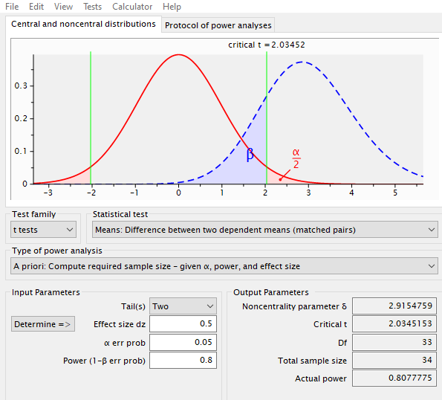
Sampling
A convenience sampling method will be used, allowing for easy access to participants. This sampling approach is cost-effective, time-efficient, and practical for involving colleagues already working at the project’s location (Purna Singh et al., 2023). The PI will seek permission from the homecare agency administrator and nurse manager to implement the project. Subsequently, the PI after receiving approval will send invitation links via Qualtrics to potential participants who are readily available and willing to join in the project. Those interested will be sent an informed consent document with detailed information about the project. The inclusion and exclusion criteria will be considered during sampling.
Inclusion Criteria
The following is the inclusion criteria:
- Psychiatric mental health registered nurses working at the project site. Individuals must have a minimum of two years of nursing experience.
- Direct care for clientele in the psychiatric unit.
- A bachelor’s degree in nursing.
Exclusion Criteria
The PI will use the following criterion to exclude individuals from participating in the project.
- Psychiatric mental health registered nurses with less than two years of nursing experience.
- Nurses working in other departments.
- Those holding directorial positions.
- Nurses who are not directly engaged in psychiatric patient care.
Ethical Considerations
Ethical considerations are fundamental to the success of any scholarly project, particularly one involving human participants. This project will focus on a cultural competence educational intervention for psychiatric mental health registered nurses, aiming to improve mental health service delivery for diverse patient populations and levels of cultural competence. The principal investigator will adhere to ethical tenets, ensuring that participants are protected, respected, and fully informed about their involvement in the study. The primary ethical considerations in this project include informed consent, beneficence, respect for secrecy and confidentiality, and respect for privacy. The PI will ensure that the participants are not harmed, are adequately informed about the project, and understand the risks and benefits of participating in the study. The following are the ethical considerations that the PI will uphold throughout the project.
Informed Consent
The principal investigator will provide each participant with an informed consent document that demarcates and elucidates all relevant information about the project of cultural competence. In addition, the informed consent will also be concise on the respondents' right to voluntarily participate or opt-out (Polit & Beck, 2021). The document will detail the project's goals and objectives, explain the data collection procedures, and describe how participants will be involved. It will also include a clause ensuring the discretion and obscurity of the respondents. Crucially, the participants will be advised of their own choice to pull out of the study at any period without facing any consequences. The principal investigator will seek approval from the Institutional Review Board (IRB) at Regis College and the hospital’s quality improvement committee to guarantee that the project is conducted morally and that respondents’ privileges and safety are safeguarded.
Beneficence
The principle of beneficence requires the project investigator to not expose participants to harm and instead maximize benefits while minimizing risks. Therefore, the principal investigator will ascertain that every effort will be made to prevent any form of harm to participants (Polit & Beck, 2021). The cultural competence education program is designed to enhance skills and improve patient outcomes, providing potential benefits for participants' professional development, levels of cultural competence, and patient care quality. Risks are anticipated to be minimal, as this study involves an educational intervention. Nonetheless, any potential discomfort or unintended negative consequences of the intervention will be monitored and addressed promptly to ensure participants’ well-being.
Anonymity and Confidentiality
The project investigator will respect the participants' anonymity and confidentiality to uphold trust and integrity throughout the research process. Per se, the respondents’ data will be de-identified by assigning codes to participants rather than using personal identifiers. Consequently, only their aggregate data will be reported, ensuring that no individual can be identified from the findings. Furthermore, access to any identifying information will be restricted to the research investigator, and data will be stored securely in encrypted files to prevent unauthorized access (Polit & Beck, 2021). These measures will help protect participants’ identities and maintain the confidentiality of their information.
Respect for Privacy
Respecting respondents’ privacy is critical, particularly when dealing with sensitive topics such as cultural competence and mental health care. Hence, the participants will be informed about the types of data being collected and how the information will be used. They will have control over the extent of their participation in completing the cultural competence self-assessment questionnaire and the volition to refuse to complete any queries they feel uncomfortable with. As a result, this strategy will play a focal role in respecting their right to privacy (Polit & Beck, 2021).
Measurement of Variables
1. Demographic Survey (See Appendix ?):
The PI will collect demographic data using a demographic data sheet. This tool will capture participant characteristics such as age, gender, and years of experience. Descriptive statistics, including means, medians, frequencies, and percentages, will be used to summarize the data, ensuring that the sample is well-described and contextualized.
2. Cultural Competence Self-Assessment Checklist (See Appendix ?):
The principal investigator will use the Cultural Competence Self-Assessment Checklist to collect pretest and posttest data. The tool has been validated for use among healthcare professionals and its reliability was established using Cronbach’s alpha with average values of 0.78 across the three sections, indicative of a great level of internal homogeneity (Argyriadis et al., 2022). Additionally, a confirmatory factor analysis (CFA) validates the tool’s structure, confirming its robustness and reliability for assessing cultural competence. These metrics bolster the use of the checklist in the project, ensuring that it provides consistent and accurate data to measure changes in cultural competence (Argyriadis et al., 2022).
Additionally, the cultural competence checklist is grounded on a Likert scale format, in which participants rate their responses to items that assess cultural awareness, knowledge, and skills. In this light, the checklist includes multiple items that address specific aspects of cultural competence across the three domains. The founders of the questionnaire ascertained that the Likert scale items are structured in a way that the participants can indicate the magnitude to which they agree or disagree with statements (Argyriadis et al., 2022). The checklist enables capturing the degree of cultural competence among respondents.
It is essential to note that the cultural competence cohort focuses on understanding cultural distinctions, self-awareness, and stereotypes. In this light, greater scores indicate a more developed awareness of cultural differences. On the other hand, the cultural knowledge scale dictates elements that assess understanding of cultural histories, discrimination, and cultural boundaries. As such, a high score reflects enhanced knowledge, and vice versa is true. The cultural expertise section includes questions on diversity acceptance, support for individuals from various backgrounds, and communication skills (Argyriadis et al., 2022).
3. Confidence Scale (C-Scale, Grundy 1993):
The confidence scale (C-scale) will help measure the participants' confidence levels in providing culturally competent care (Grundy, 1993). This instrument is suitable since it strives to evaluate the efficacy of the educational intervention such as the cultural competence educational intervention. The C-scale is a structured Likert-scale questionnaire in which participants rate their level of confidence about specific statements akin to cultural competence across several domains. These domains include cultural awareness, expertise, encounters, and knowledge (Grundy, 1993). The C-scale is a corroborated tool with strong validity and dependability, demonstrating strong psychometric properties. Grundy (1993) elucidates that the C-scale’s internal consistency is bolstered by a superior Cronbach’s alpha value and construct validity which validate the tool’s accuracy. The PI will administer the tool to the participants before and after the intervention to measure their confidence levels. The analysis will help determine the efficacy of the educational intervention
4. Open-ended Questions:
The PI will provide the participants with open-ended questionnaires to gather their perspectives on cultural competence training. As such, the questionnaires will help understand participants’ challenges, insights, and areas for improvement. The PI will use thematic analysis to recognize emerging patterns and themes akin to cultural competence in psychiatric care settings.
Educational Intervention
The principal investigator will measure the independent variable which is a cultural competency educational program using the cultural competence checklist with five-item Likert scale questions. The queries vary from “strongly disagree to strongly agree” to quantify the participants' levels of cultural competency. The cultural competence educational intervention program will be designed to boost psychiatric Registered Nurses’ levels of cultural competency including knowledge, awareness, and expertise. The educational intervention will include a PowerPoint presentation on cultural competence, disparities, and cultural sensitivity. Additionally, the PI will incorporate case studies demonstrating pragmatic scenarios about cultural diversity, and a poster to reinforce critical cultural competence concepts.
Data Collection and Analysis
All data will be collected in Qualtrics software. Once the participant is given access to the informed consent, they will agree to participate, they will be deidentified, and given a random numerical value. Only the Primary Investigator (PI) and the Project Chair will have access to this data in a password-protected computer. The data will be stored for three years and then destroyed. The data will be downloaded from Qualtrics once it has been cleaned and then securely uploaded to Intellectus Statistics, an online software program for analysis.
Timetable
The project is intended to take fourteen weeks starting in May of 2025. See Table 1 for a detailed timeline.
Table 1
Activity | Timeline | Details
Proposal Hearing | Week 1 | Present project to committee, and gather feedback.
IRB Approval | Weeks 2–6 | Submit the IRB application to secure approval from the Institution’s IRB and await approval.
Participant Recruitment and Distribution of Informed Consent Forms | Weeks 7–8 | Recruit eligible participants based on the inclusion and exclusion criteria, and obtain informed consent. Disseminate informed consent to participants via Qualtrics
Pre-Intervention Survey | Week 9 | Administer the Cultural Competence Self-Assessment Checklist pre-intervention survey to establish baseline data on participants’ current cultural competence status.
Educational Intervention | Weeks 10–12 | Conduct cultural competence training sessions via Zoom and distribute educational materials.
Post-Intervention Survey | Week 13 | Re-administer the Cultural Competence Self-Assessment Checklist.
Data Analysis | Week 14 | Use Intellectus Statistics, and conduct paired t-tests to evaluate changes in cultural competence levels.
Compile and Disseminate Findings | Week 14 | Present findings to stakeholders and academic reviewers. Share outcomes with stakeholders.
Summary
In conclusion, the chapter discussed key components such as the project’s site, actions, design, informed consent, inclusion and exclusion measures, IRB approval, tool, and data analysis. The project will comprise a sample size of forty human subjects who will complete pre-and post-intervention queries. Besides, the principal investigator will ascertain they adhere to the ethical standards required for conducting research with human subjects and foster a trustworthy environment that encourages honest and open participation. The Cultural Competence Self-Assessment Checklist is an effective and unswerving tool for assessing changes in cultural competence among nurses. The instrument will provide comprehensive data to gauge the influence of the intervention on nurses' cultural awareness, knowledge, and skills, ultimately supporting the project's aim of boosting cognitive health delivery procedures. Although the project is marred by a small sample which may restrict the generalizability of the results, the sample may provide precise and sophisticated measurements. Most importantly, the findings will allow for transferability to other clinical contexts, ensuring that readers draw insights into the significance of a culturally competent nursing workforce. Ultimately, the timeline provides an ideal structure in which the project advances efficiently, meeting all critical deadlines within the stipulated timeframe.

References
AHRQ. (2019, December 27). Cultural competence and patient safety. Agency for Healthcare Research and Quality (AHRQ). Patient Safety Network (PSNet). https://psnet.ahrq.gov/perspective/cultural-competence-and-patient-safety
Alkhamees, M., & Alasqah, I. (2023). Patient-physician communication in intercultural settings: An integrative review. Heliyon, 9(12). https://doi.org/10.1016/j.heliyon.2023.e22667
APA. (2017). Multicultural guidelines: An ecological approach to context, identity, and intersectionality, 2017. PsycEXTRA Dataset. https://doi.org/10.1037/e501962018-001
Argyriadis, A., Patelarou, E., Paoullis, P., Patelarou, A., Dimitrakopoulos, I., Zisi, V., Northway, R., Gourni, M., Asimakopoulou, E., Katsarou, D., & Argyriadi, A. (2022). Self-assessment of health professionals’ cultural competence: knowledge, skills, and mental health concepts for optimal health care. International Journal of Environmental Research and Public Health, 19(18). https://doi.org/10.3390/ijerph191811282
Arruzza, E., & Chau, M. (2021). The effectiveness of cultural competence education in enhancing knowledge acquisition, performance, attitudes, and student satisfaction among undergraduate health science students: A scoping review. Journal of Educational Evaluation for Health Professions, 18. https://doi.org/10.3352/jeehp.2021.18.3
Chae, D., Kim, J., Kim, S., Lee, J., & Park, S. (2020). Effectiveness of cultural competence educational interventions on health professionals and patient outcomes: A systematic review. Japan Journal of Nursing Science, 17(3), e12326. https://doi.org/10.1111/jjns.12326
Chu, W., Wippold, G., & Becker, K. D. (2022). A systematic review of cultural competence trainings for mental health providers. Professional Psychology, Research and Practice, 53(4), 362. https://doi.org/10.1037/pro0000469
Cruz, D., Rodriguez, Y., & Mastropaolo, C. (2019). Perceived microaggressions in health care: A measurement study. PLOS ONE, 14(2), e0211620. https://doi.org/10.1371/journal.pone.0211620
Dang, D., Dearholt, S., Bissett, K., Ascenzi, J., & Whalen, M. (2022). Johns Hopkins evidence-based practice for nurses and healthcare professionals: Model and guidelines. 4th ed. Sigma Theta Tau International
Desai, M. U., Paranamana, N., Restrepo-Toro, M., Davidson, L., & Stanhope, V. (2020). Implicit organizational bias: Mental health treatment culture and norms as barriers to engaging with diversity. The American Psychologist, 76(1), 78. https://doi.org/10.1037/amp0000621
Eken H. N., Dee E. C., Powers A. R. III, Jordan A. (2021). Racial and ethnic differences in perception of provider cultural competence among patients with depression and anxiety symptoms: A retrospective, population-based, cross-sectional analysis. The Lancet Psychiatry, 8(11), 957–968. https://doi.org/10.1016/S2215-0366(21)00285-6
Fante-Coleman, T., & Jackson-Best, F. (2020). Barriers and facilitators to accessing mental healthcare in Canada for Black youth: A scoping review. Adolescent Research Review, 5(2), 115-136. https://doi.org/10.1007/s40894-020-00133-2
Gopal, D. P., Chetty, U., Gajria, C., & Blackadder-Weinstein, J. (2021). Implicit bias in healthcare: Clinical practice, research, and decision making. Future Healthcare Journal, 8(1), 40–48. https://doi.org/10.7861/fhj.2020-0233
Handtke, O., Schilgen, B., & Mösko, M. (2019). Culturally competent healthcare – A scoping review of strategies implemented in healthcare organizations and a model of culturally competent healthcare provision. PLoS ONE, 14(7). https://doi.org/10.1371/journal.pone.0219971
HHS. (2001). National standards for culturally and linguistically appropriate services in health care: Executive summary. U.S. Department of Health and Human Services of Minority Health. https://www.govinfo.gov/content/pkg/GOVPUB-HE20-PURL-LPS75720/pdf/GOVPUB-HE20-PURL-LPS75720.pdf
Hietapakka, L., & Heponiemi, T. (2019). Increasing cultural awareness: Qualitative study of nurses' perceptions about cultural competence training. BMC Nursing, 18(1). https://doi.org/10.1186/s12912-019-0363-x
Johns Hopkins Nursing. (n.d.). Evidence-based practice. Johns Hopkins Medicine, based in Baltimore, Maryland. https://www.hopkinsmedicine.org/nursing/center-nursing-inquiry/nursing-inquiry/evidence-based-practice
Kaihlanen, A., Hietapakka, L., & Heponiemi, T. (2019). Increasing cultural awareness: Qualitative study of nurses' perceptions about cultural competence training. BMC Nursing, 18(1). https://doi.org/10.1186/s12912-019-0363-x
Ličen, S., & Prosen, M. (2023). The development of cultural competences in nursing students and their significance in shaping the future work environment: A pilot study. BMC Medical Education, 23(1), 819. https://doi.org/10.1186/s12909-023-04800-5
Lin, M., & Hsu, H. (2020). Effects of a cultural competence education program on clinical nurses: A randomized controlled trial. Nurse Education Today, p. 88, 104385. https://doi.org/10.1016/j.nedt.2020.104385
Liu J., Gill E., Li S. (2021). Revisiting cultural competence. The Clinical Teacher, 18(2), 191–197. https://doi.org/10.1111/tct.13269
Manlangit, A. T., Jabonete, F. G. V., & Ridulme, Q. R. (2022). Cultural competence and decision-making of nurse leaders in a university hospital in Saudi Arabia: A descriptive correlational study. Journal of Nursing Management, 30(5), 1215–1224. https://doi.org/10.1111/jonm.13631
Marcelin, J. R., Siraj, D. S., Victor, R., Kotadia, S., & Maldonado, Y. A. (2019). The impact of unconscious bias in healthcare: How to recognize and mitigate it. The Journal of Infectious Diseases, 220(220 Suppl 2), S62–S73. https://doi.org/10.1093/infdis/jiz214
McFarland M. R., Wehbe-Alamah H. B. (2018b). Leininger’s Sunrise Enabler to Discover Culture Care. In McFarland M. R., Wehbe-Alamah H. B. (Eds.), Leininger’s Transcultural Nursing Concepts, Theories, Research, & Practice (4th edition; p. 47). New York, NY: McGraw-Hill Education.
Mukhalalati, B., Ahmed, A., Elshami, S., & Awaisu, A. (2022). Cultural competence among healthcare professional educators: A mixed-methods study. Sustainability, 15(18), 13793. https://doi.org/10.3390/su151813793
Nair, L., & Adetayo, O. A. (2019). Cultural competence and ethnic diversity in healthcare. Plastic and Reconstructive Surgery Global Open, 7(5). https://doi.org/10.1097/GOX.0000000000002219
NPIN.CDC.gov. (n.d.). Cultural competence in health and human services. National Prevention Information Network (NPIN)| Centers for Disease Control and Prevention (CDC). https://npin.cdc.gov/pages/cultural-competence-health-and-human-services
Raval, V. V., Gopal, B., Aggarwal, P., Mohan, M. P., Padmakumari, P., Thomas, E., Luebbe, A. M., & Hay, M. C. (2024). Training in cultural competence for mental health care: A mixed-methods study of students, faculty, and practitioners from India and USA. Culture, Medicine and Psychiatry, 48(4), 699–730. https://doi.org/10.1007/s11013-024-09867-3
Rosumeck, S., Wagner, M., Wallraf, S., & Euler, U. (2020). A validation study revealed differences in design and performance of search filters for qualitative research in PsycINFO and CINAHL. Journal of Clinical Epidemiology, 128, 101-108. https://doi.org/10.1016/j.jclinepi.2020.09.031
Rukadikar, C., Mali, S., Bajpai, R., Rukadikar, A., & Singh, A. K. (2022). A review on cultural competency in medical education. Journal of Family Medicine and Primary Care, 11(8), 4319. https://doi.org/10.4103/jfmpc.jfmpc_2503_21
Sahamkhadam, N., Andersson, A. K., Golsäter, M., Harder, M., Granlund, M., & Wahlström, E. (2023). Testing the assumptions in the process of cultural competence in the delivery of healthcare services using empirical data, focusing on cultural awareness. Journal of Transcultural Nursing, 34(3), 187-194. https://doi.org/10.1177/10436596231152212
Sarvarizadeh, M., Miri, S., Darban, F., & Farokhzadian, J. (2024). Innovative cultural care training: the impact of flipped classroom methods on critical cultural competencies in psychiatric nursing: A quasi-experimental study. BMC Nursing, 23(1), 340. https://doi.org/10.1186/s12912-024-02001-z
Slobodin, O., Clempert, N., Kula, Y., & Cohen, O. (2020). Educating health professionals for cultural competence in emergency situations: A study protocol for a randomized controlled trial. Journal of Advanced Nursing, 76(1), 380–386. https://doi.org/10.1111/jan.14245
Stubbe, D. E. (2020). Practicing cultural competence and cultural humility in the care of diverse patients. Focus: Journal of Life Long Learning in Psychiatry, 18(1), 49-51. https://doi.org/10.1176/appi.focus.20190041

Appendices
Appendix A: Leininger's Sunrise Model
Appendix B-Permission for Use

Appendix C: JHNEBP Model

Appendix D: Permission for the use of the JHNEBP Model graphic

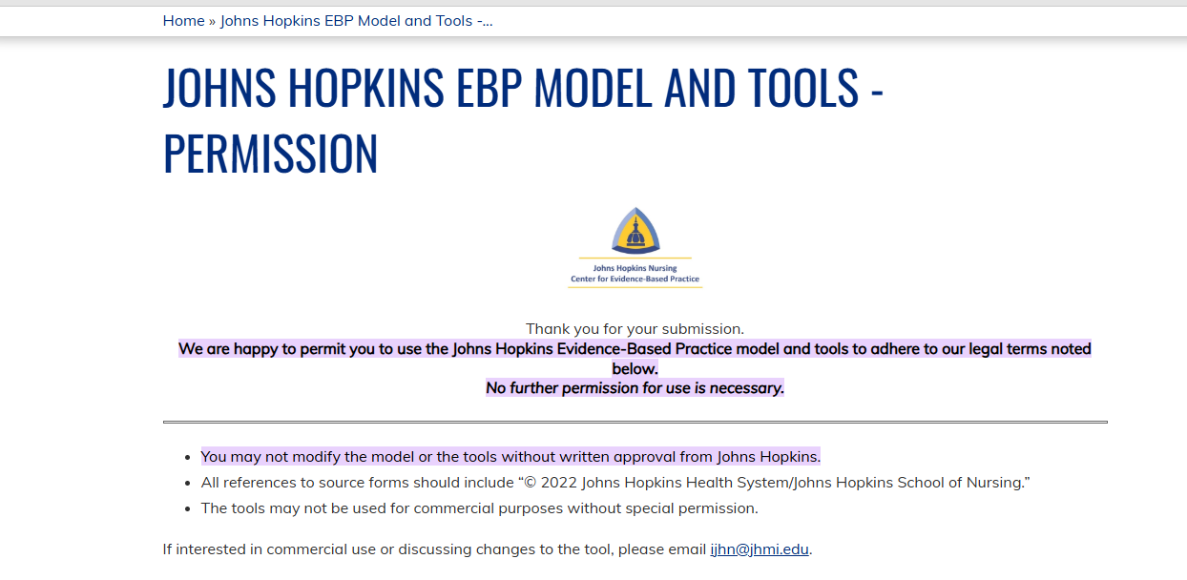

Appendix E-Levels of Evidence Table
Article  # | Author & Date | Evidence Type | Sample, Sample Size, & Setting | Study findings that help answer the EBP question | Limitations | Outcomes | Evidence Level & Quality
1 | Chu et al. (2022). | A systematic review | The study used a sample of 37 training curricula.  The sample size was 40 articles which were published between 1984 to 2019.  The articles included graduate students and practicing professionals from a wide array of disciplines across mental health settings. The selected studies were conducted in mental health settings. | Chu et al. (2022) suggested that teaching mental healthcare providers can help curtail mental health disparities and discriminatory behaviors, enhancing patient outcomes. Furthermore, implementing cultural competence education programs can amplify providers' attitudes, knowledge, and skills, enabling them to deliver culturally congruent and competent cognitive care (Chu et al., 2022). Therefore, these findings help answer the EBP question related to the scholarly practice project. | One of the limitations was the latency of publication bias and omission of curricula data. The limitation can be precipitated by the paucity of unpublished work and official protocols.  Additionally, the research study was prone to bias in the reported outcomes since most of the studies were contingent on self-assessment measures of cultural competence (Chu et al., 2022). | Cultural competence training is efficient in modifying, snowballing knowledge, and developing the expertise of mental health providers (Chu et al., 2022).  The implemented curricula positively influenced the mental health students' cultural attitudes, knowledge, learning, and skills acquisition. | Level II and quality A.
2 | Lin & Hsu (2020). | A randomized control trial | The sample were nurses.  The sample size was 97.  The study took place in a medical facility in northern Taiwan with 2089 beds. | Implementing cultural competence education curricula across the continuum of care can empower nurses to respect patients' diverse health prerequisites, predilections, beliefs, practices, and values (Lin & Hsu, 2020).  A cultural competence education program and training help nurses espouse dignified care regardless of their patient's cultural backgrounds. The intervention is integral in mental health settings since it prepares nursing students to deliver culturally congruent and compassionate care, enhancing clinical care practices (Lin & Hsu, 2020). Thus, these findings help answer the EBP question of whether cultural competence education programs affect clinical practices such as cognitive health delivery. | The study had a small sample size, which may have obviated the findings from being extrapolated.  Additionally, the research study was conducted in one setting, making it difficult to generalize the findings. | Cultural competence educational programs enhance provider cultural competencies.  The intervention equips nurses with adept cultural competence skills to provide culturally competent healthcare that boosts the cognitive health conditions of patients with diverse ethnicities and cultural backgrounds (Lin & Hsu, 2020). | Level 1 and quality A.
3. | AHRQ (2019). | Opinion of respected authorities | The study is not a research study but a supporting literature from the Agency for Healthcare Research and Quality that was grounded on the perspectives of three panelists about cultural competence and patient safety. | The article noted that cultural competence training is paramount in healthcare settings since it enhances providers cultural awareness, knowledge, skills, and attitudes. This allows the clinicians to deliver optimal patient outcomes and workflow efficiencies. These insights help answer the EBP question of whether cultural competence education programs correlate with positive patient and health outcomes. | The study was not an empirical literature and was based on the insights of a panel. The insights may be subject of individual biases and inconsistencies in the recommendations. | Cultural competence programs and training not only boosts patient outcomes and workflow efficiencies but also patient safety. | Level IV
4. | Alkhamees& Alasqah (2023). | Integrated review of literature. | A sample of 34 articles were incorporated into the study. The researchers used the Whittemore and Knafl’s method to explore the review of literature. | The findings concluded that cultural competence is focal in enhancing the patient-provider therapeutic alliance and communication strategies (Alkhamees& Alasqah, 2023). Although the study did not center on cultural competence education program, it helped understand the impact of cultural competence during policy making which allows providers to develop intercultural competencies to improve decision-making processes, satisfaction, communication, and accurate diagnoses (Alkhamees& Alasqah, 2023). This aligns with the EBP question of enhancing the efficiencies of health delivery processes in mental health settings. | The researchers used a small sample size that may limit the generalizability of the result findings. | Effective communication is a central element that enhances provider intercultural competencies including intercultural communication. This enhances their intercultural communication allowing healthcare providers to promote the continuity of care and patient satisfaction (Alkhamees& Alasqah, 2023). | Level V
5. | Sahamkhadam et al. (2023). | A cross-sectional study. | A sample of school nurses was used. The sample size was 816. The study setting was a school health service in Sweden (Sahamkhadam et al., 2023). | The study indicated that implementing a cultural competence training in healthcare settings can enhance nurses cultural competence, awareness, knowledge, skills, and encounters, resulting in positive outcomes (Sahamkhadam et al., 2023). These findings can answer the EBP question of whether cultural competence can improve the cultural constructs of nurses. | The study did not include the demographic of the participants which may limit the ability to interpret and generalize findings (Sahamkhadam et al., 2023). | There was a positive link between the process of cultural competence and cultural awareness when delivering healthcare processes (Sahamkhadam et al., 2023). | Level III.
6. | Argyriadis et al. (2022). | Mixed-methods design. | The sample encompassed doctors, nurses, psychologists, midwives, social workers, and physiotherapists from Cyprus. The sample size incorporated was 499 health scientists (Argyriadis et al., 2022). | The study findings indicated that cultural competence training is essential in expanding nurses’ knowledge and skills. Besides, cultural competence training can help improve provider effectiveness in their workplace, allowing them to deliver optimal health services (Argyriadis et al., 2022). This answers the EBP question of whether cultural competence training can augment nurses ability to deliver optimal healthcare services in mental health settings. | A small sample size was used and may restrict the ability to generalize the findings (Argyriadis et al., 2022). | Cultural competency training is equivalent to improved provider skills and knowledge which allows providers to provide inclusive care that meets the cultural components of patients from minority and ethnic groups (Argyriadis et al., 2022). | Level II.
7. | Arruzza & Chau (2021). | Systematic review. | The sample consisted of systematic review of randomized controlled trials, non-randomized controlled trials, pre-post studies, and observational studies such as prospective, and case-control studies (Arruzza & Chau, 2021). The sample size was ten articles. | According to Arruzza & Chau (2021) cultural competence education enhances the cultural knowledge, attitudes, competence, and awareness in clinical settings. Therefore, this helps answer whether implementing a cultural competency education program can improve nurses’competencies (Arruzza & Chau, 2021). | The study only included articles published in English, thus, other non-English articles were not analyzed (Arruzza & Chau, 2021). | The researchers found that integrating cultural competence training in healthcare settings improved nurse ability to deliver culturally sensitive and quality services (Arruzza & Chau, 2021). | Level II.
8. | Chae et al. (2020). | A systematic review. | Chae et al. (2020) conducted a systematic review of both randomized and non-randomized controlled trials. The investigators randomized 11 studies into randomized (n = 5) and a non-randomized controlled trial (n = 6) design. Seven articles were from USA, 3 from South Korea, and 1 from Sweden. | The study findings proved that cultural competence training directly impacts professional outcomes of nurses allowing them to deliver culturally competent care that meets the needs of the patients (Chae et al., 2020). This is in concurrence with the EBP question which seeks to investigate the impact of cultural competence training. | The small sample size can restrict the generalizability element of the study. | The study reported notable improvements in health professional outcomes such as workflow efficiencies and cultural competencies (Chae et al., 2020). | Level I.
9. | Cruz et al. (2019). | A cross-sectional study | African American and Latino participants were the sample. The sample size used was 296 respondents. The setting was a university in New Jersey. | The study does not directly answer the EBP question but it raises awareness on the health disparities that contribute to cultural incompetence among mental health nurses (Cruz et al., 2019). Per se, this is imperative in understanding the underlying issues that can inhibit the delivery of a culturally sensitive and competent healthcare services in clinical settings (Cruz et al., 2019). | This article used an online recruitment initiative and only college educated full-time participants. This may restrict the generalizability of the findings. | Effectively assessing microaggressions in health settings can help improve patient outcomes (Cruz et al., 2019). Furthermore, providers may be well-placed to understand patients’ experiences and provide culturally appropriate care that aligns with all the health needs of the diverse patient population (Cruz et al., 2019). | Level III.
10. | Desai et al. (2021). | A randomized control trial. | The sample included clients and clinicians.  The study randomized 25 clients and 12 providers. The settings of the study were community mental health centers in Northeast USA. | Desai et al. 2021 study can be used to answer the EBP query because it centers on evaluating the effectiveness if a culturally competent trained workforce. The question equally, seeks to determine whether a cultural competence education training can improve nurses competences in delivering health delivery processes. | The researchers collected data through interviews which may contribute to personal biases (Desai et al., 2021). | The lack of cultural competence among mental health nurses may pose barriers to robust engagement with patients’ diversity, leading to poor outcomes. Thus, it is vitally significant to consider cultural competence when catering to multicultural patient populations to deliver bespoke patient-centric care and mitigate existing health barriers (Desai et al., 2021).
11. | Eken et al., (2021). | A cross-section study. | The sample were adults who engaged in the National Health Interview Survey (NHIS).  The sample size included 3910 participants. | The findings of this study can that help answer the EBP question suggest that developing a cultural competence intervention like an education program can is essential for mental health providers  (Eken et al., 2021). This directly underscore the importance of cultural competence education program in mental health settings. |  | Mental settings are rife with racial and ethnic disparities that may impede the deliver of effective healthcare services (Eken et al., 2021). Therefore, it is imperative to implement education programs to eradicate the inequalities and enhance patient outcomes like improved adherence to treatment modalities (Eken et al., 2021). This aligns with the objectives of the project which is to enhance nurses cultural competence when delivery cognitive mental health services. | Level III.
12. | Slobodin et al. (2020). | A randomized control trial. | The study used a sample size of 210 undergraduate health professions students. | The study sought to tailor a culturally informed education program to examine its effectiveness. The findings indicated that the implementing the intervention can result in positive patient outcomes, effective communication and mitigation of cultural dissonance (Slobodin et al., 2020). The findings can help answer whether implementing a cultural education program enhances the efficacy of nurse cultural competence to provide culturally sensitive care. | The findings may be limited to emergency care due to the small sample size that may encumber the generalizability of the findings (Slobodin et al., 2020). | Assimilating a cultural competence program in nursing curricula can improve students’ comprehension of cultural diversity early on. This prepares the students in delivering culturally sensitive care, aligning with the goals of the project (Slobodin et al., 2020). | Level I.
13. | NPIN.CDC.gov, (n.d.). | Views of respected national bodies | The article included expert opinion on the phenomenon of interest of cultural competence. | A key insight that can inform the EBP query is the significance of cultural competence in generating impeccable outcomes. Based on the insights one can determine whether cultural competence training can enhance the effectiveness of cognitive health services (NPIN. CDC. Gov, n.d.). | The study may be subject to individual bias since it included the perspectives of people. | Cultural competence training should be incorporated in health settings to expedite learning between providers and patients. As a result, this can ensure providers understand and respect clients’ cultural beliefs and practices. More so, cultural competence improves the quality of care provided to patients from diverse cultural settings (NPIN. CDC. Gov, n.d.). | Level IV.
14. | Handtke et al. (2019). | A scoping review. | 77 studies about cultural competence were included as the sample and size. The researchers used three databases including Pubmed, PsycINFO and Web of Science (Handtke et al., 2019). | The findings of the research study can help determine whether introducing a cultural competence education program is an effective strategy to enhance provider cultural competence during the delivery of healthcare settings (Handtke et al., 2019). | The limited number of the selected articles may restrict the transferability of the findings to other contexts (Handtke et al., 2019). | A key strategy is implementing a cultural competency training in healthcare settings. This aligns with the objective of the project. | Level II.
15. | Kaihlanen et al. (2019). | A qualitative study. | The study incorporated 20 registered and practical nurses from a primary care facility in Southern Finland (Kaihlanen et al., 2019). | The findings demonstrated that training nurses can enhance their cultural competence and awareness, enabling them to provide effective health services (Kaihlanen et al., 2019). The findings can help answer if implementing a cultural competence education program can direct impact the delivery of healthcare services. | This study was conducted in a single facility which may impede the legitimacy of the findings (Kaihlanen et al., 2019). The researchers did not solicit feedback from the participants regarding the interpretation of the findings which may hamper the trustworthiness of the research findings (Kaihlanen et al., 2019). | Expanding clinicians’ cultural awareness can improve their competence allowing them to effectively work in cross-cultural settings (Kaihlanen et al., 2019). | Level III.
16. | Licen et al. (2023). | A descriptive cross-sectional design. | 180 senior year nursing students from a nursing institution in Slovenia were included in the study (Licen et al., 2023). | The findings of the study can be used to assess the impact of the program on the cultural competence of nurses This aligns with the EBP question. | A key limitation was the use of questionnaires to collect data which may result in bias (Licen et al., 2023). | The researchers found increased self-reported levels of cultural competence among the nursing students (Licen et al., 2023). Furthermore, the program will equip nurses with apt skills to work efficiently in diverse health settings to enhance the quality of patient care (Licen et al., 2023). This is in accordance with the objectives of the project which seeks to evaluate whether the program can enhance the cultural competence of nurses | Level III.
17. | Liu et al. (2021). | Systematic review. | 69 articles were selected on Medline, CINAHL, and Web of Science databases. | Clinical educators can integrate a cultural competence program to enhance clinical practice and education in distinct health settings (Liu et al., 2021). This can be used to answer if at all a cultural competence education program impact the delivery of health services and nurses cultural competence. | The small sample size may encumber the generalizability of the findings. | Training nurses can enable them to become culturally competent and provide culturally appropriate care which can boost patient outcomes (Liu et al., 2021). This is a key goal of the SPP. | Level I.
18. | Manlangit et al. (2022). | A correlational study. | 122 nurse leaders from a facility in Saudi Arabia participated in the study (Manlangit et al., 2023). | Indeed, implementing a culturally competent training can directly impact the cultural competence of nurses (Manlangit et al., 2023). This finding can help answer the stipulated EBP query. | The sample size can limit the transferability of the findings (Manlangit et al., 2023). | Integrating cultural competence education enhances provider cultural awareness, knowledge, skills and enhance the delivery of culturally sensitive care (Manlangit et al., 2023). This is contingent on the goals of the project. | Level III.
19. | Mukhalalati et al. (2023). | Mixed-methods design. | This study included 118 healthcare professional educators in the quantitative phase and 22 healthcare professional educators in the qualitative stage. The setting was an institution in Qatar (Mukhalalati et al., 2023). | The study expands upon the current literature about cultural competence and diversity. Thus, this can be used to answer whether the program will impact the efficacy of the health services provided to patients from different cultural backgrounds (Mukhalalati et al., 2023). | The questionnaires lacked the rationality and consistency of assessments (Mukhalalati et al., 2023). | Implementing cultural competence training enhances diversity and positive correlations which enable nurses deliver top-tier mental health services (Mukhalalati et al., 2023).
20. | Sarvarizadeh et al. (2024). | Quasi-experimental study. | 70 nurses working in a psychiatric hospital in southeastern Iran were involved in the study (Sarvarizadeh et al., 2024). | The use of cultural competence education programs can improve the cultural competency of nurses (Sarvarizadeh et al., 2024). This finding can be used to answer whether the implementation of a cultural competence education program impact the effectiveness of health delivery processes in mental health settings. | The results were localized to mental health settings  (Sarvarizadeh et al., 2024). | Using innovative learning methods can enhance nurses impetus to engage in cultural competence training (Sarvarizadeh et al., 2024). | Level II.
21. | Stubbe (2020). | Consensus panel grounded on scientific evidence. | The article comprised commentary from a consensus panel (Stubbe). | This supporting literature indicated that cultural competence enables providers to provide patient centric care that is cognizant of clients cultural perspectives and backgrounds (Stubbe, 2020). As such, it can be used to inform the EBP question and understanding the concept of cultural competence and humility to enhance patient outcomes. | The commentary is grounded on individual response that may result in bias, limiting the trustworthiness of the findings. | It is paramount to include cultural competence and humility to form positive correlations with culturally diverse patients, optimizing the workflow processes (Stubbe, 2020). This can promote patient centered approaches (Stubbe, 2020). This is congruent is with the key objectives of the project. | Level IV.
22. | Cerveny et al. (2020). | Cross-sectional nonexperimental study. | 267 nurses from Slovakia participated in the study. | The study found that training nurses can augment their aptitude to provide top-notch quality care to patients with diversified backgrounds, eliminating health disparities (Cerveny et al., 2020). The findings can be used to answer the EBP query and determine the impact of the program on nurses cultural ability to deliver culturally competent nursing care. | The use of a single institution can enhance individual bias. | Cultural competence improves nurses cultural awareness, sensitivity, and attitudes ensuring they deliver adequate health services. The outcome can be used to inform the benefits of introducing a cultural competence education program in health care contexts (Cerveny et al., 2020). | Level III.
23. | Kula et al. (2021). | A randomized control trial. | The researchers used a sample of undergraduate nursing students.  The sample size was 72, and the study was conducted in two academic institutions. | Kula et al. (2021) noted that implementing an online cultural competence education program boosts nurses' culturally competent knowledge. It also improves the cognitive facet of cultural competence among nursing students.  Cultural competence education programs offer nurses with a deferential, empathic and an open-minded professional attitude that allows them work harmoniously with distinct patient populations, including in geographical and socio-cultural settings (Kula et al., 2021). As such, the findings align with the goal of the EBP question to examine the efficacy of cultural competence on evidence-based practice intervention to mitigate biases and stereotypes, thereby enhancing cognitive health delivery processes. | The study was contingent on self-report measures of cultural competence and did not incorporate an objective appraisal approach like health outcomes (Kula et al., 2021). The self-measures are susceptible to a gamut of biases like social-allure or response-shift prejudice, that may confound the intervention outcome with prejudice amelioration (Kula et al., 2021).  Furthermore, the results could not be generalized to other populations, and the sample size was small. | An online education program can enhance nurses' cultural competence.  Culturally trained nurses are cognizant of their diverse patients' socio-cultural features, health disparities, risks, and auxiliary healing traditions and approaches (Kula et al., 2021). | Level 1 and quality A.

Appendix F-External Site Permission
Appendix G-Demographic Survey
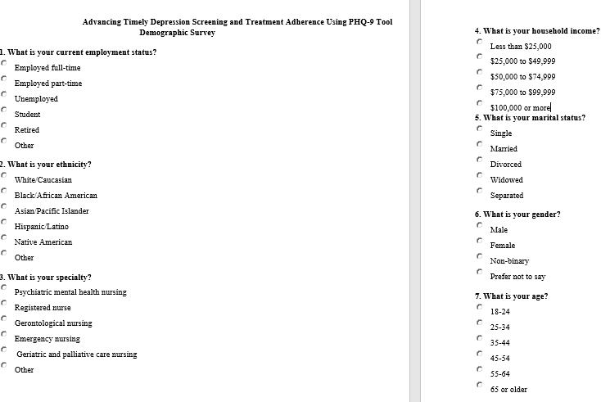
Appendix H-Instrument #1: Cultural Competence Self-Assessment Checklist
This self-assessment tool is designed to explore individual cultural competence. This tool allows us to obtain your input on the training series entitled “Culturally Relevant Programs for Probation” which will enable us to tailor this training series to fit your needs. This training supports the Enhanced Outcome-Based Supervision (EBOS) model by helping to enrich interactions with diverse populations. The checklist looks at your general skills, knowledge, and awareness pertaining to culture in the world around you—not necessarily specific to your role in supervision. It is important for us to understand your history and experiences pertaining to people with different cultural backgrounds so please answer these questions honestly—all responses are anonymous.

Please note the term ‘culture’ includes race, ethnicity and ancestry, but also the culture (e.g. beliefs, common experiences and ways of being in the world) shared by people with characteristics in common. It’s important to consider that many of the interpersonal skills you’ve developed during your lifetime through your interactions with people from differing cultural backgrounds are transferable and can be applied across various settings.

Directions: Read each entry and place a check mark in the appropriate column that best represents your opinion.

Awareness |  | Never | Sometimes/occasionally | Fairly Often/Pretty Well | Always/very well
Value Diversity | I view difference as positive and a reason to celebrate.
Know myself | I have a clear sense of my own ethnic, cultural and racial identity.
Share my culture | I am aware that in order to learn more about others I need to understand and be prepared to share my own culture.
Be aware of areas of discomfort | I am aware of my discomfort when I encounter differences in race, color, religion, sexual orientation, language, and ethnicity.
Check my assumptions | I am aware of the assumptions that I hold about people of cultures different from my own.
Challenge my stereotypes | I am aware of my stereotypes as they arise and have developed personal strategies for reducing the harm they cause.
Reflect on how my culture informs my judgement | I am aware of how my cultural perspective influences my judgement about what are ‘appropriate’, ‘normal’, or ‘admirable’ behaviors, values, and communication styles.
Accept ambiguity | I accept that in cross cultural situations there can be uncertainty and that can cause uneasiness.
 | I take the time needed to get more information in cross cultural situations.
Be curious | I take any opportunity to put myself in places where I can learn about difference and create relationships.
Aware of racial privilege | I am aware that having “racial privilege” means one’s race does not create barriers to goal attainment or justice.
 | Those who are perceived as having racial privilege may also be perceived as having certain advantages and benefits when compared to those who are perceived as not having racial privilege.
 |  | 1 pt x | 2 pt x | 3 pt x | 4 pt x

Knowledge
Gain from my mistakes | I will make mistakes and will learn from them.
Assess the limits of my knowledge | I recognize that my knowledge of certain cultural groups is limited and will commit to creating opportunities to learn more.
Ask questions | I will really listen to the answers before asking another question.
Acknowledge the importance of difference | If I am working with a person of a different culture, ethnicity, etc. I understand that I may be perceived as a person with different degrees of power or privilege, and that I may not be seen as ‘unbiased’ or as an ally.
Know the historical experiences of non-European Americans | I am knowledgeable about historical incidents in America’s past that demonstrate racism and exclusion towards Americans of non-European heritage (e.g. the Japanese internment, slavery, Jim Crow, Islamophobia…).
Understand the influence culture can have | I recognize that cultures change over time and can vary from person to person, as does attachment to culture.
Commit to life-long learning | I recognize that achieving cultural competence involves a commitment to learning over a life-time.
Understand the impact of racism, sexism, homophobia . . . | I recognize that stereotypical attitudes and discriminatory actions can dehumanize and even encourage violence against individuals because of their membership in groups which are different from myself.
Know my own family history | I know my family’s story of immigration and assimilation into America.
Know my limitations | I continue to develop my capacity for assessing areas where there are gaps in my knowledge of other cultures.
 |  | 1 pt x | 2 pt x | 3 pt x | 4 pt x

Skills
Adapt to different situations | I am developing ways to interact respectfully and effectively with individuals and groups.
Challenge discriminatory and/or racist behavior | I can effectively intervene when I observe others behaving in a racist and/or discriminatory manner.
Communicate across cultures | I am able to adapt my communication style to effectively interact with people who speak in ways that are different from my own.
Seek out situations to expand my skills | I seek out people who challenge me to maintain and increase the cross-cultural skills I have.
Become engaged | I am actively involved in initiatives, big or small, that promote understanding among members of diverse groups.
Act respectfully in cross-cultural situations | I act in ways that demonstrate respect for the culture and beliefs of others.
Practice cultural protocols | I am learning about and put into practice the specific policies and procedures related to culture which are necessary for my work.
Act as an ally | My colleagues who are of a different ethnicity than I am consider me to be an ally and know that I will support them in culturally appropriate ways.
Be flexible | I work hard to understand the perspectives of others and consult with my diverse colleagues about culturally respectful and appropriate courses of action.
Be adaptive | I know and use a variety of relationship building skills to create connections with people who are different from me.
 |  | 1 pt x | 2 pt x | 3 pt x | 4 pt x

Appendix I-Permission for Use of the Cultural Competence Checklist
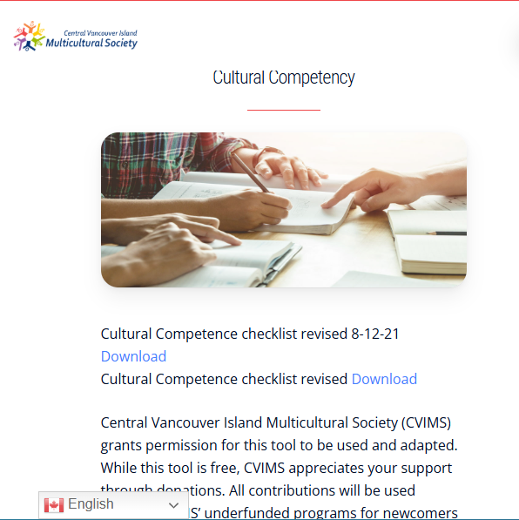

Appendix J-Instrument #2 (C-Scale)
C-Scale
Directions: Circle the number which best describes how you perceive your current ability to perform strategies to become competent in the use of cultural competence education program.
(NOTE: Make sure that the circle encloses just ONE number.)
1. I am certain that my performance is correct:
1 2 3 4 5
not at all certain certain for only a few steps fairly certain for a good number of steps certain for almost all steps absolutely certain for all steps
2. I feel that I perform the task without hesitation:
1 2 3 4 5
I have much hesitation a fair amount of hesitation a good part of it without hesitation almost completely without hesitation absolutely no hesitation
3. My performance would convince an observer that I'm competent at this task:
1 2 3 4 5
not at all agree, a little for much of it for almost all of it for absolutely all of it
4. I feel sure of myself as I perform the task:
1 2 3 4 5
not at all very little for much of it for almost all of it for absolutely all of it
5. I feel satisfied with my performance:
1 2 3 4 5
not at all very little for much of it for almost all of it absolutely satisfied with all of it
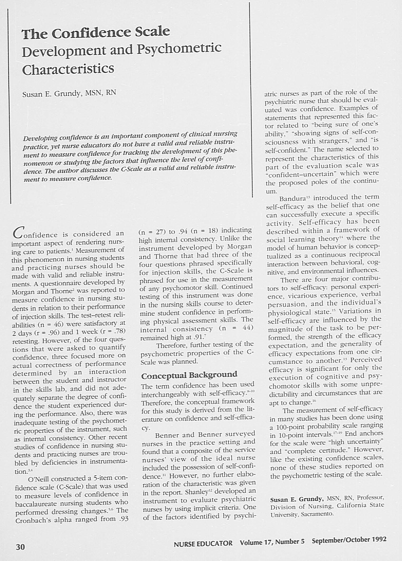

Appendix K-Permission for Use
Appendix L-Open-Ended Questions
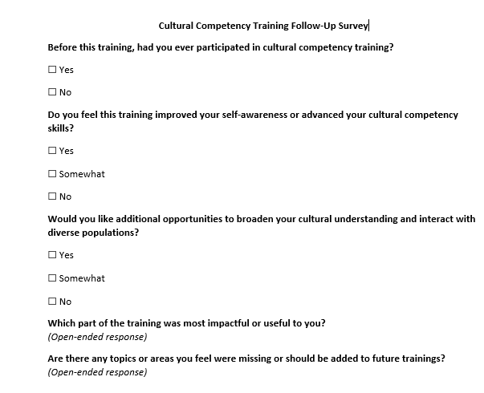
Appendix M-Educational Intervention Slides
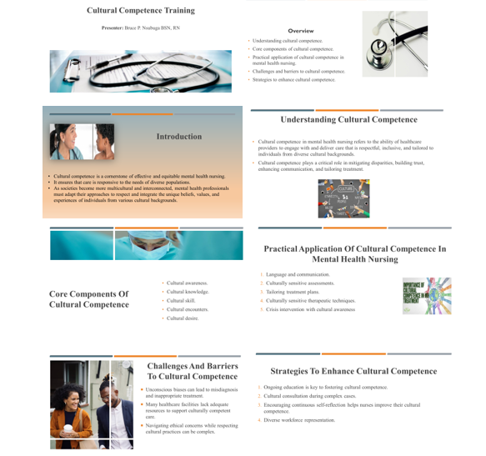
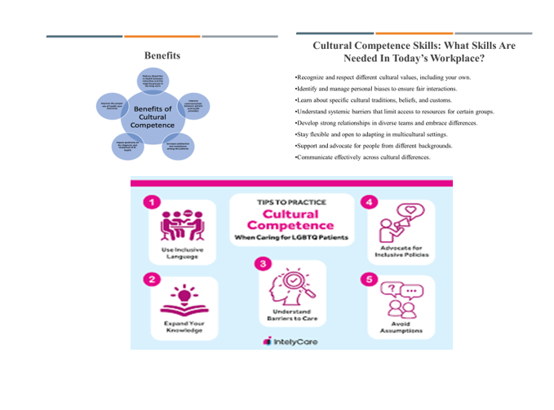

Appendix N-Regis College IRB Informed Consent
Regis College Young School of Nursing IRB Informed Consent
Informed Consent for a DNP Project entitled Cultural Competence Educational Program in Psychiatric Care Settings
Primary Investigator (PI)Researcher: Bruce Nsubuga, BSN, RN
Introduction
Please read this informed consent form slowly. The PI requests that you join a DNP project to teach nurses about cultural competency. The principal investigator carefully selected you to participate in this project because you are a nurse who has worked directly with individuals in the psychiatric inpatient or emergency department (ED), has a nursing experience of more than two years, specializes in psychiatric mental health nursing, work in the psychiatric department of the home care agency, and you are a registered nurse. You do not qualify to join if you are not a registered nurse, work in units other than the ED or inpatient psych unit, and are not directly involved with patients suffering from psychiatric conditions. Please ask any questions before joining the project.
Purpose of the Project
The project will investigate whether introducing a cultural competence education program at the home care agency will increase mental health nurse's cultural awareness, skills, and attitudes.
If you decide to join this project, the PI you to attend cultural competence training.
Timeline
Activity | Duration | Details
Pre-Test (Baseline Assessment) | Week 1(1 week) | Participants complete the Vancouver Cultural Competence Self-Assessment Checklist online. Anonymous responses ensure privacy and confidentiality.
Educational Intervention (PowerPoint Sessions & Resources) | Weeks 2-4 (2 weeks) | Four 30-minute PowerPoint presentations on cultural competence, health disparities, cultural competence constructs, and Leininger’s model. Sessions occur twice per week during lunch hours. Additional educational links and resources are provided.
Post-Test (Cultural Competence Reassessment) | Weeks 4-5 (1 week) | Participants complete the same assessment as the pre-test to measure changes in cultural competence. URL link sent via email for secure, de-identified responses.
Survey on Program Experience & Perceptions | Week 5 (1 week) | Participants complete a three-question survey reflecting on their experiences and perceptions of the program.
Benefits of Being in this Project
You will contribute to the body of knowledge about nurses and cultural competence.
Risks and Discomforts of Participating in this Project
You may feel fatigued and will need to devote time to the project to complete it. Breaks are encouraged to avoid fatigue. There are no risks other than what you experience in your daily life.
Payments
You will not receive payment for participating in the project.
Cost
There is no cost to participate.
Choosing to Participate and Quit the Project
If you decide to withdraw from the project, your decision to cancel will not affect your association with Regis or your employer. It is your choice to leave without giving any reasons. You will not be penalized for leaving the project.
Getting Dismissed from the Project
The PI may discharge you from the project for not fulfilling the following reasons:
- The lack of adherence to the study guidelines.
- The PI decides to end the project.
- You are swamped with work and cannot make time.
Privacy
The PI investigator will maintain the participants' privacy and anonymity of each participant throughout the project. The digital records will be password protected in a secure online survey website. Only the PI and Project Chair project lead will have access to the project de-identified data. No names will be used. All data will be destroyed after three years while stored in a password-protected file. Participants will refrain from using any identifying data.
Contacts and Questions
The PI conducting this project is Bruce Nsubuga, BSN, RN. For clarification please reach the PI via (774) 360- 7328 or bnsu987@regiscollege.edu. If you have any questions or concerns about your rights, reach out to Dr. Colleen, who is the chair of the Regis Institutional Review Board:
Dr. Colleen C. Malachowski, PhD
781-768-7373
colleen.malachowski@regiscollege.edu
Signature(s)/Date
Participant Printed Name: ___________________________________
Participant Signature: ___________________________________ Date: __________
Appendix O-Flesch-Kincaid Grade Level for Informed Consent

Flesch-Kincaid Grade Level Score
9.9

Appendix P- CITI Training Certificate

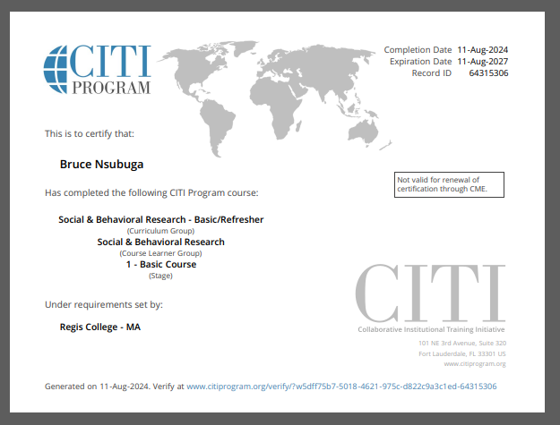
Appendix Q-Primary Investigator Resume

BRUCE P. NSUBUGA, BSN, RN-PMHNP
19th Rhodes ST
Billerica, MA 01821
(774) 360- 7328
bnsu987@regiscollege.edu
Profile |  |  | As a highly proficient BSN, RN-PMHNP with over 17 years of nursing experience, I specialize in delivering bespoke, evidence-based mental health care to clients. I am committed to delivering top-notch patient care through effective education and counseling. I have proven leadership expertise focused on increasing and enhancing patient care and satisfaction. With a strong background in leadership, I specialize in implementing streamlined safety protocols and enhancing the overall quality of care.
KEY SKILLS AND COMPETENCIES |  |  | - Adept supervisory expertise  - Excellent in impeccable communication, and problem-solving skills  - Possess sturdy verbal and written communication skills  - Compassion  - Proficient in cultural awareness  - Provides camaraderie and emotional support  - Patient-focused care  - Competent in recording patients’ vital signs  - Direct patient care expertise  - Proficient at conducting comprehensive patient assessments  - Skillfully manages medical records  - Tube feeding and medications familiarity  - Skilled at wound care  - Possess a gamut of dementia and Alzheimer’s knowledge
EDUCATION |  |  | Doctor of Nursing Practice, Jan 2023 - Current  - Regis College, Weston, MA  Master of Science Psychiatric Mental Health Nurse Practitioner (PMHNP), Jan 2021 – Jan 2023  - Regis College, Weston, MA  Bachelor of Science (BSN), Jan 2008 – Jan 2012  - Salem State University, – Salem, MA.  Licensed Practical Nurse Certificate (LPN: Nursing), Jan 2003 – Jan 2004  - St. Joseph School of Nursing – Nashua, NH  Associate of Arts: Liberal Arts and General Studies, June 2002 – September 2009  - Mass Bay Community College – Wellesley, MA
WORK EXPERIENCE |  |  | Tewksbury State Hospital, Mental Health, Tewksbury, MA, Psychiatric Mental Health Nurse Practitioner (PMHNP), 2018-01 – Current  Roles and Responsibilities  - Participates in continuous improvement by generating suggestions, engaging in problem-solving activities to support teamwork  - Performs frequent, ongoing assessments of patient's status  - Reviews post-operative orders and continuously monitors patients’ post-operative vitals.  - Delivers top-tier quality care to diverse populations while overseeing patient admission and triaging based on acuity and appropriate department admission  - Responsible for administering medications and treatment to patients and monitoring their responses while working with healthcare teams to adjust care plans  - Facilitates therapeutic communication, conflict resolution, and crisis intervention  - Complies with HIPAA laws and prevents information breaches effectively  - Updates patient charts on the EHR with data to keep records current and support accurate treatments  - Observe and document patient factors to understand conditions and actively modify treatment plans  - Recommend patients referrals to different specialists  - Reports findings to the quality department after conducting routine restraint audits  - Assesses patients’ physical and mental status by analyzing complaints and symptoms  - Educates patients and family members about medical conditions and mental health medications, treatment, and preventive measures  - Develops a treatment plan for mental health problems and psychiatric disorders based on evidence-based standards of care, biopsychosocial theories, and current practice guidelines.  - Crisis intervention.  - Perform intake screenings, initial evaluation, and triage.  - Work collaboratively with interdisciplinary teams.  Alternative Home Care Services, Methuen MA, Registered Nurse (Mental Health), 2012-01 – Current  Roles and Responsibilities  - Responsible for assessing patients’ physical and mental status  - Educating patients and family members about medical conditions  - Evaluating, ordering, and interpreting diagnostic tests to assess and identify patients’ conditions  - Performs frequent, ongoing assessment of patients’ status to address changes or any abnormal changes  - Reviews post-operative orders and continuously monitors patients’ post-operative vitals  - Leverages feedback and process improvement opportunities to create a safer and healthier environment and increase patient satisfaction  - Administers medications and treatment to patients  - Adheres to all personal and health data procedures to effectively comply with HIPAA laws  - Updates patient charts using [software]  - Partners with other healthcare providers to develop and implement individualized care plans and document all patient interactions and interventions in electronic charting systems  - Uses first-hand knowledge and clinical expertise to advocate for patients under care and enact prescribed treatment strategies  - Performs and documents a comprehensive psychiatric evaluation that includes evaluation of mental status, current and past history of violence, suicidal or self-harm behavior, substance use, level of functioning, health behaviors, trauma, sexual behaviors, and social and developmental history  - Develops a treatment plan for mental health problems and psychiatric disorders based on evidence-based standards of care, biopsychosocial theories, and current practice guidelines  - Manages patients recovering from medical or surgical procedures  - Provide patients and their families information regarding the benefits and risk of various medications  - Provide consultative psychiatric evaluations and recommendations within the continuum of mental health care  - Develop rapport and trust with patients and their families by using therapeutic communication techniques  Hospice, Danvers, MA, Registered Nurse (Hospice), 2012-01 – Current  Roles and Responsibilities  - Admissions and gathering patients’ history  - Confers with physicians to discuss diagnoses and devise well-coordinated treatment approaches  - Establishing hospice care services for elderly and disabled patients  - Building rapport with patients, families, and physicians by utilizing exemplary communication and active listening  - Provides high-level quality, compassionate care to patients and caregivers during each nursing shift  - Responsible for medication and iv administration, catheter insertion, and airway management  - Reports patients’ status and delegates nurse assignments to achieve optimal outcomes  - Monitoring patient vital signs.  - Appraising clients’ comfort levels  - Acknowledging mechanisms to personalize care  - Offering physical, emotional, and mental support to patients and their families  - Educates family members and caregivers on patient care instructions  - Provides holistic hospice health care
LICENSURE |  |  | - Registered Nurse (BSN-RN, AND-RN), 2012  - Licensed Practical Nurse since 2004
CERTIFICATIONS |  |  | - Phlebotomy  - First Aid and CPR  - Palliative care certificate  - Occupational Safety and Health Administration (OSHA) certificate  - Dementia training  - IV start certified.  - CITI training certificate
PROFESSIONAL AFFILIATIONS |  |  | - Sigma Theta Tau International Honor Society of Nursing: Member of Pi Epsilon at-Large Chapter Emmanuel College, Laboure College of Health Care, Regis College
LANGUAGES |  |  | - English
QUALIFICATIONS |  |  | - Admissions.  - Care plan development.  - Precepting.  - Chronic care management.  - Pleura drain care.  - Supervising staff.  - Implementing physician orders.  - Discharge teaching and planning.  - End of life care.  - Emergency response and management.  - Mechanical ventilators.  - IV access of peripheral line infusion.  - Management of peripheral lines, midlines, and PICC lines.  - Wound care.  - Medication administration, management, and documentation.  - Serving as a patient or family advocate.

