The Implementation of 1:1 Nurse-led Cognitive-Behavioral Therapy for Patients with Alcohol Use Disorder in an Outpatient Clinic

Doris Chika Onyima
Chamberlain College of Nursing

Abstract
Background: Alcohol use disorder is a global problem that exerts a significant burden on individuals, families, communities, and the healthcare system.
Problem: While many people are treated using medication-assisted therapy, many experience alcohol use relapse within a short period because of lack of supportive interventions to sustain abstinence.
Methods: The quality improvement (QI) project was implemented in an outpatient clinic. It targeted individuals diagnosed with AUD and struggling with relpse. The primary outcome (alcohol relapse) was assessed using AUDIT survey.
Intervention: Participants received personalized weekly 1:1 nurse-led cognitive behavioral therapy (CBT) for eight weeks.
Results: Forty-two participants (n=42) completed the intervention to the endpoint. At post-implementation, 90.5% of the participants achieved AUDIT scores ≤ 7. The mean AUDIT scores reduced from 10.67 (SD: 1.75) to 4.36 (SD: 1.23) from pre-intervention to post-intervention, with the median reducing from 11.00 to 4.00. A Wilcoxon signed-rank test revealed that the eight-week 1:1 nurse-led CBT program led to statistically significant decrease in AUDIT scores (Z = −5.680, p < .001).
Conclusions: The findings show that nurse-led CBT can significantly reduce alcohol relapse rates among individuals with AUD. Achieving the outcomes requires a competent workforce capable of implementing the intervention with fidelity.
Keywords: Alcohol use disorder, relapse, cognitive behavioral therapy, AUDIT survey

Dedication
[Directions – In NR709- a dedication provides the author with the opportunity to thank people who may have special meaning in the author’s life. For example – you may want to thank your spouse or a specific family member for their support during your doctoral education. The dedication should be concise and convey your appreciation for these individuals while you were a Doctor of Nursing Practice student.]

Acknowledgment
[Directions –In NR709- the acknowledgment page is reserved for the author to acknowledge the important role specific professionals have made toward the successful completion of the project, for example, your course faculty, your preceptor, stakeholders, and members of your DNP practicum course faculty.

Table of Contents
Abstract 2
Dedication 4
Acknowledgment 5
Problem 8
Project Aim and Supporting Objectives 10
Practice Question 10
Research Synthesis and Evidence-Based Intervention 10
Methodology 14
Organizational Setting 14
Population 14
Translation Science (or QI Model + Nursing Theory) and Project Management 15
Plans for Sustainability 18
Barriers, Facilitators, Ethical Considerations 18
Data Collection and Analysis Plan 20
Required Resources and Proposed Budget 21
Results 22
Conclusions 29
Clinical Relevance 31
References 35
Appendix A: Johns Hopkins Nursing Evidence-Based Practice Individual Evidence Summary Tool 42
Appendix B: Plan for Educational Offering 48
Appendix C: Data Collection Tool 50
Appendix D: Informed Consent for Participation in a DNP Project 52
Appendix E: Letter of Support 57
Appendix F: Compliance checklist 58
Tables 60
Figures 62

The Implementation of 1:1 Nurse-led Cognitive-Behavioral Therapy for Patients with Alcohol Use Disorder in an Outpatient Clinic
Alcohol use disorder (AUD) remains a widespread and costly behavioral problem and a leading risk factor for disease and injuries. The average population lifetime prevalence of AUD across the globe is approximately 8.6% among non-abstainers (Glantz et al., 2020), while the treatment rate is approximately 10% (Kools et al., 2022). Alcohol poses a significant public health problem in the United States, accounting for approximately 140,000 deaths annually. In addition, it accounts for approximately 89,697 deaths among adults aged 20-64 years and 4,000 deaths among those aged under 21 years (Substance Abuse and Mental Health Services Administration, 2022). The practice problem addressed in this proposed DNP project is the high rate of relapse because of inadequate treatment. As of 2023, only 7.8% of the 2.2 million adults with AUD had received treatment the previous year, with most people seeking primary care for alcohol-related medical problems instead of care to address excessive drinking (National Institute on Alcohol Abuse and Alcoholism, 2024). Moreover, over 60% of the people who receive medication-assisted treatment (MAT) relapse within the first six months. The high relapse rate following MAT indicates the need for alternative treatment options. The gap in practice that requires addressing is the lack of a nurse-led alternative psychological approach to address relapse. Consequently, the project implemented a program involving face-to-face CBT sessions for the adult population. The manuscript describes the significance of the problem, its prevalence and impact at the global, national, and practicum levels, the project aims and objectives, the methodology to use in implementing the intervention, and the barriers, facilitators, and ethical considerations. In addition, presents the results from the implementation of the intervention and discuss their relevance pertinent to the previous literature.

Problem
Alcohol use is a global public health and safety problem. According to the World Health Organization (WHO, 2024), approximately 400 million people aged 15 years and older had AUD in 2024. The global lifetime prevalence of AUD is estimated to be 8.6% among non-abstainers (Glantz et al., 2020). As of 2019, alcohol consumption was attributed to approximately 2.6 million deaths resulting from alcohol-related non-communicable diseases, injuries, and communicable diseases (WHO, 2024). While alcohol-related disability-adjusted life years (DALYs) have reduced by approximately 14.5% since 2000, the economic costs and harmful effects remain significantly high (Park & Kim, 2020). According to a recent modeling study, the global cost of alcohol consumption is approximately $1,306 per adult, with direct medical costs accounting for 38.8% and loss in productivity 61.2% (Manthey et al., 2021). As highlighted by Nguyen et al. (2020), almost 60% of adults relapse within six months of treatment, despite the refinement of psychosocial and pharmacological treatments. Moreover, global evidence shows that only 17.3% of individuals with AUD receive adequate treatment (Mekonen et al., 2021).
At the national level, similar trends appear in the prevalence and effects of AUD. As of 2023, approximately 28.1 million American adults had been diagnosed with AUD in the previous year (NIAAA, 2024). The statistics show an increase in alcohol-related deaths from 78,927 in 2019 to 105,415 in 2022. Death by suicide accounts for approximately 25% of the alcohol-related deaths in the country. The lifetime and 12-month prevalence of AUD are considerably high in the US – 29.1% and 13.9%, respectively (Grant et al., 2024). Alcohol consumption and AUD have a significant impact on individuals, families, communities, and the healthcare system. The existing evidence associates prolonged alcohol use with multiple chronic diseases, including cardiovascular disease, stroke, obesity, and diabetes (Varghese & Dakhode, 2022). Its impact on families and the community cannot be understated considering that approximately 10.5% of children aged 17 and younger live with a parent with AUD (NIAAA, 2024). Alcohol use also strains the healthcare system, with alcohol-related emergency visits increasing by 47% between 2006 and 2014 (SAMHSA, 2022). Moreover, alcohol-related costs have significantly increased. For individuals with AUD, medical expenses are approximately $14,918 per person for those with commercial insurance and $4,823 per individual for Medicaid recipients.
In 2021 and 2022, approximately 53.36% of the adult population in Maryland reported using alcohol. Of the population reporting alcohol use, approximately 11.18% have been diagnosed with AUD but only 3.66% have received treatment (Center for Behavioral Health Statistics and Quality, 2022). The statistics show gaps in access to treatment at the state level. At the practice level, AUD and other substance use disorders are among the common presenting problems. However, the practicum site uses suboxone as the only pharmacological approach to treating SUDs, with no clear practices regarding the treatment of AUD (Chinasa Nwaulu, personal communication, 2024). Conversations with the staff, clients, and stakeholders revealed that the lack of alternative treatments for AUD was contributing to frequent relapses, as evidenced by patients frequently returning with persistent symptoms (Chinasa Nwaulu, personal communication, 2024). The high relapse rate significantly affects the quality of treatment, with concerns about whether the current practices are adequate in ensuring patients’ safety and optimizing their outcomes. Therefore, the key decision-makers support implementing a supportive psychological program to address the existing gaps.

Project Aim and Supporting Objectives
The specific aim of the DNP project was to implement a 1:1 CBT program for adults with AUD and receive services at the practicum site. Consequently, the project sought to fulfill the following objectives: a) educate participants on the structure and expectations of CBT therapy sessions, including what they can anticipate from each session and how to apply CBT techniques to daily life situations, b) assess participants' adherence to CBT sessions by tracking attendance and engagement levels in the program. 3) provide participants with strategies to recognize and manage potential triggers outside of therapy sessions, equipping them with tools to sustain their progress in managing symptoms.

Practice Question
The following practice question serveed as the basis for the DNP practice change project: For adults diagnosed with alcohol use disorder in an outpatient mental health clinic, does the implementation of a nurse-led 1:1 Cognitive Behavioral Therapy (CBT), compared to current practice, impact the alcohol relapse rates over 8-10 weeks?

Research Synthesis and Evidence-Based Intervention
Evidence-Based Intervention
Cognitive behavioral therapy (CBT) has emerged as one of the leading behavioral interventions for the treatment of alcohol and substance use disorders. The intervention involved a time-limited, multi-session approach targeting affective, cognitive, and environmental risks for use (Magill et al., 2019). In delivering the interventions, individuals also are trained on coping skills to foster the achievement and maintenance of abstinence. CBT can be delivered through face-to-face sessions or digitally enabled sessions; it can be applied as a standalone intervention or adjunct treatment to pharmacotherapy (Ray et al., 2020). The American Psychological Association (APA, 2023) endorses CBT as a useful intervention for different behavioral and psychiatric conditions, with similar or more efficacy than psychotropic medications or other psychological therapies. Broadly, the intervention focuses on aiding individuals to identify distorted thoughts, understand their motivations, apply problem-solving skills, and develop self-confidence in maintaining new behaviors.
Evidence Synthesis
The search for evidence led to the identification of 10 peer-reviewed articles. Eight of the articles provided level I evidence, with seven randomized controlled trials (Johansson et al., 2021; Kiluk et al., 2024; Magill et al., 2019; Peng et al., 2022; Srivastava et al., 2022; Stasiewicz et al., 2023; Sundström et al., 2020) and one meta-analysis (Ray et al., 2020). van Amsterdam et al., 2022) offered level II evidence based on a systematic review, while Tarp et al. (2024) offered level III evidence based on a single qualitative interview-based study. The overall quality of the studies ranged from good to high, with adequate justification of the methods, clear discussion of the findings, and articulate alignment of the conclusions and results.
Main Themes in the Research
The articles revealed three primary themes: the delivery approach and intensity of CBT, the added value of CBT combined with pharmacotherapy, and the importance of personalizing CBT.
Delivery approach and intensity of CBT. While technology has been accelerating the adoption of internet-based CBT, the evidence shows that face-to-face CBT has similar effects on preventing relapse (Johansson et al., 2021; Kiluk et al., 2024; Ray et al., 2020; Srivastava et al., 2022; Sundström et al., 2020; van Amsterdam et al., 2022). Similarly, individual CBT and group-based CBT were found to have similar effects on relapse prevention (Magill et al., 2019; Peng et al., 2022). While the number of sessions differed across the studies, the findings revealed that the intensity of the intervention did not significantly affect the achievement of the outcomes (Sundström et al., 2020; Stasiewicz et al., 2023).
The added value of CBT combined with pharmacotherapy. The evidence revealed that adding CBT to pharmacotherapy had additional benefits in achieving the outcomes (Peng et al., 2022; Ray et al., 2020; Srivastava et al., 2022; van Amsterdam et al., 2022). Notably, the evidence converged on the added value of CBT on pharmacotherapeutic agents such as disulfiram, acamprosate, and buprenorphine. CBT augments the outcomes by enhancing problem-solving skills, self-management efficacy, and social functioning that improve treatment adherence.
Importance of Personalizing CBT. Personalizing CBT to address individual relapse triggers was essential to achieving the expected outcomes (Kiluk et al., 2024; Stasiewicz et al., 2023; Tarp et al., 2024). A personalized approach was associated with immediate and constructive feedback, feedback interactions, and tailored adjustments to the treatment process to meet individual needs.
Contrasting Elements in the Research
The evidence demonstrates the utility of CBT in treating AUD and preventing relapse, regardless of the modality or intensity of the intervention. However, a notable contrast regards the rate of achieving and maintaining abstinence. While Kiluk et al. (2024) found that individuals assigned to digital CBT achieved abstinence faster, Johansson et al. (2021) found that the effect of face-to-face sessions lasted longer. The outcome could be attributed to the value of personal interactions that enable a comprehensive understanding of individual needs. Secondly, the studies involved minor differences in the number of CBT sessions, with sessions ranging from eight to 12 sessions delivered over six to 12 weeks (Johansson et al., Kiluk et al., 2024; Ray et al., 2020; Stasiewicz et al., 2023; Srivastava et al., 2022; Sundström et al., 2020). The different timeframes imply that some studies involved brief or standard CBT duration, which could affect the achievement of the expected outcomes. While most studies evaluated post-implementation outcomes after three months, the follow-up period ranged from one to 12 months (Kiluk et al., 2024; Magill et al., 2019; Peng et al., 2022; Srivastava et al., 2022; Sundström et al., 2020). Acknowledging the differences could provide an understanding of CBT's short- and long-term effects on the primary outcome (relapse prevention).
Research Support for the Evidence-Based Intervention
While minor differences in the evidence exist, significant convergence on its utility in treating AUD and preventing relapse emerged. The evidence supports the effectiveness of face-to-face CBT, finding it equally effective as internet-based CBT whose adoption has increased since the COVID-19 outbreak (Johansson et al., 2021; Kiluk et al., 2024; Ray et al., 2020; Srivastava et al., 2022; Sundström et al., 2020; van Amsterdam et al., 2022). While the number of sessions may differ, the evidence from these studies shows that the effects are relatively consistent with both brief and standard CBT. The evidence supports face-to-face CBT based on the value of interpersonal interactions that occur during the sessions, fostering a comprehensive understanding of patient needs (Johansson et al., 2021). Nevertheless, clinicians could combine CBT with pharmacotherapy to enhance outcomes and tailor the intervention to meet individual needs and preferences (Kiluk et al., 2024; Peng et al., 2022; Ray et al., 2020; Srivastava et al., 2022; Tarp et al., 2024). The comprehensive approach could foster the maintenance of abstinence over the long term.

Methodology
The section explains the methods and techniques applied to ensure the success of the project. It starts with an overview of the organizational setting where the project is to be implemented and the patient population served. Further, it articulates the theoretical framework that guideed the implementation process, the project implementation plan, and strategies to sustain the change in the practice setting.

Organizational Setting
The DNP project was implemented at an outpatient clinic in Maryland that offers medical, mental, and behavioral health services. The clinic is located in an office park. The clinic offers both face-to-face and virtual services to the surrounding community. Conventionally, new appointments take 60 minutes while follow-up appointments take 30-45 minutes depending on patients’ needs. The clinic serves individuals with chronic and acute presentations. Common disorders treated at the facility include depression, schizophrenia, personality disorders, panic disorder, obsessive-compulsive disorder, and substance use disorders. The average daily census ranges from 30-35 patients, with two nurse practitioners as the onsite providers who collaborate with other clinicians in managing the disorders.

Population
Although the population served presents with diverse mental health disorders, the project targeted adult patients diagnosed with alcohol use disorder. It aimed at recruiting existing and new patients, targeting at least 45 participants. Individuals aged 18-75 years with a confirmed diagnosis of AUD based on the DSM-V criteria and receiving treatment or ready to receive treatment at the practicum site will be recruited. Persons under the age of 18 and diagnosed with other disorders were excluded. In addition, patients with serious mental and physical health comorbidities that may impede their participation were excluded. Participants were identified during clinic visits and through electronic health records. The DNP project manager contacted the identified participants to seek their informed consent to participate and enroll in their project (refer to Appendix D).

Translation Science (or QI Model + Nursing Theory) and Project Management
Theoretical Framework: Knowledge-to-Action (KTA)
Selecting an appropriate theory, framework, or model plays a crucial role in the successful translation of knowledge for implementation in practice (Steinkog et al., 2021). KTA will serve as the underpinning theoretical framework guiding project implementation. Developed by Graham et al. (2006), KTA provides a systematic, adaptive, and iterative approach to implementing evidence-based interventions in practice. The model consists of the knowledge-creation cycle and the action cycle that can be accomplished iteratively in the context of complex interventions (Graham & Tetroe, 2010). The knowledge-creation cycle involves knowledge inquiry, synthesis, and generation of knowledge tools. The action cycle encompasses identifying a problem, adapting the knowledge to the implementation context, assessing implementation barriers and facilitators, tailoring intervention implementation, monitoring knowledge use, evaluating outcomes, and sustaining change (Graham et al., 2006). Considering the fluid boundaries between knowledge creation and application in KTA, the iterative process of using the model started with identifying a practice problem. The lack of optimal interventions to reduce relapse rates among patients with AUD was identified as a priority problem that could be addressed through an evidence-based intervention. Problem identification paved the way for the search and synthesis of evidence supporting the utility of CBT in preventing relapse. The evidence justifies the benefits of implementing the intervention to fill the current gap in practice. In the action cycle, knowledge use will be adapted to the implementation context through staff training. The educational sessions on CBT for relapse prevention were expected to improve nurses’ competence to use and adapt the intervention according to patients’ unique needs and preferences. Potential barriers, including time constraints in balancing existing workloads with the new tasks, were assessed and mitigation strategies developed before the start of the intervention. In addition, seeking buy-in from the stakeholders from an early stage of the project facilitated success through a supportive environment and commitment to change. A tailored approach to implementing CBT was adopted to ensure every session meets individual needs and challenges. Formative assessments through observation of sessions and weekly staff meetings for feedback and feedforward helped to monitor knowledge use. The outcome evaluation in the KTA model was based on the AUDIT tool, a validated instrument used to detect risky or harmful drinking patterns. Sustaining change in the KTA model was established through specific strategies tailored to the practicum site and its stakeholders.
Project Implementation Plan
Week 1: This project intervention was done in three phases. The DNP leader held an initial meeting with the nursing staff of the unit to discuss the goal, purpose, and process for a 1:1 nurse-led CBT for patients with alcohol use disorder. To practice CBT, the DNP leader prepared and executed educational training for the nurses at the clinic. The DNP leader developed days/times for nurses to participate in the training. The training objectives, participant roles, and expected outcomes were provided to the nurses participating in the training (Refer to Appendix B). The DNP leader also conducted educational sessions at the practicum site on the use of the AUDIT tool as a measurement tool for the severity of alcohol withdrawal in patients with alcohol use disorder. All patients who meet the inclusion criteria were invited to participate. The pre-intervention AUDIT tool was administered to all participants.
Weeks 2-9: The intervention was implemented for 8 Weeks. The DNP leader was present at the site 3-4 times during the implementation time to provide observations, formative evaluations, and audits giving feedback to the nursing staff on the implementation of 1:1 CBT and the use of the AUDIT tool for assessment. The implementation occurred two to three times weekly at various times to accommodate all nursing staff. A pre-briefing was completed by the DNP leader with nurses noting the expected participation of nurses during implementation in the designated meeting area. Then the CBT was conducted in the approved area at the outpatient clinic. For formative evaluation, the DNP leader observed the nurses' responses and actions while implementing CBT and AUDIT tool screening during sessions, recording the observations on the Cognitive Therapy Skills Scale (CTRS). The DNP leader then completed a debriefing of the post-intervention in the outpatient clinic. The debrief analyzed the intervention experience related to the participant's response to the CBT intervention. Compliance was assessed, and real-time education was provided as needed (Refer to Appendix F for compliance checklist). Feedback was provided in weekly staff meetings and any concerns from the nursing staff were addressed to provide a formative evaluation for the intervention.
Week 10: After the intervention process was completed, participants completed the post-intervention survey in the designated meeting area. To sustain the practice change, the project intervention plan included translation of the intervention, implementation, formative, and summative evaluation plans for the stakeholders. The project was then concluded. The DNP leader thanked the nursing staff for participating in the project implementation. The DNP leader aggregated responses from the AUDIT tool and the CTRS, screening pre- and post-intervention data for summative data analysis.

Plans for Sustainability
Sustaining changes beyond the implementation stage is often challenging. According to Minogue et al. (2021), the absence of adequate sustainability measures limits the impact of evidence-based interventions on short-term benefits. In this regard, sustaining the practice change will involve several strategies. The DNP project leader will commit to ensuring the changes are embedded into the daily clinical workflows. Moon et al. (2022) agree that highlighting the importance of leadership commitment and visibility in championing sustainable change. Consistent with Silver et al. (2019), a nursing team will be delegated to support nurses who struggle with adopting the intervention in their daily practice, with the nurse manager being responsible for ongoing evaluation. Thirdly, I will lobby for ongoing staff training to ensure all the nurses have up-to-date knowledge and competence in using CBT to prevent relapse.

Barriers, Facilitators, Ethical Considerations
One of the potential barriers included resistance from staff based on the lack of confidence in using CBT and AUDIT assessment tools. The barrier was addressed through pre-implementation training on both CBT and AUDIT to enhance staff confidence and self-efficacy in implementing the intervention and assessing outcomes. Consistent with Harrison et al. (2021), early stakeholder engagement also reduced resistance by ensuring buy-in from all the relevant stakeholders. Another possible barrier was that the limited availability of trained CBT practitioners, which was addressed by collaborating with interdisciplinary team members including the PMHNPs to help mitigate the staff shortages. Another possible key challenge was the logistics of scheduling sessions. The DNP leader created a scheduling plan in collaboration with the nurse manager, ensuring the scheduled appopintments fit the participants and staff convenience to address logistical challenges and promote successful implementation of the intervention. Participants' attendance at scheduled sessions could also pose a barrier to the implementation. As supported by Gagnon et al. (2024), the existing culture of collaboration facilitated project success by ensuring shared understanding and learning, cooperation, and accountability. Nevertheless, changes in leadership could affect success through a shift in priorities and strategic goals that may not consider alcohol relapse as a significant practice problem.
Ethical considerations for confidentiality and privacy were observed throughout the project. The DNP project manager sought informed consent from participants considering that the project aims to recruit a a proportion of the population diagnosed with AUD. Appendix D outines the informed consent form to be used in recruiting the participants. Consistent with Hall et al. (2020), protecting participants’ confidentiality covered all the information collected through observations, surveys, or medical records. Consequently, the DNP leader shred the paper-based AUDIT forms after scanning the forms into the patient's records and entering them into the EHR. At the end of the project, the aggregate AUDIT scores were drawn from the EHR, transferred into an Excel sheet without personally, identifying information, and stored in a password-protected OneDrive, sharing the access code with the project supervisor only. The aggregate data will be maintained for seven years and destroyed afterward, consistent with the institution’s guidelines.
The practicum site does not require internal IRB approval for project implementation. The letter of support from the practicum site (Appendix E) confirms the institution’s approval for the project. It outlines the site’s agreement to host the intervention, acknowledging the project’s alignment with its mission for clinical practice improvements. The project does not introduce an experimental procedure or require additional patient risk assessments, considering that the project aims at integrating CBT – an evidence-based intervention – into routine AUD treatment. However, to comply with Chamberlain University’s research oversitt, the DNP project manager completed the IRB prescreening process. The step was essentiall to determine whether the project qualifies as human subjecrs research or a quality improvement initiative. The prescreening process included an outline of the practice problem, the project purose, clinical question, implementation process, and the data collection and analysis methods. In addition, it required answering questions on whether the project will generate new knowledge, expand theory or inform policy, implement an intervention that has not been published elsewhere, use a protocol deviating from a conventional protocol, or replicate or extend a previous study. Following the prescreening process, it was determined that the project is a QI initiative and would not require fll IRB review or approval.

Data Collection and Analysis Plan
The primary outcome of interest in the project is alcohol use relapse. Baseline data was collected at week 1 after participants have provided informed consent, while post-intervention data was collected at week 10 at project endpoint. The AUDIT survey is a widely used tool for assessing alcohol consumption severity. The tool is effective and reliable tool for identifying alcohol use disorder, as it has been known to have good sensitivity and specificity in detecting problem drinking (Habtamu & Madoro, 2022). The 10-item scale has an acceptable internal consistency (Cronbach's α = 0.817) (Chen et al., 2024). However, there are studies suggesting that in using the AUDIT tool, it is significant to utilize the two-factor model consisting of alcohol consumption, and alcohol-related problems (Horváth et al., 2023). Consistent with its authors, AUDIT scores were expected to drop below the cut-off score of 8, which indicates harmful or hazardous alcohol use. Participants filled in paper forms of the AUDIT tool at baseline (during recruitment) and at the project endpoint. The DNP leader scanned the information into patients' charts and entered it in the EHR for safe storage pending retrieval during data analysis.
The DNP project manager first extracted AUDIT scores from the scanned charts manually. For de-identification, each participant was assigned a number (01, 02, 03...0n) to exclude personal identifiers such as names, addresses, dates of birth, and medical record numbers from the final dataset. This data was aggregated in an Excel sheet with three columns for the assigned patient number, pre-intervention AUDIT scores, and post-intervention AUDIT scores per patient. The mean AUDIT scores at baseline and post-intervention will be calculated for the aggregated data. The mean scores at baseline (week 1 data) with be compared with the mean post-intervention scores (week 10 data) to deduce the efficacy of the intervention. In this regard, a paired samples t-test will be conducted using SPSS version 26 to compare pre- and post-intervention scores. A statistically significant reduction (p < 0.05) in mean AUDIT scores would indicate that the intervention was effective in reducing the risk of alcohol relapse. If the post-intervention scores drop below the cutoff of 8 points, it would suggest that the intervention shifted consumption from hazardous to safe or abstinence.

Required Resources and Proposed Budget
Completing the project required human, financial, and material resources. Regarding human resources, the project required the consistent participation of the nursing staff in conducting the 1:1 CBT sessions and administering the AUDIT tool. The participation of the nursing staff was not compensated because the initiative was embedded into the daily clinical workflow. The project also required stationery, office supplies, and equipment such as a projector, laptop, printer, and printing papers to facilitate staff training and printing of the data collection tools and consent forms. Table 1 illustrates the projected budget for the resources required.

Results
The QI project investigated the impact of CBT compared to current practice in reduce alcohol relapse rates among individuals with AUD. The primary outcome (changes in alcohol relapse) was measured using the AUDIT survey, an instrument designed to assess harmful or risky drinking patterns. In addition, the CTRS was used to collect observational data on nurses’ compliance with the CBT protocol. The intervention was implemented over eight weeks. For the AUDIT survey, the first step was to establish the completeness of the data. The DNP project manager reviewed the completed questionnaires, establishing that and established that all the items were filled and the aggregate score recorded. The total scores for the tool range from 0-40, whereby scores of 1-7 indicate low risk, 8-14 risky, and 13+ high risk drinking patterns. No instances of missing data were noted, allowing the inclusion of all the filled forms in the analysis. The total AUDIT scores were calculated by summing the individual scores for each item. In turn, the data was transferred into an Excel sheet and entered into SPSS for analysis. Initially, descriptive statistics, including frequencies, means, medians, and standard deviations were computed to provide a summary of the data. As supported by Kaliyadan and Kulkarni (2019), the descriptive statistics offered insights into the central tendencies, variability, and dispersion of the pre- and post-intervention AUDIT scores. In addition, descriptive statistics offered information about the fulfilment of the assumptions of normality, allowing the selection of appropriate statistical tests to compare the pre- and post-intervention scores. Consistent with Yang and Berdine (2021), the Shapiro-Wilk test was appropriate for assessing the normality of data distribution because the sample involved less than 50 participants. In this regard, p-values < 0.05 would indicate that the data was not normally distributed and vice versa (Habibzadeh, 2024). The Wilcoxon signed-rank test was used because the data was not normally distributed. According to Schober and Vetter (2020), the test offered an alternative to the t-test for the comparison of paired data in non-normally distributed data. For the CTRS, descriptive statistics were used to assess the weekly changes in the mean scores. The summary provided
In this project, forty-five participants were recruited but three dropped midway, leaving data for n = 42 participants available for analysis. At pre-intervention, the AUDIT scores ranged from 8 to 13, indicating that the participants had risky or high-risk drinking patterns. Nineteen percent of the participants (19%) had a score of 13 and 12, 16.7% a score of 11, 16.7% a score of 10, 11.9% a score of 9, and 16.7% a score of 8. At post intervention, only four participants (n=4) had scores of 8 and above, representing 2.4% (score of 10), 4.8% (score of 9), and 2.4% (score of 8), with the remaining 90.5% having scores of ≤ 7. Table 1 represents the frequencies for the AUDIT scores, with Figure 1 and 2 illustrating the mean distribution of the pre- and post-intervention scores, respectively.
Table 1
Frequency table of Pre- and Post-Intervention AUDIT Scores
Pre-Intervention Score
 |  |  | Frequency |  | Percent |  | Valid Percent |  | Cumulative Percent
Valid | 8 |  | 7 |  | 16.7 |  | 16.7 |  | 16.7
Valid | 9 |  | 5 |  | 11.9 |  | 11.9 |  | 28.6
Valid | 10 |  | 7 |  | 16.7 |  | 16.7 |  | 45.2
Valid | 11 |  | 7 |  | 16.7 |  | 16.7 |  | 61.9
Valid | 12 |  | 8 |  | 19.0 |  | 19.0 |  | 81.0
Valid | 13 |  | 8 |  | 19.0 |  | 19.0 |  | 100.0
Valid | Total |  | 42 |  | 100.0 |  | 100.0
Pre-Intervention Score
 |  |  |  | Frequency |  | Percent |  | Valid Percent |  | Cumulative Percent
Valid |  | 8 |  | 7 |  | 16.7 |  | 16.7 |  | 16.7
 |  | 9 |  | 5 |  | 11.9 |  | 11.9 |  | 28.6
 |  | 10 |  | 7 |  | 16.7 |  | 16.7 |  | 45.2
 |  | 11 |  | 7 |  | 16.7 |  | 16.7 |  | 61.9
 |  | 12 |  | 8 |  | 19.0 |  | 19.0 |  | 81.0
 |  | 13 |  | 8 |  | 19.0 |  | 19.0 |  | 100.0
 |  | Total |  | 42 |  | 100.0 |  | 100.0

Figure 1
Histogram Representing Aggregate Pre-Intervention AUDIT Scores
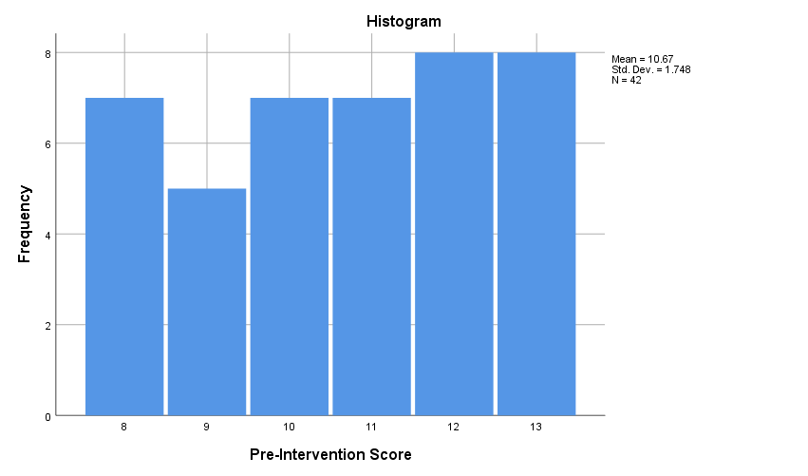
Figure 2
Histogram Representing Aggregate Post-Intervention AUDIT Scores
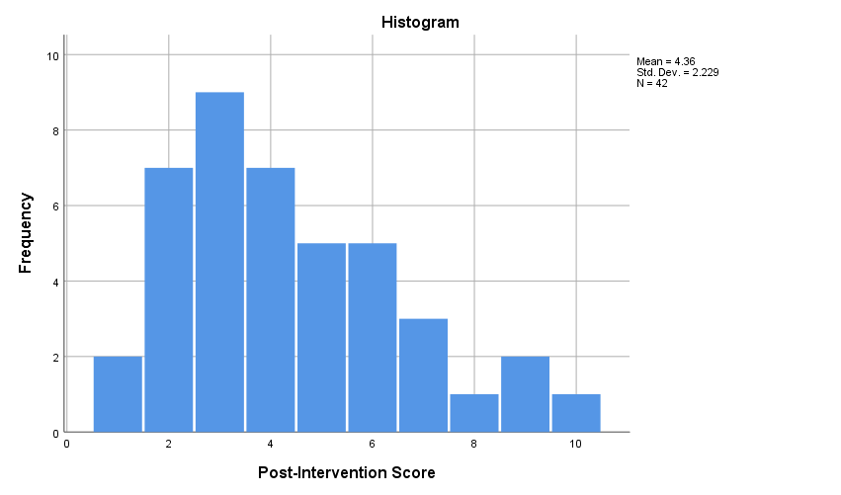

Additional descriptive statistics were conducted for the measures of central tendencies. At pre-intervention, the participants had a mean AUDIT score of 10.67 (SD: 1.75), with median score of 11.00. At post-intervention, the mean dropped to 4.36 (SD: 1.23) and the median to 4.00. The results are consistent with the structure of the AUDIT survey in which higher scores imply risky drinking patterns and vice versa, implying that the group experienced a decrease in their drinking during the study period. Table 2 provides a detailed illustration of the descriptive statistics for the sample.
Table 2
Descriptive Statistics for AUDIT Scores
 |  |  | Statistic | Std. Error
Pre-Intervention Score | Mean |  | 10.67 | 0.270
Pre-Intervention Score | 95% Confidence Interval for Mean | Lower Bound | 10.12
Pre-Intervention Score | 95% Confidence Interval for Mean | Upper Bound | 11.21
Pre-Intervention Score | 5% Trimmed Mean |  | 10.69
Pre-Intervention Score | Median |  | 11.00
Pre-Intervention Score | Variance |  | 3.057
Pre-Intervention Score | Std. Deviation |  | 1.748
Pre-Intervention Score | Minimum |  | 8
Pre-Intervention Score | Maximum |  | 13
Pre-Intervention Score | Range |  | 5
Pre-Intervention Score | Interquartile Range |  | 3
Post-Intervention Score | Mean |  | 4.36 | 0.344
Post-Intervention Score | 95% Confidence Interval for Mean | Lower Bound | 3.66
Post-Intervention Score | 95% Confidence Interval for Mean | Upper Bound | 5.05
Post-Intervention Score | 5% Trimmed Mean |  | 4.26
Post-Intervention Score | Median |  | 4.00
Post-Intervention Score | Variance |  | 4.967
Post-Intervention Score | Std. Deviation |  | 2.229
Post-Intervention Score | Minimum |  | 1
Post-Intervention Score | Maximum |  | 10
Post-Intervention Score | Range |  | 9
Post-Intervention Score | Interquartile Range |  | 3
Tests for normality were conducted to Shapiro-Wilk test was conducted alongside the other descriptive statistics to determine whether the data fulfilled the assumptions of normality. The test revealed significant departure from normality (p < .005) in the pre-intervention data [W (42) = 0.901, p = .002] and post-intervention data [W (42) = 0.934, p= .017]. Table 4 illustrates the tests for normality used.
Table 3
Tests for Normality
Tests of Normality
 | Kolmogorov-Smirnovª |  |  | Shapiro-Wilk
 | Statistic | df | Sig. | Statistic | df | Sig.
Pre-Intervention Score | .158 | 42 | .010 | .901 | 42 | .002
Post-Intervention Score | .159 | 42 | .009 | .934 | 42 | .017
Note: a. Lilliefors Significance correction
The box plots (Figure 3) further illustrate the dispersion of the scores from the median for the pre- and post-intervention data.
Figure 3
Box Plots for Pre- and Post-Intervention AUDIT scores
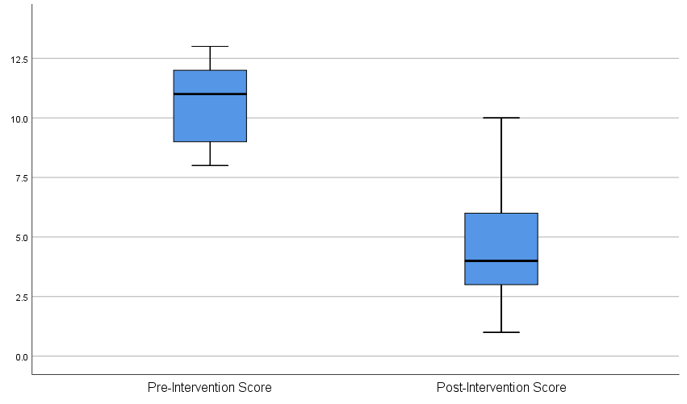
Note. Dispersion of scores from the median in the pre- and post-intervention data
Based on the non-normal distribution of the data, the median was used to conduct a Wilcoxon signed-rank test. The test was used to illustrate whether the difference between the median pre- and post-intervention AUDIT scores and the statistical significance of the difference. As illustrated in Table 4, there were N = 42 negative ranks and N = 0 positive ranks (N = 42, Mean Rank = 21.50, Sum of Ranks = 903). The scores imply that all the post-intervention scores were lower than the pre-intervention scores, which is consistent with the expected changes in AUDIT scores. Based on this, the Wilcoxon signed-rank test revealed that the 8-week CBT program resulted in statistically significant change in AUDIT scores (Z = −5.680, p < .001) (Table 5).
Table 4
Wilcoxon Signed-Ranks Test: Ranks Table
 |  | N | Mean Rank | Sum of Ranks
Post-Intervention Score - Pre-Intervention Score | Negative Ranks | 42ª | 21.50 | 903.00
Post-Intervention Score - Pre-Intervention Score | Positive Ranks | 0^{b} | .00 | .00
Post-Intervention Score - Pre-Intervention Score | Ties | 0^{c}
Post-Intervention Score - Pre-Intervention Score | Total | 42
Note: a. Post-Intervention Score < Pre-Intervention Score. b. Post-Intervention Score > Pre-Intervention Score. c. Post-Intervention Score = Pre-Intervention Score

Table 5
Wilcoxon Signed-Ranks Test: Statistics
 | Post-Score – Pre-Score
Z | -5.680ª
Asymp. Sig. (2-tailed) | .000
Note: a. Based on positive ranks.
Therefore, it can be concluded that the CBT intervention was associated with a significant change in drinking patterns, with most participants tending towards abstinence based on the p-value.
A secondary outcome for the project was to assess nurses’ adherence to the CBT protocol. The CTRS, an observer-administered survey, was used to collect data during the sessions. The data for the two nurses involved in delivering the CBT sessions aggregated weekly for an average score. Table 6 illustrates the weekly aggregate mean scores of the CTRS scores. Based on the weekly mean scores, descriptive statistics revealed a gradual increase in the CTRS scores from a mean of 37.1 at week 1 to a 68.95 at week 8 (Table 7). The descriptive statistics illustrate that the CTRS scores improved gradually from the start of the project to the endpoint. Therefore, it could be argued that the ongoing reinforcement of nurses’ knowledge and skills through weekly feedback enhanced their capacity to deliver CBT competently.
Table 6
Weekly CTRS Mean Scores
Nurse | Week 1 | Week 2 | Week 3 | Week 4 | Week 5 | Week 6 | Week 7 | Week 8
1 | 36.2 | 42.5 | 48.3 | 54.1 | 59.4 | 63.2 | 66 | 69.1
2 | 38 | 43.8 | 49.7 | 55.3 | 60.7 | 64 | 67.2 | 68.8
Note: Weekly CTRS scores collected daily and a weekly mean score calculated and recorded per individual

Table 7
Aggregate Weekly CTRS Mean Scores
Report
 | Week 1 | Week 2 | Week 3 | Week 4 | Week 5 | Week 6 | Week 7 | Week 8
Mean | 37.100 | 43.150 | 49.000 | 54.700 | 60.050 | 63.600 | 66.600 | 68.950
N | 2 | 2 | 2 | 2 | 2 | 2 | 2 | 2
Std. Deviation | 1.2728 | 0.9192 | 0.9899 | 0.8485 | 0.9192 | 0.5657 | 0.8485 | 0.2121

The findings show that the 8-week CBT program improved abstinence, reducing the rate of relapse within the period among the participants. In addition, it shows that ongoing reinforcement of nurses’ knowledge contributing to competence in delivering the intervention.

Conclusions
The DNP change project investigated the effectiveness of 1:1 nurse-led CBT intervention in reducing relapse rates among individuals diagnosed with AUD. It was justified by the lack of alternative approaches to medications in ensuring abstinence and preventing relapse. As internal communications revealed, the lack of alternative approaches was contributing to patients frequently returning to the clinic with persistent AUD symptoms and many relapsing within a short period of treatment. Indeed, state-wide statistics show that only 3.66% of the Maryland population with AUD receive optimal treatment (Center for Behavioral Health Statistics and Quality, 2022). In addition, many people with AUD relapse within the first six months of medication-assisted treatment because of inadequate support to sustain abstinence ((National Institute on Alcohol Abuse and Alcoholism, 2024). Therefore, CBT was considered an essential psychotherapeutic approach to supporting the patients towards their journey of abstaining from alcohol.
The KTA model was used as the underpinning theoretical model to facilitate the translation of the evidence. Based on the model, it was possible to adapt the evidence to the practice context, especially through staff education and individualization of the CBT to individual needs. Adequate measures were taken to ensure the project was conducted ethically, including seeking informed consent from the participants. The primary outcome was assessed using the AUDIT survey, a tool designed to assess risky or harmful drinking patterns. Although the tool assesses drinking in the past 12 months, the lack of other validated surveys to assess the outcomes justified its selection. In addition, assessing nurses’ adherence to the CBT protocol was essential because it informed the tailoring of feedback and retraining throughout the project. The CTRS was used to assess the secondary outcome. From the forty-five individuals recruited to participate, n=42 completed the project and provided complete data to assess the outcomes. Descriptive statistics revealed a trend in which the AUDIT scores decreased from baseline to post-intervention. In addition, the assessment of the secondary outcome revealed improvements in nurses’ adherence to the CBT protocol throughout the project. Overall, the analysis of the primary outcome showed that the eight-week CBT program was associated with a reduction in AUDIT scores, implying reduced relapse rates from the improved abstinence. In addition, the project revealed that ongoing feedback and retraining of nurses was critical to enhancing their knowledge and skills in implementing CBT with the participants. The weekly meetings proved essential because they allowed the provision of tailored feedback and retraining of the nurses according to their knowledge gaps.

Clinical Relevance
Alcohol use remains a global public health concern, with over 400 million people diagnosed with AUD (WHO, 2024). It is considered a risk factor for many non-communicable diseases, communicable diseases, and injuries that impose significant social and economic costs on individuals, families, and the healthcare system (Park & Kim, 2020; Manthey et al., 2021; NIAAA, 2024; SAMHSA, 2022; Varghese & Dakhode, 2022). While individuals can benefit from MAT, evidence shows that more than 60% of them relapse within six months in the absence of supportive approaches to sustain abstinence (NIAAA, 2024). At the state and local levels, this is problematic considering the large population diagnosed with AUD and not receiving adequate treatment (Center for Behavioral Health Statistics and Quality, 2022). Therefore, the project was implemented to address the gap by providing a supportive program that would foster abstinence and reduce relapses among individuals with AUD receiving care at the practice site.
In this project, all the participants had AUDIT scores ≥8 at baseline, implying risky or high-risk drinking patterns. At post-implementation, 90.5% of the participants had achieved a score of ≤ 7, implying low-risk drinking patterns. It should be noted that the four individuals with scores of 8 and above at project endpoint also had relatively high AUDIT scores at baseline. The finding is consistent with Stasiewics et al. (2023) who found that high-risk pre-treatment drinking patterns were associate with a slower change and required more intensive treatment. The aggregate mean AUDIT scores reduced from 10.67 to 4.36 from baseline to project endpoint, while the median dropped from 11.00 to 4.00. Further, the analysis revealed that the change in AUDIT scores from baseline to post-intervention were statistically significant (p < .001). The findings are consistent with previous studies illustrating the value of face-to-face CBT in reducing relapse rates (Peng et al., 2022; Ray et al., 2020; Srivastava et al., 2022). Therefore, the project shows the added value of CBT on pharmacotherapy in treating individuals diagnosed with AUD. Moreover, the rate of decline in the AUDIT scores illustrate the importance of a personalized approach to delivering CBT. The findings show that individual CBT has similar effects as other delivery approaches in reducing relapse rates, as supported by the literature (Johansson et al., 2021; Kiluk et al., 2024; Peng et al., 2022; Ray et al., 2020; Srivastava et al., 2022; Sundström et al., 2020; van Amsterdam et al., 2022). Nevertheless, the face-to-face approach was preferred because it allowed a personalized approach to delivering CBT. Indeed, the existing research shows that the personalized approach can lead to faster achievement of abstinence and sustain the outcomes for longer periods because of the immediate feedback and tailored delivery that meets individual needs identified during sessions (Kiluk et al., 2024; Tarp et al., 2024). However, the achievement of the outcomes depends significantly on the nurses’ competence in delivering CBT. As revealed by the CTRS scores, the nurses had low competence at the beginning of the project but achieved gradual improvement throughout the project. The improvement underscores the value of providing constructive feedback to frontline nurses regarding their performance in delivering CBT.
The findings have substantial implications nursing practice, nurses, individuals with AUD, and the healthcare system. For nursing practice, the project illustrates the expanded role of nurses in providing psychotherapeutic interventions aimed at improving patient and population outcomes. Indeed, this aligns with the competencies articulated by the American Association of Colleges of Nursing (AACN, 2021) that require nurses to demonstrate competence in implementing evidence-based interventions to improve patient and population health outcomes. In addition, it illustrates the value of ongoing staff training to advance their therapeutic skills. Evidence associates on-the-job training with improvements in knowledge and practices regarding EBP, which, in turn, influences their job performance and work satisfaction (Hendy et al., 2024). Indeed, this was evidenced by the improvements in CTRS scores emanating from ongoing feedback and retraining. Therefore, nurses should seek and leverage training opportunities to ensure competence in delivering evidence-based interventions.
The project underscores the benefits of participating in nurse-led CBT programs for patients struggling with AUD and relapses. As illustrated, the patient population achieved significant decrease in AUDIT scores, implying that they were moving towards complete abstinence. Participating in the 1:1 CBT sessions would offer patients opportunities to engage directly with the nurses and engage in shared decision-making about the areas that pose significant challenges in their journey towards abstinence (Tarp et al., 2024). Finally, the findings have implications for the facility and the healthcare system as a whole. Although the cost-effectiveness of the project was not assessed, existing evidence associates AUD and relapses with significant financial burden on individuals and healthcare facilities (NIAAA, 2024; SAMHSA, 2022; Varghese & Dakhode, 2022). Therefore, providing interventions to support and sustain abstinence could save the clinic and the healthcare systems the costs associated readmissions and emergency visits due to frequent relapses.
Based on the findings, it is recommended that nurse leaders advocate the integration of psychotherapeutic interventions such as CBT within staff development programs. Nurse leaders should facilitate ongoing staff training to ensure a competent workforce that can deliver the intervention with high fidelity. Pertaining future research, longitudinal studies involving larger samples and rigorous methodologies such as RCTs could be conducted to ascertain the long-term benefits of the intervention. Policies could be implemented to ensure institutional support in delivering evidence-based interventions, for instance, through funding dedicated to on-the-job staff training. Finally, it would be essential for nursing education to integrate modules on the implementation of CBT principles in the undergraduate curriculum to ensure the workforce is adequately prepared for such interventions at an early stage.

References
American Association of Colleges of Nursing. (2021, February). The essentials: Core competencies for professional nursing education. AACN. https://www.aacnnursing.org/Portals/0/PDFs/Publications/Essentials-2021.pdf
American Psychological Association. (2023). What is psychotherapy. https://www.psychiatry.org/patients-families/psychotherapy
Center for Behavioral Health Statistics and Quality. (2022). National suevey on drug use and health. Substance Abuse and Mental Health Services Administration. SAMHSA. https://www.samhsa.gov/data/sites/default/files/reports/rpt44486/2022-nsduh-sae-state-tables/NSDUHsaeMaryland2022.pdf
Chen, Y., Wills, L., Wise, H., Erford, B. T., & Yao, R. (2024). Psychometric synthesis of the Alcohol Use Disorders Identification Test (AUDIT). Journal of Counseling & Development, 102(4), 406-414. https://doi.org/10.1002/jcad.12531
Gagnon, J., Breton, M., & Gaboury, I. (2024). Decision-maker roles in healthcare quality improvement projects: A scoping review. BMJ Open Quality, 13(1), e002522. https://doi.org/10.1136/bmjoq-2023-002522
Glantz, M. D., Bharat, C., Degenhardt, L., Sampson, N. A., Scott, K. M., Lim, C. C. W., Al-Hamzawi, A., Alonso, J., Andrade, L. H., Cardoso, G., De Girolamo, G., Gureje, O., He, Y., Hinkov, H., Karam, E. G., Karam, G., Kovess-Masfety, V., Lasebikan, V., Lee, S., Levinson, D., … WHO World Mental Health Survey Collaborators (2020). The epidemiology of alcohol use disorders cross-nationally: Findings from the World Mental Health Surveys. Addictive Behaviors, 102, 106128. https://doi.org/10.1016/j.addbeh.2019.106128
Graham, I. D., & Tetroe, J. M. (2010). The knowledge to action framework. In J. Rycroft-Malone, & T. Bucknall (Eds) Models and frameworks for implementing evidence-based practice: Linking evidence to action (pp.207, 222). John Wiley & Sons.
Graham, I. D., Logan, J., Harrison, M. B., Straus, S. E., Tetroe, J., Caswell, W., & Robinson, N. (2006). Lost in knowledge translation: time for a map?. Journal of Continuing Education in the Health Professions, 26(1), 13-24. https://doi.org/10.1002/chp.47
Grant, B. F., Goldstein, R. B., Saha, T. D., Chou, S. P., Jung, J., Zhang, H., Pickering, R. P., Ruan, W. J., Smith, S. M., Huang, B., & Hasin, D. S. (2024). Epidemiology of DSM-5 alcohol use disorder: Results from the national epidemiologic survey on alcohol and related conditions III. JAMA psychiatry, 72(8), 757–766. https://doi.org/10.1001/jamapsychiatry.2024.0584
Habibzadeh F. (2024). Data distribution: Normal or abnormal?. Journal of Korean Medical Science, 39(3), e35. https://doi.org/10.3346/jkms.2024.39.e35
Habtamu, E., & Madoro, D. (2022). Psychometric properties of alcohol use disorder Identification test screening tool among medical outpatients in Dilla university referral hospital, southern Ethiopia, 2020. SAGE Open Medicine, 10, 20503121221077568. https://doi.org/10.1177/20503121221077568
Hall, S., Lee, V., & Haase, K. (2020). Exploring the challenges of ethical conduct in quality improvement projects. Canadian Oncology Nursing Journal = Revue Canadienne de Nursing Oncologique, 30(1), 64–68.
Harrison, R., Fischer, S., Walpola, R. L., Chauhan, A., Babalola, T., Mears, S., & Le-Dao, H. (2021). Where do models for change management, improvement and implementation meet? A systematic review of the applications of change management models in healthcare. Journal of Healthcare Leadership, 13, 85. https://dx.doi.org/10.2147/JHL.S289176
Hendy, A., Alsharkawy, S. S., Al-Kurdi, Z., El-Nagger, N. S., Hendy, A., Sayed, S., Al-Mugheed, K., Alsenany, S. A., & Farghaly Abdelaliem, S. M. (2024). Impact of On-the-Job Training on Nurses' Performance in Creating a Healing Environment and Clustered Nursing Care for Premature. SAGE open nursing, 10, 23779608241255863. https://doi.org/10.1177/23779608241255863
Horváth, Z., Nagy, L., Koós, M., Kraus, S. W., Demetrovics, Z., Potenza, M. N., Balester-Arnal, R., Batthyany, D., Bergeron, S., Billieux, J., Briken, P., Burkauskas, J., Cardenas-Lopez, G., Carvalho, J., Castro-Calvo, J., Chen, L., Ciocca, G., Corazza, O., Csako, R., …& Bőthe, B. (2023). Psychometric properties of the Alcohol Use Disorders Identification Test (AUDIT) across cross-cultural subgroups, genders, and sexual orientations: Findings from the International Sex Survey (ISS). Comprehensive Psychiatry, 127, 152427. https://doi.org/10.1016/j.comppsych.2023.152427
Johansson, M., Sinadinovic, K., Gajecki, M., Lindner, P., Berman, A. H., Hermansson, U., & Andréasson, S. (2021). Internet‐based therapy versus face‐to‐face therapy for alcohol use disorder, a randomized controlled non‐inferiority trial. Addiction, 116(5), 1088-1100. https://doi.org/10.1111/add.15270
Kaliyadan, F., & Kulkarni, V. (2019). Types of variables, descriptive statistics, and sample size. Indian Dermatology Online Journal, 10(1), 82–86. https://doi.org/10.4103/idoj.IDOJ_468_18
Kiluk, B. D., Benitez, B., DeVito, E. E., Frankforter, T. L., LaPaglia, D. M., O’Malley, S. S., & Nich, C. (2024). A digital cognitive behavioral therapy program for adults with alcohol use disorder: a randomized clinical trial. JAMA Network Open, 7(9), e2435205-e2435205. https://doi.org/10.1001/jamanetworkopen.2024.35205
Kools, N., Dekker, G. G., Kaijen, B. A., Meijboom, B. R., Bovens, R. H., & Rozema, A. D. (2022). Interdisciplinary collaboration in the treatment of alcohol use disorders in a general hospital department: a mixed-method study. Substance Abuse Treatment, Prevention, and Policy, 17(1), 59. https://doi.org/10.1186/s13011-022-00486-y
Magill, M., Ray, L., Kiluk, B., Hoadley, A., Bernstein, M., Tonigan, J. S., & Carroll, K. (2019). A meta-analysis of cognitive-behavioral therapy for alcohol or other drug use disorders: Treatment efficacy by contrast condition. Journal of Consulting and Clinical Psychology, 87(12), 1093. https://doi.org/10.1037/ccp0000447
Magill, M., Tonigan, J. S., Kiluk, B., Ray, L., Walthers, J., & Carroll, K. (2020). The search for mechanisms of cognitive behavioral therapy for alcohol or other drug use disorders: A systematic review. Behaviour Research and Therapy, 131, 103648. https://doi.org/10.1016/j.brat.2020.103648
Manthey, J., Hassan, S. A., Carr, S., Kilian, C., Kuitunen-Paul, S., & Rehm, J. (2021). What are the economic costs to society attributable to alcohol use? A systematic review and modelling study. PharmacoEconomics, 39(7), 809–822. https://doi.org/10.1007/s40273-021-01031-8
Mekonen, T., Chan, G. C. K., Connor, J., Hall, W., Hides, L., & Leung, J. (2021). Treatment rates for alcohol use disorders: a systematic review and meta-analysis. Addiction (Abingdon, England), 116(10), 2617–2634. https://doi.org/10.1111/add.15357
Minogue, V., Matvienko-Sikar, K., Hayes, C., Morrissey, M., Gorman, G., & Terres, A. (2021). The usability and applicability of knowledge translation theories, models, and frameworks for research in the context of a national health service. Health Research Policy and Systems, 19. https://doi.org/10.1186/s12961-021-00747-5
Moon, S. E. J., Hogden, A., & Eljiz, K. (2022). Sustaining improvement of hospital-wide initiative for patient safety and quality: a systematic scoping review. BMJ open quality, 11(4), e002057. https://doi.org/10.1136/bmjoq-2022-002057
National Institute on Alcohol Abuse and Alcoholism. (2024). Alcohol’s effects on health: Research-based information on drinking and its impact. NIAAA. https://www.niaaa.nih.gov/alcohols-effects-health
Nguyen, L. C., Durazzo, T. C., Dwyer, C. L., Rauch, A. A., Humphreys, K., Williams, L. M., & Padula, C. B. (2020). Predicting relapse after alcohol use disorder treatment in a high-risk cohort: The roles of anhedonia and smoking. Journal of Psychiatric Research, 126, 1–7. https://doi.org/10.1016/j.jpsychires.2020.04.003
Park, S. H., & Kim, D. J. (2020). Global and regional impacts of alcohol use on public health: Emphasis on alcohol policies. Clinical and Molecular Hepatology, 26(4), 652–661. https://doi.org/10.3350/cmh.2020.0160
Peng, W., Zhang, H., Yang, J., Wang, J., Kang, J., Zhu, R., Pan, W., & Xu, B. (2022). Group cognitive behavioral therapy as an effective approach for patients with alcohol dependence: A perspective study. Medicine, 101(36), e30459. http://dx.doi.org/10.1097/MD.0000000000030459
Ray, L. A., Meredith, L. R., Kiluk, B. D., Walthers, J., Carroll, K. M., & Magill, M. (2020). Combined pharmacotherapy and cognitive behavioral therapy for adults with alcohol or substance use disorders: A systematic review and meta-analysis. JAMA Network Open, 3(6), e208279-e208279. https://doi.org/10.1001/jamanetworkopen.2020.8279
Schober, P., & Vetter, T. R. (2020). Nonparametric statistical methods in medical research. Anesthesia and Analgesia, 131(6), 1862–1863. https://doi.org/10.1213/ANE.0000000000005101
Silver, S. A., McQuillan, R., Harel, Z., Weizman, A. V., Thomas, A., Nesrallah, G., Bell, C. M., Chan, C. T., & Chertow, G. M. (2019). How to sustain change and support continuous quality improvement. Clinical Journal of the American Society of Nephrology: CJASN, 11(5), 916–924. https://doi.org/10.2215/CJN.11501015
Srivastava, K., Prakash, J., Bhat, P. S., Chatterjee, K., Chaudhury, S., & Chauhan, V. (2022). Cognitive behavior therapy as an adjuvant in management of alcohol dependence syndrome. Industrial Psychiatry Journal, 31(2), 255–261. https://doi.org/10.4103/ipj.ipj_267_21
Stasiewicz, P. R., Bradizza, C. M., Lucke, J. F., Zhao, J., Dermen, K. H., Linn, B. K., Slosman, K. S., & LaBarre, C. (2023). Pretreatment changes in drinking: A test of a tailored treatment approach. Alcohol, Clinical & Experimental Research, 47(3), 549–565. https://doi.org/10.1111/acer.15022
Steinskog, T. L. D., Tranvåg, O., Nortvedt, M. W., Ciliska, D., & Graverholt, B. (2021). Optimizing a knowledge translation intervention: a qualitative formative study to capture knowledge translation needs in nursing homes. BMC Nursing, 20(1), 106. https://doi.org/10.1186/s12912-021-00603-5
Substance Abuse and Mental Health Services Administration (SAMHSA). (2022). Implementing Community-Level Policies to Prevent Alcohol Misuse. SAMHSA Publication. https://store.samhsa.gov/sites/default/files/pep22-06-01-006.pdf
Sundström, C., Eék, N., Kraepelien, M., Fahlke, C., Gajecki, M., Jakobson, M., Beckman, M., Kaldo, V., & Berman, A. H. (2020). High‐versus low‐intensity internet interventions for alcohol use disorders: Results of a three‐armed randomized controlled superiority trial. Addiction, 115(5), 863-874. https://doi.org/10.1111/add.14871
Tarp, K., Christiansen, R., Bilberg, R., Borkner, S., Dalsgaard, C., Paldam Folker, M., & Søgaard Nielsen, A. (2024). Patient perspectives on blended internet-based and face-to-face cognitive behavioral therapy for alcohol use disorder: Qualitative study. Journal of Medical Internet Research, 26, e47083. https://doi.org/10.2196/47083
van Amsterdam, J., Blanken, P., Spijkerman, R., van den Brink, W., & Hendriks, V. (2022). The added value of pharmacotherapy to cognitive behavior therapy and vice versa in the treatment of alcohol use disorders: a systematic review. Alcohol and Alcoholism, 57(6), 768-775. https://doi.org/10.1093/alcalc/agac043
Varghese, J., & Dakhode, S. (2022). Effects of alcohol consumption on various systems of the human body: A systematic review. Cureus, 14(10), e30057. https://doi.org/10.7759/cureus.30057
World Health Organization. (2024). Alcohol. WHO. https://www.who.int/health-topics/alcohol#tab=tab_1
Yang, S., & Berdine, G. (2021). Normality tests. The Southwest Respiratory and Critical Care Chronicles, 9(37), 87-90. https://doi.org/10.12746/swrccc.v9i37.805
Zhao, J., Li, X., Yan, L., Yu, Y., Hu, J., Li, S. A., & Chen, W. (2021). The use of theories, frameworks, or models in knowledge translation studies in healthcare settings in China: a scoping review protocol. Systematic Reviews, 10(1), 13. https://doi.org/10.1186/s13643-020-01567-4

Appendix A: Johns Hopkins Nursing Evidence-Based Practice Individual Evidence Summary Tool
© The Johns Hopkins Hospital/The Johns Hopkins University

 | EBP Project Practice Question: For adults diagnosed with alcohol use disorder in an outpatient mental health clinic, does the implementation of a nurse-led 1:1 Cognitive Behavioral Therapy (CBT), compared to current practice, impact the alcohol relapse rates over 8-10 weeks?
Reviewer Name(s) | Article Number | Author, Date, and Title | Type of Evidence | Population, size, and setting | Intervention | Findings that help answer the EBP question | Measures used | Limitations | Evidence level & quality | Notes to Team
 |  | Johansson et al. (2021)  Internet-based therapy versus face-to-face therapy for alcohol use disorder: A randomized controlled non-inferiority trial | Evidence: Quantitative  Type: Randomized controlled trial  Aim: To compare internet-delivered and face-to-face treatment among adult users with AUD | Population: Individuals aged 18 or older, high risk of AUD based on ICD-10 criteria, and a score higher than 15 on AUDIT  Size: N=301  Setting: Sweden | The participants were randomized at a ratio of 1:1 into blocks of 20 assigned to five modules of clinician-guided ICBT or five modules of f2f CBT delivered over three months | Alcohol consumption did not differ in the internet CBT of f2f CBT groups (mean different = 0.89). Similarly, no difference was observed in AUDIT scores between the group after three months and six-month follow-ups. | Self-reported number of standard drinks every 7 days based on time-line follow-back method | A high attrition rate in the internet CBT arm may have skewed the findings  Self-reporting may have introduced recall bias | Level I  High quality (A)
 |  | Kiluk et al. (2024)  A digital cognitive behavioral therapy program for adults with alcohol use disorder: A randomized controlled trial | Evidence: Quantitative  Type: Randomized controlled trial  Aims: To evaluate the efficacy of a digital CBT program or clinician-delivered CBT compared with standard treatment for reducing alcohol use | Population: Individuals aged 18 years or older, meeting the diagnostic criteria for AUD, and reporting drinking 14 (men) and 7 (women) or more drinks weekly with 4 or more heavy drinking days  Size: N=99  Setting: US | Participants were randomized to treatment as usual (weekly individual counseling), weekly clinician-guided CBT, and web-based CBT plus weekly clinical monitoring | Mean rate of percentage of days abstinent (PDA) was 55.7% in TAU, 70.1% in CBT, and 82.6% for digital CBT at six months. PDA decreased significantly among those receiving clinician-guided VBT compared to those who completed digital CBT or TAU | Self-reported drinking frequency and quantity to derive PDA | Underpowered sample  The short length of the study compared to standard CBT treatment protocols  Self-reporting may have introduced recall bias | Level I  High quality (A)
 |  | Magill et al. (2019)  A meta-analysis of cognitive-behavioral therapy for alcohol or other drug use disorders: Treatment efficacy by contrast condition. | Evidence: Quantitative  Type: Meta-analysis  Aims: To test the efficacy of CBT for alcohol and other drug use disorders | Population: The meta-analysis focused on RCTs involving adults diagnosed with AUD or other SUDs  Size: 30 RCTs with a mean sample size of 102 participants  Setting: N/A | The intervention examined in the study is CBT compared to no treatment, minimal treatment, and non-specific control. | CBT showed moderate and significant effect size compared to minimal treatment. The comparison of CBT to non-specific therapy or treatment as usual revealed that treatment efficacy was significant for consumption frequency and quantity early. | The inverse-variance weighted effect size for each study | Some of the effect estimates were comprised of a small number of primary studies, which could result in underpowered moderator analysis in case heterogeneity was present | Level I  High quality (A) | N/A
 |  | Peng et al. (2022)  ). Group cognitive behavioral therapy as an effective approach for patients with alcohol dependence: A prospective study. | Evidence: Quantitative  Type: Randomized controlled trial  Aim: To examine the efficacy of group cognitive behavioral therapy (GCBT) on patients with AD | Population: Individuals with a confirmed diagnosis of AD and willing to participate in the study  Size: N=128 participants  Setting: China | The intervention group received a total of eight sessions lasting 60 minutes each | The percentage of patients still drinking after the intervention was significantly lower in the intervention group compared to the control group at six months post-intervention (1.56% vs. 21.8%, P= .001) and 12 months post-intervention (4.7% vs. 51.6%, P = .001). | Insight and Treatment Attitude Questionnaire (ITAQ) to assess cognition of mental illness and treatment  Chronic disease self-cognition evaluation scale (CDSCES) to assess the efficacy of social functioning, self-cognition, and problem-solving  Relapse rate assessed as the count of individuals re-drinking 6 and 12 months after the intervention | The study involved a male-only sample that limits its generalization across genders  The small sample may not be optimal to generate results revealing the actual effect size of the intervention | Level II  Good quality (B)
 |  | Ray et al. (2020)  Combined pharmacotherapy and cognitive behavioral therapy for adults with alcohol or substance use disorders: A systematic review and meta-analysis. | Evidence: Quantitative  Type: Meta-analysis  Aim: To provide an up-to-date and comprehensive review of CBT in conjunction with pharmacotherapy for AUD/SUD | Population: The analysis targeted studies involving adults diagnosed with AUD or other SUDs  Size: 62 effect sizes from 30 RCTs were analyzed  Setting: N/A | The interventions of interest in the study included CBT, pharmacotherapy, and usual care applied in combination or individually. | Combined CBT and pharmacotherapy have a better effect than usual care, with effect sizes (Hedge’s g) ranging from 0.18 to 0.28. | The inverse-variance weighted effect size pooled into CBT+ pharmacotherapy vs usual care, CBT + pharmacotherapy vs. other specific therapy + pharmacotherapy, and CBT + pharmacotherapy and usual care vs. usual care and pharmacotherapy alone | Some of the effect sizes were drawn from a small pool of primary studies that may have led t underpowered analyses  The analysis may be subject to confounders not reported in the primary studies considering that most studies did not account for the effect of medication compliance and adjustment | Level I  Good quality (B)
 |  | Srivastava et al. (2022)  Cognitive behavior therapy as an adjuvant in the management of alcohol dependence syndrome. | Evidence: Quantitative  Type: Randomized controlled trial  Aim: To evaluate the effect of the CBT module in the management of alcohol dependence and compare it with treatment as usual (TAU) | Population: The study targeted adults meeting ICD-10 diagnostic criteria for alcohol dependence while excluding those with head injury, HIV seropositive status, organic brain disorders, comorbid psychiatric disorders, and those unwilling to participate  Size: N=226  Setting: India | The experimental group received 12 face-to-face CBT sessions over 6 weeks, emphasizing skills training and functional analysis besides standard treatment. TAU group received only standard care | The incidence rate of relapse was lower in the CBT group compared to the TU group at 6 months (0.23 vs. 0.53) and 12 months (0.28 vs. 0.67) | The severity of Alcohol Dependence Questionnaire (SADQ) to assess the severity of alcohol dependence | The hospital-based study was conducted within a single setting, which may reduce its generalizability across clinical settings that may have a patient with different characteristics | Level I  High quality (A)
 |  | Stasiewicz et al. (2023)  Pretreatment changes in drinking: A test of a tailored treatment approach | Evidence: Quantitative  Type: Randomized controlled trial  Aim: To investigate whether different types and intensities of treatment are appropriate and beneficial for individuals entering treatment for an AUD | Population: Individuals diagnosed with an AUD  Size: N=201  Setting: USA | Two parallel arms [Substantial Change (SC) and Minimal Change (MC)] were derived, with each comprising an intervention and control group. The SC arm compared 6 relapse prevention treatment (RPT) sessions with 12 CBT sessions. The MC compared 12 integrated motivational interviewing/CBT sessions and 12 CBT sessions. | CBT and RPT were both effective in reducing the number of days abstinent and several days of heavy drinking per week. No differences were found between MI/CBT and CBT alone. | Number of days abstinent (NDA) and number of days heavy drinking (NDH) per week to assess relapse | The sample allocated to each group across the arms was not adequately powered and could lead to skewed results | Level I  Good quality (B)
 |  | Sundström et al. (2020)  High- versus low-intensity internet interventions for alcohol use disorders: Results of a three-armed randomized controlled superiority trial. | Evidence: Quantitative  Type: Randomized controlled trial  Aims: To test the efficacy of a therapist-guided high-intensity internet intervention compared to an unguided low-intensity internet intervention among individuals with alcohol use disorder | Population: Individuals aged 18 and older, with AUDI score of 14 (females) or 16 (males) and meeting DSM-5 criteria for AUD  Size: N=166  Setting: Sweden | The high-intensity intervention involved 13 modules and 3-4 pages of guidance text and video clips. The low-intensity intervention involved nine modules and 1-2 pages of guidance text. | Changes in alcohol consumption were not significantly different between the high- and low-intensity groups (d = −0.17 vs. d = −0.07). | Self-reported alcohol consumption as number of drinks and number of heavy drinking days | Recruitment through self-referrals may have led to a sample of individuals with high motivation for change  Self-reported measures could have led to recall bias | Level I  High quality (A)
 |  | Tarp et al. (2024)  Patient perspectives on blended internet-based and face-to-face cognitive behavioral therapy for alcohol use disorder: Qualitative study | Evidence: Qualitative  Type: Interview  Aim: Investigate user experiences of blended CBT | Population: Individuals who had participated in blended CBT  Size: N=13  Setting: Denmark | Thirty individuals who had participated in blended CBT were contacted for telephone interviews to ass the advantages and disadvantages of experiences they had with the treatment approach. | A tailored approach allows personalized feedback, personal interactions, and adjustment of treatment to meet individual needs. | Telephone interviews to assess patients’ experiences of the treatment modality | The interview guide was not piloted, which may have influenced how questions were asked and the responses received.  The qualitative design is prone to subjective bias | Level III  Good quality (B)
 |  | van Amsterdam et al., (2022). The Added Value of Pharmacotherapy to Cognitive Behavior Therapy And Vice Versa in the Treatment of Alcohol Use Disorders: A Systematic Review. | Systematic review | The authors conducted a systematic review analysis of 28 research articles on individuals receiving treatment for alcohol use disorder. | The authors were seeking to establish the effectiveness of the combination of behavioral and pharmacological approaches in the treatment of alcohol dependence. | The results suggested that the implementation of pharmacotherapy is effective in treating individuals with alcohol use disorder either with or without psychotherapy. However, the results also revealed that psychotherapy can be best offered in combination with pharmacotherapy. | The authors utilized the PRISMA protocol in retrieving studies regarding the combined treatment of alcohol use disorder. Following the final selection of the studies, a meta-analytic review of the AUD literature was done that helped in establishing a conclusion on the best practices for treating alcohol addiction. | One of the limitations involved in the study is that the reduced medication compliance may be linked to the decrease of the suppressant effect of naloxone on drinking behavior. The length of follow-up is also another limitation, as the combination of the treatment is more efficacious following short 12-16 weeks of treatment. | Level II  Quality A  High Quality | N/A

© The Johns Hopkins Hospital/ The Johns Hopkins University

Appendix B: Plan for Educational Offering
Objective | Content | Teaching Methods | Timeframe | Evaluation Method
1). Define Cognitive Behavioral Therapy (CBT) and its principle | Overview of CBT principles: identifying negative thought patterns, cognitive restructuring, and behavioral activation | - Lecture with PowerPoint slides  - Distribution of handouts on CBT fundamentals  - Use of case examples |  | Post-session quiz with multiple-choice and short-answer questions to assess understanding of CBT principles (for example, "What is cognitive restructuring?").
  15 minutes
2).2. Explain the nurse's role in delivering 1:1 CBT for patients with alcohol use disorder (AUD). | The role of the nurse in facilitating CBT sessions, rapport building, and patient assessment for readiness and engagement. | - Interactive lecture  - Role-playing scenarios between nurse and patient  - Video demonstration of a nurse-led CBT session | 20 minutes | Observation during role-play with a checklist of key actions (e.g., building rapport, assessing patient readiness).
3). Identify techniques for reducing alcohol relapse using CBT. | Specific CBT techniques for AUD: identifying triggers, developing coping skills, and managing cravings. | - Small group discussions  - Case studies for analysis and practice  - Group brainstorming for coping strategies | 20 minutes | Group presentation of case analysis and individual written plans outlining triggers, coping skills, and relapse prevention strategies.
4). Compare the potential impact of nurse-led 1:1 CBT to current practices on relapse rates over 8–10 weeks | Comparison of nurse-led CBT to current practices: literature review, statistical outcomes, and patient testimonials. | - Presentation of data from studies comparing outcomes  - Panel discussion with nursing staff experienced in CBT  - Group Q&A | 15 minutes | Reflection paper: Participants will engage in a group discussion on how nurse-led CBT could impact relapse rates compared to current practices.
5). Develop a plan for implementing nurse-led 1:1 CBT in a clinical setting, considering barriers and facilitators. | Steps for implementation: training requirements, session scheduling, addressing barriers, and measuring success. | - Workshop for creating implementation plans  - Guided brainstorming session for addressing barriers  - Presentation of implementation frameworks | 30 minutes | Submission of a written implementation plan, evaluated using a rubric that assesses the feasibility, specificity, and inclusion of measurable outcomes.
6}. Describe how to measure and evaluate the effectiveness of nurse-led 1:1 CBT in reducing alcohol relapse rates over 8–10 weeks. | Methods for evaluation: relapse rate tracking, patient feedback, and session attendance. | - Lecture with real-world examples  - Interactive discussion on selecting evaluation tools  - Sharing of patient feedback collection templates | 15 minutes | Quiz: Participants will answer questions on evaluation methods and use a designed simple tracking tool for relapse rates.

Appendix C: Data Collection Tool
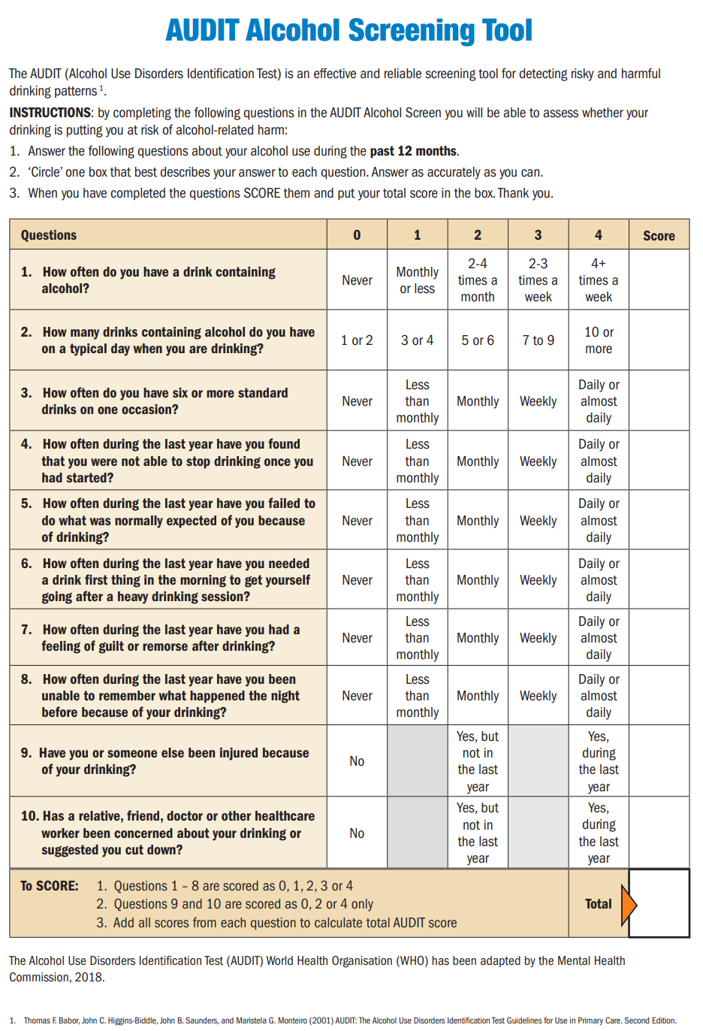
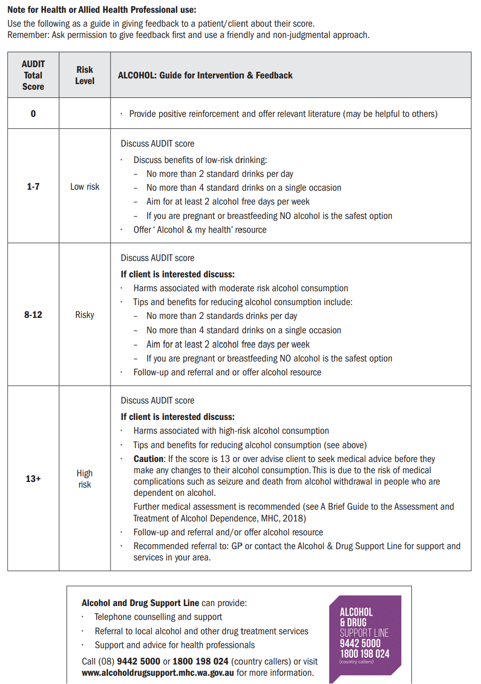

Appendix D: Informed Consent for Participation in a DNP Project
INFORMED CONSENT FOR PARTICIPATION IN A DNP PROJECT

Project Title:
The Implementation of 1:1 Nurse-Led Cognitive Behavioral Therapy for Patients with Alcohol Use Disorder in an Outpatient Clinic

Project Manager:
Doris Onyima, MPH, PMHNP, RN

Project Location:
Legacy Medical and Mental Clinic, Temple Hills, Maryland

What is the purpose of this project?
The purpose of this DNP project is to evaluate the impact of participants’ engagement in weekly face-to-face Cognitive Behavioral Therapy (CBT) for adult patients diagnosed with Alcohol Use Disorder (AUD) at an outpatient mental health clinic on alcohol relapse.

What will I be asked to do if I choose to be in this project?
If you agree to participate in this project, you will be required to sign a consent form and complete the Alcohol Use Disorders Identification Test (AUDIT) to establish baseline data. You will also participate in weekly, one-hour, face-to-face CBT sessions that are facilitated by trained clinic nurses. These sessions will cover understanding Alcohol Use Disorder (AUD), the link between adversity, behavior, and cognition (ABC model) in CBT, the development of individualized wellness plans, problem-solving through behavioral activation, and cognitive restructuring to address triggers and relapse. You will also be asked to keep a journal to document your thoughts, experiences, and concerns during the project. You will retake the AUDIT survey at the end of the 8 week intervention.

How much time will I be asked to devote to this project?
The project is expected to take a total of 10 weeks. After the recruitment and signing of the informed consent form for about 10 minutes in week 1, you will fill in the AUDIT tool, which is expected to take 3-5 minutes. You will also receive communication about what is expected of you during the project and educational materials to support you during the project (this will take about 10 minutes). The total time commitment for the first week will be approximately 25-30 minutes. In the subsequent 8 weeks, you will be engaging in weekly CBT sessions, which will last up to 60 minutes. The total anticipated time commitment for each participant is 8 hours and 30 minutes for the duration of the project over 10 weeks.

What are the possible risks or discomforts that I might experience?
There are no known risks or discomforts associated with participating in this project.

What are the possible benefits for me or others?
Participation may help improve your therapeutic relationships with clinicians and address symptoms of Alcohol Use Disorder.

What alternatives are available?
The project will be implemented through in-person sessions with no alternatives for virtual CBT session to ensure uniformity of implementation.

Do I have to participate?
Participation is entirely voluntary. You may withdraw at any time without penalty or loss of benefits.

What will happen if I do not participate?
There are no penalties for choosing not to participate. Your care at the clinic will continue as usual.

What Happens if I Withdraw?
You will be encouraged to continue with recommended treatments, including medications, if applicable but there are no penalties for withdrawal. You may quit at any time.

Will it cost me anything to participate?
There is no cost to participate in this project.

Will I get paid anything if I participate?
No compensation will be provided for participating.

How will my confidentiality and privacy rights be protected?
All information collected will remain confidential and will not contain any of your personal information or name. Only the DNP Project Manager and supervisor will have access to your collected data. Identifiable information will be removed from records to ensure your privacy. Paper forms, such as your AUDIT responses, will be secured in a locked cabinet but will not have your name on them. The forms will be destroyed the same day the data is transferred electronically. A unique identifier will be assigned to each person participating to help in linking the pre- and post-intervention data.

In this project:
- Identifiable private information or specimens (private information or specimens that can be traced back to you) will be collected:
Yes ☐ No ☒
If yes:
- Identifiable private information or specimens may be used for future quality improvement projects without gaining further permission:
Yes ☐ No ☐
- Identifiable private information or specimens may be used for future quality improvement projects, but only with your permission:
Yes ☐ No ☐
- Identifiable private information or specimens will not be used for future quality improvement projects:
Yes ☐ No ☐
Who do I contact for any questions about this project?
Doris Onyima (doris.onyima@my.chamberlain.edu). Phone 240-461-4873.

Is there anything else I need to know?
There is nothing else you need to know. If you have other questions, please contact the project manager above.

What are my rights?
- If you choose to be in this project, you have the right to be treated with respect, including respect for your decision to stop being in the project.
- You are free to stop being in the project at any time.
- Choosing not to be in this project or to stop being in this project will not result in any penalty to you or loss of benefits to which you are otherwise entitled.
- You will be given any information that either the project manager or the IRB believes is important to your choice about whether or not to be in this project.
- We will make every effort to keep information obtained as part of this project confidential. However, information about abuse or neglect may be required to be reported to the appropriate local or state agency in accordance with applicable law.
- If you want to speak with someone who is not directly involved in this project, or if you have questions about your rights as a participant, contact the DNP Program Dean at dnpdean@chamberlain.edu.
The following project has been reviewed by the Chamberlain College of Nursing and prescreened as a practice-change/ quality improvement project in collaboration with the Chamberlain University Institutional Review Board.
Authorization for Photography or Videography (Optional)
I give permission for photographs or videotapes of me to be used in this project:
__________ (initials)
I DO NOT give permission for photographs or videotapes of me to be used in this project:
___________ (initials)
Consent Statement
I have read this form and the project has been explained to me. I have been given the opportunity to ask questions and my questions have been answered. If I have additional questions, I have been told whom to contact. I agree to participate in the project described above and will receive a copy of this consent form after I sign it.

______________________ ___________________________
Signature of Participant Date

Appendix E: Letter of Support
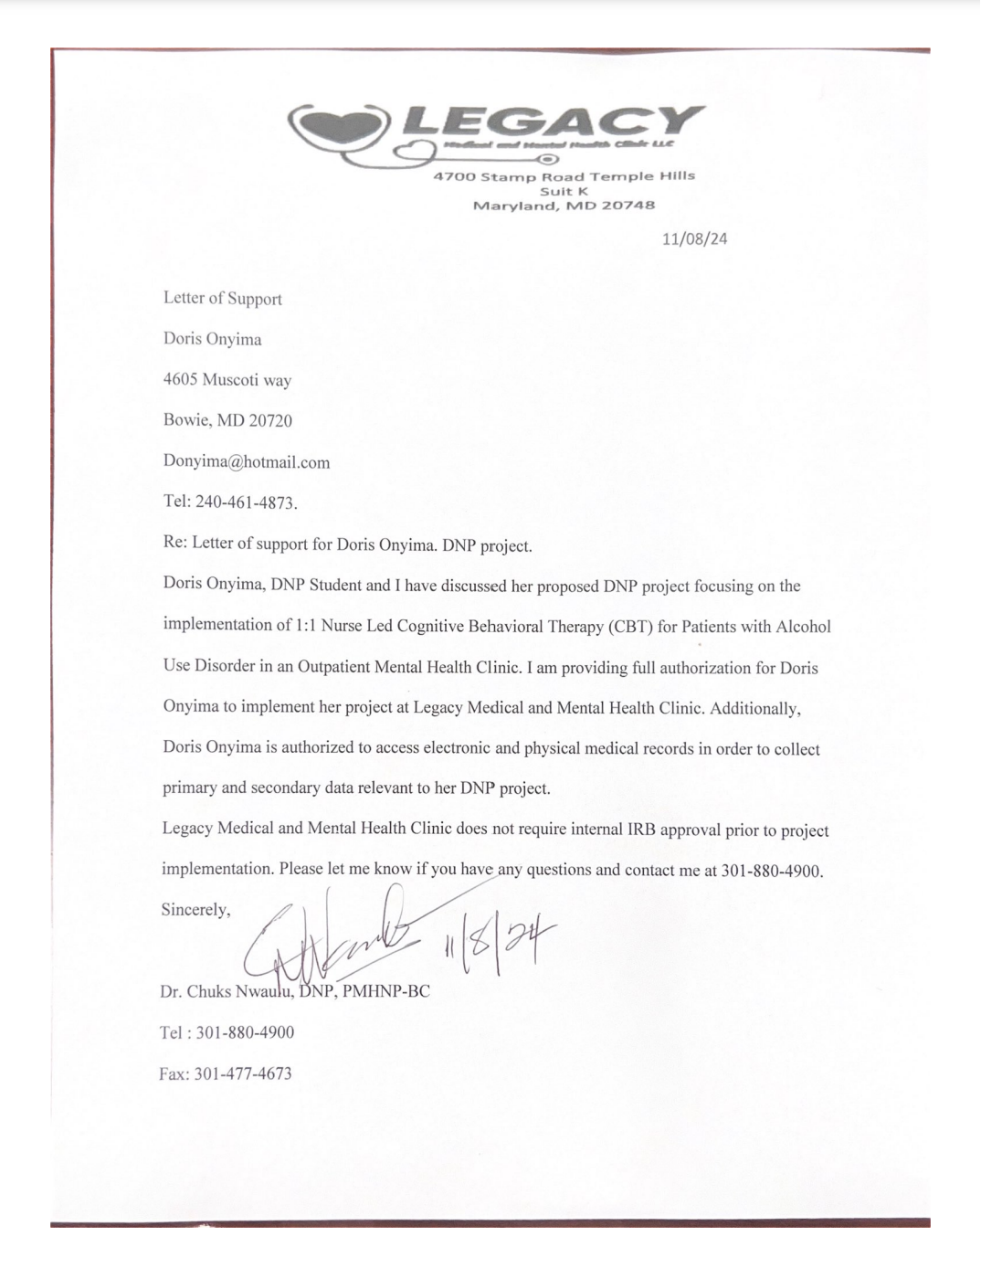

Appendix F: Compliance checklist
TASK | Completed | Comments
Week 1
Conduct initial meetings with the nursing staff. | ☐ | Discuss goals, purpose, and process for 1:1 nurse-led CBT.
Provide educational training for nurses. | ☐ | Include CBT principles, training objectives, roles, and expected outcomes.
Schedule training sessions for nurses. | ☐ | Develop accessible days/times for nurse participation.
Conduct AUDIT tool educational sessions. | ☐ | Train nurses on using the AUDIT tool for assessing alcohol withdrawal severity.
Administer pre-intervention AUDIT tool. | ☐ | Collect baseline data from all patients who meet inclusion criteria.
Weeks 2-9
Conduct initial meetings with the nursing staff. | ☐ | Discuss goals, purpose, and process for 1:1 nurse-led CBT.
Provide educational training for nurses. | ☐ | Include CBT principles, training objectives, roles, and expected outcomes.
Schedule training sessions for nurses. | ☐ | Develop accessible days/times for nurse participation.
Conduct AUDIT tool educational sessions. | ☐ | Train nurses on using the AUDIT tool for assessing alcohol withdrawal severity.
Administer pre-intervention AUDIT tool. | ☐ | Collect baseline data from all patients who meet inclusion criteria.
Week 10
Administer post-intervention AUDIT tool. | ☐ | Collect post-intervention data to assess the impact of the intervention.
Aggregate and analyze AUDIT tool data. | ☐ | Compare pre- and post-intervention results to evaluate outcomes.
Conduct stakeholder evaluation meetings. | ☐ | Present findings and discuss strategies for sustaining the practice change.
Provide feedback to nursing staff. | ☐ | Recognize contributions and address any final concerns.
Conclude the project. | ☐ | Document final results and summarize key insights for dissemination.

Tables
Table 1
Budget
EXPENSES |  | REVENUE
Direct |  | Billing
Salary and benefits | $0 | Grants
Supplies | $500 | Institutional budget support | $900
Services | $200
Statistician | $0
Indirect
Overhead | $200
Total Expenses | $900 | Total Revenue | $900
Net Balance |  |  | $0

Table 2
[Table Title]
Column Head | Column Head | Column Head | Column Head | Column Head
Row Head | 123 | 123 | 123 | 123
Row Head | 456 | 456 | 456 | 456
Row Head | 789 | 789 | 789 | 789
Row Head | 123 | 123 | 123 | 123
Row Head | 456 | 456 | 456 | 456
Row Head | 789 | 789 | 789 | 789
Note:

Figures
Figures Title

Figure 1.
For more information about all elements of APA formatting, please consult the APA Style Manual, 7th Edition.

