NU727 Week 4 Discussion: Setting, Sample, Types of Sampling

Student Name:
Institution:
Course:
Instructor
Due Date:

Setting, Sample, Types of Sampling
A comprehensive study requires an articulate research design, a suitable sample size, setting, and sampling strategy or technique. A sample refers to “a collection of individuals from a large population for a research objective (Makwana et al., 2023)”. The sampling technique or type is based on the form of data collected. The post elaborates on an assortment of applicable sampling methods, establishing the correct size, and discusses potential challenges related to the scholarly practice project (SPP). The SPP implements a motivational interviewing (MI) based training program among nursing staff to increase adherence to psychotropic medications. As the principal investigator, the SPP focuses on the recruitment of mental health nurses within the unit in the primary care setting, launches a training program on MI knowledge and skills, and examines their changes in knowledge and skills on patient adherence to psychotropic medications.
Sampling in clinical studies allows an investigator to pick the correct number of participants from a targeted or (statistical) population group, conclude and determine the generalization of findings (Campbell et al., 2020). The sample population is characterized by traits, attributes, among other considerations, to make a distinction from the general population and is defined to enable study focus and ensure statistical inferences. The most appropriate sampling method is a purposeful sampling method. It is a simple strategy that appropriately fits on assumptions, aims, and objectives of the SPP, specific participants holding varying and significant views on the question, and being included in the sample (Campbell et al., 2020). A purposeful sampling provides a convenience element to the voluntary participants aligned to the inclusion criteria, who are interested in the topic, motivating them to take part and contribute to knowledge development among the nursing staff. The recruitment of participants will depend on their willingness and availability to participate in the SPP.
The characteristics of the proposed sample population involve an inclusion and exclusion criteria aligned with SPP aims and objectives, by identifying traits and attributes that qualify participants in the study. As the principal criteria, the inclusion criteria will involve registered mental health nurses, licensed practice nurses, and nurses working in the unit within the primary care setting. The investigator will exclude administrative staff, non-licensed practice nurses, and non-registered nurses.
One of the challenges associated with a purposeful sampling-based study, such as a subjective sampling method, includes biases and unmeasurable sampling errors in study findings since the representatives cannot represent the target population to seek divergent and competing information among the participants (Stratton, 2024). The study findings are not transferable to a larger population. As such, it is inevitable to integrate a valid survey, interview, and data collection method reflected on the characteristics of the population study as a group, aligned to study objectives, depending on the specific application depending on the definite type of sampling method related to the study objectives. Informational variation derived from participants helps to determine differences among study subjects and lays the foundation for the generation of hypotheses in future studies (Stratton, 2024).
The application of an appropriate sampling strategy relies on the determination of sample size, sampling methods, and empirical findings. An appropriate sampling method presents great relevance to the validity and generalization of study findings, depending on the availability of participants. A purposive sampling is faster, cheaper, and easier to use, but it may be hampered by the underrepresentation of the population, leading to limited generalizability to a wider population (Ahmed, 2024). In this regard, the use of purposive sampling in the SPP aligns with the aims and objectives of the study to improve knowledge and skills, integrating MI to enhance medication adherence by providing insights based on changes in skills and knowledge among nursing staff.
As a quantitative quasi-experimental pre-test post-test quality improvement (QI) project, the determination of an appropriate number of sample subjects or size is crucial in the validity and reliability of results to ensure correct sample representation, minimize errors, and ensure statistical power. A G*power analysis will be used to calculate sample size. Below is a screenshot from G*Power software;
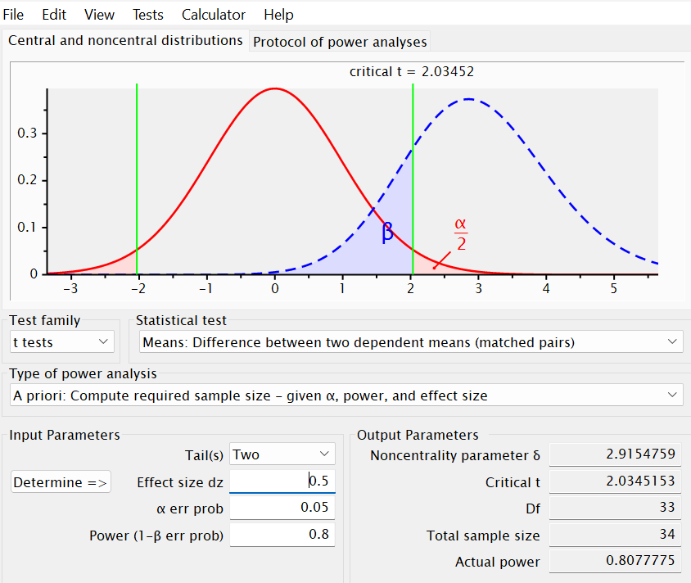
The illustration above provides G*Power output for a paired t-test power analysis to determine the required sample size in the SPP. The estimated sample size was 40. The required sample size is 34 to effectively determine a moderate effect size (dz) with 0.8 (80%) power and a 0.05 statistical level in a paired t-test. The actual power obtained is significantly higher at 80.78%, as established by the graph with critical t-value unravelling the rejection and no-rejection areas, and the balance on Type I (α) and Type II (β) errors.

References
Ahmed, S. K. (2024). How to choose a sampling technique and determine sample size for research: a simplified guide for researchers. Oral Oncology Reports, 12, 100662. https://doi.org/10.1016/j.oor.2024.100662
Campbell, S., Greenwood, M., Prior, S., Shearer, T., Walkem, K., Young, S., Bywaters, D., & Walker, K. (2020). Purposive sampling: complex or simple? Research case examples. Journal of research in nursing: JRN, 25(8), 652–661. https://doi.org/10.1177/1744987120927206
Makwana, D., Engineer, P., Dabhi, A., & Chudasama, H. (2023). Sampling methods in research: A review. Int. J. Trend Sci. Res. Dev, 7(3), 762-768. https://www.researchgate.net/publication/371985656_Sampling_Methods_in_Research_A_Review
Stratton, S. J. (2024). Purposeful sampling: advantages and pitfalls. Prehospital and disaster medicine, 39(2), 121-122. https://doi.org/10.1017/S1049023X24000281

